Supplemental Figure Legends
Supplemental Figure 1 Distribution of CD3, CD8, CD4, and differentiation subsets among total CD8⁺ T cells.
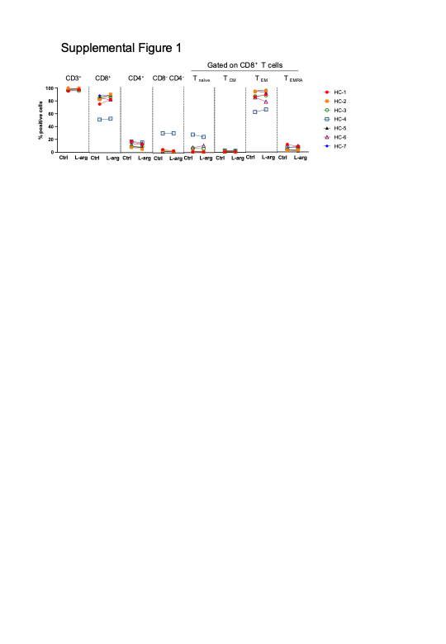
Comparative analysis of CD3, CD8, CD4, and differentiation marker (CCR7 and CD45RA) expression in CD8⁺ T cells under control and L-arginine-enriched conditions (n = 7). Based on CCR7 and CD45RA expression, CD8⁺ T cells were classified into four subsets: T_{naïve} (CCR7⁺CD45RA⁺), T_{CM} ( central memory, CCR7⁺CD45RA⁻), T_{EM} (effector memory, CCR7⁻CD45RA⁻), and T_{EMRA} (terminally differentiated effector memory re-expressing CD45RA, CCR7⁻CD45RA⁺).

Supplemental Figure 2 Gating strategy for surface marker, exhaustion marker, and phosphorylation analyses in total CD8⁺ T cells.
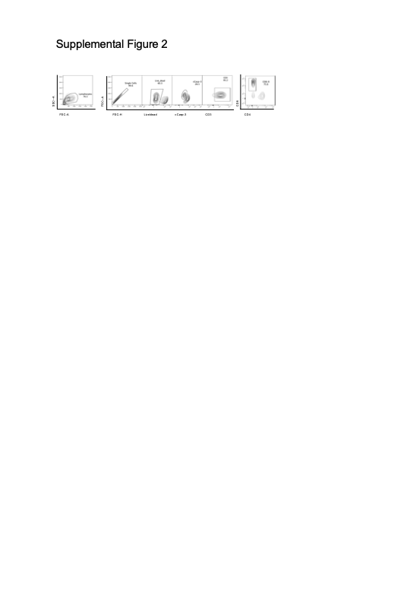
Given that apoptotic cells downregulate surface antigen expression and decrease phosphorylation levels, analyses of surface markers, exhaustion markers, and phosphorylation were conducted on cCasp-3⁻ CD8⁺ T cells to evaluate expression in the non-apoptotic population (refer to Fig. 2c-e and Fig. 3b).

