SUPPLEMENTARY INFORMATION
Enhancing Oxygen Reduction Reaction on Mn-Doped ZnO Catalysts: Structural, Electronic, and Mechanistic Insights for Selective Peroxide Production

Carlos A. Quiñones Martínez,¹ Alannisse M. Santos-Rivera,²Ninoshca M. García,¹ Héctor J. González,¹ Joshua A. Ortiz-Fernandez³, Joesene J. Soto⁶, Antonio Torres⁵, Juan A. Santana^{3,4}, Christopher J. Pollock,⁵ Héctor D. Abruña⁶ and Mitk’El B. Santiago Berrios¹

¹Department of Chemistry, University of Puerto Rico at Humacao, Call Box 860, Humacao, PR 00792, USA
²Natural Science Program, University of Puerto Rico at Cayey, P. O. Box 372230, Cayey, PR 00737, USA
³Department of Chemistry, University of Puerto Rico at Cayey, P. O. Box 372230, Cayey, PR 00737, USA
⁴Deanship of Academic Affairs, University of Puerto Rico at Cayey, P. O. Box 372230, Cayey, PR 00737, USA
⁵Cornell High Energy Synchrotron Source, Wilson Laboratory, Cornell University, Ithaca, New York 14853, USA
⁶Department of Chemistry and Chemical Biology, Baker Laboratory, Cornell University, Ithaca, New York 14853-1301, United States

Table S1. Fitting parameters for C1s (following Grey et al.’s model) and Mn (following Ilton et al.’s model).
Region | Species | Peak | Binding Energyª | Area^{ab} | FWHM^{ac} | Lineshape
C 1s | C-C, C-H | A | 284.8^{d} | -/- | -/- | GL(30)
 | C-O | B | A + 1.5 | -/- | A * 1 | GL(30)
 | C=O | C | A + 3 | -/- | A * 1 | GL(30)
 | O-C=O | D | A + 4.3 | -/- | -/- | GL(30)
 | C*-C-O | E | A + 0.2 | B * 1.25 | A * 1 | GL(30)
 | C*-C=O | F | A + 0.4 | C * 1.5 | A * 1 | GL(30)
 | C*-(C=O)-O | G | A + 0.4 | D * 1 | A * 1 | GL(30)
Mn 2p_{3/2} | Mn⁴⁺ | A | 844.45 – 544.85 | -/- | -/- | GL(50)
 |  | B | A - 0.78 | A * 0.534 | A * 1 | GL(50)
 |  | C | A + 1.37 | A * 0.496 | A * 1 | GL(50)
 |  | D | A + 2.07 | A * 0.277 | A * 1 | GL(50)
 |  | E | A + 2.84 | A * 0.167 | A * 1 | GL(50)
 |  | F | A + 3.75 | A * 0.087 | A * 1 | GL(50)
 |  | G | A + 4.84 | A * 0.036 | A * 1 | GL(50)
 |  | H | A + 5.06 | A * 0.0013 | A * 1 | GL(50)
 | Mn³⁺ | A | 844.91 – 845.31 | -/- | -/- | GL(50)
 |  | B | A - 0.79 | A * 0.955 | A * 1 | GL(50)
 |  | C | A + 0.68 | A * 0.798 | A * 1 | GL(50)
 |  | D | A + 1.44 | A * 0.618 | A * 1 | GL(50)
 |  | E | A + 2.26 | A * 0.326 | A * 1 | GL(50)
 |  | F | A + 3.2 | A * 0.175 | A * 1 | GL(50)
 |  | G | A + 4.22 | A * 0.073 | A * 1 | GL(50)
 |  | H | A - 2.49 | A * 0.036 | A * 1.274 | GL(50)
 | Mn²⁺ | A | 847.2 – 847.6 | -/- | -/- | GL(50)
 |  | B | A + 1.04 | A * 0.705 | A * 1 | GL(50)
 |  | C | A + 1.8 | A * 0.507 | A * 1 | GL(50)
 |  | D | A + 2.68 | A * 0.356 | A * 1 | GL(50)
 |  | E | A + 3.76 | A * 0.164 | A * 1 | GL(50)
 |  | F | A + 4.85 | A * 0.08 | A * 1.315 | GL(50)
 |  | G | A + 6.88 | A * 0.32 | A * 2.118 | GL(50)
 |  | H | A - 1.65 | A * 0.036 | A * 1.157 | GL(50)
Notes: a) for constrained species, the notation will be “Peak” + chemical shift; b) if the area is labeled -/- it is an unconstrained variable; c) if the FWHM is labeled -/- it is an unconstrained variable; d) value calibrated against at 284.8 eV
Scanning electron microscopy
Figure S1. SEM micrographs and elemental mapping of the catalysts. The catalysts demonstrated that they were homogeneous and evenly distributed across the sample.
Scanning Electron Microscopy (SEM), combined with Energy Dispersive X-ray Spectroscopy (EDS), was employed to analyze the morphology, particle distribution, and elemental composition of the synthesized ZnO-based catalysts. Figure 3 presents representative SEM micrographs along with corresponding elemental mapping for Zn, O, and Mn in pure ZnO, Mn_{0.036}Zn_{0.95}O, and Mn_{0.12}Zn_{0.97}O samples. The SEM micrographs reveal that all the catalysts exhibit a polycrystalline morphology composed of small, irregular particles with a tendency toward agglomeration. The agglomerated nature of these particles is consistent across all samples, indicating similar crystallization behavior regardless of the manganese doping levels.
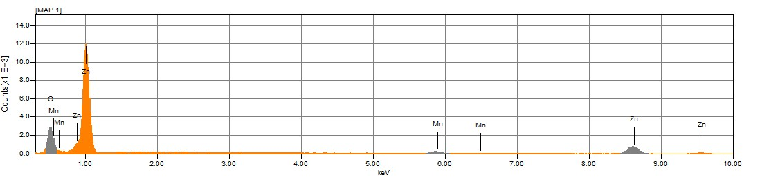
Figure S2. EDS histogram of MnZnO, manganese loading concentration 5%.

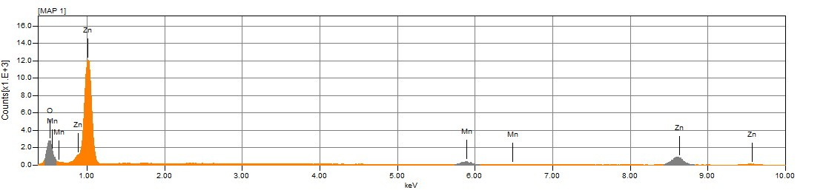
Figure S3. EDS histogram of MnZnO, manganese loading concentration 10%.

Raman Spectroscopy Analysis of ZnO and Mn-Doped ZnO Catalysts
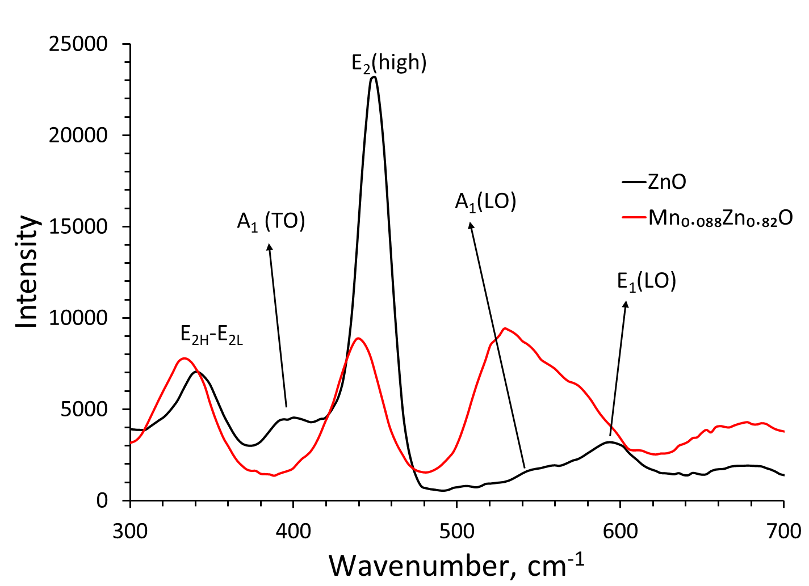
Figure S4. Raman spectra of pure ZnO and Mn_{0.088}Zn_{0.82}O catalysts. Note the reduction in intensity of the E₂(high) mode (~450 cm⁻¹), and the enhanced intensity, broadening, and shifting of the A₁(LO) vibrational mode (~535 cm⁻¹) upon Mn doping. The E₁(high) mode appears shifted and partially overlapped as a shoulder at ~580 cm⁻¹.
Raman spectroscopy was utilized to investigate the vibrational properties and structural changes induced by manganese doping in the ZnO lattice. We only analyzed the sample of lower manganese loading level since in the XRD we did not observe the presence of other crystalline species. Figure S4 displays the Raman spectra obtained for pure ZnO and the Mn-doped sample Mn_{0.088}Zn_{0.82}O.
For the pure ZnO catalyst, the characteristic Raman vibrational modes are identified. Specifically, the sharp and intense peak observed at approximately 450 cm⁻¹ corresponds to the E₂(high) mode, characteristic of the wurtzite ZnO crystal structure.¹ Additionally, distinct vibrational modes appear at around 550 cm⁻¹ (A₁(LO) mode) and 558 cm⁻¹ (E₁(high) mode), although the latter is significantly less intense in the pure ZnO spectrum. Upon doping with manganese, notable differences emerge in the vibrational spectra compared to the pure ZnO. The E₂(high) vibrational mode, at approximately 450 cm⁻¹, exhibits a noticeable decrease in intensity, indicating disruptions in the ZnO crystal symmetry due to Mn incorporation. Furthermore, the A₁(LO) mode experiences a pronounced increase in intensity, broadening, and a notable shift to a lower wavenumber (from 550 cm⁻¹ to around 535 cm⁻¹). The E₁(high) mode, initially at 558 cm⁻¹ in pure ZnO, shifts toward lower wavenumbers (around 580 cm⁻¹) and appears as a shoulder merged into the broadened A₁(LO) peak.
These spectral modifications—reduction in E₂(high) mode intensity, shift and broadening of the A₁(LO) peak, and the displacement of the E₁(high) mode has been assigned as doping agents occupying tetrahedral sites within the wurtzite structure of ZnO and/or at the defect’s sites of the material.^{2,3}As Gandhi, et. Al. and Chanda and collaborators stated independently the changes in spectra and the data obtained in the XRD shows that the inclusion of doping agents changes the electronic properties of the material. Such findings align well with previous reports on metal-doped ZnO materials, reinforcing the conclusion that manganese doping mainly impacts lattice vibrations through subtle distortions rather than promoting significant phase segregation or secondary phase formation.^{4–6}
References
(1) Marica, I.; Nekvapil, F.; Ștefan, M.; Farcău, C.; Falamaș, A. Zinc Oxide Nanostructures for Fluorescence and Raman Signal Enhancement: A Review. Beilstein Journal of Nanotechnology 2022, 13, 472. https://doi.org/10.3762/BJNANO.13.40.
(2) Chanda, A.; Gupta, S.; Vasundhara, M.; Joshi, S. R.; Mutta, G. R.; Singh, J. Study of Structural, Optical and Magnetic Properties of Cobalt Doped ZnO Nanorods. RSC Adv 2017, 7 (80), 50527–50536. https://doi.org/10.1039/C7RA08458G.
(3) Gandhi, V.; Ganesan, R.; Abdulrahman Syedahamed, H. H.; Thaiyan, M. Effect of Cobalt Doping on Structural, Optical, and Magnetic Properties of ZnO Nanoparticles Synthesized by Coprecipitation Method. Journal of Physical Chemistry C 2014, 118 (18), 9717–9725. https://doi.org/10.1021/jp411848t.
(4) Varadhaseshan, R.; Sundar, S. M.; Prema, C. On the Preparation, Structural and Magnetic Properties of ZnO:Co Nanoparticles. EPJ Applied Physics 2014, 66 (1). https://doi.org/10.1051/epjap/2014130316.
(5) Martínez, B.; Sandiumenge, F.; Balcells, L.; Arbiol, J.; Sibieude, F.; Monty, C. Structure and Magnetic Properties of Co-Doped ZnO Nanoparticles. Phys Rev B Condens Matter Mater Phys 2005, 72 (16), 1–8. https://doi.org/10.1103/PhysRevB.72.165202.
(6) Del Pilar Albadalejo, J.; Alonso-Sevilla, S.; Cintrón, N. I.; Feng, X.; García, Á. D.; Martínez-Torres, D. D.; Rodríguez, A. M.; Román-Montalvo, N. I.; Torres, J. I.; Yang, Y.; Peña-Duarte, A.; Singhal, R.; Debefve, L. M.; Pollock, C. J.; Cabrera, C. R.; Abruña, H. D.; Santiago-Berríos, M. B. Ex Situ and In Situ Analyses of the Mechanism of Electrocatalytic Hydrogen Peroxide Production by CoxZn1- XO (0 < x < 0.018) Materials in Alkaline Media. ACS Appl Energy Mater 2022, 5 (6), 6597–6605. https://doi.org/10.1021/ACSAEM.1C04030/ASSET/IMAGES/LARGE/AE1C04030_0008.JPEG.

