Supplementary Information

Figure S1 The transcriptional regulation of CTNNB1 by ONECUT2.

Figure S2 Representative images of tumor spheres.

Figure S3 Representative images from the FCM analysis of BALB/c tumor models.

Figure S4 Representative images of FCM analysis in THP-1-derived macrophages.

Figure S5 ELISA assay for CCL28 secretion.

Figure S6 Gene expression changes in THP-1-derived macrophages treated with MDA-231-conditioned supernatant.

Table S1 Patient clinical parameters and their association with ONECUT2, POU6F2 and beta-catenin gene expression.

Table S2 Primer sequences and antibodies.

Table S3 The potential target genes of ONECUT2 using the GTRD.

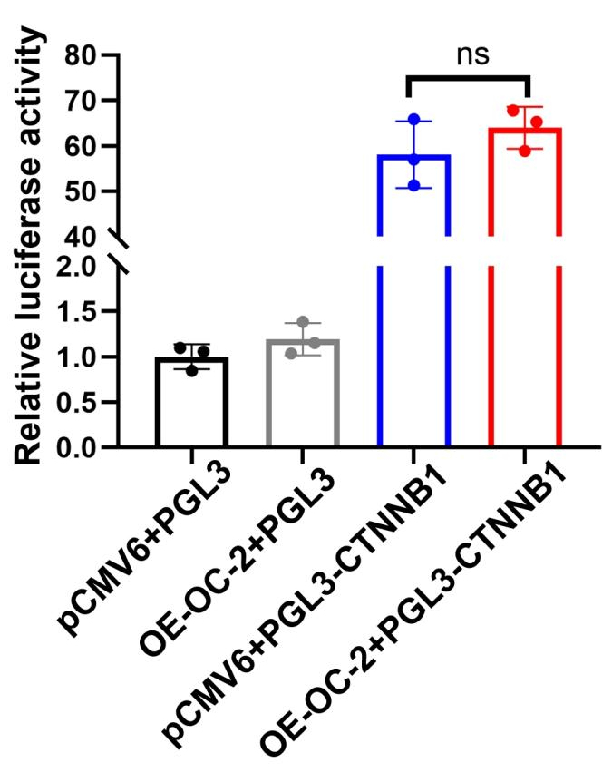

Figure S1 The transcriptional regulation of CTNNB1 by ONECUT2. Dual-luciferase reporter assays were used to assess transcriptional regulation of CTNNB1 by ONECUT2 (ns:P＞0.05, *P<0.05, **P<0.01, ***P<0.001).

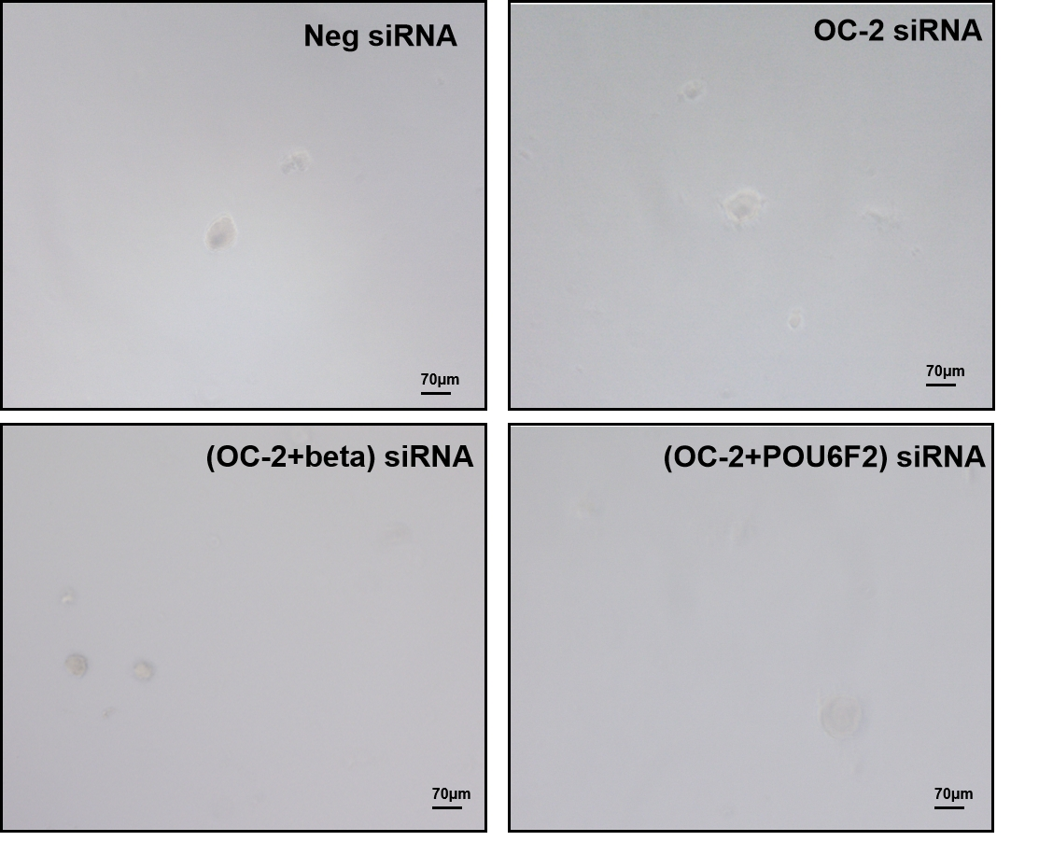

Figure S2 Representative images of tumor spheres.
MCF-7 cells were transfected with a control siRNA, siONECUT2, or mixed siRNAs (ONECUT2 plus beta-catenin or ONECUT2 plus POU6F2), and collected for sphere formation assay. Scale bar: 70 μm.

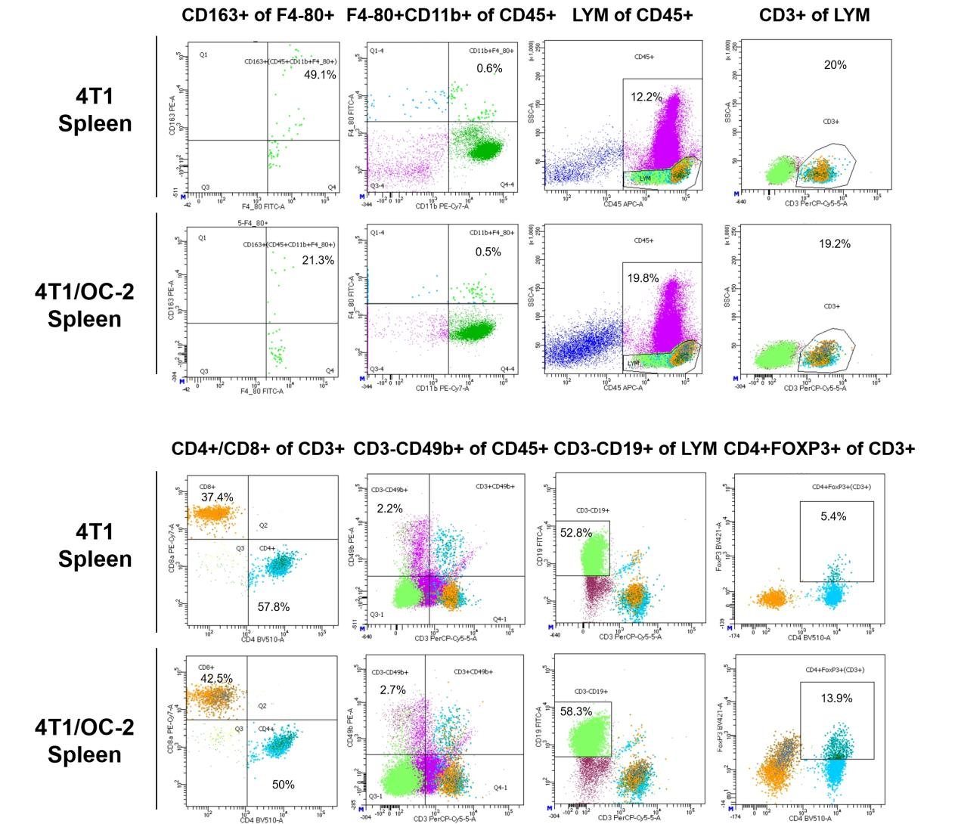

Figure S3 Representative images from the FCM analysis of BALB/c tumor models.
The percentages of immunocytes (M2-type macrophages, macrophages, CD3⁺T cells, CD4⁺T cells, CD8⁺T cells, NK cells, B cells, and Tregs) in the spleen tissues from 4T1/OC-2 or 4T1 mice were elevated by FCM analysis.

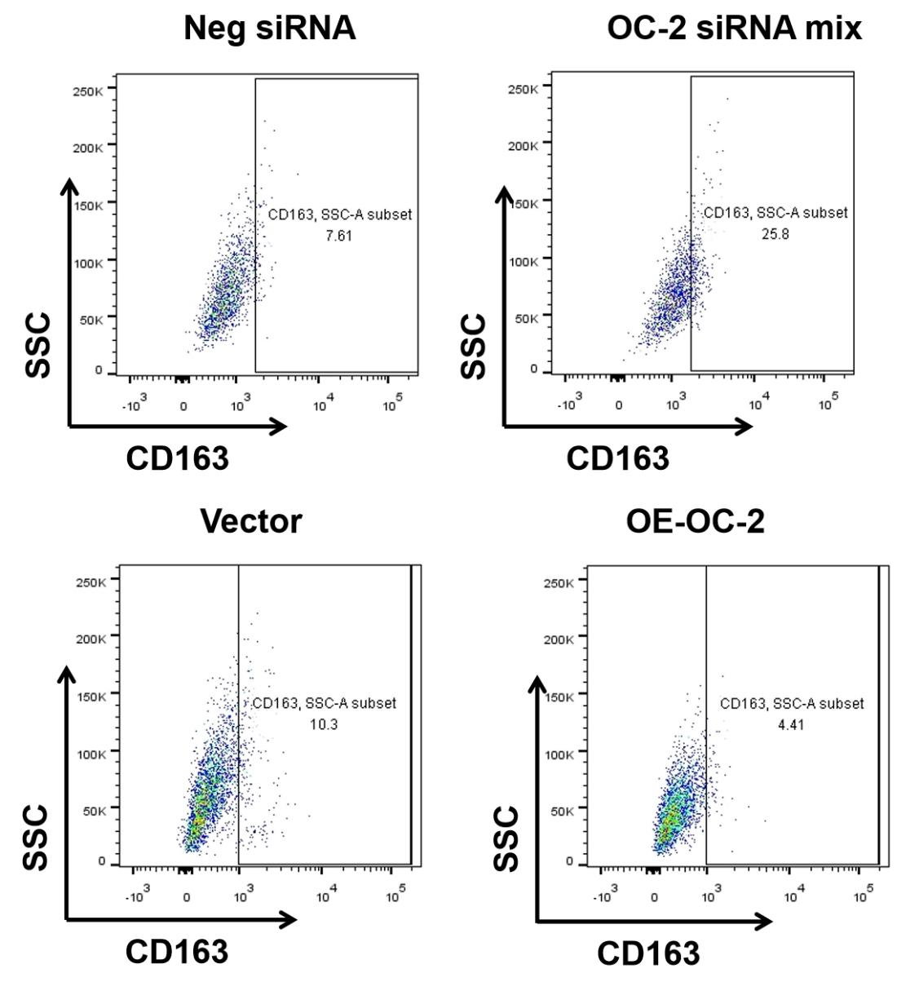

Figure S4 Representative images of FCM analysis in THP-1-derived macrophages.
THP-1 cells were co-cultured with MDA-231-conditioned supernatant, and the CD163⁺CD68⁺ population was assessed by FCM analysis.

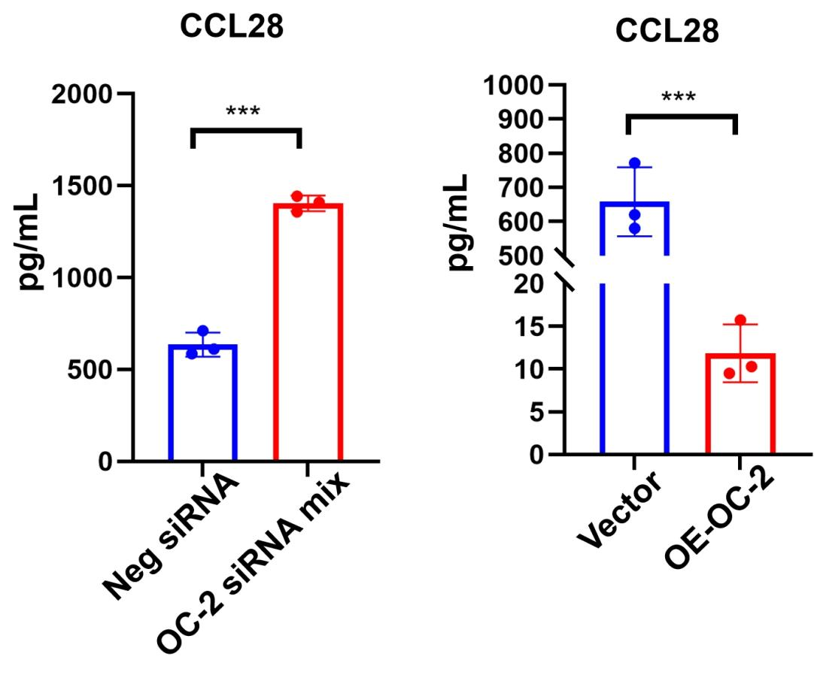

Figure S5 ELISA assay for CCL28 secretion.
ELISA were performed to test the secretion of CCL28 by MDA-231 cells transfected with ONECUT2 siRNAs or an overexpression plasmid. Error bars represent mean ± SD of three independent experiments. *P<0.05, **P<0.01, ***P<0.001.

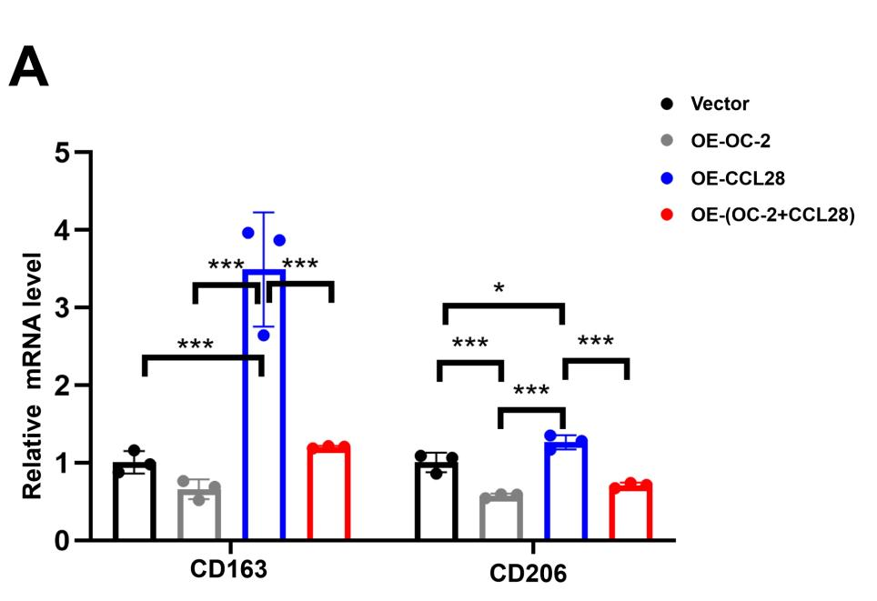

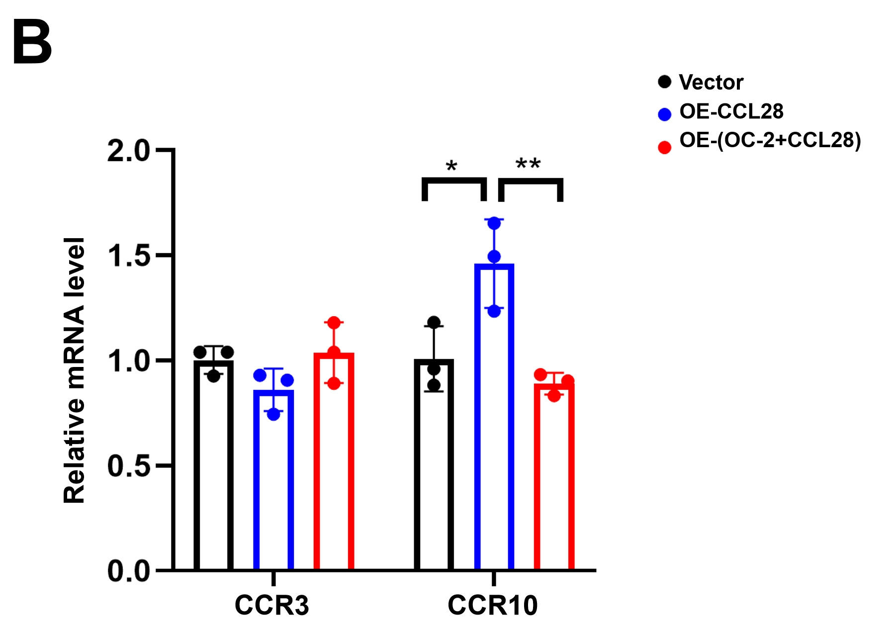

Figure S6 Gene expression changes in THP-1-derived macrophages treated with MDA-231-conditioned supernatant.
RT-qPCR analysis for the mRNA levels of CD163 and CD206 (A), or CCR3 and CCR10 (B) in THP-1 cells treated with MDA-231-conditioned supernatant. Error bars represent mean ± SD of three independent experiments. *P<0.05, **P<0.01, ***P<0.001.

