Supporting Information
Highly Sensitive LM@MWCNT Flexible Piezoresistive Sensor for Signal Recovery and Speech Recognition Enabled by CNN

Haoyu Li¹, Chenyu Mou¹, Xiaolin Ran¹, Yunlong Wang¹, Shaojiang Wang¹, Huiru Li¹, Wenfeng Qin^{1,2,}∗,Jiayu Xie^{1, 2, *}

¹Aviation Engineering Institute, Civil Aviation Flight University of China, Guanghan, China
²Key laboratory of joint innovation for aviation emergency response and rescue, Ministry of emergency management, Chengdu, Sichuan, China

1. Resistance variation of LM and LM@MWCNT coatings before and after 3 days.
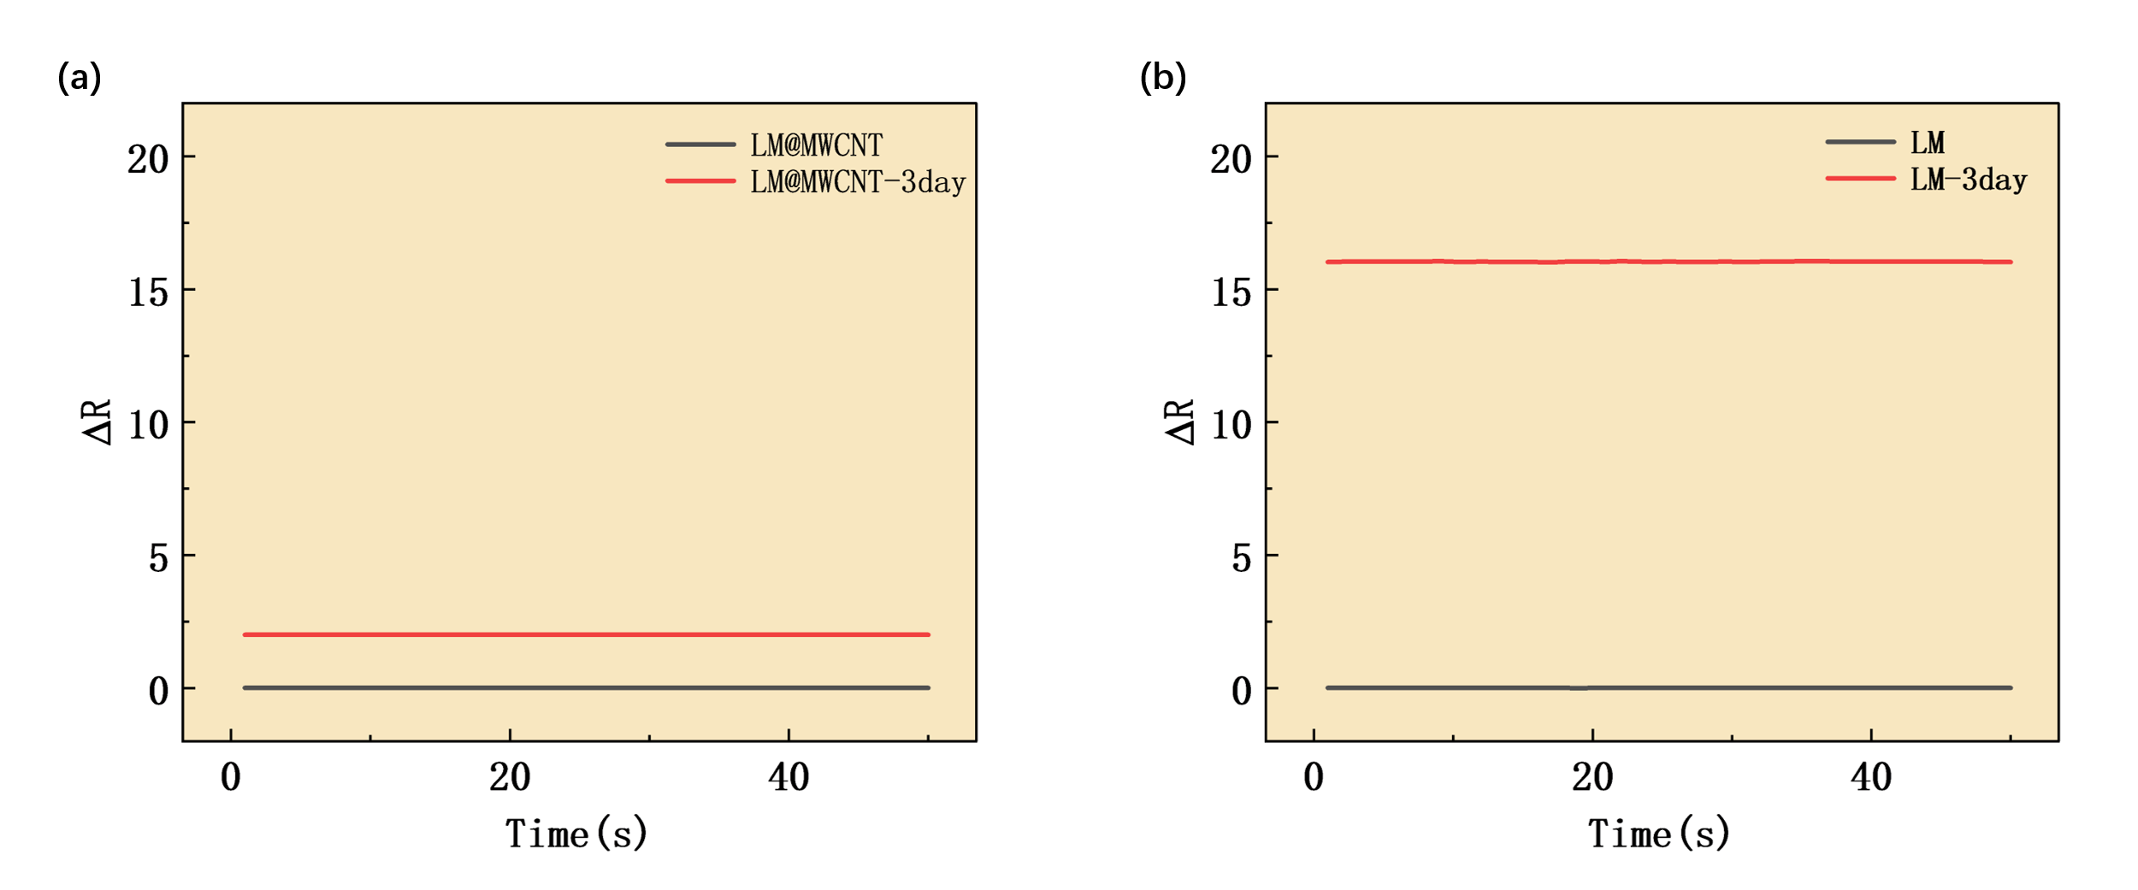
Fig. S1. (a) Resistance variation of LM@MWCNT coatings before and after 3 days. (b) Resistance variation of LM coatings before and after 3 days.

2. Pristine PDMS Substrate with Microstructures
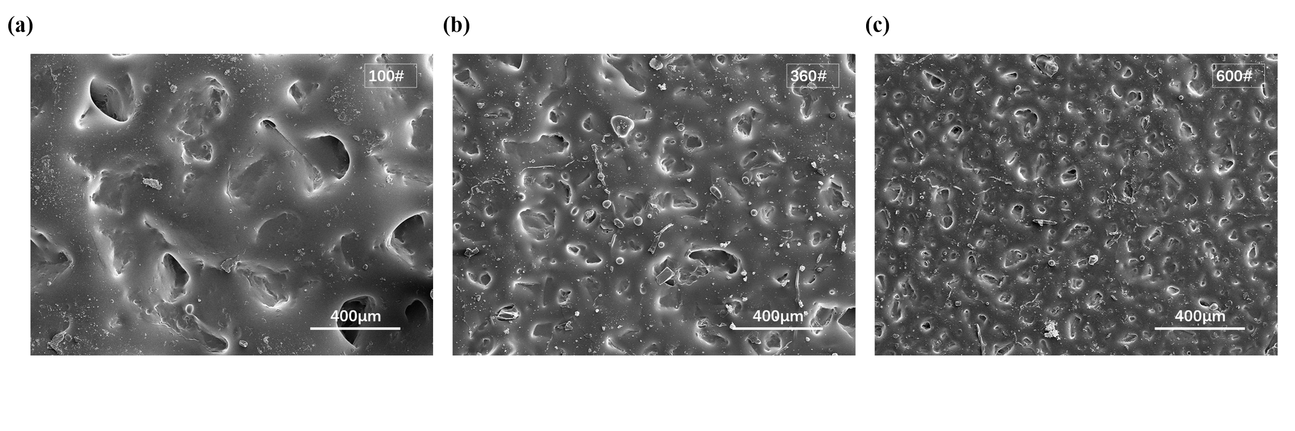
Fig. S2. (a) SEM images of PDMS surfaces fabricated with 100-grit sandpaper. (b) SEM images of PDMS surfaces fabricated with 360-grit sandpaper. (c) SEM images of PDMS surfaces fabricated with 600-grit sandpaper.

3. Comparison between actual and predicted values.
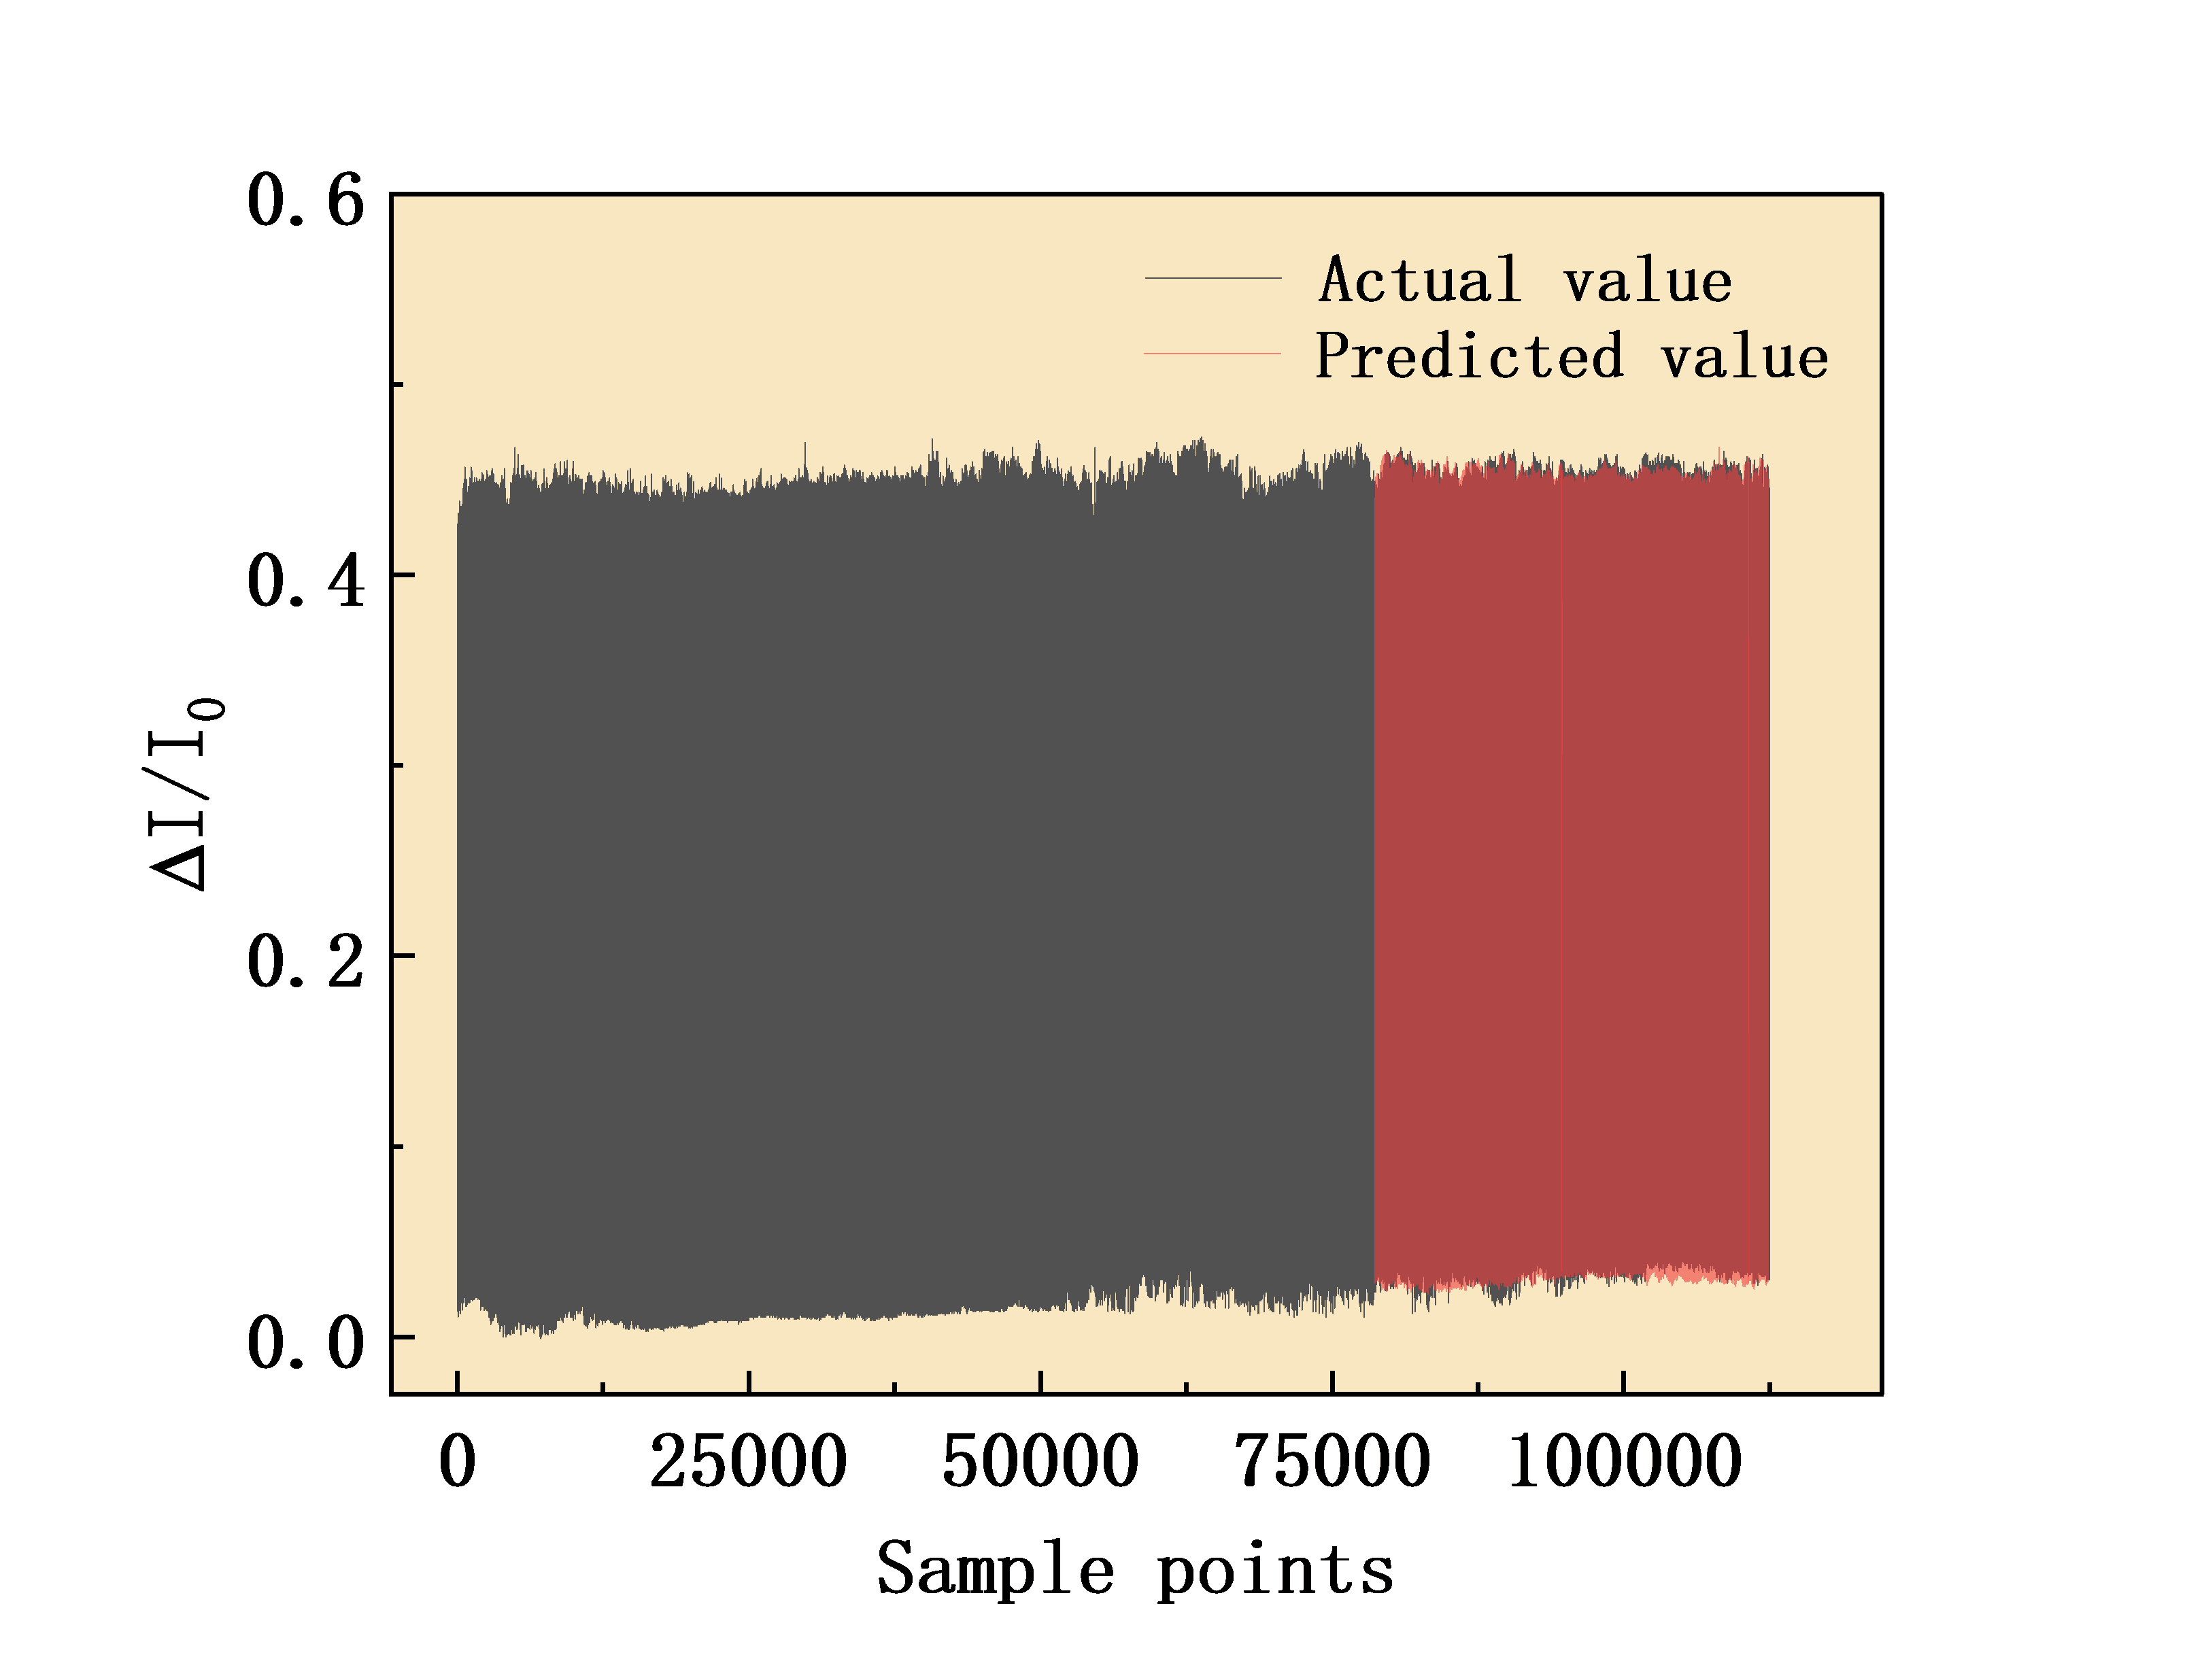
Fig. S3. Comparison of actual pulse signals and CNN-predicted values

∗ Corresponding Author. Wenfeng Qin, E-mail address: qwfgrh@126.com (W. F. Qin), Jiayu Xie, E-mail address: 12649960@qq.com

