Supporting information: Evolutionary genomics and divergence of Cacopsylla species with a special focus on the Apple Proliferation Vectors: Cacopsylla melanoneura and C. picta
Lapo Ragionieri^{a¥*}, Liliya Štarhová Serbina^{b,c¥}, Erika Correttoª, James M. Howie^{d,e}, Fernando Cruz ^{f,g}, Tyler S. Alioto^{f,g}, Nicola Zadra^{h}, Gianfranco Anfora^{h}, Christian Stauffer^{d}, Lino Ometto^{i*}, Omar Rota-Stabelli^{h,j*}, Hannes Schuler^{a,k}
ª Competence Centre for Plant Health, Free University of Bozen-Bolzano, Bozen-Bolzano, Italy
^{b} Center for Integrative Biodiversity Discovery, Leibniz Institute for Evolution and Biodiversity Science; Museum für Naturkunde, Berlin, Germany
^{c} Present address: Museum of Nature Hamburg, Leibniz Institute for the Analysis of Biodiversity Change, Hamburg, Germany.
^{d} Department of Ecosystem Management, Climate and Biodiversity, BOKU University, Vienna, Austria
^{e} Present address: Medical University of Vienna, Center for Cancer Research, Vienna, Austria
^{f} Centro Nacional de Análisis Genómico (CNAG), Baldiri Reixac 4, 08028 Barcelona, Spain
^{g} Universitat de Barcelona (UB), Barcelona, Spain
^{h} University of Trento, Center Agriculture Food Environment (C3A), Trento, Italy
^{i} Department of Biology and Biotechnology, University of Pavia, Pavia, Italy
^{j} Centro Ricerca ed Innovazione, Fondazione Edmund Mach, San Michele all’ Adige, Italy
^{k} Free University of Bozen-Bolzano, Faculty of Natural Sciences and Technology, 39100, Bozen, Italy

*Authors for Correspondence, ¥Contributed equally

Table S1. Sequencing Data
Sample | Library | Read length (bp) |  | Fragment length (bp)¹ |  |  | Yield (Gb) |  | Coverage² |  | phix error r1 (%) |  | phix error r2 (%)
Cmel_1 | PE310 | 2x251 |  | 310 |  |  | 57.85 |  | 131.87 |  | 1.745 |  | 1.845
Cmel_2 | PE290 | 2x251 |  | 289 |  |  | 59.37 |  | 135.34 |  | 1.745 |  | 1.845
Cmel_4 | PE700 | 2x251 |  | 689 |  |  | 75.34 |  | 171.74 |  | 1.5725 |  | 1.9525
Cpic_2 | PE510 |  | 2x251 |  | 507 | 121.46 |  | 192.15 |  | 1.5725 |  | 1.953
Cpic_2 | PE750 |  | 2x251 |  | 746 | 74.94 |  | 118.57 |  | 1.5725 |  | 1.953

¹ Fragment size used during agarose gel size selection for C. melanoneura. Paired End Libraries are referred as PE310, PE290 and PE700 attending to their genomic fragment size. ² The sequencing coverage was calculated assuming a genome size of 438.7 Mb (as it was estimated with Genomescope v1.1 with=17).¹ Fragment size used during agarose gel size selection (including adapter and other technical sequences) for C. melanoneura. Paired End Libraries were named PE510 and PE750 attending to their genomic fragment size. ² The sequencing coverage was calculated assuming a genome size of 632.08 Mb (as it was estimated with Genomescope v1.1 from the PE510 library using a k=17).

Table S2. Genome Properties of Cacopsylla melanoneura
 | Property* | min | max
Cacopsylla melanoneura | Heterozygosity | 2.51% | 2.53%
 | Genome Haploid Length (bp) | 438,045,262 | 438,672,560
 | Genome Repeat Length (bp) | 250,936,758 | 251,296,110
 | Genome Unique Length (bp) | 187,108,503 | 187,376,450
 | Model Fit | 86.89% | 94.21%
 | Read Error Rate | 1.05% | 1.05%
 | Repetitive Fraction of the Genome | 57.28% | 57.28%
Cacopsylla picta | Heterozygosity | 1.37% | 1.37%
 | Genome Haploid Length (bp) | 631,347,990 | 632,082,702
 | Genome Repeat Length (bp) | 423,571,562 | 424,064,480
 | Genome Unique Length (bp) | 207,776,428 | 208,018,222
 | Model Fit | 85.59% | 97.20%
 | Read Error Rate | 0.68% | 0.68%
 | Repetitive Fraction of the Genome | 67.09% | 67.09%

*Estimated from the Illumina PE700 2x251bp reads using GenomeScope version 1.0 (k = 17)

Table S3. Contaminant Species detected with Kraken
 | Species Name | NCBI TaxID | %Reads Covered
Cacopsylla melanoneura | Myceliophthora thermophila | 78579 | 1.63
 | Candida dubliniensis | 42374 | 1.26
 | Leishmania major | 5664 | 1.14
 | Thielavia terrestris | 35720 | 0.46
 | Methanobacterium formicicum | 2162 | 0.31
 | Streptococcus sp. VT 162 | 1419814 | 0.26
 | Saccharomyces cerevisiae | 4932 | 0.18
 | Pandoravirus dulcis | 1349409 | 0.08
 | Cronobacter sakazakii | 28141 | 0.07
 | Alteromonas mediterranea | 314275 | 0.06
 | Piscine myocarditis-like virus | 1798085 | 0.06
 | Mycoplasma hyopneumoniae | 2099 | 0.06
 | Kluyveromyces lactis | 28985 | 0.05
 | Methanococcus voltae | 2188 | 0.04
 | Candidatus Carsonella ruddii | 114186 | 0.03
 | Pandoravirus salinus | 1349410 | 0.03
 | Methanosarcina lacustris | 170861 | 0.03
Cacopsylla picta | Bacillus halodurans | 86665 | 4.31
 | Methanobacterium formicicum | 2162 | 4.24
 | Myceliophthora thermophila | 78579 | 2.57
 | Candida dubliniensis | 42374 | 2.35
 | Leishmania major | 5664 | 1.45
 | Thielavia terrestris | 35720 | 0.79
 | Alteromonas mediterranea | 314275 | 0.58
 | Candidatus Carsonella ruddii | 114186 | 0.57
 | Saccharomyces cerevisiae | 4932 | 0.37
 | Streptococcus sp. VT 162 | 1419814 | 0.26
 | Buchnera aphidicola | 9 | 0.13
 | Methanococcus voltae | 2188 | 0.12
 | Mycoplasma hyopneumoniae | 2099 | 0.11
 | Piscine myocarditis-like virus | 1798085 | 0.1
 | Kluyveromyces lactis | 28985 | 0.1
 | Pandoravirus dulcis | 1349409 | 0.09
 | Methanosarcina lacustris | 170861 | 0.05

Table S4. Summary contiguity statistics of Cmel1 assembly
 | Contigs |  | Scaffolds
 | Length (bp) | Number | Length (bp) | Number
N0 | 23,792 | 1 | 94,132 | 1
N5 | 4,910 | 5,378 | 16,600 | 1,634
N10 | 3,867 | 13,235 | 13,042 | 3,999
N15 | 3,280 | 22,779 | 10,934 | 6,900
N20 | 2,860 | 33,846 | 9,409 | 10,303
N25 | 2,542 | 46,411 | 8,168 | 14,234
N30 | 2,279 | 60,472 | 7,108 | 18,755
N35 | 2,056 | 76,100 | 6,182 | 23,956
N40 | 1,866 | 93,375 | 5,361 | 29,939
N45 | 1,694 | 112,403 | 4,612 | 36,869
N50 | 1,539 | 133,352 | 3,921 | 44,968
N55 | 1,398 | 156,417 | 3,254 | 54,610
N60 | 1,266 | 181,840 | 2,624 | 66,389
N65 | 1,135 | 209,999 | 2,040 | 81,300
N70 | 997 | 241,779 | 1,572 | 100,578
N75 | 856 | 278,276 | 1,200 | 125,681
N80 | 688 | 322,177 | 940 | 158,244
N85 | 523 | 378,576 | 650 | 201,835
N90 | 398 | 454,011 | 432 | 267,199
N95 | 303 | 550,515 | 317 | 359,291
N100 | 51 | 678,097 | 250 | 483,574
Total | 676,207,714 | 678,097 | 688,997,636 | 483,574

Table S5. Summary contiguity statistics of Cpic3 assembly
 | Contigs |  | Scaffolds
 | Length (bp) | Number | Length (bp) | Number
N0 | 60,181 | 1 | 83,674 | 1
N5 | 7,692 | 3,578 | 24,248 | 1,184
N10 | 5,868 | 9,127 | 18,815 | 2,937
N15 | 4,917 | 16,006 | 15,654 | 5,102
N20 | 4,267 | 24,038 | 13,440 | 7,656
N25 | 3,773 | 33,206 | 11,745 | 10,602
N30 | 3,365 | 43,523 | 10,311 | 13,964
N35 | 3,030 | 55,028 | 9,103 | 17,781
N40 | 2,728 | 67,803 | 8,082 | 22,094
N45 | 2,461 | 81,974 | 7,145 | 26,952
N50 | 2,224 | 97,670 | 6,289 | 32,467
N55 | 2,002 | 115,070 | 5,494 | 38,753
N60 | 1,799 | 134,426 | 4,748 | 45,985
N65 | 1,608 | 156,014 | 4,038 | 54,416
N70 | 1,425 | 180,261 | 3,361 | 64,430
N75 | 1,248 | 207,782 | 2,703 | 76,665
N80 | 1,076 | 239,415 | 2,060 | 92,292
N85 | 904 | 276,648 | 1,462 | 113,532
N90 | 703 | 322,528 | 982 | 144,672
N95 | 479 | 384,742 | 594 | 193,132
N100 | 24 | 498,189 | 200 | 287,478
Total | 734,172,073 | 498,189 | 739,042,261 | 287,478

Table S6 List of species used in this study
species | acc num mitogenome | SRA/BioProject
Cacopsylla_melanoneura | PX243765 | PRJNA1312285
Cacopsylla_picta | PX243766 | PRJNA1312285
Cacopsylla_pyri | PV137636 | PRJNA853726
Cacopsylla_pyricola | PV137637 | PRJNA853282
Cacopsylla_mali | PV137633 | PRJNA1211559
Cacopsylla_pruni | PV137635 | PRJNA1211557
Cacopsylla_pyrisuga | PV137638 | PRJNA1211560
Cacopsylla_burckhardti | NC_069642.1 | SRX15496259
Cacopsylla_jukyungi | NC_069847.1 | SRX16308894
Cacopsylla_coccinea | NC_027087.1 | -
Cacopsylla_fuscicella | NC_080374.1 | -
Cacopsylla_citrisuga | NC_053749.1 | -
Heteropsylla cubana | PV137639 | -
Diaphorina citri | MF426268.1 | -
Euphyllura phillyreae | NC_038134.1 | -
Livia junci | NC_038137.1 | -
Paurocephala sauteri | NC_053635.1 | -
Melanastera paucipunctata | NC_038109.1 | -
Pachypsylla venusta | AY278317.1 | -
Lanthanaphalara mira | NC_038111.1 | -
Aphis gossypii | NC_024581.1 | -
Myzus persicae | NC_029727.1 | -
Bemisia tabaci | NC_006279.1 | -
Aleurodicus dugesii | NC_005939.1 | -

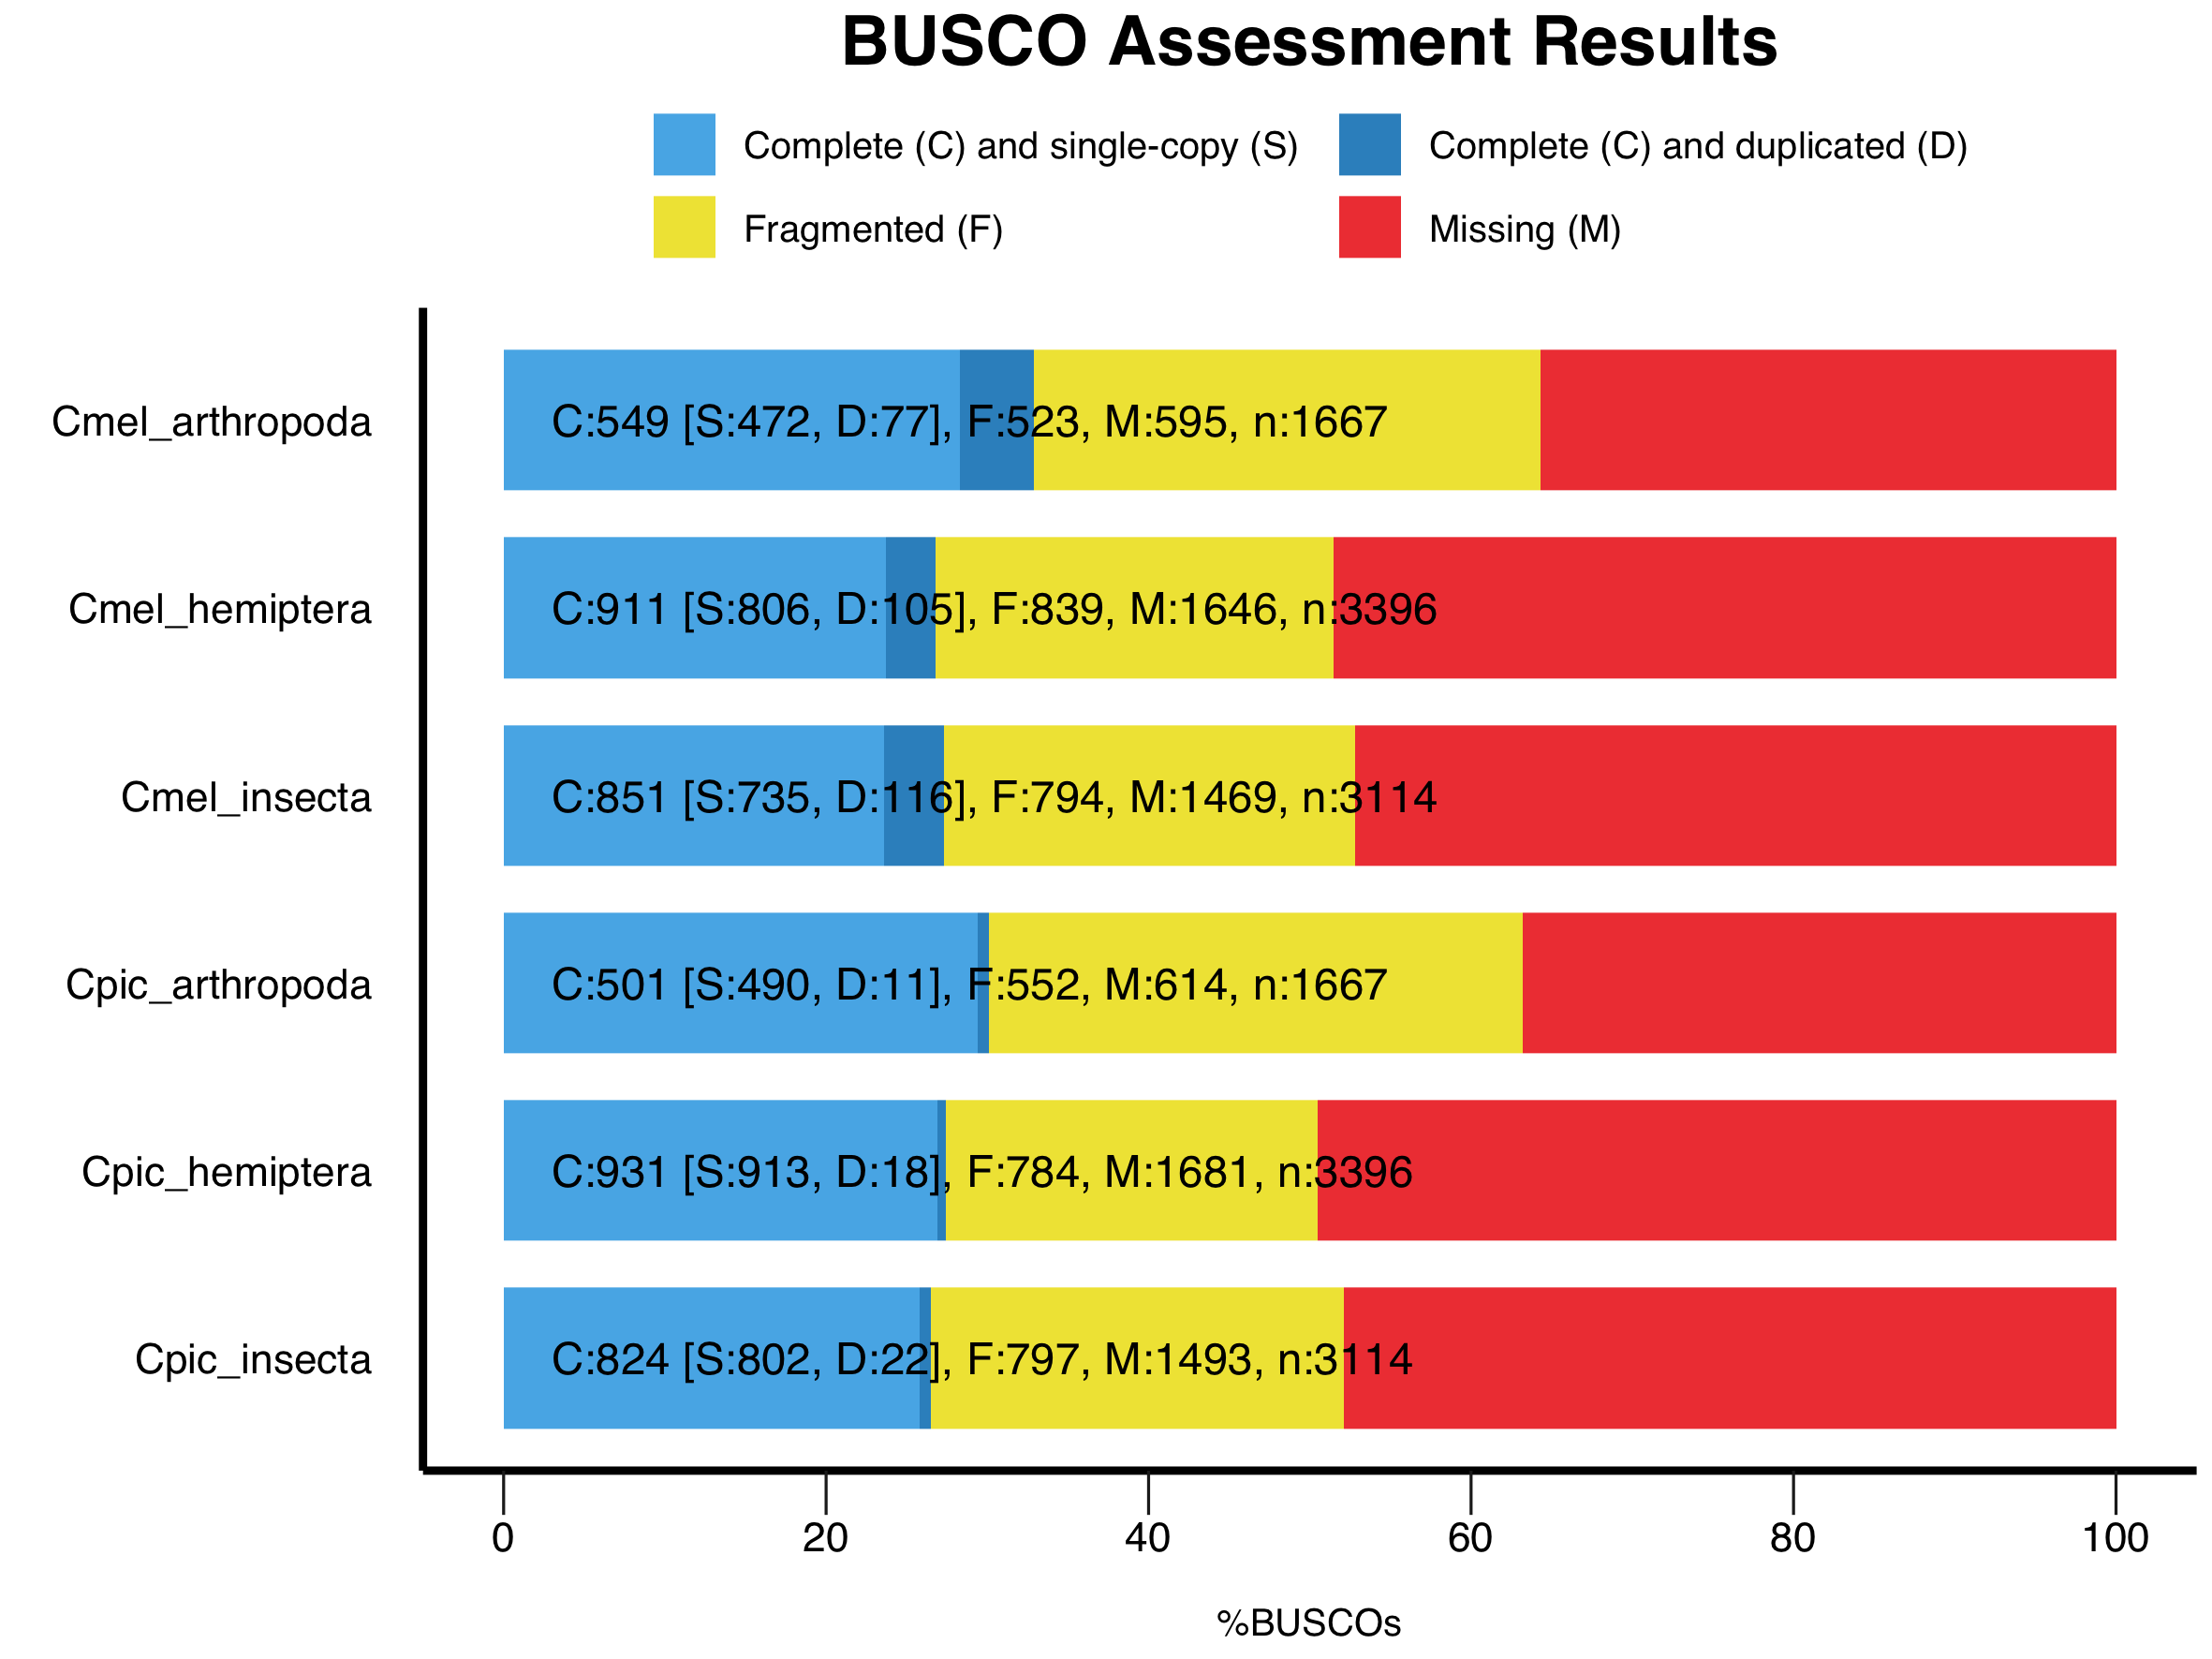

Figure S1

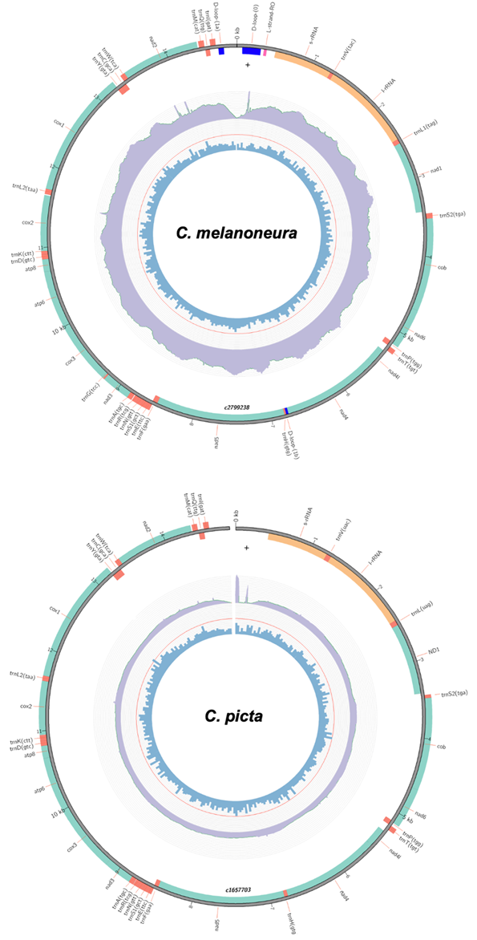
Figure S2

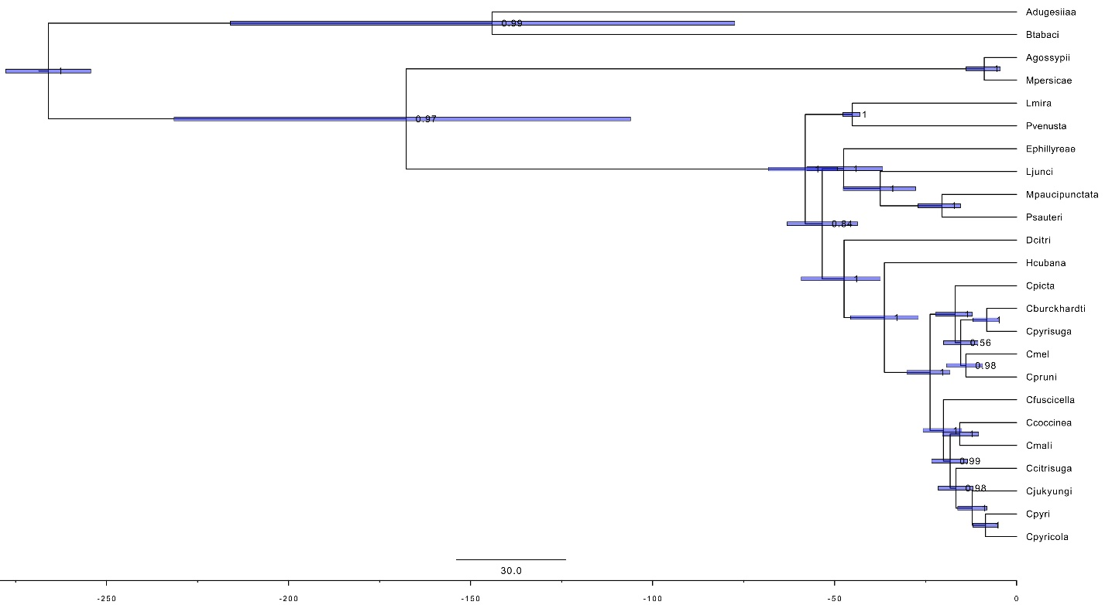

Figure S3

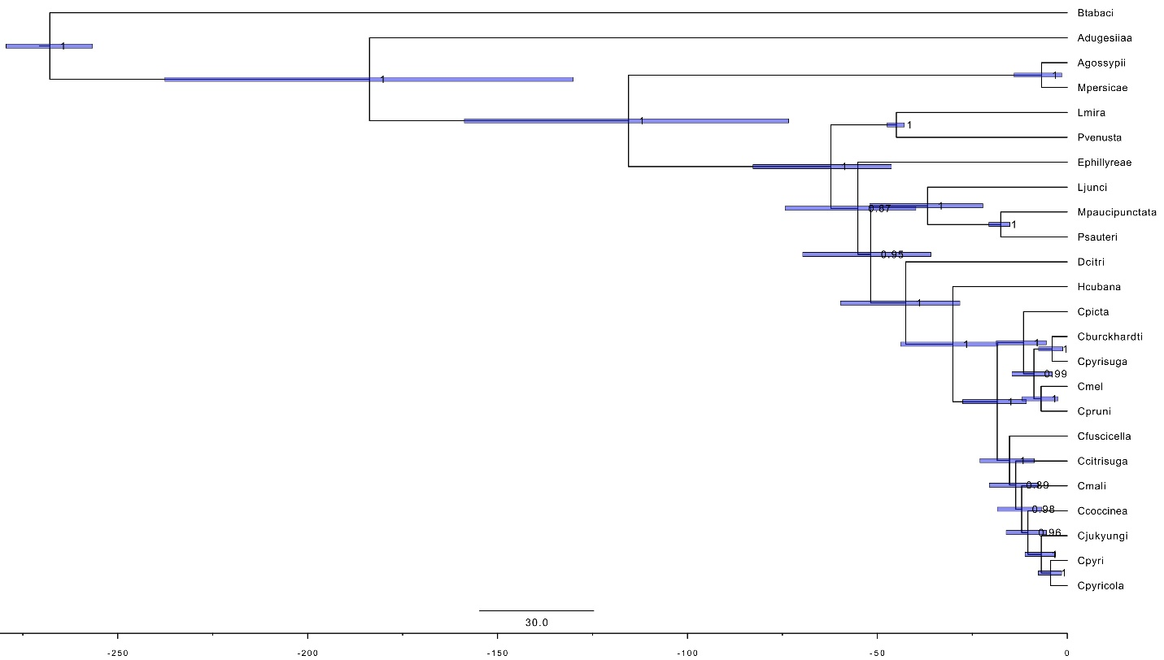

Figure S4

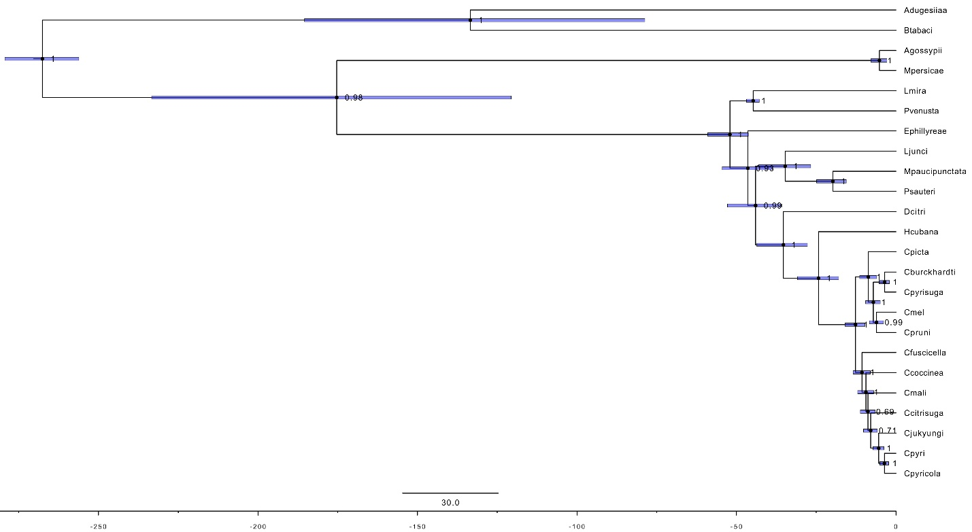
Figure S5

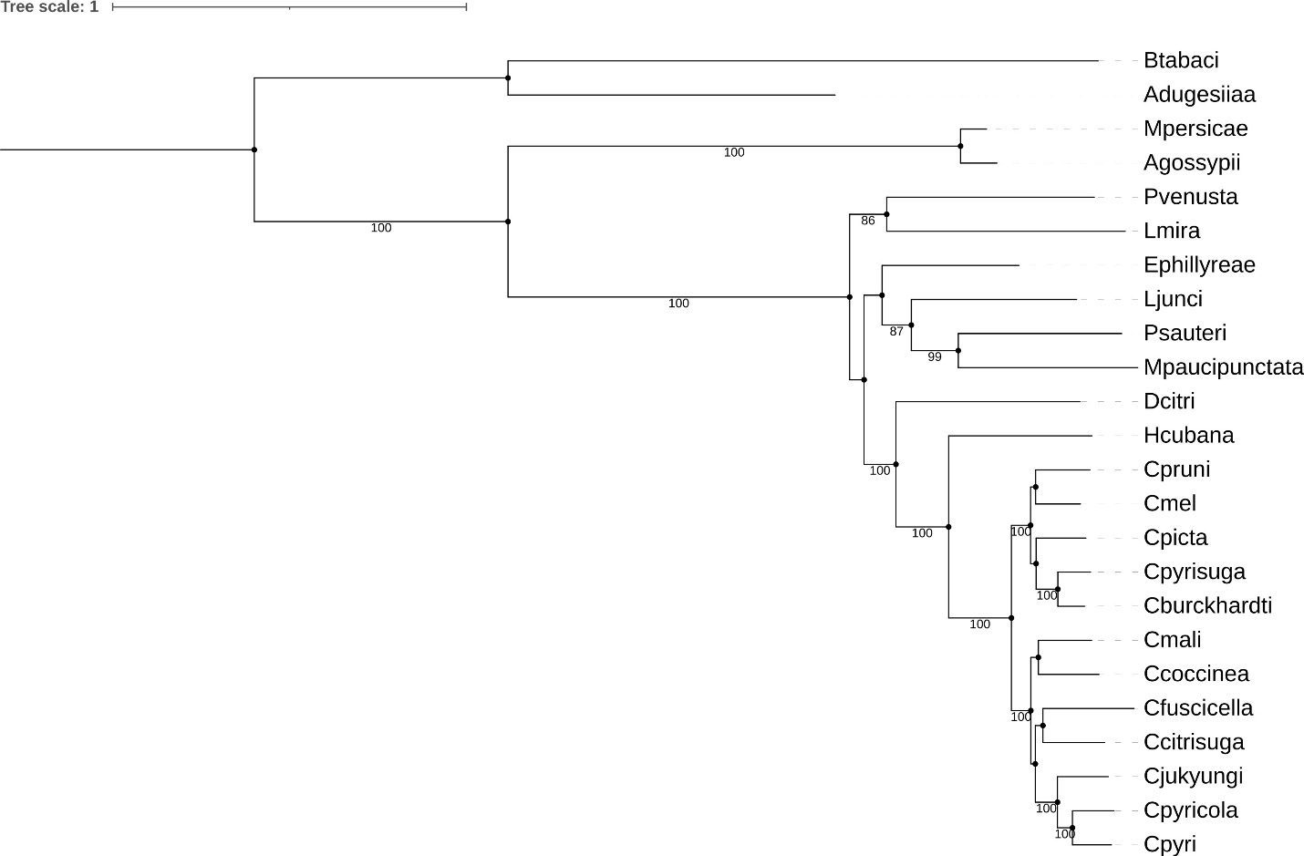

Figure S6

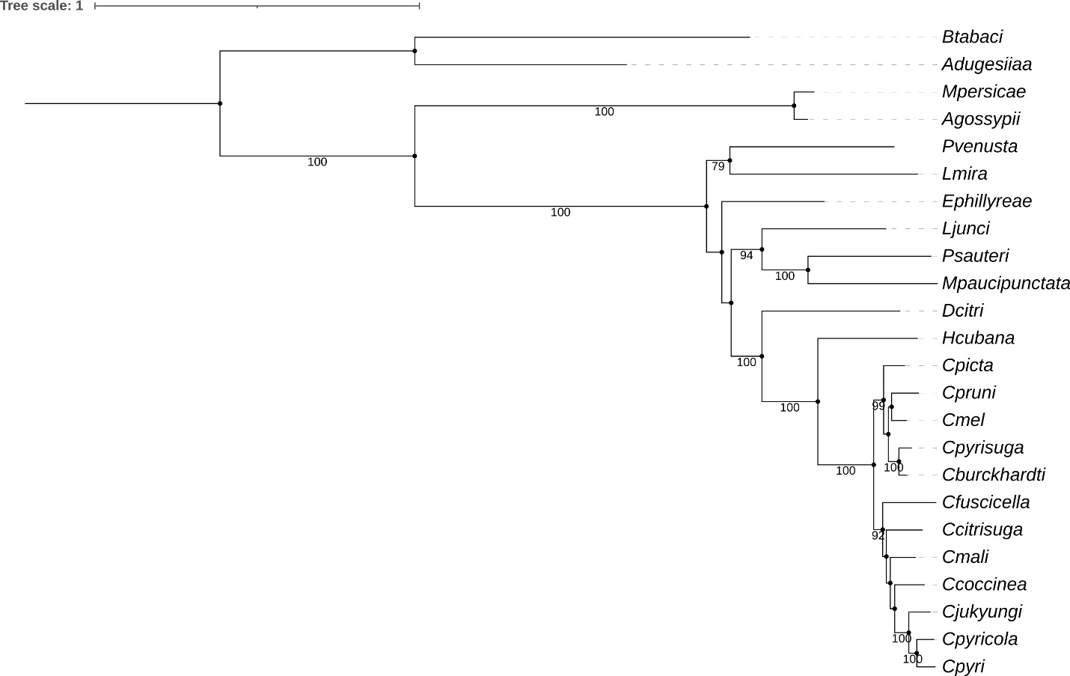

Figure S7

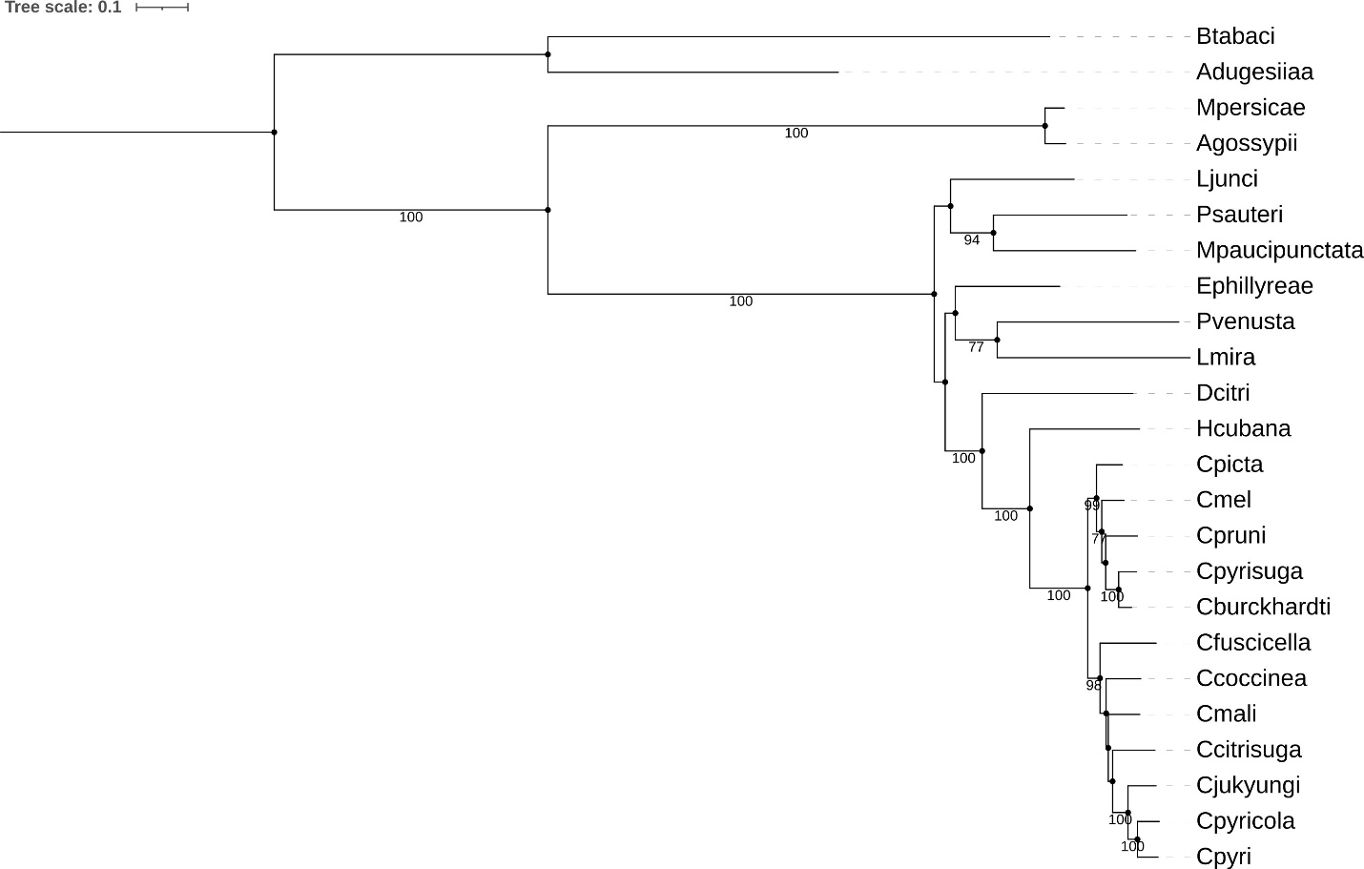

Figure S8

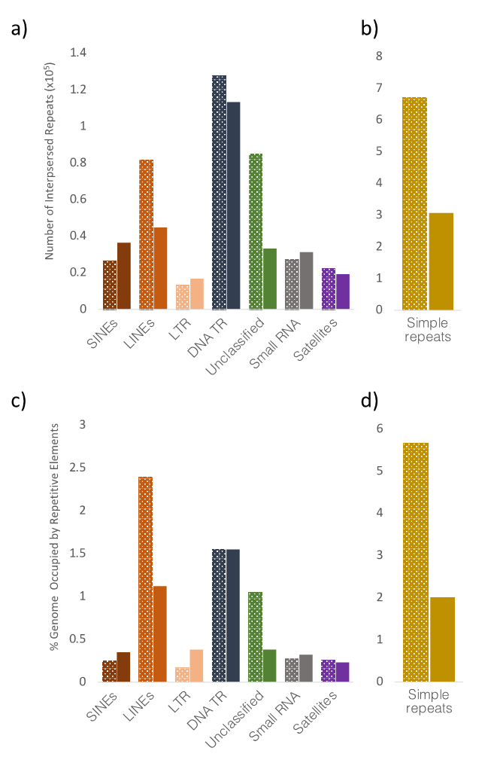
Figure S9

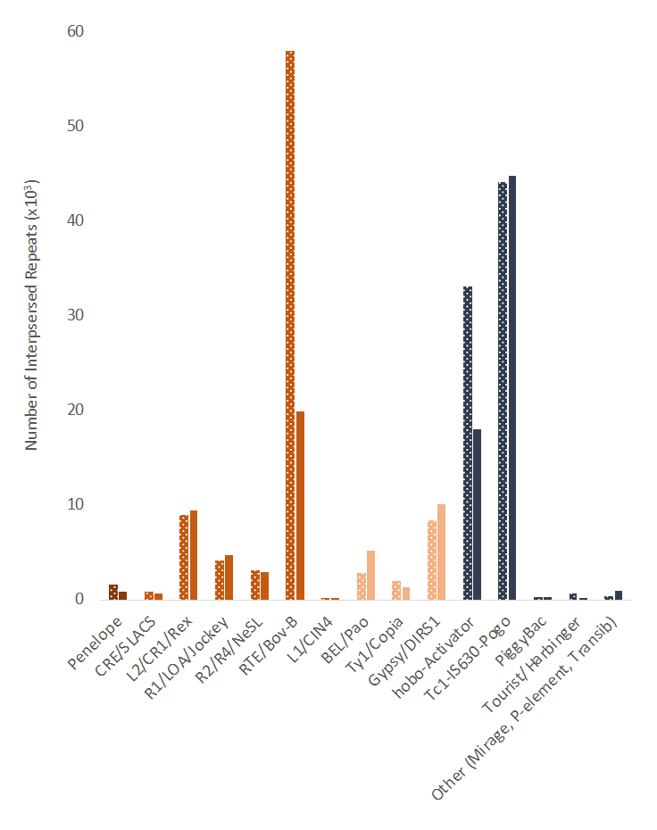
Figure S10

