Supporting Information - Bridging Feature-Based Models and Graph Neural Networks: A Hybrid Approach for Accurate and Interpretable Materials Modeling

S1. MatMiner features
The MatMiner features included in this work were implemented in the DeBreuck2020Featurizer class in the MODNet package. Featurizers can be broadly categorized into composition-based, structure-based, and site-level descriptors.
Composition featurizers extract information from the elemental makeup of a material. For example, the AtomicOrbitals featurizer characterizes the orbital nature of the highest occupied molecular orbital (HOMO) and the lowest unoccupied molecular orbital (LUMO), whereas AtomicPackingEfficiency quantifies how efficiently atoms are packed in the structure. The BandCenter featurizer calculates the weighted average of the atomic orbital energy levels. ElementFraction and ElementProperty descriptors, the latter based on the Magpie dataset, represent elemental fractions and properties such as electronegativity, ionization energy, and atomic radius. IonProperty and Miedema featurizers predict ion formation tendencies and formation enthalpies, respectively. Stoichiometry encodes elemental ratios, whereas TMetalFraction computes the proportion of transition metals. ValenceOrbital describes the distribution of valence orbitals, and YangSolidSolution assesses the potential for solid-solution formation. Additionally, oxidation-aware descriptors include ElectronegativityDiff, which measures electronegativity differences, and OxidationStates, which encodes oxidation state information.
Structural featurizers focus on features derived from the spatial arrangement of atoms. DensityFeatures calculate the density and atomic density of the material, while GlobalSymmetryFeatures capture symmetry information, such as the crystal system and centrosymmetry. The RadialDistributionFunction describes atomic pair distributions at various distances, and both CoulombMatrix and SineCoulombMatrix encode electrostatic interactions in the structure. EwaldEnergy estimates the lattice energy using Ewald summation, and BondFractions quantify the proportion of specific bond types. StructuralHeterogeneity measures the variability in bond lengths and angles, while MaximumPackingEfficiency calculates the theoretical packing density. Other structural descriptors include ChemicalOrdering, which quantifies the degree of atomic ordering, and XRDPowderPattern, which simulates X-ray diffraction patterns.
Finally, site-level featurizers focus on local atomic environments. For instance, AGNIFingerprints generate atomic neighborhood fingerprints, whereas AverageBondAngle and AverageBondLength measure the mean bond angles and lengths based on Voronoi tesselation. BondOrientationalParameter captures the angular distribution of bonds, and CoordinationNumber quantifies the number of neighboring atoms. CrystalNNFingerprint encodes local atomic environments using crystal-graph techniques. Additional descriptors such as GaussianSymmFunc and GeneralizedRadialDistributionFunction represent atom-pair distributions and property-weighted distances, respectively. LocalPropertyDifference measures differences in properties between neighboring atoms, and fingerprints like OPSiteFingerprint and VoronoiFingerprint further characterize local atomic arrangements.
By leveraging this diverse set of features, the MatMiner featurizer enables a comprehensive representation of materials, facilitating accurate and interpretable machine learning predictions across various material properties. All featurizers are configured with default parameters tailored for broad applicability and optimized for MatMiner version 0.6.2.

S2. Orbital field matrix featurizer
This study follows the original Orbital Field Matrix (OFM) implementation from Lam Pham et al. (2017), as also found in the MatMiner featurizer. The neutral valence shell electronic configurations of the elements can be represented as one-hot encoded vectors using an ordered dictionary, D = {s¹, s², p¹, p², ..., p⁶, d¹, d², ..., d¹⁰, f¹, f², ..., f¹⁴}. For example, Na and Cl have the electronic configurations [Ne]3s¹ and [Ne]3s²3p⁵, respectively. Sodium can then be represented by a one-hot encoded vector with position s¹ set to 1, while chlorine's vector has positions s² and p⁵ set to 1 (the remaining entries are zeros). If we consider these elements within a crystal structure, as illustrated in Fig. S1, the OFM descriptor aims to capture the valence shell interactions at each site.
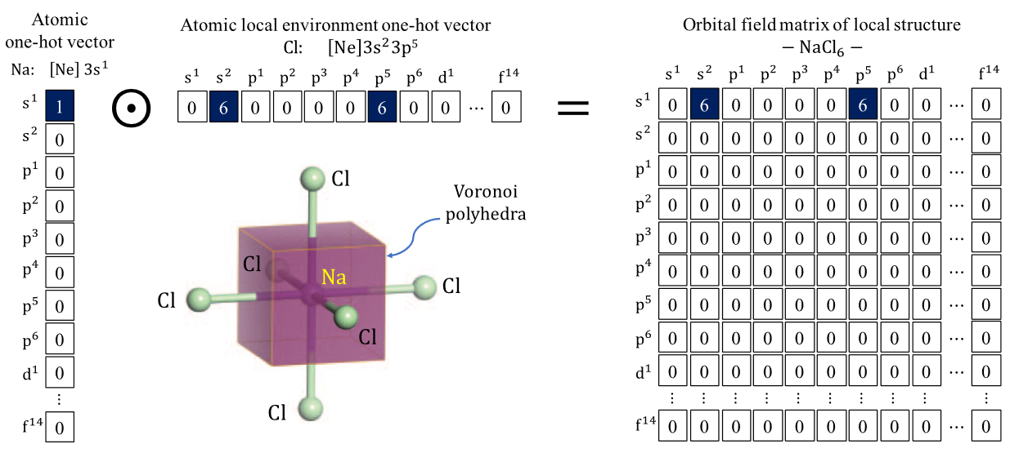
Fig. S1 | OFM representation for a Na atom in a regular octahedral site surrounded by six Cl atoms. Sourced from Lam Pham et al.¹, reproduced with permission under the CC BY license.
It is important that the descriptor captures the site coordination and element distance from neighboring atoms. Therefore, the OFM for a central atom in a site (X^{p}) is defined as the weighted outer vector product of one-hot encoded atomic vectors, such as:
 | $$X_{ij}^{p}=\sum_{k=1}^{n_{p}}{o_{i}^{p}o_{j}^{k}}\frac{θ_{k}^{p}}{θ_{max}^{p}} \frac{1}{r_{pk}} .$$ | (1)
Here, i, j ∈ D, k is the index of nearest-neighbor atoms, $n_{p}$ is the number of such atoms around site p, $θ_{k}^{p}$/$θ_{max}^{p}$ represents the weight of atom $k$ in the coordination of the central atom at site $p$, $θ_{k}^{p}$ is the solid angle determined by the Voronoi polyhedron face separating k and p, and $θ_{max}^{p}$ is the maximum among $n_{p}$ them. $r_{pk}$ captures the distance separating atoms p and k, also distinguishing elements with the same valence configuration. To construct the OFM for a crystal structure, local OFMs are summed, and the values are averaged by the number of sites:
 | $$F_{ij}^{ }=\frac{1}{N_{p}}\sum_{p}^{N_{p}}{X_{ij}^{p}}$$ | (2)

S3. MEGNet framework and pretrained models
Fig. S2 illustrates the architecture of the MEGNet framework based on a graph convolutional network. As depicted in the figure, the final MLP of the model preceding the output contains two sequential dense layers of 32 and 16. These values can be tuned for hyperparameter optimization as elaborated in the next section, particularly the default architecture corresponds to $h_{1}=64, h_{2} = 32$, and $h_{3}$ = $16$. In which $h_{1}$ influences the MLPs inside the MEGNet blocks.

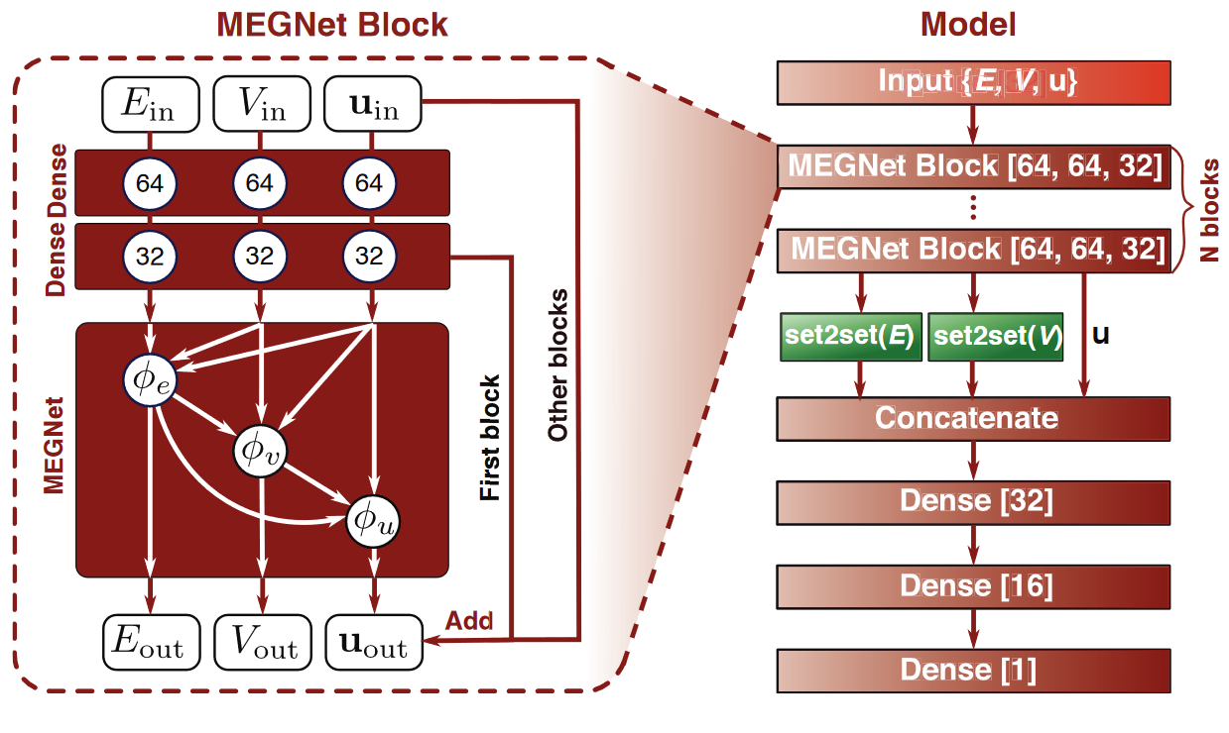
Fig. S2 | Architecture of the MEGNet model. In the pretrained models used in this work, the same architecture was present with three MEGNet blocks. The numbers in brackets indicate the number of neurons for each layer. Reprinted (adapted) with permission from Chen et al². Copyright 2024 American Chemical Society.

S4. Latent-space optimization for OFM and MatMiner descriptors
An autoencoder is trained to compress the OFM features computed on the structures from Materials Project database, producing a latent-space representation that efficiently captures critical information from these structures. We consider a snapshot of the Materials Project database from 2019.04.02. This dataset excludes entries with a formation energy above 150 meV or those containing noble gases. Identical to the dataset used for band gap prediction task in MatBench. Different compression ratios (c.r.) are tested after hyperparameter tuning, the details of which are discussed in the following section. In Table S1, we compare two autoencoders with c.r. values of 20% and 10% by applying these compressed representations to replace the original OFM features for the new predictions. The 20% c.r. latent space notably improve the predictive accuracy over the original OFM features, likely due to transfer learning effects where chemical patterns from a broader dataset contribute to a more compact, chemically informative feature set. However, at 10% c.r., the compressed representation loses some chemical information, reducing its effectiveness compared to the original OFM features. Furthermore, as shown in Table S1, reducing the feature space to 20% c.r. using PCA is slightly less effective than using the autoencoder. Therefore, we retain the latent features from the OFM autoencoder, henceforth called ℓ-OFM for brevity.
Table S1 | Mean absolute errors (MAE) for MODNet models on the matbench_perovskites task including pristine OFM features and different latent space reductions of OFM features in addition to the default MatMiner features. $n$ represents the number of features after removing constant features across the dataset. The shaded rows highlight the chosen latent-space representation using the autoencoder and the PCA-reduced representation with the same dimensions for comparison. In parentheses, the percentage MAE deviation is given with respect to the default MatMiner featurizer in MODNet.
Features | $$n$$ | MAE (eV)
Default MatMiner (MM) | $$1020$$ | $$0.0888$$
MM + original OFM | $$1020+943$$ | $$0.0751$$  $$(-15.3\%)$$
MM + latent OFM 20% c.r.  (ℓ-OFM) | $$1020+188$$ | $0.0743$  $$(-16.2\%)$$
MM + latent OFM 10% c.r. | $$1020+94$$ | $0.0777$  $$(-12.4\%)$$
MM + PCA reduced OFM  ($n=188)$ | $$1020+188$$ | $0.0748$  $$(-15.7\%)$$
Next, we benchmark latent-space representations of MatMiner features (ℓ-MM) against their original implementations (Table S2), evaluating their performance on the matbench_perovskites and matbench_mp_gap tasks. For the heat of formation predictions in perovskites, latent-space features consistently improve performance, which is attributed to transfer learning benefits from a larger dataset. For band gap predictions, a similar improvement is observed initially; however, compression beyond 60% c.r. leads to a decline in accuracy. This aligns with our hypothesis that the autoencoder aids transfer learning, which is comparable to the role of elemental embeddings in graph-based models².
Replacing the autoencoder with PCA resulted in a larger relative performance drop for the MatMiner features compared with OFM, likely due to the autoencoder’s capacity to capture nonlinear patterns, which is essential for MatMiner's complex feature set. This result supports the choice of a 60% c.r. autoencoder for MatMiner features (ℓ-MM), which offers an optimal balance of feature reduction with minimal accuracy loss, thereby favoring encoder-based over PCA-based latent-space representations.
Table S2 | Evaluation of the effects of dimensionality reduction on default MatMiner features used on the MODNet model on the Matbench tasks matbench_perovskites and matbench_mp_gap. $n$ is the number of features (constant features across the dataset removed) for the respective model and N the number of samples comprised in the dataset. The percentage MAE deviation from the default MatMiner featurizer in MODNet is indicated between parentheses for each task.
Features used | Task
Features used | matbench perovskites  (N=18,928) |  | matbench mp_gap  (N=106,113)
Features used | $$n$$ | MAE (eV) | $$n$$ | MAE (eV)
Default MatMiner | $$1020$$ | $$0.0888$$  $$±0.0028$$ | $$1264$$ | $$0.2724$$  $$±0.0052$$
Latent MatMiner without compression (1:1 latent space) | $$1264$$ | $$0.0767$$  $$(-13.6\%)$$ | $$1264$$ | $$0.2542$$  $$(-6.7\%)$$
Latent MatMiner 80% c.r. | $$1011$$ | $$0.0788$$  $$(-11.3\%)$$ | $$1011$$ | $$0.2809$$  $$(+3.1\%)$$
Latent MatMiner 60% c.r.  (ℓ-MM) | $$758$$ | $$0.0793$$  $$(-10.7\%)$$ | $$758$$ | $$0.2911$$  $$(+6.8\%)$$
Latent MatMiner 40% c.r. | $$505$$ | $$0.0844$$  $$(-4.9\%)$$ | $$505$$ | $$0.3280$$  $$(+20.4\%)$$
PCA reduced MatMiner  ($n=758)$ | $$758$$ | $$0.0816$$  $$(-8.1\%)$$ | $$758$$ | $$0.2968$$  $$(+8.9\%)$$
Finally, to streamline featurization, we implemented MEGNet GNN models as proxy featurizers for structure-based feature derivation. This approach allows these proxy GNNs, once trained, to be reused with new datasets, thereby significantly reducing the computational burden. The implementation details can be found in the section on hyperparameter tuning.

S5. Descriptor-oriented GNNs for ℓ-OFM and ℓ-MM descriptors
In Table S3, the models including GNN-derived latent MatMiner features, ℓ-MM (via GNN), show an increase in MAE of 0.025 eV, most probably due to reconstruction errors. However, these models still outperform Automatminer and random forest benchmarks (Table 2) and allow faster featurization. For the OFM features, the GNN-derived latent representation performs nearly as well as the original, with only a 0.0051 eV decline. Combining latent features from both GNN models slightly reduces the MAE, highlighting the potential benefits of integrating multiple latent representations of chemical descriptors. We highlight that in the main paper ℓ-MM and ℓ-OFM are always obtained via GNN proxies, this distinction is only made in this section for evaluation.
These results emphasize the effectiveness of our proposed proxy GNN featurizers in capturing essential chemical information, even in the presence of reconstruction challenges, while also significantly reducing the computation time and making the feature-based models more efficient for large-scale applications. By further refining the models, such as training on larger, more carefully curated datasets, we can mitigate reconstruction errors and enhance the descriptor-oriented GNN featurizer in MatterVial to identify chemical patterns.

Table S3 | Mean absolute errors (MAEs) for MODNet models on the matbench_perovskites task comparing the inclusion of latent features originally obtained from the autoencoder and through the GNN featurizers. The relative MAE deviation from the default MatMiner featurizer in MODNet is reported in parentheses.
Features | MAE (eV)
Default MatMiner (MM) | $$0.0888$$
MM + original OFM | $$0.0751$$  $$(-15.3\%)$$
ℓ-MM | $$0.0793$$  $$(-10.7\%)$$
ℓ-MM (via GNN) | $$0.1052$$  $$(+18.5\%)$$
MM + ℓ-OFM | $0.0743$  $$(-16.2\%)$$
MM + ℓ-OFM (via GNN) | $0.0794$  $$(-10.6\%)$$
ℓ-MM (via GNN) +  ℓ-OFM (via GNN) | $0.0973$  $$(+9.6\%)$$

S6. Task-Oriented GNNs: investigating pretrained GNN feature integration via MVL featurizers
To incorporate pretrained GNN models from MVL as features, we extract the values from the last layers of the MLP regression head of the MEGNet model architecture. Table S4 presents a performance comparison for the matbench_perovskites task, incorporating the hidden layers with 32 neurons (referred to as MVL-32), the layers with 16 neurons (referred to as MVL-16), and both layers at once (MVL). Additionally, we conduct assessments on randomly selected subsets comprising 5000 samples and 1000 samples from the initial matbench_perovskites dataset to verify the consistency of our findings across smaller datasets and the effect of transfer learning.
Our analysis reveals a consistent enhancement in performance with the inclusion of the MVL-32 featurizer over the MVL-16 featurizer, irrespective of the dataset size. This improvement is attributed to a more general latent-space representation in the earlier layers of the model. When both layers are used concomitantly, the results are slightly better in general, which we attribute to MODNet capacity to wisely select the meaningful features. Notably, the percentage reduction in MAE compared with the exclusive use of MatMiner features increases as the dataset size decreases. This underscores the essence of transfer learning of this technique: transferring pre-acquired chemical knowledge from larger datasets to enhance performance on small datasets.
Table S4 | Mean absolute errors (MAEs) for MODNet models on the matbench_perovskites task and subsets comparing the inclusion of features from pre-trained MEGNet models distributed by Materials Virtual Lab. $N$ represents the size of the dataset used for the prediction. The relative MAE deviation from the default MatMiner featurizer in MODNet is reported in parentheses for each task.
Features | Task
Features | matbench perovskites  (N=18,928) | matbench perovskites  (N=5,000) | matbench perovskites  (N=1,000)
Features | MAE (eV) | MAE (eV) | MAE (eV)
Default MatMiner (MM) | $$0.0888$$ | $$0.1667$$ | $$0.2802$$
MM + MVL-16 | $$0.0752$$  $$(-15.3\%)$$ | $$0.1202$$  $$(-27.9\%)$$ | $$0.1862$$  $$(-33.5\%)$$
MM + MVL-32 | $$0.0726$$  $$(-18.2\%)$$ | $$0.1167$$  $$(-30.0\%)$$ | $$0.1749$$  $$(-37.6\%)$$
MM + MVL | $$0.0730$$  $$(-17.8\%)$$ | $$0.1122$$  $$(-32.7\%)$$ | $$0.1716$$  $$(-38.7\%)$$

S7. Hyperparameter tuning for descriptor-oriented GNNs

S7.1. Autoencoders’ hyperparameters
The autoencoder architecture employed in this study consists of a feedforward neural network constructed with the Keras framework^{4,} consisting of a single hidden layer for both the encoder and decoder. The number of neurons in the hidden layer is initialized at 2 times the number of features in the featurizer ($n$), whether OFM or general MatMiner features. Architectures with two hidden layers are excluded in the preliminary tests, as are hidden layers with a number of neurons smaller than $n$, which yielded poorer results. Hyperparameter tuning is conducted in two steps. Initially, the features' compression is fixed at 50% (approximately $n/2$ resulting features), and the optimal configuration is sought, considering the following possibilities, shown in Table S5. The Adam optimizer is utilized for weight optimization during backpropagation. For these combinations, the configurations with the smallest average reconstruction errors over three runs, employing a train-test split of 9:1, are presented in Table S6.
Table S5 | Hyperparameters and corresponding values considered for the autoencoder optimization.
Hyperparameter | Possible Values
Batch Size | $$16, 32, 64, 128$$
Number of Epochs | $$50, 100, 200, 300$$
Learning Rate | $$0.0005, 0.001, 0.002$$

Table S6 | Best hyperparameters for autoencoders in this work, considering a 50% compression.
Encoded featurizer | Batch size | Number of epochs | Learning rate
OFM | 64 | 300 | 0.001
MatMiner MODNet v.0.1.13 | 64 | 200 | 0.0005
Based on these parameters, we proceed with a similar approach to vary the number of neurons in the dense layer, ranging from 1.5$n$ to 2.5$n$ in increments of 0.1$n$. This time, we test compressions of 20%, 50% and 80%. The combined loss for these compressions is assessed to identify the optimal architecture. As a result, the hidden layer sizes are determined to be 2.5$n$ for the OFM featurizer and 2.2$n$ for the MatMiner featurizer. The final architecture for each autoencoder is depicted in Fig. S3.
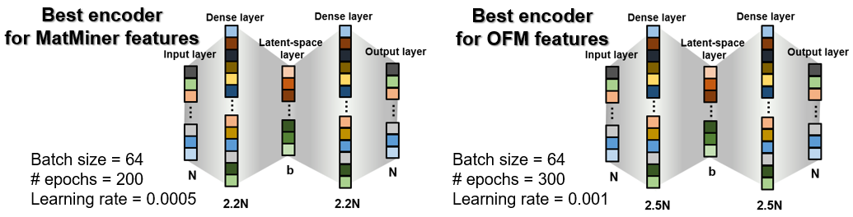
Fig. S3 | Best autoencoder architectures found for MatMiner and OFM featurizers trained on matbench_v.0.1_mp_gap dataset.
Subsequently, the reconstruction loss is assessed for various levels of compression in each autoencoder, employing the same 9:1 train-test split. The results are outlined in Table S7 and Table S8. The encoder for MatMiner features consistently maintains the reconstruction error below 1%, even up to a compression to a latent-space size of 10% of the initial features. In the case of the OFM, the compression is highly efficient, remaining below 0.1% MAE for most of the tested latent-space sizes. Consequently, the reconstruction error is not anticipated to significantly impact the predictions. Nonetheless, the most suitable latent-space size must be determined by evaluating their performances in prediction tasks.

Table S7 | Reconstruction errors with different compression ratios for the autoencoder for MODNet’s v.0.1.13 MatMiner featurizer. Errors in data normalized to the interval 0 to 1, metric for losses is MSE.
Compression ratio | Latent $n$ | Train Loss | Validation Loss | Test MAE
1.0* | 1264 | 7.91e-05 | 7.69e-05 | 0.004789
0.9 | 1137 | 8.66e-05 | 8.52e-05 | 0.005098
0.8 | 1011 | 8.59e-05 | 8.04e-05 | 0.005010
0.7 | 884 | 8.60e-05 | 9.20e-05 | 0.005309
0.6 | 758 | 9.27e-05 | 9.45e-05 | 0.005411
0.5 | 631 | 9.79e-05 | 1.06e-04 | 0.005733
0.45 | 568 | 1.02e-04 | 1.13e-04 | 0.005880
0.4 | 505 | 1.09e-04 | 1.14e-04 | 0.005929
0.35 | 442 | 1.14e-04 | 1.28e-04 | 0.006269
0.3 | 379 | 1.29e-04 | 1.44e-04 | 0.006624
0.25 | 316 | 1.53e-04 | 1.64e-04 | 0.006962
0.2 | 252 | 1.82e-04 | 1.85e-04 | 0.007387
0.15 | 189 | 2.38e-04 | 2.32e-04 | 0.008094
0.1 | 126 | 3.26e-04 | 3.24e-04 | 0.009452
0.05 | 63 | 5.92e-04 | 5.87e-04 | 0.012396
* A compression ratio of 1.0 indicates a remapping to a latent space with the same dimensions.
Note the number of dimensions may not precisely match the original featurizer’s number of descriptors as some descriptors remain constant (0) throughout the dataset.

Table S8 | Reconstruction errors with different compression ratios for the autoencoder for OFM featurizer. Errors in data normalized to the interval from 0 to 1, the metric for losses is MSE.
Compression ratio | Latent $n$ | Train Loss | Validation Loss | Test MAE
1.0* | 943 | 2.50e-05 | 3.26e-05 | 0.000898
0.9 | 848 | 1.45e-05 | 1.55e-05 | 0.000718
0.8 | 754 | 5.09e-06 | 6.69e-06 | 0.000534
0.7 | 660 | 3.80e-06 | 5.10e-06 | 0.000518
0.6 | 565 | 8.59e-06 | 1.04e-05 | 0.000915
0.5 | 471 | 3.51e-06 | 4.80e-06 | 0.000474
0.45 | 424 | 5.34e-06 | 6.53e-06 | 0.000507
0.4 | 377 | 7.25e-06 | 1.02e-05 | 0.000608
0.35 | 330 | 3.26e-06 | 5.01e-06 | 0.000442
0.3 | 282 | 4.82e-05 | 5.38e-05 | 0.001278
0.25 | 235 | 1.56e-05 | 1.61e-05 | 0.000750
0.2 | 188 | 4.70e-06 | 8.52e-06 | 0.000742
0.15 | 141 | 2.06e-05 | 2.66e-05 | 0.000790
0.1 | 94 | 1.45e-05 | 2.10e-05 | 0.000821
0.05 | 47 | 1.00e-05 | 1.13e-05 | 0.000837
* A compression ratio of 1.0 indicates a remapping to a latent space with the same dimensions. Note that the number of dimensions may not precisely match the original featurizer’s number of descriptors as some descriptors remain constant (0) throughout the dataset.

S7.2. MEGNet models’ hyperparameters
MEGNet models are trained to generate latent-space representations of encoded features (OFM and MatMiner features). In the case of the adjacent model, which produces general features based on the target property, both MEGNet and the coGN (Connectivity-Optimized Graph Network) model are utilized. No extensive hyperparameter tuning is performed for either graph neural network for adjacent models. The selected MEGNet and coGN parameters are detailed in Table S9.
Table S9 | Hyperparameters applied to the adjacent MEGNet and coGN models. Parameters not referred to in the table follow the default values as of MEGNet’s version 1.3.2 and coGN.
Hyperparameters  MEGNet | Values | Hyperparameters coGN | Values
Number of blocks | $$3$$ | Number of blocks | $$4$$
nfeat_bond | $$100$$ | Embedding dimension | $$64$$
r_cutoff | $5$ Å | r_cutoff | $$5 Å$$
gaussian_width | $$0.5$$ | Activation function | Swish
Number of epochs | $$100$$ | Number of epochs | $$800$$
MLP architecture  $$\left(h_{1}x h_{2}x h_{3}\right)$$ | $$64x64x128$$ | MLP architecture  $$\left(h_{1}x h_{2}x h_{3}\right)$$ | $$64x64x64$$
Batch size | $$128$$ | Batch size | $$64$$
Learning Rate | $$0.001$$ | Learning Rate | Polynomial decay from 5×10⁻⁴ to 1×10⁻⁵
 |  | Number of neighbors (k) | $$24$$

For the MEGNet models used to generate latent space features, hyperparameter tuning plays a crucial role. It is executed in three steps. Initially, the number of epochs varies across three different MLP architectures. Subsequently, the batch size (initially set at 32) and learning rate (default value of 0.001) are adjusted, with a new screening for the optimal number of epochs. Finally, a verification step is undertaken to assess whether increasing $h_{1}$ in the MLP architecture from 64 to 128 yields improvement. This process results in a total of 37 trained models, all evaluated on the same train-test split, with 20% of the dataset reserved for testing. All hyperparameter values considered for the respective optimization cases are presented in Table S10.
Table S10 | Considered hyperparameter values for MEGNet models to generate encoded features for OFM and MatMiner featurizers.
Hyperparameter |  | Possible Values
Number of epochs |  | $$10, 15, 20, 25, 30, 50, 70, 100$$
MLP architecture  $$\left(h_{1}x h_{2}x h_{3}\right)$$ | $$h_{1}$$ | $$64, 128$$
MLP architecture  $$\left(h_{1}x h_{2}x h_{3}\right)$$ | $$h_{2} x{ h}_{3}$$ | $$(16x32), (32x64), (64x128)$$
Batch size |  | $$16, 32, 64, 128$$
Learning Rate |  | $$0.0005, 0.001, 0.002$$
A MEGNet model is trained to generate the latent OFM representation (20% compression), producing 188 features, and another MEGNet model to generate the latent representation of MatMiner features (60% compression), producing 758 features. A few selected results for both MEGNet models considered are shown in Table S11. We can observe the relevance of hyperparameter tuning on the final loss of these models. Despite the substantial number of features, the MEGNet framework is very successful in reproducing the latent space features directly from the structure. Even for the more heterogeneous and large set of MatMiner features, the error is about 0.03, which corresponds to 3% of the total variation within each normalized feature.

Table S11 | MEGNet models’ hyperparameters and reconstruction loss for generation of latent space features. Evaluation conducted on normalized features (range 0 to 1), highlighted in gray, was the best obtained model on the hyperparameter screening.
Encoded featurizer | Hyperparameters |  |  |  | Reconstruction Loss (MAE)
Encoded featurizer | Number of epochs | Batch size | Learning rate | MLP architecture  $$\left(h_{1}x h_{2}x h_{3}\right)$$ | Training | Test
Latent OFM,  20% compression  (188 features) | 15 | 32 | 0.0005 | $$64 x 64 x 32$$ | 0.0180 | 0.0182
Latent OFM,  20% compression  (188 features) | 25 | 64 | 0.001 | $$64 x 64 x 32$$ | 0.0164 | 0.0166
Latent OFM,  20% compression  (188 features) | 15 | 128 | 0.001 | $$64 x 64 x 32$$ | 0.0137 | 0.0138
Latent OFM,  20% compression  (188 features) | 25 | 32 | 0.0005 | $$64 x 128 x 64$$ | 0.0131 | 0.0132
Latent OFM,  20% compression  (188 features) | 25 | 32 | 0.001 | $$64 x 128 x 64$$ | 0.0126 | 0.0127
Latent MatMiner DeBreuck2020, 60% compression  (758 features) | 50 | 16 | 0.001 | $$64 x 32 x 16$$ | 0.0671 | 0.0671
 | 20 | 64 | 0.0005 | $$64 x 128 x 64$$ | 0.0484 | 0.0486
 | 30 | 16 | 0.001 | $$64 x 32 x 16$$ | 0.0393 | 0.0393
 | 20 | 128 | 0.001 | $$128 x 128 x 64$$ | 0.0324 | 0.0326
 | 50 | 128 | 0.0005 | $$64 x 128 x 64$$ | 0.0306 | 0.0308

S8. SISSO method in MatterVial
The Sure Independence Screening and Sparsifying Operator (SISSO) method⁵ is an advanced symbolic regression technique designed to derive physically interpretable descriptors from an initially broad set of primary features. The workflow begins by generating a vast pool of candidate features through the recursive application of mathematical operators to fundamental descriptors extracted from materials data (e.g., via MatMiner). These operators include basic arithmetical functions (add, sub, mult, div), non-linear functions (sin, cos, exp, log), and specialized operations (e.g., abs_diff, square, cube, and root functions). These operations are arranged in a binary-expression-tree structure that respects physical constraints, such as unit consistency and valid operational domains (e.g., ensuring that arguments to logarithm functions remain positive).
However, the initial number of MatMiner features can be large, up to 1300 for structure-based tasks and 300 for composition-based, and the subsequent generation of candidate features becomes computationally prohibitive. To circumvent this computational challenge, we first reduce the pool of primary features to a more manageable set of 30. This is achieved using recursive feature elimination (RFE) guided by XGBoost models within a 5-fold cross-validation framework. In each iteration, features are marked for removal if they fall within the lowest 20th percentile of importance, and they are pruned from the set if at least three of the five models agree on their low rank. We term this integrated methodology xgb-rfe-SISSO, following the naming convention of similar hybrid approaches in the literature, like i-SISSO and rf-SISSO.
Once the candidate pool is established, the SISSO algorithm performs a sure-independence screening (SIS) step to rank features according to their individual correlations, typically quantified using Pearson coefficients, with the target material property. The top-ranked features are then refined through a ℓ₀-norm based sparsification process, which constructs a minimal set of descriptors by selecting those symbols that not only possess high predictive power but also minimize redundancy. A distinctive advantage of the SISSO method is its ability to track multiple residuals from simpler, lower-dimensional models. This multi-residual approach enables the capture of independent and orthogonal contributions from candidate features, thereby enhancing both the robustness and interpretability of the final model.
In our implementation, the SISSO-derived symbolic expressions (as documented in the SIS_summary.txt file) include examples such as:
- ("TMetalFraction|transition metal fraction" + "ValenceOrbital|avg f valence electrons");
- ("ElectronegativityDiff|range EN difference" * "ElementFraction|O");
- (|"CrystalNNFingerprint|std_dev wt CN_2" - "ElementProperty|MagpieData minimum NValence"|);
- Etc.
These expressions are used to augment the original MatMiner feature set. Prior to the symbolic regression, the features are normalized using a robust scaler to facilitate the discovery of meaningful interactions. By merging these SISSO-based descriptors with the primary features, we obtain a rich and complementary feature space that synergistically enhances model performance. This approach, combining traditional descriptors with generated symbolic expressions, results in models that are not only more accurate but also offer valuable physical insights.
Below is an excerpt from our SISSO++ JSON configuration, which specifies all key hyperparameters and operational settings for the SISSO++ run used for most of the tasks:
{
"data_file": "path_to_csv_with_MatMiner_features_and_target",
"property_key": "target",
"desc_dim": 2,
"n_sis_select": 10,
"max_rung": 1,
"n_residual": 3,
"calc_type": "regression",
"min_abs_feat_val": 1e-05,
"max_abs_feat_val": 100000000.0,
"n_models_store": 1,
"leave_out_frac": 0.05,
"leave_out_inds": [],
"opset": ["add", "sub", "abs_diff", "mult", "div", "inv", "abs", "exp", "log", "sin", "cos", "sq", "cb", "six_pow", "sqrt", "cbrt", "neg_exp"],
"data_file_relative_to_json": true
}
This configuration not only sets the recursion and sparsification parameters but also carefully defines the operator set to balance the complexity and physical relevance of the generated descriptors. With this setup, a total of 20 formulas are generated during the SIS step in each task. These results form the basis for our enhanced descriptor space, which has been shown to improve material property prediction when integrated with our overall modeling framework.
Table S12 summarizes all the tasks (datasets) that were included to produce the SISSO_FORMULAS_v1 file:
Table S12 | List of datasets and corresponding references used to generate rung 1 (pairs of features) SISSO formulas from MatMiner descriptors that are meaningful for materials predictions in diverse tasks.
 | Reference | Dataset Name
 | 6 | matbench_steels
 | 7 | matbench_jdft2d
 | 8 | matbench_phonons
 | 9 | matbench_expt_gap
 | 9 | matbench_expt_is_metal
 | 10,11 | matbench_glass
 | 12 | matbench_dielectric
 | 13 | matbench_perovskites
14 |  | matbench_log_gvrh
 | 14 | matbench_log_kvrh
 | 15 | matbench_mp_is_metal
 | 15 | matbench_mp_gap
 | 15 | matbench_mp_e_form
 | 16 | noemd_hse_pbe_diff
 | 16 | noemd_shg

S9. SHAP analysis definition and computation
In understanding complex machine learning models, SHAP (SHapley Additive exPlanations) emerges as a robust tool for revealing feature contributions¹⁷. SHAP values (ϕ) provide a clear view of how each feature influences predictions, employing Shapley values from cooperative game theory obtained through the formula,
 | $$ϕ_{i}\left(f\right) = \frac{1}{N} \sum_{S ⊆ N ∖ \{i\}}{\frac{\left|S\right|!\left(\left|N\right|-\left|S\right|-1\right)!}{\left|N\right|!} }\left[f\left(S ∪ \{i\}\right) - f\left(S\right)\right],$$ | (3)
ensures a fair distribution of contributions, capturing the unique impact of each feature on model predictions. In the equation, the factorial terms in the denominator are crucial for normalization. The factorial function, denoted by the exclamation mark, represents the product of all positive integers up to a given integer $n$. Specifically, the terms $|S|!(|N|-|S|-1)!$ and $|N|!$ ensure that contributions from each feature are appropriately scaled relative to the size of subsets ($S$) and the total number of features ($N$). Normalization plays a pivotal role in ensuring a fair and unbiased distribution of feature contributions. By accounting for the varying sizes of feature subsets and the entire set of features, the formula effectively weighs each feature's contribution. This weighting ensures that the impact of individual features on model predictions is accurately reflected, without being overshadowed by the influence of larger feature sets.
All of our SHAP analysis calculations used the SHAP python library. For our MODNet models, using 300 samples and 500 perturbations on 24 CPU cores, gives converged feature importances and the analysis takes about 20 minutes to complete. In contrast, the XGBoost models used as surrogates for the latent GNN features are tree-based which allows for significantly faster SHAP calculations on the same configuration and hardware setup.

S10. Interpretability of MODNet@MV(noORB) model for the matbench_perovskites task
Based on Figure 3 of the main paper, we give here a more descriptive analysis of the important features in the model separated by groups of features to highlight the synergy of these feature groups. Let's delve into the specific interpretations of the presented formulas. For instance, the MVL32_Eform_MP2019_#3 feature, derived from MVL’s formation energy model, is associated with large electronegativity gaps (ElectronegativityDiff∣mean_EN_difference), which promotes an ionic A/B-O/F bonding character. Its exponential term, $e^{-f_{d}}$ (where $f_{d}$​ is ValenceOrbital∣frac_d_valence_electrons), favors a low d-electron fraction, suggesting a preference for early transition metals. Similarly, MVL32_Eform_MP2019_#16 suggests that a negative band center (BandCenter|band_center), displayed by deep O-2p bands, for example, favors stability. Furthermore, alkaline-earth elements (with their higher number of s-valence electrons, from ElementProperty∣MagpieData_mean_NsValence) coupled with a low $f_{d}$, are favored by increasing the feature value and, in turn, reducing the heat of formation.
SISSO rung 1 features such SISSO_matbench_glass_12 indicate a preference for structures with single early transition metals without lanthanides, based on the normalized $f_{d}$ and normal average deviation of f-valence electrons (ElementProperty∣MagpieData_avg_dev_NfValence). This also correctly implies that lanthanides tend to prefer later transition metals in these structures. Beyond individual formulas, several SISSO features collectively highlight key factors. High melting point elements (ElementProperty∣MagpieData_mean_MeltingT​) combined with ordered CN=6 coordination (CrystalNNFingerprint∣std_dev_wt_CN_6​) lead to enhanced structural stability (seen in SISSO_matbench_log_kvrh_#12). An excess of d-electrons (ValenceOrbital∣avg_d_valence_electrons​) and heterogeneous unfilled d-states (ElementProperty∣MagpieData_avg_dev_NdUnfilled​) contribute to destabilizing electronic effects (seen in SISSO_matbench_perovskites_13). Wide bandgap anions and compact early d-cations are optimal for achieving desirable ionic character in perovskites, this is suggested by the combined features StructuralHeterogeneity∣range_neighbor_distance_variation and DensityFeatures∣density​ in SISSO_matbench_mp_is_metal_#7. Lastly, SISSO_log_kvrh_#4, besides favoring dense packing also indicates that 3Å contacts are stabilizing factors for perovskites via the radial distribution function feature (GeneralizedRDF∣mean_Gaussian center=3.0 width=1.0​), deeming long bonds and poor packing as factors to increase the heat of formation, as expected.
The ROOST_Eform_PoolingLayer_#11 feature, from the ROOST model's pooling layer trained for the energy of formation, has a low R² of 0.20 however, we still see sensible behavior. It involves the minimum atomic number (ElementProperty∣MagpieData_minimum_Z), stoichiometry, and the mean electronegativity (ElementProperty∣MagpieData_mean_Electronegativity). Physically, a larger minimum atomic number often indicates heavier chemistries where the lightest atom in the lattice is relatively heavy, potentially leading to less strongly bound structures per atom. This feature thus encodes the idea that perovskites built from chemically diverse, heavier, and thermally mismatched elements tend to have higher heats of formation.
For brevity the features in the ℓ-OFM group, we obtained from the interpreter the most important OFM features by SHAP values, grouped them and indicated their proportionality to the feature value. These include specific orbital configurations and their proportionality to the feature value and, by consequence, to the heat of formation, they are as follows: p⁴ - p³(+), p³ - p³(+), s² - s¹(+), p⁵ - s²(+), f¹⁴ - s²(+), d⁵ - p⁴(-), and s² - p⁴(-). As expected, the heat of formation of perovskites decreases when the interaction of orbitals s² and p⁴ is present (OFM: s²-p⁴), characteristic of many oxide perovskites. Conversely, the presence of pnictogen elements (OFM: p³-p³, OFM: p⁴-p³) correlates with weaker chemical bonds, similar to halide perovskites (OFM: p⁵-s²). Additionally, complete or almost complete d or f shells also correlate to a high heat of formation.
Finally, the physical interpretation of ℓ-MM_#730 feature for the heat of formation can be understood as a balance between destabilizing and stabilizing factors. Specifically, it suggests that a perovskite rich in wide-band-gap elements (ElementProperty∣MagpieData_mean_GSbandgap) and containing structurally heterogeneous constituents (implied by the Gaussian symmetry function term) will tend to have a more positive heat of formation, thus reducing its stability. This aligns with observations that oxygen and fluorine, which have lower ground state band gaps among common anions (e.g., O (0 eV) < Br (1.457 eV) < F (1.97 eV) < Cl (2.493 eV) < N (6.437 eV) < I (6.456 eV)), are most frequent in perovskites with negative heats of formation. Conversely, the introduction of transition-metal species with many empty d states (ElementProperty∣MagpieData_maximum_NdUnfilled) or elements with larger covalent radii (ElementProperty∣MagpieData_maximum_CovalentRadius) offsets this penalty, decreasing ΔH_{f}​ and thereby favoring stability.
The varying R² values for the SISSO approximations also indicate how effectively complex GNN features can be represented by simpler, interpretable formulas. However, general MatMiner and OFM features still fall short in capturing chemically diverse local environments, highlighting the need for more meaningful, compact, and computationally inexpensive chemical descriptors. It's important to remember that this SHAP analysis is local; as MODNet leverages non-linear neural networks, features are not always utilized simultaneously. Interaction terms, for instance, can either amplify or diminish a feature's influence based on the range of another. Nevertheless, the model successfully incorporates established solid-state chemistry principles for perovskites, while also capturing subtle nuances that contribute to the enhanced accuracy achieved with deeper neural networks.

S11. Interpretability of MODNet models compared
In this section, the SHAP value analysis plots are presented in Figs. S4–S6 for different MODNet models used to predict the heat of formation of perovskites (matbench_perovskites). These MODNet models incorporate increasingly complex and meaningful features, up to the model leveraging MatterVial + adjacent coGN features, which presents the lowest mean absolute error.
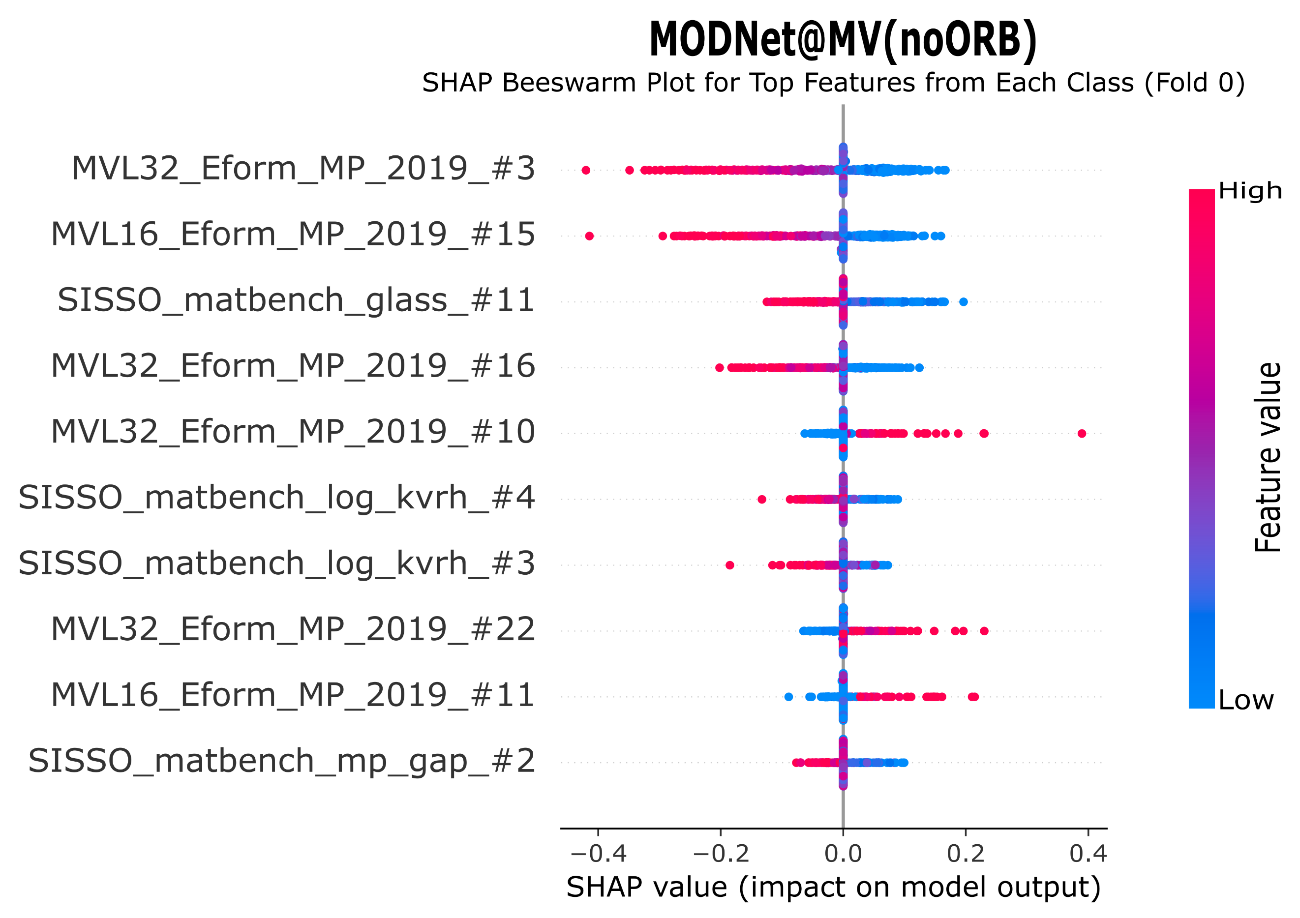
Fig. S4 | SHAP analysis plot of the MODNet@MV(noORB) model, using MatterVial features excluding the ORB featurizer, on the matbench_perovskites task.

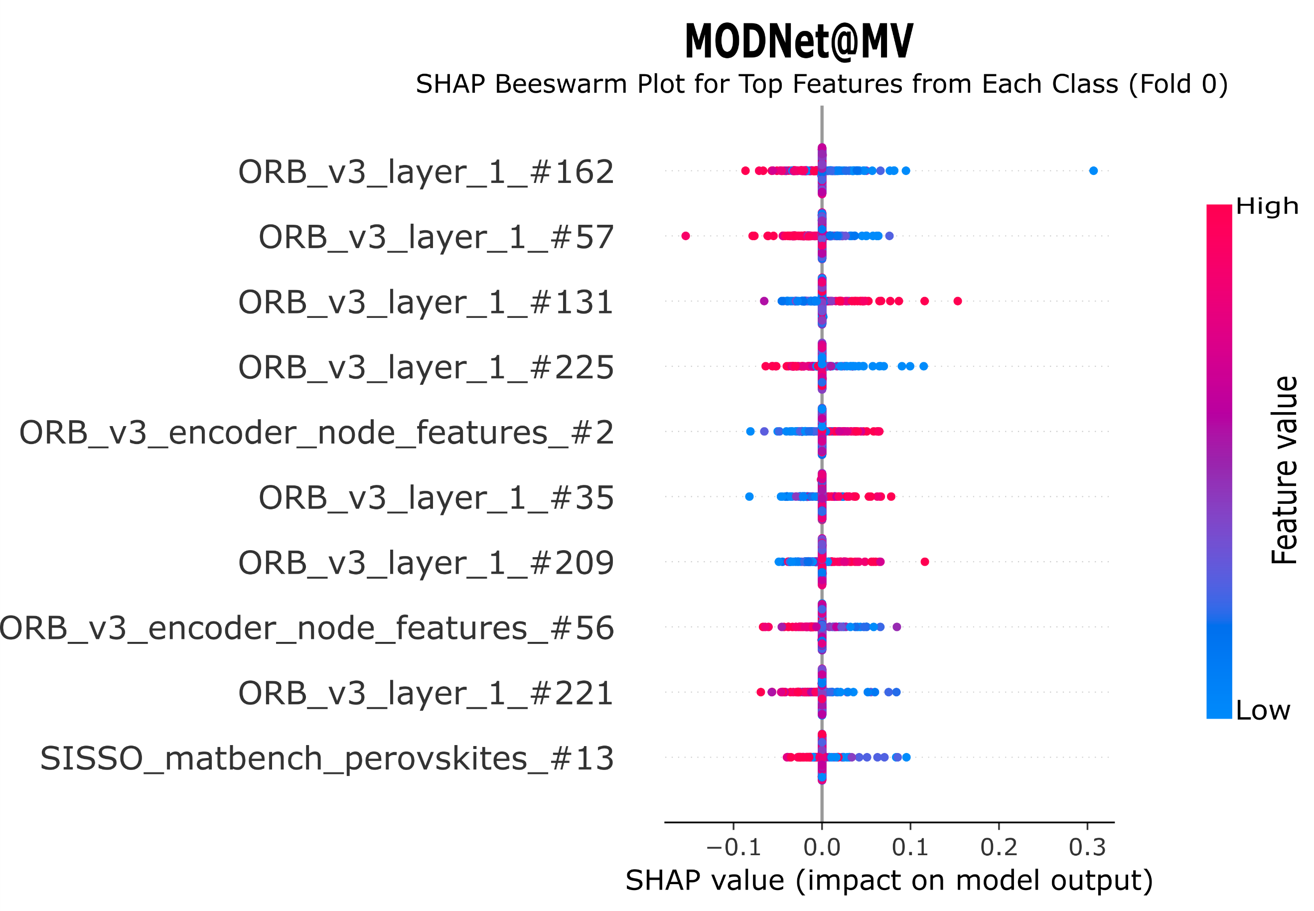
Fig. S5 | SHAP analysis plot of the MODNet@MV model, using MatterVial features including the ORB featurizer, on the matbench_perovskites task.
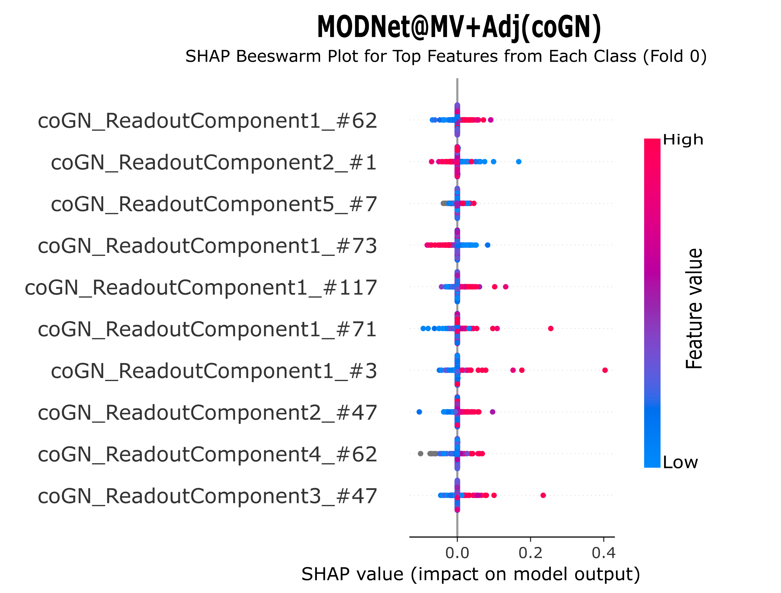
Fig. S6 | SHAP analysis plot of the MODNet@MV+Adj(coGN) using MatterVial features and adjacent coGN model features, on the task of matbench_perovskites.
The coGN model, once trained for the matbench_perovskites task, is used to evaluate structures from the MP2018-stable dataset, which is fully featurized with interpretable MatMiner descriptors and can be downloaded via MatterVial. Subsequently, we train surrogate XGBoost models that map the interpretable MatMiner and ℓ-OFM features to each adjacent-model feature. The top 30 features are passed to SISSO++ to predict an approximate formula. For the pretrained models included in MatterVial, the data are precomputed, and calling the interpreter module retrieves the approximate formulas.
In Fig. S7, we show the full SISSO formulas, with up to five terms, for the top features in each of the three analyzed models. We observe that the model with simpler features leverages primarily chemical information. When ORB features are introduced, the top feature leverages geometrical fingerprints and packing efficiency. The best-performing model seems to leverage the intertwined representations of chemical and geometrical features in the coGN features. Interestingly, the R² of the formula progressively decreases from the model without ORB and coGN to the model with the adjacent GNN, which can capture much more intricate relationships. This indicates that general chemical and geometrical descriptors become more limited as we move to models with deeper representations.
To further verify this observation, we analyzed the correlation of the top 20 features in each model with the interpretable MatMiner and OFM features instead of relying solely on the most important feature. These results are shown in Table S13, we can observe the same trend of more chemically oriented features in the model without ORB features, a bias towards using multiple geometrical features when the ORB features are introduced, and the resurge of more chemically oriented features in the model including full MatterVial featurizer with the addition of the adjacent coGN model features. Importantly, the correlation of the most important features decreases progressively, meaning that these interpretable descriptors become more and more limited to represent the nuances that the GNN features learn.

MODNet@MV(noORB): MVL32_Eform_MP_2019_#3, R_{form.}² = 0.91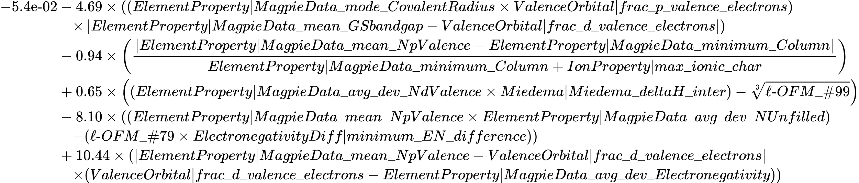
MODNet@MV(ORB): ORB_v3_layer_1_#162, R_{form.}² = 0.84
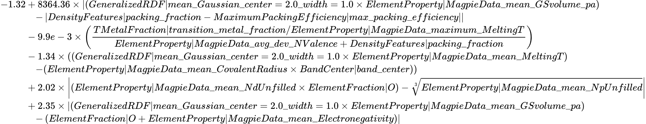
MODNet@MV+adj(coGN): coGN_ReadoutComponent1_#62 , R_{form.}² = 0.70
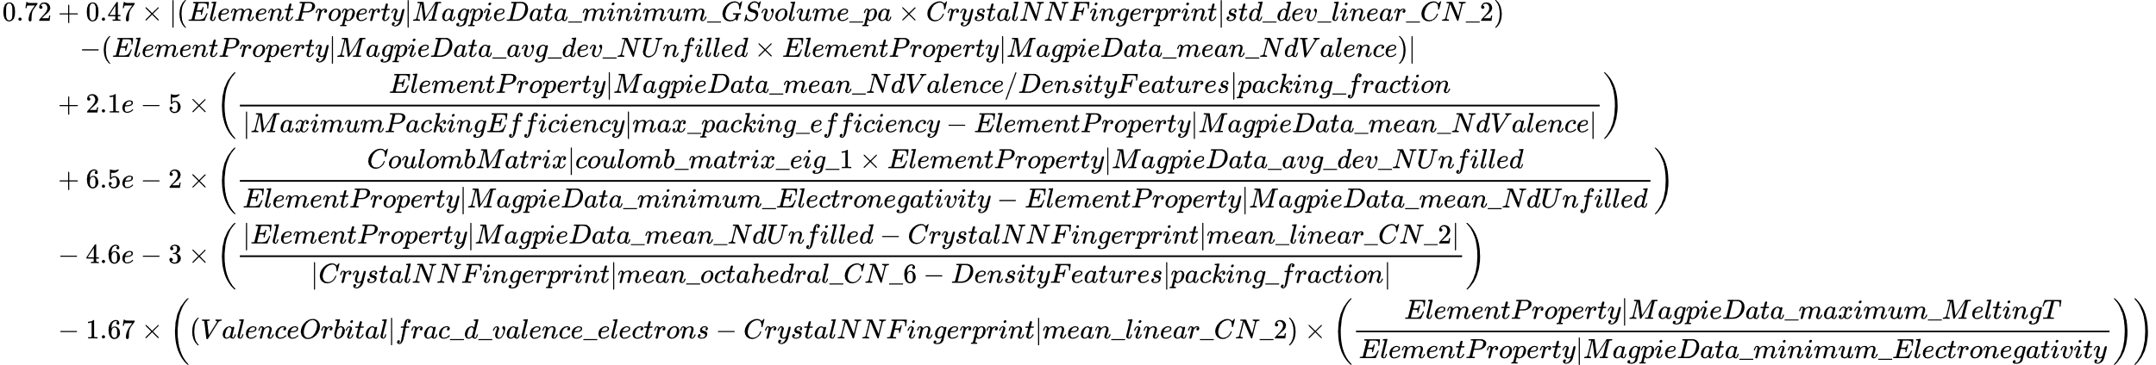
Fig. S7 | SISSO formulas retrieved with the MatterVial interpreter module for the top feature in each of the analyzed MODNet models for the matbench_perovskites task. Deep GNN features from MVL, ORB, or coGN, were approximated with MatMiner features from the DeBreuck2020Featurizer and ℓ-OFM features, the coefficient of determination of the formulas against the real features is shown.
Table S13 | Correlation between MatMiner and OFM of the top 20 features in the three analyzed MODNet models for matbench_perovskites.
MODNet@MV(noORB) | Corr. | MODNet@MV | Corr. | MODNet@MV+adj(coGN) | Corr.
ElementFraction|N | 0.3482 | ElementProperty|MagpieData_mean_GSvolume_pa | 0.2419 | ElementFraction|N | 0.1967
ElementProperty|MagpieData_mean_SpaceGroupNumber | 0.3392 | ElementProperty|MagpieData_maximum_GSvolume_pa | 0.2408 | ElementProperty|MagpieData_mean_SpaceGroupNumber | 0.1966
LocalPropertyDifference|mean_local_diff_in_Electronegativity | 0.3389 | ElementProperty|MagpieData_avg_dev_GSvolume_pa | 0.2395 | ElementProperty|MagpieData_mean_GSbandgap | 0.1936
ElementProperty|MagpieData_mean_GSbandgap | 0.3328 | BandCenter|band_center | 0.2386 | OFM:s²_-_p³ | 0.1906
IonProperty|avg_ionic_char | 0.3328 | ElementProperty|MagpieData_range_GSvolume_pa | 0.2385 | OFM:p³_-_s² | 0.19
ElementProperty|MagpieData_range_Electronegativity | 0.3327 | ElementProperty|MagpieData_minimum_Electronegativity | 0.2331 | ElementProperty|MagpieData_range_MeltingT | 0.1895
IonProperty|max_ionic_char | 0.3278 | ElementProperty|MagpieData_maximum_CovalentRadius | 0.2319 | ElementProperty|MagpieData_maximum_MeltingT | 0.1895
ElementProperty|MagpieData_avg_dev_Electronegativity | 0.325 | ElementProperty|MagpieData_mean_Electronegativity | 0.2295 | ElementProperty|MagpieData_avg_dev_MeltingT | 0.1883
ElementProperty|MagpieData_minimum_MeltingT | 0.3237 | ElementProperty|MagpieData_minimum_MendeleevNumber | 0.2275 | ElementProperty|MagpieData_avg_dev_SpaceGroupNumber | 0.1851
ElementProperty|MagpieData_mode_GSbandgap | 0.3178 | ElementProperty|MagpieData_mean_CovalentRadius | 0.2271 | ElementProperty|MagpieData_minimum_MeltingT | 0.1817
ElementProperty|MagpieData_maximum_Column | 0.3173 | ElementProperty|MagpieData_range_CovalentRadius | 0.226 | ElementProperty|MagpieData_mean_MeltingT | 0.1817
ElementProperty|MagpieData_maximum_NpValence | 0.3173 | ElementProperty|MagpieData_avg_dev_MendeleevNumber | 0.2246 | ElementProperty|MagpieData_avg_dev_GSbandgap | 0.179
ElementProperty|MagpieData_mode_SpaceGroupNumber | 0.3165 | ElementProperty|MagpieData_mean_MendeleevNumber | 0.2222 | YangSolidSolution|Yang_omega | 0.1783
ElementProperty|MagpieData_avg_dev_SpaceGroupNumber | 0.3136 | ElementProperty|MagpieData_range_MendeleevNumber | 0.2214 | OFM:p³_-_p³ | 0.1767
ElementProperty|MagpieData_maximum_Electronegativity | 0.3103 | IonProperty|avg_ionic_char | 0.2172 | ElementProperty|MagpieData_mode_GSbandgap | 0.1767
ElementProperty|MagpieData_maximum_MendeleevNumber | 0.3078 | ElementProperty|MagpieData_minimum_NValence | 0.2154 | ElementProperty|MagpieData_maximum_Column | 0.1765
ElementProperty|MagpieData_minimum_CovalentRadius | 0.2992 | AGNIFingerPrint|std_dev_AGNI_eta=2_89e+00 | 0.2151 | ElementProperty|MagpieData_maximum_NpValence | 0.1765
ElementProperty|MagpieData_minimum_SpaceGroupNumber | 0.298 | ElementProperty|MagpieData_avg_dev_CovalentRadius | 0.2143 | ElementFraction|O | 0.1763
OFM:p³_-_s² | 0.2964 | GaussianSymmFunc|std_dev_G2_4.0 | 0.2143 | ElementProperty|MagpieData_mode_SpaceGroupNumber | 0.176
OFM:s²_-_p³ | 0.2958 | ElementProperty|MagpieData_avg_dev_Electronegativity | 0.214 | ElementProperty|MagpieData_avg_dev_NpValence | 0.1758
ElementProperty|MagpieData_avg_dev_GSbandgap | 0.2934 | VoronoiFingerprint|mean_Voro_dist_minimum | 0.2115 | ElementProperty|MagpieData_maximum_Electronegativity | 0.1757
SineCoulombMatrix|sine_coulomb_matrix_eig_3 | 0.2915 | LocalPropertyDifference|mean_local_diff_in_Electronegativity | 0.2113 | OFM:f⁴_-_d¹⁰ | 0.1753
CoulombMatrix|coulomb_matrix_eig_3 | 0.2889 | AverageBondLength|mean_Average_bond_length | 0.21 | ElementProperty|MagpieData_mean_Electronegativity | 0.1743
ElementProperty|MagpieData_mean_NpValence | 0.2866 | ElementProperty|MagpieData_range_Electronegativity | 0.2096 | IonProperty|avg_ionic_char | 0.1729
ValenceOrbital|avg_p_valence_electrons | 0.2866 | IonProperty|max_ionic_char | 0.2078 | ElementProperty|MagpieData_mean_NpValence | 0.1716
ElementProperty|MagpieData_range_SpaceGroupNumber | 0.2849 | VoronoiFingerprint|std_dev_Voro_vol_sum | 0.2074 | ValenceOrbital|avg_p_valence_electrons | 0.1716
ElementProperty|MagpieData_mode_GSvolume_pa | 0.2807 | DensityFeatures|packing_fraction | 0.2042 | ElementProperty|MagpieData_maximum_MendeleevNumber | 0.1706
Miedema|Miedema_deltaH_amor | 0.2801 | DensityFeatures|density | 0.2037 | VoronoiFingerprint|mean_Voro_dist_maximum | 0.1705
OFM:f⁴_-_d¹⁰ | 0.276 | LocalPropertyDifference|std_dev_diff_in_Electronegativity | 0.2018 | ElementProperty|MagpieData_avg_dev_Electronegativity | 0.1703
ElementProperty|MagpieData_range_NpValence | 0.2756 | AGNIFingerPrint|std_dev_AGNI_eta=4_43e+00 | 0.1996 | ElementProperty|MagpieData_minimum_CovalentRadius | 0.1697
OFM:p³_-_p³ | 0.2705 | VoronoiFingerprint|mean_Voro_vol_sum | 0.1976 | ElementProperty|MagpieData_range_Electronegativity | 0.1697
ElementFraction|O | 0.2695 | DensityFeatures|vpa | 0.1972 | LocalPropertyDifference|mean_local_difference_in_Electronegativity | 0.1695
Miedema|Miedema_deltaH_inter | 0.2663 | ElementProperty|MagpieData_mean_MeltingT | 0.1971 | IonProperty|max_ionic_char | 0.1686
SineCoulombMatrix|sine_coulomb_matrix_eig_4 | 0.2627 | ElementProperty|MagpieData_avg_dev_MeltingT | 0.1963 | ElementProperty|MagpieData_minimum_SpaceGroupNumber | 0.1668
ElementProperty|MagpieData_range_MendeleevNumber | 0.2601 | ElementProperty|MagpieData_mean_Column | 0.1948 | ElementProperty|MagpieData_range_SpaceGroupNumber | 0.1638
AtomicPackingEfficiency|dist_from_3_clusters__APE_<_0.010 | 0.2575 | AverageBondLength|std_dev_Average_bond_length | 0.194 | BandCenter|band_center | 0.1629
CoulombMatrix|coulomb_matrix_eig_4 | 0.2571 | MaximumPackingEfficiency|max_packing_efficiency | 0.1927 | CrystalNNFingerprint|mean_linear_CN_2 | 0.1626
AtomicPackingEfficiency|dist_from_1_clusters__APE_<_0.010 | 0.2568 | ElementProperty|MagpieData_mean_NdValence | 0.1926 | VoronoiFingerprint|mean_Voro_dist_minimum | 0.1626
ElementProperty|MagpieData_minimum_Electronegativity | 0.2567 | ValenceOrbital|avg_d_valence_electrons | 0.1926 | OFM:p³_-_d¹⁰ | 0.1623
ElementProperty|MagpieData_avg_dev_MendeleevNumber | 0.2562 | GeneralizedRDF|std_dev_Gaussian_center=2.0_width=1.0 | 0.1921 | OFM:d¹⁰_-_p³ | 0.1623
OFM:p⁴_-_s² | 0.2561 | VoronoiFingerprint|mean_Voro_area_sum | 0.1912 | VoronoiFingerprint|mean_Voro_dist_mean | 0.1622
ElementFraction|F | 0.256 | ValenceOrbital|frac_s_valence_electrons | 0.1908 | ElementProperty|MagpieData_range_NpValence | 0.1618
OFM:s²_-_p⁴ | 0.2547 | ElementProperty|MagpieData_avg_dev_Column | 0.1897 | OFM:f¹⁰_-_d³ | 0.1599
ElementProperty|MagpieData_minimum_GSvolume_pa | 0.2545 | GeneralizedRDF|std_dev_Gaussian_center=4.0_width=1.0 | 0.1893 | OFM:d¹⁰_-_f⁴ | 0.1594
AtomicPackingEfficiency|dist_from_5_clusters__APE____0_010 | 0.2536 | CrystalNNFingerprint|mean_linear_CN_2 | 0.1886 | CoulombMatrix|coulomb_matrix_eig_3 | 0.1594
ValenceOrbital|frac_p_valence_electrons | 0.2498 | StructuralHeterogeneity|mean_neighbor_distance_variation | 0.1881 | GlobalSymmetryFeatures|crystal_system_int | 0.159
LocalPropertyDifference|std_dev_diff_in_Electronegativity | 0.248 | ElementProperty|MagpieData_avg_dev_NdValence | 0.1879 | OFM:d³_-_f¹⁰ | 0.1584
ElementProperty|MagpieData_range_CovalentRadius | 0.2477 | ElementProperty|MagpieData_minimum_Column | 0.1878 | ElementProperty|MagpieData_mode_GSvolume_pa | 0.1581
ElementProperty|MagpieData_mode_NUnfilled | 0.2455 | YangSolidSolution|Yang_delta | 0.1873 | AverageBondLength|mean_Average_bond_length | 0.1578
OFM:d⁸_-_f⁷ | 0.2453 | VoronoiFingerprint|mean_Voro_vol_mean | 0.1873 | CrystalNNFingerprint|mean_wt_CN_2 | 0.1574

Supporting Information References
1. Lam Pham, T. et al. Machine learning reveals orbital interaction in materials. Science and Technology of Advanced Materials 18, 756–765 (2017).
2. Chen, C., Ye, W., Zuo, Y., Zheng, C. & Ong, S. P. Graph Networks as a Universal Machine Learning Framework for Molecules and Crystals. Chem. Mater. 31, 3564–3572 (2019).
3. Dunn, A., Wang, Q., Ganose, A., Dopp, D. & Jain, A. Benchmarking materials property prediction methods: the Matbench test set and Automatminer reference algorithm. npj Computational Materials 6, 1–10 (2020).
4. Chollet, F. Keras. (2015).
5. Ouyang, R., Curtarolo, S., Ahmetcik, E., Scheffler, M. & Ghiringhelli, L. M. SISSO: A compressed-sensing method for identifying the best low-dimensional descriptor in an immensity of offered candidates. Phys. Rev. Materials 2, 083802 (2018).
6. Citrine Informatics. Mechanical properties of some steels.
7. Choudhary, K., Kalish, I., Beams, R. & Tavazza, F. High-throughput Identification and Characterization of Two-dimensional Materials using Density functional theory. Sci Rep 7, 5179 (2017).
8. Petretto, G. et al. High-throughput density-functional perturbation theory phonons for inorganic materials. Sci Data 5, 180065 (2018).
9. Zhuo, Y., Mansouri Tehrani, A. & Brgoch, J. Predicting the Band Gaps of Inorganic Solids by Machine Learning. J. Phys. Chem. Lett. 9, 1668–1673 (2018).
10. Kawazoe, Y., Masumoto, T., Tsai, A.-P., Yu, J.-Z. & Aihara Jr., T. 1 Introduction. in Nonequilibrium Phase Diagrams of Ternary Amorphous Alloys (eds. Kawazoe, Y., Yu, J.-Z., Tsai, A.-P. & Masumoto, T.) vol. 37A 1–32 (Springer-Verlag, Berlin/Heidelberg, 1997).
11. Ward, L., Agrawal, A., Choudhary, A. & Wolverton, C. A general-purpose machine learning framework for predicting properties of inorganic materials. npj Comput Mater 2, 16028 (2016).
12. Petousis, I. et al. High-throughput screening of inorganic compounds for the discovery of novel dielectric and optical materials. Sci Data 4, 160134 (2017).
13. Castelli, I. E. et al. New cubic perovskites for one- and two-photon water splitting using the computational materials repository. Energy Environ. Sci. 5, 9034 (2012).
14. De Jong, M. et al. Charting the complete elastic properties of inorganic crystalline compounds. Sci Data 2, 150009 (2015).
15. Jain, A. et al. Commentary: The Materials Project: A materials genome approach to accelerating materials innovation. APL materials 1, 11002 (2013).
16. Trinquet, V. et al. Second-harmonic generation tensors from high-throughput density-functional perturbation theory. Sci Data 11, 757 (2024).
17. Lundberg, S. M. & Lee, S.-I. A unified approach to interpreting model predictions. in Advances in neural information processing systems (eds. Guyon, I. et al.) vol. 30 (Curran Associates, Inc., 2017).

