 | Population | Intervention | Comparator | Outcomes | Study Design
Definition | Diagnosis of Episodic Migraine | Use of anti CGRP monoclonal antibodies | Placebo | -
MeSH Heading | Migraine Disorder | Ajovy (fremanezumab), Aimovig (erenumab), Emgality (galcanezumab), Vyepti (eptinezumab) | Placebo
Entry terms | - Disorder, Migraine  - Disorders, Migraine  - Migraine Disorder  - Headache, Migraine  - Headaches, Migraine  - Migraine Headaches  - Migraine  - Migraines  - Migraine Headache  - Acute Confusional Migraine  - Acute Confusional Migraines  - Migraine, Acute Confusional  - Migraines, Acute Confusional  - Status Migrainosus  - Abdominal Migraine  - Abdominal Migraines  - Migraine, Abdominal  - Migraines, Abdominal  - Cervical Migraine Syndrome  - Cervical Migraine Syndromes  - Migraine Syndrome, Cervical  - Migraine Syndromes, Cervical  - Hemicrania Migraine  - Hemicrania Migraines  - Migraine, Hemicrania  - Migraines, Hemicrania  - Migraine Variant  - Migraine Variants  - Variant, Migraine  - Variants, Migraine  - Sick Headache  - Headache, Sick  - Headaches, Sick  - Sick Headaches | - AMG 334  - Aimovig  - erenumab-aooe  - fremanezumab-vfrm  - Ajovy  - galcanezumab-gnlm  - Emgality  - TEV-48125  - LY2951742  - LY-2951742  - ALD403  - ALD-403  - vyepti | Sham Treatment

Table 1: PICOS Table
Search Query:
(Migraine Disorder OR Headache, Migraine OR Migraine Headaches OR Migraine OR Migraine Headache OR Acute Confusional Migraine OR Migraine, Acute Confusional OR Status Migrainosus OR Abdominal Migraine OR Migraine, Abdominal OR Cervical Migraine Syndrome OR Migraine Syndrome, Cervical OR Hemicrania Migraine OR Migraine, Hemicrania OR Migraine Variant OR Variant, Migraine OR Sick Headache OR Headaches, Sick) AND (Erenumab OR AMG 334 OR Aimovig OR erenumab-aooe OR fremanezumab-vfrm OR Ajovy OR galcanezumab-gnlm OR Emgality) OR (Fremanezumab OR TEV-48125) OR (galcanezumab OR LY2951742 OR LY-2951742) OR ( Eptinezumab OR ALD403 OR ALD-403 OR vyepti) AND (Placebo OR sham treatment) AND (RCT OR Randomized control trial)

Study , Auther, Year | Drug | Population | Mean Age | Male | Mean(SD) numbEr of migraine days | Mean(SD)numbEr of headache days | Mean(SD)% days with headache medication usage
Ashina 2020 | Eptinezumab 30mg | 219 | 39.1(11.54) | 34 | 8.7(3.05) | 10.2(3.35) | 24.9(18.65)
Ashina 2020 | Eptinezumab 100mg | 223 | 40.0(10.66) | 44 | 8.7(2.85) | 10.0(3.02) | 24.7(17.44)
Ashina 2020 | Eptinezumab 300mg | 224 | 40.2(11.72) | 25 | 8.6(2.87) | 10.1(3.06) | 26.1(19.40)
Ashina 2020 | Placebo | 222 | 39.9(11.67) | 36 | 8.4(2.68) | 9.9(2.83) | 24.7(19.14)
BiGal 2015 | Fremanezumab 225 mg | 96 | 40·8 (12·4) | 9 | 11·5 (1·9) | 12·6 (3·1) | 10·4 (3·6)
BiGal 2015 | Fremanezumab 675 mg | 97 | 40·7 (12·6) | 15 | 11·3 (2·2) | 12·5 (2·65) | 9·8 (4·0)
BiGal 2015 | Placebo | 104 | 42·0 (11·6) | 12 | 11·5 (2·24) | 12·4 (2·3) | 10·4 (3·6)
Chawdhury 2022 | Erenumab 70 mg | 133 | 34.9 (9.2) | 31 | 7.69 (2.67) | 8.75 (2.88) | 0.20 (1.14)
Chawdhury 2022 | Erenumab 140 mg | 94 | 35.4 (7.2) | 16 | 8.34 (3.75) | 9.48 (4.67) | 0.10 (0.58)
Chawdhury 2022 | Placebo | 124 | 35.3 (8.9) | 27 | 7.56 (2.27) | 8.50 (2.55) | 0.20 (1.00)
Dodick 2018 (a) | Erenumab 70 mg | 286 | 42 ± 11 | 41 | 8.1 ± 2.7 | 9.1 ± 2.7 | 3.7 ± 3.6
Dodick 2018 (a) | Placebo | 291 | 42 ± 12 | 44 | 8.4 ± 2.6 | 9.3 ± 2.7 | 3.4 ± 3.6
Dodick 2018 (b) | Fremanezumab 225 mg | 290 | 42.9(12.67) | 46 | 8.9(2.63) | 11.0(2.49) | 7.7(3.37)
Dodick 2018 (b) | Fremanezumab 675 mg | 291 | 41.1(11.41) | 40 | 9.3(2.65) | 11.1(2.42) | 7.8(3.74)
Dodick 2018 (b) | Placebo | 294 | 41.3(12.04) | 47 | 9.1(2.65) | 11.2(2.45) | 7.7(3.60)
Goadsby 2017 | Erenuman 70 mg | 317 | 41.1 ± 11.3 (18-63) | 49 | 8.3 ± 2.5 | 9.1 ± 2.6 | 3.2 ± 3.4
Goadsby 2017 | Erenumab 140 mg | 319 | 40.4 ± 11.1 (19-65) | 47 | 8.3 ± 2.5 | 9.3 ± 2.5 | 3.4 ± 3.5
Goadsby 2017 | Placebo | 319 | 41.3 ± 11.2(18-65) | 45 | 8.2 ± 2.5 | 9.3 ± 2.6 | 3.4 ± 3.4
Hu 2022 | Galcanezumab 120mg | 261 | 37.2 (9.3) | 73 | 8.2 (2.8) | 9.1 (3.3) | 5.4 (4.9)
Hu 2022 | Placebo | 259 | 36.8 (9.8) | 63 | 8.3 (2.7) | 9.1 ( 2.9) | 4.9 (4.5)
ReutEr 2018 | Erenumab 140 mg | 118 | 44.6 (10.5) | 24 | 9.2 (2.6) | 10.1 (2.8) | 9.2 (2.6)
ReutEr 2018 | Placebo | 122 | 44.2 (10.6) | 22 | 9.3 (2.7) | 10.1 (2.7) | 9.3 (2.7)
Sakai 2019 | Erenumab 28mg | 67 | 43 | 12 | 7.7 (2.1) | 8.9 (2.2) | 5.5 (2.8)
Sakai 2019 | Erenumab 70mg | 135 | 44 | 20 | 7.8 (2.3) | 9.0 (2.6) | 5.4 (2.9)
Sakai 2019 | Erenumab 140mg | 137 | 45 | 25 | 8.1 (2.4) | 9.6 (2.6) | 5.9 (2.9)
Sakai 2019 | Placebo | 136 | 43 | 18 | 7.7 (2.3) | 9.1 (2.6) | 5.6 (2.5)
Sakai 2020 | Galcanezumab 120 mg | 115 | 43.2(10.0) | 20 | N/A | 8.6(2.8) | 7.3(2.9)
Sakai 2020 | Galcanezumab 240 mg | 114 | 44.8(10.2) | 18 | N/A | 9.0(3.0) | 7.8(3.0)
Sakai 2020 | Placebo | 230 | 44.2(10.0) | 34 | N/A | 8.6(3.0) | 7.4(3.0)
Sakai 2021 | Fremanezumab 225mg | 121 | 44.4 (9.5) | 20 | 8.6 (2.5) | 11.0 (2.1) | 120 (99.2)
Sakai 2021 | Fremanezumab 675mg | 119 | 41.9 (10.1) | 18 | 8.7 (2.5) | 11.0 (2.5) | 117 (98.3)
Sakai 2021 | Placebo | 117 | 44.2 (10.7) | 17 | 9.0 (2.8) | 11.1 (2.5) | 117 (100.0)
Shljarevski 2018 (a) | Galcanezumab 5mg | 68 | 41.40(11.15) | 13 | 6.68(2.73) | N/A | N/A
Shljarevski 2018 (a) | Galcanezumab 50mg | 68 | 39.63(12.42) | 7 | 6.41(2.66) | N/A | N/A
Shljarevski 2018 (a) | Galcanezumab 120mg | 70 | 40.57(10.92) | 11 | 6.95(2.56) | N/A | N/A
Shljarevski 2018 (a) | Galcanezumab 300mg | 67 | 40.79(13.20) | 11 | 6.73(2.48) | N/A | N/A
Shljarevski 2018 (a) | Placebo | 137 | 39.54(12.10) | 28 | 6.64(2.73) | N/A | N/A
Shljarevski 2018 (b) | Galcanezumab 120 mg | 231 | 40.9 (11.2) | 33 | N/A | 9.07 (2.9) | 7.47 (3.3)
Shljarevski 2018 (b) | Galcanezumab 240 mg | 223 | 41.9 (10.8) | 33 | N/A | 9.06 (2.9) | 7.47 (3.3)
Shljarevski 2018 (b) | Placebo | 461 | 42.3 (11.3) | 68 | N/A | 9.2 (3.0) | 7.6 (3.4)
StauffEr 2024 | Galcanezumab 120 mg | 213 | 40.9 (11.9) | 32 | 9.2 (3.1) | 9.21(3.05) | N/A
StauffEr 2024 | Galcanezumab 240 mg | 212 | 39.1 (11.5 | 37 | 9.1 (2.9) | 9.14(2.91) | N/A
StauffEr 2024 | Placebo | 433 | 41.3 (11.4) | 71 | 9.1 (3.0) | 9.08(2.97) | N/A
Sun 2016 | Erenumab 7 mg | 108 | 40·3 (10·9) | 20 | 8·6 (2·8) | N/A | N/A
Sun 2016 | Erenumab 21 mg | 108 | 39·9 (12·3) | 21 | 8·9 (2·9) | N/A | N/A
Sun 2016 | Erenumab 70 mg | 107 | 42·6 (9·9) | 25 | 8·6 (2·5) | N/A | N/A
Sun 2016 | Placebo | 160 | 41·4 (10·0) | 28 | 8·8 (2·7) | N/A | N/A
Wang 2021 | Erenumab 70mg | 338 | 37.3 (10.0) | 66 | 8.1 (2.6) | 9.2 (2.7) | 308 (91.1)
Wang 2021 | Erenumab 140mg | 224 | 37.1 (9.6) | 40 | 8.3 (3.1) | 9.5 (3.9) | 207 (92.4)
Wang 2021 | Placebo | 338 | 38.0 (10.1) | 57 | 8.4 (2.8) | 9.2 (2.8) | 313 (92.6)

Table 2: Baseline

eptinezumab 100mg | -0.13 [-0.48; 0.22] | -0.03 [-0.38; 0.32] | . | . | . | . | . | . | . | . | . | . | . | . | 0.23 [-0.12; 0.58]
-0.13 [-0.48; 0.22] | eptinezumab 300mg | 0.10 [-0.25; 0.45] | . | . | . | . | . | . | . | . | . | . | . | . | 0.36 [ 0.01; 0.71]
-0.03 [-0.38; 0.32] | 0.10 [-0.25; 0.45] | eptinezumab 30mg | . | . | . | . | . | . | . | . | . | . | . | . | 0.26 [-0.09; 0.62]
-0.15 [-0.54; 0.23] | -0.02 [-0.41; 0.37] | -0.12 [-0.50; 0.27] | erenumab 140mg | . | 0.21 [-0.21; 0.63] | 0.08 [-0.10; 0.27] | . | . | . | . | . | . | . | . | 0.38 [ 0.22; 0.55]
0.19 [-0.31; 0.69] | 0.32 [-0.18; 0.82] | 0.22 [-0.27; 0.72] | 0.34 [-0.03; 0.72] | erenumab 21mg | . | -0.20 [-0.61; 0.20] | 0.17 [-0.24; 0.57] | . | . | . | . | . | . | . | -0.01 [-0.40; 0.38]
0.06 [-0.44; 0.57] | 0.20 [-0.31; 0.70] | 0.10 [-0.41; 0.61] | 0.22 [-0.15; 0.59] | -0.13 [-0.63; 0.37] | erenumab 28mg | -0.34 [-0.76; 0.08] | . | . | . | . | . | . | . | . | 0.37 [-0.05; 0.79]
-0.07 [-0.45; 0.31] | 0.06 [-0.32; 0.44] | -0.04 [-0.42; 0.34] | 0.08 [-0.09; 0.25] | -0.26 [-0.62; 0.10] | -0.13 [-0.50; 0.23] | erenumab 70mg | 0.37 [-0.03; 0.77] | . | . | . | . | . | . | . | 0.30 [ 0.15; 0.45]
0.36 [-0.14; 0.86] | 0.49 [ 0.00; 0.99] | 0.39 [-0.10; 0.89] | 0.51 [ 0.14; 0.89] | 0.17 [-0.24; 0.57] | 0.30 [-0.20; 0.79] | 0.43 [ 0.08; 0.78] | erenumab 7mg | . | . | . | . | . | . | . | -0.18 [-0.57; 0.21]
-0.27 [-0.69; 0.14] | -0.14 [-0.56; 0.27] | -0.24 [-0.66; 0.17] | -0.12 [-0.39; 0.15] | -0.47 [-0.88; -0.05] | -0.34 [-0.77; 0.09] | -0.21 [-0.47; 0.06] | -0.63 [-1.05; -0.22] | fremanezumab 225mg | 0.04 [-0.18; 0.26] | . | . | . | . | . | 0.51 [ 0.29; 0.72]
-0.24 [-0.65; 0.18] | -0.10 [-0.52; 0.31] | -0.20 [-0.62; 0.21] | -0.08 [-0.36; 0.19] | -0.43 [-0.84; -0.01] | -0.30 [-0.73; 0.13] | -0.17 [-0.43; 0.09] | -0.60 [-1.01; -0.18] | 0.04 [-0.18; 0.26] | fremanezumab 675mg | . | . | . | . | . | 0.47 [ 0.25; 0.69]
-0.27 [-0.66; 0.12] | -0.14 [-0.53; 0.25] | -0.24 [-0.62; 0.15] | -0.12 [-0.35; 0.11] | -0.46 [-0.85; -0.07] | -0.34 [-0.74; 0.06] | -0.20 [-0.42; 0.01] | -0.63 [-1.02; -0.25] | 0.00 [-0.27; 0.28] | -0.03 [-0.31; 0.24] | galcanezumab 120mg | 0.03 [-0.18; 0.24] | 0.19 [-0.26; 0.64] | 0.24 [-0.20; 0.69] | 0.21 [-0.24; 0.65] | 0.50 [ 0.34; 0.66]
-0.27 [-0.67; 0.13] | -0.14 [-0.54; 0.26] | -0.24 [-0.64; 0.16] | -0.12 [-0.37; 0.13] | -0.46 [-0.87; -0.06] | -0.34 [-0.75; 0.08] | -0.20 [-0.45; 0.04] | -0.63 [-1.03; -0.23] | 0.00 [-0.29; 0.29] | -0.04 [-0.33; 0.26] | -0.00 [-0.20; 0.20] | galcanezumab 240mg | . | . | . | 0.53 [ 0.33; 0.73]
0.07 [-0.46; 0.59] | 0.20 [-0.32; 0.72] | 0.10 [-0.42; 0.62] | 0.22 [-0.20; 0.63] | -0.13 [-0.65; 0.40] | 0.00 [-0.53; 0.53] | 0.13 [-0.28; 0.55] | -0.29 [-0.81; 0.23] | 0.34 [-0.10; 0.78] | 0.30 [-0.14; 0.74] | 0.34 [-0.05; 0.73] | 0.34 [-0.08; 0.76] | galcanezumab 300mg | 0.05 [-0.40; 0.50] | 0.01 [-0.44; 0.46] | 0.06 [-0.36; 0.48]
0.12 [-0.40; 0.64] | 0.25 [-0.27; 0.77] | 0.15 [-0.37; 0.67] | 0.27 [-0.15; 0.69] | -0.07 [-0.60; 0.45] | 0.05 [-0.48; 0.58] | 0.19 [-0.22; 0.60] | -0.24 [-0.76; 0.28] | 0.39 [-0.05; 0.83] | 0.35 [-0.09; 0.79] | 0.39 [ 0.00; 0.78] | 0.39 [-0.03; 0.81] | 0.05 [-0.40; 0.50] | galcanezumab 50mg | -0.04 [-0.49; 0.41] | 0.01 [-0.41; 0.42]
0.08 [-0.44; 0.60] | 0.21 [-0.31; 0.73] | 0.11 [-0.41; 0.63] | 0.23 [-0.19; 0.65] | -0.11 [-0.63; 0.41] | 0.01 [-0.52; 0.54] | 0.15 [-0.26; 0.56] | -0.28 [-0.80; 0.24] | 0.35 [-0.09; 0.80] | 0.31 [-0.13; 0.76] | 0.35 [-0.04; 0.74] | 0.35 [-0.07; 0.77] | 0.01 [-0.44; 0.46] | -0.04 [-0.49; 0.41] | galcanezumab 5mg | 0.05 [-0.37; 0.46]
0.23 [-0.12; 0.58] | 0.36 [ 0.01; 0.71] | 0.26 [-0.09; 0.62] | 0.38 [ 0.22; 0.54] | 0.04 [-0.31; 0.39] | 0.17 [-0.20; 0.53] | 0.30 [ 0.15; 0.44] | -0.13 [-0.48; 0.22] | 0.51 [ 0.29; 0.72] | 0.47 [ 0.25; 0.68] | 0.50 [ 0.34; 0.66] | 0.50 [ 0.31; 0.70] | 0.16 [-0.22; 0.55] | 0.11 [-0.27; 0.50] | 0.15 [-0.23; 0.54] | placebo

Table 3: League Table MMD

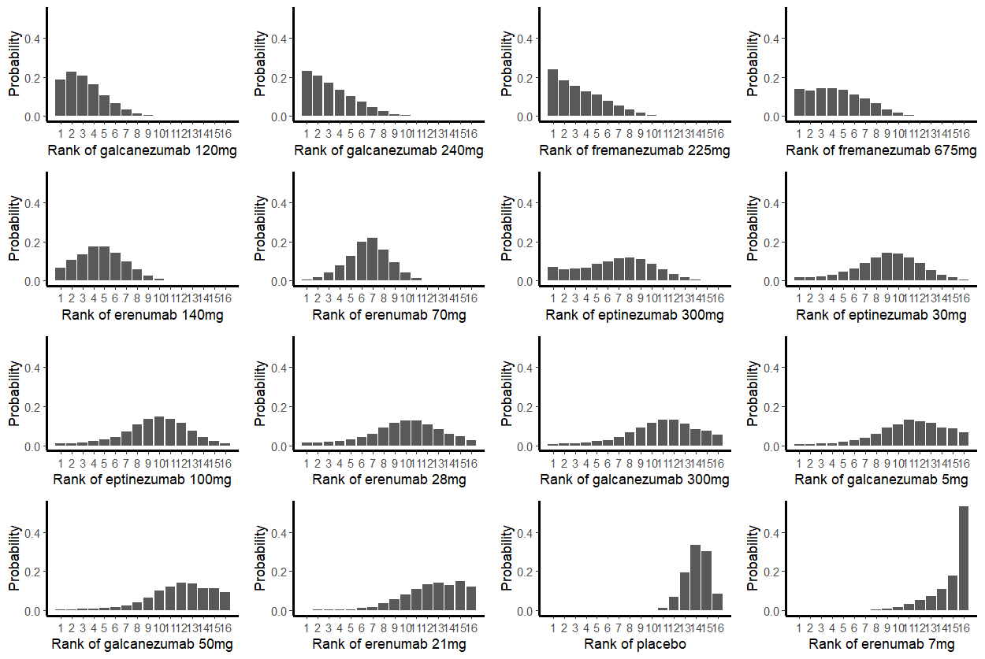
Figure 1: Rank plot for Change in MMD from baseline

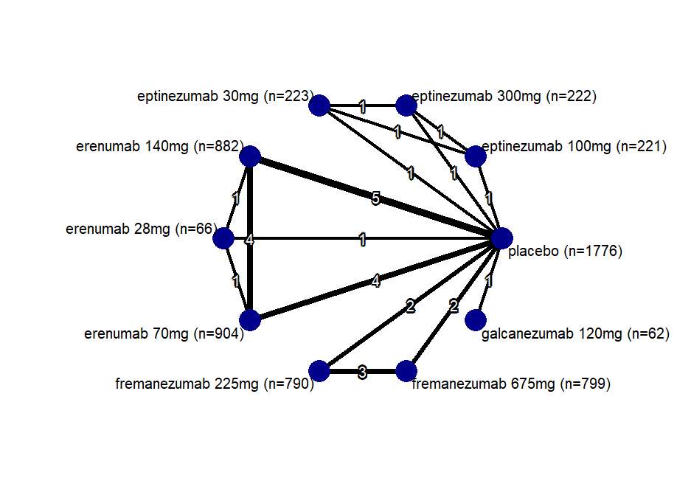
Figure 2: Network plot of 50%

eptinezumab 100mg | 0.77 [0.38; 1.56] | 0.98 [0.49; 1.99] | . | . | . | . | . | . | 1.66 [0.82; 3.37]
0.77 [0.38; 1.56] | eptinezumab 300mg | 1.28 [0.63; 2.58] | . | . | . | . | . | . | 2.16 [1.06; 4.38]
0.98 [0.49; 1.99] | 1.28 [0.63; 2.58] | eptinezumab 30mg | . | . | . | . | . | . | 1.69 [0.83; 3.43]
0.73 [0.33; 1.61] | 0.95 [0.43; 2.09] | 0.74 [0.34; 1.64] | erenumab 140mg | 1.51 [0.59; 3.83] | 1.00 [0.70; 1.45] | . | . | . | 2.32 [1.63; 3.29]
0.99 [0.33; 3.01] | 1.29 [0.42; 3.92] | 1.01 [0.33; 3.07] | 1.36 [0.59; 3.15] | erenumab 28mg | 0.60 [0.24; 1.53] | . | . | . | 3.09 [1.06; 8.99]
0.75 [0.34; 1.67] | 0.98 [0.44; 2.17] | 0.76 [0.34; 1.70] | 1.03 [0.72; 1.47] | 0.76 [0.33; 1.76] | erenumab 70mg | . | . | . | 2.19 [1.50; 3.19]
0.52 [0.22; 1.26] | 0.68 [0.28; 1.65] | 0.53 [0.22; 1.29] | 0.72 [0.38; 1.35] | 0.53 [0.19; 1.44] | 0.70 [0.37; 1.32] | fremanezumab 225mg | 1.02 [0.68; 1.53] | . | 3.23 [1.87; 5.60]
0.53 [0.22; 1.29] | 0.70 [0.29; 1.68] | 0.54 [0.23; 1.31] | 0.73 [0.39; 1.38] | 0.54 [0.20; 1.47] | 0.71 [0.38; 1.35] | 1.02 [0.68; 1.53] | fremanezumab 675mg | . | 3.14 [1.81; 5.44]
0.86 [0.27; 2.72] | 1.12 [0.35; 3.54] | 0.88 [0.28; 2.77] | 1.18 [0.44; 3.12] | 0.87 [0.25; 3.02] | 1.15 [0.43; 3.05] | 1.64 [0.58; 4.69] | 1.61 [0.56; 4.59] | galcanezumab 120mg | 1.93 [0.78; 4.78]
1.66 [0.82; 3.37] | 2.16 [1.06; 4.38] | 1.69 [0.83; 3.43] | 2.27 [1.60; 3.22] | 1.67 [0.71; 3.93] | 2.21 [1.53; 3.19] | 3.17 [1.87; 5.36] | 3.10 [1.84; 5.25] | 1.93 [0.78; 4.78] | placebo

Table 4: League table 50%

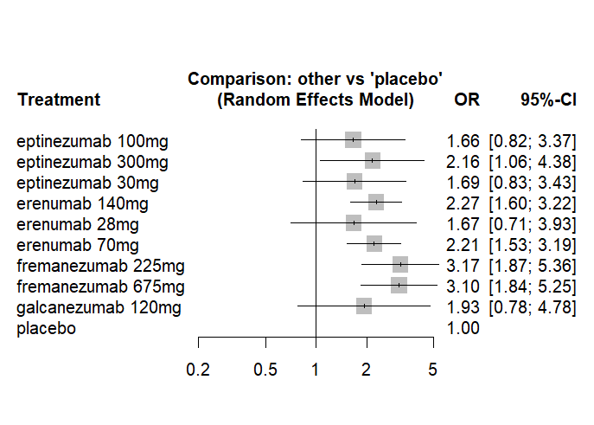
Figure 3: Forest plot of 50%

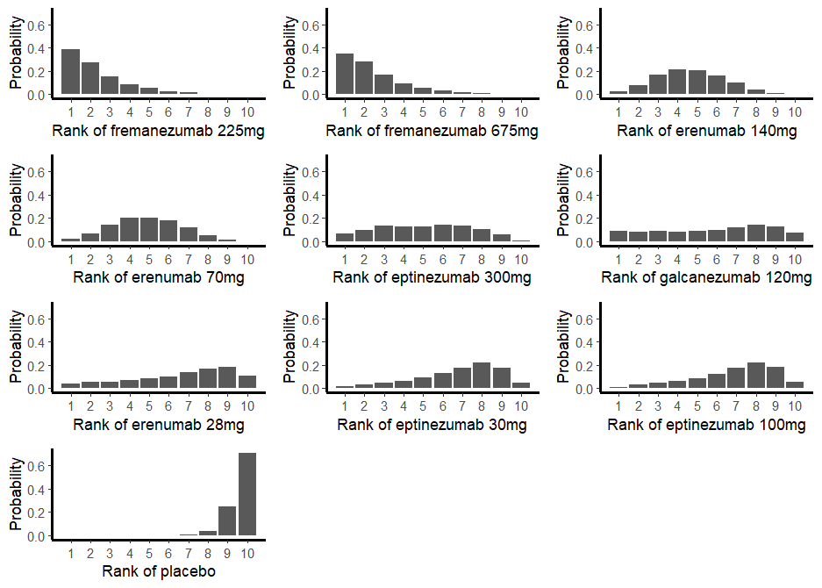
Figure 4: Rank plot of 50%
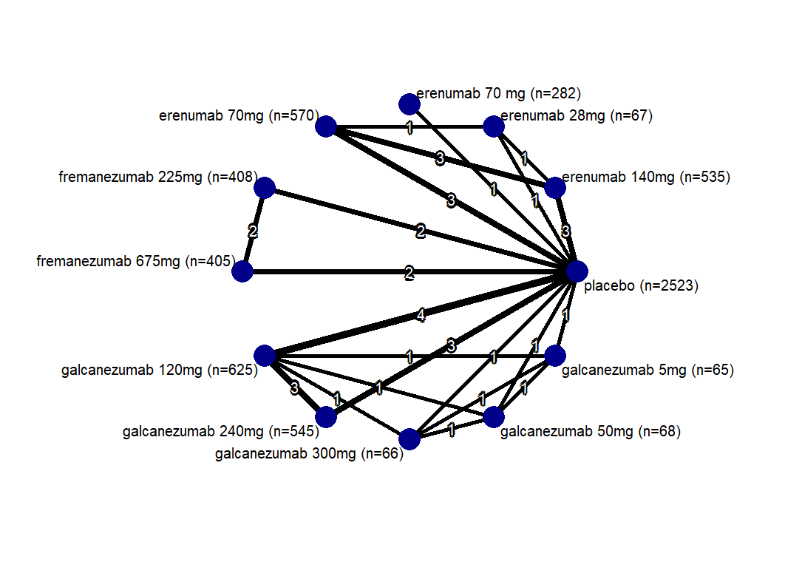
Figure 5: Network plot of Acute Med

erenumab 140mg | 0.37 [-0.15; 0.89] | . | 0.16 [-0.13; 0.44] | . | . | . | . | . | . | . | 0.52 [ 0.24; 0.81]
0.57 [ 0.10; 1.04] | erenumab 28mg | . | -0.38 [-0.91; 0.14] | . | . | . | . | . | . | . | -0.26 [-0.79; 0.26]
0.17 [-0.38; 0.71] | -0.40 [-1.06; 0.26] | erenumab 70 mg | . | . | . | . | . | . | . | . | 0.36 [-0.11; 0.82]
0.16 [-0.13; 0.44] | -0.41 [-0.88; 0.06] | -0.01 [-0.56; 0.53] | erenumab 70mg | . | . | . | . | . | . | . | 0.37 [ 0.09; 0.65]
-0.00 [-0.45; 0.44] | -0.57 [-1.15; 0.01] | -0.17 [-0.75; 0.41] | -0.16 [-0.60; 0.28] | fremanezumab 225mg | 0.01 [-0.33; 0.36] | . | . | . | . | . | 0.53 [ 0.18; 0.87]
0.01 [-0.43; 0.46] | -0.55 [-1.13; 0.03] | -0.16 [-0.74; 0.42] | -0.14 [-0.59; 0.30] | 0.01 [-0.33; 0.36] | fremanezumab 675mg | . | . | . | . | . | 0.51 [ 0.17; 0.86]
-0.10 [-0.47; 0.27] | -0.67 [-1.19; -0.14] | -0.27 [-0.79; 0.26] | -0.26 [-0.63; 0.12] | -0.10 [-0.52; 0.32] | -0.11 [-0.53; 0.31] | galcanezumab 120mg | 0.05 [-0.23; 0.33] | 0.17 [-0.38; 0.72] | 0.39 [-0.16; 0.94] | 0.12 [-0.43; 0.67] | 0.62 [ 0.38; 0.87]
-0.08 [-0.47; 0.31] | -0.64 [-1.18; -0.10] | -0.25 [-0.78; 0.29] | -0.23 [-0.62; 0.15] | -0.08 [-0.51; 0.36] | -0.09 [-0.53; 0.34] | 0.02 [-0.25; 0.29] | galcanezumab 240mg | . | . | . | 0.63 [ 0.36; 0.90]
0.18 [-0.37; 0.74] | -0.38 [-1.05; 0.29] | 0.01 [-0.66; 0.69] | 0.03 [-0.53; 0.59] | 0.19 [-0.40; 0.78] | 0.17 [-0.42; 0.76] | 0.28 [-0.20; 0.77] | 0.26 [-0.26; 0.79] | galcanezumab 300mg | 0.22 [-0.33; 0.77] | -0.05 [-0.60; 0.51] | 0.25 [-0.28; 0.77]
0.40 [-0.15; 0.96] | -0.16 [-0.83; 0.51] | 0.23 [-0.44; 0.90] | 0.25 [-0.31; 0.80] | 0.41 [-0.18; 1.00] | 0.39 [-0.20; 0.98] | 0.50 [ 0.02; 0.99] | 0.48 [-0.04; 1.01] | 0.22 [-0.33; 0.77] | galcanezumab 50mg | -0.26 [-0.82; 0.29] | 0.03 [-0.50; 0.55]
0.14 [-0.42; 0.70] | -0.43 [-1.10; 0.25] | -0.03 [-0.70; 0.64] | -0.02 [-0.58; 0.54] | 0.14 [-0.45; 0.73] | 0.13 [-0.47; 0.72] | 0.24 [-0.25; 0.73] | 0.22 [-0.31; 0.75] | -0.05 [-0.60; 0.51] | -0.27 [-0.82; 0.29] | galcanezumab 5mg | 0.29 [-0.24; 0.82]
0.52 [ 0.24; 0.81] | -0.04 [-0.51; 0.43] | 0.36 [-0.11; 0.82] | 0.37 [ 0.09; 0.65] | 0.53 [ 0.18; 0.87] | 0.51 [ 0.17; 0.86] | 0.62 [ 0.38; 0.87] | 0.60 [ 0.34; 0.87] | 0.34 [-0.14; 0.82] | 0.12 [-0.36; 0.60] | 0.39 [-0.10; 0.87] | placebo

Table 5: League Table for Acute Med
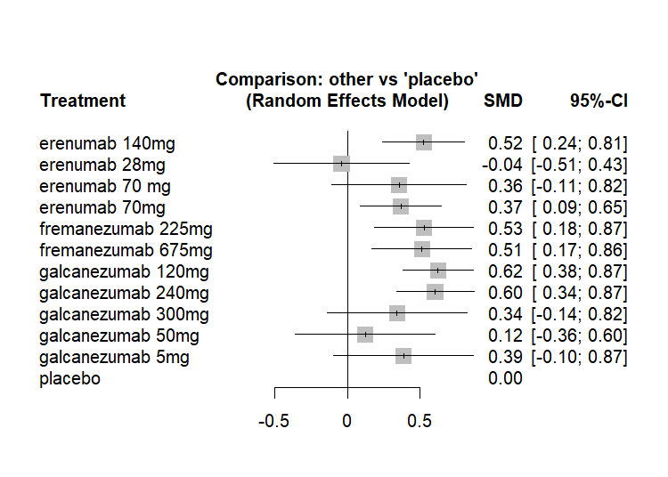
Figure 6: Forest plot of Acute Med

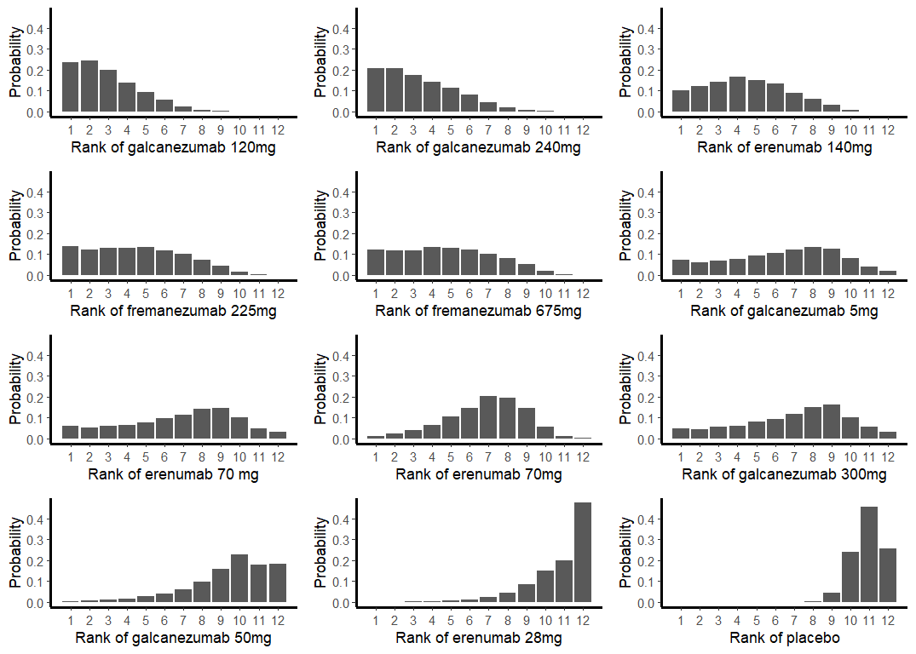
Figure 7: Forest plot of Acute Med

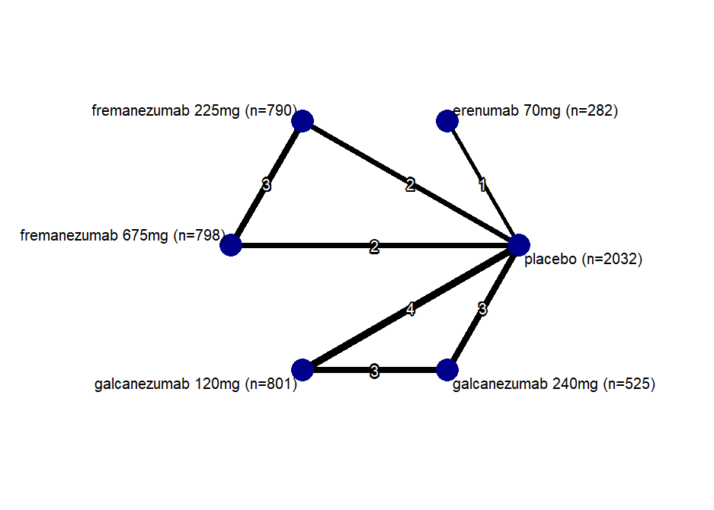
Figure 8: Network plot of MIDAS score

erenumab 70mg | . | . | . | . | 0.10 [-0.14; 0.34]
-0.52 [-0.82; -0.23] | fremanezumab 225mg | 0.07 [-0.08; 0.21] | . | . | 0.65 [ 0.46; 0.83]
-0.45 [-0.75; -0.16] | 0.07 [-0.08; 0.21] | fremanezumab 675mg | . | . | 0.53 [ 0.34; 0.72]
-0.20 [-0.47; 0.07] | 0.32 [ 0.10; 0.54] | 0.25 [ 0.04; 0.47] | galcanezumab 120mg | 0.07 [-0.09; 0.22] | 0.30 [ 0.18; 0.42]
-0.14 [-0.42; 0.13] | 0.38 [ 0.15; 0.61] | 0.31 [ 0.08; 0.54] | 0.06 [-0.09; 0.21] | galcanezumab 240mg | 0.25 [ 0.10; 0.39]
0.10 [-0.14; 0.34] | 0.62 [ 0.44; 0.80] | 0.55 [ 0.38; 0.73] | 0.30 [ 0.18; 0.42] | 0.24 [ 0.10; 0.38] | placebo

Table 6: League Table for MIDAS

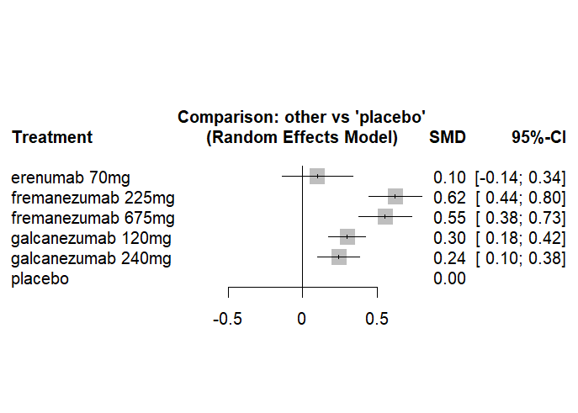
Figure 9: Forest plot of MIDAS

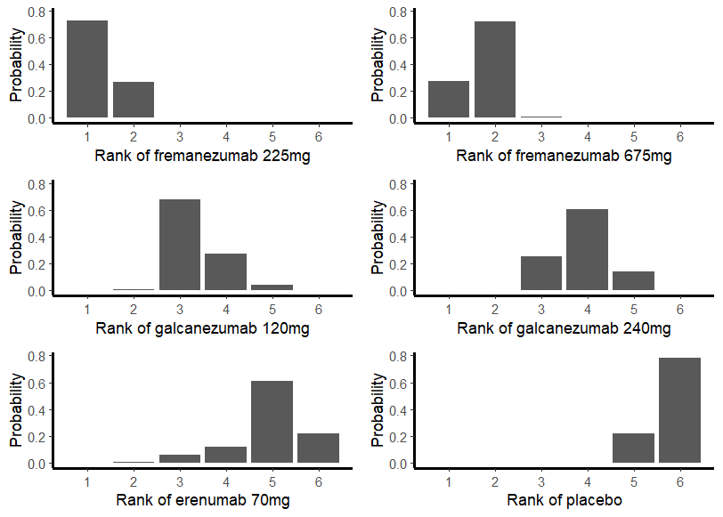
Figure 10: Rank plot of MIDAS
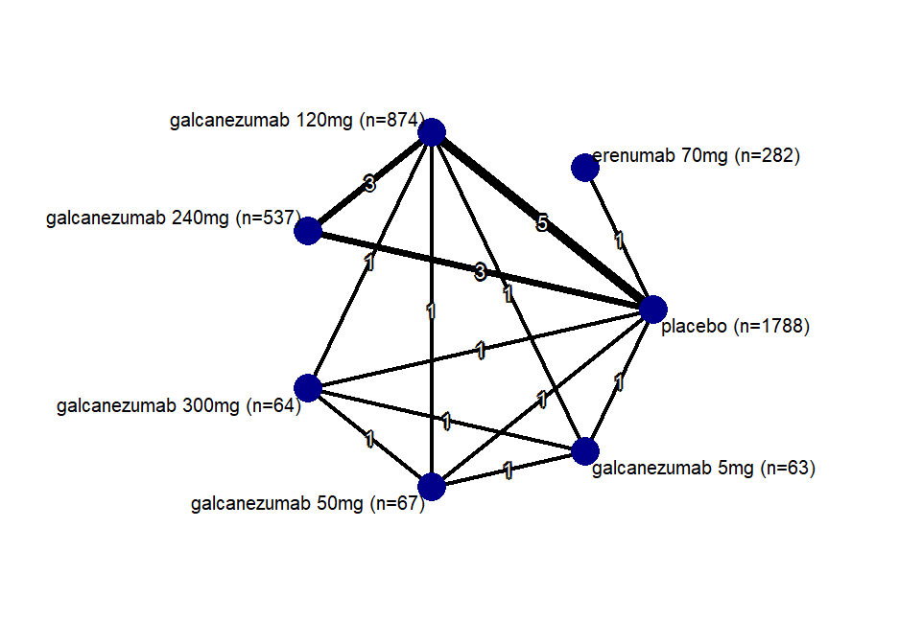
Figure 11: Network plot for MSQ

erenumab 70mg | . | . | . | . | . | -0.24 [-0.40; -0.07]
-0.69 [-0.88; -0.50] | galcanezumab 120mg | 0.06 [-0.06; 0.18] | 0.13 [-0.21; 0.48] | 0.24 [-0.11; 0.58] | 0.13 [-0.22; 0.48] | 0.45 [ 0.37; 0.54]
-0.63 [-0.82; -0.44] | 0.06 [-0.05; 0.17] | galcanezumab 240mg | . | . | . | 0.39 [ 0.29; 0.49]
-0.55 [-0.88; -0.22] | 0.14 [-0.15; 0.43] | 0.08 [-0.22; 0.38] | galcanezumab 300mg | 0.10 [-0.24; 0.45] | -0.00 [-0.35; 0.35] | 0.31 [ 0.01; 0.61]
-0.45 [-0.77; -0.12] | 0.24 [-0.04; 0.53] | 0.18 [-0.11; 0.48] | 0.10 [-0.24; 0.45] | galcanezumab 50mg | -0.11 [-0.45; 0.24] | 0.21 [-0.09; 0.50]
-0.55 [-0.88; -0.22] | 0.14 [-0.15; 0.43] | 0.07 [-0.23; 0.38] | -0.00 [-0.35; 0.35] | -0.11 [-0.45; 0.24] | galcanezumab 5mg | 0.32 [ 0.01; 0.62]
-0.24 [-0.40; -0.07] | 0.45 [ 0.37; 0.54] | 0.39 [ 0.29; 0.49] | 0.32 [ 0.03; 0.60] | 0.21 [-0.07; 0.49] | 0.32 [ 0.03; 0.60] | placebo

Table 7: League Table for MSQ
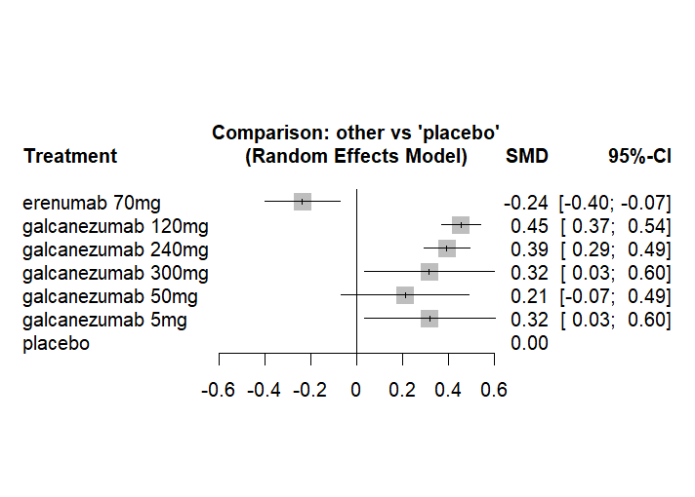
Figure 12: Forest plot for MSQ

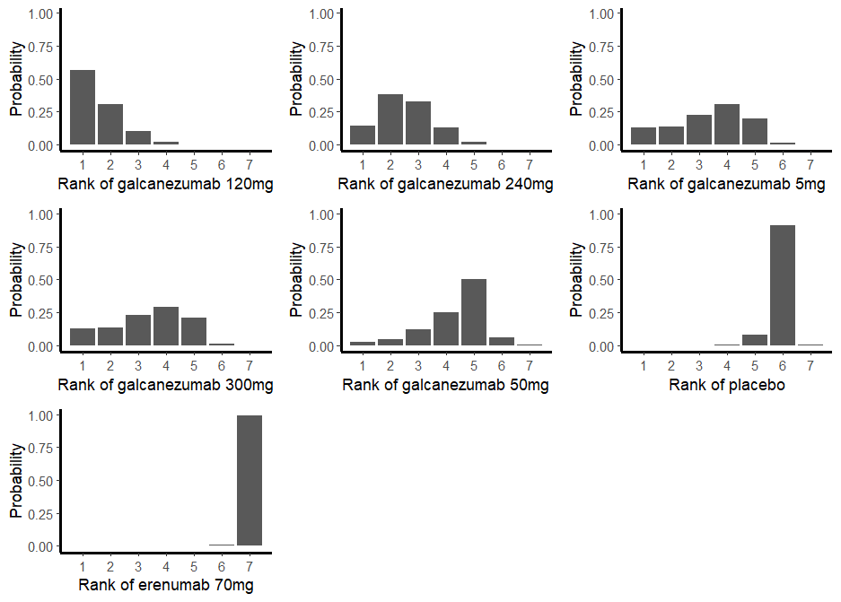
Figure 13: Rank plot for MSQ

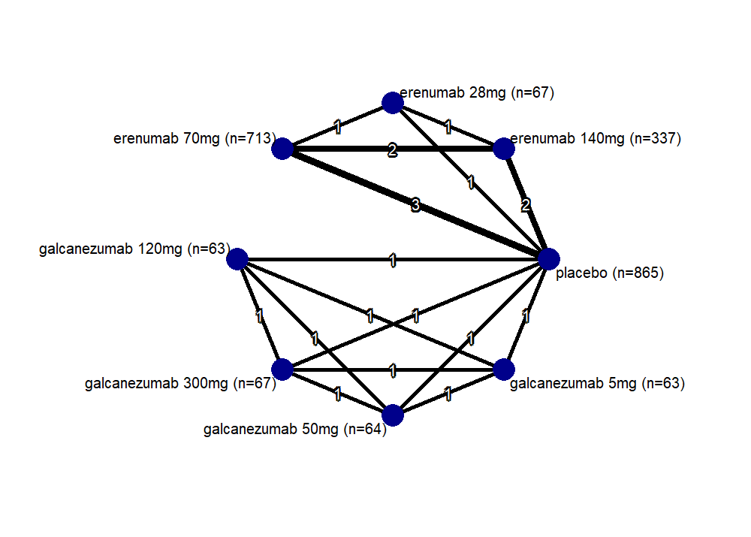
Figure 14: Network for HIT 6

erenumab 140mg | 0.32 [ 0.02; 0.61] | 0.07 [-0.07; 0.21] | . | . | . | . | 0.36 [ 0.22; 0.50]
0.34 [ 0.07; 0.61] | erenumab 28mg | -0.34 [-0.63; -0.04] | . | . | . | . | 0.06 [-0.24; 0.35]
0.06 [-0.07; 0.20] | -0.28 [-0.55; -0.01] | erenumab 70mg | . | . | . | . | 0.30 [ 0.20; 0.41]
0.18 [-0.15; 0.50] | -0.17 [-0.57; 0.24] | 0.11 [-0.20; 0.43] | galcanezumab 120mg | 0.11 [-0.24; 0.45] | 0.12 [-0.23; 0.47] | 0.05 [-0.30; 0.40] | 0.19 [-0.11; 0.49]
0.28 [-0.04; 0.61] | -0.06 [-0.46; 0.34] | 0.22 [-0.09; 0.53] | 0.11 [-0.24; 0.45] | galcanezumab 300mg | 0.01 [-0.33; 0.36] | -0.06 [-0.40; 0.29] | 0.09 [-0.21; 0.38]
0.29 [-0.03; 0.62] | -0.05 [-0.45; 0.35] | 0.23 [-0.08; 0.55] | 0.12 [-0.23; 0.47] | 0.01 [-0.33; 0.36] | galcanezumab 50mg | -0.07 [-0.42; 0.28] | 0.07 [-0.23; 0.37]
0.22 [-0.11; 0.55] | -0.12 [-0.52; 0.28] | 0.16 [-0.16; 0.48] | 0.05 [-0.30; 0.40] | -0.06 [-0.40; 0.29] | -0.07 [-0.42; 0.28] | galcanezumab 5mg | 0.14 [-0.16; 0.44]
0.37 [ 0.23; 0.50] | 0.03 [-0.24; 0.29] | 0.30 [ 0.20; 0.41] | 0.19 [-0.11; 0.49] | 0.09 [-0.21; 0.38] | 0.07 [-0.23; 0.37] | 0.14 [-0.16; 0.44] | placebo

Table 8: League Table for HIT-6
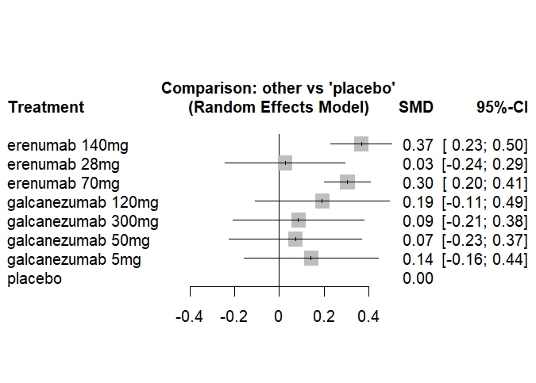
Figure 15: Forest plot for HIT-6 Scores

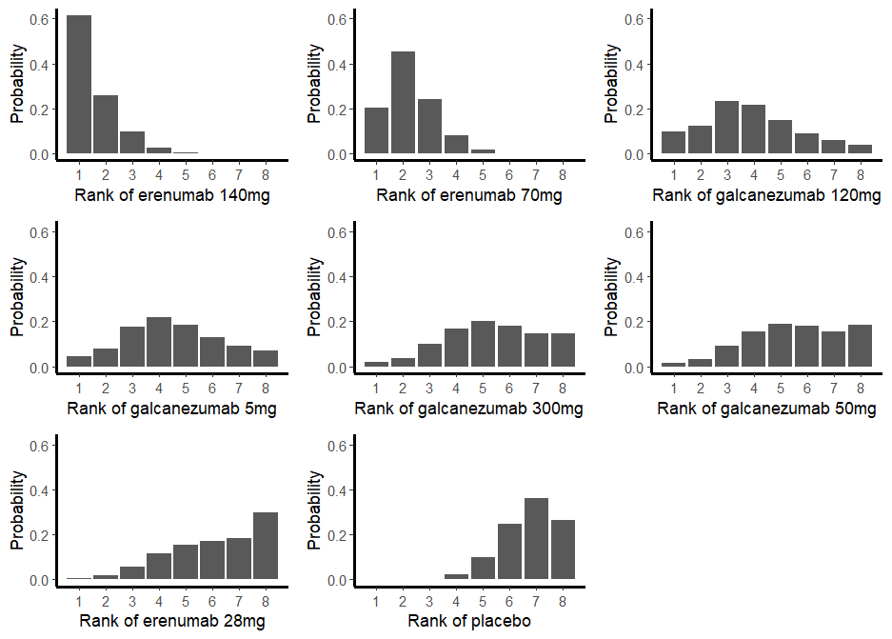
Figure 16: Rank plot for HIT-6 Scores
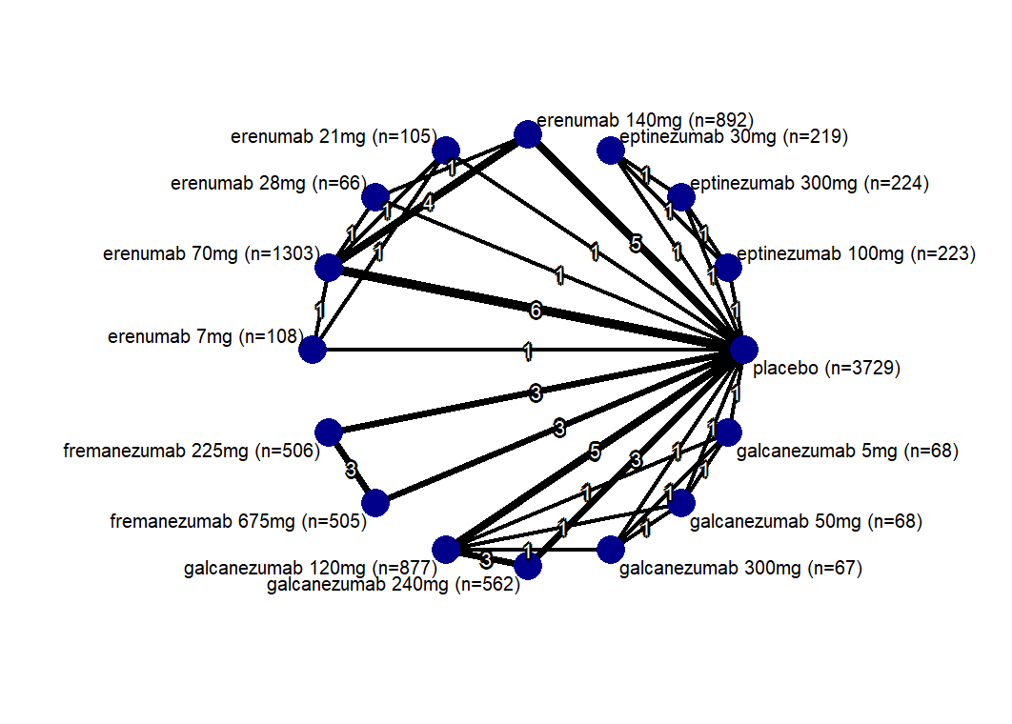
Figure 17: Network plot for Adverse Events

eptinezumab 100mg | -0.13 [-0.43; 0.17] | -0.03 [-0.33; 0.27] | . | . | . | . | . | . | . | . | . | . | . | . | 0.23 [-0.07; 0.53]
-0.13 [-0.43; 0.17] | eptinezumab 300mg | 0.10 [-0.20; 0.40] | . | . | . | . | . | . | . | . | . | . | . | . | 0.36 [ 0.06; 0.66]
-0.03 [-0.33; 0.27] | 0.10 [-0.20; 0.40] | eptinezumab 30mg | . | . | . | . | . | . | . | . | . | . | . | . | 0.26 [-0.03; 0.56]
-0.22 [-0.55; 0.12] | -0.08 [-0.42; 0.25] | -0.18 [-0.52; 0.15] | erenumab 140mg | . | 0.21 [-0.17; 0.58] | 0.06 [-0.11; 0.24] | . | . | . | . | . | . | . | . | 0.46 [ 0.31; 0.62]
0.16 [-0.27; 0.59] | 0.29 [-0.14; 0.72] | 0.19 [-0.24; 0.62] | 0.37 [ 0.04; 0.71] | erenumab 21mg | . | -0.20 [-0.56; 0.16] | 0.17 [-0.19; 0.53] | . | . | . | . | . | . | . | -0.01 [-0.35; 0.33]
0.02 [-0.43; 0.46] | 0.15 [-0.30; 0.60] | 0.05 [-0.39; 0.50] | 0.23 [-0.10; 0.57] | -0.14 [-0.59; 0.31] | erenumab 28mg | -0.34 [-0.72; 0.03] | . | . | . | . | . | . | . | . | 0.37 [-0.01; 0.74]
-0.14 [-0.47; 0.18] | -0.01 [-0.34; 0.32] | -0.11 [-0.44; 0.22] | 0.07 [-0.09; 0.23] | -0.30 [-0.62; 0.01] | -0.16 [-0.49; 0.17] | erenumab 70mg | 0.37 [ 0.01; 0.73] | . | . | . | . | . | . | . | 0.38 [ 0.25; 0.52]
0.33 [-0.10; 0.76] | 0.46 [ 0.03; 0.89] | 0.36 [-0.07; 0.79] | 0.54 [ 0.21; 0.88] | 0.17 [-0.19; 0.53] | 0.31 [-0.14; 0.75] | 0.47 [ 0.16; 0.78] | erenumab 7mg | . | . | . | . | . | . | . | -0.18 [-0.52; 0.16]
-0.27 [-0.62; 0.09] | -0.14 [-0.49; 0.22] | -0.23 [-0.59; 0.12] | -0.05 [-0.29; 0.19] | -0.43 [-0.79; -0.06] | -0.29 [-0.67; 0.10] | -0.12 [-0.35; 0.11] | -0.60 [-0.96; -0.23] | fremanezumab 225mg | 0.04 [-0.15; 0.23] | . | . | . | . | . | 0.50 [ 0.31; 0.69]
-0.23 [-0.58; 0.13] | -0.10 [-0.45; 0.26] | -0.19 [-0.55; 0.16] | -0.01 [-0.25; 0.23] | -0.39 [-0.75; -0.02] | -0.25 [-0.63; 0.14] | -0.08 [-0.31; 0.15] | -0.55 [-0.92; -0.19] | 0.04 [-0.15; 0.23] | fremanezumab 675mg | . | . | . | . | . | 0.46 [ 0.27; 0.65]
-0.27 [-0.60; 0.06] | -0.14 [-0.47; 0.19] | -0.24 [-0.57; 0.09] | -0.05 [-0.26; 0.15] | -0.43 [-0.77; -0.09] | -0.29 [-0.65; 0.07] | -0.13 [-0.32; 0.06] | -0.60 [-0.94; -0.26] | -0.00 [-0.24; 0.23] | -0.04 [-0.28; 0.19] | galcanezumab 120mg | 0.03 [-0.15; 0.21] | 0.19 [-0.22; 0.60] | 0.24 [-0.16; 0.65] | 0.21 [-0.20; 0.61] | 0.50 [ 0.36; 0.64]
-0.27 [-0.61; 0.07] | -0.14 [-0.48; 0.20] | -0.24 [-0.58; 0.10] | -0.05 [-0.28; 0.17] | -0.43 [-0.78; -0.07] | -0.29 [-0.66; 0.08] | -0.13 [-0.34; 0.09] | -0.60 [-0.95; -0.25] | -0.00 [-0.25; 0.25] | -0.04 [-0.29; 0.21] | -0.00 [-0.17; 0.17] | galcanezumab 240mg | . | . | . | 0.53 [ 0.35; 0.70]
0.07 [-0.39; 0.53] | 0.20 [-0.25; 0.66] | 0.10 [-0.35; 0.56] | 0.29 [-0.09; 0.66] | -0.09 [-0.56; 0.38] | 0.05 [-0.43; 0.53] | 0.21 [-0.16; 0.59] | -0.26 [-0.72; 0.21] | 0.34 [-0.06; 0.73] | 0.30 [-0.10; 0.69] | 0.34 [-0.01; 0.69] | 0.34 [-0.03; 0.72] | galcanezumab 300mg | 0.05 [-0.36; 0.46] | 0.01 [-0.40; 0.42] | 0.06 [-0.31; 0.43]
0.12 [-0.33; 0.58] | 0.25 [-0.20; 0.71] | 0.16 [-0.30; 0.61] | 0.34 [-0.04; 0.71] | -0.04 [-0.50; 0.43] | 0.10 [-0.37; 0.58] | 0.27 [-0.10; 0.64] | -0.20 [-0.67; 0.26] | 0.39 [ 0.00; 0.78] | 0.35 [-0.04; 0.74] | 0.39 [ 0.04; 0.74] | 0.39 [ 0.02; 0.77] | 0.05 [-0.36; 0.46] | galcanezumab 50mg | -0.04 [-0.45; 0.37] | 0.01 [-0.36; 0.38]
0.08 [-0.37; 0.54] | 0.22 [-0.24; 0.67] | 0.12 [-0.34; 0.57] | 0.30 [-0.08; 0.68] | -0.07 [-0.54; 0.39] | 0.07 [-0.41; 0.55] | 0.23 [-0.14; 0.60] | -0.24 [-0.71; 0.22] | 0.35 [-0.04; 0.75] | 0.31 [-0.08; 0.71] | 0.35 [ 0.00; 0.71] | 0.35 [-0.02; 0.73] | 0.01 [-0.40; 0.42] | -0.04 [-0.45; 0.37] | galcanezumab 5mg | 0.05 [-0.33; 0.42]
0.23 [-0.07; 0.53] | 0.36 [ 0.06; 0.66] | 0.26 [-0.03; 0.56] | 0.45 [ 0.30; 0.60] | 0.07 [-0.24; 0.39] | 0.21 [-0.12; 0.54] | 0.37 [ 0.24; 0.51] | -0.10 [-0.41; 0.21] | 0.50 [ 0.31; 0.69] | 0.46 [ 0.27; 0.65] | 0.50 [ 0.36; 0.64] | 0.50 [ 0.34; 0.67] | 0.16 [-0.19; 0.51] | 0.11 [-0.24; 0.45] | 0.15 [-0.20; 0.49] | placebo

Table 9: League Table for AEs
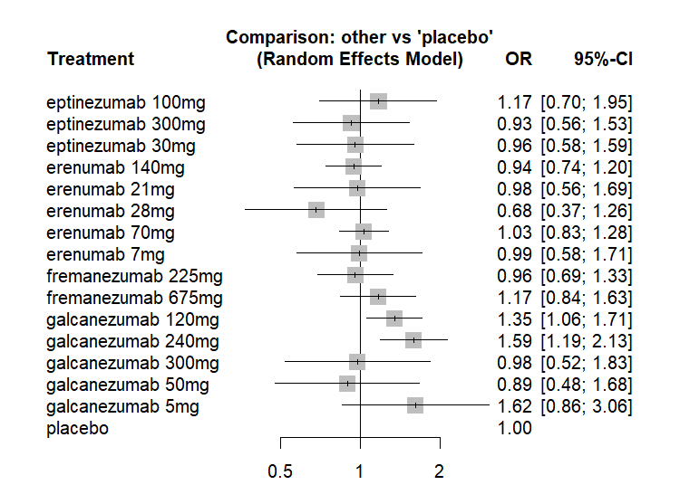
Figure 18: Forest plot for Adverse Events
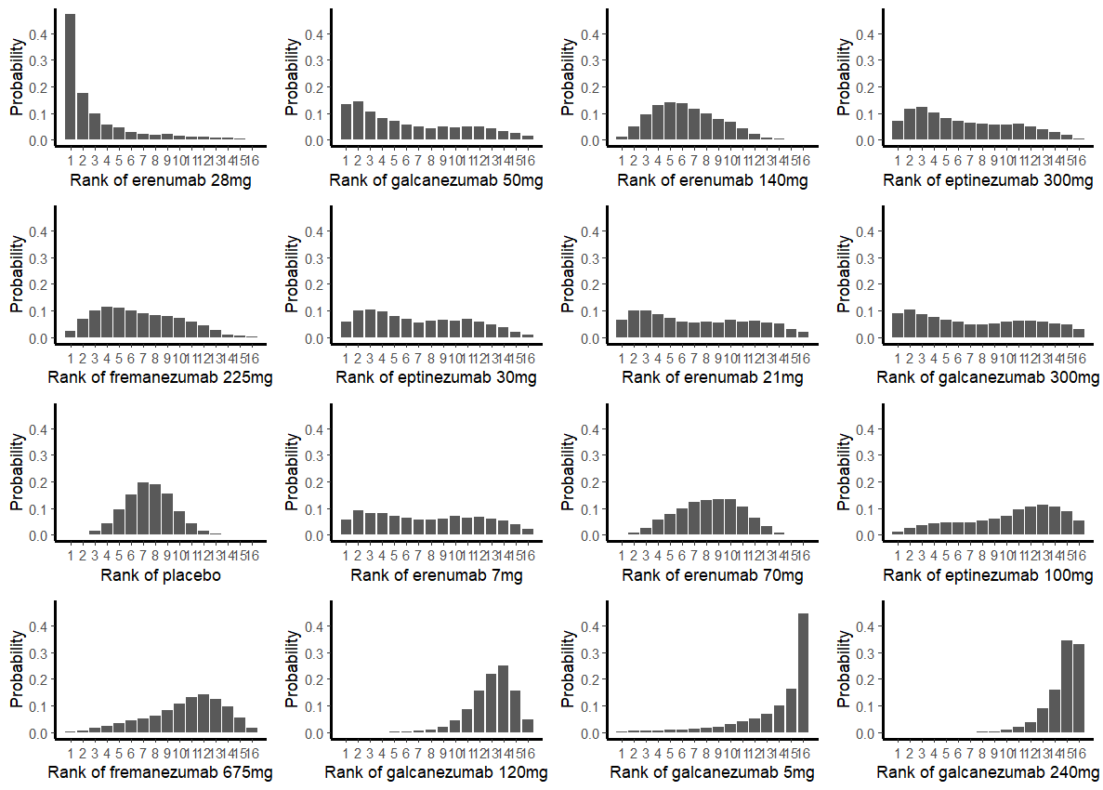
Figure 19: Rank plot for Adverse Events

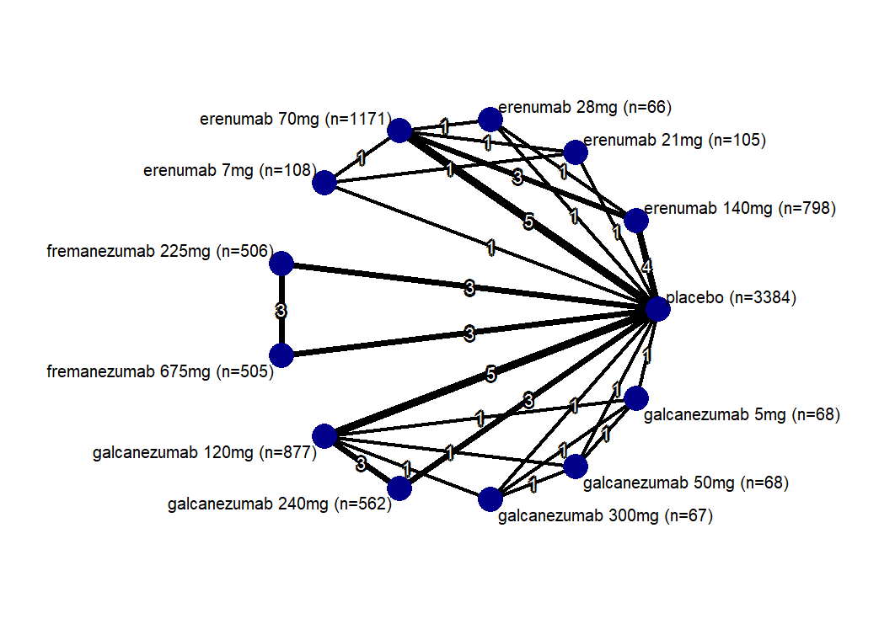
Figure 20: Network plot for Serious Adverse Events

erenumab 140mg | . | 0.48 [0.03; 7.76] | 0.67 [0.26; 1.72] | . | . | . | . | . | . | . | . | 0.72 [0.30; 1.73]
1.77 [0.08; 39.60] | erenumab 21mg | . | 0.33 [0.01; 8.28] | 0.34 [0.01; 8.43] | . | . | . | . | . | . | . | 0.48 [0.02; 11.94]
0.91 [0.10; 8.50] | 0.51 [0.01; 20.50] | erenumab 28mg | 2.06 [0.13; 33.48] | . | . | . | . | . | . | . | . | 0.51 [0.06; 4.63]
0.73 [0.31; 1.76] | 0.41 [0.02; 8.48] | 0.81 [0.09; 7.27] | erenumab 70mg | 1.02 [0.10; 9.95] | . | . | . | . | . | . | . | 0.92 [0.47; 1.80]
0.60 [0.07; 5.05] | 0.34 [0.01; 8.43] | 0.66 [0.04; 12.24] | 0.82 [0.11; 6.08] | erenumab 7mg | . | . | . | . | . | . | . | 1.42 [0.15; 13.82]
1.13 [0.27; 4.64] | 0.63 [0.03; 16.00] | 1.24 [0.11; 14.05] | 1.54 [0.41; 5.74] | 1.87 [0.19; 18.66] | fremanezumab 225mg | 1.00 [0.32; 3.14] | . | . | . | . | . | 0.68 [0.21; 2.22]
1.13 [0.27; 4.66] | 0.64 [0.03; 16.07] | 1.24 [0.11; 14.11] | 1.54 [0.41; 5.76] | 1.87 [0.19; 18.73] | 1.00 [0.32; 3.14] | fremanezumab 675mg | . | . | . | . | . | 0.68 [0.21; 2.22]
0.38 [0.12; 1.18] | 0.21 [0.01; 4.80] | 0.42 [0.04; 4.05] | 0.52 [0.19; 1.42] | 0.63 [0.07; 5.34] | 0.34 [0.09; 1.32] | 0.33 [0.08; 1.32] | galcanezumab 120mg | 1.20 [0.51; 2.83] | 0.31 [0.01; 7.85] | 0.97 [0.02; 49.66] | 0.32 [0.01; 7.97] | 1.76 [0.81; 3.82]
0.39 [0.11; 1.29] | 0.22 [0.01; 5.04] | 0.42 [0.04; 4.30] | 0.53 [0.18; 1.57] | 0.64 [0.07; 5.67] | 0.34 [0.08; 1.44] | 0.34 [0.08; 1.43] | 1.02 [0.44; 2.34] | galcanezumab 240mg | . | . | . | 2.25 [0.90; 5.63]
0.11 [0.01; 1.73] | 0.06 [0.00; 3.43] | 0.13 [0.00; 3.61] | 0.16 [0.01; 2.24] | 0.19 [0.01; 4.97] | 0.10 [0.01; 1.70] | 0.10 [0.01; 1.70] | 0.30 [0.02; 3.99] | 0.30 [0.02; 4.25] | galcanezumab 300mg | 3.09 [0.12; 77.21] | 1.02 [0.10; 10.01] | 6.20 [0.25; 154.32]
0.36 [0.01; 12.11] | 0.20 [0.00; 19.30] | 0.39 [0.01; 22.30] | 0.48 [0.01; 15.90] | 0.59 [0.01; 31.19] | 0.32 [0.01; 11.68] | 0.31 [0.01; 11.64] | 0.94 [0.03; 28.97] | 0.92 [0.03; 30.19] | 3.09 [0.12; 77.21] | galcanezumab 50mg | 0.33 [0.01; 8.21] | 2.01 [0.04; 102.25]
0.12 [0.01; 1.75] | 0.07 [0.00; 3.48] | 0.13 [0.00; 3.66] | 0.16 [0.01; 2.27] | 0.19 [0.01; 5.04] | 0.10 [0.01; 1.73] | 0.10 [0.01; 1.72] | 0.31 [0.02; 4.05] | 0.30 [0.02; 4.31] | 1.02 [0.10; 10.01] | 0.33 [0.01; 8.21] | galcanezumab 5mg | 6.11 [0.25; 152.01]
0.69 [0.30; 1.60] | 0.39 [0.02; 7.98] | 0.76 [0.09; 6.49] | 0.94 [0.48; 1.83] | 1.15 [0.15; 8.47] | 0.61 [0.20; 1.91] | 0.61 [0.20; 1.91] | 1.83 [0.85; 3.93] | 1.79 [0.75; 4.27] | 6.01 [0.46; 78.80] | 1.94 [0.06; 59.85] | 5.92 [0.45; 77.62] | placebo

Table 10: League Table for SAEs
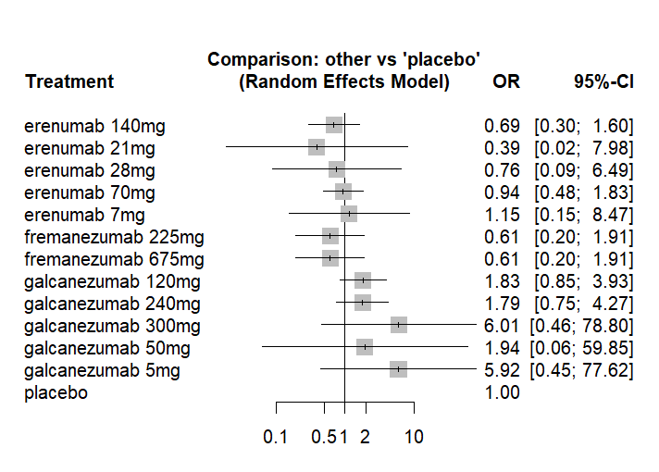
Figure 21: Forest plot for Serious Adverse Events

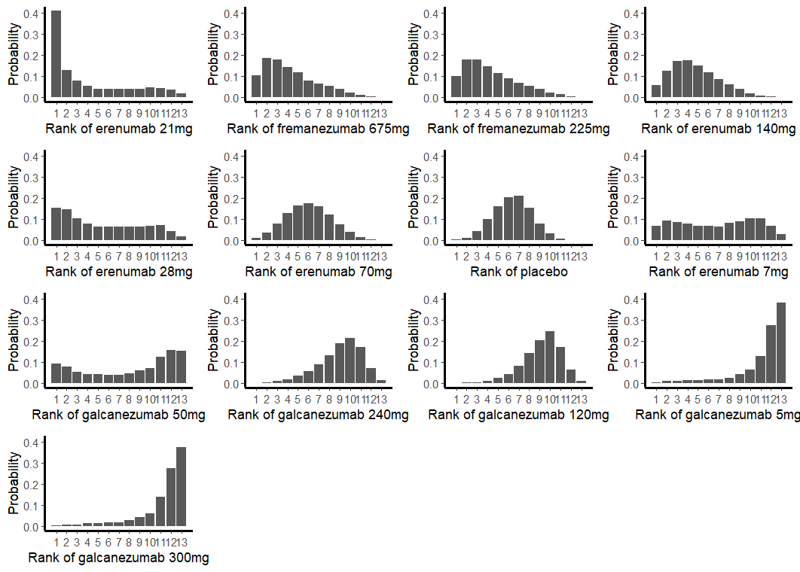
Figure 22: Rank plot for SAEs
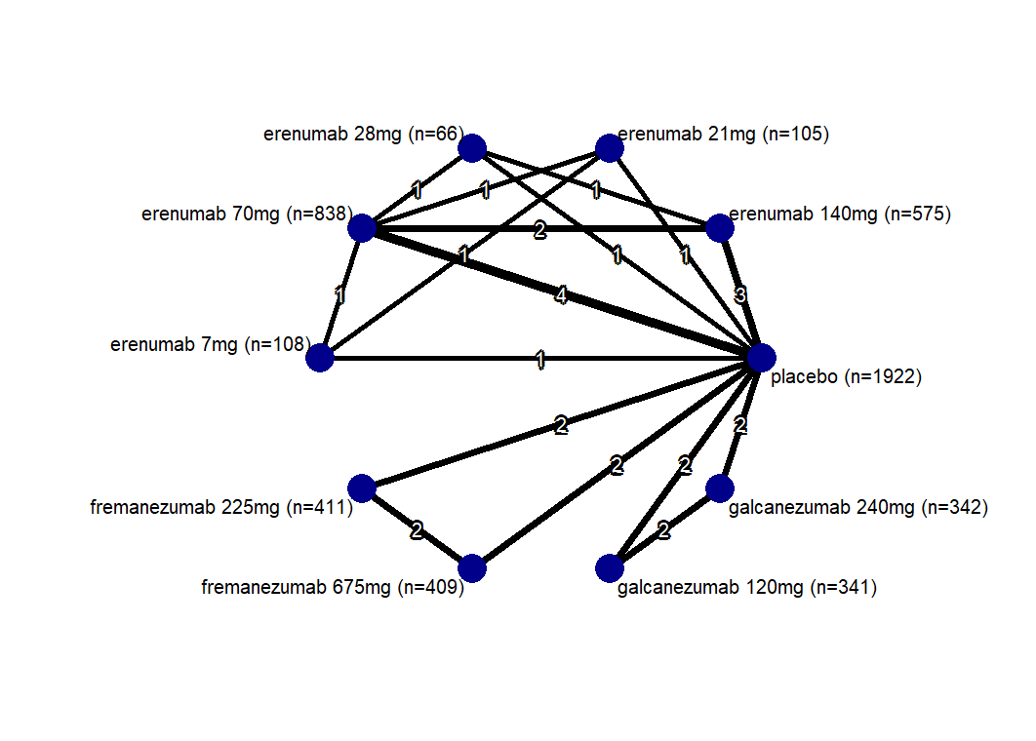
Figure 23: Network plot for DC AE

erenumab 140mg | . | 0.48 [0.01; 25.38] | 0.62 [0.21; 1.86] | . | . | . | . | . | 0.70 [0.24; 2.03]
0.67 [0.10; 4.74] | erenumab 21mg | . | 0.67 [0.10; 4.34] | 1.03 [0.13; 7.89] | . | . | . | . | 1.47 [0.19; 11.20]
1.11 [0.05; 24.19] | 1.66 [0.05; 50.68] | erenumab 28mg | 0.40 [0.02; 8.81] | . | . | . | . | . | 0.68 [0.03; 17.52]
0.50 [0.18; 1.41] | 0.75 [0.13; 4.26] | 0.45 [0.02; 8.89] | erenumab 70mg | 1.54 [0.24; 10.04] | . | . | . | . | 1.71 [0.75; 3.87]
0.69 [0.10; 4.88] | 1.03 [0.13; 7.89] | 0.62 [0.02; 19.02] | 1.38 [0.24; 7.86] | erenumab 7mg | . | . | . | . | 1.42 [0.19; 10.88]
0.84 [0.18; 3.94] | 1.25 [0.15; 10.39] | 0.75 [0.03; 18.85] | 1.67 [0.41; 6.88] | 1.21 [0.15; 10.10] | fremanezumab 225mg | 1.17 [0.34; 4.05] | . | . | 1.00 [0.31; 3.19]
0.96 [0.19; 4.77] | 1.43 [0.17; 12.40] | 0.86 [0.03; 22.21] | 1.92 [0.44; 8.37] | 1.39 [0.16; 12.05] | 1.15 [0.34; 3.93] | fremanezumab 675mg | . | . | 0.86 [0.25; 2.95]
0.61 [0.14; 2.70] | 0.90 [0.11; 7.24] | 0.55 [0.02; 13.31] | 1.21 [0.31; 4.69] | 0.88 [0.11; 7.03] | 0.73 [0.15; 3.55] | 0.63 [0.12; 3.25] | galcanezumab 120mg | 0.92 [0.35; 2.41] | 1.20 [0.39; 3.73]
0.61 [0.14; 2.55] | 0.90 [0.12; 6.93] | 0.54 [0.02; 12.92] | 1.21 [0.33; 4.39] | 0.87 [0.11; 6.73] | 0.72 [0.16; 3.36] | 0.63 [0.13; 3.08] | 1.00 [0.38; 2.60] | galcanezumab 240mg | 1.63 [0.59; 4.53]
0.84 [0.30; 2.33] | 1.25 [0.21; 7.35] | 0.75 [0.04; 15.17] | 1.67 [0.74; 3.75] | 1.21 [0.21; 7.14] | 1.00 [0.31; 3.19] | 0.87 [0.25; 2.98] | 1.38 [0.47; 4.08] | 1.38 [0.51; 3.79] | placebo

Table 11: League Table for DC

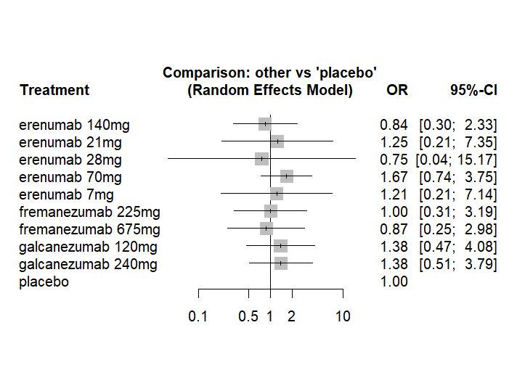
Figure 24: Forest plot for DC AE
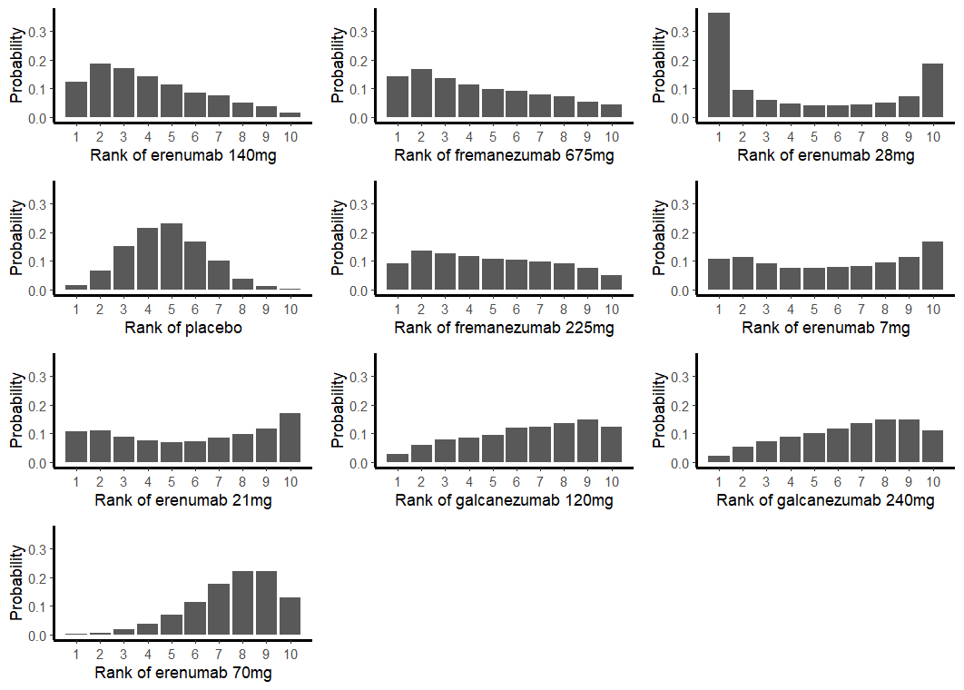
Figure 25: Rank plot for DC AE

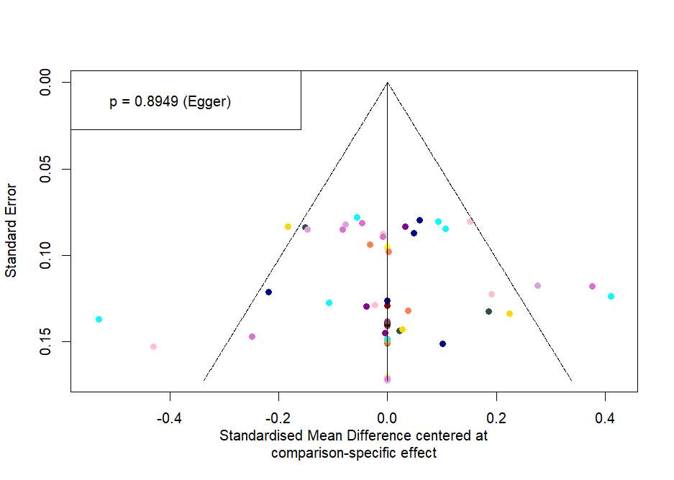
Figure 26: Funnel plot

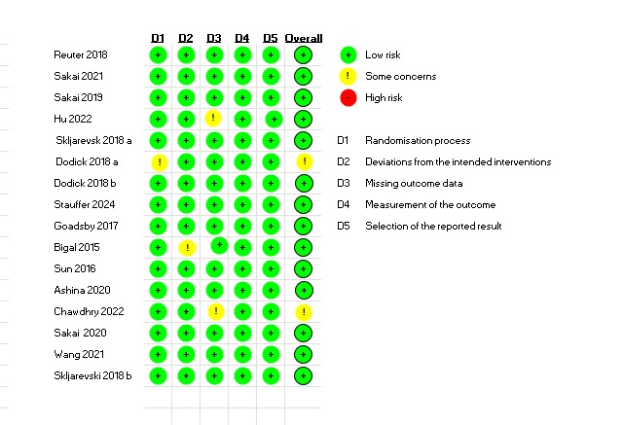
Figure 27: Traffic plot for risk of bias

