Supplemental Figures and Tables

Table S1. Protein compositions of reassembly mixtures for the MS2nc@ApoF, MS2nc@Tg, and MS2nc@DHNA samples presented in the main text.
Cargo Protein | MS2 monomer: cargo monomer ratio* | MS2 cage: cargo ratio** | MS2 monomer final conc. (µM) | Cargo monomer final conc. (µM)
ApoF (24-mer) | 25:1 | 3.33:1 | 125 | 5
Tg (2-mer) | 75:1 | 0.83:1 | 125 | 1.67
DHNA (8-mer) | 12.5:1 | 0.56:1 | 125 | 10
* Ratio of MS2 coat protein monomer to cargo protein monomer
** Ratio of an assembled MS2 cage (180 CPs) to cargo in its quaternary state

Table S2. Example reassembly mixture.
Solution Component | Stock concentration | Final concentration | Volume added (µL)
MS2 solution (disassembled) | 162 µM | 125 µM | 463.0
Apoferritin monomer | 123 µM | 5 µM | 24.4
TMK buffer | 10x | 1x | 60.0
Water | – | – | 52.6
 |  | Total volume | 600 µL
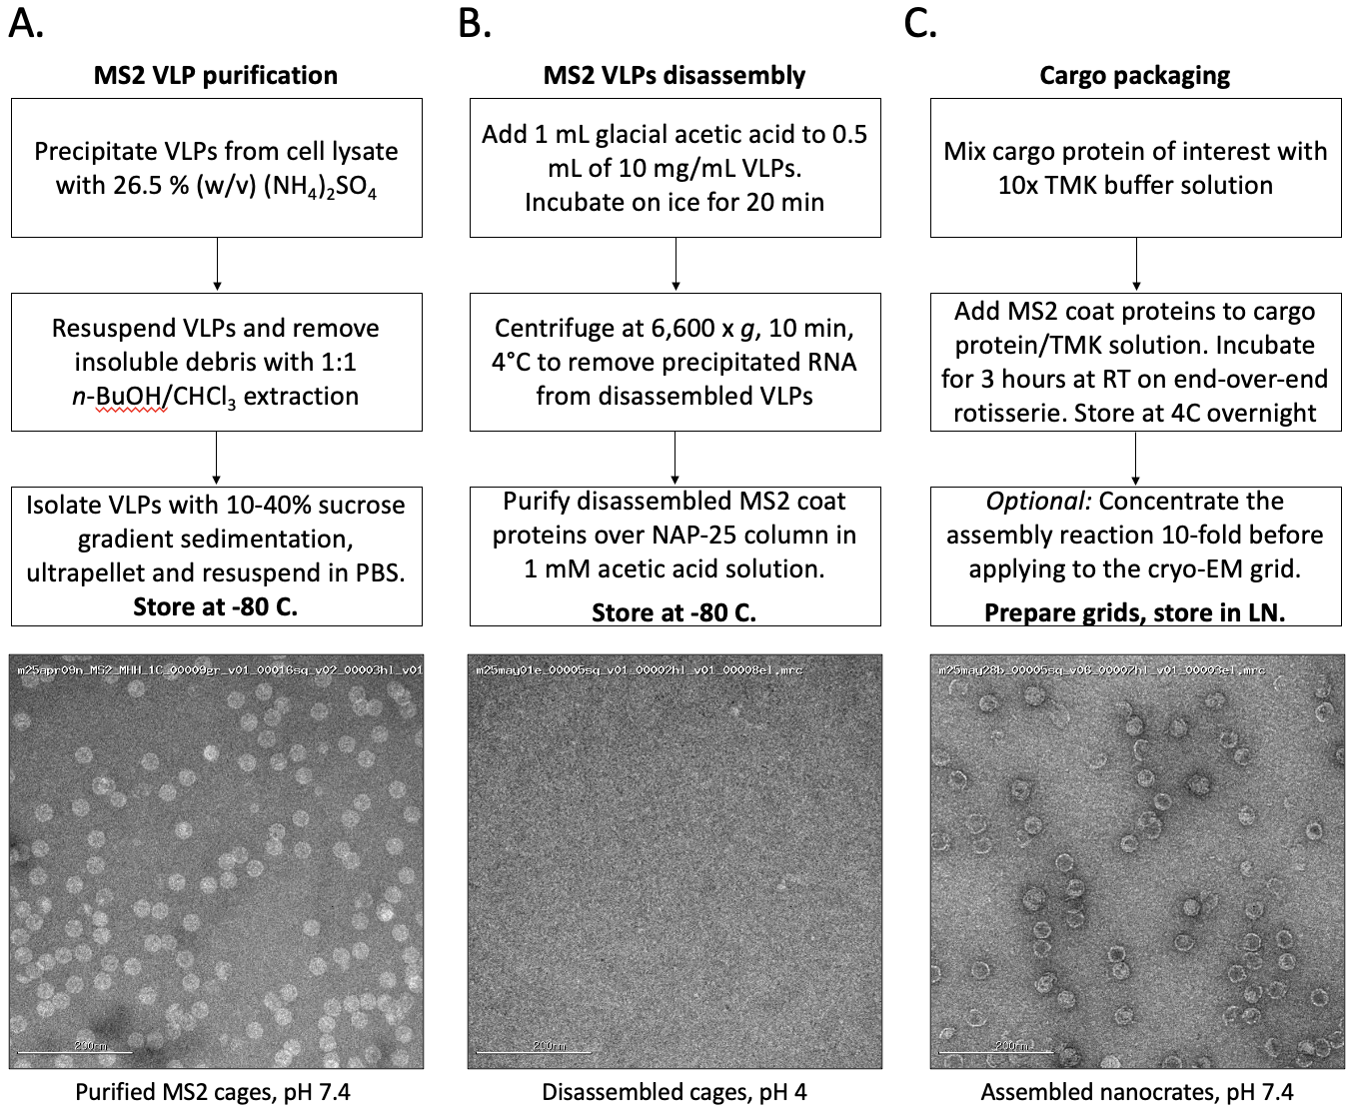
Figure S1. MS2 purification, disassembly and cargo packaging workflow.
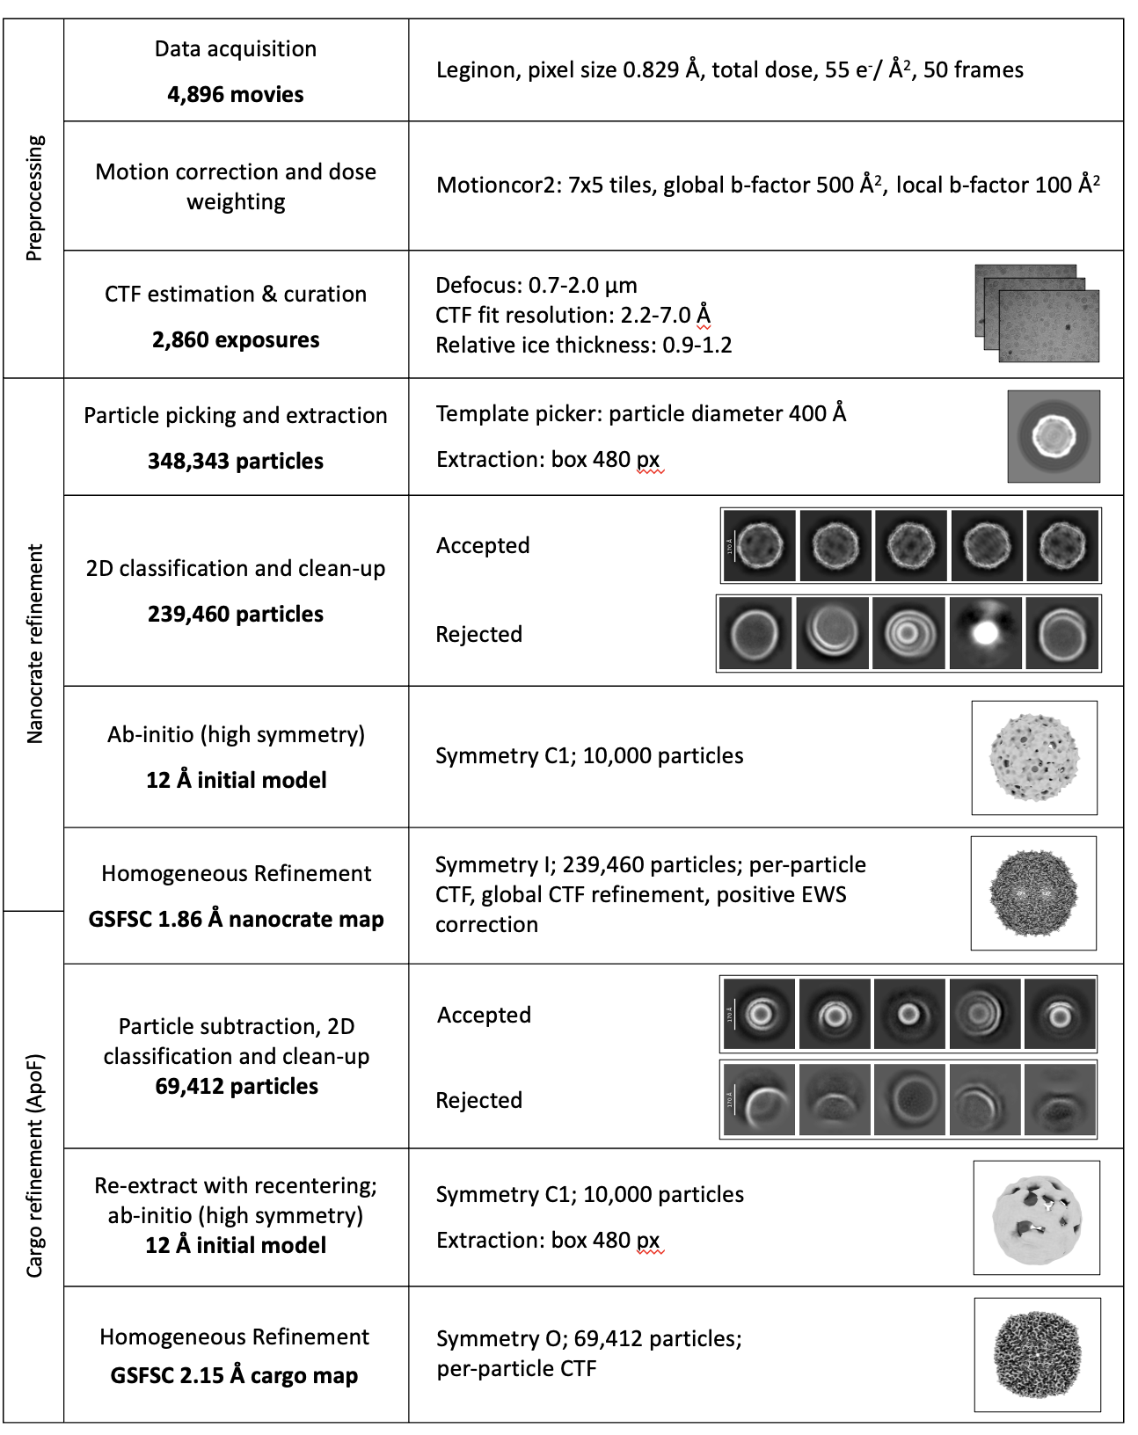

Figure S2. Caged particle reconstruction processing workflow.

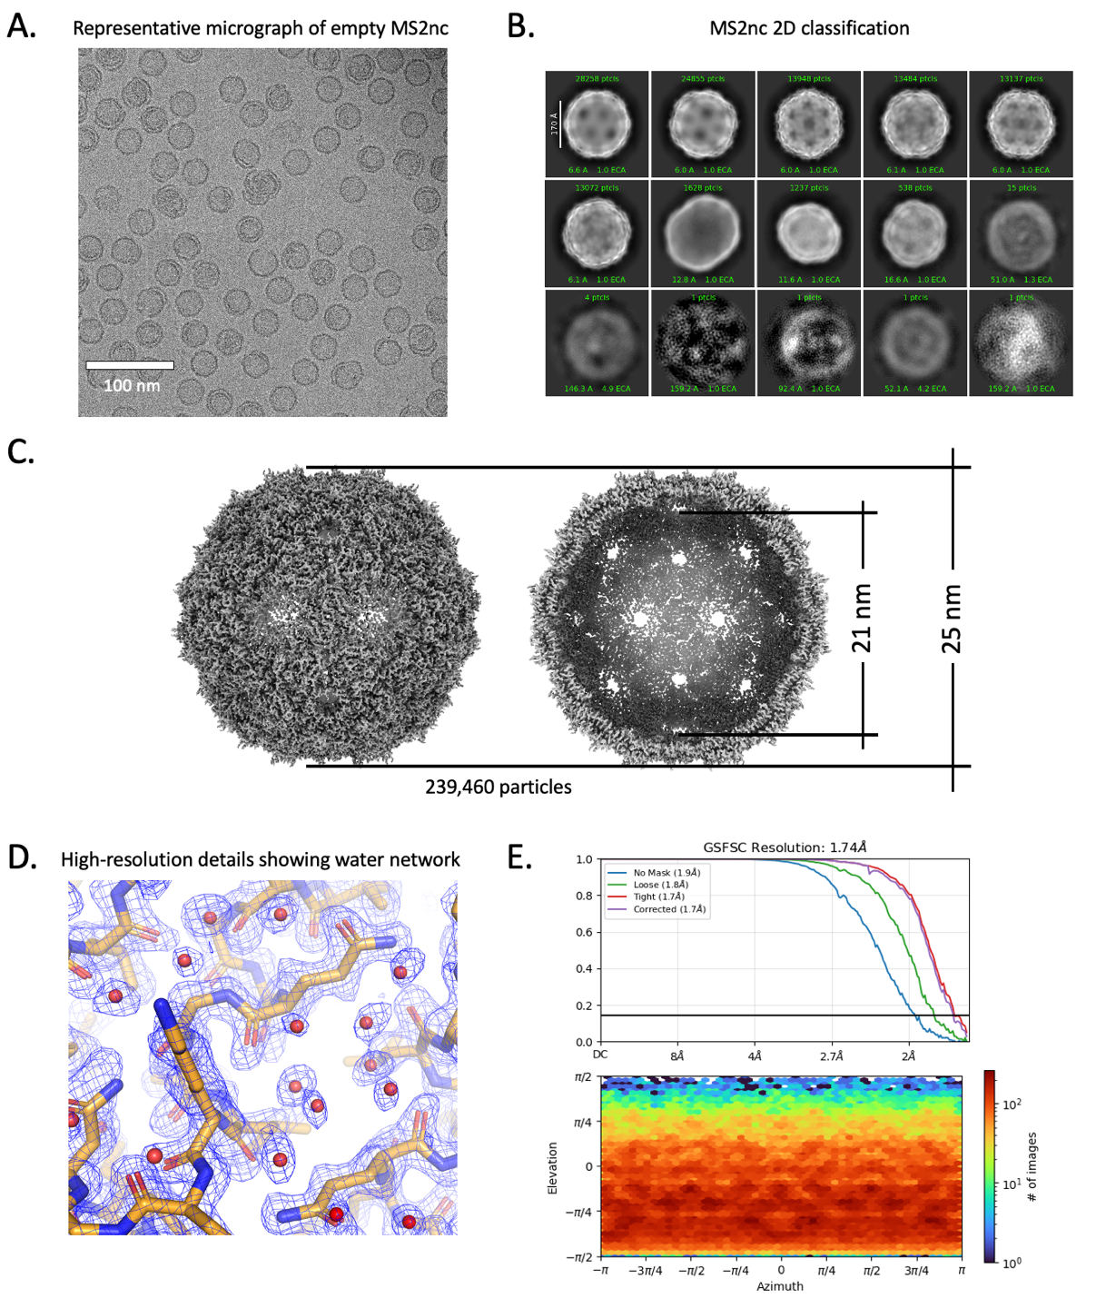
Figure S3. Empty MS2-nanocrate processing details. A. Representative micrograph of empty MS2-nanocrates. B. 2D classification of MS2nc without particle subtraction. C. refined map with I symmetry, MS2 nanocrate outer diameter = 25 nm, inner diameter = 21 nm, opening diameter of a 5-fold or 6-vertex pores = ~1.5 nm. D. Detailed view of a selected area of the MS-nanocrate map (shown as blue mesh), showing high-resolution resolvability of sidechains and coordinated water. Modeled protein is displayed in stick representation with carbon in tan, oxygen in red, and nitrogen in blue. Waters are depicted as red spheres. E. GSFSC plot showing 1.74 Å resolution and viewing direction distribution plot, showing isotropic orientation distribution.
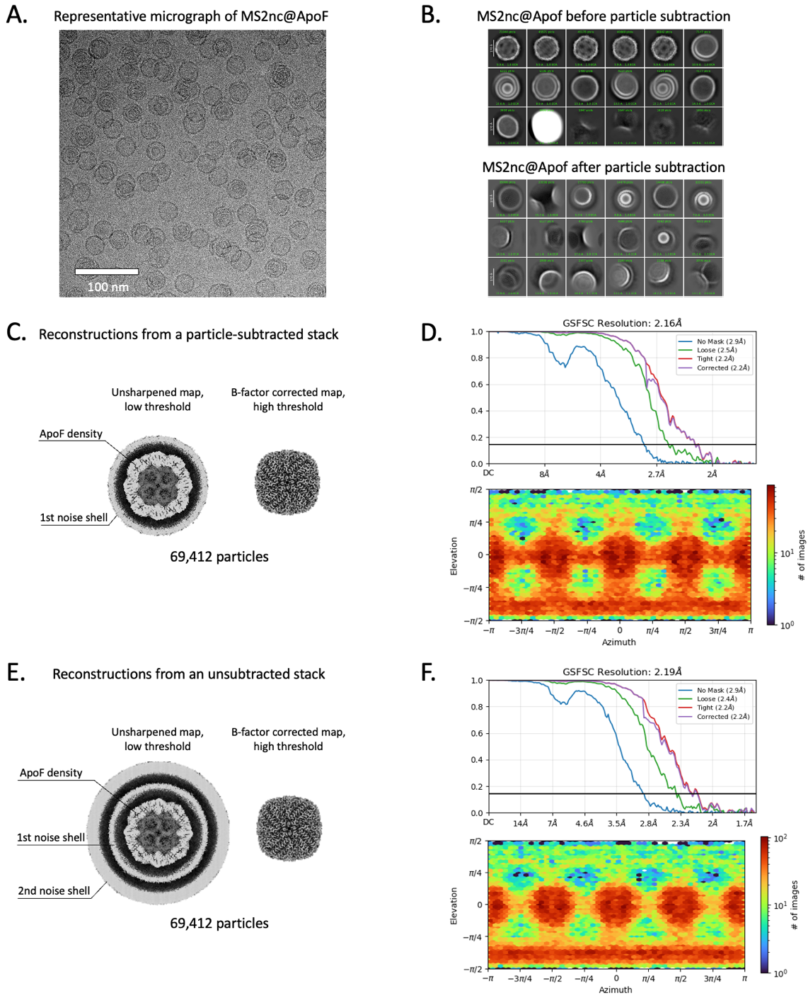
Figure S4. MS2nc@ApoF processing details. A. Representative micrograph. B. 2D classification before (top) and after nanocrate density subtraction. C. Refined map with O symmetry. D. GSFSC plot showing 2.16 Å resolution and viewing direction distribution plot, showing isotropic orientation distribution. E. Refinement with static mask, but without particle subtraction, using smaller box size and displayed at low threshold – nanocrate densities are averaged out into a uniform noise shell around the ApoF map. F. GSFSC plot showing 2.19 Å resolution and viewing direction distribution plot, showing isotropic orientation distribution.

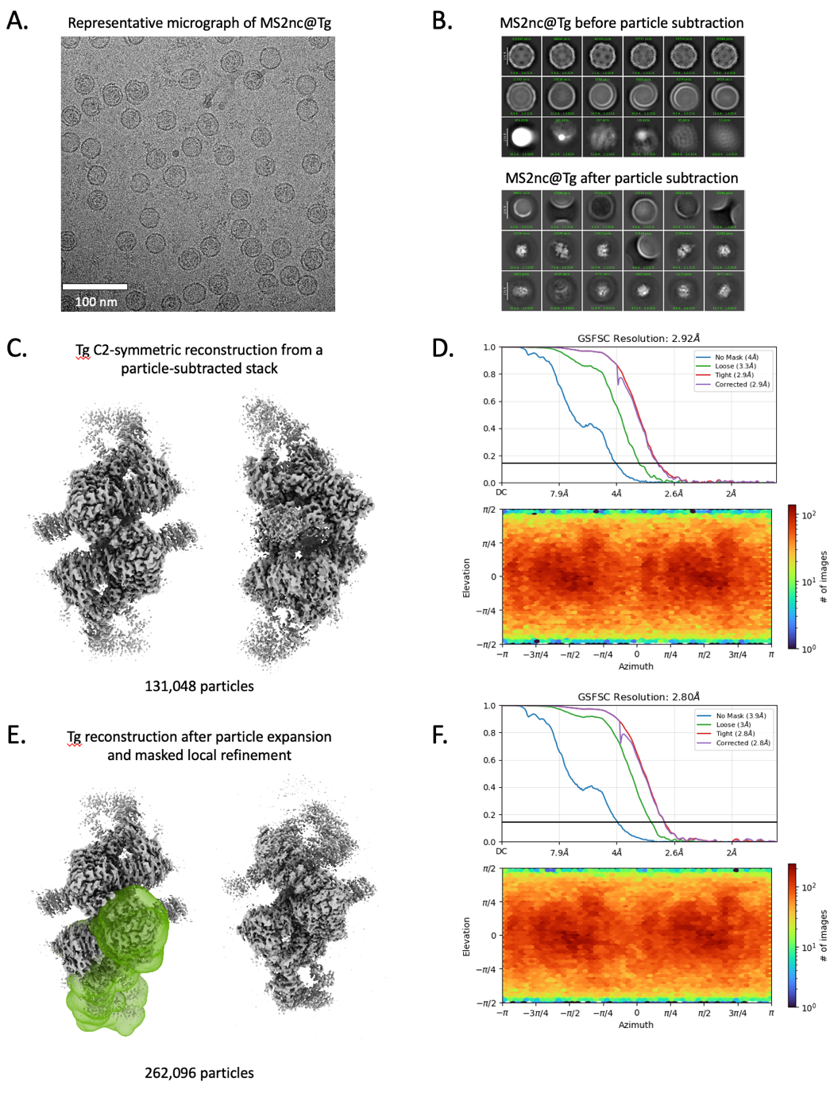

Figure S5. MS2nc@Tg processing details. A. Representative micrograph. B. 2D classification before (top) and after nanocrate density subtraction. C. Refined map with C2 symmetry. D. GSFSC plot showing 2.92 Å resolution and viewing direction distribution plot, showing isotropic orientation distribution. E. (left) Tg map with a mask region highlighted; (right) C1 reconstruction after local refinement of the masked region with corresponding GSFSC and viewing distribution plots F.

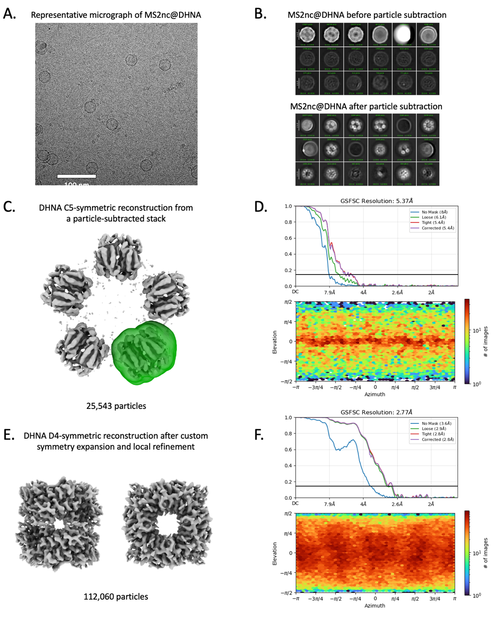
Figure S6. MS2nc@DHNA processing details. A. Representative micrograph. C. 2D classification before (top) and after nanocrate density subtraction. C. Refined map with C5 symmetry. A single DHNA copy was selected as a reference volume (masked in green) for symmetry expansion processing. D. GSFSC plot showing 5.375 Å resolution and viewing direction distribution plot, showing orientation distribution predominantly along the equator. E. Refined DHNA map after symmetry expansion and local refinement with D4 symmetry. F. GSFSC and viewing distribution plots corresponding to the reconstruction in E.
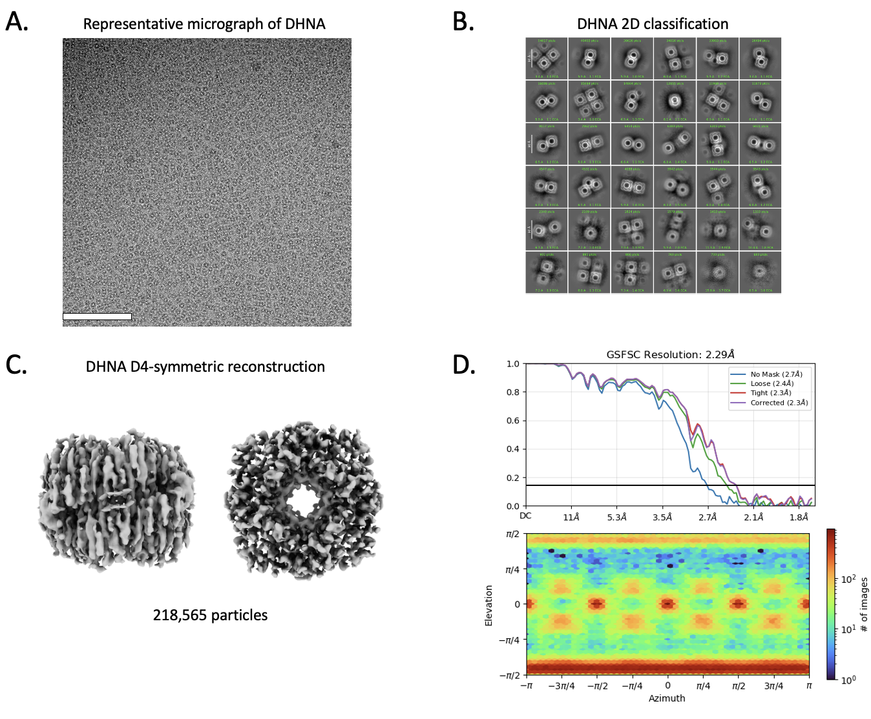
Figure S7. DHNA processing without nanocrates. A. Representative micrograph. B. 2D classification showing exclusively top views. C. Refined map with D4 symmetry enforced. The map is highly anisotropic and stretched in the direction of the preferred view, making it unsuitable for model building D. GSFSC plot showing 2.29 Å resolution and viewing direction distribution plot, showing highly preferred orientation.

Cryo-EM data collection, refinement, and validation statistics for MS2 capsid and empty MS2nc

 | MS2 capsid  (EMD-72124)  (PDB 9Q1D) | MS2nc no cargo  (EMD-72122)  (PDB 9Q1B)
Data collection and processing
Magnification | 105,000 | 105,000
Voltage (kV) | 300 | 300
Electron exposure (e–/Å²) | 52.36 | 54.58
Defocus range (μm) | -0.7 to -2.0 | -0.7 to -2.0
Pixel size (Å) | 0.829 | 0.829
Symmetry imposed | I | I
Particle images (no.) | 106,754 | 239,460
Map resolution (Å)  FSC threshold | 1.75  0.143 | 1.74  0.143
Refinement
Initial model used (PDB code) | 9Q1B | 2IZM
Model resolution (Å)  FSC threshold | 1.75  0.143 | 1.74  0.143
Map sharpening B factor (Å²) | 45.4 | 47.6
Model composition  Non-hydrogen atoms  Protein residues  Waters | 3160  387  265 | 3123  387  228
Map-to-model FSC at threshold of 0.5
CCvolume/CCmask
B factors (Å²) (min/max/mean)  Protein  Waters | 6.38/85.57/21.79  15.54/60.71/31.30 | 1.34/68.84/11.65  4.92/39.09/18.55
R.m.s. deviations  Bond lengths (Å)  Bond angles (°) | 0.003  0.543 | 0.002  0.494
Validation  MolProbity score  Clashscore  Poor rotamers (%) | 1.04  2.59  0.00 | 1.06  2.76  0.00
Ramachandran plot  Favored (%)  Allowed (%)  Disallowed (%) | 98.69  1.31  0.00 | 98.95  1.05  0.00
CaBLAM outliers (%)
EMRinger score
Average Q-score | 0.789 | 0.80

