name | desc | Non-depression (N=417) | Depression (N=934) | OR (univariable) | OR (multivariable)
Feel hopeful about the Future, | Mean ± SD | 2.7 ± 1.3 | 2.1 ± 1.2 | 0.66 (0.60-0.73, p<.001) | 0.71 (0.64-0.79, p<.001)
Retirement status | Mean ± SD | 0.1 ± 0.3 | 0.0 ± 0.2 | 0.49 (0.31-0.79, p=.003) | 0.50 (0.28-0.89, p=.019)
History of falls | Mean ± SD | 0.2 ± 0.4 | 0.4 ± 0.5 | 1.68 (1.30-2.18, p<.001) | 1.29 (0.97-1.72, p=.079)
Marital status | Mean ± SD | 0.9 ± 0.3 | 0.8 ± 0.4 | 0.72 (0.52-0.99, p=.042) | 0.93 (0.65-1.34, p=.711)
Life satisfaction | Mean ± SD | 3.4 ± 0.8 | 3.0 ± 0.9 | 0.59 (0.51-0.68, p<.001) | 0.65 (0.56-0.77, p<.001)
Multisite pain | Mean ± SD | 0.6 ± 0.5 | 0.7 ± 0.5 | 1.64 (1.29-2.10, p<.001) | 1.10 (0.82-1.46, p=.520)
Place of residence | Mean ± SD | 0.6 ± 0.5 | 0.7 ± 0.4 | 1.51 (1.18-1.94, p=.001) | 1.36 (1.02-1.82, p=.034)
Educational attainment | Mean ± SD | 1.7 ± 0.9 | 1.5 ± 0.8 | 0.82 (0.72-0.94, p=.005) | 1.02 (0.86-1.20, p=.824)
disability | Mean ± SD | 0.4 ± 0.5 | 0.5 ± 0.5 | 1.56 (1.23-1.98, p<.001) | 1.08 (0.82-1.42, p=.587)
Self perceived health status | Mean ± SD | 2.7 ± 0.9 | 2.3 ± 0.8 | 0.61 (0.53-0.70, p<.001) | 0.73 (0.63-0.85, p<.001)
Hypertension | Mean ± SD | 0.4 ± 0.5 | 0.4 ± 0.5 | 1.10 (0.87-1.40, p=.431)
Diabetes mellitus | Mean ± SD | 0.1 ± 0.3 | 0.1 ± 0.4 | 1.25 (0.89-1.77, p=.196)
Cancer | Mean ± SD | 0.0 ± 0.1 | 0.0 ± 0.2 | 1.61 (0.69-3.75, p=.270)
Lung disease | Mean ± SD | 0.2 ± 0.4 | 0.2 ± 0.4 | 1.14 (0.85-1.54, p=.382)
Heart disease | Mean ± SD | 0.2 ± 0.4 | 0.3 ± 0.5 | 1.45 (1.12-1.89, p=.005) | 1.20 (0.89-1.61, p=.224)
History of stroke | Mean ± SD | 0.0 ± 0.2 | 0.0 ± 0.2 | 1.25 (0.65-2.37, p=.504)
Arthritis | Mean ± SD | 0.6 ± 0.5 | 0.7 ± 0.5 | 1.78 (1.40-2.27, p<.001) | 1.42 (1.07-1.89, p=.014)
Dyslipidemia | Mean ± SD | 0.2 ± 0.4 | 0.2 ± 0.4 | 1.07 (0.81-1.41, p=.623)
Liver disease | Mean ± SD | 0.1 ± 0.3 | 0.1 ± 0.3 | 1.10 (0.73-1.64, p=.657)
Kidney disease | Mean ± SD | 0.1 ± 0.3 | 0.2 ± 0.4 | 1.59 (1.12-2.25, p=.009) | 1.20 (0.82-1.76, p=.342)
Digest disease | Mean ± SD | 0.5 ± 0.5 | 0.5 ± 0.5 | 1.39 (1.10-1.75, p=.005) | 1.09 (0.84-1.41, p=.528)
Asthma | Mean ± SD | 0.1 ± 0.3 | 0.1 ± 0.3 | 1.28 (0.82-2.01, p=.274)
Memory impairment | Mean ± SD | 0.0 ± 0.2 | 0.1 ± 0.2 | 1.65 (0.88-3.08, p=.118)
Drinking behavior | Mean ± SD | 0.2 ± 0.4 | 0.1 ± 0.4 | 0.82 (0.60-1.13, p=.223)
Health insurance | Mean ± SD | 0.9 ± 0.3 | 0.9 ± 0.3 | 1.08 (0.71-1.64, p=.709)
Smoke behavior | Mean ± SD | 0.1 ± 0.3 | 0.1 ± 0.2 | 0.77 (0.48-1.24, p=.283)
Systolic | Mean ± SD | 126.7 ± 21.0 | 125.1 ± 20.9 | 1.00 (0.99-1.00, p=.212)
Diastolic | Mean ± SD | 74.4 ± 11.9 | 74.2 ± 11.8 | 1.00 (0.99-1.01, p=.859)
Pulse | Mean ± SD | 74.8 ± 10.0 | 75.1 ± 10.3 | 1.00 (0.99-1.01, p=.651)
Left grip | Mean ± SD | 23.0 ± 7.8 | 21.0 ± 8.1 | 0.97 (0.95-0.98, p<.001) | 1.00 (0.98-1.02, p=.747)
Right grip | Mean ± SD | 24.3 ± 7.9 | 22.3 ± 8.5 | 0.97 (0.96-0.98, p<.001) | 0.99 (0.97-1.01, p=.248)
Pulmonary function | Mean ± SD | 266.4 ± 89.7 | 253.6 ± 86.3 | 1.00 (1.00-1.00, p=.014) | 1.00 (1.00-1.00, p=.679)
Sleep duration | Mean ± SD | 6.1 ± 2.2 | 5.3 ± 2.2 | 0.86 (0.81-0.91, p<.001) | 0.88 (0.83-0.94, p<.001)
Age | Mean ± SD | 58.9 ± 11.3 | 59.2 ± 10.1 | 1.00 (0.99-1.01, p=.705)
Supplementary Table S1 Univariate and Multivariate Logistic Regression Analysis of Factors Associated with Depression

 | level | Test | Validation | p
n |  | 579 | 1518
Depression (%) | No | 152 (26.3) | 410 (27.0) | 0.768
 | YES | 427 (73.7) | 1108 (73.0)
Feel hopeful about the Future, n (%) | Rarely or never (<1 day) | 224 (38.7) | 461 (31.6) | 0.011
 | Occasional (1-2 days) | 89 (15.4) | 263 (18.0)
 | Sometimes (3-4 days) | 113 (19.5) | 278 (19.1)
 | Almost always (5-7 days) | 153 (26.4) | 456 (31.3)
Retirement status n (%) | No | 542 (93.6) | 1412 (95.6) | 0.079
 | Yes | 37 (6.4) | 65 (4.4)
History of falls, n (%) | No | 410 (70.8) | 1062 (70.0) | 0.759
 | Yes | 169 (29.2) | 455 (30.0)
Marital status, n (%) | Unmarried | 117 (20.2) | 232 (15.3) | 0.008
 | Married | 462 (79.8) | 1286 (84.7)
Life satisfaction, n (%) | Not at all satisfied | 31 (5.4) | 90 (6.8) | <0.001
 | Not very satisfied | 76 (13.1) | 274 (20.9)
 | Somewhat satisfied | 270 (46.6) | 751 (57.2)
 | Very satisfied | 161 (27.8) | 183 (13.9)
 | Completely satisfied | 41 (7.1) | 16 (1.2)
Multisite pain, n (%) | No | 181 (31.3) | 692 (46.1) | <0.001
 | Yes | 398 (68.7) | 808 (53.9)
Place of residence, n (%) | rural | 192 (33.2) | 452 (29.8) | 0.147
 | Urban | 387 (66.8) | 1066 (70.2)
Educational attainment, n (%) | Elementary school or below | 379 (65.5) | 1051 (69.2) | 0.001
 | Middle school | 131 (22.6) | 239 (15.7)
 | High school | 44 (7.6) | 159 (10.5)
 | Above high school | 25 (4.3) | 69 (4.5)
Disability, n (%) | No | 302 (52.2) | 1123 (74.1) | <0.001
 | Yes | 277 (47.8) | 393 (25.9)
Self perceived health status, n (%) | Very good | 90 (15.5) | 201 (13.2) | 0.002
 | Poor | 214 (37.0) | 667 (44.0)
 | Fair | 247 (42.7) | 584 (38.5)
 | Good | 16 (2.8) | 55 (3.6)
 | Very good | 12 (2.1) | 10 (0.7)
Hypertension n (%) | No | 335 (57.9) | 1055 (70.2) | <0.001
 | Yes | 244 (42.1) | 448 (29.8)
Diabetes mellitus, n (%) | No | 484 (83.6) | 1384 (92.6) | <0.001
 | Yes | 95 (16.4) | 111 (7.4)
Cancer, n (%) | No | 564 (97.4) | 1484 (98.7) | 0.069
 | Yes | 15 (2.6) | 20 (1.3)
Lunge disease, n (%) | No | 471 (81.3) | 1293 (85.9) | 0.013
 | Yes | 108 (18.7) | 213 (14.1)
Heart disease, n (%) | No | 381 (65.8) | 1185 (78.8) | <0.001
 | Yes | 198 (34.2) | 318 (21.2)
History of stroke n (%) | No | 553 (95.5) | 1469 (97.2) | 0.08
 | Yes | 26 (4.5) | 43 (2.8)
Arthritis, n (%) | No | 174 (30.1) | 675 (44.7) | <0.001
 | Yes | 405 (69.9) | 835 (55.3)
Dyslipidemia, n (%) | No | 430 (74.3) | 1285 (86.9) | <0.001
 | Yes | 149 (25.7) | 193 (13.1)
Liver disease, n (%) | No | 519 (89.6) | 1424 (95.4) | <0.001
 | Yes | 60 (10.4) | 68 (4.6)
Kidney disease, n (%) | No | 492 (85.0) | 1355 (90.3) | 0.001
 | Yes | 87 (15.0) | 145 (9.7)
Digestive disease, n (%) | No | 261 (45.1) | 925 (61.5) | <0.001
 | Yes | 318 (54.9) | 580 (38.5)
Asthma, n (%) | No | 522 (90.2) | 1400 (92.7) | 0.066
 | Yes | 57 (9.8) | 110 (7.3)
Memory impairment, n (%) | No | 539 (93.1) | 1468 (97.4) | <0.001
 | Yes | 40 (6.9) | 39 (2.6)
Drinking behavior n (%) | No | 496 (85.7) | 1310 (86.3) | 0.761
 | Yes | 83 (14.3) | 208 (13.7)
Health insurance, n (%) | No | 58 (10.0) | 91 (6.0) | 0.002
 | Yes | 521 (90.0) | 1415 (94.0)
Smoking, behavior n (%) | No | 541 (93.4) | 1422 (93.7) | 0.92
 | Yes | 38 (6.6) | 96 (6.3)
Systolic Blood Pressure, (mean (SD)) |  | 125.76 (21.52) | 128.66 (22.14) | 0.008
Diastolic Blood Pressure (mean (SD)) |  | 74.03 (11.90) | 74.60 (11.95) | 0.341
Pulse (mean (SD)) |  | 74.76 (9.92) | 72.53 (10.39) | <0.001
Left grip strength (mean (SD)) |  | 21.80 (7.77) | 23.06 (7.49) | 0.001
Right strength (mean (SD)) |  | 22.87 (8.21) | 24.17 (7.48) | 0.001
Height (mean (SD)) |  | 1.51 (0.10) | 1.52 (0.08) | 0.144
Weight (mean (SD)) |  | 55.65 (11.50) | 54.50 (10.85) | 0.038
Waist circumference (mean (SD)) |  | 84.17 (14.91) | 83.12 (13.42) | 0.131
Pulmonary function(mean (SD)) |  | 250.26 (86.63) | 237.54 (93.32) | 0.005
Sleep duration (mean (SD)) |  | 5.49 (2.36) | 5.56 (2.18) | 0.517
Age, (mean (SD)) |  | 59.68 (10.77) | 58.36 (9.82) | 0.007
Supplementary Table S2 Baseline characteristics of participants in the Test and Validation cohorts 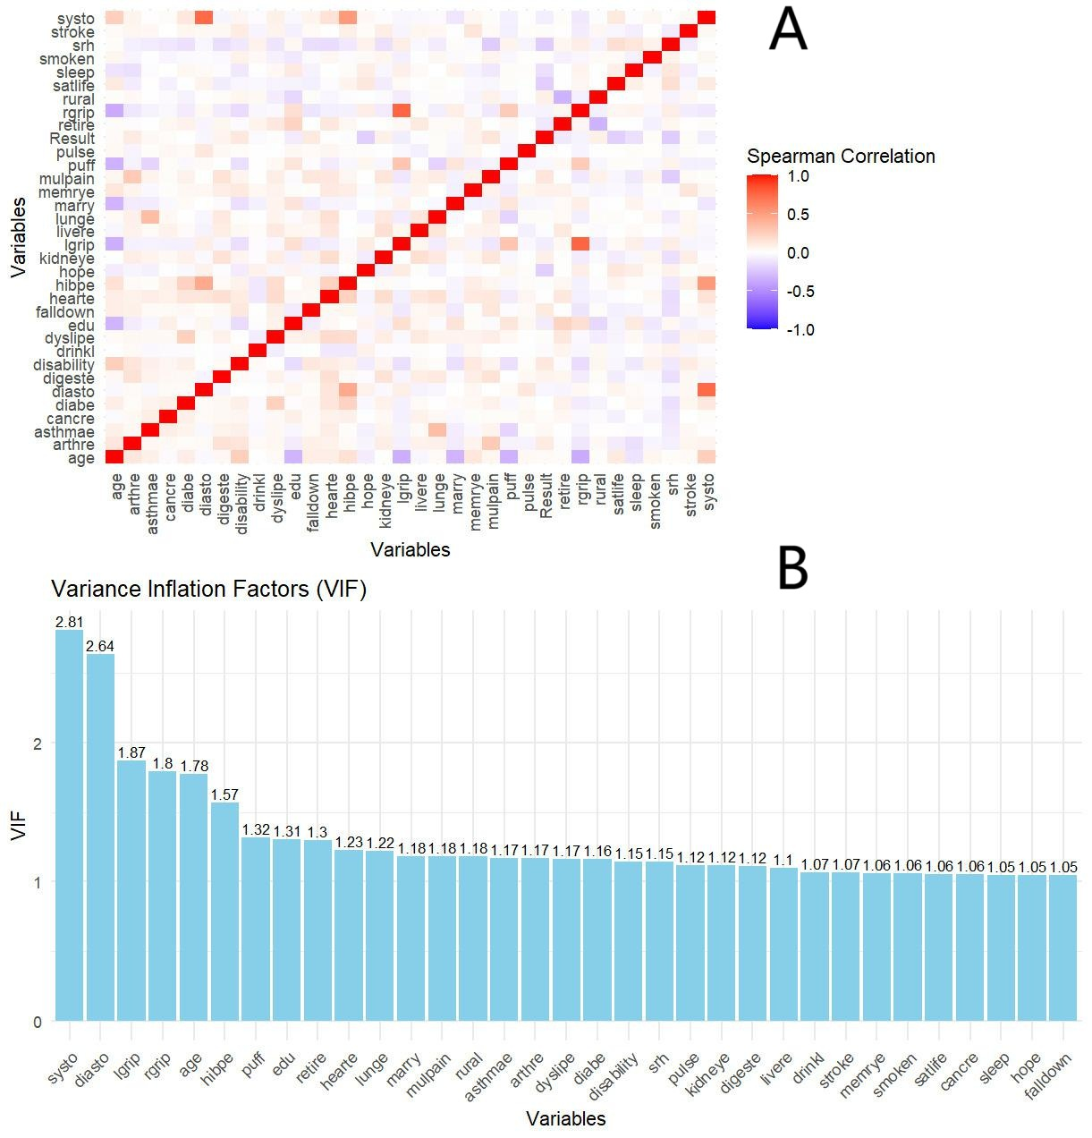
Supplementary Picture S1:VIF (A). Heatmap of variable correlations (B) VIF plot for all variables

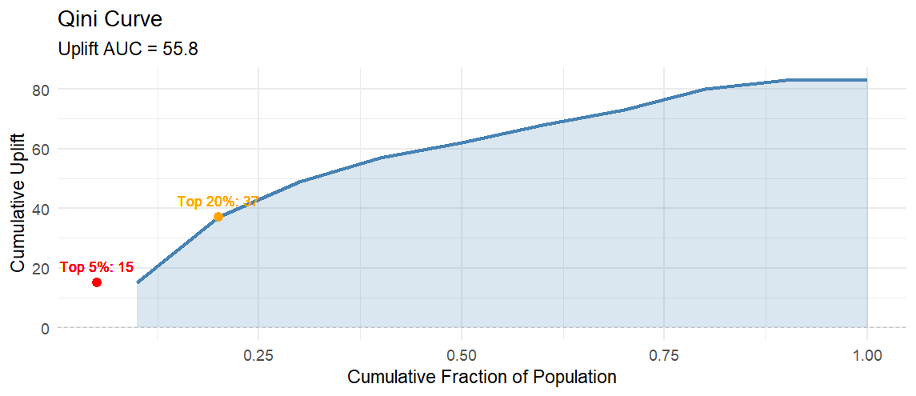
Supplementary Picture S2 :Qini Curve for individualized treatment effect estimation.
The curve illustrates the cumulative uplift across the population, with an uplift AUC of 55.8. The top 5% of high-risk individuals showed a cumulative uplift of 15, while the top 20% subgroup achieved an uplift of 37, demonstrating that the model effectively stratifies individuals according to their potential benefit from life-satisfaction–enhancing interventions.

