Additional files：
TableS1- The incidence, DALYs, YLDs, prevalence (in age-standardized rate) of gastroesophageal reflux disease in East Asia countries from 1990 to 2021
TableS2- The incidence, DALYs, YLDs, prevalence (in crude rate) of gastroesophageal reflux disease in East Asia countries from 1990 to 2021
FigureS1-Heatmap of incidence, DALYs, YLDs, prevalence (in crude rate) of gastroesophageal reflux disease in East Asia countries from 1990 to 2021
FigureS2- Heatmap of incidence, DALYs, YLDs, prevalence (in age-standardized rate) of gastroesophageal reflux disease in East Asia countries from 1990 to 2021
FigureS3- The global incidence, DALYs, YLDs, prevalence (in cases and age-standardized rates) of gastroesophageal reflux disease by gender (both, male, and female) from 1990 to 2021
FigureS4- The incidence, DALYs, YLDs, prevalence (in cases and age-standardized rates) of gastroesophageal reflux disease by gender (both, male, and female) in Japan from 1990 to 2021
FigureS5- The incidence, DALYs, YLDs, prevalence (in cases and age-standardized rates) of gastroesophageal reflux disease by gender (both, male, and female) in Republic of Korea from 1990 to 2021
FigureS6- The global incidence, DALYs, YLDs, prevalence (in cases and age-standardized rates) of gastroesophageal reflux disease by age in 2021
FigureS7- The incidence, DALYs, YLDs, prevalence (in cases and age-standardized rates) of gastroesophageal reflux disease by age in Japan in 2021
FigureS8- The incidence, DALYs, YLDs, prevalence (in cases and age-standardized rates) of gastroesophageal reflux disease by age in Republic of Korea in 2021
FigureS9-Heatmap of change rate of gastroesophageal reflux disease in different age groups from 1990 to 2021 in different ages in both gender in China, Japan and Republic of Korea
FigureS10- Heatmap of change rate of gastroesophageal reflux disease in different age groups from 1990 to 2021 in different ages in male in China, Japan and Republic of Korea
FigureS11- Heatmap of change rate of gastroesophageal reflux disease in different age groups from 1990 to 2021 in different ages in female in China, Japan and Republic of Korea
FigureS12- Frontier analysis based on SDI and age-standardized gastroesophageal reflux disease incidence rates from 1990 to 2021 in East Asia countries

TableS1- The incidence, DALYs, YLDs, prevalence (in age-standardized rate) of gastroesophageal reflux disease in East Asia countries from 1990 to 2021
 | ASIR |  |  |  | ASDR |  |  |  | YLD |  |  |  | Prevalence
location | 1990 | 2021 | EAPC  (1990-2021) | Change | 1990 | 2021 | EAPC  (1990-2021) | Change | 1990 | 2021 | EAPC  (1990-2021) | Change | 1990 | 2021 | EAPC  (1990-2021) | Change
Global | 3739.86  (3314.2 to 4142.33) | 3881.86  (3445.56 to 4299.95) | 0.1  (0.06 to 0.13) | 3.80% | 73.01  (36.75 to 129.66) | 75.56  (38.05 to 133.87) | 0.08  (0.04 to 0.12) | 3.49% | 73.01  (36.75 to 129.66) | 75.56  (38.05 to 133.87) | 0.08  (0.04 to 0.12) | 3.49% | 9516.49  (8427.33 to 10664.72) | 9838.6  (8732.46 to 11056.05) | 0.08  (0.04 to 0.12) | 3.38%
People's Republic of China | 1851.79  (1617.16 to 2089.3) | 1844.31  (1605.06 to 2084.12) | -0.08  (-0.2 to 0.04) | -0.40% | 35.27  (17.69 to 62.79) | 35.12  (17.63 to 62.34) | -0.09  (-0.22 to 0.05) | -0.43% | 35.27  (17.69 to 62.79) | 35.12  (17.63 to 62.34) | -0.09  (-0.22 to 0.05) | -0.43% | 4562.63  (3972.15 to 5176.18) | 4540.66  (3950.76 to 5156.56) | -0.09  (-0.22 to 0.05) | -0.48%
Japan | 2475.82  (2167.09 to 2769.55) | 2486.79  (2176.98 to 2782.55) | 0.07  (0.02 to 0.11) | 0.44% | 46.62  (23.36 to 84.5) | 46.93  (23.57 to 85.18) | 0.08  (0.03 to 0.13) | 0.66% | 46.62  (23.36 to 84.5) | 46.93  (23.57 to 85.18) | 0.08  (0.03 to 0.13) | 0.66% | 6028.37  (5281.01 to 6825.67) | 6058.25  (5306.58 to 6856.53) | 0.07  (0.02 to 0.12) | 0.50%
Republic of Korea | 2780.85  (2429.52 to 3114.11) | 2777.11  (2424.66 to 3108.48) | 0.26  (0.07 to 0.45) | -0.13% | 52.49  (26.22 to 93.29) | 52.45  (26.26 to 93.69) | 0.37  (0.11 to 0.62) | -0.07% | 52.49  (26.22 to 93.29) | 52.45  (26.26 to 93.69) | 0.37  (0.11 to 0.62) | -0.07% | 6813.66  (5959.77 to 7690.32) | 6796.45  (5941.76 to 7670.2) | 0.36  (0.1 to 0.62) | -0.25%
Democratic People's Republic of Korea | 1938.58  (1691.63 to 2193.53) | 1927.59  (1683.71 to 2178.28) | -0.02  (-0.02 to -0.02) | -0.57% | 36.41  (18.38 to 64) | 36.22  (18.4 to 63.62) | -0.02  (-0.02 to -0.01) | -0.51% | 36.41  (18.38 to 64) | 36.22  (18.4 to 63.62) | -0.02  (-0.02 to -0.01) | -0.51% | 4699.73  (4132.49 to 5330.99) | 4672.05  (4103.02 to 5297.65) | -0.02  (-0.02 to -0.02) | -0.59%
Mongolia | 4312.34  (3803.97 to 4799.2) | 4320.35  (3812.84 to 4804.82) | 0.01  (0.01 to 0.01) | 0.19% | 83.6  (42.18 to 147.53) | 83.64  (41.96 to 147.77) | 0.01  (0 to 0.01) | 0.05% | 83.6  (42.18 to 147.53) | 83.64  (41.96 to 147.77) | 0.01  (0 to 0.01) | 0.05% | 10851.17  (9481.07 to 12170.7) | 10874.73  (9501.75 to 12195.21) | 0.01  (0.01 to 0.01) | 0.22%
ASIR, age-standardized incidence rates; ASDR, age-standardized DALYs rate; DALYs, disability adjusted life years; EAPC, estimated annual percentage change.
Change (%) = [(2021 values - 1990 values) / 1990 values] × 100%.

TableS2- The incidence, DALYs, YLDs, prevalence (in crude rate) of gastroesophageal reflux disease in East Asia countries from 1990 to 2021
 | Incidence |  |  |  | DALYs |  |  |  | YLD |  |  |  | Prevalence
location | 1990 | 2021 | EAPC  (1990-2021) | Change | 1990 | 2021 | EAPC  (1990-2021) | Change | 1990 | 2021 | EAPC  (1990-2021) | Change | 1990 | 2021 | EAPC  (1990-2021) | Change
Global | 3375.16  (2974.73 to 3748.86) | 4107.53  (3645.68 to 4548.17) | 0.63  (0.61 to 0.65) | 21.70% | 65.11  (32.86 to 114.91) | 80.29  (40.42 to 142.45) | 0.66  (0.64 to 0.69) | 23.32% | 65.11  (32.86 to 114.91) | 80.29  (40.42 to 142.45) | 0.66  (0.64 to 0.69) | 23.32% | 8451.39  (7452.32 to 9592.7) | 10462.13  (9288.51 to 11728.73) | 0.67  (0.65 to 0.7) | 23.79%
People's Republic of China | 1773.44  (1532.96 to 2013.56) | 2276.43  (1957.62 to 2580.3) | 0.8  (0.72 to 0.89) | 28.36% | 33.48  (16.99 to 59.04) | 44.02  (21.91 to 78.43) | 0.87  (0.78 to 0.96) | 31.48% | 33.48  (16.99 to 59.04) | 44.02  (21.91 to 78.43) | 0.87  (0.78 to 0.96) | 31.48% | 4303.78  (3742.62 to 4940.5) | 5716.22  (4976 to 6462.81) | 0.9  (0.81 to 1) | 32.82%
Japan | 2974.58  (2594.77 to 3345.9) | 3582.89  (3148.33 to 4027.59) | 0.64  (0.61 to 0.68) | 20.45% | 56.53  (28.28 to 103.08) | 68.93  (34.1 to 124.12) | 0.7  (0.66 to 0.74) | 21.95% | 56.53  (28.28 to 103.08) | 68.93  (34.1 to 124.12) | 0.7  (0.66 to 0.74) | 21.95% | 7327.52  (6381.52 to 8292.24) | 9043.32  (7950.16 to 10263.71) | 0.73  (0.69 to 0.78) | 23.42%
Republic of Korea | 2698.29  (2331.76 to 3032.4) | 3843.15  (3355.28 to 4359.51) | 1.42  (1.23 to 1.61) | 42.43% | 50.49  (25.23 to 89.01) | 73.84  (37.28 to 132.38) | 1.61  (1.35 to 1.87) | 46.26% | 50.49  (25.23 to 89.01) | 73.84  (37.28 to 132.38) | 1.61  (1.35 to 1.87) | 46.26% | 6503.79  (5668.02 to 7433.62) | 9632.57  (8372.57 to 10877.35) | 1.65  (1.39 to 1.91) | 48.11%
Democratic People's Republic of Korea | 1865.01  (1609.46 to 2118.85) | 2268.17  (1974.71 to 2568.03) | 0.66  (0.64 to 0.69) | 21.62% | 34.96  (17.71 to 61.61) | 43.04  (21.77 to 75.81) | 0.7  (0.68 to 0.72) | 23.11% | 34.96  (17.71 to 61.61) | 43.04  (21.77 to 75.81) | 0.7  (0.68 to 0.72) | 23.11% | 4492.44  (3917.4 to 5119) | 5556.57  (4859.73 to 6274.62) | 0.71  (0.69 to 0.74) | 23.69%
Mongolia | 3128.12  (2730.75 to 3509.05) | 4059.45  (3532.98 to 4545.55) | 1.02  (0.91 to 1.12) | 29.77% | 58.84  (30.02 to 104.01) | 78.74  (39.73 to 139.8) | 1.13  (1.03 to 1.24) | 33.82% | 58.84  (30.02 to 104.01) | 78.74  (39.73 to 139.8) | 1.13  (1.03 to 1.24) | 33.82% | 7580.25  (6563.95 to 8611.9) | 10183.2  (8782.54 to 11615.36) | 1.14  (1.04 to 1.24) | 34.34%
DALYs, disability adjusted life years; EAPC, estimated annual percentage change. Change (%) = [(2021 values - 1990 values) / 1990 values] × 100%.

FigureS1-Heatmap of incidence, DALYs, YLDs, prevalence (in crude rate) of gastroesophageal reflux disease in East Asia countries from 1990 to 2021. A. Rate of incidence, B. DALYs rate, C. YLDs rate, D. Rate of prevalence. DALYs, disability adjusted life years; YLD, years lived with disability.
FigureS2- Heatmap of incidence, DALYs, YLDs, prevalence (in age-standardized rate) of gastroesophageal reflux disease in East Asia countries from 1990 to 2021. A. Rate of incidence, B. DALYs rate, C. YLDs rate, D. Rate of prevalence. DALYs, disability adjusted life years; YLD, years lived with disability.
FigureS3- The global incidence, DALYs, YLDs, prevalence (in cases and age-standardized rates) of gastroesophageal reflux disease by gender (both, male, and female) from 1990 to 2021. A. Rate of incidence, B. DALYs rate, C. YLDs rate, D. Rate of prevalence. DALYs, disability adjusted life years; ASR, age-standardized rate; YLD, years lived with disability.
FigureS4- The incidence, DALYs, YLDs, prevalence (in cases and age-standardized rates) of gastroesophageal reflux disease by gender (both, male, and female) in Japan from 1990 to 2021. A. Rate of incidence, B. DALYs rate, C. YLDs rate, D. Rate of prevalence. DALYs, disability adjusted life years; ASR, age-standardized rate; YLD, years lived with disability.
FigureS5- The incidence, DALYs, YLDs, prevalence (in cases and age-standardized rates) of gastroesophageal reflux disease by gender (both, male, and female) in Republic of Korea from 1990 to 2021. A. Rate of incidence, B. DALYs rate, C. YLDs rate, D. Rate of prevalence. DALYs, disability adjusted life years; ASR, age-standardized rate; YLD, years lived with disability.
FigureS6- The global incidence, DALYs, YLDs, prevalence (in cases and age-standardized rates) of gastroesophageal reflux disease by age from 1990 to 2021. A. Rate of incidence, B. DALYs rate, C. YLDs rate, D. Rate of prevalence. DALYs, disability adjusted life years; ASR, age-standardized rate; YLD, years lived with disability.
FigureS7- The incidence, DALYs, YLDs, prevalence (in cases and age-standardized rates) of gastroesophageal reflux disease by age in Japan from 1990 to 2021. A. Rate of incidence, B. DALYs rate, C. YLDs rate, D. Rate of prevalence. DALYs, disability adjusted life years; ASR, age-standardized rate; YLD, years lived with disability.
FigureS8- The incidence, DALYs, YLDs, prevalence (in cases and age-standardized rates) of gastroesophageal reflux disease by age in Republic of Korea from 1990 to 2021. A. Rate of incidence, B. DALYs rate, C. YLDs rate, D. Rate of prevalence. DALYs, disability adjusted life years; ASR, age-standardized rate; YLD, years lived with disability.
FigureS9-Heatmap of change rate (in crude rate) of gastroesophageal reflux disease in different age groups from 1990 to 2021 in different ages in both gender in China, Japan and Republic of Korea. A. Rate of incidence, B. DALYs rate, C. YLDs rate, D. Rate of prevalence. DALYs, disability adjusted life years; YLD, years lived with disability. Change=(Rate2021-rate1990)/rate1990*100%
FigureS10- Heatmap of change rate (in crude rate) of gastroesophageal reflux disease in different age groups from 1990 to 2021 in different ages in male in China, Japan and Republic of Korea. A. Rate of incidence, B. DALYs rate, C. YLDs rate, D. Rate of prevalence. DALYs, disability adjusted life years; YLD, years lived with disability. Change=(Rate2021-rate1990)/rate1990*100%
FigureS11- Heatmap of change rate (in crude rate) of gastroesophageal reflux disease in different age groups from 1990 to 2021 in different ages in female in China, Japan and Republic of Korea. A. Rate of incidence, B. DALYs rate, C. YLDs rate, D. Rate of prevalence. DALYs, disability adjusted life years; YLD, years lived with disability. Change=(Rate2021-rate1990)/rate1990*100%
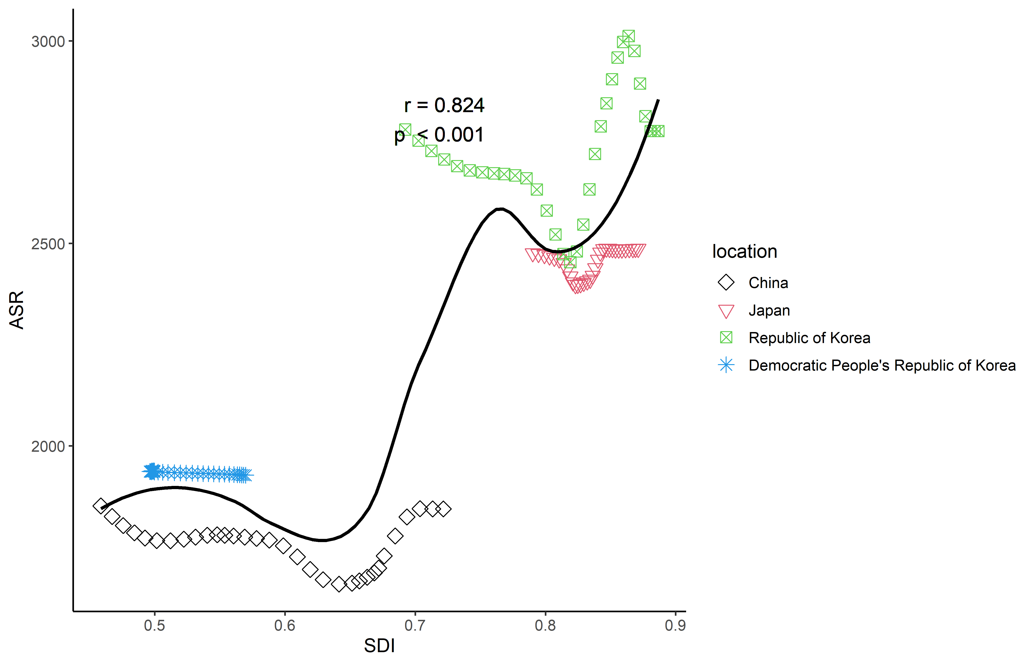
FigureS12- Frontier analysis based on SDI and age-standardized gastroesophageal reflux disease incidence rates from 1990 to 2021 in East Asia countries
The scatter trend chart displaying incidence and SDI for GERD from 1990 to 2021, featuring 32 scatter points for each group. The legend on the right indicates the corresponding relationship between color graphics and countries. SDI, socio-demographic index.

