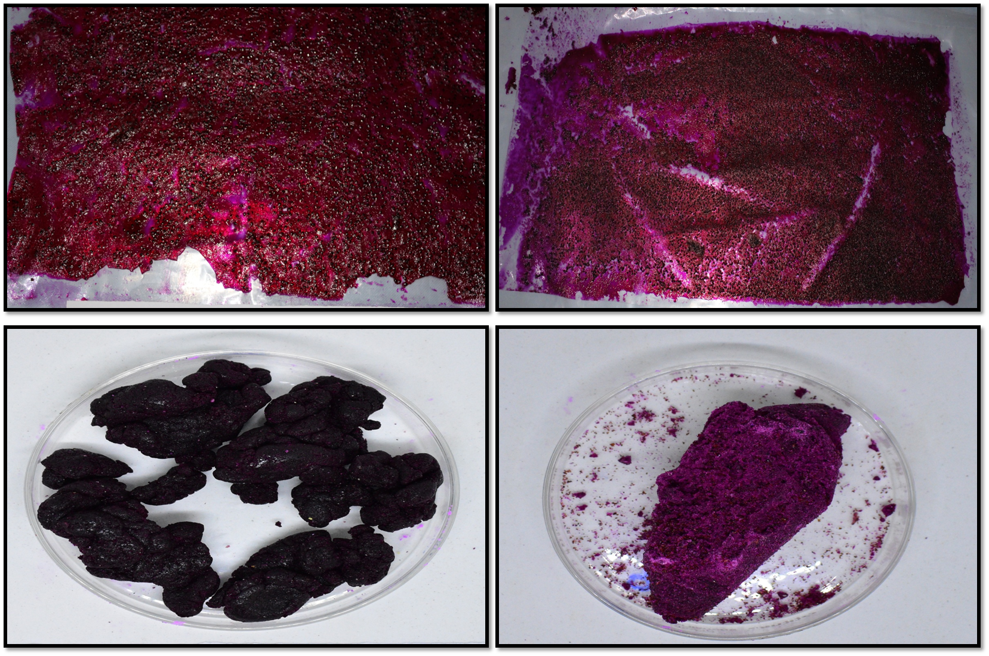
Plate 1: Different additive combinations failed responce to produce free flowing dragon fruit powder

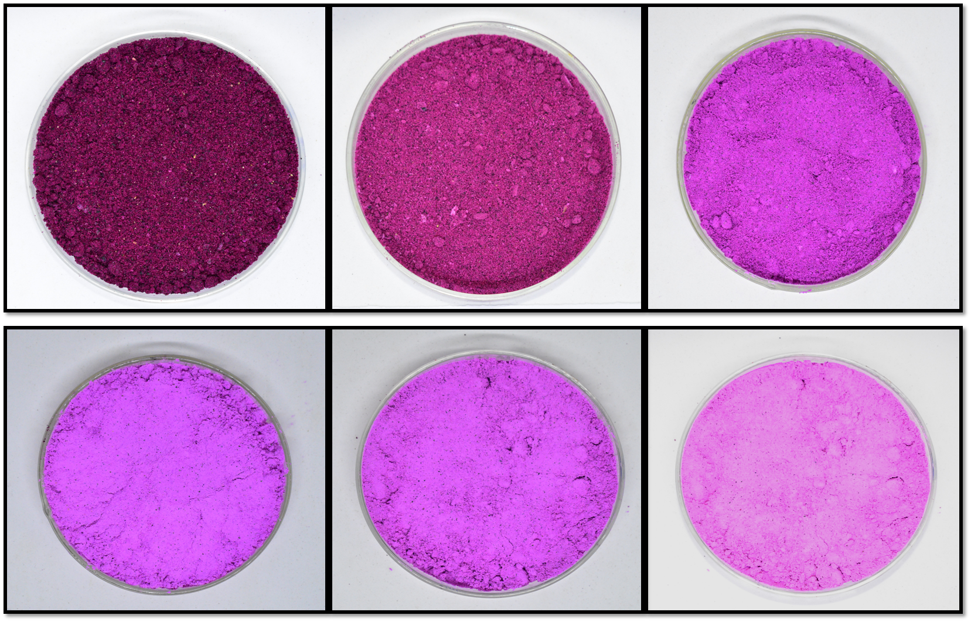
Plate 2: Dragon fruit powder produced using different levels of additive combination-3 (Predominantly cornstarch)

