Tetrahedral Frameworks and Helical Chains: oP32– CaC₂O₅ and mP80– CaCO₃ Calcium Carbonates above 100 GPa
Apostolos Pantousas* ^{[a], [b]}, Georgios Aprilis ^{[a]}, Alena Aslandukova ^{[d]}, Ilya Kupenko ^{[a]}, Xiang Li ^{[a][c]}, Susanne Müller ^{[a], [c]}, W. Zhou^{[d]}, P. Leveque^{[e]}, Michael Hanfland ^{[a]}, Leonid Dubrovinsky ^{[b]} and Anna Pakhomova* ^{[a]}
[a] European Synchrotron Radiation Facility
Grenoble Cedex F-38043, France
E-mail: apostolos.pantousas@esrf.fr
[b] Bayerisches Geoinstitut,
Universität Bayreuth,
Bayreuth 95440, Germany
[c] University of Institut für Mineralogie,
University of Münster,
Corrensstraße 24, D-48149, Münster, Germany
[d] Material Physics and Technology at Extreme Conditions,
Laboratory of Crystallography,
Universität Bayreuth,
Bayreuth 95440, Germany
[e] Nantes Université, Univ Angers, Le Mans Université,
CNRS, Laboratoire de Planétologie et Géosciences,
LPG UMR 6112, 44000 Nantes, France
[f] Institute of Geosciences,
Goethe University Frankfurt
60438 Frankfurt, Germany

Contents
Section A: Previous knowledge 3
Section B: Methods 5
Section C: CaC₂O₅ 7
Section D: CaCO₃ 15
Section E: References 22

Section A: Previous knowledge

Table S1: Previously studied members of the Ca-C-O system at various pressures. Results from calculations, single-crystal X-ray diffraction (SC-XRD) and Powder X-ray diffraction (P-XRD).
(sp² carbonates, mixed sp² & sp³ carbonate)

Phase | Space Group | Pearson Symbol | Pressure range (GPa) | Method | Study
CaC₂O₅ | Fdd2 | oF64 | 38 - 72 | Calculations | Yao 2018^{[1]}, Wang 2024^{[2]}
CaC₂O₅ | Fdd2 | oF64 | 58 - 76 | Calculations | Sagatova 2022^{[3]}
CaC₂O₅ | Pc | mP16 | 72 - 82 | Calculations | Yao 2018, Wang 2024
CaC₂O₅ | Pc | mP16 | 76 - 85 | Calculations | Sagatova 2022
CaC₂O₅ | C2 | mC16 | 82 - 160 | Calculations | Yao 2018, Wang 2024
CaC₂O₅ | C2 | mC16 | 85 - 100 | Calculations | Sagatova 2022
CaC₂O₅ | Cmcm | oC36 | 11 - 55 | Calculations | Yao 2018
CaC₂O₅ | I4/mcm | oI36 | 55 - 160 | Calculations | Yao 2018
CaC₂O₅ | Cc | mC32 | 9 - 22 | Calculations | Sagatova 2022^{[3]} , Wang 2024
CaC₂O₅ | C2 | mC60 | 22 - 58 | Calculations | Sagatova 2022, Wang 2024
CaC₂O₅ | Fd$\overline{3}$m | cF128 | 25 - 50 | Calculations | Sagatova 2022
CaC₂O₅ | I$\overline{4}$2d | tI64 | 21 - 59 | Calculations | Sagatova 2022, Wang 2024
CaC₂O₅ | I$\overline{4}$2d | tI64 | 18 - 50 | SC-XRD | König 2022^{[4]}
Calcite | R$\overline{3}$c | hR30 | ambient | Calculations | Yao 2018
Calcite | R$\overline{3}$c | hR30 | ambient | SC-XRD | Wyckoff1920^{[5]}, Maslen 1993^{[6]}
CaCO₃ II | P2₁/c | mP20 | 1.5 - 2.5 | SC-XRD | Merrill 1975^{[7]}
CaCO₃ III | P1 | aP25 | 2.5 - 15 | SC-XRD | Merlini 2012^{[8]}
CaCO₃ IIIb | P1 | aP10 | 1.5 - 11.3 | SC-XRD | Merlini 2012
CaCO₃ IV | R$\overline{3}$m | hR48 | 2 - 4.5 | SC-XRD | Ishizawa^{[9]}
CaCO₃ V | R$\overline{3}$m | hR24 | 1 - 29 | SC-XRD | Ishizawa^{[9]}, Druzhbin^{[10]}
CaCO₃ Vb | P2₁/m | mP10 | 3.4 - 29 | SC-XRD | Druzhbin^{[10]}
CaCO₃ VI | P1 | aP5 | 20 - 40.3 | SC-XRD | Merlini 2012
CaCO₃ VII | P2₁/c | mP20 | 35 - 50 | P-XRD | Gavryushkin 2017^{[11]}
Aragonite | Pnma | oP20 | 4 - 32 | Calculations | Yao 2018
Aragonite | Pnma | oP20 | 0 - 50 | P-XRD | Santillán 2004^{[12]}
Aragonite | Pnma | oP20 | 0 - 40 | SC-XRD | Palaich 2016^{[13]}
Post aragonite | Pmmn | oP12 | 47 - 75 | Calculations | Yao 2018
Post aragonite | Pmmn | oP12 | 30 - 50 | SC-XRD | Gavryushkin 2017
Aragonite-II | P2₁/c  C222₁ | mP20 | 76 - 137 | Calculations | Oganov 2006^{[14]}
Aragonite-II | P2₁/c  C222₁ | oC20 | 137 - 200 | Calculations | Pickard 2015^{[15]}
Aragonite-II | P2₁/c  C222₁ | mP20 | 105 | P-XRD | Lobanov 2017^{[16]}
Ca₂CO₄ | P2₁/m | mP14 | 76 - 160 | Calculations | Yao 2018
Ca₂CO₄ | Pnma | oP28 | 20 - 89 | SC-XRD | Binck 2022^{[17]}
Ca₃CO₅ | Cmcm | oC | 11 – 55 | Calculations | Yao 2018
Ca₃CO₅ | I4/mcm | tI | 55 - 160 | Calculations | Yao 2018
Ca₃[C₂O₅]₂[CO₃] | P2₁/n | mP168 | 20 | SC-XRD | Spahr 2024^{[18]}

Table S2: Previously reported sp3-carbonates with their ${CO}_{4}^{4-}$ groups isolated or arranged in groups, chains, rings, or pyramidal configurations (calcium compounds excluded).

CO₄ configuration | Phase | Space Group | Pearson Symbol | Pressure range (GPa) | Method | Study
Isolated | Li₄CO₄ | C2/c | mC36 | 25 – 50 | Calculations | Sagatova 2020^{[19]}
Isolated | Na₄CO₄ | C2/c | mC36 | 23 – 50 | Calculations | Sagatova 2020
Isolated | K₄CO₄ | P2₁/c | mP36 | 21 - 50 | Calculations | Sagatova 2020
Isolated | Sr₃[CO₄]O | I4/mcm | oI36 | 20 - 30 | SC-XRD | Spahr 2021^{[20]}
Isolated | Sr₃[CO₄]O | Pnma | oP36 | ambient | SC-XRD | Spahr 2021^{[20]}
Isolated | Sr₂CO₄ | Pnma | oP28 | 20 | SC-XRD | Spahr 2021^{[21]}
Framework | SrC₂O₅ | Fdd2 | oF64 | 32 - 90 | Calculations | Sagatova 2023^{[22]}
Framework | PbC₂O₅ | Fdd2 | oF64 | 35 - 60 | Calculations | Banaev 2022^{[23]}
Rings | Fe_{2.25}Mg_{0.75}C₃O₉ | C2/m | mC60 | 80 - 103 | Calculations | Boulard 2015^{[24]}
Pyramidal | C₄Fe₂O₁₀ | Fd$\overline{3}$m | cF128 | 25 - 65 | SC-XRD | Kovalev 2025^{[25]}
Pyramidal | Ba[H₄C₄O₁₀][H₃C₄O₁₀] [H₂CO₃][HCO₃] | P1 | aP48 | 0 - 40 | SC-XRD | Spahr 2025^{[26]}
Pyramidal | CaC₂O₅ | I$\overline{4}$2d | tI64 | 18 - 50 | SC-XRD | König 2022^{[4]}
Layered | SrC₂O₅ | C2 | mC16 | 90 - 100 | Calculations | Sagatova 2023
Groups | Mg₂Fe₂C₄O₁₃ | C2/c | mC84 | 141 | SC-XRD | Merlini 2015^{[27]}
Groups | Fe₄C₃O₁₂ | R3c | hR114 | 74 | SC-XRD | Cerantola 2017^{[28]}
Groups | Mn₄C₄O₁₃ | C2/c | mC84 | 88 - 130 | SC-XRD | Chariton 2020^{[29]}
Chains | CaCO₃ | P2₁/c | mP20 | 76 - 137 | Calculations | Oganov 2006^{[14]}
Chains | CaCO₃ | C222₁ | oC20 | 137 - 200 | Calculations | Pickard 2015^{[15]}

Section B: Methods

Sample preparation
A BX90-type diamond anvil cell (DAC) equipped with synthetic diamond anvils with a culet size of 150 μm was prepared^{[30]}. The rhenium gasket used was indented from an initial thickness of 220 μm down to 20 μm and laser-drilled to create a circular pressure chamber of 80 μm in diameter. A natural sample of CaSiO₃ (wollastonite) was grinded to a fine powder using an agate mortar and loaded to the pressure chamber. A crystal of Fe_{0.94}O of a few μm, synthesized as described by Kantor et al.^{[31]} was also loaded to the pressure chamber. The DAC was then compressed to 122 GPa as determined by the pressure-induced shift of the Raman spectrum of the diamonds at the culets. The sample was then heated from both sides of the DAC to 2800(200) K using a custom-made, double-sided Nd-YAG laser system at the ID-18 nuclear resonance beamline of the European Synchrotron Radiation Facility (ESRF) using the sample’s black-body radiation spectrum as a source of temperature information^{[32]}.
In situ single crystal X-Ray diffraction
In situ X-ray diffraction measurements were performed at the High-Pressure Diffraction Beamline ID15B^{[32]} (ESRF, Grenoble). An EIGER2 X CdTe 9M detector was used and a monochromatic X-ray beam (λ = 0. 0.41505 Å) was focused on the sample with a spot area of approximately 1.5 × 1.5 μm². An X-ray map of the laser-heated spot was obtained by scanning the sample chamber by a 15x15 position grid with a step of 5 μm at ω = 0º. The resulting map was analyzed using the XDI software suite in order to identify positions with interesting diffraction data. At each position of interest, scans of a continuous exposure with an exposure time of 2 s per frame were collected during ω rotations of ±35° of the DAC with a step of 0.5°. The resulting diffraction images experiments were analyzed using the CrysAlisPro^{[33]} software suite. The Domain Auto Finder (DAFi) program was used for the search of reflection’s groups belonging to the individual single crystal domains^{[34]}. This approach allowed to identify several products of chemical reactions between the CaSiO₃, FeO and diamond, including two new calcium carbonates discussed here, mP32 CaC₂O₅ and mP80 CaCO₃. The data were processed using the Jana2006^{[35]} structural refinement software and successful resolution of the crystal structures of the new compounds was achieved. Crystallographic Information Files (CIF) for mP32 CaC₂O₅ and mP80 CaCO₃ are deposited as Supporting Information as well as in the Cambridge Structural Database (CSD) under deposition numbers CSD 2430600 and 2393144, respectively.
Computational Details.
The first-principles calculations were done using the framework of density functional theory (DFT) as implemented in the Vienna Ab initio Simulation Package (VASP)^{[36]}. To expand the electronic wave function in plane waves we used The Projector-Augmented-Wave (PAW) method^{[37]}. The Generalized Gradient Approximation (GGA) functional was used for calculating the exchange-correlation energies, as proposed by Perdew–Burke–Ernzerhof (PBE)^{[38]}. The PAW potentials with the following valence configurations of 3s²3p⁶4s² for Ca (“Ca_sv”), 3s²3p² for Si (“Si”), 2s²2p² for C (“C”) and 2s²2p⁴ for O (“O”) were used. Convergence tests with a threshold of 2 meV per atom in energy led to a Monkhorst-Pack^{[39]} k-point grid of 11x7x5 and an energy cutoff for the plane wave expansion of 750 eV. The phonon frequencies and phonon band structure calculations were performed in the harmonic approximation with non-analytical term correction with the help of PHONOPY software^{[40]} using the finite displacement method for 3x3x2 supercell (made for the primitive cell (PPOSCAR)) with respectively adjusted k-points: 4x4x2. For Brillouin zone integrations, a mesh of 8x8x4 k-points was used within the tetrahedron method^{[41]}. Equation of state and static enthalpy calculations were performed via variable-cell structural relaxations between 1 bar and 160 GPa. In our static calculations of equation of state, the effect of zero-point motion and temperature was neglected.

Section C: oP32 CaC₂O₅

Figure S1: Comparative diagram of Ca-O bond of the compounds presented in this study and previously predicted phases at the experimental pressure (122 GPa). The oP32 CaC₂O₅ has shorter Ca-O bonds with a smaller deviation of the minimum and maximum bond lengths from the average. The new mP80 CaCO₃ phase has Ca-O bonds that are in between the extremes of the two previously reported phases.
Figure S2: Comparative diagram of C-O bond of the compounds presented in this study and previously predicted phases at the experimental pressure (122 GPa). The oP32 CaC₂O₅ has shorter C-O bonds with a smaller deviation of the minimum and maximum bond lengths from the average. The new mP80 CaCO₃ phase has C-O bonds that are in between the extremes of the two previously reported phases, but with a much larger deviation of the minimum and maximum bond lengths from the average.
Figure S3: Comparative diagram of Ca-O bond of the compounds presented in this study and previously predicted phases at the experimental pressure (122 GPa). While the average O-C-O angle remains the same for all compounds, the minimum and maximum angles deviate differently from the average of each phase. For the oP32 CaC₂O₅ phase, they deviate less than previously predicted phases, while for the mP80 CaCO₃ phase, the deviation is far more pronounced.

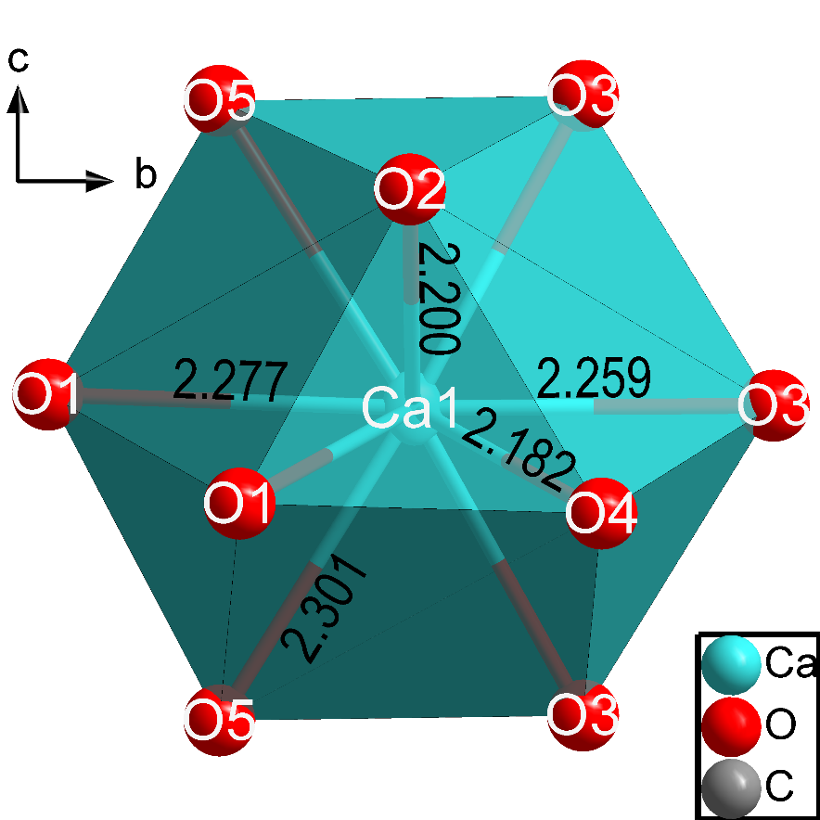
Figure S4. Geometry of a CaO₁₂ anticuboctahedron in the crystal structure of oP32 CaC₂O₅ at 122 GPa, resolved from the single-crystal X-ray diffraction data.
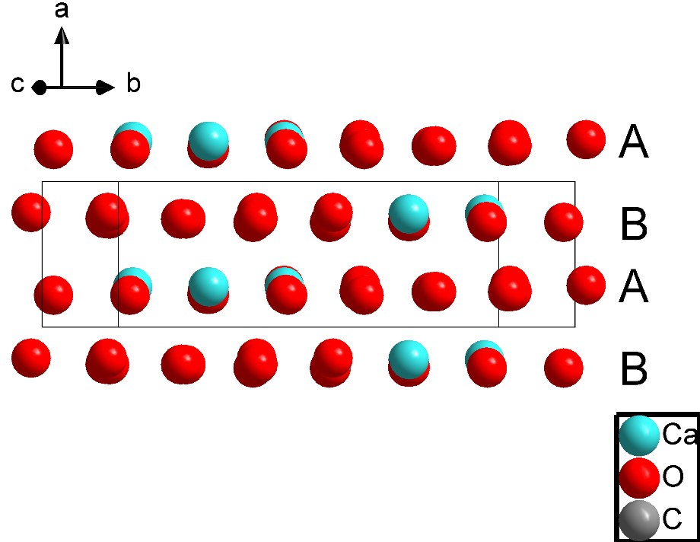
Figure S5. In the crystal structure of oP32 CaC₂O₅, layers of Ca and O atoms are stacking normal to the a axis in ABAB manner with formation of distorted hexagonal-close packing (hcp) arrangement.
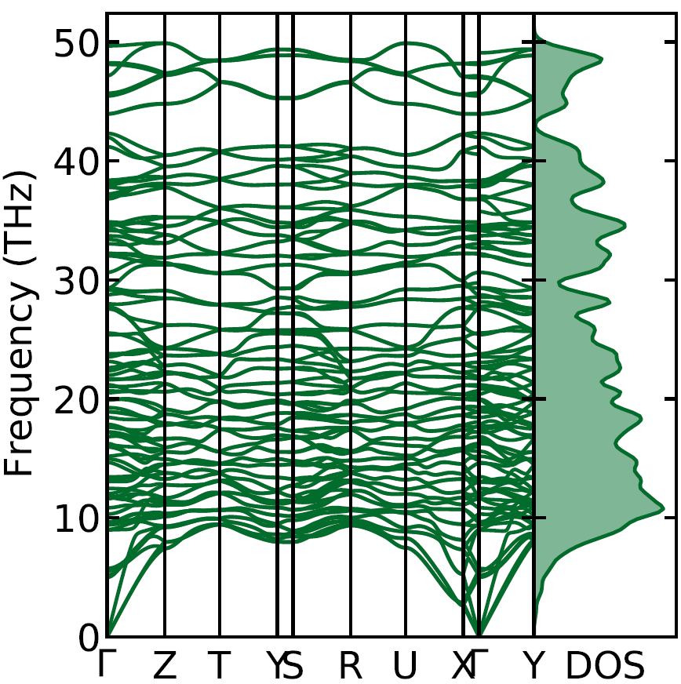
Figure S6. Phonon dispersion curves along high-symmetry directions in the Brillouin zone for oP32 CaC₂O₅ calculated at the experimental volume of ~ 189.68 Å3 (corresponds to theoretical pressure of ~126.9 GPa)^{[42]}.
Figure S7: Results of DFT calculated enthalpy difference between novel oP32 CaC₂O₅ and previously reported phases: a) tI64 CaC₂O₅^{[4]}, b) oF64 CaC₂O₅^{[1]} and c) mC16 CaC₂O₅^{[1]}. The calculations were performed in the pressure range of 20GPa – 160GPa with the step of 10GPa and indicate a higher stability of the experimental phase than all previously reported models.

Table S3. Crystal data and structure refinement for oP32 CaC₂O₅ at 293 K and 122 GPa.
 | Experimental | Calculated
Empirical formula | Ca C2 O5 | Ca C2 O5
Formula weight | 144.1 g/mol | 144.1 g/mol
Temperature | 293 K | -
Wavelength | 0.41 Å | -
Crystal system | orthorhombic | orthorhombic
Space group | P n a 21 | P 21 c n
Unit cell dimensions | a = 3.8651(18) Å, α = 90°  b = 13.334(5) Å, β = 90°  c = 3.6804(13) Å, γ = 90° | a = 3.8684 Å, α = 90°  b = 13.4135 Å, β = 90°  c = 3.6945 Å, γ = 90°
Volume | 189.68(13) Å³ | 191.7016 Å³
Z | 4 | 4
Density (calculated) | 5.046 g/cm³ | 4.9927 g/cm³
Absorption coefficient | 0.673 mm⁻¹ | -
Crystal size | 0.03 x 0.02 x 0.01 mm³ | -
θ range for data collection | 3.31 to 21° | -
Index ranges | -4<=h<=4, -17<=k<=19, -4<=l<=5 | -
Reflections collected | 356 | -
Independent reflections | 304 [R_{int} = 0.0742] | -
Completeness to θ = 15.5° | 57% | -
Data / restraints / parameters | 304 / 0 / 38 | -
Goodness-of-fit | 1.3005 | -
Final R indices [I>3σ(I)] | R_{obs} = 0.0567, wR_{obs} = 0.0750 | -
R indices [all data] | R_{all} = 0.1290, wR_{all} = 0.0828 | -
Largest diff. peak and hole | 1.42 and -1.66 e·Å⁻³ | -

Table S4. Results of ab initio calculations of oP32 CaC₂O₅.
Phase | Pressure (GPa) | Lattice parameters (Å, deg) |  |  | Atom | Coordinates
 |  |  |  |  |  | x | y | z
oP32 CaC₂O₅ | 126 | a = 3.85589 | b = 13.36968 | c = 3.67939 | Ca1 | 0.06629 | 0.37465 | 0.22065
 |  | α = 90 | β = 90 | γ = 90 | Ca2 | 0.93371 | 0.62535 | 0.72065
 |  |  |  |  | Ca3 | 0.56629 | 0.12535 | 0.22065
 |  |  |  |  | Ca4 | 0.43371 | 0.87465 | 0.72065
 |  |  |  |  | C1 | 0.60235 | 0.45749 | 0.64736
 |  |  |  |  | C2 | 0.39765 | 0.54251 | 0.14736
 |  |  |  |  | C3 | 0.10235 | 0.04251 | 0.64736
 |  |  |  |  | C4 | 0.89765 | 0.95749 | 0.14736
 |  |  |  |  | C5 | 0.57149 | 0.29227 | 0.61505
 |  |  |  |  | C6 | 0.42851 | 0.70773 | 0.11505
 |  |  |  |  | C7 | 0.07149 | 0.20773 | 0.61505
 |  |  |  |  | C8 | 0.92851 | 0.79227 | 0.11505
 |  |  |  |  | O1 | 0.91608 | 0.45469 | 0.72926
 |  |  |  |  | O2 | 0.08392 | 0.54531 | 0.22926
 |  |  |  |  | O3 | 0.41608 | 0.04531 | 0.72926
 |  |  |  |  | O4 | 0.58392 | 0.95469 | 0.22926
 |  |  |  |  | O5 | 0.41694 | 0.37525 | 0.754
 |  |  |  |  | O6 | 0.58306 | 0.62475 | 0.254
 |  |  |  |  | O7 | 0.91694 | 0.12475 | 0.754
 |  |  |  |  | O8 | 0.08306 | 0.87525 | 0.254
 |  |  |  |  | O9 | 0.57124 | 0.29417 | 0.27344
 |  |  |  |  | O10 | 0.42876 | 0.70583 | 0.77344
 |  |  |  |  | O11 | 0.07124 | 0.20583 | 0.27344
 |  |  |  |  | O12 | 0.92876 | 0.79417 | 0.77344
 |  |  |  |  | O13 | 0.89718 | 0.28635 | 0.75937
 |  |  |  |  | O14 | 0.10282 | 0.71365 | 0.25937
 |  |  |  |  | O15 | 0.39718 | 0.21365 | 0.75937
 |  |  |  |  | O16 | 0.60282 | 0.78635 | 0.25937
 |  |  |  |  | O17 | 0.4336 | 0.53817 | 0.77367
 |  |  |  |  | O18 | 0.5664 | 0.46183 | 0.27367
 |  |  |  |  | O19 | 0.9336 | 0.96183 | 0.77367
 |  |  |  |  | O20 | 0.0664 | 0.03817 | 0.27367
mP32 CaC₂O₅ | 20 | a = 4.50919 | b = 14.13241 | c = 5.11895 | Ca1 | 0.98911 | 0.37284 | 0.20173
 |  | α = 90 | β = 90 | γ = 90 | Ca2 | 0.01089 | 0.62716 | 0.70173
 |  |  |  |  | Ca3 | 0.48911 | 0.12716 | 0.20173
 |  |  |  |  | Ca4 | 0.51089 | 0.87284 | 0.70173
 |  |  |  |  | C1 | 0.62986 | 0.46138 | 0.67569
 |  |  |  |  | C2 | 0.37015 | 0.53862 | 0.17569
 |  |  |  |  | C3 | 0.12986 | 0.03862 | 0.67569
 |  |  |  |  | C4 | 0.87015 | 0.96138 | 0.17569
 |  |  |  |  | C5 | 0.54844 | 0.28986 | 0.64805
 |  |  |  |  | C6 | 0.45156 | 0.71014 | 0.14805
 |  |  |  |  | C7 | 0.04844 | 0.21014 | 0.64805
 |  |  |  |  | C8 | 0.95156 | 0.78986 | 0.14805
 |  |  |  |  | O1 | 0.90059 | 0.45014 | 0.61225
 |  |  |  |  | O2 | 0.0994 | 0.54986 | 0.11225
 |  |  |  |  | O3 | 0.40059 | 0.04986 | 0.61225
 |  |  |  |  | O4 | 0.5994 | 0.95014 | 0.11225
 |  |  |  |  | O5 | 0.45719 | 0.38465 | 0.73648
 |  |  |  |  | O6 | 0.54281 | 0.61535 | 0.23648
 |  |  |  |  | O7 | 0.95719 | 0.11535 | 0.73648
 |  |  |  |  | O8 | 0.04281 | 0.88465 | 0.23648
 |  |  |  |  | O9 | 0.56008 | 0.28345 | 0.39937
 |  |  |  |  | O10 | 0.43992 | 0.71655 | 0.89938
 |  |  |  |  | O11 | 0.06008 | 0.21655 | 0.39937
 |  |  |  |  | O12 | 0.93992 | 0.78345 | 0.89937
 |  |  |  |  | O13 | 0.82229 | 0.26879 | 0.78989
 |  |  |  |  | O14 | 0.17771 | 0.73121 | 0.28989
 |  |  |  |  | O15 | 0.32229 | 0.23121 | 0.78989
 |  |  |  |  | O16 | 0.67771 | 0.76879 | 0.28989
 |  |  |  |  | O17 | 0.51269 | 0.5414 | 0.70932
 |  |  |  |  | O18 | 0.48731 | 0.4586 | 0.20932
 |  |  |  |  | O19 | 0.01269 | 0.9586 | 0.70932
 |  |  |  |  | O20 | 0.98731 | 0.0414 | 0.20932

Section D: mP80 CaCO3

Supplementary Text S1: Analysis of the experimentally obtained diffraction images was performed using the CrysAlisPro software suite and the Jana 2020 software. For the mP80 CaCO₃ phase, analyzing the crystal structure in the lower symmetry, chiral space group P2₁, parameter refinement yields a flack parameter of 0.5. This points to a racemic configuration, as is also suggested by the improved refinement statistics that the racemic configuration boasts over the models with fully Δ- or Λ- helicity. This led us to exclude an orthorhombic unit cell, though systematic extinctions pointed to a C-centered space group. This was done because all C-centered, as well as all primitive, orthorhombic space groups fail to appropriately describe the chirality of the tetrahedral chains, as they have a ratio of either 1:0 or 2:3 between chains of tetrahedra of Δ and Λ helicity. We attribute this mismatch to the dynamic disorder of the carbon atoms within the structure, which we were unable to refine reliably, due to the limitations of the opening of the diamond anvil cell used in the experiment. The resulting monoclinic, racemic model lies in agreement both with the previously reported model^{[16]} and the model produced by the ab initio calculations performed in this work, both of which suggest the P2₁/c space group (albeit for different unit cells), widely used to describe racemic compounds. Taking all this information into account, the P2₁/c space group was chosen as the most accurate description of the crystal structure of the new CaCO₃ phase.

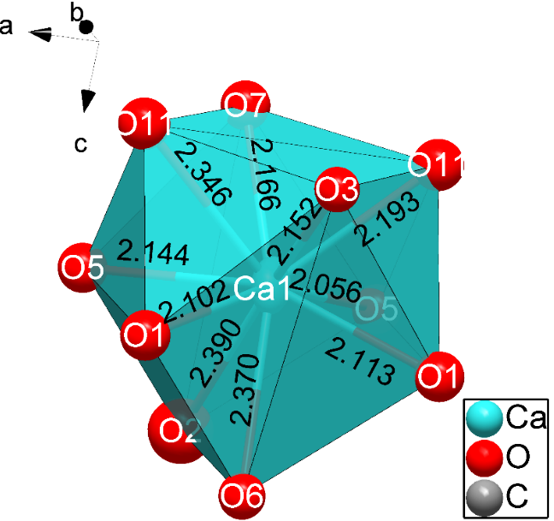
Figure S8. Geometry of a CaO₁₀ hendecahedron in the crystal structure of mP80 CaCO₃ at 122 GPa, resolved from the single-crystal X-ray diffraction data.

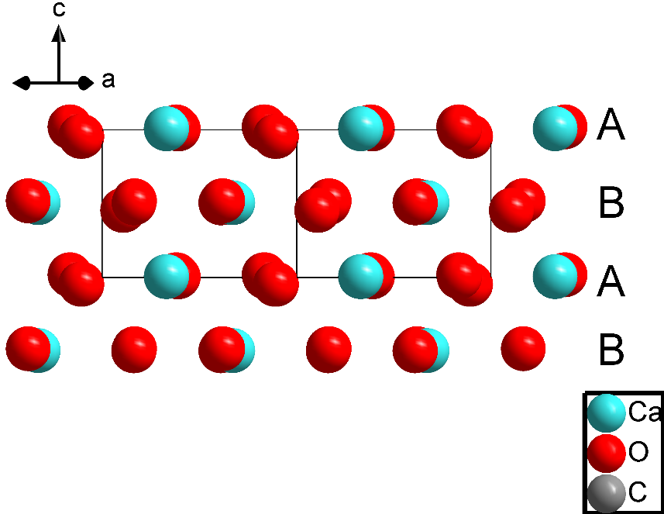
Figure S9. In the crystal structure of mP80 CaCO₃, layers of Ca and O atoms are stacking normal to the c axis in ABAB manner with formation of distorted hexagonal-close packing (hcp) arrangement.
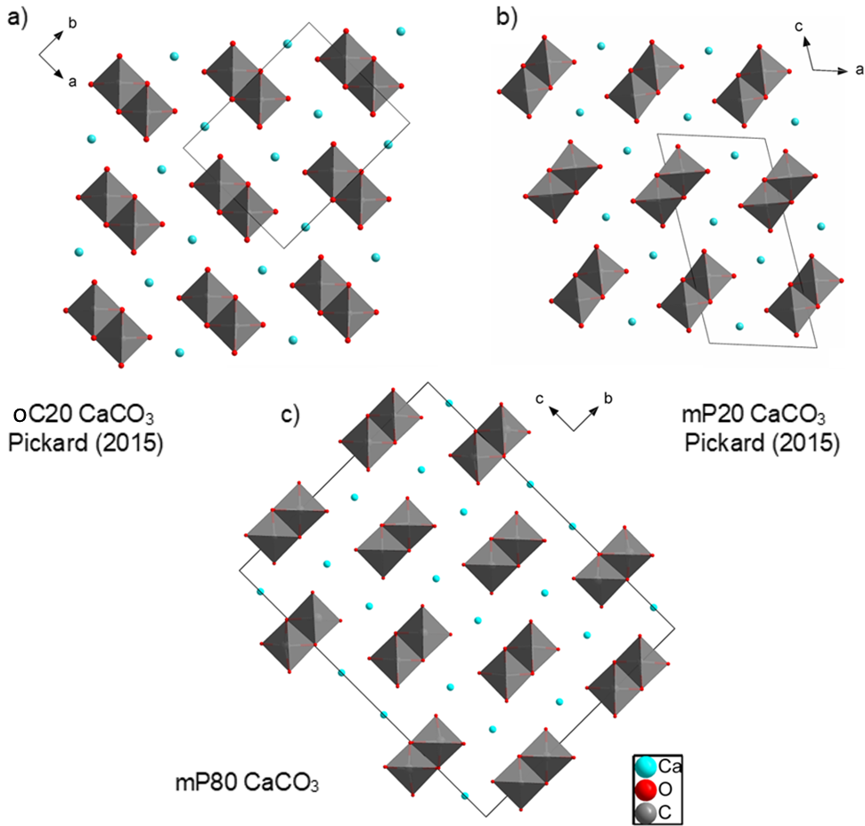
Figure S10: Comparison of chirality of the ${CO}_{4}^{4-}$ chains between the different models. a) The previously calculated oC20 CaCO₃ model (unit cell parameters a = 5.5057 (4) Å, b = 7.2389(3) Å, c = 3.3425(2) Å, V = 133.2161(2) Å³)^{[16]} displays only one chirality for all chains. b) The previously calculated mP20 CaCO₃ (unit cell parameters a = 4.5288(13) Å, b = 3.3345(3) Å, c = 9.0927(24) Å, β = 105.57(9)°, V = 132.27256(2) Å³)^{[16]} features a racemic mixture of chains of both Δ and Λ helicity, in agreement to the c) mP80 CaCO₃ structure (unit cell parameters a = 3.2989(4) Å, b = 10.877(4) Å, c = 14.224(4) Å, β = 90.162(16)°, V = 510.4(2) Å³) determined by our experimental data.

Figure S11: Le bail profile fitting of data for CaCO₃ at 105 GPa published by Lobanov et al.^{[16]}. The goodness of fit parameters are (a) 1.47 for the mP80 CaCO₃ that we determined in this work, (b) 1.70 for the mP20 CaCO₃ model^{[15]}, and (c) 2.11 for the oC20 CaCO₃ model^{[15]}. While all reflection observed by Lobanov et al.^{[16]} can be described by our structural model, some reflections not as well accounted by models proposed before^{[15-16]}. Thus we conclude that the mP20 CaCO₃-phase could be the same described by Lobanov et al.^{[16]}. Original diffraction data were provided by Dr S. Lobanov.

Figure S12: Results of ab initio calculations on the new mP80 CaCO₃ phase. a) Enthalpy difference as a function of pressure between the mP80 CaCO₃ phase and previously calculated oC20 and mP20 models. The relaxed structure of the experimentally determined model demonstrates higher stability than previously calculated models. b) The pressure dependence of the mP80 CaCO₃ unit cell volume. The red and black solid circle represents experimental and theoretical data, respectively. The black dashed line shows the fit of the calculated P-V data using the third-order Birch-Murnaghan equation of state.

Table S5. Crystal data and structure refinement for mP80 CaCO₃ at 293 K and 122 GPa.
 | Experimental | Calculated
Empirical formula | Ca C O3 | Ca C O3
Formula weight | 100.1 g/mol | 100.1 g/mol
Temperature | 293 K | -
Wavelength | 0.41 Å | -
Crystal system | monoclinic | monoclinic
Space group | P 21/c 1 1 | P 21/c 1 1
Unit cell dimensions | a = 3.2989(4) Å, α = 90°  b = 10.877(4) Å, β = 90.162(16)°  c = 14.224(4) Å, γ = 90° | a = 10.872 Å, α = 90°  b = 3.298 Å, β = 90°  c = 14.217 Å, γ = 90°
Volume | 510.4(2) Å³ | 509.7627 Å³
Z | 16 | 16
Density (calculated) | 5.2102 g/cm³ | 5.2165 g/cm³
Absorption coefficient | 0.922 mm⁻¹ | -
Crystal size | 0.03 x 0.015 x 0.01 mm³ | -
θ range for data collection | 3.66 to 20.89° | -
Index ranges | -4<=h<=4, -11<=k<=13, -15<=l<=18 | -
Reflections collected | 1399 | -
Independent reflections | 787 [R_{int} = 0.0108] | -
Completeness to θ = 13.48° | 45% | -
Data / restraints / parameters | 787 / 0 / 101 | -
Goodness-of-fit | 1.51 | -
Final R indices [I>3σ(I)] | R_{obs} = 0.0391, wR_{obs} = 0.0501 | -
R indices [all data] | R_{all} = 0.1014, wR_{all} = 0.0536 | -
Largest diff. peak and hole | 0.64 and -0.59 e·Å⁻³ | -

Table S6. Results of ab initio calculations in this study.
Phase | Pressure (GPa) | Lattice parameters (Å, deg) |  |  | Atom | Coordinates
 |  |  |  |  |  | x | y | z
mP80 CaCO₃ | 128 | a = 10.87200 | b = 3.29800 | c = 14.21700 | Ca1 | 0.750063 | 0.288630 | 0.164228
 |  | α = 90 | β = 90 | γ = 90 | Ca2 | 0.250063 | 0.288629 | 0.664228
 |  |  |  |  | Ca3 | 0.999934 | 0.711372 | 0.085772
 |  |  |  |  | Ca4 | 0.499935 | 0.711371 | 0.585772
 |  |  |  |  | O1 | 0.637780 | 0.790127 | 0.193534
 |  |  |  |  | O2 | 0.137781 | 0.790127 | 0.693534
 |  |  |  |  | O3 | 0.612219 | 0.290130 | 0.056467
 |  |  |  |  | O4 | 0.112219 | 0.290130 | 0.556466
 |  |  |  |  | O5 | 0.861460 | 0.777023 | 0.193239
 |  |  |  |  | O6 | 0.361460 | 0.777022 | 0.693239
 |  |  |  |  | O7 | 0.888539 | 0.222981 | 0.056761
 |  |  |  |  | O8 | 0.388539 | 0.222981 | 0.556761
 |  |  |  |  | O9 | 0.500518 | 0.260739 | 0.195565
 |  |  |  |  | O10 | 0.000518 | 0.260739 | 0.695565
 |  |  |  |  | O11 | 0.749483 | 0.760743 | 0.054435
 |  |  |  |  | O12 | 0.249483 | 0.760743 | 0.554435
 |  |  |  |  | C13 | 0.572875 | 0.007557 | 0.250405
 |  |  |  |  | C14 | 0.072875 | 0.007556 | 0.750404
 |  |  |  |  | C15 | 0.322875 | 0.492439 | 0.000404
 |  |  |  |  | C16 | 0.822875 | 0.492439 | 0.500404

Section E: References

[1] X. Yao, C. Xie, X. Dong, A. R. Oganov, Q. Zeng, Physical Review B 2018, 98, 014108.
[2] H. Wang, L. Liu, Z. Gao, L. Yang, G. Naren, S. Mao, Nature Communications 2024, 15, 755.
[3] D. N. Sagatova, P. N. Gavryushkin, N. E. Sagatov, M. V. Banaev, Physical Chemistry Chemical Physics 2022, 24, 23578-23586.
[4] J. König, D. Spahr, L. Bayarjargal, P. N. Gavryushkin, D. Sagatova, N. Sagatov, V. Milman, H.-P. Liermann, B. Winkler, ACS Earth and Space Chemistry 2022, 6, 73-80.
[5] R. W. G. Wyckoff, American journal of science 1920, 4, 317-360.
[6] E. N. Maslen, V. A. Streltsov, N. R. Streltsova, Acta Crystallographica Section B 1993, 49, 636-641.
[7] L. Merrill, W. A. Bassett, Acta Crystallographica Section B 1975, 31, 343-349.
[8] M. Merlini, M. Hanfland, W. Crichton, Earth and planetary science letters 2012, 333, 265-271.
[9] aN. Ishizawa, Powder Diffraction 2014, 29, S19-S23; bN. Ishizawa, H. Setoguchi, K. Yanagisawa, Scientific Reports 2013, 3, 2832.
[10] D. Druzhbin, S. V. Rashchenko, A. Shatskiy, W. A. Crichton, ACS Earth and Space Chemistry 2022, 6, 1506-1513.
[11] P. N. Gavryushkin, N. S. Martirosyan, T. M. Inerbaev, Z. I. Popov, S. V. Rashchenko, A. Y. Likhacheva, S. S. Lobanov, A. F. Goncharov, V. B. Prakapenka, K. D. Litasov, Crystal Growth & Design 2017, 17, 6291-6296.
[12] J. Santillán, Q. Williams, American mineralogist 2004, 89, 1348-1352.
[13] S. E. Palaich, R. A. Heffern, M. Hanfland, A. Lausi, A. Kavner, C. E. Manning, M. Merlini, American Mineralogist 2016, 101, 1651-1658.
[14] A. R. Oganov, C. W. Glass, S. Ono, Earth and Planetary Science Letters 2006, 241, 95-103.
[15] C. J. Pickard, R. J. Needs, Physical Review B 2015, 91, 104101.
[16] S. S. Lobanov, X. Dong, N. S. Martirosyan, A. I. Samtsevich, V. Stevanovic, P. N. Gavryushkin, K. D. Litasov, E. Greenberg, V. B. Prakapenka, A. R. Oganov, A. F. Goncharov, Physical Review B 2017, 96, 104101.
[17] J. Binck, D. Laniel, L. Bayarjargal, S. Khandarkhaeva, T. Fedotenko, A. Aslandukov, K. Glazyrin, V. Milman, S. Chariton, V. B. Prakapenka, American Mineralogist 2022, 107, 336-342.
[18] D. Spahr, L. Bayarjargal, M. Bykov, L. Brüning, P. L. Jurzick, Y. Wang, V. Milman, K. Refson, M. Mezouar, B. Winkler, Communications Chemistry 2024, 7, 238.
[19] D. Sagatova, A. Shatskiy, N. Sagatov, P. N. Gavryushkin, K. D. Litasov, Lithos 2020, 370-371, 105637.
[20] D. Spahr, J. König, L. Bayarjargal, P. N. Gavryushkin, V. Milman, H.-P. Liermann, B. Winkler, Inorganic Chemistry 2021, 60, 14504-14508.
[21] D. Spahr, J. Binck, L. Bayarjargal, R. Luchitskaia, W. Morgenroth, D. Comboni, V. Milman, B. Winkler, Inorganic Chemistry 2021, 60, 5419-5422.
[22] D. N. Sagatova, P. N. Gavryushkin, N. E. Sagatov, M. V. Banaev, Journal of Computational Chemistry 2023, 44, 2453-2460.
[23] M. V. Banaev, N. E. Sagatov, D. N. Sagatova, P. N. Gavryushkin, ChemistrySelect 2022, 7, e202201940.
[24] E. Boulard, D. Pan, G. Galli, Z. Liu, W. L. Mao, Nature Communications 2015, 6, 6311.
[25] V. Kovalev, D. Spahr, B. Winkler, L. Bayarjargal, L. Wedek, A. Aslandukova, A. Pakhomova, G. Garbarino, E. Bykova, Communications Chemistry 2025, 8, 66.
[26] D. Spahr, E. Bykova, L. Bayarjargal, V. Milman, H.-P. Liermann, B. Winkler, Chemical Communications 2025, 61, 161-164.
[27] M. Merlini, M. Hanfland, A. Salamat, S. Petitgirard, H. Müller, American Mineralogist 2015, 100, 2001-2004.
[28] V. Cerantola, E. Bykova, I. Kupenko, M. Merlini, L. Ismailova, C. McCammon, M. Bykov, A. I. Chumakov, S. Petitgirard, I. Kantor, Nature Communications 2017, 8, 15960.
[29] aS. Chariton, (Bayreuth), 2020; bS. Chariton, M. Bykov, E. Bykova, E. Koemets, T. Fedotenko, B. Winkler, M. Hanfland, V. B. Prakapenka, E. Greenberg, C. McCammon, L. Dubrovinsky, Acta Crystallogr E Crystallogr Commun 2020, 76, 715-719.
[30] I. Kantor, V. Prakapenka, A. Kantor, P. Dera, A. Kurnosov, S. Sinogeikin, N. Dubrovinskaia, L. Dubrovinsky, Rev Sci Instrum 2012, 83, 125102.
[31] I. Y. Kantor, C. A. McCammon, L. S. Dubrovinsky, Journal of Alloys and Compounds 2004, 376, 5-8.
[32] I. Kupenko, X. Li, S. C. Müller, D. Bessas, S. Yaroslavtsev, G. Aprilis, A. I. Chumakov, J. P. Celse, R. Rüffer, High Pressure Research 2024, 44, 310-336.
[33] Y. Agilent Technologies Ltd, Oxfordshire, England, 2014.
[34] A. Aslandukov, M. Aslandukov, N. Dubrovinskaia, L. Dubrovinsky, Journal of Applied Crystallography 2022, 55, 1383-1391.
[35] aV. D. Petricek, M., 2000; bL. Palatinus, G. Chapuis, Journal of Applied Crystallography 2007, 40, 786-790.
[36] G. Kresse, J. Furthmüller, Computational Materials Science 1996, 6, 15-50.
[37] aP. E. Blöchl, Physical Review B 1994, 50, 17953-17979; bG. Kresse, D. Joubert, Physical Review B 1999, 59, 1758-1775.
[38] J. P. Perdew, K. Burke, M. Ernzerhof, Physical Review Letters 1996, 77, 3865-3868.
[39] H. J. Monkhorst, J. D. Pack, Physical Review B 1976, 13, 5188-5192.
[40] A. Togo, I. Tanaka, Scripta Materialia 2015, 108, 1-5.
[41] P. E. Blöchl, O. Jepsen, O. K. Andersen, Physical Review B 1994, 49, 16223-16233.
[42] aA. Togo, Journal of the Physical Society of Japan 2022, 92, 012001; bA. Togo, L. Chaput, T. Tadano, I. Tanaka, Journal of Physics: Condensed Matter 2023, 35, 353001.

