Schwann cell-derived extracellular vesicles inhibit osteoclastogenesis through the PTEN/AKT axis in peripheral nerve-bone crosstalk
Huijian Yang^{1,2,3,4,5,6✝}, Biao Yu^{1,2,3,4,5✝}, Ruiyang Li^{7✝}, Yang Hong^{1,2,3,4,5✝}, Mingzhu Shen^{1,2,3,4,5}, Tianzhuo Shen^{1,2,3,4,5}, Xiuhui Wang^{1,2,3,4}, Han Liu^{1,2,3,4}, Ke Xu^{1,2,3,4*}, Yuhai Ma^{7*}, Mengmeng Li^{1,2,3,4,8*}, Jiacan Su^{1,2,3,4,7*}

Supplementary data

Fig. S1 Effects of SCs and SC-CM on the viability of BMMs. A) Cell viability of BMMs after direct co-culture with SCs. B) Cell viability of BMMs after co-culture with SC-CM. n = 3, *P < 0.05, **P < 0.01, ***P < 0.001.
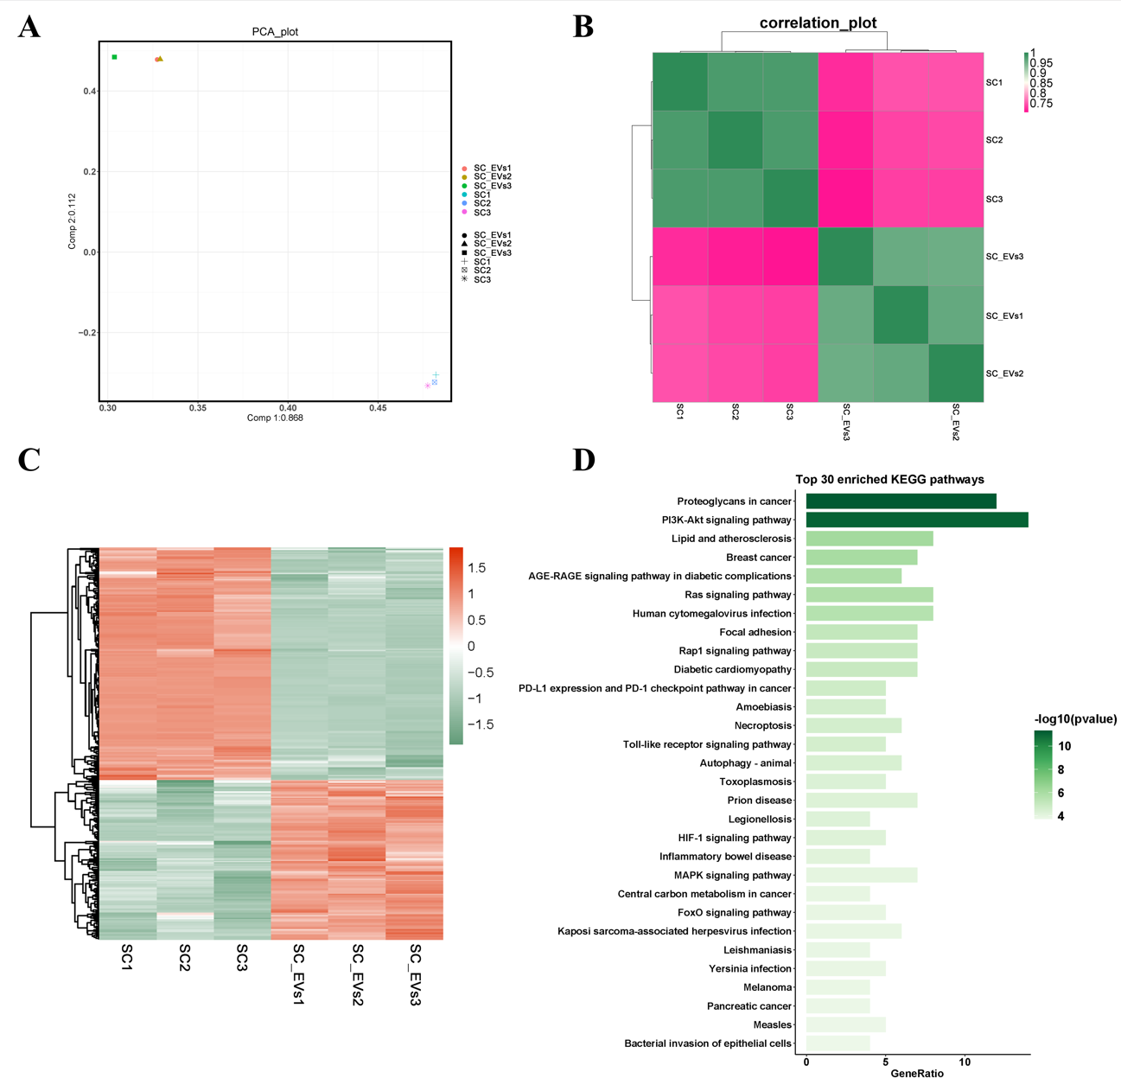

Fig. S2 Differential miRNA expression profiles between SCs and SC-EVs. A) PCA. B) Inter-sample correlation. C) Heatmap of differentially expressed miRNAs. D) KEGG pathway enrichment bar plot

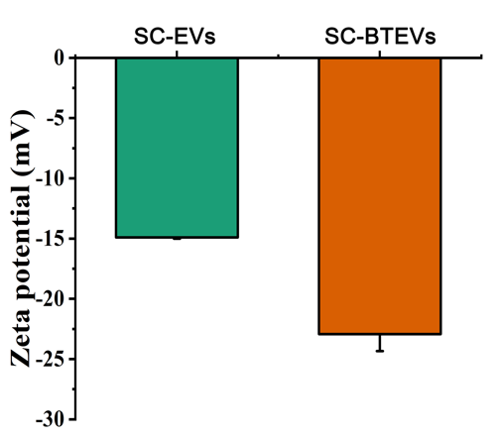

Fig. S3 Zeta potential of engineered SC-BTEVs by DLS.Zeta potential of engineered SC-BTEVs measured by DLS.

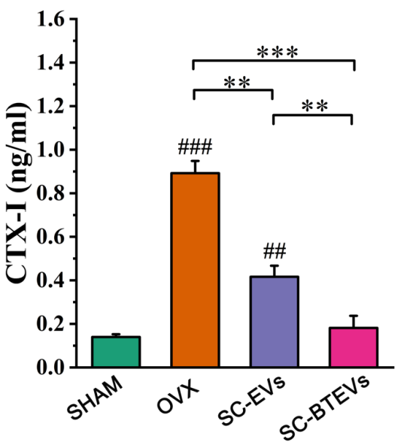

Fig. S4 Serum levels of the bone resorption marker CTX-I measured by ELISA from mice in different treatment groups. n = 5, *P < 0.05, **P < 0.01, ***P < 0.001; #P < 0.05, ##P < 0.01, ###P < 0.001 vs. SHAM

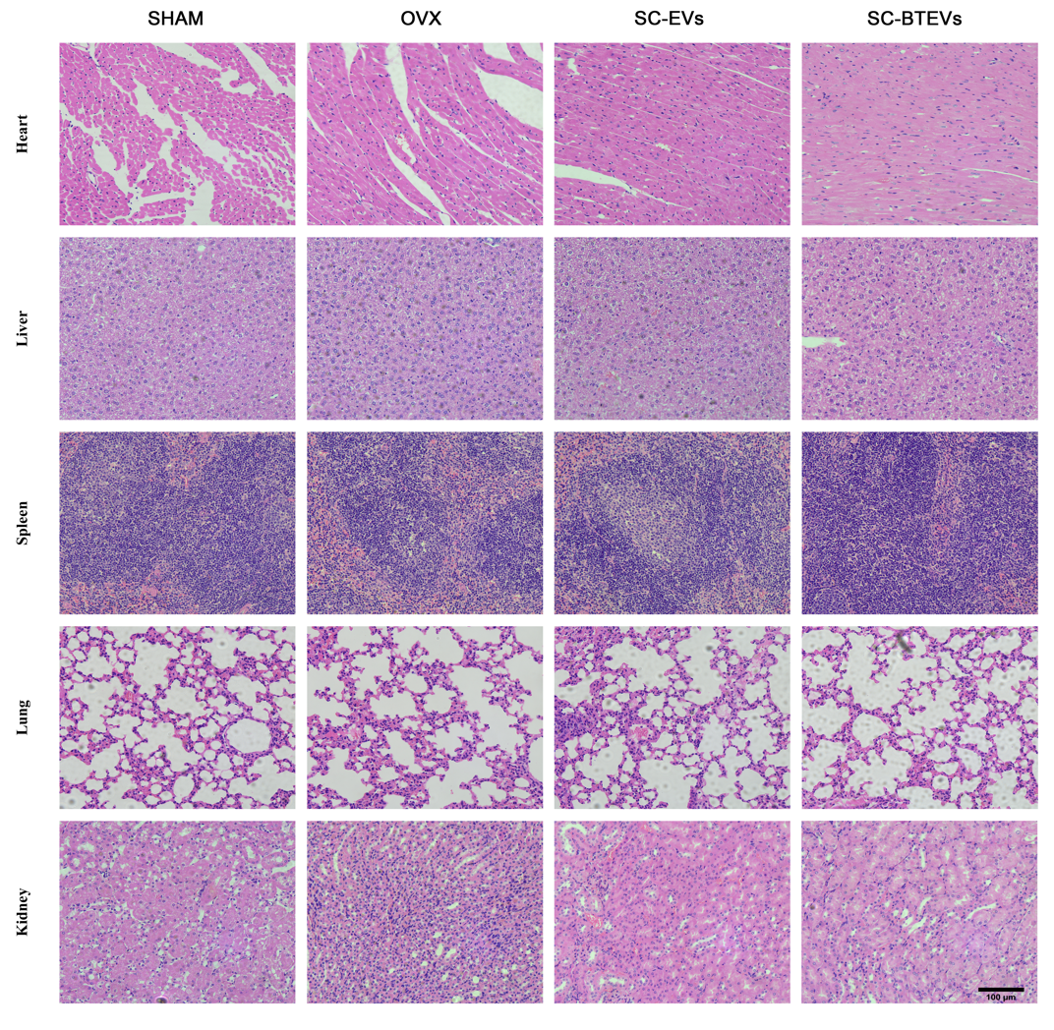

Fig. S5 H&E staining of heart, liver, spleen, lung, and kidney from mice in different treatment groups

Table S1 The primers of genes used in the article

Gene | Primer sequence (5‘ to 3’)
Nfatc1-F | CACTCCACCCACTTCTGACTTCC
Nfatc1-R | GGCTGCCTTCCGTCTCATAGTG
ACP5-F | CACGATGCCAGCGACAAGA
ACP5-R | TGAAGCGCAAACGGTAGTAAGG
Ctsk-F | GTTGACTTCCGCAATCCTTACC
Ctsk-R | CAGCAGAAACTTGAACACCCAC
PTEN-F | TTGAAGACCATAACCCACCACA
PTEN-R | ATCATTACACCAGTCCGTCCCT
GAPDH -F | CCTCGTCCCGTAGACAAAATG
GAPDH -R | TGAGGTCAATGAAGGGGTCGT

✝Huijian Yang, Biao Yu, Ruiyang Li and Yang Hong contributed equally to this work. ___________________________ *Correspondence: Ke Xu kexu@shu.edu.cn Yuhai Ma yuhaima@126.com Mengmeng Li mengmengli@shu.edu.cn Jiacan Su drsujiacan@163.com Full list of author information is available at the end of the article

