A Preliminary Validation Study of PES-JP Item 5 With and Without Explanatory Labels
Study Overview
A preliminary validation study involving 200 participants was conducted to examine whether the version of PES-JP Item 5 (exerting physical effort does not appeal to me) with explanatory labels on the scale points demonstrated better construct validity than the version without such labels. The results indicated that the labeled version showed stronger concurrent, convergent, and discriminant validity.

Group Classification
Group 1 (n = 100): Participants who completed the questionnaire version with explanatory labels added to the scale points of Item 5.
Group 2 (n = 100): Participants who completed the version without explanatory labels.

Concurrent Validity
Concurrent validity was assessed by examining the associations between PES-JP Item 5 and physical activity (PA) levels as measured by the IPAQ, comparing responses between Group 1 (with explanatory labels) and Group 2 (without explanatory labels). The results are summarized in Supplemental Table 1.

Supplemental Table 1. Concurrent, convergent, and discriminant validity of PES-JP Item 5 across two versions (with and without explanatory labels).
 | Group 1 |  |  |  | Group 2
 | N | β | p |  | N | β | p
Concurrent validity | 100 |  |  |  | 100
Usual level of PA | 100 |  |  |  | 100
MVPA | 100 | -0.19 | 0.053 |  | 100 | 0.00 | 0.977
Moderate PA | 100 | -0.10 | 0.340 |  | 100 | 0.06 | 0.560
Vigorous PA | 100 | -0.20 | 0.042 |  | 100 | -0.04 | 0.710
Walking | 100 | -0.26 | 0.010 |  | 100 | 0.03 | 0.735
Sitting | 100 | 0.23 | 0.022 |  | 100 | 0.20 | 0.045
Convergent validity
Autonomous motivation | 100 | -0.43 | <0.001 |  | 100 | -0.28 | 0.005
Affective attitudes | 100 | -0.21 | 0.038 |  | 100 | -0.20 | 0.045
Intentions | 100 | -0.33 | 0.001 |  | 100 | -0.02 | 0.850
Automaticity | 100 | -0.28 | 0.005 |  | 100 | -0.16 | 0.123
Discriminant validity
Controlled motivation | 100 | -0.11 | 0.287 |  | 100 | -0.15 | 0.141
Instrumental attitudes | 100 | -0.01 | 0.895 |  | 100 | 0.01 | 0.958
Notes. Usual level of PA =Physical activity as assessed by the International Physical Activity Questionnaire (IPAQ; Craig et al., 2003); MVPA = moderate-to-vigorous physical activity. Univariate linear regressions were used to assess the associations. All the variables were scaled to obtain standardized coefficients. Group 1 refers to participants who completed the version of the questionnaire with explanatory labels on Item 5 scale points, while Group 2 refers to those who completed the version without explanatory labels.

In Group 1, Item 5 showed significant associations with vigorous PA (β = –.20, p = .042), walking (β = –.26, p = .010), and sitting time (β = .23, p = .022). No significant associations were found with moderate PA or moderate-to-vigorous PA (MVPA).
In Group 2, the version without explanatory labels showed weaker concurrent validity. Item 5 was significantly associated only with sitting time (β = .20, p = .045), with no significant associations observed for MVPA, moderate PA, vigorous PA, or walking.

Convergent and Discriminant Validity
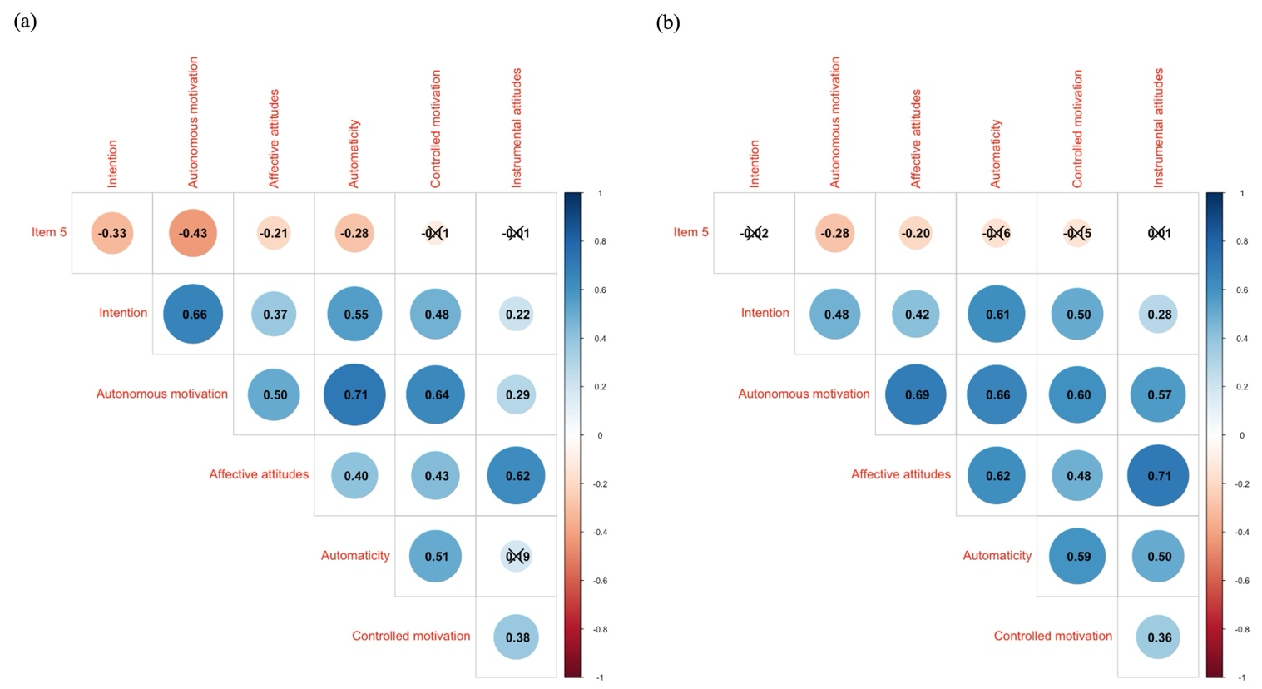
Supplemental Figure 1 illustrates the correlations between PES-JP Item 5 score and the variables used to assess convergent and discriminant validity. To assess convergent and discriminant validity, PES-JP Item 5 was examined in relation to theoretically relevant constructs for both Group 1 (with explanatory labels) and Group 2 (without explanatory labels): autonomous motivation, affective attitudes, and intentions (convergent validity); and controlled motivation and instrumental attitudes (discriminant validity).

Supplemental Figure 1. Correlation PES-JP Item 5 and related psychological variables.
Notes. Correlation coefficients are represented as colored circles. Larger and bluer circles indicate stronger positive correlations (closer to +1), redder and larger circles indicate stronger negative correlations (closer to –1), and smaller, whiter circles indicate weak or no correlation (closer to 0). (a) Group 1: Participants who completed the version with explanatory labels added to the scale points of Item 5. (b) Group 2: Participants who completed the version without explanatory labels.

In Group1, convergent validity was supported by statistically significant associations in the expected directions. Item 5 showed significant negative associations with autonomous motivation (β = -.43, p < 0.001), affective attitudes (β = -.21, p = .038), and intentions (β = -.33, p = .001), and automaticity (β = -.28, p = .005). For discriminant validity, no significant associations were observed with controlled motivation or instrumental attitudes.
In Group 2, convergent validity was partially supported. Item 5 showed significant negative associations with autonomous motivation (β = -.28, p = .005) and affective attitudes (β = -.20, p = .045), whereas no significant associations were observed for intentions and automaticity. As in Group 1, no significant associations were found with controlled motivation or instrumental attitudes.

These results collectively support the use of explanatory labels on PES-JP Item 5 to enhance construct validity.

Distribution of Physical Activity
A substantial proportion of participants reported no engagement in PA (Supplemental Figure 2). Specifically, among the 200 participants, 119 (59.5%) reported no MVPA, 142 (71.0%) reported no vigorous PA, and 140 (70.0%) reported no moderate PA. These findings underscore the high prevalence of physical inactivity in this preliminary validation study.
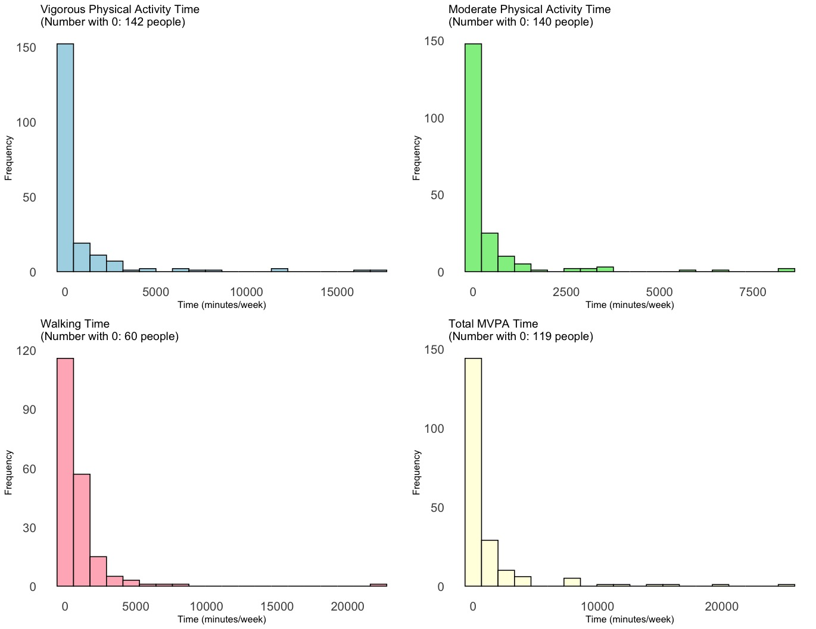
Supplemental Figure 2. Physical Activity Distribution in the Preliminary Validation Study

