ITS sequencing of the synthesised ectomycorrhizae confirmed their identity as T. umbilicatum (GenBank accession no. PQ657276), designated as mycorrhiza UM11 (Fig. S1).
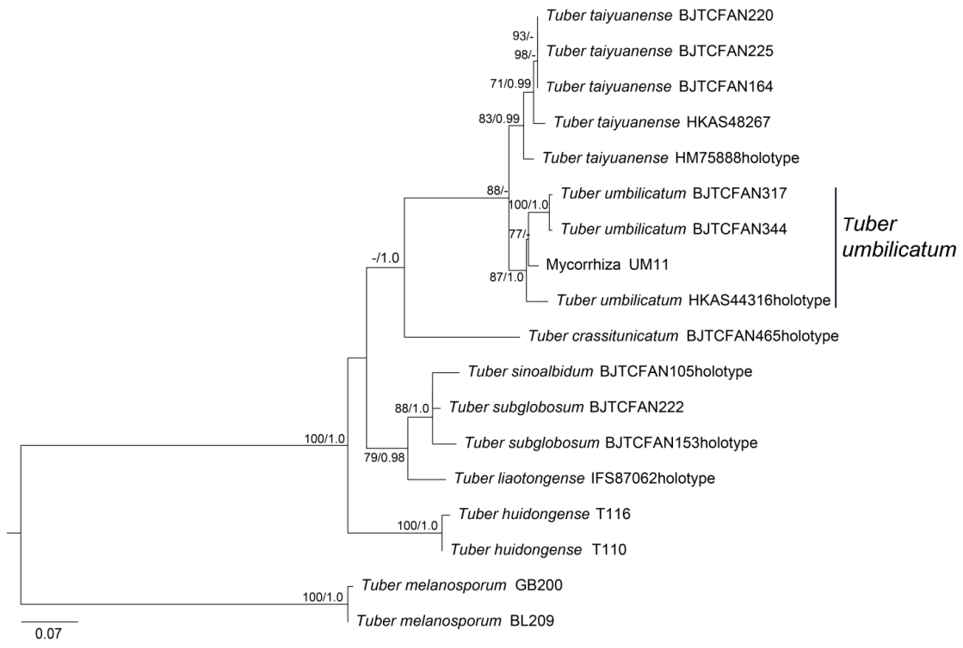
Fig. S1 ML tree inferred from the ITS sequences. Bootstrap values (≥ 70) and Posterior Probabilities (≥ 0.90) obtained from Bayesian Inference are indicated along nodes

Table S1 Content of available N, P, K in mycorrhizosphere substrate on different stages of inoculated and uninoculated T. umbilicatum
Sampling period | Treatment | Available nitrogen (mg/kg) | Available phosphorus (mg/kg) | Available potassium (mg/kg)
M2 | CK | 31.85±0.88a | 46.98±1.51b | 322.66±2.60c
M2 | T. umbilicatum | 32.84±0.65A | 47.53±2.13C | 323.20±2.18B
M4 | CK | 33.32±0.33a | 46.92±1.66b | 326.92±1.58b
M4 | T. umbilicatum | 32.87±1.05A | 48.42±0.81BC | 327.99±2.44B
M6 | CK | 32.39±2.04a | 48.47±0.88ab | 331.03±2.29a
M6 | T. umbilicatum | 32.76±2.71A | 50.77±1.52B | 339.54±3.96A
M8 | CK | 32.68±2.00a | 49.67±0.28a* | 332.52±1.21a
M8 | T. umbilicatum | 33.8±0.71A | 55.11±1.50A* | 341.97±4.11A
Note: CK: Control treatment; T. umbilicatum: inoculation treatment; M2, M4, M6, M8: samples collected 2, 4, 6, and 8 months after inoculation, respectively. Different lowercase letters indicate significant differences (p < 0.05) among different sampling periods for control treatment plants; different uppercase letters indicate significant differences (p < 0.05) among different sampling periods for T. umbilicatum inoculation treatment plants. * indicates a significant difference (p < 0.05) between the control treatment and the T. umbilicatum inoculation treatment at the same period

