Supplementary Materials

Degradable Scaffold-Mediated Synergistic Matrix Formation by Endogenous Cells: An In Vivo Manufacturing Strategy for Off-the-Shelf Cardiovascular Bypass Grafts to Address Clinical Shortages
Yijie Heª, Yunfei Moª, Xiaoyan Shenª, Jialin Xu ª, Shiwen Liuª, Xiuhong Sun ^{b}, Rui Zhou^{b}, Kai Fu^{b}, Yuqing Niu^{a,*}
ª School of Life and Health Technology, Dongguan University of Technology, Dongguan, 523808, China
^{b} Department of Pediatric Surgery, Guangdong Provincial Key Laboratory of Research in Structural Birth Defect Disease, Guangzhou Women and Children's Medical Center, Guangzhou Medical University, Guangzhou 510623, Guangdong, PR China
Corresponding authors: Yuqing Niu, School of Life and Health Technology, Dongguan University of Technology, Dongguan, 523808, China. E-mail: niuyuqing@dgut.edu.cn Telephone: +86-0769-22862190
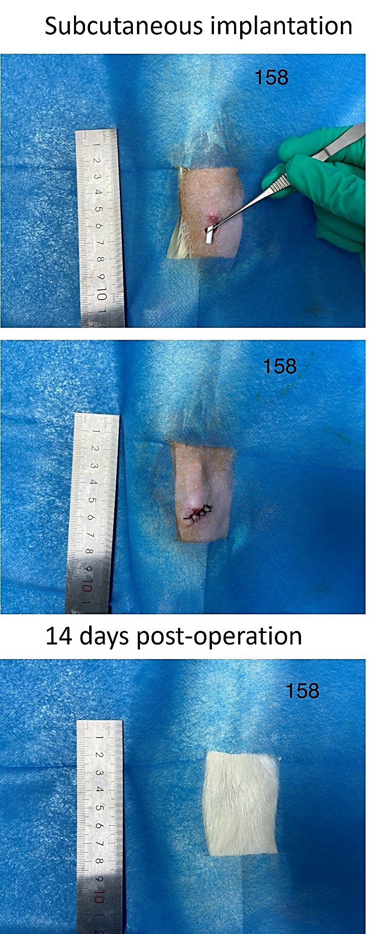
Figure S1. Representative digital images showing the incision site before (upper panel) and 14 days after (lower panel) subcutaneous implantation of the PLCL nanofibrous scaffold.
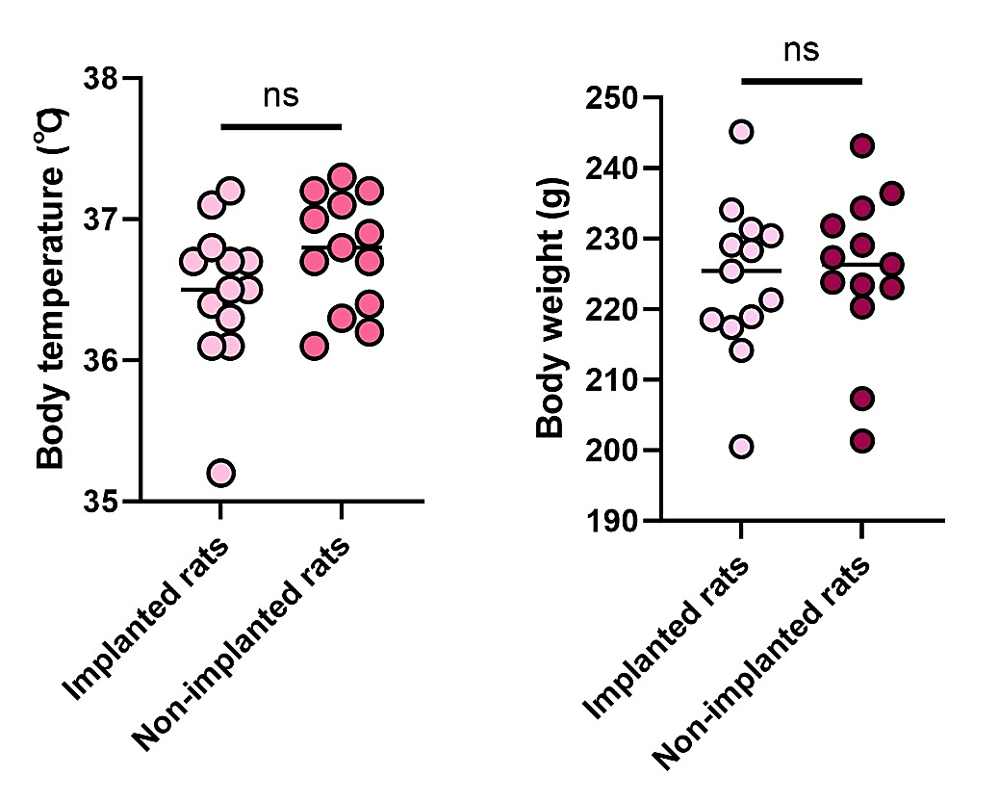
Figure S2. Quantitative data showing changes in body weight and body temperature in animals before and after implantation of the PLA scaffold (data are presented as mean ± SD, n=13).
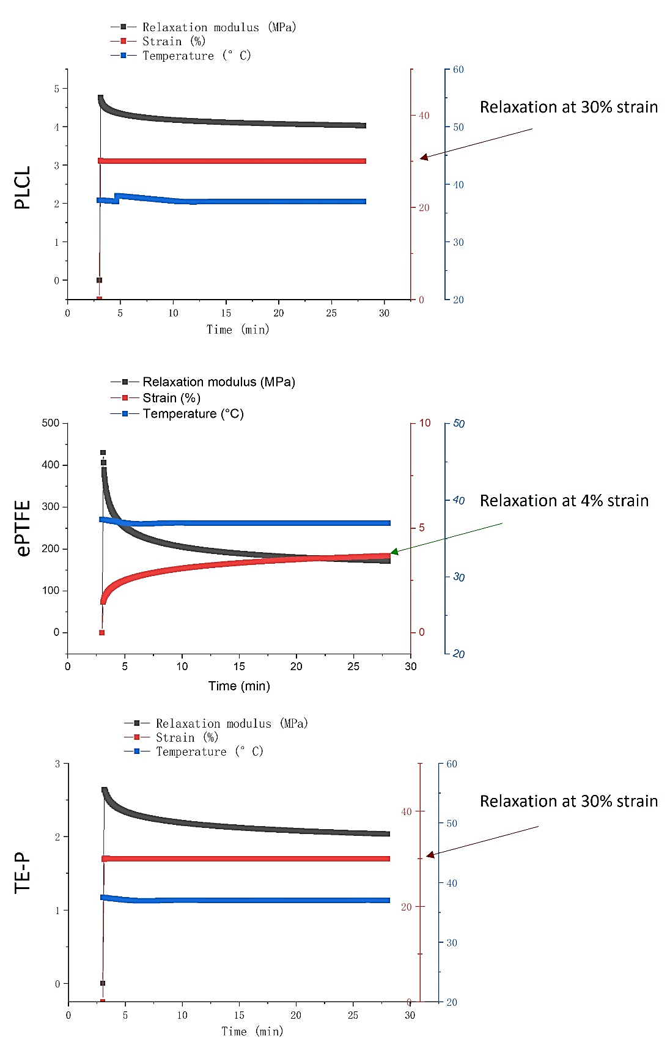
Figure S3. Relaxation responses of 30% strain PLCL nanofibers, 4% strain ePTFE, and 30% strain TE-P under continuous longitudinal stretching, showing time - dependent changes in relaxation modulus (MPa), strain (%), and temperature (°C) (data presented with dual - axis plots for modulus/strain vs temperature).
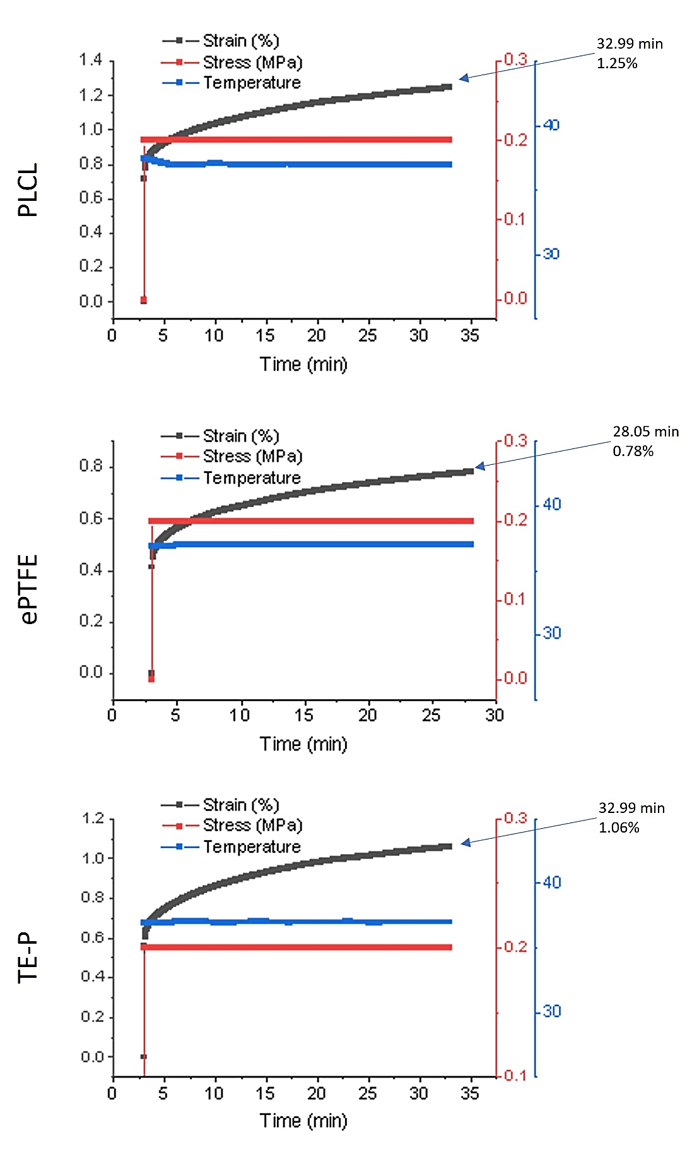
Figure S4. Time - dependent changes in strain (%), stress (MPa), and temperature for PLCL, ePTFE, and TE - P under continuous longitudinal stretching, showing the time to reach a specific strain threshold (32.99 min for PLCL with 1.25% strain change, 28.05 min for ePTFE with 0.78% strain change, and 32.99 min for TE-P with 1.06% strain change).
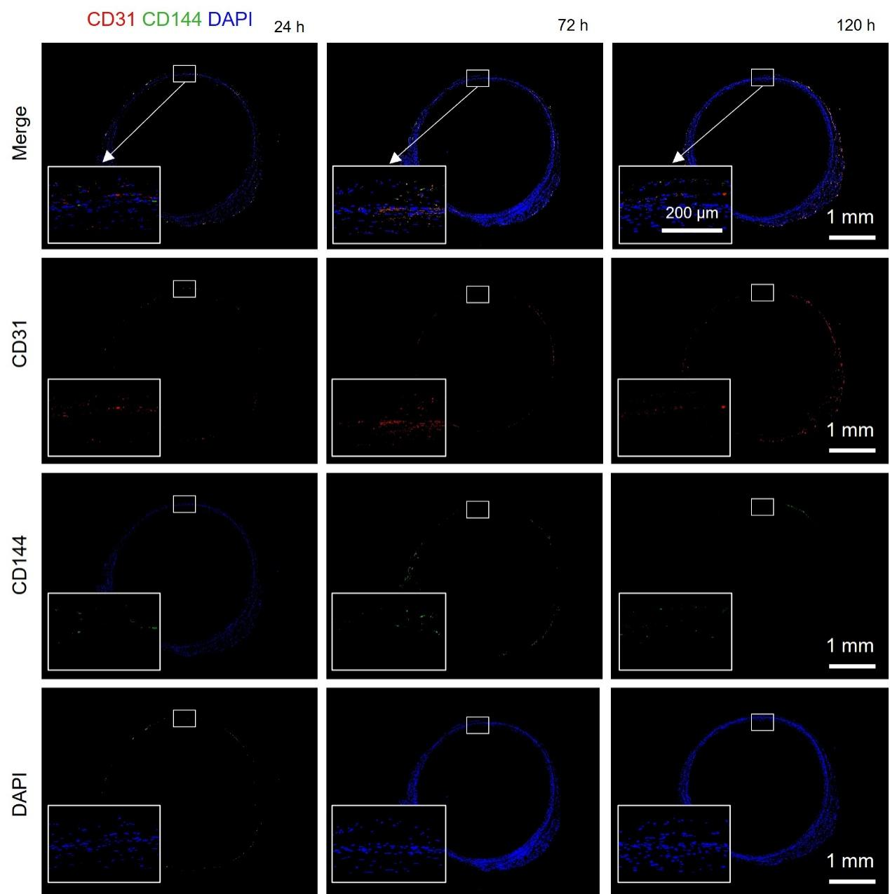
Figure S5. Immunofluorescence analysis of EC adhesion and junction formation on PLCL tissue sections at 24 h, 72 h, and 120 h after seeding with rat ECs. Panels are arranged from top to bottom as follows: merged image (CD31 in red, CD144 in green, and DAPI in blue), individual channel of CD31 (red, endothelial junction marker), CD144 (green, VE-cadherin, adherens junction protein), and DAPI (blue, nuclear counterstain). Insets show magnified views of the boxed regions, highlighting the progressive formation of cell-cell junctions and nuclear distribution over time.
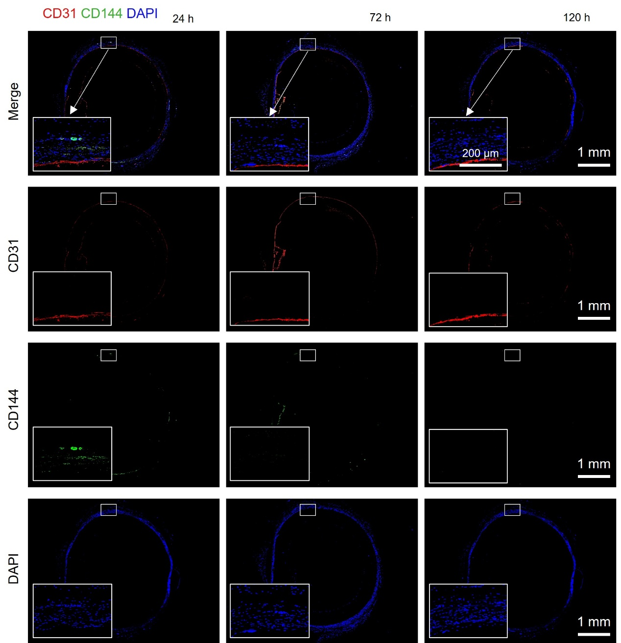
Figure S6. Immunofluorescence analysis of EC adhesion and junction formation on TE-P tissue sections at 24 h, 72 h, and 120 h after seeding with rat ECs. Panels are arranged from top to bottom as follows: merged image (CD31 in red, CD144 in green, and DAPI in blue), individual channel of CD31 (red, endothelial junction marker), CD144 (green, VE-cadherin, adherens junction protein), and DAPI (blue, nuclear counterstain). Insets show magnified views of the boxed regions, highlighting the progressive formation of cell-cell junctions and nuclear distribution over time.
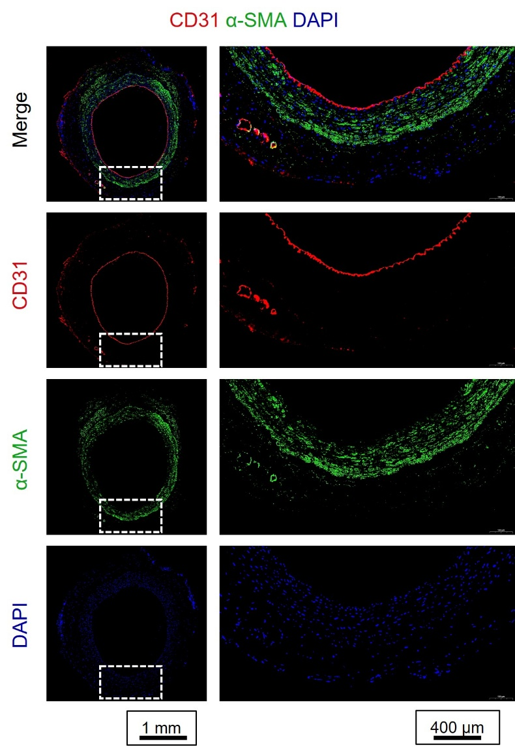
Figure S7. CD31 and α-SMA immunofluorescence staining in autograft tissue sections at 90 days post-treatment. Panels from top to bottom: merged image (CD31, red; α-SMA, green; DAPI, blue), CD31 (red, endothelial cell marker), α-SMA (green, smooth muscle cell marker), and DAPI (blue, nuclear stain). Insets show magnified views of the boxed areas, highlighting the organization of the endothelium and smooth muscle layer.
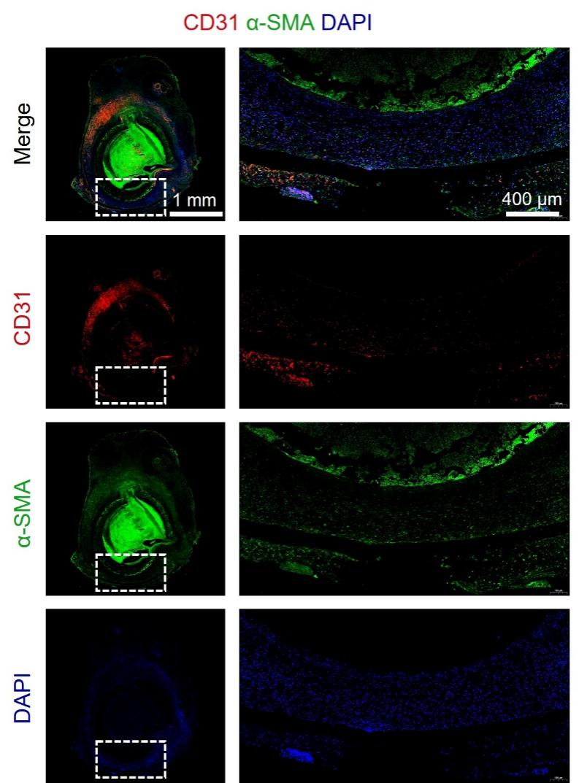
Figure S8. CD31 and α-SMA immunofluorescence staining in ePTFE tissue sections at 90 days post-treatment. Panels from top to bottom: merged image (CD31, red; α-SMA, green; DAPI, blue), CD31 (red, endothelial cell marker), α-SMA (green, smooth muscle cell marker), and DAPI (blue, nuclear stain). Insets show magnified views of the boxed areas, highlighting the organization of the endothelium and smooth muscle layer.
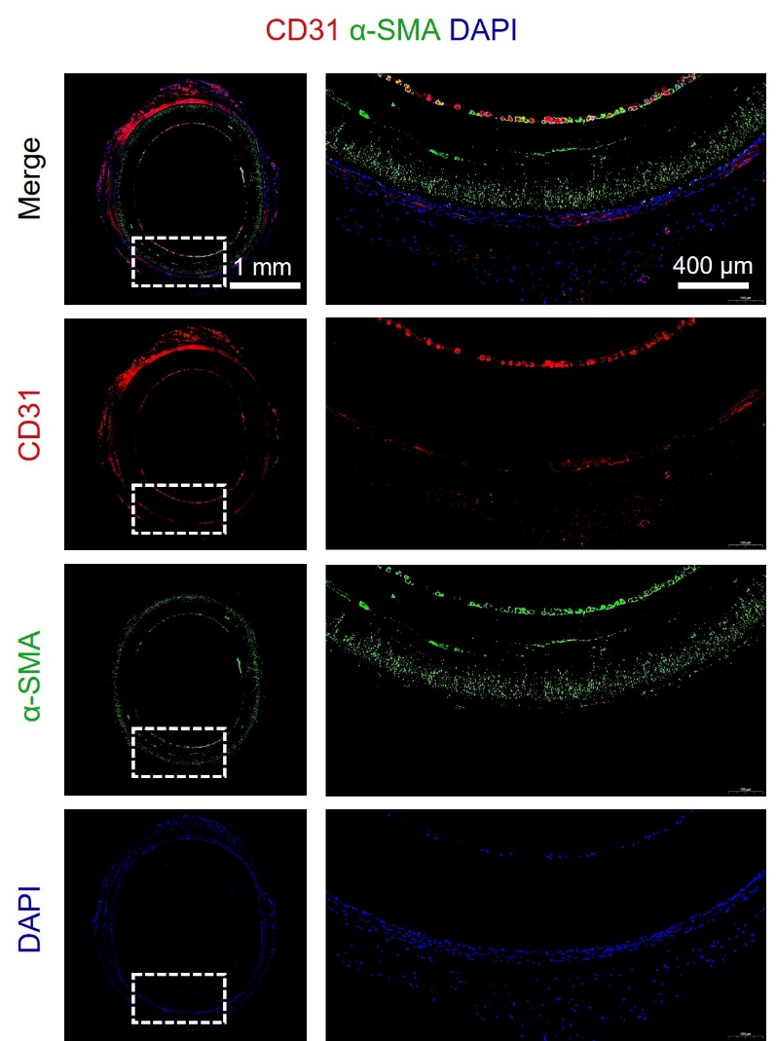
Figure S9. CD31 and α-SMA immunofluorescence staining in TE-P tissue sections at 90 days post-treatment. Panels from top to bottom: merged image (CD31, red; α-SMA, green; DAPI, blue), CD31 (red, endothelial cell marker), α-SMA (green, smooth muscle cell marker), and DAPI (blue, nuclear stain). Insets show magnified views of the boxed areas, highlighting the organization of the endothelium and smooth muscle layer.
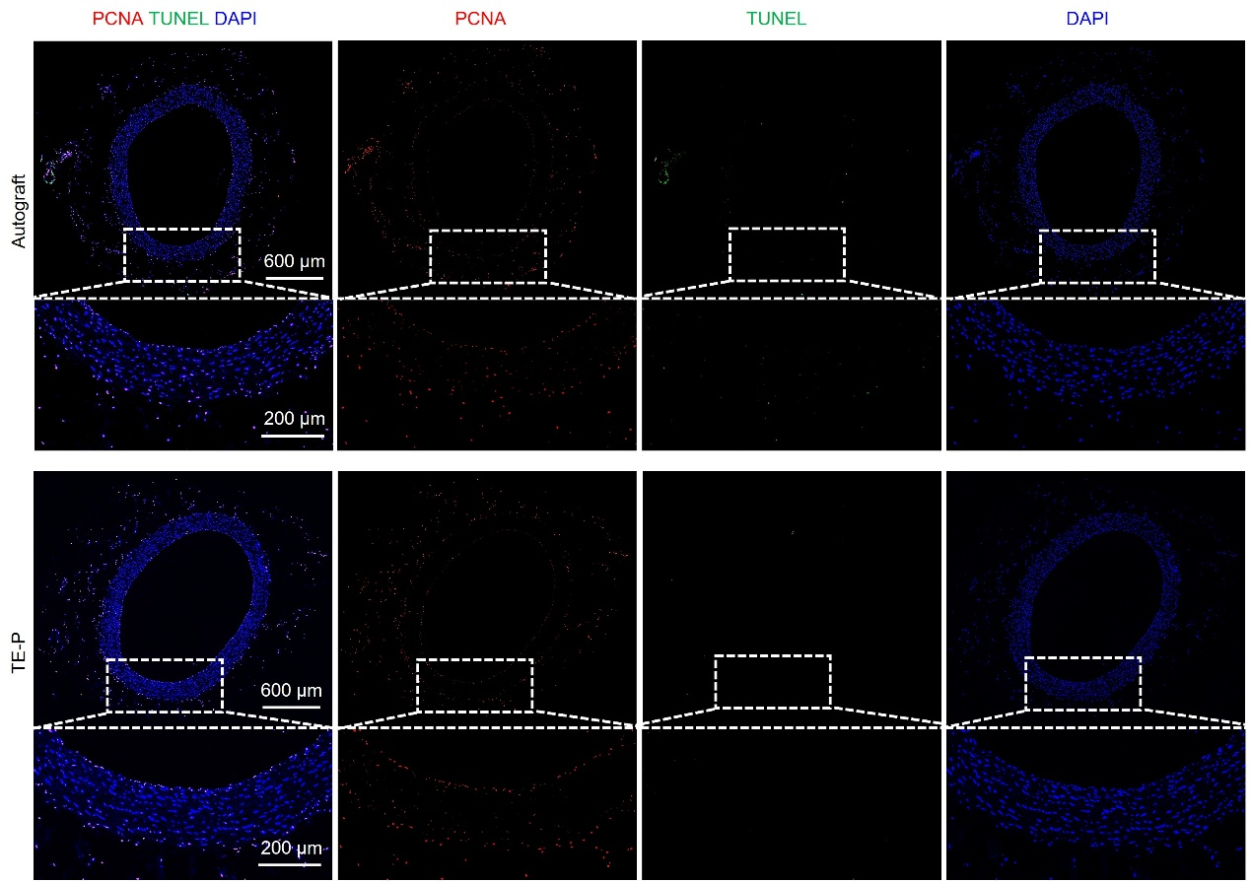
Figure S10. Fluorescence imaging of cell proliferation, apoptosis, and nuclei in autograft and TE-P graft tissue sections at 90 days post-treatment. Images are arranged from left to right: merged image (PCNA in red, TUNEL in green, DAPI in blue), PCNA channel (red, proliferating cells), TUNEL channel (green, apoptotic cells), and DAPI channel (blue, nuclear stain). Insets show magnified views of the boxed regions, highlighting representative areas of cellular activity.
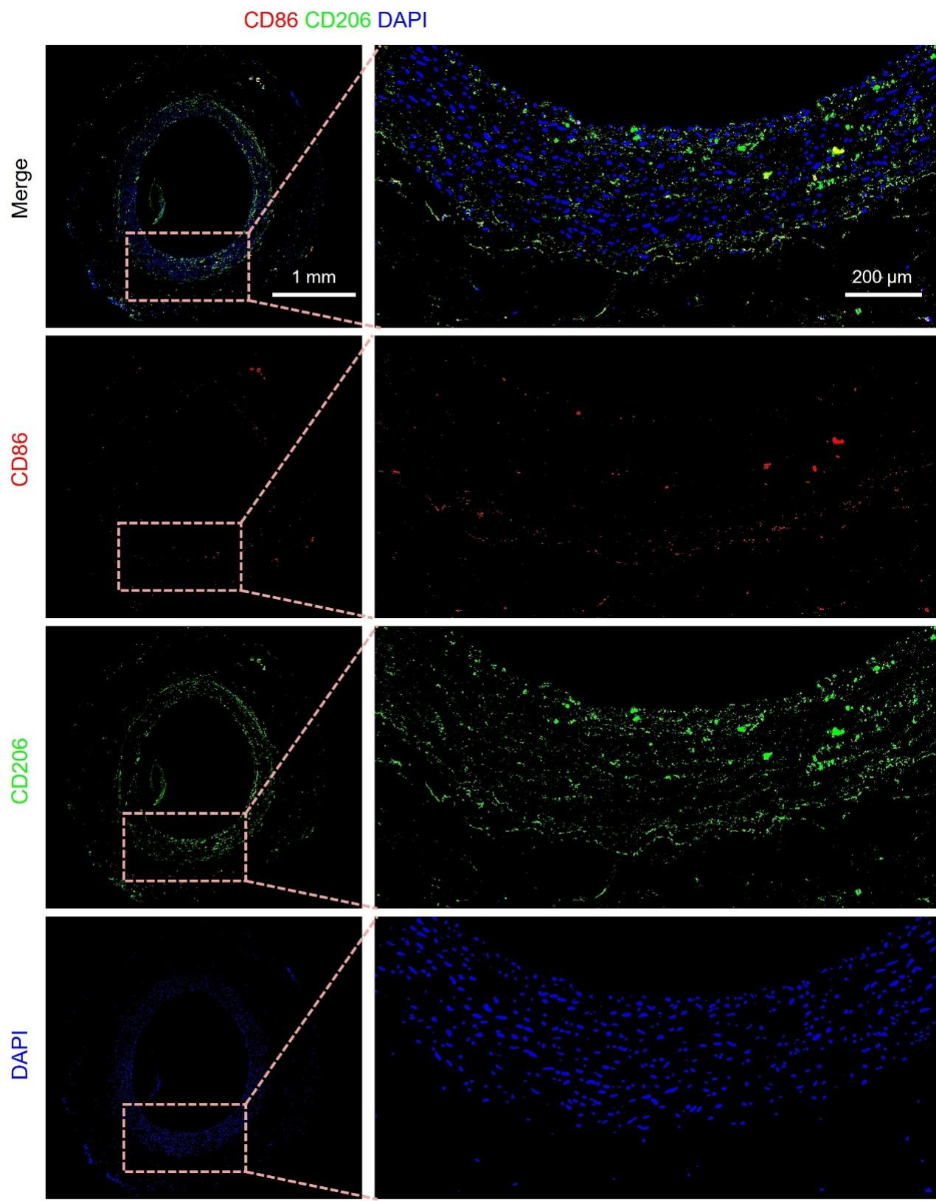
Figure S11. Immunofluorescence staining of pro-inflammatory (labeled with CD86) and anti-inflammatory (labeled with CD206) macrophages in tissue sections of autografts at 90 days post-treatment. Panels are arranged from top to bottom as follows: merged image (CD86 in red, CD206 in green, and DAPI in blue), CD86 channel (red, pro-inflammatory macrophages), CD206 channel (green, anti-inflammatory macrophages), and DAPI channel (blue, nuclear stain). Insets show magnified views of the boxed regions, highlighting the distribution and co-localization of macrophage subtypes.
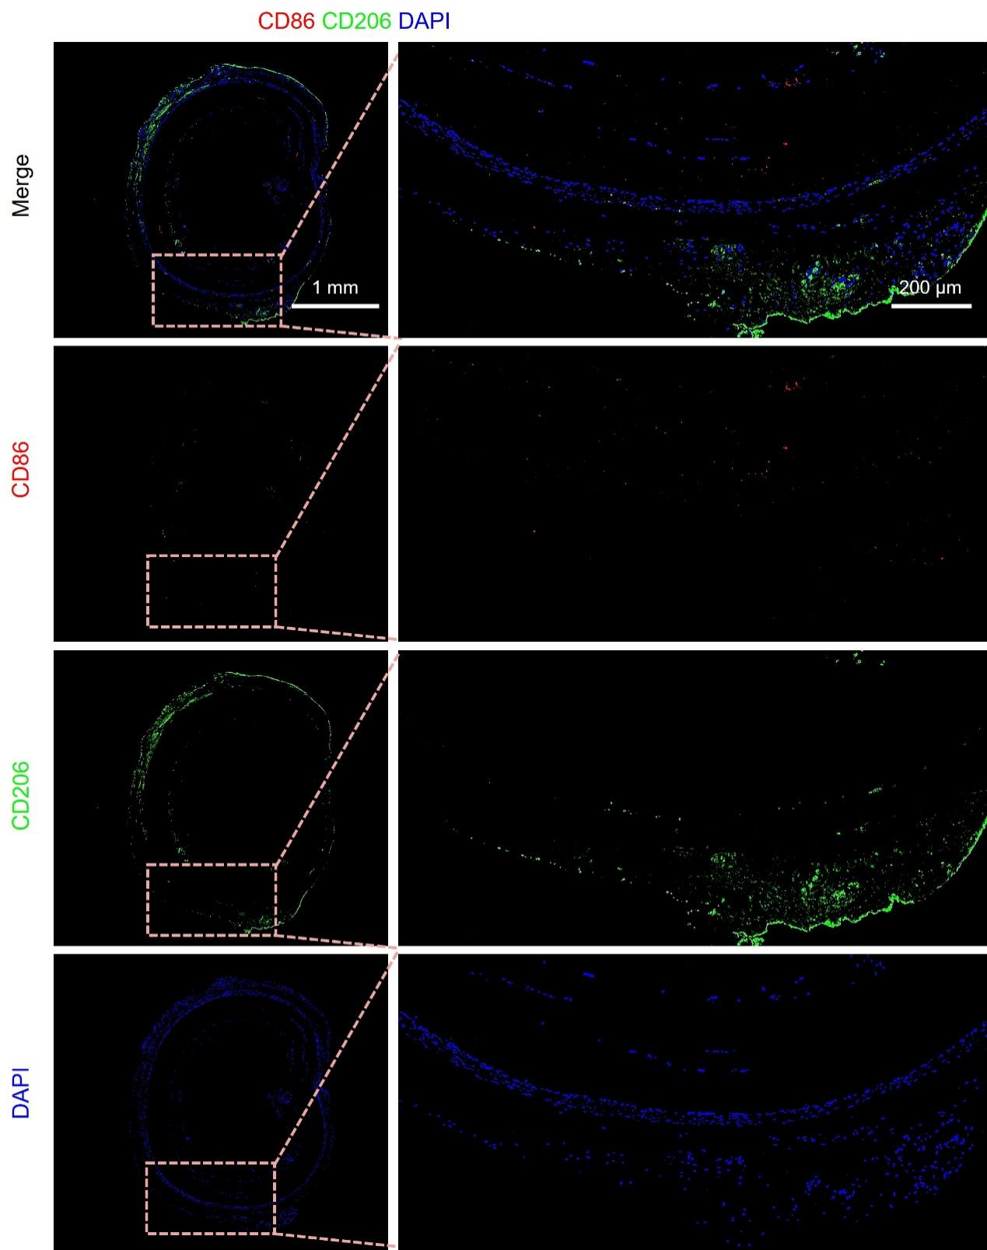
Figure S12. Immunofluorescence staining of pro-inflammatory (labeled with CD86) and anti-inflammatory (labeled with CD206) macrophages in tissue sections of TE-Ps at 90 days post-treatment. Panels are arranged from top to bottom as follows: merged image (CD86 in red, CD206 in green, and DAPI in blue), CD86 channel (red, pro-inflammatory macrophages), CD206 channel (green, anti-inflammatory macrophages), and DAPI channel (blue, nuclear stain). Insets show magnified views of the boxed regions, highlighting the distribution and co-localization of macrophage subtypes.

