Supplementary Material
Table S1. PCR primers used to amplify the coding sequences of An. dirus and An. minimus GluCl.
Species | Forward Primer | Reverse Primer
An. dirus | 5’- ATGGCCTCGGGCCATTTC -3’ | 5’ – TTAGTCTTCCTCCTCTTCGCG ‘3’
An. minimus | 5’- ATGGCCTCGGGCCATTTC -3’ | 5’ – TTAGTCCTCCTCCTCTTCGCG ‘3’

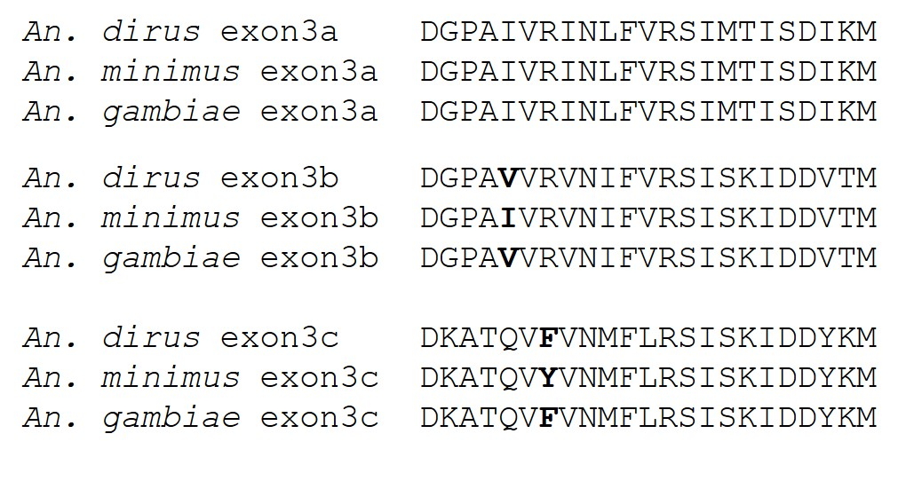
Figure S1. Alignment of alternatively spliced GluCl exon 3 sequences of An. dirus, An. gambiae and An. minimus. Residues that are not identical in all three species for each variant are shown in bold.

