Table S4. Primers used in this study.
Forward primer | Reverse primer | Description
TCAGACACAAGCAGCTAGGC | TGCTGGTTTTGGTTTCCCCT | qRT-PCR of SpWRKY40
TCCGACAACAGGGGCTTTAC | TGCTGGTTTTGGTTTCCCCT | qRT-PCR of SpWRKY51
TTGGCATCGTTGAGGGTCT | CAGTGGGAACACGGAAAGC | qRT-PCR for SpGAPDH
GAGAACACGGGGGACTCTAGAATGGGATGCTCTAGTACTGC | GCTCACCATGGTACCCCCGGGGCAAAGCAATGATTCGAAAAAAA | Sublocation for SpWRKY40
GAGAACACGGGGGACTCTAGAATGGGATTCTCTTCTACTGC | GCTCACCATGGTACCCCCGGGGCAAAGCAATGATTCAAAAAAAA | Sublocation for SpWRKY51
GCCACCTCGCCCAATGGTACCAGTCAACGAGTCAACGAGTCAACG | TGCGTCCGGCGTAGAGGATCCCGTTGACTCGTTGACTCGTTGACT | Cloning MA1076 into pHis2
GCCACCTCGCCCAATGGTACCAGACAACGAGACAACGAGACAACG | TGCGTCCGGCGTAGAGGATCCCGTTGTCTCGTTGTCTCGTTGTCT | Cloning MA1076_mutant into pHis2
GCCACCTCGCCCAATGGTACCTTGACCGAGCCTTGACCGAGCC | TGCGTCCGGCGTAGAGGATCCGGCTCGGTCAAGGCTC | Cloning MA0589 into pHis2
GCCACCTCGCCCAATGGTACCTTAACCGAGCCTTAACCGAGCC | TGCGTCCGGCGTAGAGGATCCGGCTCGGTTAAGGCTC | Cloning MA0589_mutant into pHis2

Table S5. Basic information of SpWRKYs identified in S. portulacastrum.
Gene name | Protein ID |  | amino acids  (aa) | MW (Da) | Isoelectric point (pI) | Aliphatic index | Grand average of hydropathicity | Instability index | Subcellular localization
Spor0438730 | SpWRKY1 | 305 |  | 34346.89 | 5.64 | 54.98 | -0.882 | 46.96 | Nuclear
Spor0366980 | SpWRKY2 | 265 |  | 30076.65 | 9.03 | 55.17 | -1.036 | 47.6 | Extracellular
Spor0260040 | SpWRKY3 | 357 |  | 39952.97 | 10.04 | 69.89 | -0.692 | 55.75 | Nuclear
Spor0307250 | SpWRKY4 | 243 |  | 28134.83 | 8.13 | 44.44 | -1.201 | 49.65 | Nuclear
Spor0252040 | SpWRKY5 | 143 |  | 16838.93 | 9.61 | 61.89 | -1.158 | 49.67 | Nuclear
Spor0074100 | SpWRKY6 | 217 |  | 24386.11 | 5.53 | 67.33 | -0.758 | 46.45 | Nuclear
Spor0351980 | SpWRKY7 | 347 |  | 38037.49 | 8.24 | 64.06 | -0.699 | 44.92 | Nuclear
Spor0244550 | SpWRKY8 | 492 |  | 54550.01 | 7.73 | 50.12 | -0.958 | 67.19 | Nuclear
Spor0389800 | SpWRKY9 | 1314 |  | 144736.1 | 9.16 | 73.01 | -0.593 | 47.89 | Extracellular
Spor0383930 | SpWRKY10 | 219 |  | 23889.96 | 9.48 | 58.40 | -0.669 | 45.18 | Nuclear
Spor0466420 | SpWRKY11 | 323 |  | 35417.03 | 6.15 | 52.51 | -0.830 | 55.53 | Nuclear
Spor0399500 | SpWRKY12 | 627 |  | 67851.44 | 9.22 | 56.16 | -0.911 | 49.24 | Extracellular
Spor0009980 | SpWRKY13 | 107 |  | 12285.08 | 6.40 | 72.80 | -0.590 | 21.50 | Nuclear
Spor0378350 | SpWRKY14 | 304 |  | 33209.33 | 6.59 | 43.62 | -0.941 | 65.48 | Nuclear
Spor0443530 | SpWRKY15 | 639 |  | 69681.77 | 6.23 | 59.89 | -0.828 | 49.81 | Nuclear
Spor0016220 | SpWRKY16 | 364 |  | 39590.61 | 9.62 | 64.12 | -0.612 | 52.63 | Nuclear
Spor0457780 | SpWRKY18 | 287 |  | 31461.49 | 5.52 | 50.98 | -0.830 | 52.51 | Nuclear
Spor0259060 | SpWRKY19 | 543 |  | 58529.04 | 5.12 | 59.48 | -0.796 | 44.51 | Nuclear
Spor0541220 | SpWRKY20 | 291 |  | 32926.13 | 8.76 | 72.65 | -0.758 | 44.00 | Extracellular
Spor0423760 | SpWRKY21 | 531 |  | 58137.12 | 5.71 | 63.62 | -0.832 | 41.82 | Nuclear
Spor0017410 | SpWRKY22 | 484 |  | 53691.04 | 7.73 | 49.36 | -0.999 | 63.87 | Nuclear
Spor0388680 | SpWRKY23 | 646 |  | 70307.67 | 5.66 | 56.19 | -0.890 | 41.84 | Extracellular
Spor0211420 | SpWRKY24 | 859 |  | 94169.78 | 5.76 | 65.82 | -0.617 | 52.56 | Extracellular
Spor0382470 | SpWRKY25 | 494 |  | 54677.25 | 7.27 | 50.12 | -0.942 | 67.65 | Nuclear
Spor0166850 | SpWRKY26 | 519 |  | 56326.85 | 6.41 | 51.14 | -0.881 | 56.92 | Nuclear
Spor0205090 | SpWRKY27 | 330 |  | 37022.41 | 6.08 | 75.30 | -0.706 | 41.73 | Nuclear
Spor0106790 | SpWRKY28 | 356 |  | 38856.56 | 9.85 | 55.37 | -0.791 | 53.65 | Nuclear
Spor0091920 | SpWRKY29 | 448 |  | 48280.38 | 6.27 | 56.16 | -0.754 | 49.20 | Nuclear
Spor0202640 | SpWRKY30 | 209 |  | 23592.75 | 5.20 | 37.80 | -0.947 | 44.86 | Nuclear
Spor0514710 | SpWRKY31 | 215 |  | 25131.37 | 6.96 | 46.60 | -1.208 | 33.91 | Nuclear
Spor0377750 | SpWRKY32 | 210 |  | 24525.85 | 7.44 | 49.57 | -1.153 | 32.64 | Nuclear
Spor0589110 | SpWRKY33 | 741 |  | 80995.54 | 6.16 | 58.53 | -0.733 | 50.02 | Extracellular
Spor0031720 | SpWRKY34 | 531 |  | 58086.03 | 5.74 | 63.09 | -0.817 | 43.17 | Nuclear
Spor0511490 | SpWRKY35 | 514 |  | 55986.62 | 7.07 | 57.96 | -0.784 | 46.75 | Nuclear
Spor0396060 | SpWRKY36 | 187 |  | 21680.06 | 9.24 | 59.30 | -1.082 | 48.69 | Nuclear
Spor0393330 | SpWRKY37 | 491 |  | 54266.75 | 5.38 | 55.93 | -1.074 | 40.60 | Extracellular
Spor0029950 | SpWRKY38 | 465 |  | 50867.5 | 8.66 | 57.46 | -0.895 | 47.76 | Nuclear
Spor0156880 | SpWRKY39 | 361 |  | 39968.12 | 9.57 | 68.61 | -0.750 | 59.72 | Nuclear
Spor0279350 | SpWRKY40 | 614 |  | 66580.01 | 7.25 | 51.51 | -0.819 | 58.71 | Nuclear
Spor0165770 | SpWRKY41 | 570 |  | 62222.85 | 8.22 | 57.77 | -0.794 | 50.49 | Nuclear
Spor0045890 | SpWRKY42 | 291 |  | 31725.85 | 6.35 | 51.89 | -0.821 | 55.45 | Nuclear
Spor0568180 | SpWRKY43 | 446 |  | 48207.37 | 6.30 | 54.24 | -0.778 | 50.46 | Extracellular
Spor0254940 | SpWRKY44 | 491 |  | 54458.96 | 5.50 | 54.34 | -1.128 | 42.96 | Extracellular
Spor0437760 | SpWRKY45 | 331 |  | 36213.67 | 6.43 | 46.80 | -0.942 | 57.69 | Nuclear
Spor0465490 | SpWRKY46 | 218 |  | 24878.51 | 9.81 | 48.76 | -1.106 | 48.79 | Nuclear
Spor0446710 | SpWRKY47 | 520 |  | 56724.86 | 6.08 | 66.48 | -0.743 | 43.85 | Nuclear
Spor0518030 | SpWRKY48 | 355 |  | 39242.93 | 6.26 | 61.61 | -0.708 | 65.67 | Extracellular
Spor0445730 | SpWRKY49 | 603 |  | 65164.97 | 5.87 | 53.00 | -0.783 | 60.37 | Nuclear
Spor0141660 | SpWRKY50 | 347 |  | 37885.09 | 8.30 | 60.72 | -0.762 | 44.78 | Nuclear
Spor0315070 | SpWRKY51 | 609 |  | 66138.4 | 6.99 | 52.41 | -0.807 | 58.58 | Nuclear
Spor0399400 | SpWRKY52 | 314 |  | 35669.15 | 6.27 | 76.69 | -0.725 | 43.18 | Nuclear
Spor0313120 | SpWRKY53 | 392 |  | 42122.37 | 5.33 | 51.53 | -0.624 | 56.68 | Nuclear
Spor0155550 | SpWRKY54 | 394 |  | 43424.72 | 5.80 | 51.42 | -0.817 | 52.68 | Extracellular
Spor0563350 | SpWRKY55 | 453 |  | 50014.57 | 6.34 | 57.13 | -0.846 | 56.04 | Extracellular
Spor0306290 | SpWRKY56 | 810 |  | 88452.9 | 5.90 | 58.62 | -0.689 | 53.28 | Extracellular
Spor0153920 | SpWRKY57 | 436 |  | 48983.38 | 7.15 | 39.54 | -1.203 | 70.01 | Nuclear
Spor0080080 | SpWRKY58 | 242 |  | 27976.74 | 8.23 | 44.26 | -1.185 | 51.72 | Nuclear
Spor0023800 | SpWRKY59 | 186 |  | 21587.11 | 9.37 | 60.70 | -1.018 | 44.46 | Nuclear
Spor0422400 | SpWRKY60 | 603 |  | 64917.8 | 6.33 | 54.15 | -0.774 | 59.01 | Nuclear
Spor0343150 | SpWRKY61 | 243 |  | 28162.93 | 8.47 | 42.47 | -1.214 | 52.10 | Nuclear
Spor0460330 | SpWRKY62 | 634 |  | 69055.98 | 6.33 | 60.84 | -0.828 | 50.73 | Nuclear
Spor0043030 | SpWRKY63 | 288 |  | 31483.41 | 5.52 | 48.09 | -0.842 | 58.55 | Nuclear
Spor0541310 | SpWRKY64 | 669 |  | 72758.96 | 9.10 | 56.85 | -0.906 | 48.32 | Extracellular
Spor0364750 | SpWRKY65 | 548 |  | 61080.42 | 5.90 | 44.96 | -1.024 | 65.01 | Nuclear
Spor0374240 | SpWRKY66 | 567 |  | 61736.18 | 8.64 | 59.28 | -0.758 | 50.24 | Nuclear
Spor0522900 | SpWRKY67 | 449 |  | 48385.51 | 6.30 | 53.21 | -0.758 | 50.47 | Extracellular
Spor0026290 | SpWRKY68 | 478 |  | 53086.51 | 5.48 | 55.61 | -1.099 | 45.93 | Extracellular

Table S6. Prediction of SpWRKYs secondary structure.
Protein | Alpha helix | Extended strand | Random coil | Distribution of secondary structure elements
SpWRKY1 | 11.80% | 4.92% | 83.28% | 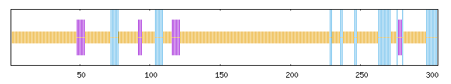
SpWRKY2 | 13.96% | 5.28% | 80.75% | 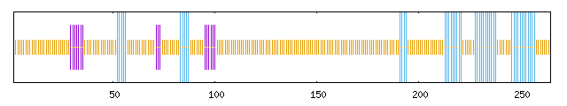
SpWRKY3 | 14.57% | 4.76% | 80.67% | 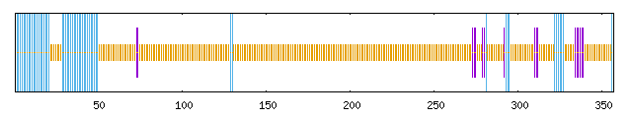
SpWRKY4 | 8.23% | 9.05% | 82.72% | 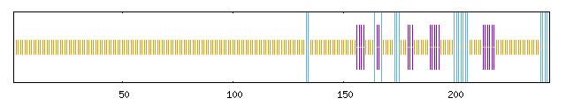
SpWRKY5 | 19.58% | 10.49% | 69.93% | 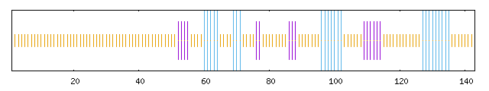
SpWRKY6 | 13.36% | 6.91% | 79.72% | 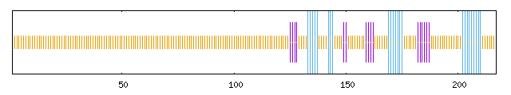
SpWRKY7 | 28.53% | 7.78% | 63.69% | 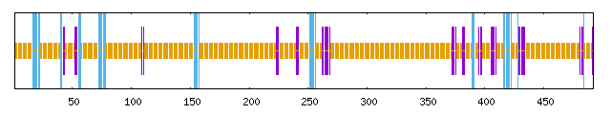
SpWRKY8 | 8.33% | 10.16% | 81.50% | 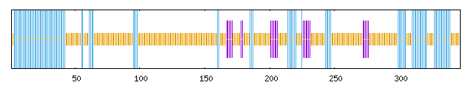
SpWRKY9 | 27.47% | 15.37% | 57.15% | 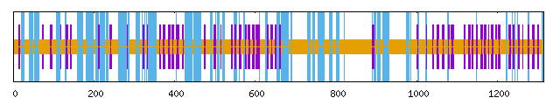
SpWRKY10 | 17.81% | 5.48% | 76.71% | 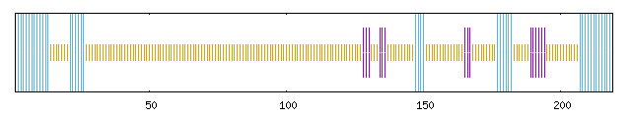
SpWRKY11 | 8.98% | 4.64% | 86.38% | 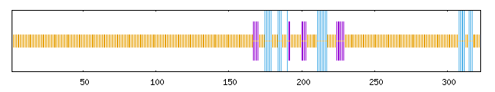
SpWRKY12 | 8.61% | 5.58% | 85.81% | 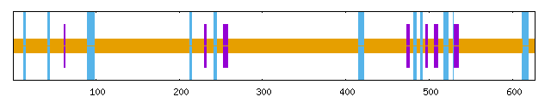
SpWRKY13 | 26.17% | 8.41% | 65.42% | 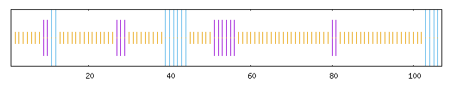
SpWRKY14 | 6.58% | 4.93% | 88.49% | 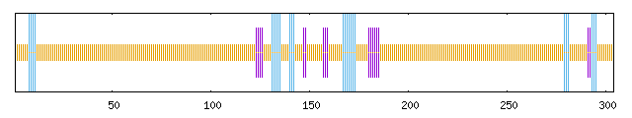
SpWRKY15 | 19.72% | 7.67% | 72.61% | 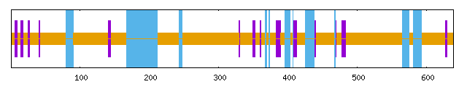
SpWRKY16 | 20.05% | 4.40% | 75.55% | 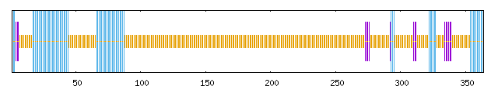
SpWRKY17 | 7.65% | 4.08% | 88.27% | 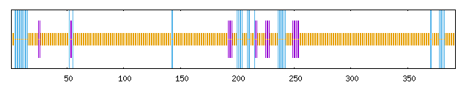
SpWRKY18 | 10.10% | 6.27% | 83.62% | 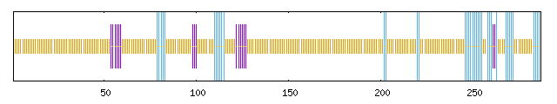
SpWRKY19 | 21.18% | 5.52% | 73.30% | 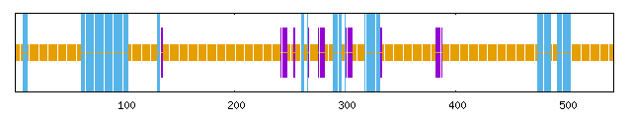
SpWRKY20 | 23.02% | 7.90% | 69.07% | 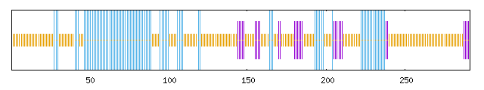
SpWRKY21 | 21.09% | 6.03% | 72.88% | 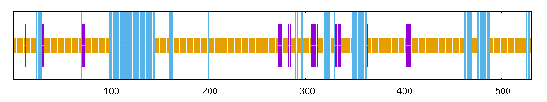
SpWRKY22 | 6.20% | 8.26% | 85.54% | 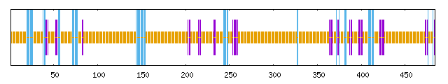
SpWRKY23 | 18.89% | 5.42% | 75.70% | 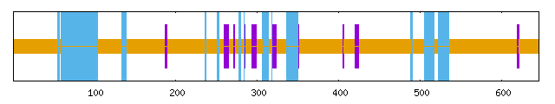
SpWRKY24 | 7.68% | 5.01% | 87.31% | 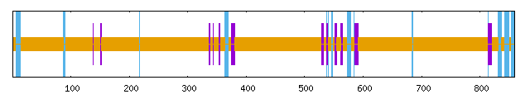
SpWRKY25 | 6.28% | 9.11% | 84.62% | 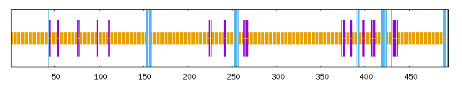
SpWRKY26 | 5.78% | 8.29% | 85.93% | 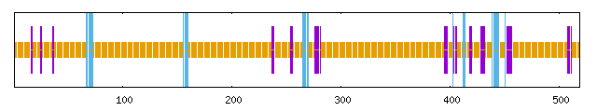
SpWRKY27 | 30.61% | 10.61% | 58.79% | 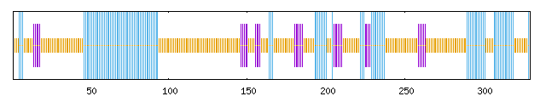
SpWRKY28 | 16.85% | 4.78% | 78.37% | 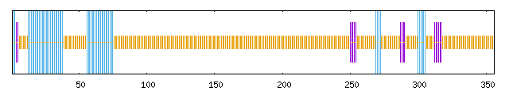
SpWRKY29 | 6.47% | 5.80% | 87.72% | 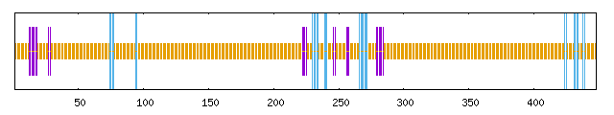
SpWRKY30 | 7.18% | 8.13% | 84.69% | 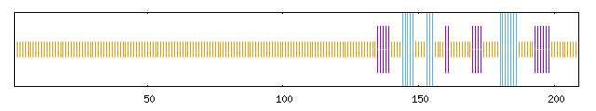
SpWRKY31 | 11.16% | 9.77% | 79.07% | 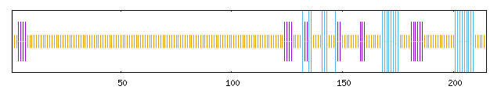
SpWRKY32 | 13.81% | 12.38% | 73.81% | 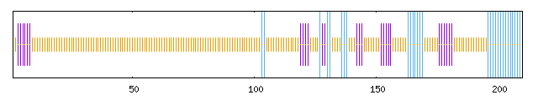
SpWRKY33 | 7.29% | 5.13% | 87.58% | 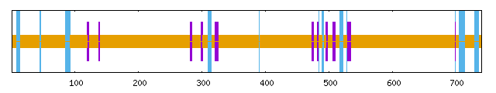
SpWRKY34 | 22.79% | 6.78% | 70.43% | 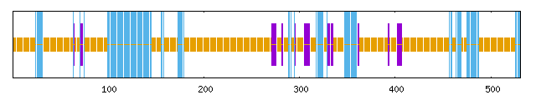
SpWRKY35 | 20.62% | 5.45% | 73.93% | 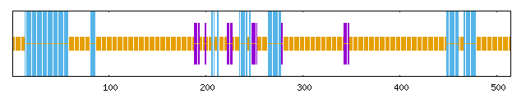
SpWRKY36 | 13.37% | 9.63% | 77.01% | 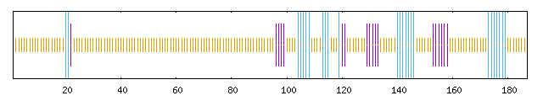
SpWRKY37 | 5.70% | 7.13% | 87.17% | 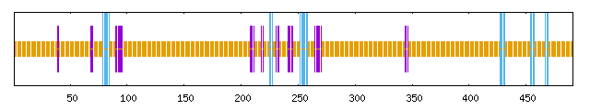
SpWRKY38 | 5.59% | 7.31% | 87.10% | 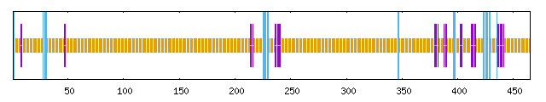
SpWRKY39 | 15.79% | 4.71% | 79.50% | 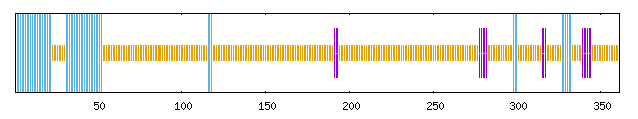
SpWRKY40 | 3.09% | 5.86% | 91.04% | 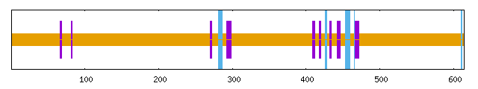
SpWRKY41 | 16.84% | 7.54% | 75.61% | 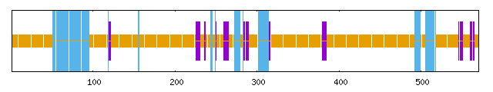
SpWRKY42 | 6.19% | 5.50% | 88.32% | 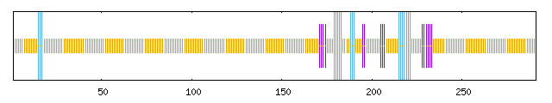
SpWRKY43 | 5.38% | 5.38% | 89.24% | 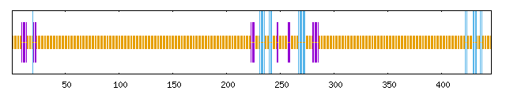
SpWRKY44 | 7.74% | 8.15% | 84.11% | 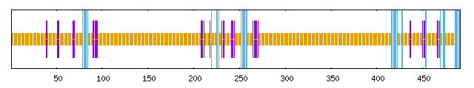
SpWRKY45 | 9.06% | 4.83% | 86.10% | 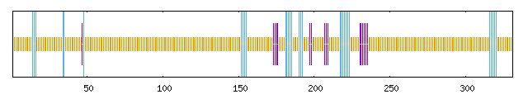
SpWRKY46 | 5.96% | 9.63% | 84.40% | 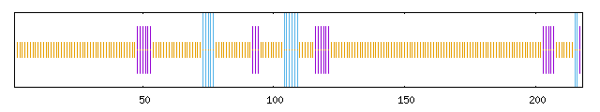
SpWRKY47 | 24.42% | 6.73% | 68.85% | 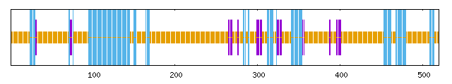
SpWRKY48 | 14.65% | 4.51% | 80.85% | 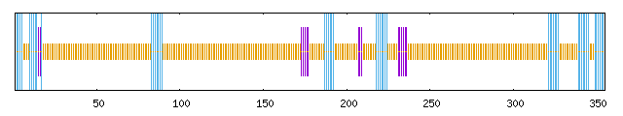
SpWRKY49 | 3.32% | 7.30% | 89.39% | 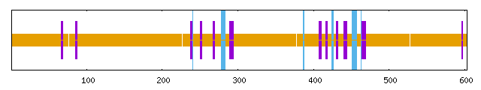
SpWRKY50 | 32.85% | 8.36% | 58.79% | 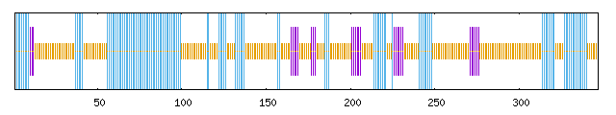
SpWRKY51 | 5.42% | 6.73% | 87.85% | 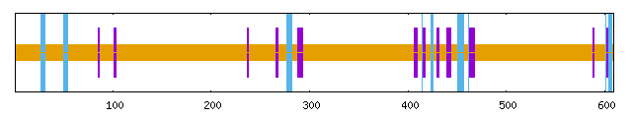
SpWRKY52 | 30.25% | 9.24% | 60.51% | 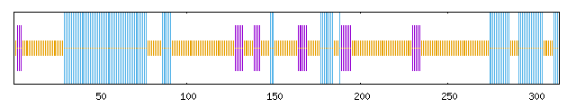
SpWRKY53 | 12.76% | 4.85% | 82.40% | 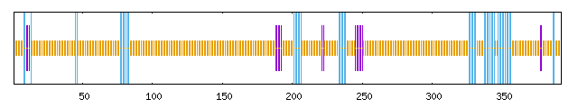
SpWRKY54 | 8.63% | 5.58% | 85.79% | 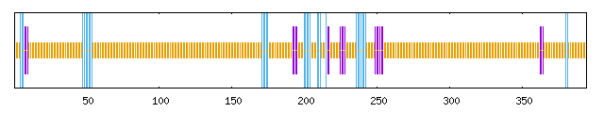
SpWRKY55 | 13.25% | 7.95% | 78.81% | 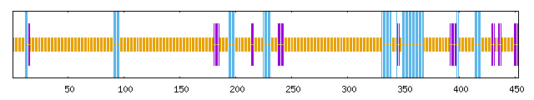
SpWRKY56 | 6.67% | 5.68% | 87.65% | 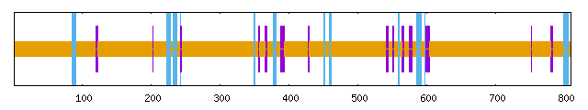
SpWRKY57 | 4.59% | 6.65% | 88.76% | 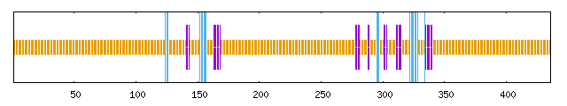
SpWRKY58 | 8.68% | 9.09% | 82.23% | 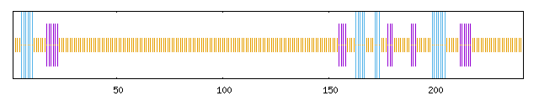
SpWRKY59 | 14.52% | 8.60% | 76.88% | 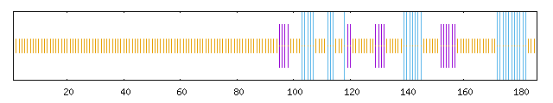
SpWRKY60 | 5.47% | 5.80% | 88.72%
SpWRKY61 | 9.05% | 9.88% | 81.07% | 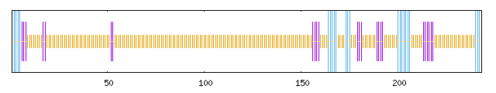
SpWRKY62 | 17.03% | 7.41% | 75.55% | 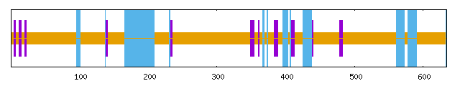
SpWRKY63 | 12.85% | 6.25% | 80.90% | 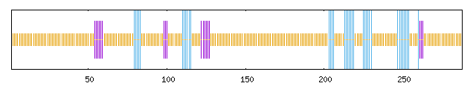
SpWRKY64 | 5.68% | 5.23% | 89.09% | 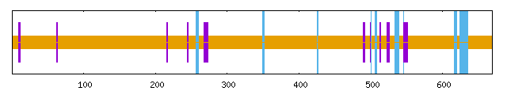
SpWRKY65 | 6.20% | 6.57% | 87.23% | 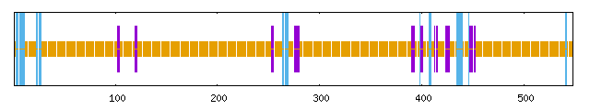
SpWRKY66 | 19.58% | 7.41% | 73.02% | 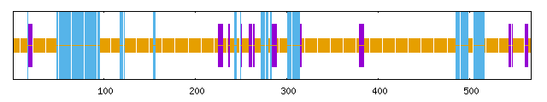
SpWRKY67 | 8.24% | 6.01% | 85.75% | 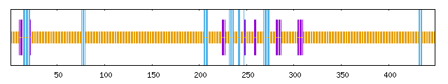
SpWRKY68 | 6.07% | 7.11% | 86.82% | 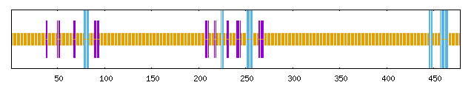

Table S7. Ka, Ks, and Ka/Ks values for the homologous gene pair gene 1 and gene 2 in SpWRKYs.
Gene 1 | Gene 2 | Ka | Ks | Ka/Ks
SpWRKY46 | SpWRKY1 | 0.076977165 | 0.183935272 | 0.418501378
SpWRKY4 | SpWRKY61 | 0.027366977 | 0.077261235 | 0.354213551
SpWRKY4 | SpWRKY58 | 0.023663422 | 0.077216 | 0.306457496
SpWRKY5 | SpWRKY31 | 0.291465797 | 2.049002582 | 0.142247648
SpWRKY22 | SpWRKY8 | 0.017141026 | 0.053230471 | 0.322015292
SpWRKY11 | SpWRKY42 | 0.048063064 | 0.164480203 | 0.292211848
SpWRKY11 | SpWRKY45 | 0.023065696 | 0.101809944 | 0.226556413
SpWRKY12 | SpWRKY64 | 0.031055534 | 0.064480227 | 0.481628797
SpWRKY62 | SpWRKY15 | 0.014213506 | 0.134239378 | 0.105881793
SpWRKY47 | SpWRKY15 | 0.431666941 | 1.869305256 | 0.230923729
SpWRKY34 | SpWRKY15 | 0.418596517 | 1.91610739 | 0.218461929
SpWRKY21 | SpWRKY15 | 0.453039817 | 2.018790966 | 0.224411455
SpWRKY18 | SpWRKY46 | 0.483624611 | 3.469145699 | 0.139407408
SpWRKY18 | SpWRKY63 | 0.01371641 | 0.073938453 | 0.18551118
SpWRKY19 | SpWRKY41 | 0.510605063 | 1.910262512 | 0.267295756
SpWRKY19 | SpWRKY35 | 0.462673732 | 1.915023464 | 0.241602122
SpWRKY27 | SpWRKY20 | 0.059845301 | 0.104334602 | 0.57359016
SpWRKY52 | SpWRKY20 | 0.114615893 | 0.190678805 | 0.601094036
SpWRKY47 | SpWRKY21 | 0.018318979 | 0.066778156 | 0.274325918
SpWRKY62 | SpWRKY21 | 0.43556933 | 2.067151377 | 0.210709934
SpWRKY34 | SpWRKY21 | 0.014633619 | 0.023353869 | 0.626603625
SpWRKY66 | SpWRKY23 | 0.48907444 | 2.343801826 | 0.208667147
SpWRKY24 | SpWRKY33 | 0.016995375 | 0.040633722 | 0.418257896
SpWRKY27 | SpWRKY52 | 0.047982992 | 0.118105499 | 0.406272291
SpWRKY29 | SpWRKY43 | 0.008825073 | 0.047662092 | 0.185159167
SpWRKY29 | SpWRKY67 | 0.018191649 | 0.084767541 | 0.214606307
SpWRKY59 | SpWRKY31 | 0.35211036 | 2.439664109 | 0.144327393
SpWRKY32 | SpWRKY36 | 0.326339537 | 1.802565112 | 0.181041747
SpWRKY56 | SpWRKY33 | 0.025904426 | 0.049189728 | 0.526622673
SpWRKY47 | SpWRKY34 | 0.019994242 | 0.066930627 | 0.298730836
SpWRKY62 | SpWRKY34 | 0.401432696 | 2.087975551 | 0.192259289
SpWRKY40 | SpWRKY51 | 0.013024929 | 0.070167998 | 0.185624924
SpWRKY41 | SpWRKY35 | 0.023282293 | 0.046690104 | 0.49865583
SpWRKY42 | SpWRKY45 | 0.032123187 | 0.119493323 | 0.268828298
SpWRKY43 | SpWRKY67 | 0.017124032 | 0.08885087 | 0.192727787
SpWRKY68 | SpWRKY44 | 0.056360914 | 0.063756161 | 0.884007329
SpWRKY44 | SpWRKY49 | 0.527911255 | 1.744862467 | 0.302551785
SpWRKY44 | SpWRKY60 | 0.522460381 | 1.814636438 | 0.287914632
SpWRKY46 | SpWRKY63 | 0.497764398 | 2.218098632 | 0.224410398
SpWRKY47 | SpWRKY62 | 0.427469245 | 1.985250549 | 0.215322567
SpWRKY55 | SpWRKY48 | 0.083229923 | 0.101151939 | 0.822820842
SpWRKY68 | SpWRKY49 | 0.561865944 | 2.070334752 | 0.271388935
SpWRKY49 | SpWRKY60 | 0.016076611 | 0.074533768 | 0.215695673
SpWRKY7 | SpWRKY50 | 0.021169819 | 0.074163035 | 0.285449738
SpWRKY53 | SpWRKY55 | 0.702869154 | 2.877127029 | 0.244295489
SpWRKY65 | SpWRKY57 | 0.024107632 | 0.068207569 | 0.35344512
SpWRKY61 | SpWRKY58 | 0.010593085 | 0.012966287 | 0.816971312
SpWRKY68 | SpWRKY60 | 0.555973357 | 1.72950349 | 0.321464143

Table S8. WGD/segmental duplication event of SpWRKYs in S. portulacastrum.
Gene ID | Duplication type
SpWRKY1 |  | WGD or Segmental
SpWRKY2 |  | WGD or Segmental
SpWRKY3 |  | WGD or Segmental
SpWRKY4 |  | WGD or Segmental
SpWRKY5 |  | WGD or Segmental
SpWRKY6 |  | WGD or Segmental
SpWRKY7 |  | WGD or Segmental
SpWRKY8 |  | WGD or Segmental
SpWRKY9 |  | WGD or Segmental
SpWRKY10 |  | WGD or Segmental
SpWRKY11 |  | WGD or Segmental
SpWRKY12 |  | WGD or Segmental
SpWRKY13 |  | WGD or Segmental
SpWRKY14 |  | WGD or Segmental
SpWRKY15 |  | WGD or Segmental
SpWRKY16 |  | WGD or Segmental
SpWRKY17 |  | WGD or Segmental
SpWRKY18 |  | WGD or Segmental
SpWRKY19 |  | WGD or Segmental
SpWRKY20 |  | WGD or Segmental
SpWRKY21 |  | WGD or Segmental
SpWRKY22 |  | WGD or Segmental
SpWRKY23 |  | WGD or Segmental
SpWRKY24 |  | WGD or Segmental
SpWRKY25 |  | WGD or Segmental
SpWRKY26 |  | WGD or Segmental
SpWRKY27 |  | WGD or Segmental
SpWRKY28 |  | WGD or Segmental
SpWRKY29 |  | WGD or Segmental
SpWRKY30 |  | WGD or Segmental
SpWRKY31 |  | WGD or Segmental
SpWRKY32 |  | WGD or Segmental
SpWRKY33 |  | WGD or Segmental
SpWRKY34 |  | WGD or Segmental
SpWRKY35 |  | WGD or Segmental
SpWRKY36 |  | WGD or Segmental
SpWRKY37 |  | WGD or Segmental
SpWRKY38 |  | Dispersed
SpWRKY39 |  | WGD or Segmental
SpWRKY40 |  | WGD or Segmental
SpWRKY41 |  | WGD or Segmental
SpWRKY42 |  | WGD or Segmental
SpWRKY43 |  | WGD or Segmental
SpWRKY44 |  | WGD or Segmental
SpWRKY45 |  | WGD or Segmental
SpWRKY46 |  | WGD or Segmental
SpWRKY47 |  | WGD or Segmental
SpWRKY48 |  | WGD or Segmental
SpWRKY49 |  | WGD or Segmental
SpWRKY50 |  | WGD or Segmental
SpWRKY51 |  | WGD or Segmental
SpWRKY52 |  | WGD or Segmental
SpWRKY53 |  | WGD or Segmental
SpWRKY54 |  | WGD or Segmental
SpWRKY55 |  | WGD or Segmental
SpWRKY56 |  | WGD or Segmental
SpWRKY57 |  | WGD or Segmental
SpWRKY58 |  | WGD or Segmental
SpWRKY59 |  | WGD or Segmental
SpWRKY60 |  | WGD or Segmental
SpWRKY61 |  | WGD or Segmental
SpWRKY62 |  | WGD or Segmental
SpWRKY63 |  | WGD or Segmental
SpWRKY64 |  | WGD or Segmental
SpWRKY65 |  | WGD or Segmental
SpWRKY66 |  | WGD or Segmental
SpWRKY67 |  | WGD or Segmental
SpWRKY68 |  | WGD or Segmental

