Supplementary Figures

Supplementary Figure S1. Immunohistochemistry depicting the tumoral distribution of PAPPA in melanoma tissues (T1-3). Human placenta was used as a positive control. Scale bar, 100 µm.

Supplementary Figure S2. Flow cytometric analysis of surface PAPPA expression on parental LM-MEL-62 (red) cell line and the matched line transformed with the PAPPA-OE (blue) vector.

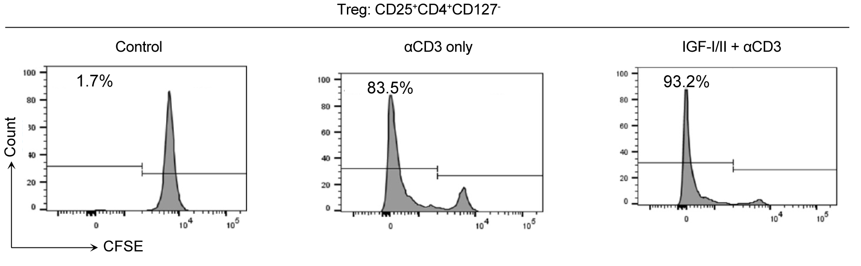
Supplementary Figure S3. IGF signaling stimulates expansion of Tregs. Proliferation of CFSE-labelled Treg cells (CD25+CD4+CD127- T-cells) stimulated for 3 d with anti-CD3 ± IGF-I/II, assessed by flow cytometry. CFSE intensity is inversely correlated with cell division. Results revealed that IGFR/CD3 co-activation enhanced proliferation of patient-derived Tregs compared to anti-CD3 alone.

