Electronic Supporting Information
Synthesis of (E)-2-(1H-tetrazole-5-yl)-3-phenylacrylenenitrile derivatives under green conditions catalyzed by magnetic periodic mesoporous ognosilica embedded with ZnO nanoparticles
Sajedeh Safapoor, Mohammad G. Dekamin, * Arezoo Akbari and M. Reza Naimi-Jamal
Pharmaceutical and Heterocyclic Compounds Research Laboratory, Department of Chemistry, Iran University of Science and Technology, Tehran 16846-13114, Iran
* E-mail: mdekamin@iust.ac.ir

Contents
General data II
General procedure for the synthesis of 5-substituted-1H-tetrazoles derivatives III
Characterization of Selected compound on the basic of their IR, ¹H NMR spectral data III

General Data

Reagents and Equipments
Chemical reagents with high purity were purchased from Merck and Aldrich and only liquid aldehydes were distilled before use. All reactants and the purity of the products were monitored by thin-layer chromatography (TLC) using aluminum plates with 0.2 mm think coated with silica gel F254 plates (Merck) and the UV lamp with wavelength of 245 nm was also used in this experiment. Product identification was performed using Shimaduzu infrared spectroscopy with potassium bromide and a 500 MHz Advance Broker core magnetic resonance spectroscopy was performed for hydrogen and carbon nuclei in DMSO solvent and at room temperature. The BET specific surface area analysis was performed with ASAP 2020TM and Thermal gravimetric analysis was obtained by Bahr company STA 504 equipment. X-ray diffraction pattern was performed with STOE apparatus and Field emission scanning electron microscopy images were recorded by Zeiss (EM10C) device. Melting points were measured using an electro thermal 9100 device.

Typical Procedure for Preparation of PMO-ICS
A new periodic mesoporous organosilica named PMO-ICS was synthesized by self-assembly of tris[3-(trimethoxysilyl) propyl] isocyanurate (ICS, Aldrich), tetraethyl orthosilicate (TEOS from Aldrich) and the poly (ethylene oxide)-poly (propylene oxide)-poly (ethylene oxide) triblock copolymer (Pluronic 123 from Aldrich, average Mw ≅ 5800 Dalton) under acidic conditions. In a typical experiment, weigh 2 g of P123 into a baker and slowly add a mixture of 15 cc deionized water and 60 cc hydrochloric acid solution (2M) and stirred until P123 is completely dissolved in acid and water. Then, 0.01 mole (3.08 g) of tris[3-trimethoxysilyl) propyl] isocyanurate (ICS, Aldrich) and 0.03 mole tetraethyl orthosilicate (TEOS, 3.12 g)) was added dropwise into that solution. The obtained white gel and precipitates was stirred at room temperature for 24 h in a round bottom balloon. The mixture was aged at 100 °C for 48 h without stirring. The solid was filtered off and washed thoroughly with hot EtOH/HCl (60 mL of EtOH 96% and 2 mL of 12 M HCl) using a soxhelet apparatus for 72 h to remove the surfactant molecules. The obtained white powder was dried in air at 100 ⸰C overnight.

General procedure for the preparation of the Fe₃O₄@PMO catalyst
Magnetic PMO synthesis involves the use of Fe²⁺ and Fe³⁺ in the presence of ammonia. By first dispersing 2 g of PMO-ICS in 20 cc toluene at room temperature. After 15 Minutes stirring, 2.0 g of FeCl₂.4H₂O and 4.0 g of FeCl₃.6H₂O was added to the above mixture under nitrogen atmosphere. The reaction mixture was heated in an oil bath at 80 °C during stirring, then 20 cc of ammonia (25% w/w) was added dropwise over the mixture over a period of 30 minutes until the pH reached 11 and allowed to rotates for 1h at the same temperature. The black precipitate is finally washed with water and ethanol and dried at 100 °C.

Synthesis of ZnO NPs supported on mesoporous Fe₃O₄@PMO
At this stage, zinc acetate in the presence of PEG-600 surfactant was used to embedded ZnO nanoparticles onto the catalyst surface. First dissolve 0.1 g of zinc acetate and 0.1 g of PEG in 50 ml of twice-distilled water then add NH₃ dropwise solution to reach pH=10 and finally solution heated for 8 h at 80 °C and then cooled to ambient temperature.

General procedure for the synthesis of 5-substituted-1H-tetrazoles derivatives

The reaction mixture of 4-chlorobenzaldehyde (1mmol), malononitrile (1mmol) and sodium azide (1.2mmol) was heated in the presence of nano-porous catalyst (1) at 80 °C under ethanol reflux conditions. (Table1) Under the conditions mentioned, the reaction progress was monitored by TLC (ethylacetate/n-hexane, 1:3). After completion of the reaction in a very short time it was easily separated using a catalyst external magnet and the desired product was obtained by adding distilled water to the bottom of the container. The organic layer obtained was washed several times with distilled water to remove impurities from it until the solution was discolored. The solid product was easily re-crystallized in ethanol solvent for purification. The formation of our desired product was confirmed by ¹H NMR and ¹³C NMR measurements, melting point, FT-IR and comparison with reported data.

Characterization of Selected compound on the basic of their IR, ¹H NMR spectral data

3‑Phenyl‑2(1H‑tetrazole‑5‑yl) acrylonitrile (5a)
Cream solid powder, Mp: 165-167 °C. FT-IR (KBR) ν: 3283, 3027, 2206, 1592, 1473, 984, 826, 676. ¹H NMR (500 MHz, DMSO-d6): δ (ppm) 3.44 (s, br, NH overlap with solvent), 7.91-7.96 (d, J=7.4 Hz, 3H), 7.43-7.55(m, 2H), 8.10 (d, J=12.3Hz, 1H)

(E)-3-(4-Chlorophenyl)-2-(1H-tetrazol-5-yl) acrylonitrile (5b)
Pale yellow powder, Mp: 158-160 °C. FT-IR (KBR) ν: 3158, 2267, 1584,1426,1123,930,810,691, 652. ¹H NMR (500 MHz, DMSO-d6): δ (ppm) 3.50 (s, br, NH overlap with solvent), 7.72 (d, J=8.5 Hz,2H),7.95 (d, J=8.5 Hz, 2H), 8.56(s,1H, CH)
3‑(4-methylphenyl‑2‑(1H‑tetrazole‑5‑yl) acrylonitrile (5e)
Cream solid powder, Mp: 189-191 °C. FT-IR (KBR) ν: 3033, 2219,1585,1556,1376,1218,1184,813,609; ¹H NMR (500 MHz, DMSO-d6): δ (ppm) 2.44(s, 3H, CH₃), 3.31 (s, br, NH overlap with solvent), 7.44 (d, J=8.0 Hz,2H), 7.86 (d, J=8.1 Hz, 2H), 8.47(s, 1H, CH)
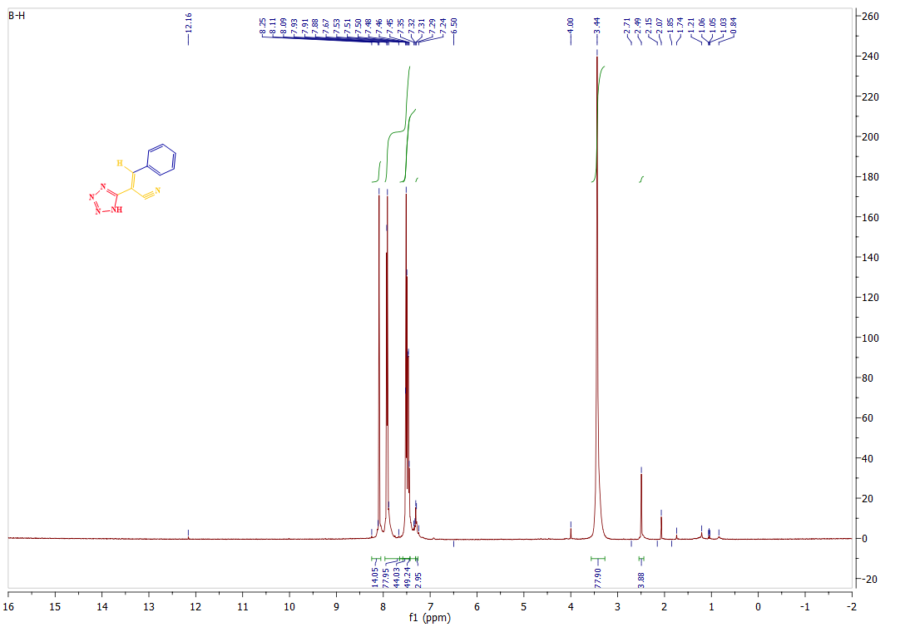
¹H NMR spectra of compound 5a
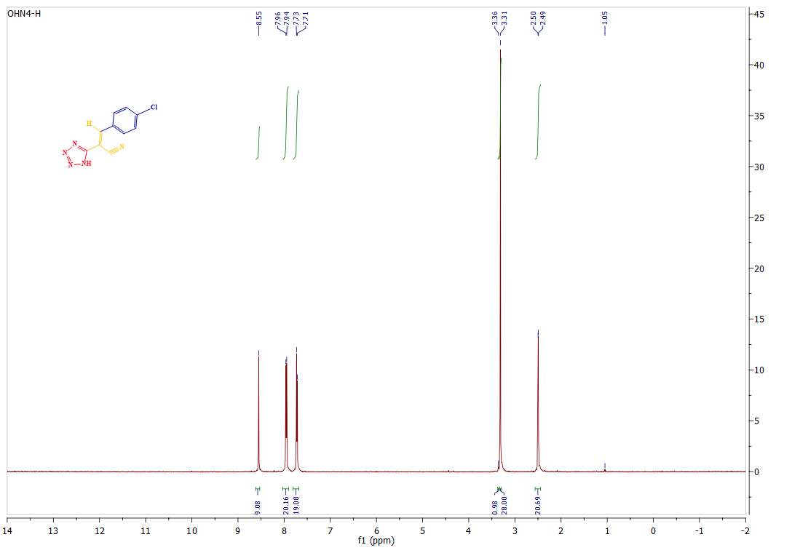
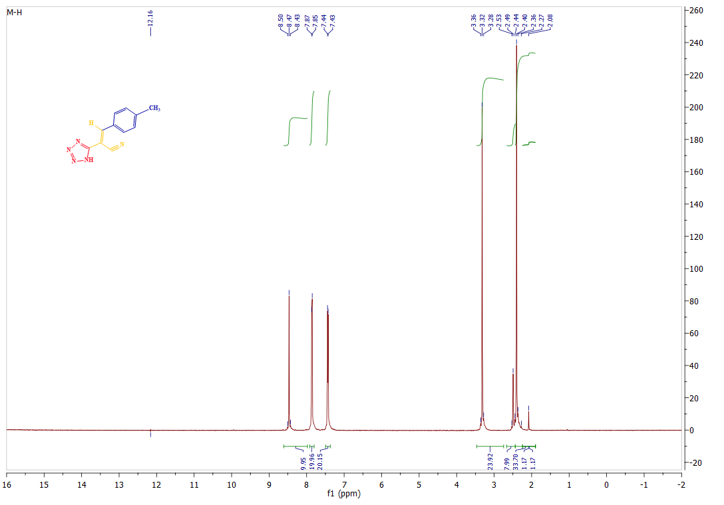
¹H NMR spectra of compound 5b
¹H NMR spectra of compound 5e

