Supplementary Material

Section S1 Data Sources and Acquisition Procedures

S1.1 Overview of Data Sources
This study synthesized data from five internationally recognized databases to construct a comprehensive panel dataset covering 204 countries and territories from 1990 to 2021.

S1.2 Disease Burden Data
Disease burden estimates were obtained from the Global Burden of Disease Study 2021 (GBD 2021), accessed through the Institute for Health Metrics and Evaluation (IHME) GBD Results Tool (https://vizhub.healthdata.org/gbd-results/). We extracted age-standardized prevalence rates and years lived with disability (YLD) for diabetes-related blindness and vision loss (ICD-10 codes: E10.3, E11.3, E12.3, E13.3, E14.3). Data extraction was performed in January 2024, utilizing the GBD 2021 final release. The GBD methodology employs Bayesian meta-regression using the DisMod-MR 2.1 tool to generate internally consistent estimates across locations and time periods[1].

S1.3 Health Expenditure Data
Health financing indicators were compiled from two complementary sources to maximize temporal and geographic coverage. The World Health Organization Global Health Expenditure Database (WHO-GHED; https://apps.who.int/nha/database) provided standardized health accounts data for 194 WHO member states from 2000 to 2023, following the System of Health Accounts 2011 framework.
The IHME Global Health Spending Database (https://ghdx.healthdata.org/record/ihme-data/global-health-spending-1995-2021) offered extended historical coverage from 1995 to 2021, with all values adjusted to 2021 purchasing power parity-adjusted US dollars. Data harmonization followed established protocols to address discrepancies between sources.

S1.4 Ophthalmologist Density Data
Ophthalmologist workforce density estimates for 2015 were derived from the International Council of Ophthalmology global workforce assessment[2]. This cross-sectional survey collected data through national ophthalmological societies and ministries of health, covering 195 countries representing 99.3% of the global population.

S1.5 Digital Readiness Assessment
Government artificial intelligence readiness was measured using the Oxford Insights Government AI Readiness Index 2024 (https://www.oxfordinsights.com/government-ai-readiness-index). This composite index evaluates 188 countries across 40 indicators in three pillars: government capacity, technology sector maturity, and data and infrastructure availability. The 2024 edition incorporated enhanced metrics for AI governance and ethical frameworks[3].

S1.6 Socio-demographic Index
The Socio-demographic Index (SDI) was obtained from the GBD 2021 study (https://ghdx.healthdata.org/record/ihme-data/gbd-2021-socio-demographic-index-sdi-1950-2021). SDI represents a composite measure of development status based on lag-distributed income per capita, mean educational attainment for those aged 15 years and older, and total fertility rate for those younger than 25 years. Countries were categorized into quintiles: low (SDI<0.45), low-middle (0.45-0.60), middle (0.60-0.70), high-middle (0.70-0.85), and high (>0.85) SDI regions.

Section S2 Statistical Methods

S2.1 Panel Data Model Specification
The panel data analysis encompassed 203 countries with 4,466 country-year observations from 2000 to 2021. To address heteroskedasticity and ensure linearity of trends, we applied natural logarithm transformations to continuous variables exhibiting skewed distributions. The general panel model specification was:
$y_{it}=α_{it}+β_{it}^{′}x_{it}^{′}+u_{it}$ (Equation A1)
The specific econometric model estimated was:
$ln⁡\left(DRD_YLD_RATE_{it}\right)=α_{i}+β_{1}ln⁡\left(THE_PC_PPP_{it}\right)+β_{2}GHES_SHARE_{it}+β_{3}OOP_SHARE_{it}+β_{4}SDI_{it}+β_{5}YEAR_TREND_{it}+β_{6}POST_{2008}_{it}+u_{it}$ (Equation A2)
Model selection between pooled OLS, fixed effects, and random effects specifications was determined through formal hypothesis testing. The F-test for individual effects yielded F(202, 4260) = 905.73 (p<0.001), rejecting the null hypothesis of homogeneous intercepts. The Hausman test statistic χ²(6) = 134.52 (p<0.001) indicated systematic differences between fixed and random effects estimators, supporting the fixed effects specification.

S2.2 Threshold Regression Analysis
We employed Hansen's threshold regression methodology to identify critical thresholds in ophthalmologist density and AI readiness associated with discontinuous changes in diabetic retinopathy burden. The threshold model specification was:
$Y_{i}=α+β_{1}⋅I\left(X_{i}≥γ\right)+β_{2}⋅SDI_{i}+ε_{i}$ (Equation A3)
where $I$ denotes the indicator function and γ represents the estimated threshold parameter. The threshold search algorithm evaluated 300 equally spaced candidate values within the empirical distribution range, selecting the value minimizing the residual sum of squares. Statistical inference employed 500 bootstrap replications to construct confidence intervals for threshold estimates. Multiple comparison adjustments using Bonferroni correction (α = 0.05/ p = 0.0056) were applied to control family-wise error rates across nine quantile-based threshold tests.

Section S3 Supplementary Results
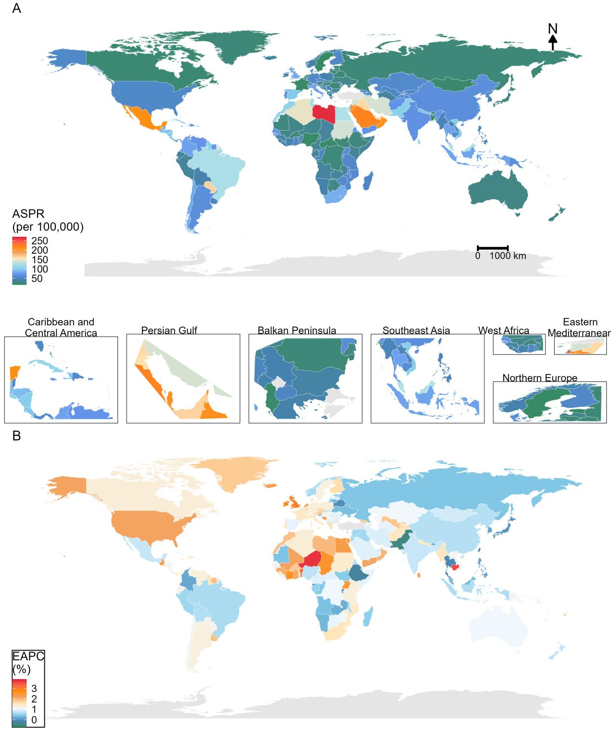

Figure S1 Global distribution of diabetic retinopathy prevalence in 2021 (A) and EAPC from 1990-2021 (B)

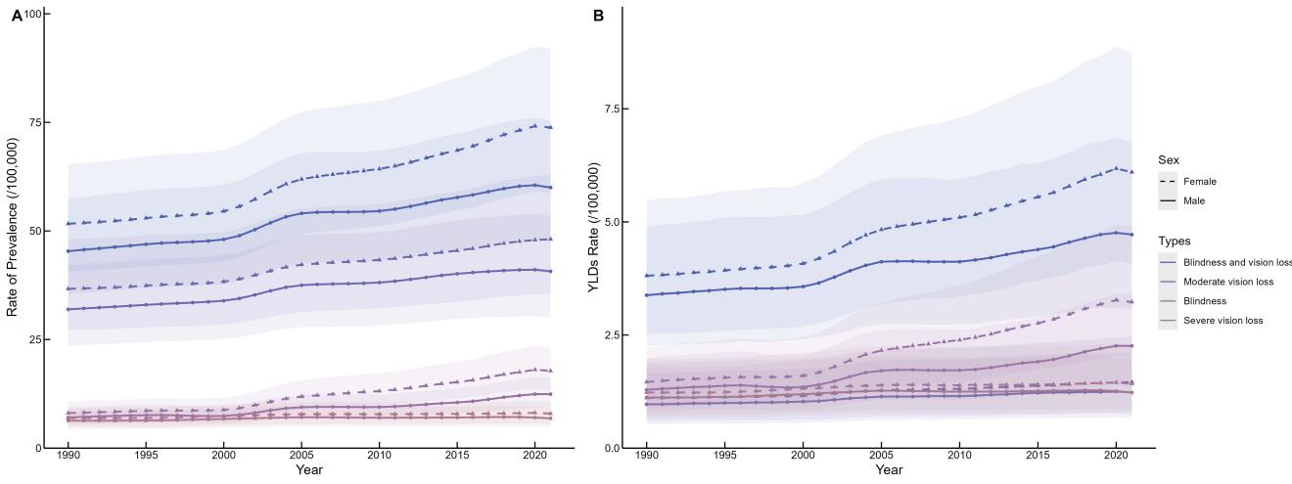

Figure S2 Disease burden of different degrees of diabetic retinopathy by gender from 1990-2021

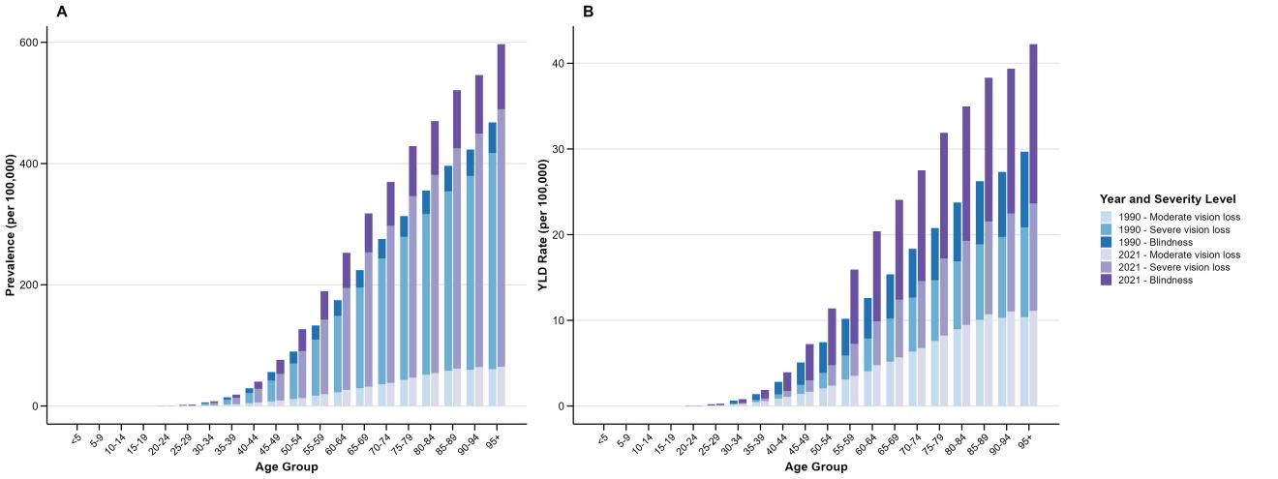

Figure S3 Disease burden of different degrees of diabetic retinopathy by age groups in 1990 and 2021

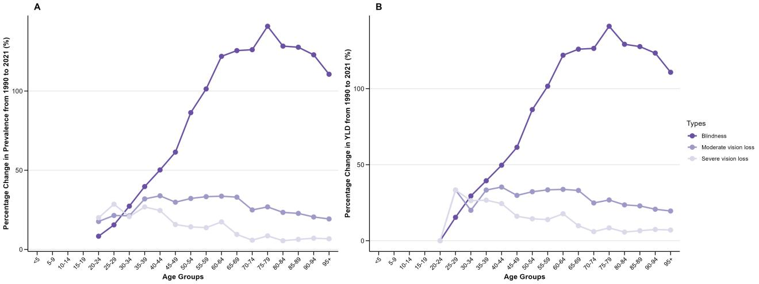

Figure S4 Change rates of disease burden of different degrees of diabetic retinopathy by age groups from 1990-2021

Note S1 Panel Data Regression Results by SDI Strata
Panel regression analyses stratified by SDI level revealed heterogeneous effects of health expenditure components on diabetic retinopathy burden. In low-SDI countries (n=1,113 observations), per capita health expenditure demonstrated a positive association with YLD rates (β=0.020, SE=0.010, p=0.046), while out-of-pocket expenditure share showed the strongest positive effect (β=0.164, SE=0.038, p<0.001). The socio-demographic index exhibited a consistent negative association across all strata, with the largest magnitude in high-middle SDI countries (β=-1.485, SE=0.199, p<0.001).

Note S2 Robustness Checks and Sensitivity Analyses
Multiple robustness tests validated the stability of our primary findings. Temporal subsample analysis comparing pre-2008 (n=1,624) and post-2008 (n=2,842) periods demonstrated consistent coefficient signs and significance levels. Exclusion of outliers identified through Cook's distance (n=226, 5.1% of sample) did not materially alter conclusions. Alternative outcome specifications using prevalence rates yielded qualitatively similar results. Instrumental variable estimation, employing two-period lagged health expenditure and within-SDI-group mean expenditure as instruments, confirmed the direction and statistical significance of key associations while suggesting potential underestimation of effect sizes in the baseline fixed effects model (first-stage F-statistic = 9.19×10³¹, Sargan test p=0.31).

Section S4 Data Quality Assessment and Limitations

S4.1 Data Completeness and Missing Data Patterns
Data completeness varied across variables and country-income groups. Disease burden indicators achieved 98.2% completeness, with missing values primarily occurring in small island states and territories with populations below 50,000. Health expenditure data demonstrated 92.4% completeness, with systematic missingness concentrated in the earliest years (2000-2005) for low-income countries. Ophthalmologist density data, available for 87.3% of countries, exhibited non-random missingness associated with lower health system capacity. Multiple imputation using chained equations (MICE) was implemented for health expenditure variables, with convergence diagnostics indicating stable parameter estimates across 20 imputed datasets (R-hat < 1.05 for all variables).

S4.2 External Validity Assessment
Cross-validation with independent data sources confirmed the reliability of our primary datasets. Diabetic retinopathy prevalence trends showed strong correlation with the International Diabetes Federation Atlas estimates (Pearson r=0.87, 95% CI: 0.83-0.90). Health expenditure efficiency rankings demonstrated moderate agreement with WHO efficiency reports (Kendall's τ=0.73, p<0.001). Regional burden patterns aligned with findings from the Lancet Global Health Commission on Global Eye Health (κ=0.82 for categorical burden classifications).

S4.3 Methodological Limitations
Several limitations warrant consideration when interpreting these findings. The ecological design precludes individual-level causal inference, and within-country heterogeneity remains unaddressed. Temporal misalignment between ophthalmologist density (2015) and outcome data (2021) may attenuate observed associations, though sensitivity analyses assuming ±30% variation in workforce density supported the robustness of threshold estimates. The observational nature of the study design, despite multiple identification strategies, cannot definitively establish causality. Future research employing quasi-experimental designs or exploiting natural policy experiments would strengthen causal inference.

Reference
1. GBD 2021 Diseases and Injuries Collaborators. Global incidence, prevalence, years lived with disability (YLDs), disability-adjusted life-years (DALYs), and healthy life expectancy (HALE) for 371 diseases and injuries in 204 countries and territories and 811 subnational locations, 1990-2021: A systematic analysis for the global burden of disease study 2021. Lancet (London, England). 2024;403:2133–61. https://doi.org/10.1016/S0140-6736(24)00757-8.
2. Resnikoff S, Lansingh VC, Washburn L, Felch W, Gauthier T-M, Taylor HR, et al. Estimated number of ophthalmologists worldwide (international council of ophthalmology update): Will we meet the needs? Br J Ophthalmol. 2020;104:588–92. https://doi.org/10.1136/bjophthalmol-2019-314336.
3. 2024 government AI readiness index. Oxford Insights. https://oxfordinsights.com/ai-readiness/ai-readiness-index/. Accessed 14 Jun 2025.

