Supplementary information 2
Broadband plasmon modulation and high-intensity nanofocusing for high-resolution nanoscale imaging using Fabry-Pérot probes

Hanjin Dong ¹, Shuming Yang ^{1 *}, Wenbo Hu ¹, Peirui Ji ¹, Weihao Tao ¹, Shuhao Zhao ¹, Ze Zhang ¹, Shenghan Qin ¹, Jiaxiang Liang ¹
¹ State Key Laboratory for Manufacturing Systems Engineering, Xi’an Jiaotong University, Xi’an, Shaanxi, 710049, China.

*Corresponding author: Shuming Yang (shuming.yang@mail.xjtu.edu.cn)

Abstract: This paper details the fabrication process of a double-slit plasmonic platform-based fiber probe, primarily encompassing the machining of the front cone, the preparation of the platform toroidal plane, and the etching of the double slit structure.

1. Preparation prior to probe preparation
The single-mode optical fiber used in the preparation experiment was the 630-HP single-mode optical fiber from Coherent/Nufern, with parameters as shown in Table S1.
Table S1. Parameters of the 630-HP single-mode optical fiber
parameters | unit | indicator
Operation Wavelength | nm | 600-770
Numerical Aperture | NA | 0.13
Cladding Diameter | um | 125±1.5
Coating Diameter | um | 245±15
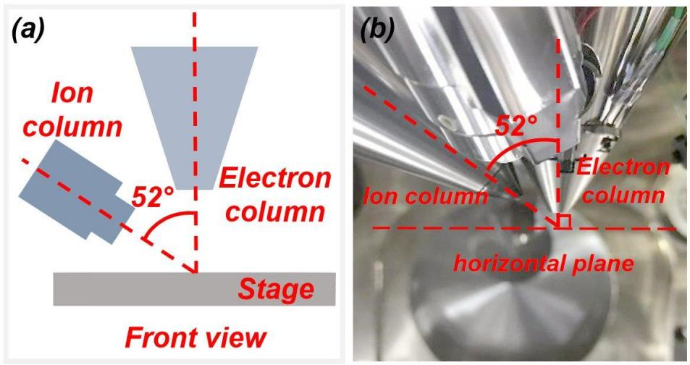
Fig. S2. Position relationship between electron column and ion column. a Theoretical schematic diagram. b Actual schematic diagram.
To controllably prepare probes with extremely small tip sizes, this study utilized Focused Ion Beam (FIB) for micro/nanofabrication of the probes¹. The focused ion beam electron microscope used in the experiment was the Thermo Scientific Helios 5 UX. As shown in Fig. S2, the positional relationship between the electron column and the ion column is illustrated. The FIB system used was a dual beam instrument where the electron and ion columns are placed vertically (at 0°) and at an angle of 52°, respectively. The ion source type is a gallium (Ga) ion source, with an acceleration voltage range of 0.5 kV to 30 kV and a beam current intensity of 1 pA to 65 nA. The electron beam acceleration voltage ranges from 1 kV to 30 kV, with a maximum resolution of 0.6 nm at an acceleration voltage of 15 kV.
2. Probe preparation process
To utilize FIB for preparing probe tips with extremely small curvature radii, we proposed a new probe preparation process. Fig. S3 shows the overall process flow diagram for preparing DSPP. The preliminary preparation of high-performance probes primarily consists of two steps: the preparation of ordinary conical fibers and the vacuum evaporation of metal thin films. Ordinary conical fibers are prepared using the tube etching method, followed by vacuum deposition of a 300 nm thick gold (Au) thin film on the surface of the conical structure to achieve conductivity. The probe axis is then aligned with the ion column axis, and a ring pattern is designed for multiple etching steps. The center of the ring pattern is always aligned with the center of the probe tip. The outer diameter of the ring pattern etched each time matches the inner diameter of the previous etching. In the final circular pattern etching, the inner diameter of the circular pattern is designed to be the curvature radius required for the probe tip. The final structure obtained is a conical structure with a concave tip, where the cone angle and cone length can be controlled by adjusting the inner and outer radii of the ring pattern and the depth of each etching.
After the front cone is processed, the gold on it is etched away, leaving the surface of the front cone exposed ${\text{SiO}}_{\text{2}}$. Due to the conical structure of the probe, there will be protuberances around the front cone that have not been etched away. Therefore, in order to prepare a platform toroidal plane, the protuberances around the front cone need to be cut off evenly. At this point, the optical fiber probe needs to be rotated multiple times with its axis perpendicular to the axis of the ion column and cut away to prepare an optical fiber probe with a front cone and a platform toroidal plane at the bottom of the front cone. Since the Au film on the surface of the front cone has been etched away at this point, FPFP can be prepared by evaporating Au onto the surface of the optical fiber probe again. Finally, a double slit structure is fabricated on the FPFP, completing the preparation of the DSPP.
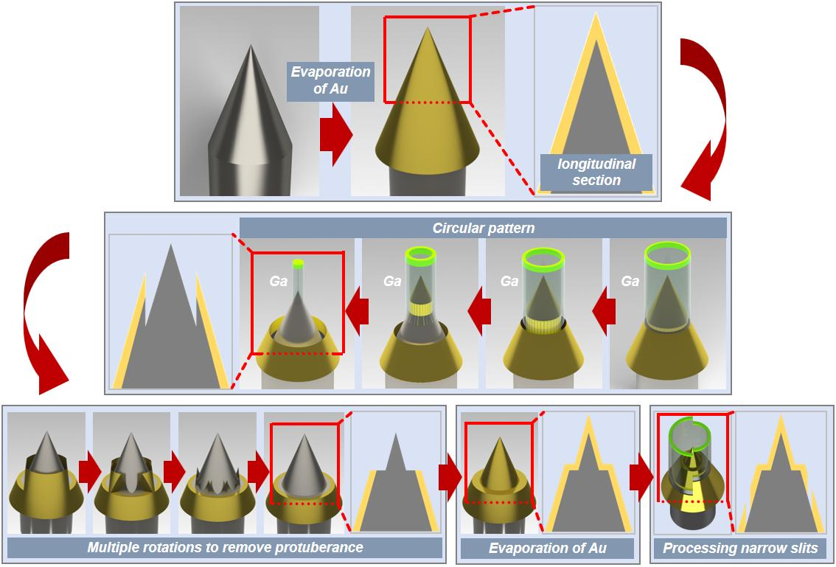
Fig. S3. Overall flowchart for the preparation of DSPP. A layer of Au film is vapor-deposited on the conical optical fiber probe to make it conductive. The front cone structure and the curvature radius of the needle tip are precisely controlled using ring etching technology. Then, a platform toroidal plane with high flatness is prepared using rotation cutting technique. After vapor deposition on the probe again, two asymmetrical semicircular slits are etched to complete the preparation of DSPP.
3. Preparation of the front cone
The specimen holder used in the experiments is shown in Fig. S4. It has the axis of the ion column aligned with the axis of the optical fiber. The sample stage has a 45° inclined plane from the horizon. A tilt axis beneath the stage allows rotation, with a maximum tilt of 10° along the blue arrow and 52° along the red arrow. The relationship between the ion column and the sample stage is illustrated in the upper right window of the Figure.
The actual alignment of the ion column axis with the fiber axis is shown in Fig. S5. The fiber was glued to the sample plate as shown in Fig. S5a, which was then clamped onto the specimen holder. In Fig. S5b, the top view of the specimen holder shows the alignment of the ion column and the probe. The ion column must be aligned with the probe axis, as shown in Fig. S5c, where the tilt angle of the stage was adjusted to 7° to align the probe axis parallel to the ion column. Fig. S5d displays a view of the probe under the ion beam window to confirm alignment.
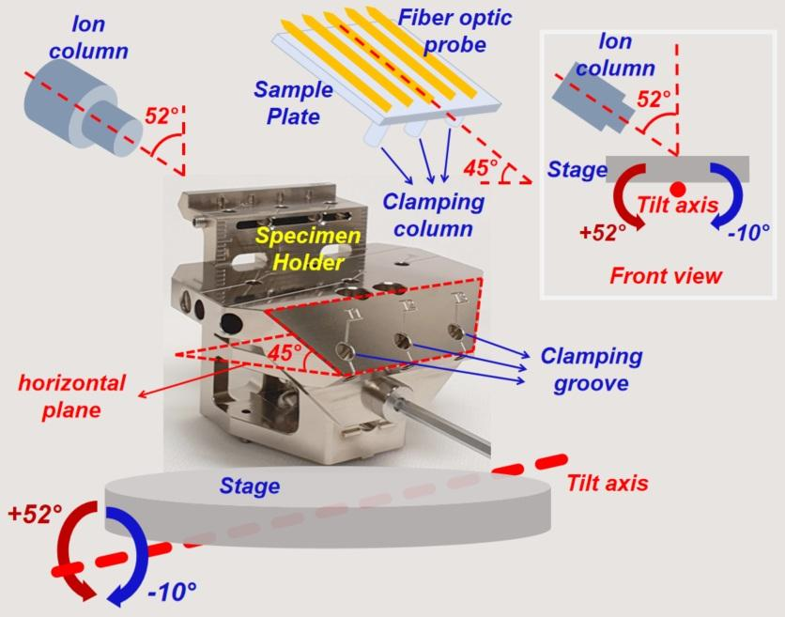
Fig. S4. The diagram of the specimen holder with the axis of the ion column aligned with the axis of the optical fiber.
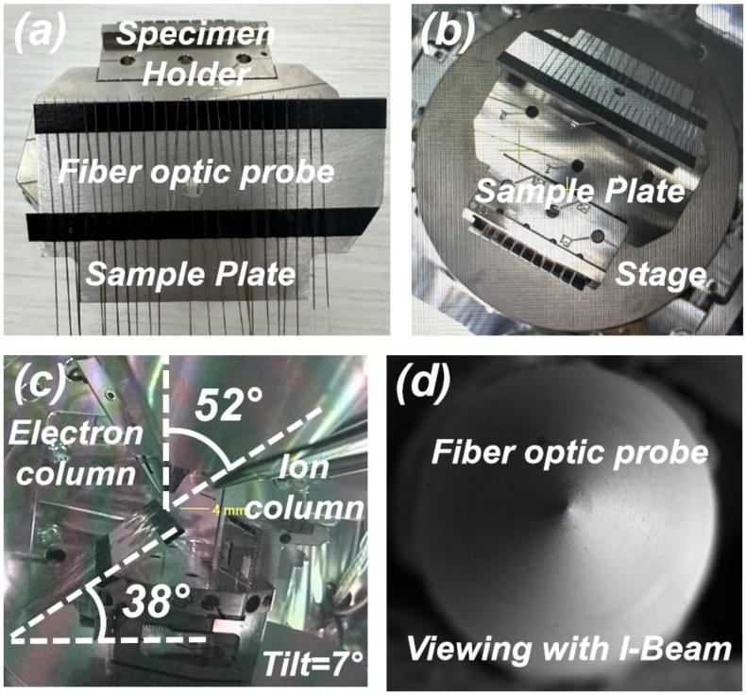
Fig. S5. Align the ion column axis with the fiber axis. a Glue the fiber to the sample plate. b Top view of specimen holder fixed on stage. c Adjust the tilt angle of stage to 7°. d Viewing the probe with I-Beam.
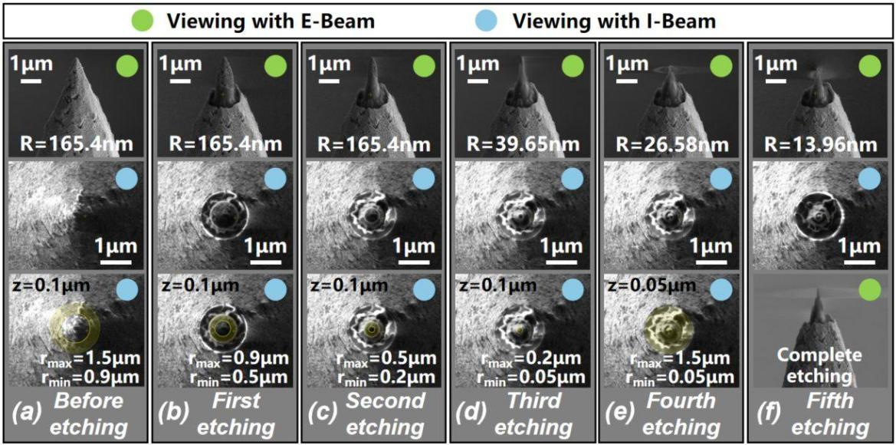
Fig. S6. The process of the sleeve-ring etching technique.
The fabrication process of the sleeve-ring etching technique is illustrated in Fig. S6. The image marked with a green circle in the upper right corner represents the probe under the electron beam, while the image marked with a blue circle shows the probe under the ion beam. Fig. S6a shows the characterization of the probe before processing, with a tip curvature radius of approximately 165 nm. The first ring pattern, designed under the ion beam window, has an outer diameter ${\text{r}}_{\text{max}}$ of 1.5 μm, an inner diameter ${\text{r}}_{\text{min}}$ of 0.9 μm, and a processing depth z of 0.1 μm. Fig. S6b shows the probe after the first etching, where the ring pattern has been removed. However, the curvature radius of the probe tip remains unchanged due to the relatively large inner diameter of the ring. A second ring pattern was designed with the outer diameter matching the inner diameter of the first ring. Fig. S6c shows the probe after the second etching. The curvature radius of the tip remains unchanged, but the etching position was closer to the probe tip, indicating the size reduction. During the third etching, the outer diameter of ring pattern was designed to match the inner diameter of the second pattern. Fig. S6d shows the characterization of the probe after the third etching, where the tip curvature radius is reduced to 39.65 nm. After the fourth etching, Fig. S6e shows a further decrease in the curvature radius to approximately 26 nm. By far, the surface of the front cone remains rough. Therefore, a finishing ring pattern was designed, with the outer diameter equal to that of the first pattern and the inner diameter matching that of the final etching pattern. The depth of the final etching was reduced to 0.05 μm, as shown in Fig. S6e. The final characterization of the probe after the fifth etching is shown in Fig. S6f with a tip curvature radius of 13.96 nm. This represented an improvement of more than an order of magnitude in tip curvature, and the surface quality of the front cone was significantly enhanced. The probe with a well-defined front cone is shown in Fig. S7.
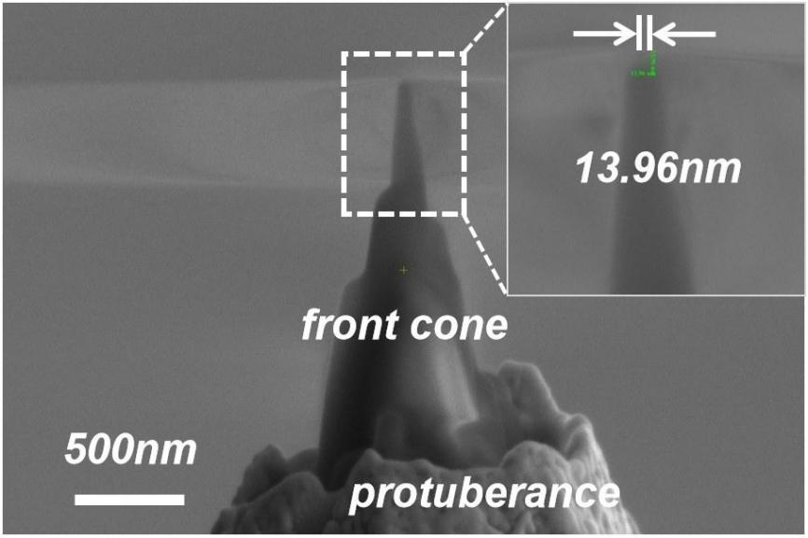
Fig. S7. The probe with a front cone.
4. Preparation of the platform toroidal plane
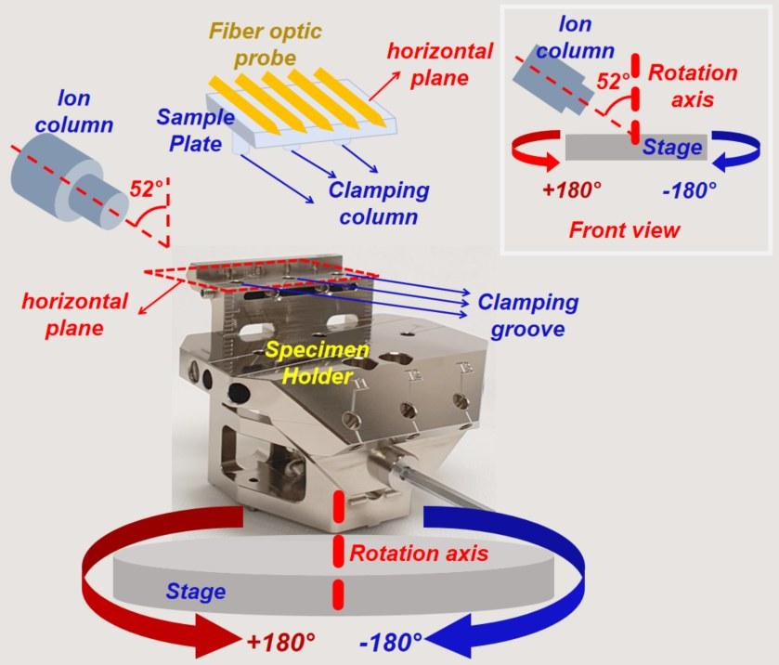
Fig. S8. The diagram of the clamping for machining with the axis of the ion column perpendicular to the axis of the probe.
After processing the front cone, the next step is to prepare the platform toroidal plane, which involves removing the protuberance around the front cone. This process requires the ion column axis to be perpendicular to the probe. Due to the limitations of the tilt angle of the stage, the method of clamping the sample plate must be adjusted. As shown in Fig. S8, the upper surface of the specimen holder used for processing is parallel to the horizontal plane. The sample plate was clamped onto the upper surface of the specimen holder. The stage of the FIB has a rotational axis, which allows the stage to rotate around the central axis at any angle. The view of the rotating stage is shown in the upper-right corner of the Figure, illustrating that the rotation angle is not limited. The central axis of the probe lies on the horizontal plane, with the specimen holder fixed to the stage.
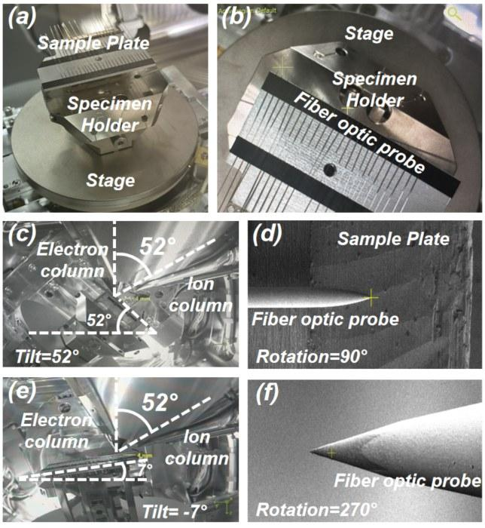
Fig. S9. The ion column axis is perpendicular to the probe axis. a The probe is glued to the sample plate. b Top view of specimen holder fixed on stage. c Adjust the tilt angle of stage to 52 °. d Viewing the probe with I-Beam with the rotation angle of 90 °. e Adjust the tilt angle to -7 °. f Viewing the probe with I-Beam with the rotation angle of 270 °.
Fig. S9 presents a diagram illustrating the alignment of the ion column axis perpendicular to probe axis. Fig. S9a shows that the sample plate is clamped onto the upper surface of specimen holder, with the probe axes lying on the horizontal plane. Fig. S9b is the top view of the specimen holder fixed to the stage. The rotation angle of the stage must be adjusted so that the axis of the probe becomes perpendicular to the ion column axis to remove the protuberance around the front cone. The tilt angle of the stage was then continuously adjusted to perform the rotary excision of the protuberance. Fig. S9c shows the positional relationship between the probe and ion column axes when the tilt angle is 52°. Fig. S9e shows this relationship when the tilt angle is -7°. Fig. S9d and S9f provide views of the probe under the ion beam window, demonstrating that the axis of the ion column is indeed perpendicular to that of the probe.
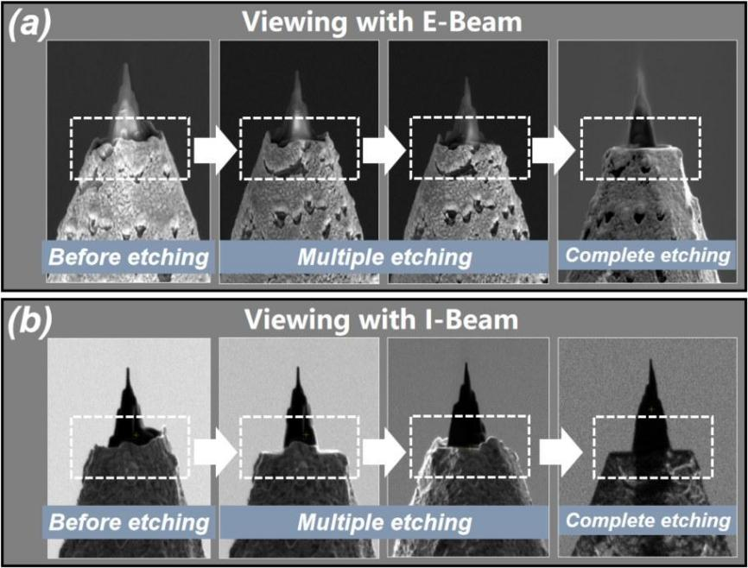
Fig. S10. The process of removing the protuberance on the front cone.
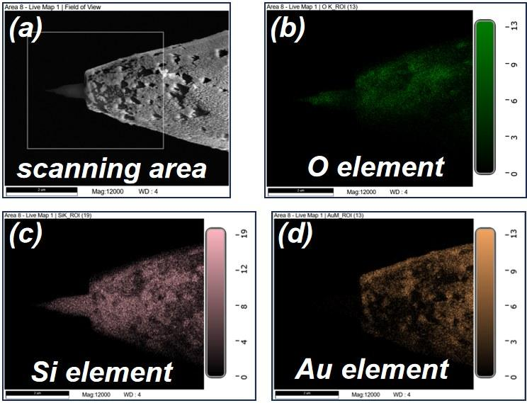
Fig. S11. The EDS elemental analysis.
The process of cutting off the excess material on the front cone is shown in Fig. S10. During this process, the axis of the probe remained perpendicular to that of the ion column. The tilt angle of the stage was adjusted from -10° to 52° to gradually remove the protuberance around the front cone. Fig. S10a shows the characterization under the electron beam, while Fig. S10b provides the characterization under the ion beam. After the final etching step, the protuberance around the front cone was smoothly cut off, forming a platform toroidal plane at the bottom of the front cone of the probe. The elemental analysis of the treated probe was performed, and the protrusions of the probe were mainly composed of the elements oxygen (O) and silicon (Si). In addition, the protuberance around the front cone was completely removed. The Au layer on the surface of the front cone was also completely etched away to ensure the quality of the subsequent metal film deposition. The corresponding EDS elemental analysis diagram is shown in Fig. S11.
5. Evaporation of metal layer
The Au layer on the surface of the front cone has been etched away. However, Au must be re-deposited onto the probe surface to enable the excitation of surface plasmons. Fig. S12 presents the multiple probes that were ultimately fabricated. The results showed that the prepared probes had the feature of a very flat platform toroidal plane, with both the angle and length of the front cone being controllable. Furthermore, the final platform-based plasmonic probes exhibited a significantly smaller tip curvature radius, with the tip curvature improved by more than an order of magnitude compared to the unprocessed probes.
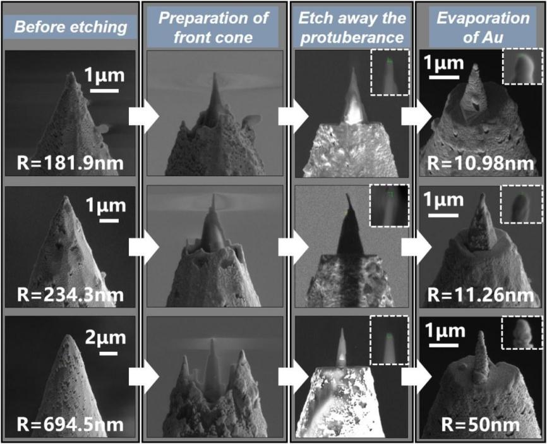
Fig. S12. The preparation of multiple platform-based plasmon probes.
6. Preparation of double slit structure
Based on the successfully prepared platform-based optical fiber probes, two asymmetrical semi-circular slit structures were processed to complete the preparation of DSPP. Fig. S13 shows the process of preparing the double slit of the DSPP probe in Fig. 1d and e.
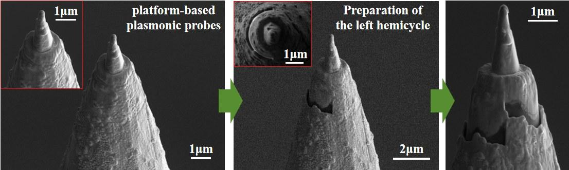
Fig. S13. Preparation process of the double slit structure.
7. References
(1) Shiotari, A.; Nishida, J.; Hammud, A.; Schulz, F.; Wolf, M.; Kumagai, T.; Müller, M. Scattering near-Field Optical Microscopy at 1-Nm Resolution Using Ultralow Tip Oscillation Amplitudes. Sci. Adv. 2025, 11 (24), eadu1415.

