Supplementary information 1
Broadband plasmon modulation and high-intensity nanofocusing for high-resolution nanoscale imaging using Fabry-Pérot probes

Hanjin Dong ¹, Shuming Yang ^{1 *}, Wenbo Hu ¹, Peirui Ji ¹, Weihao Tao ¹, Shuhao Zhao ¹, Ze Zhang ¹, Shenghan Qin ¹, Jiaxiang Liang ¹
¹ State Key Laboratory for Manufacturing Systems Engineering, Xi’an Jiaotong University, Xi’an, Shaanxi, 710049, China.

*Corresponding author: Shuming Yang (shuming.yang@mail.xjtu.edu.cn)

Abstract: This paper primarily consists of the following four sections: 1. Focusing enhancement effect of platform-based plasmonic fiber probes, 2. Two-dimensional planar structure of DSPP and DSP, and parameter settings in simulation, 3. Probe film thickness parameter optimization, 4. Nanofocusing of DSPP under broadband.

1. Focusing enhancement effect of platform-based plasmonic fiber probes
Most existing plasmonic fiber probes use radially polarization mode (${\text{TM}}_{\text{01}}$) to excite radially polarized SPP modes (${\text{TM}}_{\text{01}}\text{-SPP}$) on the surface of axially symmetric metal-coated films, thereby achieving nanofocusing at the tip of the probe^{1–4}.In order to achieve greater electric field enhancement at the probe tip, existing research has used Fabry-Pérot interference structures to control the propagation of surface plasmonics on the probe surface⁵, thereby preparing a platform-based plasmonic fiber probe (FPFP)⁶.
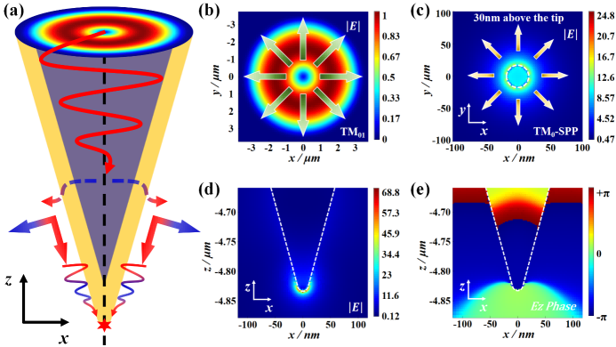
Fig. S1. Electric field and phase distribution of ${\text{TM}}_{\text{01}}\text{-SPP}$ excited by ${\text{TM}}_{\text{01}}$ coupling in an axisymmetric Au-coated conical fiber probe. a Schematic diagram of surface plasmon polaritons excited by ${\text{TM}}_{\text{01}}$ coupling in an Au-coated conical fiber. b Electric field distribution and polarization of ${\text{TM}}_{\text{01}}$. c Electric field distribution and polarization of ${\text{TM}}_{\text{01}}\text{-SPP}$. d Electric field distribution near the probe tip. e ${\text{E}}_{\text{z}}$ phase distribution near the probe tip. The direction of the arrows in the Figure. indicates the direction of the electric field.
In this paper, the finite-difference time-domain (FDTD) method was used to simulate ordinary conical fiber probes and FPFPs. Fig. S1a shows that ${\text{TM}}_{\text{01}}$ coupled and excited ${\text{TM}}_{\text{01}}\text{-SPP}$ in an axisymmetric metal-coated conical fiber probe, and nanofocusing was achieved at the tip of the probe. Fig. S1b and S1c show the electric field distributions of ${\text{TM}}_{\text{01}}$ and the corresponding ${\text{TM}}_{\text{01}}\text{-SPP}$, respectively. The electric field directions of both modes diverge from the center along the radial direction and exhibit a symmetrical distribution along the probe axis. ${\text{TM}}_{\text{01}}\text{-SPP}$ coupled by ${\text{TM}}_{\text{01}}$ does not undergo mode cutoff ^{4,7–9}, so nanofocusing can be achieved at the tip of the probe, as shown in Fig. S1c and S1d. The phase distribution along the Z direction shown in Fig. S1e reveals that the phase distribution of ${\text{TM}}_{\text{01}}\text{-SPP}$ is identical at positions symmetrical to the probe axis, indicating that ${\text{TM}}_{\text{01}}\text{-SPP}$ exhibits symmetrical polarization distribution along the probe axis.
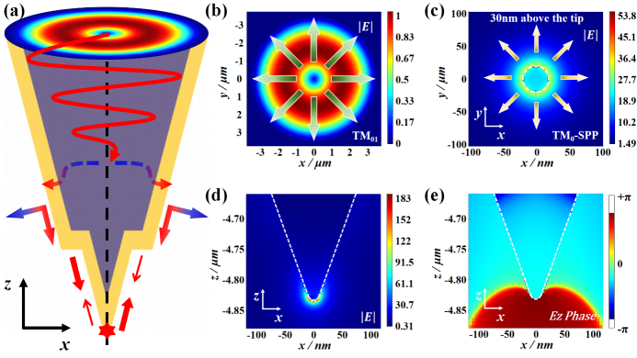
Fig. S2. Electric field and phase distribution of ${\text{TM}}_{\text{01}}\text{-SPP}$ excited by ${\text{TM}}_{\text{01}}$ coupling in FPFP. a Schematic diagram of surface plasmon polaritons excited by ${\text{TM}}_{\text{01}}$ coupling in FPFP. b Electric field distribution and polarization of ${\text{TM}}_{\text{01}}$. c Electric field distribution and polarization of ${\text{TM}}_{\text{01}}\text{-SPP}$. d Electric field distribution near the probe tip. e ${\text{E}}_{\text{z}}$ phase distribution near the probe tip. The direction of the arrows in the Figure. indicates the direction of the electric field.
Under the same simulation parameters, a platform-based structure was designed on a normal conical probe, and the simulation was performed again. Fig. S2 shows that ${\text{TM}}_{\text{01}}$ coupling excited ${\text{TM}}_{\text{01}}\text{-SPP}$ in FPFP, and nanofocusing was achieved at the tip of the probe. The simulation results show that FPFP can not only achieve nanofocusing at the tip of the probe, but also, due to the presence of the platform toroidal plane, the probe can utilize the Fabry-Pérot interference mechanism to achieve multiple energy superpositions, resulting in an electric field strength at the tip of the needle that is much higher than that of a normal probe.
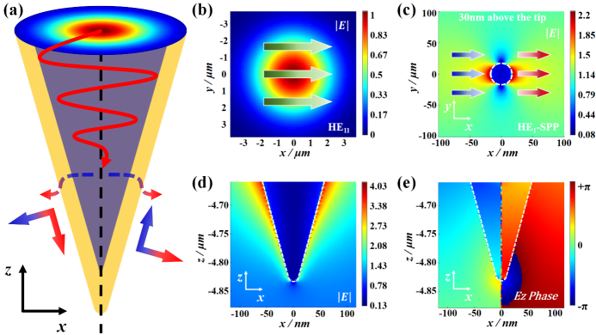
Fig. S3. Electric field and phase distribution of ${\text{HE}}_{\text{11}}\text{-SPP}$ excited by ${\text{HE}}_{\text{11}}$ coupling in an axisymmetric Au-coated conical fiber probe. a Schematic diagram of surface plasmon polaritons excited by ${\text{HE}}_{\text{11}}$ coupling in an Au-coated conical fiber. b Electric field distribution and polarization of ${\text{HE}}_{\text{11}}$. c Electric field distribution and polarization of ${\text{HE}}_{\text{11}}\text{-SPP}$. d Electric field distribution near the probe tip. e ${\text{E}}_{\text{z}}$ phase distribution near the probe tip. The direction of the arrows in the Figure. indicates the direction of the electric field.
Based on the above simulation, the linearly polarized SPP mode (${\text{HE}}_{\text{11}}\text{-SPP}$) of the Au-coated conical fiber probe was excited by coupling the linearly polarized mode (${\text{HE}}_{\text{11}}$), and ${\text{HE}}_{\text{11}}\text{-SPP}$ had the same antisymmetric polarization distribution as ${\text{HE}}_{\text{11}}$ at positions symmetrical to the probe axis, as shown in Fig. S3. Fig. S3b and S3c show the electric field distributions of ${\text{HE}}_{\text{11}}$ and the corresponding ${\text{HE}}_{\text{11}}\text{-SPP}$, respectively. As can be seen from the Figure, the two modes have the same electric field polarization direction in the XY plane. Additionally, as shown in Fig. S3c, due to the excitation of ${\text{HE}}_{\text{11}}\text{-SPP}$, the field distribution of the waveguide mode has already diffused at the cylindrical waveguide located 30 nm from the probe tip, and cannot be tightly confined around the metal cylinder. As the ${\text{HE}}_{\text{11}}\text{-SPP}$ propagates further, it undergoes mode cutoff near the probe tip and leaks into free space, becoming background noise, as shown in Fig. S3d. Fig. S3e shows the phase distribution of ${\text{HE}}_{\text{11}}\text{-SPP}$ in the Z direction at the tip of the probe. It is observed that the phase distribution of the waveguide mode is opposite at positions symmetrical along the probe axis, which also indicates that ${\text{HE}}_{\text{11}}\text{-SPP}$ has an antisymmetric polarization distribution along the probe axis.
The simulation results of FPFP under ${\text{HE}}_{\text{11}}$ are shown in Fig. 2c to 2e. As shown in Fig. 2c, due to the excitation of ${\text{HE}}_{\text{11}}\text{-SPP}$, the electric field distribution of the waveguide mode has already diffused in the cylindrical waveguide at a distance of 30 nm from the probe tip, and cannot be tightly confined around the metal cylindrical waveguide. The arrow direction in the Figure represents the electric field direction. As shown in Fig. 2d, as the ${\text{HE}}_{\text{11}}\text{-SPP}$ propagates further, it undergoes mode cutoff near the probe tip and leaks into the surrounding space, becoming background noise. Fig. 2e shows the phase distribution of the ${\text{HE}}_{\text{11}}\text{-SPP}$ along the Z direction at the probe tip position. It is observed that the phase distribution of the waveguide mode at the probe axis symmetrical position is opposite, further confirming that the ${\text{HE}}_{\text{11}}\text{-SPP}$ exhibits an antisymmetric polarization distribution along the probe axis.
Therefore, although FPFP can achieve greater electric field enhancement than ordinary Au-coated conical fiber probes, FPFP still relies on ${\text{TM}}_{\text{01}}$ to excite ${\text{TM}}_{\text{01}}\text{-SPP}$ on the surface of the Au film before stronger nanofocusing can be achieved at the tip of the probe.
2. Two-dimensional planar structure of DSPP and DSP, and parameter settings in simulation
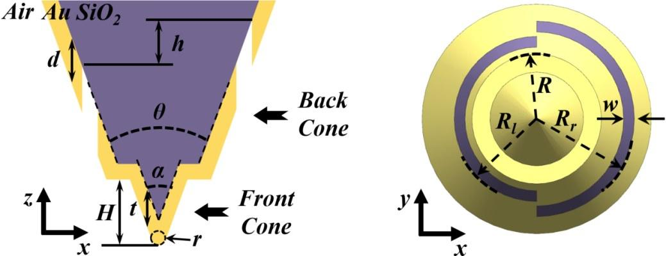
Fig. S4. Schematic diagram of the two-dimensional structure of DSPP in the XZ plane and the XY plane.
In order to achieve nanofocusing at the tip of the probe under ${\text{HE}}_{\text{11}}$, existing studies have designed two asymmetrical semicircular slit structures on ordinary conical metal-coated fiber probes. This structure is used to achieve polarization reversal under linear polarized light, thereby achieving nanofocusing at the needle tip. However, the focusing electric field strength at the tip of the probe is low, and there is no effective energy recycling enhancement mechanism¹⁰. To overcome the above limitations, this study proposes a dual-slit platform-based plasmonic fiber probe (DSPP). The two-dimensional plane structure of the DSPP is shown in Fig. S4. The two semicircular ring slit structures have a specific height difference h. A center-symmetric platform toroidal plane is designed at the probe structure with a radius smaller than the two semicircular rings. The front end structure of the probe located on the platform toroidal plane is the front cone, and the probe structure located behind the platform toroidal plane is the back cone. The angle of the front cone of the DSPP is α, the height of the front cone is H, and the thickness of the Au film along the probe axis of the front cone and the platform toroidal plane is t. The angle of the back cone is θ, and the thickness of the Au film along the probe axis of the back cone is d. The radius R of the platform toroidal plane is defined as the diameter of the largest outer circle. The width of the two asymmetric semicircular ring slits is w, where the radius of the smaller semicircular ring slit is ${\text{R}}_{\text{l}}$, and the radius of the larger semicircular ring slit is ${\text{R}}_{\text{r}}$. The radius of the semicircular ring slit is defined as the radius of the largest outer semicircle.
In order to further study the nanofocusing effect of DSPP, a geometric model of a common asymmetric double-slit probe (DSP) was also established. The two-dimensional plane structure of DSP is shown in Fig. S5. The cone angle of DSP is θ', the thickness of the Au film along the probe axis is t', and the height difference between the two semicircular ring slits is h'.
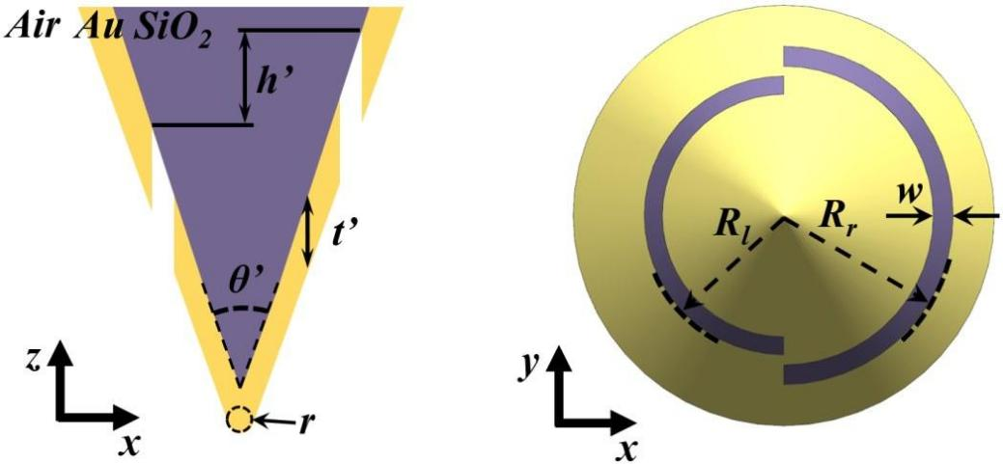
Fig. S5. Schematic diagram of the two-dimensional structure of DSP in the XZ plane and the XY plane.
In the simulation experiment, in order to ensure the consistency of the comparison between DSPP and DSP, the cone angle θ' of DSP and the back cone angle θ of DSPP were both set to 32°, and the film thickness t' of DSP was the same as the front cone film thickness t of DSPP. The double slit height difference h’ of the DSP is kept consistent with the double slit height difference h of the DSPP, set to 935 nm in this study. The smaller semi-circular slit radius ${\text{R}}_{\text{l}}$ and the larger semi-circular slit radius ${\text{R}}_{\text{r}}$ of both the DSP and DSPP are the same, and the slit width w is set to 120 nm. Additionally, the light source parameters, material properties, and mesh size in the simulation are all kept consistent.
3. Probe film thickness parameter optimization
For axisymmetric FPFP, ${\text{HE}}_{\text{11}}$ in the optical fiber can excite ${\text{HE}}_{\text{11}}\text{-SPP}$ outside the metal film, as shown in Fig. 2c to e, but this plasmonic mode will undergo mode cutoff at the probe tip and convert to background noise. Therefore, it is necessary to optimize the Au film thickness to reduce the influence of background noise, ensuring that the surface plasmon modes propagating outside the metal film are ${\text{TM}}_{\text{01}}\text{-SPP}$ modes regulated by the asymmetric half-ring slit. The thickness of the metal film affects the penetration depth of incident light within the fiber and the coupling efficiency of plasmon modes outside the metal film. Therefore, background noise can be eliminated by optimizing the metal film thickness, as shown in Fig. S6. As the Au film thickness increases, the intensity of background noise gradually decreases, while the transmittance of background leakage light gradually decreases. According to the simulation results, when the Au film thickness exceeds 180 nm, the scattered light transmittance (SLT) is less than 10%. At this point, it can be considered that there is basically no background light leakage in the front cone part. Therefore, based on the simulation results and actual operating experience, the Au film thickness t of the front cone part is selected as 180 nm.
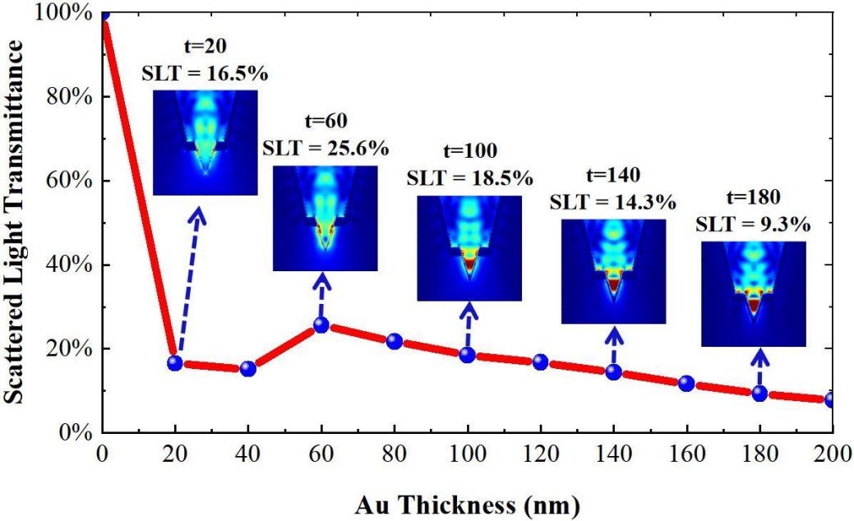
Fig. S6. Optimization of Au film thickness on the surface of the front cone
From the preparation process of the probe, it can be seen that the preparation of DSPP requires two evaporation steps. The first evaporation of a 300 nm Au film is to ensure that the probe can conduct electricity during FIB processing, and the second evaporation is to evenly deposit a layer of Au film on the front cone structure and platform toroidal plane exposed by SiO₂. Therefore, the Au film thickness t along the probe axis is 180 nm for both the front cone structure and the platform toroidal plane. After the platform toroidal plane is prepared by FIB, theoretically, the Au film thickness d of the back cone should be 300 nm. However, based on experience with FIB processing, during the processing, the Au film on the back cone will be partially etched away due to exposure to the ion beam. Therefore, after the second Au film deposition, the thickness d of the Au film on the back cone should be less than the sum of the thicknesses of the two Au films. In the simulation in this paper, the thickness of the Au film on the back cone is set to 420 nm. Additionally, to better compare the performance of DSPP and DSP probes, the DSP film thickness t’ is also set to 180 nm.
4. Nanofocusing of DSPP under broadband
In order to verify the nanofocusing characteristics of DSPP in a broadband range, multimode optical fiber was used in the experiment. The parameters of this optical fiber are shown in Table S7. As can be seen from the parameter table, this multimode optical fiber has a wider wavelength range and is more suitable for broadband experimental testing.
Table S7. Parameters of multimode optical fiber
parameters | unit | indicator
Operation Wavelength | nm | 300 - 2400
Numerical Aperture | NA | 0.22 ± 0.02
Core Diameter | um | 105 ± 3
Cladding Diameter | um | 125 ± 2
Coating Diameter | um | 250 ± 10
In order to study the nanofocusing effect of DSPP with changes in front cone height and angle in a broadband range, the electric field distribution and phase distribution at the tip of DSPP were simulated. Fig. S8 shows the electric field and phase distribution at the tip of DSPP under incident light of different wavelengths and front cones of different heights when the front cone angle is 32°. Fig. S9 shows the electric field and phase distribution of the DSPP needle tip under incident light of different wavelengths and front cones of different angles when the front cone height is 500 nm. The simulation results show that, in a broadband range, different front cone heights and angles can achieve nanofocusing at the tip, and the electric field enhancement effect is significant. At the same time, the phases on both sides of the probe show the same phase distribution at the needle tip, indicating that interference nanofocusing occurs at the needle tip.
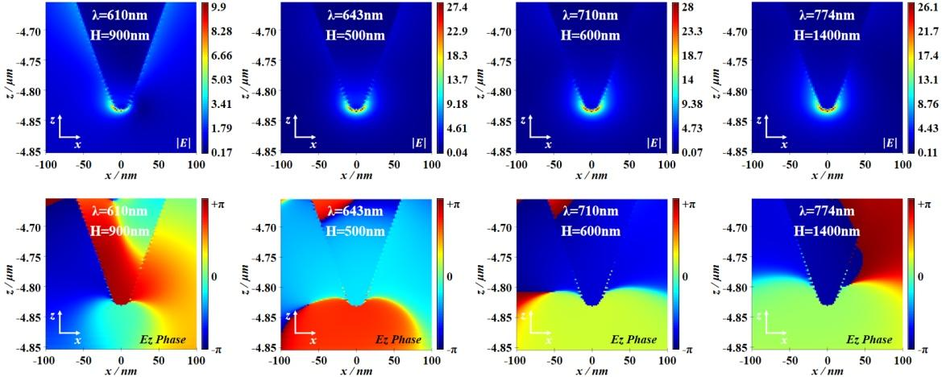
Fig. S8. Electric field and phase at the probe tip as a function of incident wavelength and front cone height when the front cone angle is 32°.
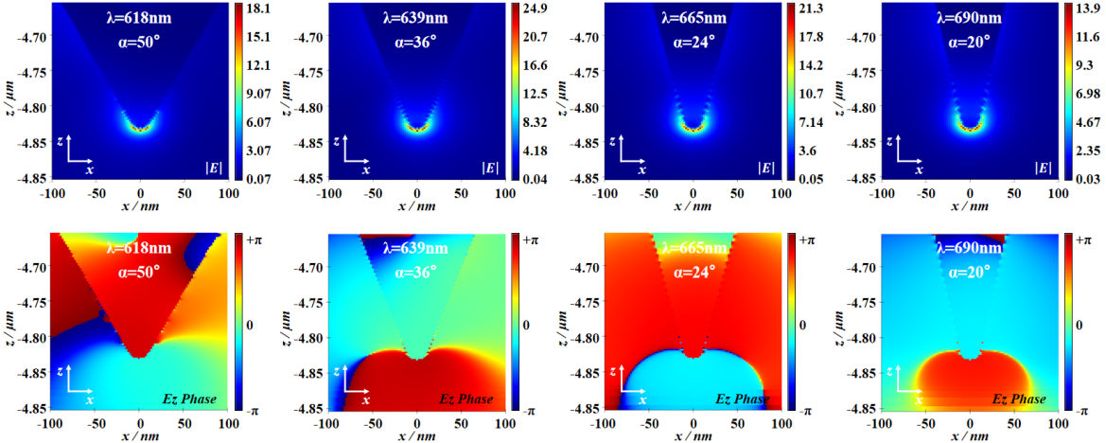
Fig. S9. Probe tip electric field and phase as a function of incident wavelength and front cone angle when the front cone height is 500 nm.
5. References
(1) Liu, M.; Lu, F.; Zhang, W.; Huang, L.; Liang, S.; Mao, D.; Gao, F.; Mei, T.; Zhao, J. Highly Efficient Plasmonic Nanofocusing on a Metallized Fiber Tip with Internal Illumination of the Radial Vector Mode Using an Acousto-Optic Coupling Approach. Nanophotonics 2019, 8 (5), 921–929.
(2) Lu, F.; Zhang, W.; Zhang, L.; Liu, M.; Xue, T.; Huang, L.; Gao, F.; Mei, T. Nanofocusing of Surface Plasmon Polaritons on Metal-Coated Fiber Tip under Internal Excitation of Radial Vector Beam. Plasmonics 2019, 14 (6), 1593–1599.
(3) Tugchin, B. N.; Janunts, N.; Klein, A. E.; Steinert, M.; Fasold, S.; Diziain, S.; Sison, M.; Kley, E.-B.; Tünnermann, A.; Pertsch, T. Plasmonic Tip Based on Excitation of Radially Polarized Conical Surface Plasmon Polariton for Detecting Longitudinal and Transversal Fields. ACS Photonics 2015, 2 (10), 1468–1475.
(4) Li, S.; Yang, S. Nanofocusing of a Novel Plasmonic Fiber Tip Coupling with Nanograting Resonance. J. Phys. D: Appl. Phys. 2020, 53 (21), 215102.
(5) Böckmann, H.; Liu, S.; Müller, M.; Hammud, A.; Wolf, M.; Kumagai, T. Near-Field Manipulation in a Scanning Tunneling Microscope Junction with Plasmonic Fabry-Pérot Tips. Nano Lett. 2019, 19 (6), 3597–3602.
(6) Wang, F.; Li, S.; Zhao, S.; Zhang, Z.; Ji, P.; Xia, C.; Cheng, B.; Zhang, G.; Yang, S. A Flat-Based Plasmonic Fiber Probe for Nanoimaging. Nano Res. 2023, 16 (5), 7545–7549.
(7) Janunts, N. A.; Baghdasaryan, K. S.; Nerkararyan, Kh. V.; Hecht, B. Excitation and Superfocusing of Surface Plasmon Polaritons on a Silver-Coated Optical Fiber Tip. Opt. Commun. 2005, 253 (1–3), 118–124.
(8) Kim, S.; Yu, N.; Ma, X.; Zhu, Y.; Liu, Q.; Liu, M.; Yan, R. High External-Efficiency Nanofocusing for Lens-Free near-Field Optical Nanoscopy. Nat. Photonics 2019, 13 (9), 636–643.
(9) Wu, Y.; Lu, L.; Chen, Y.; Feng, L.; Qi, X.; Ren, H.-L.; Guo, G.-C.; Ren, X. Excitation and Analyzation of Different Surface Plasmon Modes on a Suspended Ag Nanowire. Nanoscale 2019, 11 (46), 22475–22481.
(10) Li, S.; Yang, S.; Wang, F.; Liu, Q.; Cheng, B.; Rosenwaks, Y. Plasmonic Interference Modulation for Broadband Nanofocusing. Nanophotonics 2021, 10 (16), 4113–4123.

