Supporting information

Low silver loaded biphase of TiO₂ microrods with TiO₂(B)/anatase and their photocatalytic and antibacterial properties
Zhijie Ding^{a,b}, Zetan Zhangª, Zhitao Chenª, Yang Wangª, Ruiqi Wangª, Xinyu Xiaª, Lei Bai^{a*}, You Liu^{a,b}, Xuchun Wang^{a,b}, Yu Guo^{a,b}
（a. College of Chemistry and Materials Engineering, Anhui Science and Technology University, Bengbu, 233000, China；
b. Anhui Province Quartz Sand Purification and Photovoltaic Glass Engineering Research Center, Chuzhou, 233100, China）
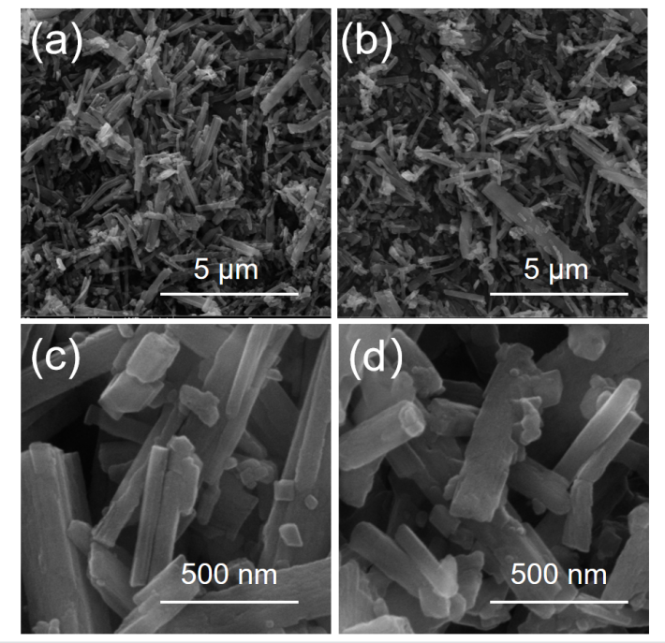
SFig. 1 SEM images of TiO₂ MRs (image a and c) and Ag/TiO₂ MRs-B (image b and d)

SFig. 2 UV–Vis difuse refection spectra (a) and (Fhν) 1/2 as a function of photon energy (hν) of the samples (b), where F is the Kubelka–Munk function of the difuse refectance R

SFig. 3 N₂ adsorption–desorption isotherm of TiO₂ MRs (a)and Ag/TiO₂ MRs-B (b)

STable 1 Rate constants for the photocatalytic degradation of MB under ultraviolet radiation
Sample | Apparent rate constant/min⁻¹ | R²
TiO₂ MRs | 0.05564 | 0.98554
Ag/TiO₂ MRs-A | 0.07464 | 0.99034
Ag/TiO₂ MRs-B | 0.08915 | 0.99741
Ag/TiO₂ MRs-C | 0.05378 | 0.98352

STable 2 Rate constants for the photocatalytic degradation of RhB under ultraviolet radiation
Sample | Apparent rate constant/min⁻¹ | R²
TiO₂ MRs | 0.02371 | 0.99979
Ag/TiO₂ MRs-A | 0.08949 | 0.99879
Ag/TiO₂ MRs-B | 0.11382 | 0.99926
Ag/TiO₂ MRs-C | 0.07529 | 0.99838

STable 3 Rate constants for the photocatalytic degradation of RhB by Ag/TiO₂ MRs-B
Temperature/K | Apparent rate constant/min⁻¹ | R²
285.15 | 0.07981 | 0.98598
296.15 | 0.11382 | 0.99926
308.15 | 0.16325 | 0.99990

SFig. 4 Photoluminescence spectroscopy of TiO₂ MRs (A)and Ag/TiO₂ MRs-B (B)

SFig. 5 EIS spectroscopy data fitting of TiO₂ MRs and Ag/TiO₂ MRs-B

STable 4 Rate constants for the photocatalytic degradation of RhB under xenon lamp
Sample | Apparent rate constant/min⁻¹ | R²
TiO₂ MRs | 0.01463 | 0.99614
Ag/TiO₂ MRs-A | 0.01541 | 0.99646
Ag/TiO₂ MRs-B | 0.01992 | 0.99761
Ag/TiO₂ MRs-C | 0.01848 | 0.99595

STable 5 Diameter of inhibition zones
Sample | Replicate 1/mm | Replicate 2/mm | Replicate 3/mm | Mean/mm | RSD/%
Ag/TiO₂ MRs-B | 12.50 | 12.80 | 12.20 | 12.5 | 2.40
Ag/TiO₂ MRs-C | 12.00 | 13.00 | 11.60 | 12.2 | 5.91

