Table S1. Strains and plasmids used in this study.
Strains/plasmids | Genotype or relevant | Source/Ref
Strains
E. coli DH5α | Plasmid cloning | Vazyme Biotech Co., Ltd (Nan Jing)
E. coli BL21(DE3) | Protein expression | Vazyme Biotech Co., Ltd (Nan Jing)
EcN::T7ΔompT | ompT gene deficiency | This study
EcN::T7 Δlon | lon gene deficiency | This study
EcN::T7ΔiclR | iclR gene deficiency | This study
EcN::T7ΔarcA | arcA gene deficiency | This study
EcN::T7ΔompTΔiclR | ompT、iclR gene deficiency | This study
EcN::T7ΔompTΔarcA | ompT、arcA gene deficiency | This study
EcN::T7ΔiclRΔarcA | iclR、arcA gene deficiency | This study
EcN::T7ΔompTΔiclRΔarcA | ompT、iclR、arcA gene deficiency | This study
Plasmid
pET28a-GFP | T7 promotor | This study
pCas | Cas9 | This study
pTargetF-N20-ompT | sgRNA-ompT | This study
pTargetF-N20-lon | sgRNA-lon | This study
pTargetF-N20-iclR | sgRNA-iclR | This study
pTargetF-N20-arcA | sgRNA-arcA | This study

Table S2. Primers used in this study.
primer | sequences
N20-ompT-F | atccggccatgagtcccaggGTTTTAGAGCTAGAAATAGCAAGTTAA
N20-ompT-R | cctgggactcatggccggatACTAGTATTATACCTAGGACTGAGCTAGC
N20-lon-F | tagaaccgatgtaagtacggGTTTTAGAGCTAGAAATAGCAAGTTAAA
N20-lon-R | ccgtacttacatcggttctaACTAGTATTATACCTAGGACTGAGCTAGC
N20-iclR-F | acgatgaggaacatgcgctgGTTTTAGAGCTAGAAATAGCAAGTTAAA
N20-iclR-R | cagcgcatgttcctcatcgtACTAGTATTATACCTAGGACTGAGCTAGC
N20-arcA-F | aggtacgtttaatcaccacgGTTTTAGAGCTAGAAATAGCAAGTTAAA
N20-arcA-R | cgtggtgattaaacgtacctACTAGTATTATACCTAGGACTGAGCTAGC
H1-ompT-F | aagtggcaccgagtcggtgcAACTGCCCCTGATATTGAGTG
H1-ompT-R | cgattgaatggagaccttttCAACGTTAAATAGATTTTCTCCCC
H2-ompT-F | agaaaatctatttaacgttgAAAAGGTCTCCATTCAATCGTT
H2-ompT-R | ctctagagaattcaaaaaaaTTCGCCGGAAACATGTCG
H1-lon-F | aagtggcaccgagtcggtgcGGCGAAGACGTTGAAAACATCATT
H1-lon-R | gtgcattttgcgcgaggtcaAGAGCTCTCTCTTAGTTTAATTTCCG
H2-lon-F | ttaaactaagagagagctctTGACCTCGCGCAAAATG
H2-lon-R | ctctagagaattcaaaaaaaGTTTCAGCTCACGAGCGT
H1-iclR-F | aagtggcaccgagtcggtgcGCATTCCGCAATACGCG
H1-iclR-R | ataaatcagaggcgaaaaagGACAGTCTCCTTTTTCTGTATCGT
H2-iclR-F | tacagaaaaaggagactgtcCTTTTTCGCCTCTGATTTATACG
H2-iclR-R | ctctagagaattcaaaaaaaATTGTTTTTGGCTTTGCGC
H1-arcA-F | aagtggcaccgagtcggtgcTCGATCCCCTGCCCG
H1-arcA-R | tgttttccatgatctcttccCATTATTCCTTTAACACTTTTTCAAA
H2-arcA-F | aaagtgttaaaggaataatgGGAAGAGATCATGGAAAACAAAC
H2-arcA-R | ctctagagaattcaaaaaaaTAAGAAAATTACGGTTTTTCAGTGA
pTargetF-ompT-F | ggcgacatgtttccggcgaatttttttgaattctctagagtcgaCC
pTargetF-ompT-R | actcaatatcaggggcagttGCACCGACTCGGTGCCA
pTargetF-lon-F | acgctcgtgagctgaaactttttttgaattctctagagtcga
pTargetF-lon-R | aatgatgttttcaacgtcttcgccGCACCGACTCGGTGCC
pTargetF-iclR-F | cgcgcaaagccaaaaacaattttttttgaattctctagagtcga
pTargetF-iclR-R | tgtcgcgtattgcggaatgcGCACCGACTCGGTGCC
pTargetF-arcA-F | gaaaaaccgtaattttcttatttttttgaattctctagagtcga
pTargetF-arcA-R | tttatcgggcaggggatcgagcaccgactcggtgccac
ompT-test-F | TTGCTGAACCGAGTTGATACAT
ompT-test-R | CAGCAAAACCGGTTTATATCAGTA
lon-test-F | TGACGCAACCACGCTGA
lon-test-R | CCTGCTCATCGCTGATACCC
iclR-test-F | CGACGGCGAGTTATTTATTGA
iclR-test-R | GCGTCGAGATCGTATTCACC
arcA-test-F | TCGTTTCCAGATTTCTTGGC
arcA-test-R | AGCGGTTTGTGAACTTCGC

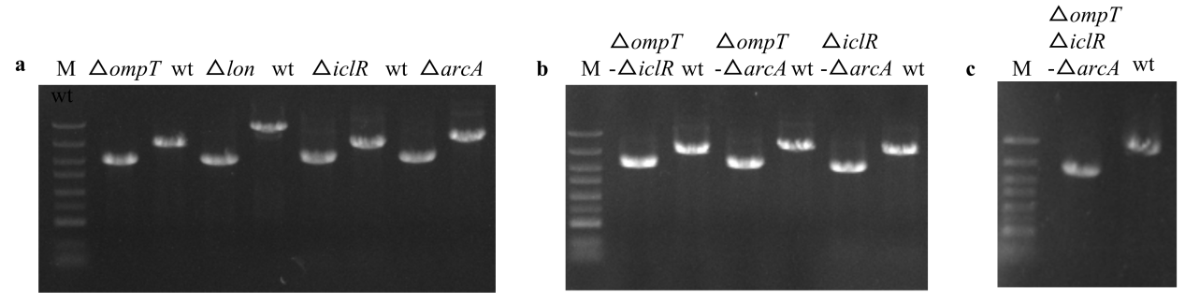
Figure S1. PCR gel electrophoresis of EcN engineering strain.

