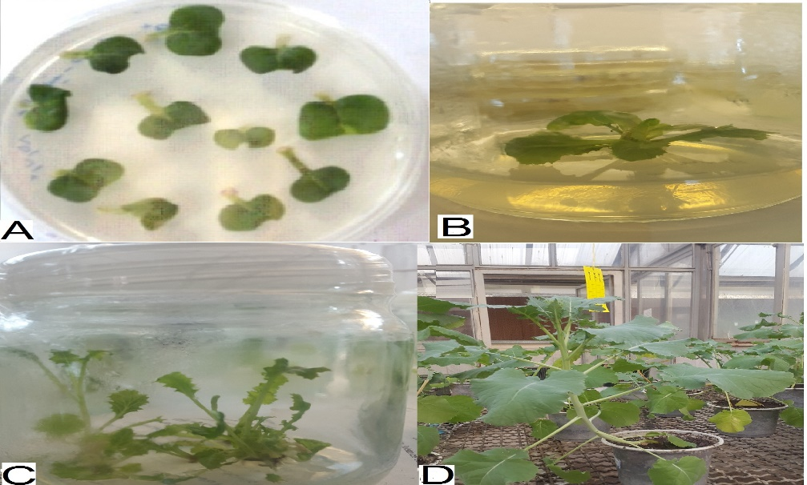

Fig 1S. Sequential stages of agrobacterium tumefaciens-mediated transformation of canola using cotyledon explants of mature seeds. A, canola cotyledon explants of mature seeds; B, three-day-cotyledon explants co-cultivated with Agrobacterium on MS medium; C, shoot initiation on shoot-inducing medium containing 250 mgL⁻¹ cefotaxime; D: elongated shoots on poliferation medium containing 25 mgL⁻¹ kanamycin and 200 mgL⁻¹ cefotaxime; E, rooted canola transgenic plantlet; F and G, adoptation and acclemation of the transgenic canola plants.

