Supplementary Material
Effect of lead and cadmium exposure on antioxidant defences in rock lizard Psammophilus blanfordanus
Bijayeeta Deb^{1*}, Sibaprasad Parida² and Puspanjali Parida^{3*}
¹ Department of Zoology, Dharanidhar University, Keonjhar, Odisha, India, 758001.
² Department of Zoology, School of Applied Science, Centurion University of Technology and Management, Ramchandrapur, Jatni, Bhubaneswar, Khurda, Odisha, India – 752050
³ Department of Zoology, Maharaja Sriram Chandra Bhanja Deo University, Takatpur, Baripada, Odisha, India, 757003.
* Address for correspondence- Department of Zoology, Dharanidhar University, Keonjhar, Odisha, India, 758001. Email- bijayeetadeb@dduniversity.ac.in
Department of Zoology, Maharaja Sriram Chandra Bhanja Deo University, Takatpur, Baripada, Odisha, India, 757003. Email- pparidamscbdu@gmail.com

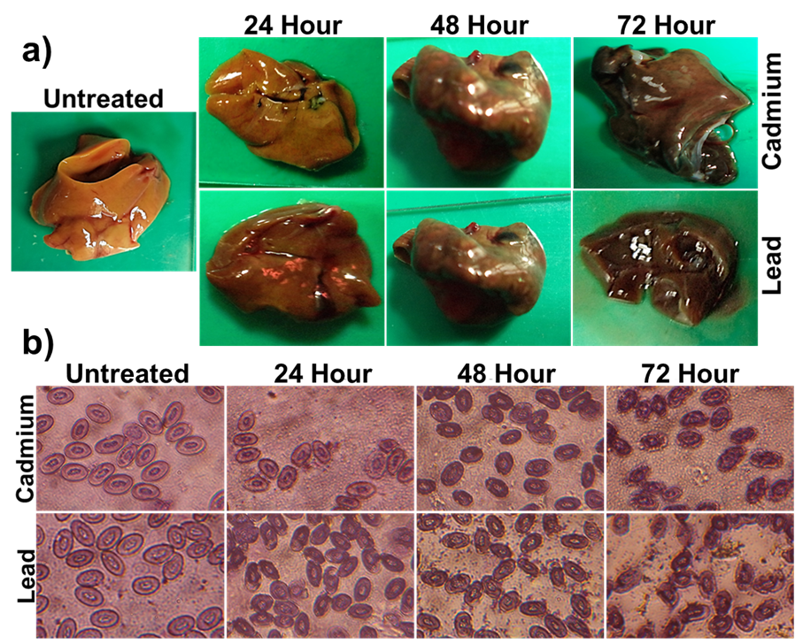

Suppl. fig. 1. Morphological alteration in liver and RBC of Psammophilus blanfordanus post CdCl2 and Pb (NO₃)₂ treatment. (a) Representative image of P. blanfordanus liver treated with cadmium and lead after 24, 48 and 72 hours post treatment along with untreated control. (b) Representative image of P. blanfordanus RBCs after 24, 48- and 72-hour’s exposure to cadmium and lead.

