`Biotechnology for Biofuels and Bioproducts

Supplementary Information

Yuki Ogawa, Akihiko Kondo, Tomokazu Shirai

Table S1 Primer sequences used for site-directed mutagenesis of YADH. Bold letters indicate mutation sites.
No | Primer name | Sequence (5′ to 3′)
1 | pCold-F | CTCGAGGGATCCGAATTCAA
2 | pCold-R | CATATGCCTACCTTCGATAT
3 | pCold-seq-F | CACGCCATATCGCCGAAAG
4 | pCold-seq-R | GCAGGGATCTTAGATTCTGTGC
5 | YADH-T45A-F | ATAGCGGTGTTTGTCATGCCGATCTGCATGCATGGCAT
6 | YADH-T45A-R | GACAAACACCGCTATATTTCAC
7 | YADH-W54A-F | GCATGGCATGGTGATGCACCTCTGCCGGTTAAACTG
8 | YADH-W54A-R | ATCACCATGCCATGCATGCAG
9 | YADH-L56A-F | CATGGTGATTGGCCTGCACCGGTTAAACTGCCGCTG
10 | YADH-L56A-R | AGGCCAATCACCATGCCATG
11 | YADH-W92A-F | TACGCAGGTATTAAAGCACTGAATGGTAGCTGTATG
12 | YADH-W92A-R | TTTAATACCTGCGTAATCAC
13 | YADH-Y119A-F | GCCGATCTGAGCGGTGCAACCCATGATGGTAGCTTT
14 | YADH-Y119-R | ACCGCTCAGATCGGCATGCG
15 | YADH-M270A-F | ACCGTTCTGGTTGGTGCACCTGCCGGTGCAAAATGT
16 | YADH-M270A-R | ACCAACCAGAACGGTGGTGC
17 | YADH-Y294A-F | AGCATTGTTGGTAGCGCAGTTGGTAATCGTGCAGAT
18 | YADH-Y294A-R | GCTACCAACAATGCTAATGC
19 | YADH-V295A-F | ATTGTTGGTAGCTATGCAGGTAATCGTGCAGATACC
20 | YADH-V295-R | ATAGCTACCAACAATGCTAA
21 | YADH-W54NNT | GCATGGCATGGTGATNNTCCTCTGCCGGTTAAACTG
22 | YADH-W54CMC | GCATGGCATGGTGATCMCCCTCTGCCGGTTAAACTG
23 | YADH-W54AMG | GCATGGCATGGTGATAMGCCTCTGCCGGTTAAACTG
24 | YADH-W54GAC | GCATGGCATGGTGATGACCCTCTGCCGGTTAAACTG
25 | YADH-W54CNS | GCATGGCATGGTGATCNSCCTCTGCCGGTTAAACTG
26 | YADH-W54ANS | GCATGGCATGGTGATANSCCTCTGCCGGTTAAACTG
27 | YADH-W54GAS | GCATGGCATGGTGATGASCCTCTGCCGGTTAAACTG
28 | YADH-W92NNT | TACGCAGGTATTAAANNTACTGAATGGTAGCTGTATG
29 | YADH-W92TVC | TACGCAGGTATTAAATVCACTGAATGGTAGCTGTATG
30 | YADH-W92CNS | TACGCAGGTATTAAACNSACTGAATGGTAGCTGTATG
31 | YADH-W92ANS | TACGCAGGTATTAAAANSACTGAATGGTAGCTGTATG
32 | YADH-W92GWS | TACGCAGGTATTAAAGWSACTGAATGGTAGCTGTATG
33 | YADH-W54ACT | GCATGGCATGGTGATACTCCTCTGCCGGTTAAACTG
34 | YADH-Y119NNT | GCCGATCTGAGCGGTNNTACCCATGATGGTAGCTTT
35 | YADH-Y119CHS | GCCGATCTGAGCGGTCHSACCCATGATGGTAGCTTT
36 | YADH-Y119AHA | GCCGATCTGAGCGGTAHAACCCATGATGGTAGCTTT
37 | YADH-Y119GAS | GCCGATCTGAGCGGTGASACCCATGATGGTAGCTTT
38 | YADH-Y119TDC | GCCGATCTGAGCGGTTDCACCCATGATGGTAGCTTT
39 | YADH-Y119W | GCCGATCTGAGCGGTTGGACCCATGATGGTAGCTTT
40 | YADH-Y119F | GCCGATCTGAGCGGTTTCACCCATGATGGTAGCTTT
41 | YADH-Y119N | GCCGATCTGAGCGGTAACACCCATGATGGTAGCTTT
42 | YADH-Y119E | GCCGATCTGAGCGGTGAGACCCATGATGGTAGCTTT
43 | YADH-Y119M | GCCGATCTGAGCGGTATGACCCATGATGGTAGCTTT
44 | YADH-W92NNT | TACGCAGGTATTAAANNTCTGAATGGTAGCTGTATG
45 | YADH-W92TVC | TACGCAGGTATTAAATVCCTGAATGGTAGCTGTATG
46 | YADH-W92CNS | TACGCAGGTATTAAACNSCTGAATGGTAGCTGTATG
47 | YADH-W92ANS | TACGCAGGTATTAAAANSCTGAATGGTAGCTGTATG
48 | YADH-W92GWS | TACGCAGGTATTAAAGWSCTGAATGGTAGCTGTATG
49 | YADH-W92TWC | TACGCAGGTATTAAATWCCTGAATGGTAGCTGTATG
50 | YADH-W92CWS | TACGCAGGTATTAAACWSCTGAATGGTAGCTGTATG
51 | YADH-W92AHC | TACGCAGGTATTAAAAHCCTGAATGGTAGCTGTATG
52 | YADH-W92GRS | TACGCAGGTATTAAAGRSCTGAATGGTAGCTGTATG
53 | YADH-W92YAC | TACGCAGGTATTAAAYACCTGAATGGTAGCTGTATG
54 | YADH-W92GAS | TACGCAGGTATTAAAGASCTGAATGGTAGCTGTATG
55 | YADH-W92ATC | TACGCAGGTATTAAAATCCTGAATGGTAGCTGTATG
56 | YADH-W92Y | TACGCAGGTATTAAATACCTGAATGGTAGCTGTATG
57 | YADH-W92H | TACGCAGGTATTAAACACCTGAATGGTAGCTGTATG
58 | YADH-W92D | TACGCAGGTATTAAAGACCTGAATGGTAGCTGTATG
59 | YADH-Y119CMC | GCCGATCTGAGCGGTCMCACCCATGATGGTAGCTTT
60 | YADH-Y119AYG | GCCGATCTGAGCGGTAYGACCCATGATGGTAGCTTT
61 | YADH-Y119TGG | GCCGATCTGAGCGGTTGGACCCATGATGGTAGCTTT
62 | YADH-Y119H | GCCGATCTGAGCGGTCACACCCATGATGGTAGCTTT
63 | YADH-Y119T | GCCGATCTGAGCGGTACCACCCATGATGGTAGCTTT
64 | YADH-M270NNT | ACCGTTCTGGTTGGTNNTCCTGCCGGTGCAAAATGT
65 | YADH-M270TRS | ACCGTTCTGGTTGGTTRSCCTGCCGGTGCAAAATGT
66 | YADH-M270CNS | ACCGTTCTGGTTGGTCNSCCTGCCGGTGCAAAATGT
67 | YADH-M270ANS | ACCGTTCTGGTTGGTANSCCTGCCGGTGCAAAATGT
68 | YADH-M270GRG | ACCGTTCTGGTTGGTGRGCCTGCCGGTGCAAAATGT
69 | YADH-M270CMC | ACCGTTCTGGTTGGTCMCCCTGCCGGTGCAAAATGT
70 | YADH-M270AHW | ACCGTTCTGGTTGGTAHWCCTGCCGGTGCAAAATGT
71 | YADH-M270TAC | ACCGTTCTGGTTGGTTACCCTGCCGGTGCAAAATGT
72 | YADH-M270AAG | ACCGTTCTGGTTGGTAAGCCTGCCGGTGCAAAATGT
73 | YADH-M270GGT | ACCGTTCTGGTTGGTGGTCCTGCCGGTGCAAAATGT
74 | YADH-Y294MCG | AGCATTGTTGGTAGCMCGGTTGGTAATCGTGCAGAT
75 | YADH-Y294T | AGCATTGTTGGTAGCACCGTTGGTAATCGTGCAGAT
76 | YADH-Y294CNS | AGCATTGTTGGTAGCCNSGTTGGTAATCGTGCAGAT
77 | YADH-Y294ANR | AGCATTGTTGGTAGCANRGTTGGTAATCGTGCAGAT
78 | YADH-Y294TGG | AGCATTGTTGGTAGCTGGGTTGGTAATCGTGCAGAT
79 | YADH-Y294GTT | AGCATTGTTGGTAGCGWAGTTGGTAATCGTGCAGAT
80 | YADH-Y294CMT | AGCATTGTTGGTAGCCMTGTTGGTAATCGTGCAGAT
81 | YADH-Y294AMG | AGCATTGTTGGTAGCAMGGTTGGTAATCGTGCAGAT

Fig. S1 SDS-PAGE analyses of purified YADH variants. wild-type YADH (Lane 1, 38.3 kDa) (A) and alanine-substituted variants, (B-C) W54 variants, (D-E) W92 variants, (F-G) Y119 variants, (H-I) M270 variants, and (J-K) Y294 variants. Lane M: Molecular weight marker. The construction of the plasmid and SDS-PAGE analysis of the mutated YADH variants were conducted using the same procedure.
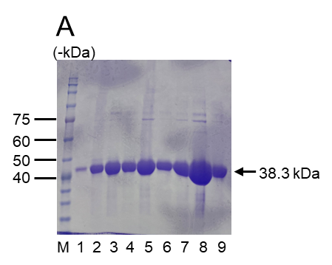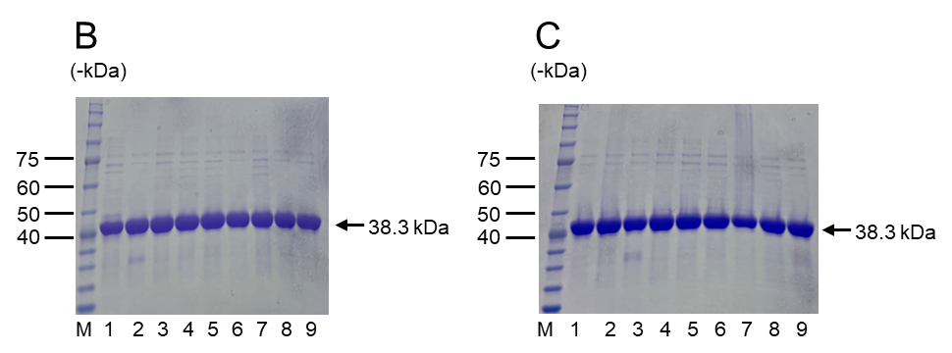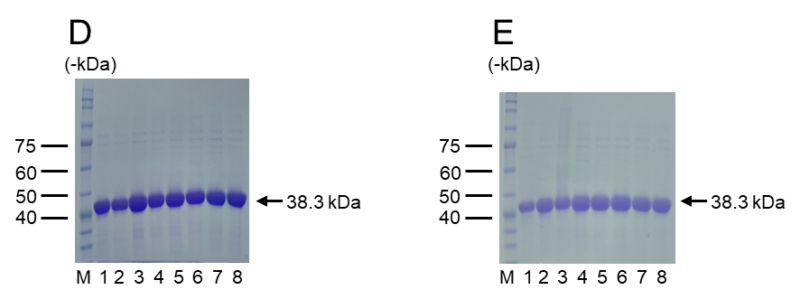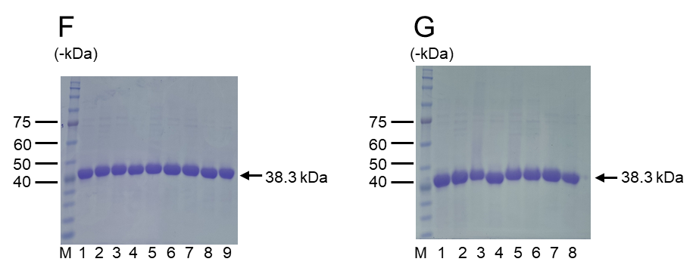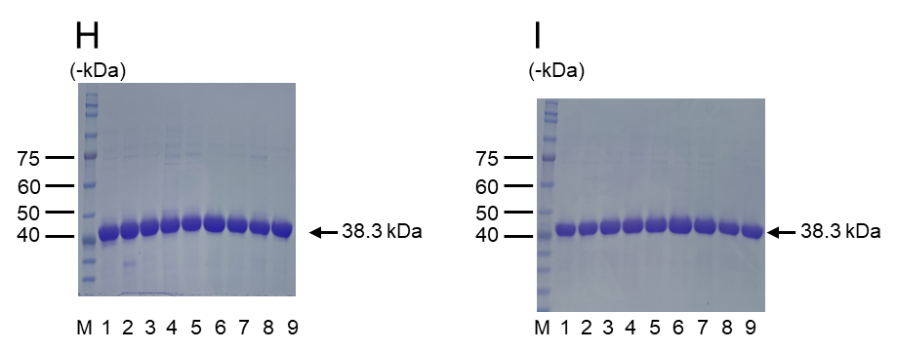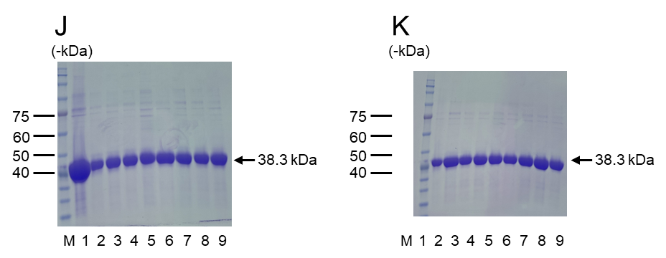
Table S2 List of YADH variants generated through site-directed mutagenesis, with corresponding SDS-PAGE lane identifiers.
Mutation | SDS-PAGE
WT | A-1
T45A | A-2
W54A | A-3
L56A | A-4
W92A | A-5
Y119A | A-6
M270A | A-7
Y294A | A-8
V295A | A-9
W54C | B-1
W54D | B-2
W54E | B-3
W54F | B-4
W54G | B-5
W54H | B-6
W54I | B-7
W54K | B-8
W54L | B-9
W54M | C-1
W54N | C-2
W54P | C-3
W54Q | C-4
W54R | C-5
W54S | C-6
W54T | C-7
W54V | C-8
W54Y | C-9
W92C | D-1
W92D | Not expressed
W92E | Not expressed
W92F | D-2
W92G | D-3
W92H | D-4
W92I | D-5
W92K | D-6
W92L | D-7
W92M | D-8
W92N | E-1
W92P | E-2
W92Q | E-3
W92R | E-4
W92S | E-5
W92T | E-6
W92V | E-7
W92Y | E-8
Y119C | F-1
Y119D | F-2
Y119E | F-3
Y119F | F-4
Y119G | F-5
Y119H | F-6
Y119I | F-7
Y119K | F-8
Y119L | F-9
Y119M | G-1
Y119N | G-2
Y119Q | G-3
Y119R | G-4
Y119S | G-5
Y119T | G-6
Y119V | G-7
Y119W | G-8
M270C | H-1
M270D | H-2
M270E | H-3
M270F | H-4
M270G | H-5
M270H | H-6
M270I | H-7
M270K | H-8
M270L | H-9
M270N | I-1
M270P | I-2
M270Q | I-3
M270R | I-4
M270S | I-5
M270T | I-6
M270V | I-7
M270W | I-8
M270Y | I-9
Y294C | J-1
Y294D | J-2
Y294E | J-3
Y294F | J-4
Y294G | J-5
Y294H | J-6
Y294I | J-7
Y294K | J-8
Y294L | J-9
Y294M | K-1
Y294N | K-2
Y294P | K-3
Y294Q | K-4
Y294R | K-5
Y294S | K-6
Y294T | K-7
Y294V | K-8
Y294W | K-9

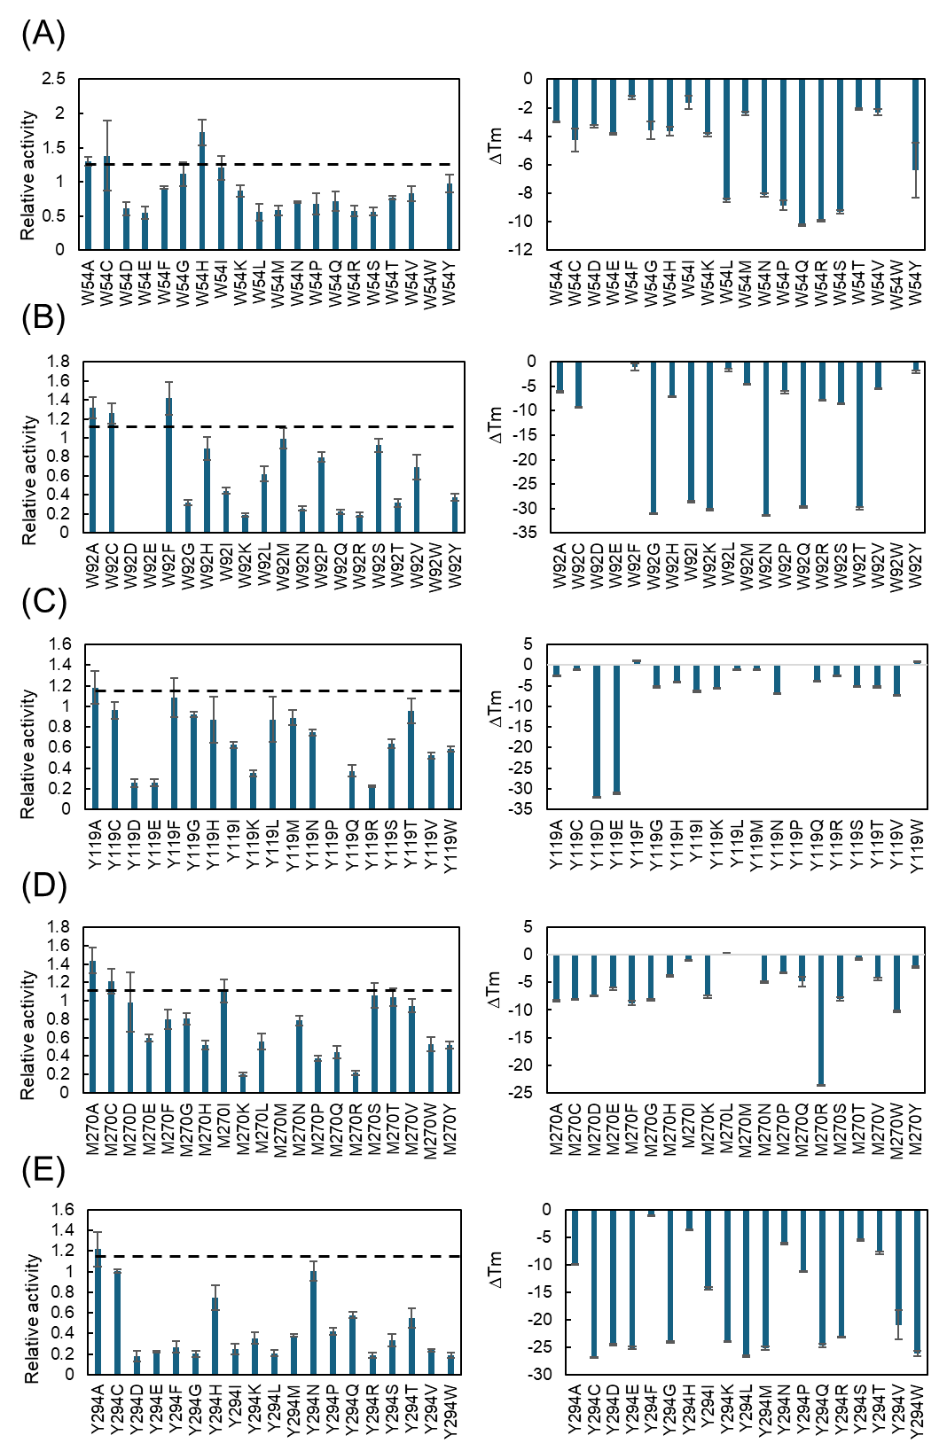
Fig. S2 Relative activity and thermostability of YADH variants with single amino acid substitutions at five key residues: (A) W54, (B) W92, (C) Y119, (D) M270, and (E) Y294. Error bars indicate standard error (n = 3).
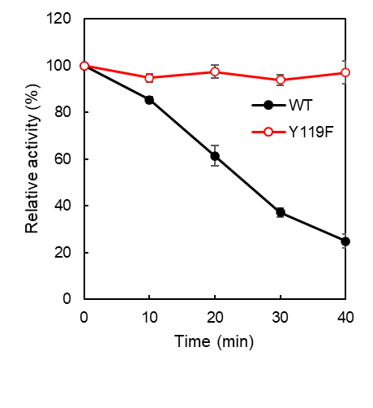
Fig. S3 Half-life (t₁/₂) at 65 °C for WT-YADH and YADH-Y119F.
Error bars indicate standard error (n = 3).

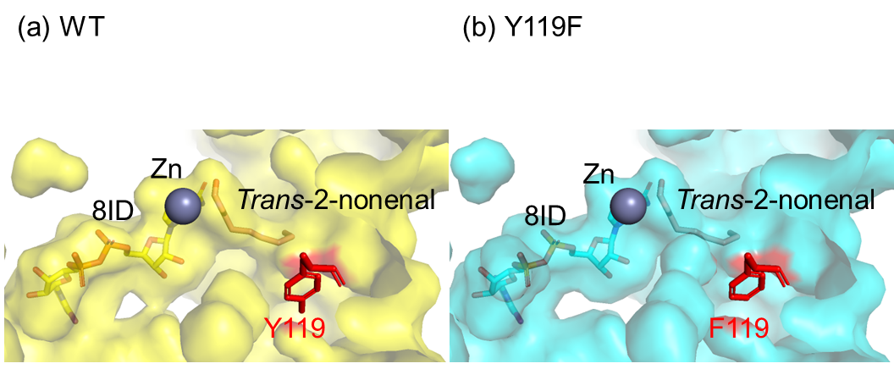
Fig. S4 Modeled three-dimensional structures of WT-YADH (A) and YADH-Y119F (B), highlighting the position of residue 119 at the substrate-binding pocket entrance.

