Supplementary Information
to
Contribution of microbial necromass to soil organic carbon and its influencing factors under diverse ecosystems in Southwest China
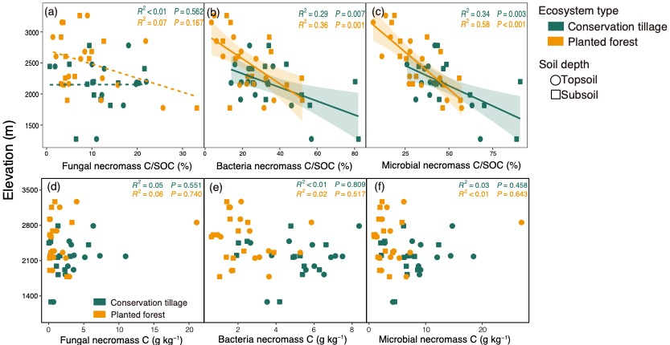
Fig. S1. Variation in the contents of fungal necromass C, bacterial necromass C, total microbial necromass C and their contribution to SOC in conservation tillage (CT) and planted forest (PF) ecosystems along an elevational gradient. *, p < 0.05; **, p < 0.01; ***, p < 0.001.
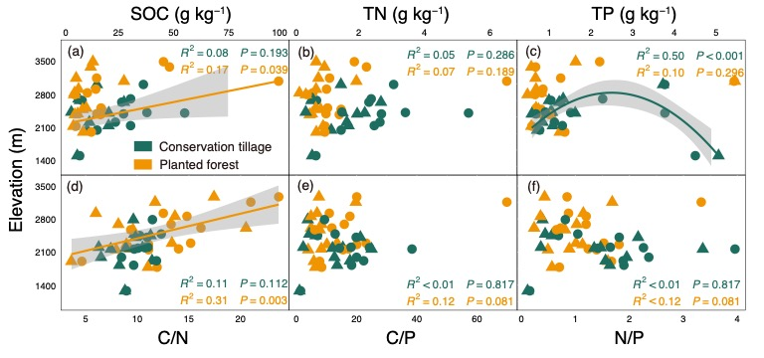
Fig. S2. Variation in the SOC, TN and TP (a-c) and their stoichiometry (d-f) in conservation tillage and planted forest along an elevational gradient. *, p < 0.05; **, p < 0.01; ***, p < 0.001.
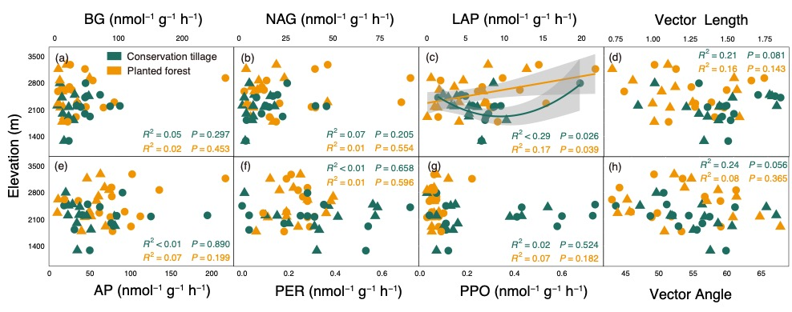
Fig. S3. Variation in the activities of soil extracellular enzyme and stoichiometry in conservation tillage and planted forest ecosystems along an elevational gradient. *, p < 0.05; **, p < 0.01; ***, p < 0.001.
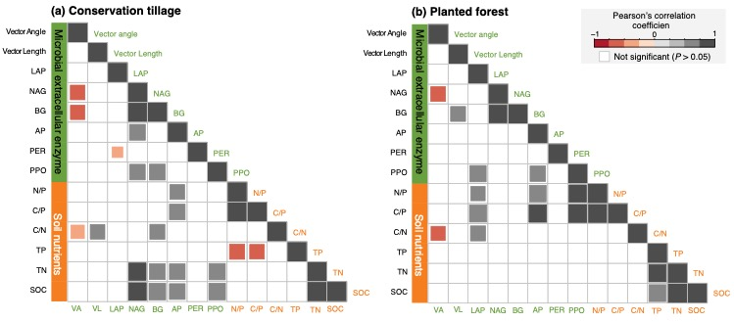
Fig. S4. Pairwise correlations among soil nutrients and microbial extracellular enzyme activities in conservation tillage (a) and planted forest (b) ecosystems. Correlations were calculated using Pearson’s correlation, with significant values displayed on the heat map. Non-significant correlations (P > 0.05) are not shown.
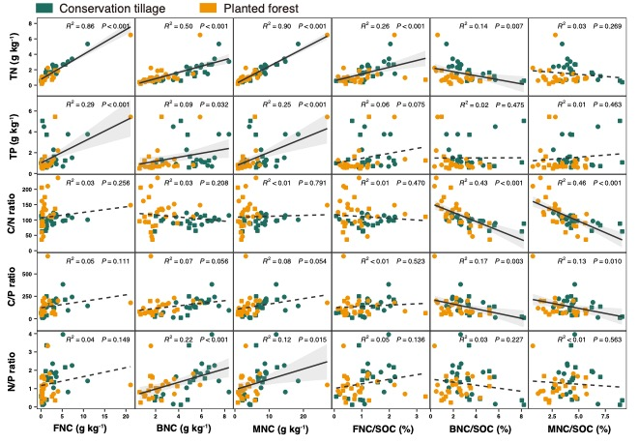
Fig. S5. Correlations of microbial necromass C and soil TN, TP and C-N-P stoichiometry in conservation tillage and planted forest ecosystem.
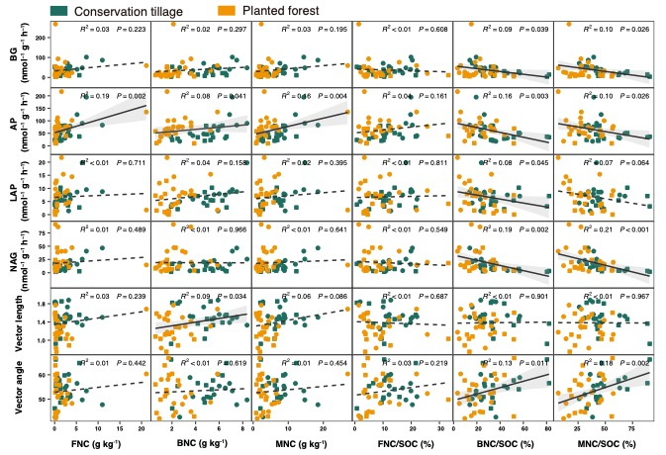
Fig. S6. Correlations of microbial necromass C and soil hydrolases extracellular enzyme and stoichiometry in conservation tillage and planted forest ecosystem.

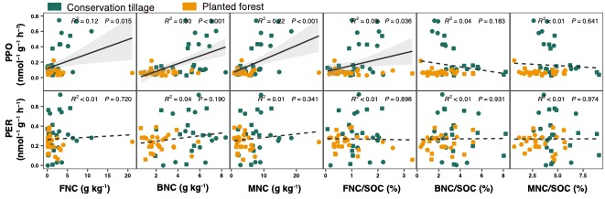
Fig. S7. Correlations of microbial necromass C and soil oxidases extracellular enzyme in conservation tillage and planted forest ecosystem.
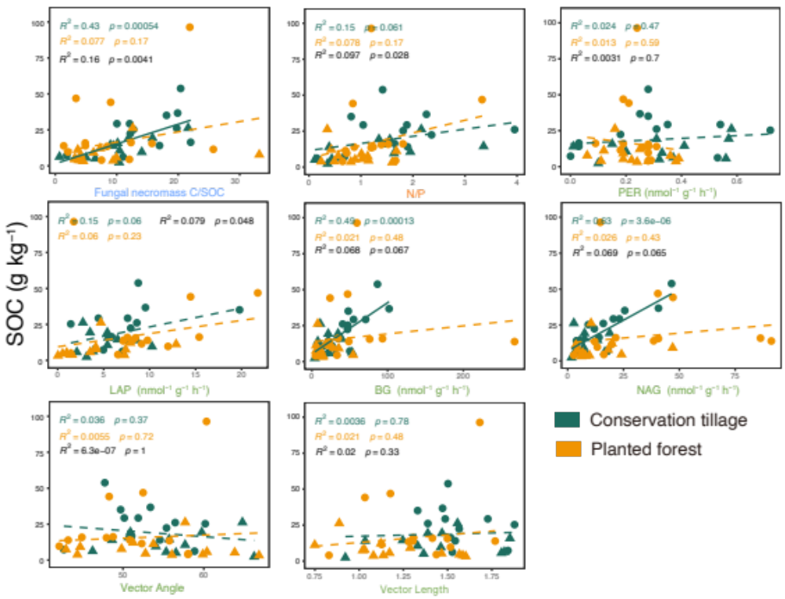
Fig. S8. Correlations between SOC and microbial necromass C components, soil nutrients, and enzyme activities.

