**Supplementary Materials**

**Figure S1: Time engaged in adolescent play behavior in rats treated with** **JZL184, URB597, or vehicle.** Overall, play time on PND40 was increased in a novel context (2-way treatment x context ANOVA; main effect of context F1,5=68.34; **p=0.0004). However no main effect of adolescent drug treatment or context x treatment interaction was found.

**Figure S2: Closed arm behavior in adolescent rats tested on the elevated plus maze following t****reatment with JZL184, URB597, or vehicle.** One-way ANOVA failed to show differences across adolescent drug treatment groups in the time spent in (Figure S2A), distance traveled in (Figure S2B), or entries into (Figure S2C) the closed arms of the elevated plus maze, assessed on PND41. Sample size: n=18/adolescent treatment group.

**Figure S3: Baseline preference in the 3-chamber social test apparatus in rats treated with JZL184, URB597, or vehicle during adolescence.** Two-way adolescent drug treatment x compartment ANOVA failed to show overall preference for or treatment effects on time spent (Figure S3A) or distance traveled (Figure S3B) in the left vs. right compartment of the 3-chamber social preference test chamber during the habituation session in adult rats (PND65). Sample size: n=18/adolescent treatment group.

**Figure S4: Compartment time spent and distance traveled during 3-chamber social testing in adult rats treated with JZL184, URB597, or vehicle during adolescence.** Data in S4A-F represent the *time spent* in each compartment during the S1 session during which rats were provided a choice between a novel rat or object and an empty compartment (S4A-C) or during the S2 session during which rats were provided a choice between a novel rat vs. a familiar object or novel object vs. a familiar rat (S4D-F). During the S1 session, there was an overall preference for the occupied chamber over the empty chamber (i.e., more time spent in the occupied chamber; F1,48=57.398; p<0.001). Main effects of adolescent drug treatment or compartment occupant (rat vs. object) were not observed. Interactions among the factors (adolescent treatment, compartment occupant, and preference) were also not observed. During the S2 session, there was an overall preference for the rat-occupied vs. the object occupied chamber (i.e., more time spent in the rat occupied chamber; F1,48 = 37.448, p<0.001). Main effects of adolescent drug treatment or familiarity/novelty of the rat vs. object were not observed, nor were interactions among the factors. Data in S4A-F represent the *distance traveled* in each compartment during the S1 session during which rats were provided a choice between a novel rat or object and an empty compartment (S4G-I) or during the S2 session during which rats were provided a choice between a novel rat vs. a familiar object or novel object vs. a familiar rat (S4J-L). During the S1 session, there was an overall preference for the occupied chamber over the empty chamber (i.e., greater distance traveled in the occupied chamber; F1,48=34.687, p<0.001). Main effects of adolescent drug treatment or compartment occupant (rat vs. object) were not observed. Main effects of adolescent drug treatment or familiarity/novelty of the rat vs. object were not observed. However, there was a significant interaction between compartment preference and what resided in the occupied compartment (rat vs. object; F1,48=9.047, p=0.004) with more distanced traveled in the compartment occupied by the novel rat (vs. the novel object; Tukey’s HSD test; p <0.05). During the S2 session, there was an overall preference for another rat over an object (i.e., greater distance traveled in the rat vs. object occupied compartment; F1,48 = 241.896, p<0.001). Overall preference varied based on prior exposure to the rat or object. Rats previously exposed to the rat showed less overall distance traveled (F1,48 = 11.572, p=0.001) during the session. This is likely the result of familiarity resulting from earlier exposure to the rat, as indicated by a significant preference x prior exposure effect (F1,48 = 65.648, p=0.001) with post-hoc testing revealing a significant reduction in distance traveled in the rat-containing compartment in rats previously exposed to the rat related to rats previously exposed to the object (Tukey’s HSD; p<0.001). No main effect of or interactions involving adolescent drug treatment condition were observed. Sample sizes are as follows: Veh S1, rat first/S2 familiar rat: n=10; Veh S1 object first/S2 novel rat: n=8; JZL S1, rat first/S2 familiar rat: n=10; JZL S1 object first/S2 novel rat: n=8; URB S1, rat first/S2 familiar rat: n=11; URB S1 object first/S2 novel rat: n=7.

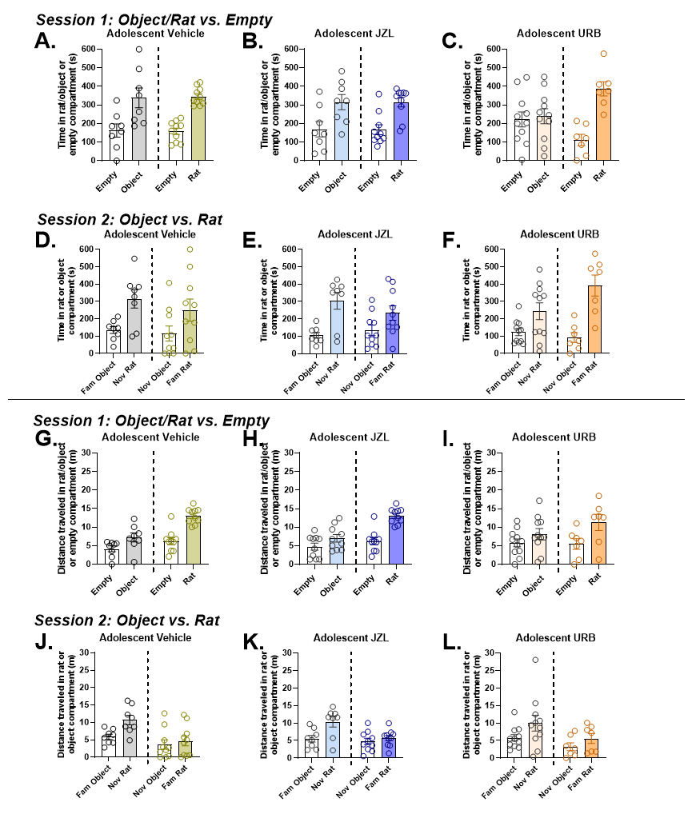

**Figure S5: Distance traveled, center time and freezing on day one and day two of open field testing in adult rats treated with JZL184, URB597, or vehicle during adolescence.** A subset of rats (n=12 per treatment group) was tested twice for open field behavior – first on PND65 and then on PND66. Overall rats habituated to the open field conditions as indicated by increases in the total distance traveled (2-way treatment x open field test day ANOVA; significant main effects of test day: F1,11=39.31, p<0.0001; Figure S5A) and time in the center of the chamber (2-way treatment x open field test day ANOVA; significant main effects of test day: F1,11=10.85, p=0.007; Figure S5B) and reductions in freezing (2-way treatment x open field test day ANOVA; significant main effects of test day: F1,11=72.15, p<0.0001; Figure S5C). As was the case with day one of open field testing when all rats (n=18/group) were test (Figure 5), overall effects of adolescent drug treatment were not observed nor was a treatment x test day interaction.

**Figure S6: Infusions and inactive lever responses during test for cocaine self-administration and drug seeking in adult rats treated with JZL184, URB597, or vehicle during adolescence.** In addition to cocaine-reinforced responses (Figure 6), cocaine infusions were assessed during the initial 14-day FR4 self-administration period (Figure S6A), the 4-day PR self-administration period (Figure S6B), and the 5-day FR4 self-administration retest period (S6C) in adult rats treated with URB, JZL, or vehicle during adolescence. Two-way ANOVA failed to show statistically significant overall effects of adolescent drug treatment or test day, or treatment x test day interactions in any of these cases. Inactive lever pressing was also assessed during the drug seeking session (Figure S6D), and across extinction and reinstatement testing (data not shown). Treatment effects on inactive lever pressing were not found.

