SUPPLEMENTAL MATERIAL
Plasma exosome samples processed for Protein quantification by DIA-SWATH method
Plasma protein exosome extraction: One the exosomes were isolated the samples were mixed with a lysis buffer in ratio 1:1 (4% SDS, 100mM tris pH7.6 and 0.1mM DTT) and incubated at 95°C for 5 min [1].
Plasma processing
Aliquotes of each samples (30 μL) was depleted with dithiothreitol (DTT). Fresh DTT (500 mM) was mixed with 30 μL of human plasma samples and vortex briefly. Then the samples were incubated until to observe a viscous white precipitate that persist for 60 min, then centrifuge at 18,84 g for 20 min. Supernatants were transferred to a clean tube for protein alkylation process. For reduction SH-groups the proteins were treated with iodoacetic acid (IAA) for 45 min at room temperature avoided light. After this in both cases, proteins were loaded on a 10% SDS-PAGE gel. The run was stopped as soon as the front had penetrated 3 mm into the resolving gel. The protein band was detected by Sypro-Ruby fluorescent staining (Lonza, Switzerland), excised, and processed for in-gel, manual tryptic digestion as described elsewhere [2-4]. Peptides were extracted by carrying out three 20-min incubations in 40 μL of 60% acetonitrile dissolved in 0.5% HCOOH. The resulting peptide extracts were pooled, concentrated in a SpeedVac, and stored at −20 °C.
Quantitative proteomic analysis
Proteomic profiling was performed using a sequential window acquisition of all theoretical fragment ion spectra mass spectrometry (SWATH-MS), following protocols previously described by our group [5].
Spectral Library Generation
To build the MS/MS spectral library, a data-dependent acquisition (DDA) approach was applied. Representative peptide pools from the study groups were analyzed by micro-liquid chromatography coupled to tandem mass spectrometry (LC-MS/MS)[6],[7, 8] using a 40-minute gradient to ensure comprehensive representation of peptides and proteins within the samples. For each pool, 4 μL (~4 μg) were injected into a hybrid quadrupole time-of-flight mass spectrometer (TripleTOF® 6600, Sciex, Redwood City, CA, USA). The resulting data were analyzed using ProteinPilot software v5.0.1 (SCIEX, Framingham, MA, USA), in combination with the human-specific UniProt database (https://www.uniprot.org/) to generate the spectral library. Only peptides and proteins identified with a FDR below 1% were included in the final SWATH-MS library.
Relative Quantification via SWATH-MS Acquisition
Quantitative analysis was conducted on the same TripleTOF® 6600 LC-MS/MS system using a data-independent acquisition (DIA) approach. All individual samples, along with two technical triplicates per sample, were analyzed separately (4 μL per injection). SWATH-MS acquisition consisted of 100 high-sensitivity TOF MS/MS scans (400–1500 m/z, 50 ms acquisition time) with overlapping precursor isolation windows of variable widths (1 m/z overlap), covering the 400–1250 m/z range. Each cycle included a prior TOF MS scan (400–1500 m/z, 50 ms), resulting in a total cycle time of 6.3 s.
Data were processed using PeakView software (version 2.2; SCIEX) and the SWATH Acquisition MicroApp (version 2.0; SCIEX). Protein quantification was based on signal intensity from 10 peptides per protein and 7 fragment ions per peptide, ensuring high accuracy. After statistical analysis, normalization was applied using the Most Likely Ratio (MLR) method to correct for potential sample preparation variability across different samples.

Table S1. Significant proteins in plasma of patients with CADASIL. Downregulated proteins included key mediators of energy metabolism (e.g., MT-CO2, IDH1, IDH3A, SLC2A3, PYGM), protein synthesis and gene expression (RPL4, RPL11, RPL23A, IGF2BP1), and protein folding (FKBP1A, ST13). Structural proteins essential for cytoskeletal integrity (TUBB, CFL1, PFN1, NEFL, MSN) and components of vesicular trafficking (NUTF2, ABCG2, AP2S1, RAB5B, RAB14, SYNJ1) were also downregulated. Immune-related and stress response proteins (S100A8, CD47, CFI, CSTA, MAPT, CNTN1, SYNCRIP, GSTP1) showed reduced expression, suggesting impairment in neuroimmune homeostasis and oxidative stress management. Upregulated proteins included fibrinogen chains (FGA, FGB, FGG), indicative of prothrombotic activity, and acute-phase/inflammatory markers (CRP, CFI, C4B, IGHG4), along with components involved in tissue remodeling (HABP2) and intracellular signaling and metabolism (YWHAB, GNAO1, AK1, CAPS.

Gene UniProt reference |  | FC | * | p-value
ABCG2 | Q9UNQ0 | 0,18728552 | ↓ | 0,00075798
FKBP1A | P62942 | 0,27530402 | ↓ | 0,03951087
CSTA | P01040 | 0,30044617 | ↓ | 0,00159455
IGF2BP1 | Q9NZI8 | 0,32928903 | ↓ | 0,01277238
PYGM | P11217 | 0,34254318 | ↓ | 0,02490242
ST13 | P50502 | 0,36871751 | ↓ | 0,00139374
RAB14 | P61106 | 0,4043024 | ↓ | 0,01796206
MSN | P26038 | 0,41509879 | ↓ | 0,01550252
ATP1A1 | P05023 | 0,41830285 | ↓ | 0,00014353
SYNJ1 | O43426 | 0,42722782 | ↓ | 0,02377375
RPL23A | P62750 | 0,43945594 | ↓ | 0,00011955
MAPT (isoform 5) | P10636-5 | 0,47125793 | ↓ | 0,01942605
RPL11 | P62913 | 0,4943212 | ↓ | 0,03181043
CNTN1 | Q12860 | 0,50147297 | ↓ | 0,03949994
RPL4 | P36578 | 0,50737798 | ↓ | 0,01130743
RAB5B | P61020 | 0,50966049 | ↓ | 0,00757267
MT-CO2 | P00403 | 0,5288047 | ↓ | 0,03790411
NEFL | P07196 | 0,55369821 | ↓ | 0,00351147
NUTF2 | P61970 | 0,55553683 | ↓ | 0,04320783
S100A8 | P05109 | 0,56607399 | ↓ | 0,0328902
CD47 | Q08722 | 0,58012359 | ↓ | 0,04848782
AP2S1 | P53680 | 0,59239009 | ↓ | 0,02865883
PFN1 | P07737 | 0,60791649 | ↓ | 0,02210158
GSTP1 | P09211 | 0,61370814 | ↓ | 0,03602554
SYNCRIP | O60506 | 0,62950214 | ↓ | 0,00824975
SLC2A3 | P11169 | 0,6354553 | ↓ | 0,02891526
TUBB | P07437 | 0,63952657 | ↓ | 0,00622956
CFL1 | P23528 | 0,6447066 | ↓ | 0,02537534
IDH1 | O75874 | 0,65779241 | ↓ | 0,03361681
IDH3A | P50213 | 0,70877336 | ↓ | 0,01354529
CFI | P05156 | 0,8357324 | ↓ | 0,02724929
HABP2 | Q14520 | 1,19069396 | ↑ | 0,0153735
FGA | P02671 | 1,306245 | ↑ | 0,01650373
A1BG | P04217 | 1,39465666 | ↑ | 0,0199025
GNA01 | P09471 | 1,40071277 | ↑ | 0,04489782
FGG (isoform 2) | P02679-2 | 1,4027883 | ↑ | 0,00422705
FGB | P02675 | 1,56295681 | ↑ | 0,02692789
IGKV1D-37 | P0DSN7 | 1,60143247 | ↑ | 0,00349391
C4B | P0C0L5 | 1,79135062 | ↑ | 0,02291969
AK1 | P00568 | 2,9173503 | ↑ | 0,00285648
IGHG4 | P01861 | 2,95972178 | ↑ | 0,03517001
CAPS | Q13938 | 3,3136652 | ↑ | 0,0163798
YWHAB | P31946 | 3,73449516 | ↑ | 0,03905183
CRP | P02741 | 5,43280633 | ↑ | 0,03078086
* FC<1 downregulated ↓; FC>1 upregulated ↑

Table S2. Significant proteins in total EVs of patients with CADASIL. A total of 29 proteins were significantly downregulated, including key regulators of oxidative stress and cytoskeletal stability (PRDX5, ALDH1L1, CFL1), energy metabolism and cellular homeostasis (PGLYRP2, HNRNPA0, SLC2A1, PHB1), intracellular signaling (TRIM28, PHB1) and calcium control (YWHAE, PCP4), immune modulation and endothelial integrity (THBS1, C8A, PAICS, ITIH1) and cytoskeletal organization (IGF2BP3, SEPTIN7, SH3BGRL3, PAPL), and immune modulation and endothelial integrity (THBS1, C8A, PAICS). Proteins involved in protein folding and assembly (DYNC1I1, CCT6A) also showed reduced expression. Nine proteins were significantly upregulated, including CLU and RPL29, associated with cellular stress responses; IGHV5-10-1, linked to immune activation; and AFM, FTL, related to iron metabolism and oxidative stress. Additional upregulated proteins (SPP2, QDPR, STXBP1, and PCYT2) are involved in extracellular matrix remodeling, neurotransmitter synthesis, synaptic function, and phospholipid biosynthesis, respectively
Gene UniProt reference |  | FC | * | p-value
THBS1 | P07996 | 0,10382039 | ↓ | 0,04435953
PCP4 | P48539 | 0,12899889 | ↓ | 0,01977149
PAPL | Q6TUY0 | 0,14549007 | ↓ | 0,02112549
PGLYRP2 | Q96PD5 | 0,2151038 | ↓ | 0,02764053
PRDX5 | P30044 | 0,21992023 | ↓ | 0,03836891
ALDH1L1 | O75891 | 0,22705379 | ↓ | 0,01692015
IGF2BP3 | O00425 | 0,24180807 | ↓ | 0,03478366
SEPTIN7 | Q16181 | 0,25022556 | ↓ | 0,00199882
PAICS | P22234 | 0,30856866 | ↓ | 0,01833586
CFL1 | P23528 | 0,33667874 | ↓ | 0,04668687
SLC2A1 | P11166 | 0,34859323 | ↓ | 0,02597182
C8A | P07357 | 0,36010702 | ↓ | 0,03806472
DYNC1I1 | O14576 | 0,36106626 | ↓ | 0,01660854
CCT6A | P40227 | 0,38415912 | ↓ | 0,03632341
ENPP6 | Q6UWR7 | 0,4026263 | ↓ | 0,00984236
TRIM28 | Q13263 | 0,41793488 | ↓ | 0,01081677
HNRNPA0 | Q13151 | 0,42220542 | ↓ | 0,0346529
ITIH1 | P19827 | 0,4415894 | ↓ | 0,0122264
PHB1 | P35232 | 0,44844269 | ↓ | 0,04801991
SH3BGRL3 | Q9H299 | 0,46249815 | ↓ | 0,0344086
YWHAE | P62258 | 0,47368015 | ↓ | 0,04233927
PTPN23 | Q9H3S7 | 0,48603261 | ↓ | 0,0422541
LYZ | P61626 | 0,54419632 | ↓ | 0,0179025
MAPT | P10636-5 | 0,5851735 | ↓ | 0,02938633
HEBP1 | Q9NRV9 | 0,62174243 | ↓ | 0,03692493
HSPA8 | P11142 | 0,6700216 | ↓ | 0,0469038
IGKV1D-37 | P0DSN7 | 0,69244627 | ↓ | 0,04159671
IDH1 | O75874 | 0,74125131 | ↓ | 0,04245316
CLU | P10909 | 1,39841955 | ↑ | 0,02013213
AFM | P43652 | 1,47880303 | ↑ | 0,02069914
SPP2 | Q13103 | 1,83624274 | ↑ | 0,04222158
IGHV5-10-1 | A0A0J9YXX1 | 1,85715699 | ↑ | 0,03249342
QDPR | P09417 | 2,20086485 | ↑ | 0,04777321
RPL29 | P47914 | 2,29285999 | ↑ | 0,02814657
PCYT2 | Q99447 | 2,52245071 | ↑ | 0,02315125
FTL | P02792 | 2,82034694 | ↑ | 0,03375871
STXBP1 | P61764 | 3,07148383 | ↑ | 0,0345275
* FC<1 downregulated ↓; FC>1 upregulated ↑

Table S3.Significant proteins from neuronal EVs of CADASIL patients. Downregulated proteins included key regulators of immune homeostasis (FCN2, C1QB), hormone signaling and axonal plasticity (PGRMC1, RTN4), ribosomal components (RPL23, RPL14, NPM1), as well as proteins involved in ubiquitination (UBE2N, USP5), gene regulation (HMGB2, PCBP1), membrane trafficking and calcium homeostasis (ANXA6), and vascular integrity (LUM). Additional immune-related proteins (HV266, HV372, KVD28) were also downregulated. Among the 11 upregulated proteins were involved in RNA processing (DDX5), metabolism (PDHA1) and calcium modulation (CAPN1), as well as regulation of cellular stability and function (CTSD, PHB2, FAU), extracellular matrix and tissue structure (FBLN1, MOG) and ribosomal proteins (RPL28 and RPL14). A global overview of the data showed 14 proteins with p < 0.05 concentrated at the extremes of the volcano plot.
Gene UniProt reference |  | FC | * | p-value
FCN2 | Q15485 | 0,1612662 | ↓ | 0,04668211
PGRMC1 | O00264 | 0,37274127 | ↓ | 0,00627993
RPL23 | P62829 | 0,37802636 | ↓ | 0,0460863
RTN4 | Q9NQC3 | 0,45949545 | ↓ | 0,02934878
NPM1 | P06748 | 0,46212162 | ↓ | 0,04426974
LUM | P51884 | 0,47433122 | ↓ | 0,01253342
HV226 | A0A0B4J1V2 | 0,48034881 | ↓ | 0,00598077
C1QB | P02746 | 0,52020111 | ↓ | 0,02946211
KVD28 | P01615 | 0,52661665 | ↓ | 0,00750033
RPL14 | P50914 | 0,54793646 | ↓ | 0,04890592
UBE2N | P61088 | 0,56104404 | ↓ | 0,03924909
HMGB2 | P26583 | 0,57049147 | ↓ | 0,03878785
USP5 | P45974 | 0,65501533 | ↓ | 0,03097136
ANXA6 | P08133 | 0,73645112 | ↓ | 0,02135558
PCBP1 | Q15365 | 0,73667601 | ↓ | 0,03780612
DDX5 | P17844 | 1,27767901 | ↑ | 0,01502632
PDHA1 | P08559-4 | 1,59313055 | ↑ | 0,03214984
CAPN1 | P07384 | 1,71530958 | ↑ | 0,04971114
HV372 | A0A0B4J1Y9 | 1,81497806 | ↑ | 0,01051657
FBLN1 | P23142 | 1,89524263 | ↑ | 0,00085539
SPP2 | Q13103 | 2,07404838 | ↑ | 0,01926551
CTSD | P07339 | 2,18449523 | ↑ | 0,02173368
RPL28 | P46779 | 2,50435759 | ↑ | 0,03800349
PHB2 | Q99623 | 2,69993737 | ↑ | 0,02209793
FAU | P62861 | 3,02654243 | ↑ | 0,03628888
MOG | Q16653-3 | 4,16556014 | ↑ | 0,04902658
* FC<1 downregulated ↓; FC>1 upregulated ↑

Table S4.Significant proteins from astrocytic EVs of CADASIL patients. Sixteen proteins were downregulated, including proteins implicated in metabolic and proteolytic pathways (QDPR, PDXP, PSMC2); proteins associated with neuronal structural integrity (TPM2, RPL7A, ALDH7A1, MAG) and proteins involved in cellular stress responses and signaling (PDIA6, SET, YWHAZ, SERPINA5). Additional downregulated proteins involved in gene transcription (H4C1), adaptive immunity (IGLV2-14, KV230) and protein synthesis and RNA processing (RPL6, DDX5) Conversely, 15 proteins were upregulated, associated with inflammation and tissue remodeling (ITIH2 and C8B), related to complement activation and endothelial integrity (CFH, VWF); and proteins, involved in cytoskeletal dynamics and protein folding (ACTB, CANX). Other upregulated proteins included processes like: RNA metabolism and gene regulation (HNRNPD, SYNCRIP, YBX1), vesicular trafficking (NAPG), energy homeostasis AK1 (AK1), synaptic plasticity (PCP4), immune regulation (HV338), and ribosomal components (RPL3, RPL18A).
Gene UniProt reference |  | FC | * | p-value
QDPR | P09417 | 0,26480837 | ↓ | 0,01142221
PDXP | Q96GD0 | 0,33643808 | ↓ | 0,01906314
PSMC2 | P35998 | 0,43682311 | ↓ | 0,04179149
TPM2 | P07951 | 0,47855254 | ↓ | 0,0444906
RPL7A | P62424 | 0,49568245 | ↓ | 0,05587089
ALDH7A1 | P49419 | 0,50024214 | ↓ | 0,0143492
IGLV2-14 | P01704 | 0,51254871 | ↓ | 0,02464176
PDIA6 | Q15084 | 0,53368124 | ↓ | 0,02334178
KV230 | P06310 | 0,54337643 | ↓ | 0,01520146
H4C1 | P62805 | 0,61731931 | ↓ | 0,04523085
SET | Q01105 | 0,63765508 | ↓ | 0,04970737
MAG | P20916 | 0,6401821 | ↓ | 0,05141993
YWHAZ | P63104 | 0,65582154 | ↓ | 0,03358772
SERPINA5 | P05154 | 0,66046137 | ↓ | 0,04654536
RPL6 | Q02878 | 0,66282651 | ↓ | 0,00719577
DDX5 | P17844 | 0,66506212 | ↓ | 0,01638455
ITIH2 | P19823 | 1,34420166 | ↑ | 0,01115975
C8B | P07358 | 1,36904122 | ↑ | 0,04851983
HNRNPD | Q14103 | 1,37379437 | ↑ | 0,00512255
SYNCRIP | O60506 | 1,56511116 | ↑ | 0,00851705
NAPG | Q99747 | 1,6884433 | ↑ | 0,05018468
CFH | P08603 | 1,68887698 | ↑ | 0,04808075
VWF | P04275 | 1,83895389 | ↑ | 0,0448333
RPL3 | P39023 | 1,95426559 | ↑ | 0,01038249
HV338 | A0A0C4DH36 | 2,018091 | ↑ | 0,04148483
RPL18A | Q02543 | 2,36374325 | ↑ | 0,03499781
ACTB | P60709 | 2,46871399 | ↑ | 0,03582268
CANX | P27824 | 2,73220593 | ↑ | 0,01806673
PCP4 | P48539 | 2,8370701 | ↑ | 0,05097907
AK1 | P00568 | 3,08829146 | ↑ | 0,02482934
YBX1 | P67809 | 23,4360563 | ↑ | 0,01281874
* FC<1 downregulated ↓; FC>1 upregulated ↑

Table S5.Significant proteins from oligodendrocytes EVs of CADASIL patients. comprising 13 downregulated and 10 upregulated proteins. Downregulated proteins included AP2B1 and SNAP91, essential for vesicular trafficking and endocytosis; HNRNPAB and EEF1G, involved in RNA processing and translational regulation; and TKT, UCHL1, and VDAC1, which play key roles in energy metabolism, proteostasis, and mitochondrial ion transport. Additional downregulated proteins such as CYTB, SAA1, IGHV3-38, IGHV3-72, ITIH3, and NCDN are associated with lysosomal function, extracellular matrix stability, and intracellular signaling, indicating broad disruption of cellular homeostasis and intercellular communication. Conversely, upregulated proteins included metabolic enzymes (IMPDH2, ALDH2, PGLS), signaling mediators (CALM3, AHCY, SERPINB9), structural and regulatory components (H3-4, RPL27A, TMEM67), many of which are implicated in nucleotide biosynthesis, mitochondrial detoxification, calcium signaling, apoptosis regulation, and cilia-associated functions
Gene UniProt reference |  | FC | * | p-value
AP2B1 | P63010 | 0,017401794 | ↓ | 0,012343429
ITIH3 | Q06033 | 0,384082469 | ↓ | 0,038814600
NCDN | Q9UBB6 | 0,392359839 | ↓ | 0,004950691
CSTB | P04080 | 0,452695614 | ↓ | 0,026053021
TKT | P29401 | 0,458971623 | ↓ | 0,005517768
UCHL1 | P09936 | 0,491834763 | ↓ | 0,040464573
SAA1 | P0DJI8 | 0,567752533 | ↓ | 0,010788659
IGHV3-38 | A0A0C4DH36 | 0,575198188 | ↓ | 0,018092475
EEF1G | P26641 | 0,620449747 | ↓ | 0,019652946
SNAP91 | O60641 | 0,622200916 | ↓ | 0,036857262
HNRNPAB | Q99729-3 | 0,652537947 | ↓ | 0,039754036
IGHV3-72 | A0A0B4J1Y9 | 0,665368576 | ↓ | 0,030768410
VDAC1 | P21796 | 0,759598764 | ↓ | 0,044485575
IMPDH2 | P12268 | 1,464012882 | ↑ | 0,049190660
ALDH2 | P05091 | 1,621564830 | ↑ | 0,001856867
AMPH | P49418 | 1,626633970 | ↑ | 0,007845707
AHCY | P23526 | 1,642683528 | ↑ | 0,027017368
SERPINB9 | P50453 | 1,801374062 | ↑ | 0,036402067
PGLS | O95336 | 2,026488735 | ↑ | 0,008029012
H3-4 | Q16695 | 2,033033999 | ↑ | 0,000892957
CALM3 | P0DP25 | 2,043473941 | ↑ | 0,019877138
RPL27A | P46776 | 2,193153489 | ↑ | 0,015541500
TMEM67 | Q5HYA8 | 2,722506179 | ↑ | 0,012358365
* FC<1 downregulated ↓; FC>1 upregulated ↑

Figure S1.
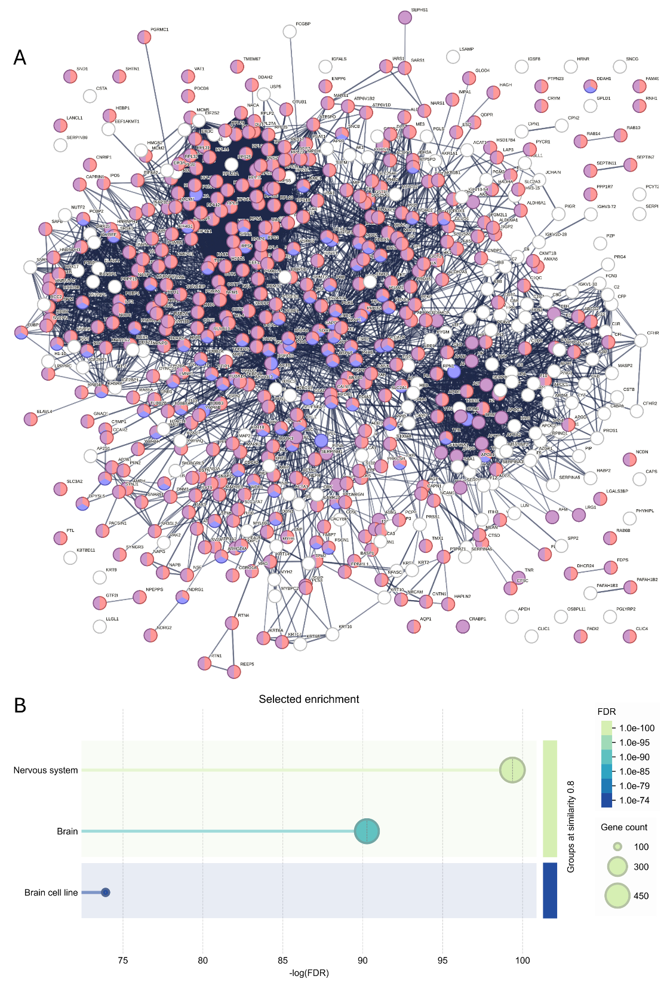
Figure S1. Enrichment analysis of total quantified proteins. (A) A protein–protein interaction (PPI=0,07) network was constructed using the STRING database, based on the total set of proteins quantified by SWATH-MS. (B) Subsequent Gene Ontology Cellular Component (GO:CC) enrichment analysis revealed that the identified proteins were significantly enriched in brain, nervous system and brain-derived cell line compartments, suggesting a strong association with neural-specific cellular contexts.

Figure S2.
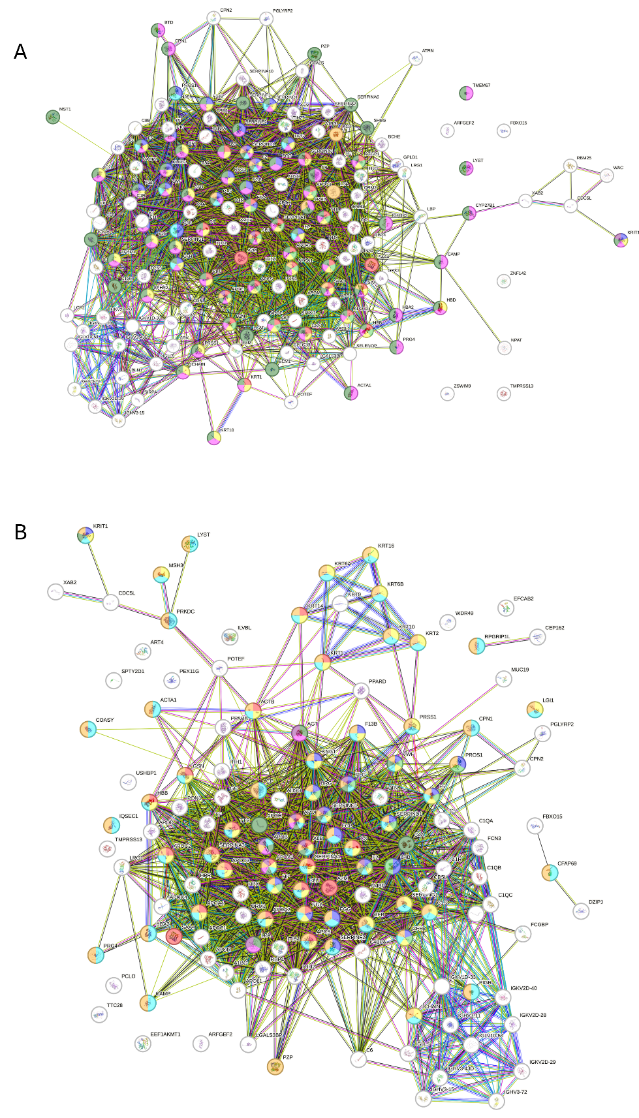
Figure S2. Networks of differentially expressed proteins in plasma and total EVs. (A) STRING Disease Gene Association analysis of total dysregulated plasma proteins revealed links to conditions such as amyloidosis, coagulation disorders, artery disease, and various genetic and vascular diseases. Although the overall PPI score was modest, the disease associations suggest relevant pathophysiological implications. (B) In the EV_{T} protein dataset, STRING disease associations highlighted connections with amyloidosis, blood coagulation, monogenic and autosomal genetic diseases, as well as vascular and artery-related disorders. These findings suggest a potential role for EV proteins in mechanisms underlying these conditions.
Figure S3.
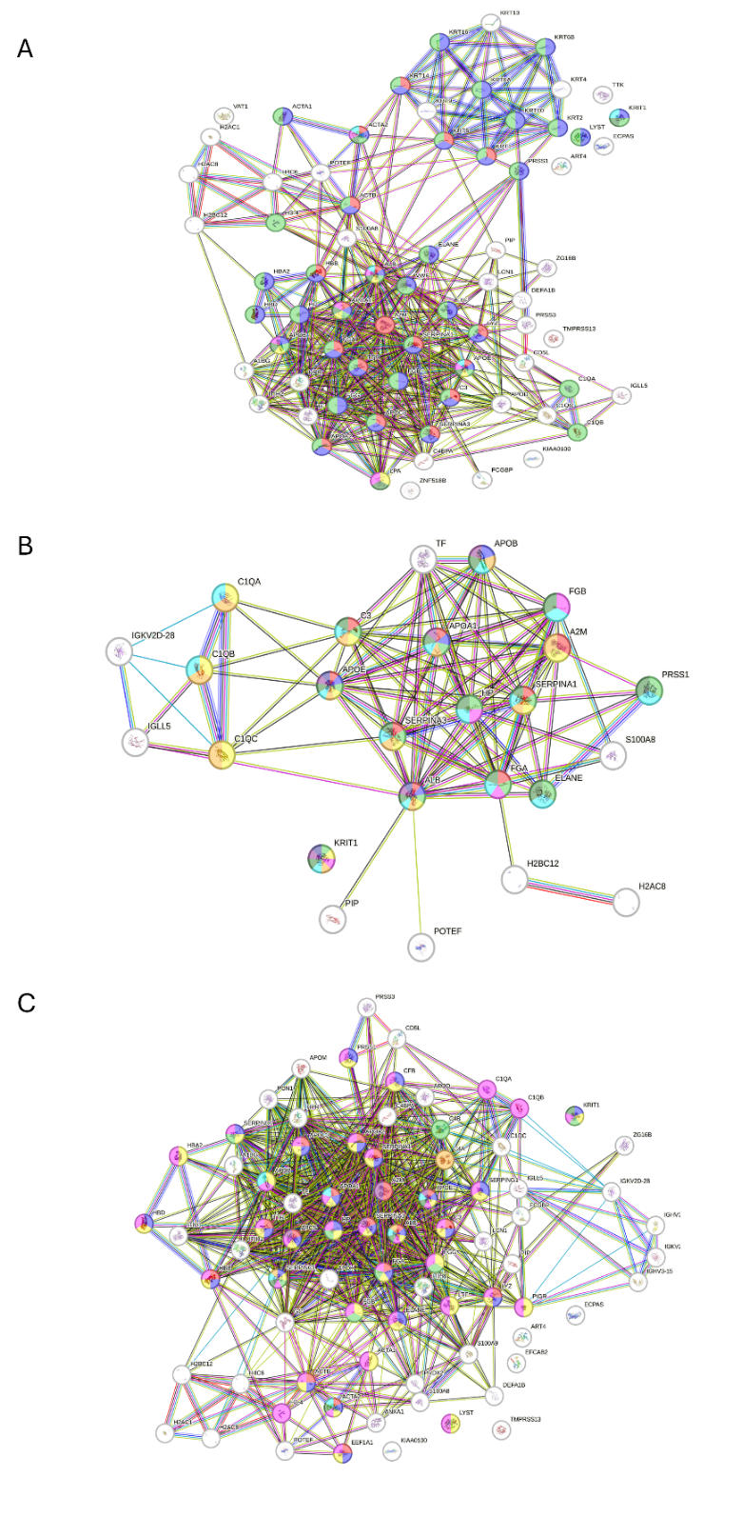
Figure S3. Networks of differentially expressed proteins in enriched EVs. (A) STRING-based protein–protein interaction network showing functional associations among significantly of total dysregulated proteins in the nEVs dataset, with enrichment of extracellular matrix, vesicle-related, and ribosomal components. (B) STRING interaction network constructed from the significantly altered proteins in aEVs, identifying clusters related to vesicle biology, ribosomal units, and extracellular matrix components. (C) STRING analysis of the oEVs proteome highlights a functional network of interacting proteins enriched in vesicular, matrix-associated, and ribosomal elements.

Figure S4.
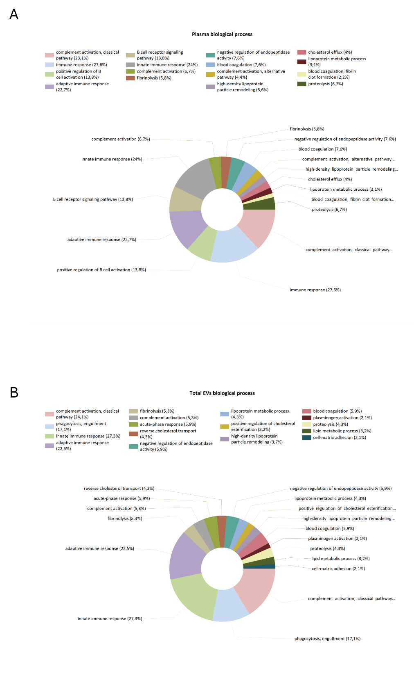
Figure S4. Functional profiling of dysregulated EV_{T} and plasma proteins. Biological processes were analyzed using FunRich by comparing the lists of dysregulated proteins in plasma (A) and EV_{T} (B) against the UniProt-based background database. The most significantly enriched biological processes are highlighted, reflecting the functional roles in which these proteins are predominantly involved.

Figure S5
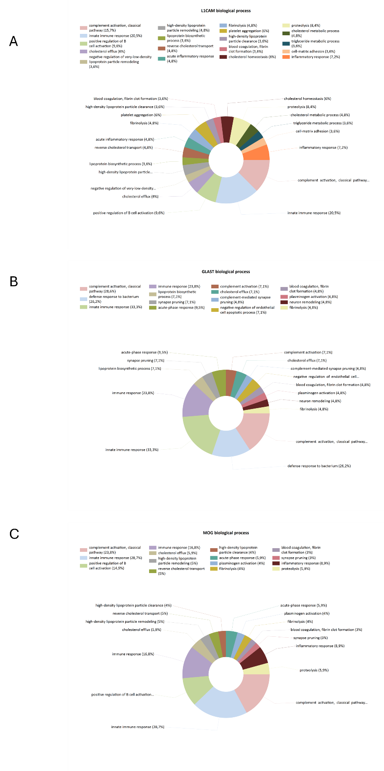
Figure S5. Functional analysis of specific EVs proteins. Biological process enrichment analysis was performed using FunRich, comparing dysregulated proteins from nEVs (A), aEvs (B) and oEVs (C) with the UniProt reference database. The most significantly overrepresented biological processes are shown, highlighting key functional pathways associated with these protein sets.

REFERENCES
1. Abramowicz A, Marczak L, Wojakowska A, Zapotoczny S, Whiteside TL, Widlak P, Pietrowska M: Harmonization of exosome isolation from culture supernatants for optimized proteomics analysis. PLoS One 2018, 13:e0205496.
2. Rodrigues JS, Chenlo M, Bravo SB, Perez-Romero S, Suarez-Farina M, Sobrino T, Sanz-Pamplona R, Gonzalez-Prieto R, Blanco Freire MN, Nogueiras R, et al: dsRNAi-mediated silencing of PIAS2beta specifically kills anaplastic carcinomas by mitotic catastrophe. Nat Commun 2024, 15:3736.
3. Candamo-Lourido M, Dopico-Lopez A, Lopez-Arias E, Lopez-Amoedo S, Correa-Paz C, Chantada-Vazquez MP, Bugallo-Casal A, Del Pozo-Filiu L, Perez-Gayol L, Palomar-Alonso N, et al: Comparative Brain Proteomic Analysis between Sham and Cerebral Ischemia Experimental Groups. Int J Mol Sci 2024, 25.
4. Casado-Fernandez L, Laso-Garcia F, Piniella D, Gomez-de Frutos MC, Otero-Ortega L, Bravo SB, Fuentes-Gimeno B, Docando F, Alonso-Lopez E, Ruiz-Ares G, et al: The proteomic signature of circulating extracellular vesicles following intracerebral hemorrhage: Novel insights into mechanisms underlying recovery. Neurobiol Dis 2024, 201:106665.
5. Bugallo-Casal A, Muino E, Bravo SB, Hervella P, Arias-Rivas S, Rodriguez-Yanez M, Vara-Leon E, Quintas-Rey R, Perez-Gayol L, Maisterra-Santos O, et al: NOTCH3 Variant Position Affects the Phenotype at the Pluripotent Stem Cell Level in CADASIL. Neuromolecular Med 2025, 27:18.
6. Alvarez JV, Bravo SB, Chantada-Vazquez MP, Pena C, Colon C, Tomatsu S, Otero-Espinar FJ, Couce ML: Morquio A Syndrome: Identification of Differential Patterns of Molecular Pathway Interactions in Bone Lesions. Int J Mol Sci 2024, 25.
7. Ayuso-Garcia P, Sanchez-Rueda A, Velasco-Aviles S, Tamayo-Caro M, Ferrer-Pinos A, Huarte-Sebastian C, Alvarez V, Riobello C, Jimenez-Vega S, Buendia I, et al: Neddylation orchestrates the complex transcriptional and posttranscriptional program that drives Schwann cell myelination. Sci Adv 2024, 10:eadm7600.
8. Garcia-Vega D, Sanchez-Lopez D, Rodriguez-Carnero G, Villar-Taibo R, Vinuela JE, Lestegas-Soto A, Seoane-Blanco A, Moure-Gonzalez M, Bravo SB, Fernandez AL, et al: Semaglutide modulates prothrombotic and atherosclerotic mechanisms, associated with epicardial fat, neutrophils and endothelial cells network. Cardiovasc Diabetol 2024, 23:1.

