Supplementary material

- Depth and Thickness of Glacial Beds in the study interval

Table S1: Depth and Thickness of Glacial Beds on site U1524, hole A.
 | Core-Section | Top offset (cm) | Top depth CSF-B (m) | Bottom depth CSF-B (m) | Thickness (m)
1 | 23-1 | 135 | 200.15 | 200.28 | 0.13
2 | 23-2 | 20 | 200.36 | 200.48 | 0.12
3 | CC-4 | 11 | 208.17 | 208.47 | 0.30
4 | 24-2 | 126 | 211.07 | 211.26 | 0.19
5 | 24-4 | 118 | 213.60 | 213.70 | 0.10
6 | 25-1 | 52 | 218.32 | 218.50 | 0.18
7 | 25-2 | 7 | 219.22 | 219.30 | 0.08
8 | 25-2 | 105 | 220.87 | 220.99 | 0.12
9 | 25-3 | 38 | 223.65 | 223.77 | 0.12
10 | 25-6 | 42 | 225.07 | 225.17 | 0.10
11 | 25-7 | 18 | 226.21 | 226.33 | 0.12
12 | 26-2 | 95 | 229.61 | 229.82 | 0.21
13 | 26-4 | 120 | 232.73 | 232.95 | 0.22
14 | 26-5 | 14 | 233.09 | 233.13 | 0.04
15 | 26-6 | 42 | 234.81 | 234.94 | 0.13
16 | 27-2 | 135 | 239.48 | 240.90 | 1.42
17 | 27-5 | 39 | 242.65 | 242.72 | 0.07
18 | 28-1 | 76 | 247.06 | 247.21 | 0.15
19 | 28-2 | 130 | 248.93 | 249.08 | 0.15
20 | 28-3 | 90 | 249.87 | 250.00 | 0.13
21 | 28-7 | 125 | 255.60 | 255.72 | 0.12
22 | 29-5 | 95 | 262.07 | 262.17 | 0.10
23 | 30-4 | 12 | 269.36 | 270.66 | 1.30
24 | 32-2 | 145 | 272.72 | 272.77 | 0.05
25 | 33-1 | 55 | 280.85 | 280.94 | 0.09
26 | 34-1 | 0 | 289.90 | 290.36 | 0.46
Figure S1: Photograph of cores 23 and 27 from Site U1524, Hole A. Vertical gray lines highlight gray layers, interpreted as glacial deposits. Yellow arrows indicate clasts within the gray layers.

- Data from the IODP LIMS database
Reflectance b*, Mn, Al, Zr and Rb data are available in the IODP LIMS database. When data were not available for the exact position of our samples, we used the nearest neighbor (~1 cm offset), verifying core photographs to ensure the sample remained within the targeted lithology.
Table S2: Site, core, depth, reflectance b*, Mn/Al and Zr/Rb of studied samples.
Site | Hole | Core | Section | Top Offset (cm) | Bottom Offset (cm) | Depth CSF-B (m) | Interpretation | Reflectance b* | Mn/Al | Zr/Rb
U1524 | A | 23 | 1 | 5 | 7 | 198.85 | Open water | -0.11 | 0.30 | 1.17
U1524 | A | 23 | 2 | 23 | 25 | 200.39 | Perennial ice coverage | -6.52 | 0.14 | 1.04
U1524 | A | 23 | 3 | 7 | 9 | 201.59 | Open water | 2.19 | 0.39 | 0.93
U1524 | A | 23 | 5 | 7 | 9 | 204.36 | Open water | 1.13 | 0.34 | 1.25
U1524 | A | 23 | 7 | 4 | 6 | 207.11 | Open water | 1.77 | 0.45 | 1.22
U1524 | A | 23 | CC | 6 | 8 | 208.20 | Perennial ice coverage | -3.54 | NA | NA
U1524 | A | 24 | 1 | 7 | 9 | 208.37 | Perennial ice coverage | -4.78 | 0.20 | 1.03
U1524 | A | 24 | 2 | 3 | 5 | 209.73 | Open water | 1.4 | 0.33 | 1.08
U1524 | A | 24 | 3 | 7 | 9 | 211.15 | Perennial ice coverage | -3.96 | 0.18 | 1.32
U1524 | A | 24 | 4 | 7 | 9 | 212.49 | Open water | -0.12 | 0.37 | 1.09
U1524 | A | 24 | 4 | 118 | 120 | 213.60 | Perennial ice coverage | -4.17 | 0.16 | 1.14
U1524 | A | 24 | 5 | 7 | 9 | 213.85 | Open water | -0.19 | 0.38 | 1.04
U1524 | A | 24 | 7 | 3 | 5 | 216.65 | Open water | -2.91 | 0.30 | 1.62
U1524 | A | 25 | 1 | 66 | 68 | 218.46 | Perennial ice coverage | -4.86 | 0.20 | 1.12
U1524 | A | 25 | 1 | 80 | 82 | 218.60 | Open water | 0.8 | 0.20 | 1.12
U1524 | A | 25 | 2 | 8 | 10 | 219.22 | Perennial ice coverage | -4.08 | 0.20 | 1.06
U1524 | A | 25 | 3 | 5 | 7 | 220.57 | Open water | -0.87 | 0.27 | 1.13
U1524 | A | 25 | 3 | 40 | 42 | 220.90 | Perennial ice coverage | -3.55 | 0.22 | 1.15
U1524 | A | 25 | 5 | 5 | 7 | 223.32 | Open water | -0.33 | 0.27 | 1.06
U1524 | A | 25 | 6 | 47 | 49 | 225.12 | Perennial ice coverage | -2.71 | 0.19 | 1.10
U1524 | A | 25 | 7 | 3 | 5 | 226.06 | Open water | 1.16 | 0.24 | 0.97
U1524 | A | 25 | 7 | 22 | 24 | 226.25 | Perennial ice coverage | -2.7 | 0.20 | 1.02
U1524 | A | 26 | 1 | 7 | 9 | 227.37 | Open water | 2.51 | 0.39 | 1.16
U1524 | A | 26 | 2 | 98 | 100 | 229.64 | Perennial ice coverage | -2.77 | 0.26 | 0.93
U1524 | A | 26 | 3 | 7 | 9 | 230.17 | Open water | 2.57 | 0.31 | 0.92
U1524 | A | 26 | 4 | 128 | 130 | 232.81 | Perennial ice coverage | -3.3 | 0.27 | 1.12
U1524 | A | 26 | 5 | 7 | 9 | 233.02 | Open water | 2.62 | 0.42 | 0.97
U1524 | A | 26 | 5 | 13 | 15 | 233.08 | Perennial ice coverage | 2.26 | 0.30 | 1.12
U1524 | A | 26 | 6 | 7 | 9 | 234.46 | Open water | -1.29 | 0.43 | 1.08
U1524 | A | 26 | 6 | 47 | 49 | 234.76 | Perennial ice coverage | -1.5 | 0.19 | 1.16
U1524 | A | 26 | 7 | 7 | 9 | 235.90 | Open water | 3.29 | 0.34 | 1.10
U1524 | A | 27 | 1 | 7 | 9 | 236.87 | Open water | 2.02 | 0.63 | 1.37
U1524 | A | 27 | 3 | 6 | 8 | 239.51 | Perennial ice coverage | -3.05 | 0.22 | 1.67
U1524 | A | 27 | 5 | 7 | 9 | 242.33 | Open water | 0.06 | 0.37 | 0.96
U1524 | A | 27 | 5 | 41 | 43 | 242.67 | Perennial ice coverage | -0.68 | 0.25 | 1.04
U1524 | A | 27 | 7 | 7 | 9 | 245.03 | Open water | -1.2 | 0.42 | 1.05
U1524 | A | 28 | 1 | 7 | 9 | 246.37 | Open water | 0.74 | 0.29 | 1.09
U1524 | A | 28 | 1 | 81 | 83 | 247.11 | Perennial ice coverage | -2.9 | 0.21 | 1.31
U1524 | A | 28 | 2 | 7 | 9 | 247.70 | Open water | -2.17 | 2.21* | 1.17
U1524 | A | 28 | 2 | 137 | 139 | 249.00 | Perennial ice coverage | -3.64 | 1.37* | 1.21
U1524 | A | 28 | 3 | 4 | 6 | 249.01 | Open water | -2.98 | 0.20 | 1.02
U1524 | A | 28 | 3 | 93 | 95 | 249.90 | Perennial ice coverage | -3.48 | 0.14 | 1.35
U1524 | A | 28 | 5 | 7 | 9 | 251.73 | Open water | -0.96 | 0.34 | 1.09
U1524 | A | 28 | 7 | 13 | 15 | 254.48 | Open water | -1.38 | 0.31 | 1.28
U1524 | A | 28 | 7 | 123 | 125 | 255.58 | Mixed sampling** | 0.33 | 0.20 | 1.32
U1524 | A | 29 | 1 | 7 | 9 | 255.87 | Open water | -0.65 | 0.28 | 1.10
U1524 | A | 29 | 3 | 7 | 9 | 258.53 | Open water | -1.52 | 0.32 | 1.20
U1524 | A | 29 | 5 | 5 | 7 | 261.19 | Open water | -1.54 | 0.33 | 1.21
U1524 | A | 29 | 5 | 98 | 100 | 262.12 | Perennial ice coverage | -2.15 | 0.19 | 1.15
U1524 | A | 29 | 7 | 8 | 10 | 263.87 | Open water | -2.62 | 0.35 | 1.20
U1524 | A | 30 | 1 | 7 | 9 | 265.37 | Open water | 0.65 | 0.39 | 1.22
U1524 | A | 30 | 3 | 5 | 7 | 267.85 | Open water | -0.67 | 0.35 | 1.22
U1524 | A | 30 | CC | 7 | 9 | 269.95 | Perennial ice coverage | -5.4 | 0.13 | 1.39
U1524 | A | 32 | 1 | 4 | 6 | 270.74 | Open water | -0.24 | 0.38 | 1.20
U1524 | A | 32 | 2 | 147 | 149 | 272.74 | Perennial ice coverage | -2.16 | 0.18 | 1.25
U1524 | A | 32 | CC | 5 | 7 | 272.83 | Open water | -3.06 | NA | NA
U1524 | A | 33 | 1 | 58 | 60 | 280.35 | Perennial ice coverage | -4.61 | NA | NA
U1524 | A | 33 | 2 | 5 | 7 | 281.44 | Open water | -4.54 | NA | NA
U1524 | A | 34 | CC | 5 | 7 | 289.95 | Perennial ice coverage | -1.37 | 0.18 | 1.63
- * Outliers (excluded from Fig. 5 in the main text)
- ** Mixed sampling (taken exactly at the glacial/open-water contact), so the sample represents neither open-water nor glacial conditions, but a mixture of both. Not used in Figs. 1 and 5 of the main text.

- Age model
The geomagnetic polarity timescale was used to tie ages of paleomagnetic reversals with depths in the core (Table S3) ¹. δ¹³Corg data were used for spectral analyses to identify cyclic patterns, which revealed two frequencies above the confidence interval (Figure 5 in the main text, which highlights the 41 ka and 16 ka periodicities).
Table S3: Paleomagnetic reversals identified in the studied core. The table lists the depth (m CSF-B) and corresponding age (ka) of each reversal boundary¹.
 | Age (ka) | ±1σ Age (ka) | Depth CSF-B (m)
Matuyama/Gauss | 2581² | - | 120.98
Kaena Top | 3032³ | 15⁴ | 208.26
Kaena-Bottom | 3116³ | 15⁴ | 227.13
Mammoth top | 3207³ | 15⁴ | 240.07
Mammoth bottom | 3330³ | - | 271.36

Table S4: Depth-to-time conversion of δ¹³Corg, using paleomagnetic anchors shown in table S3, performed with Acycle⁵.
Age (ka) | δ¹³Corg | Age (ka) | δ¹³Corg
2983.38 | -25 | 3177.67 | -25.2
2991.33 | -26.5 | 3184.50 | -25
2997.53 | -25 | 3203.06 | -27.3
3011.85 | -25.1 | 3215.88 | -25.2
3026.06 | -25.1 | 3217.22 | -26.5
3031.28 | -27 | 3226.50 | -25
3032.49 | -27.7 | 3231.77 | -25
3038.54 | -25 | 3234.67 | -27.2
3044.86 | -27.2 | 3236.99 | -25
3050.83 | -25.1 | 3242.10 | -26.8
3055.77 | -26.4 | 3242.14 | -25
3056.88 | -24.9 | 3245.64 | -26.9
3069.35 | -25.1 | 3252.84 | -25
3077.41 | -27.5 | 3263.65 | -25.1
3078.03 | -24.9 | 3267.97 | -25.7
3080.79 | -26.9 | 3269.11 | -25.1
3086.80 | -24.8 | 3279.57 | -25.3
3088.27 | -27.2 | 3290.02 | -25.2
3099.04 | -24.6 | 3293.68 | -27.8
3107.05 | -27.7 | 3300.56 | -25.1
3111.24 | -24.8 | 3306.45 | -25.3
3112.08 | -26 | 3316.20 | -25.4
3117.69 | -25 | 3324.46 | -27.7
3133.65 | -27.5 | 3327.56 | -24.9
3137.38 | -25 | 3335.42 | -26.8
3155.94 | -27.9 | 3335.78 | -24.9
3157.42 | -25 | 3365.34 | -27.3
3157.84 | -26.2 | 3369.62 | -25.2
3167.55 | -25.1 | 3403.08 | -28.1
3169.66 | -28.3

- Statistical Evidence for Bimodality in the Dataset
To evaluate whether the difference in Reflectance b*, Corg (%), δ¹³C, C/N, Mn/Al and Zr/Rb between the visually defined lithological groups is statistically significant, we performed an independent two-sample t-test (Table S4 and Figure S2). The results indicate that the observed difference is statistically significant (p < 0.05) in Reflectance b*, Corg (%), δ¹³C, C/N, supporting the interpretation that organic carbon content varies systematically during the mPWP. Contrastingly, Mn/Al and Zr/Rb do not show statistically significant differences between the groups (p-values of 6.95x10-² and 1.95x10⁻¹, respectively).

Table S5: Results of the Two-Sample t-Test. Reflectance b*, Corg (%), δ¹³C, C/N, Mn/Al and Zr/Rb comparing the two lithological groups (gray sediments vs. green sediments).
 | p-value | H₀
Reflectance b* | 1.31e-07 | reject
Corg (%) | 2.20e-31 | reject
δ¹³C | 2.77e-15 | reject
C/N | 6.84e-19 | reject
Mn/Al | 6.95e-02 | accept
Zr/Rb | 1.95e-01 | accept

Figure S2: Boxplots showing the distribution of data for warm vs cold intervals. Data plotted are: reflectance b*, Corg (%), δ¹³C, C/N, Mn/Al and Zr/Rb. The horizontal line represents the median, boxes show the interquartile range, and whiskers extend to 1.5× IQR. Outliers are shown as individual points. All parameters, except for Mn/Al and Zr/Rb, defined lithological groups that are statistically significant. A Welch’s two-sample t-test indicates a statistically significant difference between the two groups (p >0.05).
- Paleo-drainage catchments of major troughs of the Ross Sea during the last glacial maximum
Upstream of the study site, the Glomar Challenger Trough (Figure S2), a primary channel in the Ross Sea, drains a wide area of West Antarctica, including the Kamb, Whillans, Mercer, and Beardmore ice streams (Danielson & Bart, 2024), and potentially delivered organic matter sourced from these areas to Site U1524.
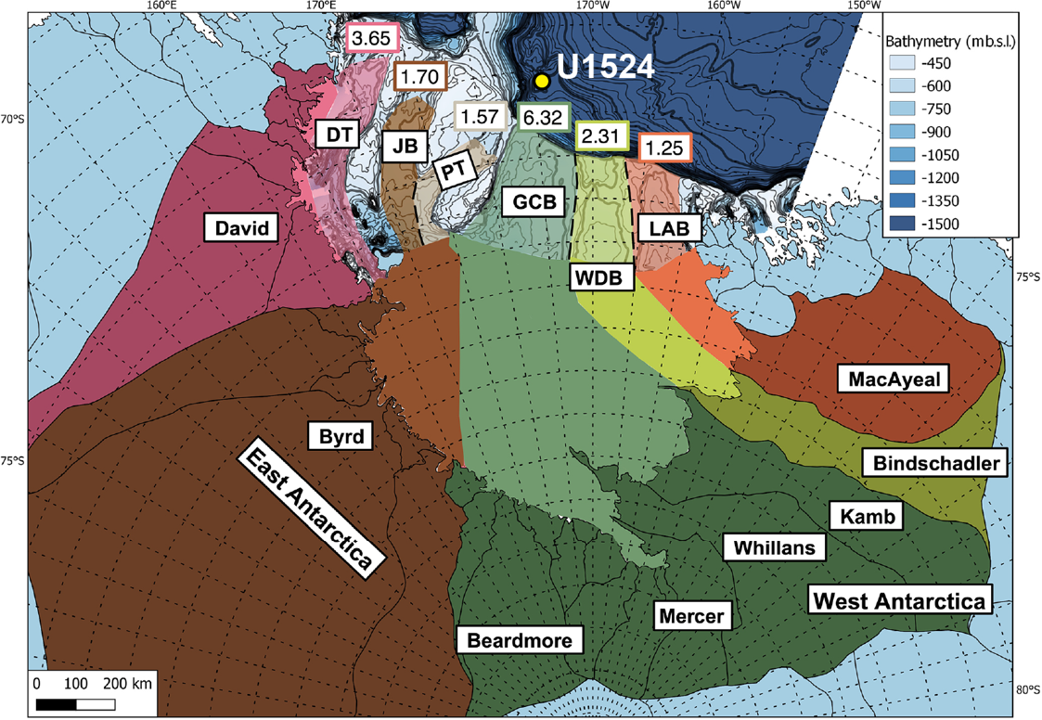
Figure S3: Estimated paleo-drainage catchments for each of the major troughs across the Ross Sea during the LGM. The study site is shown as a yellow dot. The darker shades correspond to the present-day drainage areas, while the lighter shades correspond to the projected paleo-drainage into the troughs when the ice sheet extent was expanded ⁶.

Reference
1. Ross Sea West Antarctic Ice Sheet History. vol. 374 (International Ocean Discovery Program, 2019).
2. Cande, S. C. & Kent, D. V. Revised calibration of the geomagnetic polarity timescale for the Late Cretaceous and Cenozoic. J. Geophys. Res. Solid Earth 100, 6093–6095 (1995).
3. Lourens, L. J. et al. Evaluation of the Plio‐Pleistocene astronomical timescale. Paleoceanography 11, 391–413 (1996).
4. Deino, A. L. et al. Chronostratigraphy of the Baringo-Tugen Hills-Barsemoi (HSPDP-BTB13-1A) core – 40Ar/39Ar dating, magnetostratigraphy, tephrostratigraphy, sequence stratigraphy and Bayesian age modeling. Palaeogeogr. Palaeoclimatol. Palaeoecol. 570, 109519 (2021).
5. Li, M., Hinnov, L. & Kump, L. Acycle: Time-series analysis software for paleoclimate research and education. Comput. Geosci. 127, 12–22 (2019).
6. Danielson, M. A. & Bart, P. J. The staggered retreat of grounded ice in the Ross Sea, Antarctica, since the Last Glacial Maximum (LGM). The Cryosphere 18, 1125–1138 (2024).

