Robust preferences for information that violates one’s self-perception: the case of non-human sources

Abstract
Individuals actively work to maintain their self-concept. To date, self-concept maintenance has been portrayed mainly as the result of self-verification and self-enhancement motivations. These motivations have been suggested to influence a plethora of behaviors, including engagement with sources of information predicted to provide motivation-consistent information. In tandem, information-seeking perspectives highlight the value of instrumental information that facilitates growth and learning, which could be self-inconsistent. Across five pre-registered studies, we demonstrate that individuals indeed seek engagement with self-inconsistent information when provided by non-human information sources. In Studies 1-2 (and S4), people forwent money to retake questionnaires that provided self-violating evaluations, particularly negative ones. In Study 3 (and S5), participants forwent money and displayed less conflict when choosing potentially self-violating information from a valid algorithm. Combined, the robust preference for informational sources providing self-inconsistent information suggests a hitherto neglected motivation that shapes informational preferences in certain contexts to potentially facilitate self-learning.

Key Words:
- Self-verification
- Self-enhancement
- Self-learning
- Information-seeking
- Self-concept
- Self-feedback

Research Transparency Statement:
General Disclosures
Conflicts of interest: All authors declare no conflicts of interest.
Funding: This work was supported by the Israel Science Foundation (Grant No. 520/20, to Anonymized) and the National Institution for Psychobiology in Israel (No. 10-22-23).
Artificial intelligence: Artificial intelligence such as ChatGPT was used only to refine the analysis code and the phrasing and spell check of the manuscript, AI was not used to create any content.
Ethics: All the studies presented in this article received approval from a Departmental Review Board. All primary data and analysis scripts, for all the following studies, are publicly available (https://osf.io/47kmq/?view_only=b3ec3d3ebed54348959127af0b7360c5).
Study One
Preregistration: The hypotheses and methods were preregistered (https://osf.io/zcahn?view_only=b3ec3d3ebed54348959127af0b7360c5) after collecting data from 6 participants, but the data had not been inspected before pre-registration. The analysis plan was preregistered. There were minor deviations from the preregistration as elaborated in the analysis section under Study 1. Materials: All study materials are publicly available in the supplementary materials of the manuscript (S1). This study was approval from a Departmental Review Board (18.11.2021).
Study Two
Preregistration: The hypotheses and methods were preregistered (https://osf.io/bh597?view_only=b3ec3d3ebed54348959127af0b7360c5) after collecting a portion of the data, but the data had not been inspected before pre-registration. The analysis plan was preregistered. There was a minor deviation from the preregistration as elaborated in the methods section under Study 2. Materials: All study materials are publicly available in the supplementary materials of the manuscript (S2). This study was approval from a Departmental Review Board (10.12.2021).
Study Three
Preregistration: The hypotheses and methods were preregistered (https://osf.io/b67mk?view_only=b3ec3d3ebed54348959127af0b7360c5) prior to data collection. The analysis plan was preregistered. There were major deviations from the preregistration as elaborated in the analysis section under Study 3. Materials: All study materials are publicly available in the supplementary materials of the manuscript (S3). This study was approval from a Departmental Review Board (10.01.2023).
Replication One (S4)
Preregistration: The hypotheses and methods were preregistered (https://osf.io/uv7f6?view_only=b3ec3d3ebed54348959127af0b7360c5) after collecting the data, but the data had not been inspected before pre-registration, other than participants' anxiety scores in order to contact them in case they passed the clinical cut-off. The analysis plan was preregistered. There were no deviations from the preregistration. Materials: All study materials are publicly available in the supplementary materials of the manuscript (S4). This study was approval from a Departmental Review Board (31.12.2023).
Replication Two (S5)
Preregistration: The hypotheses and methods were preregistered (https://osf.io/ t3s2q?view_only=b3ec3d3ebed54348959127af0b7360c5) after collecting the data, but the data had not been inspected before pre-registration, other than participants' anxiety scores in order to contact them in case they passed the clinical cut-off. The analysis plan was preregistered. There were no deviations from the preregistration. Materials: All study materials are publicly available in the supplementary materials of the manuscript (S5). This study was approval from a Departmental Review Board (09.01.2023).
Pilot One (S6)
Preregistration: As a pilot study, this study was not pre-registered. Materials: All study materials are publicly available in the supplementary materials of the manuscript (S6). This study was approval from a Departmental Review Board (06.03.2021).

Introduction
An average day in a person’s life features numerous encounters with self-relevant social information, be it explicit feedback such as a peer indicating one is smarter than they thought or a more implicit input such as a daunting silence after a joke they told. To decide how to seek, interpret and weigh specific inputs, individuals rely on their prior beliefs and specific motivations concerning the new information (Kruglanski et al., 2020; Kube & Rozenkrantz, 2021). In the case of self-relevant information, prior beliefs and motivations pertain to the self-concept (Hohwy & Michael, 2017; Mokady & Reggev, 2022; Van de Cruys & Van Dessel, 2021), the theory a person has on how they are (Epstein, 1973; Mead, 1934; Woźniak et al., 2025). This manuscript examines self-relevant information preferences by pitting monetary values and different types of information—verifying, enhancing, or violating self-perceptions—against each other.
Two primary motivations have been suggested to be at play when individuals seek and process information concerning themselves, self-verification and self-enhancement. Self-verification is the motivation driving people to maintain a stable self-concept (Swann, 2011), driving people to seek information consistent with their self-concept (Kruglanski et al., 2018). Complementarily, self-enhancement motivation drives people to seek positive and even optimistic information about themselves (Sedikides & Gregg, 2008; Taylor & Brown, 1988), allowing them to uplift their self-esteem and improve their mental health. Both motivations have been shown to affect information-seeking (Charpentier et al., 2018; Sedikides, 1993; Swann et al., 1994; Swann & Read, 1981a), attention allocation, information recall (Maheshwari et al., 2021; Sedikides & Green, 2000; Swann & Read, 1981b) , and the perception of the information source (Markant, 2025). Self-enhancing feedback further facilitates changes in self-perception in aspects peripheral to the self-concept, demonstrating general self-enhancement while maintaining core aspects of the self (Elder et al., 2022, 2023; García-Arch et al., 2024; Sharot & Garrett, 2016). Notably, self-verification and self-enhancement may drive behavior in tandem, driving people to seek self-congruent information on positive aspects of their self-concept (Swann et al., 1989; Szumowska et al., 2023).
The preference of information congruent with self-relevant motivations suggests that satisfying the motivation (by, e.g., perceiving motivation-congruent information) holds value for the perceiver. For example, driven by the motivation for cognitive consistency, people value information congruent with their belief (Kruglanski et al., 2018). In the social domain, people value information confirming social expectations (e.g., stereotypes; Reggev et al., 2021). When interacting with others, receiving and disclosing information about the self is valuable and rewarding (Swann & Read, 1981a; Tamir & Mitchell, 2012). In parallel, satisfying positivity motivations (i.e., receiving information about positive outcomes and beliefs) is also associated with value. People assign a positive value to knowledge when seeking a desirable outcome and to ignorance when expecting an undesirable outcome (Charpentier et al., 2018). Furthermore, optimistic updates to self-relevant beliefs trigger subsequent activity in reward related brain regions, pointing to the value of these updates (Kuzmanovic et al., 2016; Lefebvre et al., 2017). To sum, individuals value both information satisfying congruency motivations and information satisfying positivity motivations across domains, ranging from general beliefs on how the world works to concrete outcomes regarding oneself (Bromberg-Martin & Sharot, 2020).
Although evidence shows that people prefer self-verifying and self-enhancing information, separately or in tandem, it remains unclear whether, when, and how these preferences translate to value. Characterizing and quantifying the subjective value individuals attribute to self-relevant information offers a more implicit and potentially more sensitive measure of the subtle differences in self-verification tendencies. Furthermore, employing continuous value measures would allow the detection of the simultaneous activation of both (or multiple) motivations rather than the either-or measures typically employed.
Adopting the quantitative value lens, we hypothesized that if people are dominantly driven to self-verify, they will value self-concept congruent information more than violating information, and the highest value would be attributed to information verifying positive aspects of the self. The current manuscript reports three studies (and two replications in SM) investigating this hypothesis. Studies 1 & 2 examined whether people attribute value to self-verifying information, self-enhancing information, or their combination. We explored this question using a modified pay-per-view paradigm to measure the amount of money people would forgo to interact with a source providing a specific type of self-relevant information. Study 3 employed a mouse-tracking paradigm to follow up on two competing explanations for the obtained results and pit the motivation to self-verify and maintain the self-concept with the motivation to learn about, and update, the self-concept. To foreshadow our results, we found that people are willing to forgo money to receive information that mismatches (Studies 1 & 2, replication Study S4) or can potentially mismatch (Study 3, replication Study S5) their self-rated evaluations; in tandem, people forwent money to avoid information that aligns and repeats these evaluations. These results suggest that contrary to our hypothesis, in the contexts employed in these studies, young healthy individuals value information that violates rather than verifies their self-concept.
Method & Results
Study 1
Overview
To quantify the value of self-verifying and self-enhancing information, participants in Study 1 completed a modified pay-per-view paradigm in which they could choose to forgo money to increase their chances of re-interacting with questionnaires evaluating specific traits. Participants saw manipulated self-relevant evaluations on previously measured traits and attributed value (i.e., chose whether and how much money to forgo) to re-interact with the evaluators (i.e., questionnaires). Across trials, participants saw evaluations that verified or violated their self-concept both positively and negatively.
The data was collected online using Gorilla (Anwyl-Irvine et al., 2020) and took place between 28/11/2021 and 20/01/2022. The study was ethically approved by the Department of Psychology ethical committee for experiments with human participants and pre-registered via the Open Science Framework (OSF; https://osf.io/zcahn?view_only=b3ec3d3ebed54348959127af0b7360c5).
Participants
Participants were psychology undergraduate students who participated for course credit and were paid an additional monetary bonus based on their in-study choices. Participants were native Hebrew speakers with normal or corrected-to-normal vision without attention deficits, ascertained by self-report.
The sample size for the study was calculated to enable a statistical power of 80% to detect the difference in preference between self-verifying and self-violating feedback. A sample size of 60 participants accounted for an effect size of Cohen's d = 0.35 based on both prior literature (suggested an effect size of Cohen's d = 0.25; Kwang & Swann, 2010) and a pilot study (N = 52) using our specific methodology that yielded an effect size of Cohen's d = 0.73 (see S6.4).
A total of 91 participants participated in the study. After excluding 33 participants according to pre-registered criteria (see S1.1), the final sample included 58 participants with analyzable data (Mean_{age} = 23.3, SD = 1.39, Range: 21-25; 84% identified as women and the rest as men). All participants identified as Israeli, and 58% also identified as Jewish. The sample was overall not religious (Mean = 27.4, SD = 27.3, range 0-89, on a 0-100 scale).
Materials and Measures
Stimuli. Traits. To measure and provide manipulated feedback we used 30 positive traits, validated for Hebrew speakers in a prior study (Armony-Sivan et al., 2013; list in S1.2).
Bogus trait questionnaire. For each trait, 2-4 research assistants wrote a bogus trait questionnaire consisting of three questions per trait (S1.2). For example, a shyness questionnaire could include a question such as 'It is hard for me to talk in front of an audience'.
Manipulation. For each questionnaire, participants received feedback on their supposedly calculated (in truth, manipulated) rating on the trait. Feedback was equally divided into 4 conditions: negative violation (feedback approximately 30 points below the self-rating), non-positive verification (feedback similar to the self-rating but only on traits that were self-rated as neutral, i.e., between 35 and 65), positive violation (feedback approximately 30 points above the self-rating), and positive self-verification (feedback similar to the self-rating specifically on traits that received a very high self-rating, i.e., above 75).
Value Measurement. To measure the value participants attributed to the different questionnaires, we told participants that they would retake a third of the questionnaires at the end of the study for validation purposes. Participants were instructed that they could affect which questionnaires they would retake by indicating their preference on a continuous scale ranging from 'Do not want to retake' to 'Want to retake', with the middle being 'Do not care' (scale direction was counterbalanced across participants). Thus, the further from the middle participants placed the curser, the more they wanted to either retake or avoid a specific questionnaire. Importantly, the scale also corresponded to monetary values that were added to the bonus the participant received at the end of the study. The middle of the scale (corresponding to 'Do not care') corresponded with the highest amount (0.7 NIS ~ 0.2 USD), whereas both ends of the scale corresponded with the smallest amount (0.2 NIS ~ 0.06 USD). These amounts were determined such that the minimum bonus was 10% of the base payment typically paid for participation in studies with a comparable duration, and the maximum bonus was 50%. This scale ensured that participants had to forgo some of their bonus money to indicate any preference, such that the stronger their preference, the more money they had to forgo.
Additional Questionnaires. Participants answered the Rosenberg Self-Esteem scale (RSE; Rosenberg, 1965). The effects of self-esteem as a mediating factor were highly inconsistent between the studies, therefore they are not reported here (all pre-registered analyses are reported in the SM, S1.3). Participants also answered the Patient Health Questionnaire-2 (PHQ-2; Löwe et al., 2005; Manea et al., 2016), a non-diagnostic depression questionnaire. Due to a very low variance in the scale, we did not perform the pre-registered analysis using the PHQ-2.
Procedure
Participants completed two sessions online. After providing their informed consent and indicated compliance with task requirements, participants in the first session completed an attention check, followed by a gender identification question that was used to determine the gender form of the instructions, feminine or masculine (Hebrew is a gendered language in which adjectives such as traits have different suffixes for men and women). Then, participants rated themselves on all 30 traits on two 0 to 100 scales on all traits: self-rating (e.g., "How shy are you?") and importance (e.g., "How important is the trait shyness to who you are?"). Additionally, participants rated on a continuous scale how positive (100) or negative (0) each trait is. Subsequently, participants answered, in this order, the RSE questionnaire, the PQH-2 questionnaire, and a demographic questionnaire.
After 7-9 days (Mean = 7.24, SD = 0.43, Median = 7) participants started the second session. After indicating their informed consent and compliance with task requirements, participants answered all 16 trait questionnaires (see questionnaire selection procedure in S1.2) in a randomized order (Figure 1A). Participants rated each question in each questionnaire on its self-fit using a 0 ('does not describe me at all') to 100 (describes me very well') scale. After answering the bogus questionnaires, participants rated 'how they feel at the moment' on a scale ranging from 'not good at all' (0) to 'very good' (100). Then, for every trait, participants were reminded of their self-rating directly followed by a screen displaying the (manipulated) questionnaire rating. Participants rated how accurate they thought each questionnaire was on a scale of 'very inaccurate' (0) to 'very accurate' (100) (Figure 1B). On the next screen, participants rated how much they wanted to retake or avoid the specific questionnaire using the value measurement scale (see Value Measurement subsection).
Before the end of the second session, participants answered semi-structured gradual open-ended question probes concerning the perceived aim of the study, as well as any extremely positive or negative events in the week between the sessions. Two independent coders coded all the open-ended questions. Finally, participants were debriefed and paid.
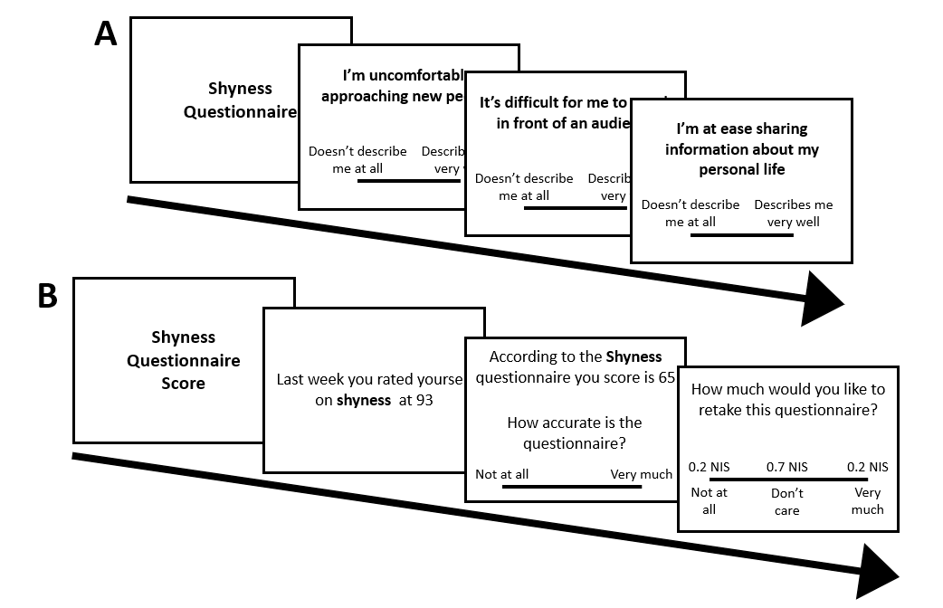
Figure 1. A typical trial in the second session of the study. Pannel A displays the questionnaire phase, all participants answer 16 questionnaires one after the other in a random randomized order. Pannel B displays the trait feedback phase for a single trait; traits were presented in a randomized order.
Analysis
To analyze the data, we used linear mixed models with effect-coded fixed effects of feedback type (verifying versus violating), feedback valence (non-positive versus positive), and their interaction. Random effects included random intercepts, random slopes of feedback type (verifying versus violating) and feedback valence (non-positive versus positive), and their random interaction both for participants and traits (we deviated from the pre-registered analyses that included only a random intercept for traits and no random interaction of feedback and valence following the advice of a statistician). The dependent variable in all the models was the preference to retake or avoid each questionnaire, corresponding to forgoing money for the preferred outcome.
Further pre-registered secondary analyses are reported in the SM alongside their corresponding data (S1.3).
Results
Examining the impact of feedback type revealed that participants were willing to forgo money to retake violating questionnaires (Mean = 17.1, SE = 3.26, 95% CI [10.6, 23.67]) and avoid retaking verifying questionnaires (Mean= -15.5, SE = 3.99, 95% CI [-23.5, -7.51]; main effect of feedback type: t_{(57.6)} = 5.82, p < .001, Cohen's d = .77, 95% CI [0.47, 1.07]). Additionally, participants preferred retaking questionnaires providing non-positive evaluations (Mean = 8.05, SE = 2.85, 95% CI [2.31, 13.79]) and avoiding retaking questionnaires providing positive evaluations (Mean = -6.45, SE = 2.89, 95% CI [-12.26, -0.63]; main effect of feedback valence: t_{(55.9)} = 4.33, p < .001, d = 0.7, 95% CI [0.33, 1.05]). The interaction between feedback type and feedback valence was not significant (t_{(49.7)} = .93, p = .355; see Figure 2).
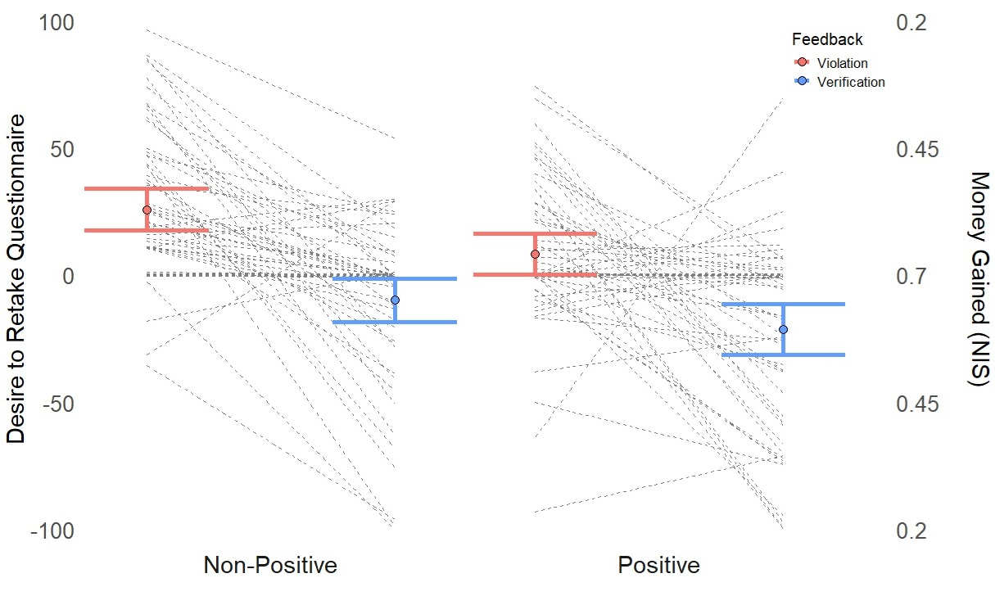
Figure 2. The main results in Study 1. The X-axis within each facet represents the feedback type, red denoting violating and blue verifying feedback. Facets represent the feedback valence, non-positive evaluations on the left and positive evaluations on the right. The Y-axis denotes the participants’ ratings of their desire to retake/avoid retaking each questionnaire, where -100 means 'do not want to retake', +100 means 'do want to retake', and 0 means 'do not care'. Additionally, -100 and +100 corresponded to the minimal possible bonus (0.2 NIS), and 0 corresponded to the maximal bonus (0.7 NIS) as demonstrated by the y-axis on the right. The grey dotted lines represent the average preference of every participant in each condition, and the red and blue error bars represent the mean and 95% confidence intervals of violating and verifying conditions respectively.
Interestingly, the largest monetary sacrifice was seen in the negatively violating condition in which participants forwent an average of 15.7% of their possible bonus amount to retake these questionnaires (desire to retake: Mean = 25.86, SE = 4.15, 95% CI [17.52, 34.19]), whereas they forwent only 5.8% to retake positively violating questionnaires (Mean = 8.39, SE = 4.01, 95% CI [0.3, 16.47]; t_{(37.8)} = 3.56, p < .01, d = 0.58, 95% CI [0.23, 0.92]). Complementing this gap, although the magnitude of violation was similar for both positive and negative violations, negatively violating questionnaires felt less accurate (Mean = 30.5, SD = 24.7, 95% CI [27.3, 33.7]) than positively violating questionnaires (Mean = 45.6, SD = 25.6, 95% CI [42.28, 48.92]; t₍₅₇₎ = 4.79, p < .001, d = 0.63, 95% CI [0.35, 0.91]). A similar asymmetry was descriptively seen between non-positive and positive verifications, where participants descriptively (but not statistically significantly) forwent more money to avoid retaking positively verifying questionnaires (15% of the possible bonus from the condition; Mean = -21.29, SE = 4.92, 95% CI [-31.17, -11.4]) than they forwent to avoid questionnaires providing non-positive verifications (6.9% of the possible bonus from this condition; Mean = -9.76, SE = 4.24, 95% CI [-18.28, -1.23]; t_{(32.7)} = 2.54, p = .071, d = 0.44, 95% CI [0.08, 0.80]). This comparison also corresponded to participants' perceived accuracy, such that positively verifying questionnaires seemed significantly more accurate (Mean = 89.8, SD = 12.5, 95% CI [88.18, 91.42]) than non-positively verifying ones (Mean = 78.6, SD = 24.1, 95% CI [75.49, 81.71]; t₍₅₇₎ = 5.39, p < .001, d = 0.71, 95% CI [0.42, 0.99]).
Combined, the pre-registered analyses do not support our pre-registered hypotheses of a preference for self-verifying information and show, instead, a preference for self-violating information; we address these and additional mismatches with our original hypotheses in the Discussion section.
Study 2
Overview
Study 1 demonstrated that people are willing to forgo money to retake self-violating, and especially negatively self-violating, questionnaires. However, Study 1 featured a limited set of traits, avoiding negatively laden traits. To enhance the ecological validity of our findings and test whether receiving verifications on negative traits is valued differently than on positive traits, Study 2 featured two major differences from Study 1. First, participants received verifying and violating evaluations on both positive traits (e.g., brave) and negative traits (e.g., selfish). Second, participants were more diverse and participated for monetary compensation instead of course credit. We expected a smaller main effect for feedback type due to a possibly less compliant and more money-driven sample. As data collection for Study 2 began before finishing data collection for Study 1, our pre-registered hypothesis predicted that participants would forgo money to retake positively violating questionnaires and avoid unfavorable questionnaires (reflecting self-enhancement), whereas self-verification would manifest in avoiding violating questionnaires regardless of the direction of violation.
The study included 6 conditions in a 3 (feedback type: lower, similar, or higher evaluation than self-rating) X 2 (trait valence: positive or negative) study design. Due to the significantly extended length of each session compared to the previous study, Study 2 was conducted in the lab. Notably, the in-lab data collection began during a peak of COVID-19 spread in Israel (26/12/2021) which called for extra safety measures such as wearing masks during interviews, and even a short pause in data collection between 9/1/2022-7/3/2022 (which was also the students' exams period). Data collection ended on 19/06/2022. As in Study 1, Study 2 was conducted using Gorilla, approved by the Department of Psychology ethical committee, and pre-registered via OSF (https://osf.io/bh597?view_only=b3ec3d3ebed54348959127af0b7360c5.
Participants
Participants for this study were recruited via participant pools of students with no affiliation to a specific department or degree. Social networks such as Facebook were also used for recruitment, limited to students only. All the participants participated for monetary compensation of 35 NIS (~10.3 USD) for completing both sessions and a bonus that was determined by their choices in the second session that ranged between 5 NIS (~1.5 USD) and 17 NIS (~5 USD).
Similar to Study 1, we aimed for a sample size of 60 participants with analyzable data. A total of 85 participants participated in the study. Twenty-one were excluded according to pre-registered criteria (see S2.1), and 5 participants were eliminated due to guessing the study’s aim (as evidenced by their open-ended answers). Finally, N = 59 participants finished the study with analyzable data (Mean_{age} = 23.6, SD = 1.59, range 19-27; 69% identified as women, 28% as men, and one participant preferred not to answer). Ninety-three percent of the participants identified as Israeli, 74% also identified as Jewish, and one participant identified as "Other". The sample was overall not religious (Mean = 22, SD = 23.2, range 0-75, on a 0-100 scale).
Procedure
Study 2 followed the exact procedure as Study 1 except for the number of traits rated in the first session (40 traits, 20 positive and 20 negative traits; see S2.2), the number of questionnaires in the second session (24 individually pseudo-randomly chosen traits, 12 positive and 12 negative traits see S2.2), and adjustments for a lab-based study. Within each valence of traits (positive or negative), traits were equally divided between the verifying condition (evaluation similar to the self-rating), the higher condition (evaluation approximately 30 points higher than the self-rating), and the lower condition (evaluation approximately 30 points lower than the self-rating). Overall, the first session took approximately 18-20 minutes, and the second session took approximately 25-30 minutes, and were completed on average 7.2 days apart (SD = 0.514).
Analysis
Data analyses followed the same approach as in Study 1. The main model included fixed effects of two independent variables and their interaction: feedback type (lower, similar, or higher than self-rating) and trait valence (negative or positive trait, effect-coded). We examined two main models; the first modeled feedback type with a linear component, corresponding to a preference for positive evaluations over verifying and mostly over negative evaluations. The second model modeled feedback type with both a linear and a polynomial component, contrasting verifying feedback with both directions of violating feedback. The main model was chosen after comparing the two models (see below). Additional exploratory analyses were conducted as in Study 1 on the chosen main model (see S2.3).
Results
Comparing the models with and without the polynomial component revealed similar significant effects in both models. Nonetheless, the model with a quadratic component was chosen due to better fit ($∆AIC=136, ∆BIC=126, {χ^{2}}_{(2)}=139.74, p<.001)$ and all subsequent analysis refer to it. Examining the main model revealed that the quadratic main effect of feedback type was significant (see Table 1) such the participants preferred to retake questionnaires providing both lower (Mean = 9.99, SE = 2.39, 95% CI[5.21, 14.77]) and higher violations (Mean = 6.46, SE = 1.82, 95% CI[2.80, 10.12]) but preferred to avoid retaking verifying questionnaires (Mean = -10.54, SE = 2.05, 95% CI[-14.62, -6.47]). The interaction between the quadratic effect of feedback type and trait valence was not significant. Additionally, although the main effect of the linear component of feedback type and the main effect of trait valence were non-significant, their interaction was significant. Specifically, for negative traits, participants preferred retaking questionnaires providing a higher evaluation (i.e., a negative violation; slope = 3.11, SE = 1.89, 95% CI[-0.69, 6.92]), while for positive traits they preferred retaking questionnaires providing a lower evaluation (i.e., also a negative violation; slope = -6.56, SE = 1.83, 95% CI[-10.25, -2.88]; t₍₅₁₎ = 3.121, p = 0.003, d = 0.44, 95% CI [0.15, 0.72]; further statistics at each level of feedback are elaborated in Table 2), thus producing the expected mirror image and indicating that participants' preference to retake questionnaires was asymmetric with a larger preference for negatively violating questionnaires (Figure 3). Similar to Study 1, the preference to retake or avoid questionnaires corresponded to the perceived accuracy of the questionnaire such that the less accurate the score was the participants wanted to retake the questionnaire (Table 3). As in Study 1, the pre-registered analyses did not support the pre-registered hypothesis in a similar manner; participants preferred interacting with violating questionnaires rather than verifying questionnaires.
Table 1
Effects in the Quadratic Main Model, Study 2
 | Estimate | St. Error | df | t value | p-value
Feedback (linear) | -1.76 | 1.02 | 47.33 | -1.731 | .09
Feedback (quadratic) | 18.76 | 1.53 | 1273.92 | 12.203 | < .001***
Valence | -0.87 | 1.33 | 221.61 | -0.656 | .51
Feedback (linear)* valence | 4.84 | 1.54 | 55.68 | 3.133 | .002**
Feedback (quadratic)* valence | -1.82 | 1.53 | 1274.38 | -1.184 | 0.23

Table 2
Examination of the Feedback and Valence interaction, Study 2
Valence | Feedback | Mean _{(preference)} | St. Error | df | 95% CI
Negative | Lower | 2.45 | 3.19 | 61.3 | [-3.92, 8.82]
Negative | Similar | -11.42 | 2.60 | 119.1 | [-16.56, -6.28]
Negative | Higher | 8.60 | 2.47 | 52.6 | [3.11, 14.09]
Positive | Lower | 17.52 | 2.94 | 59.0 | [11.64, 23.40]
Positive  Positive | Similar  Higher | -9.67  4.31 | 2.29  2.36 | 139.8  43.6 | [-14.20, -5.13]  [-0.44, 9.07]

Table 3
Questionnaire's perceived accuracy, Study 2
Valence | Feedback | Mean _{(accuracy)} | Sd | 95% CI
Negative | Lower | 45.85 | 25.45 | [42.59, 49.11]
Negative | Similar | 92.91 | 12.63 | [91.29, 94.53]
Negative | Higher | 39.90 | 25.10 | [36.68, 43.12]
Positive | Lower | 35.98 | 25.39 | [32.73, 39.23]
Positive  Positive | Similar  Higher | 92.84  47.91 | 12.83  25.42 | [91.20, 94.48]  [44.65, 51.17]

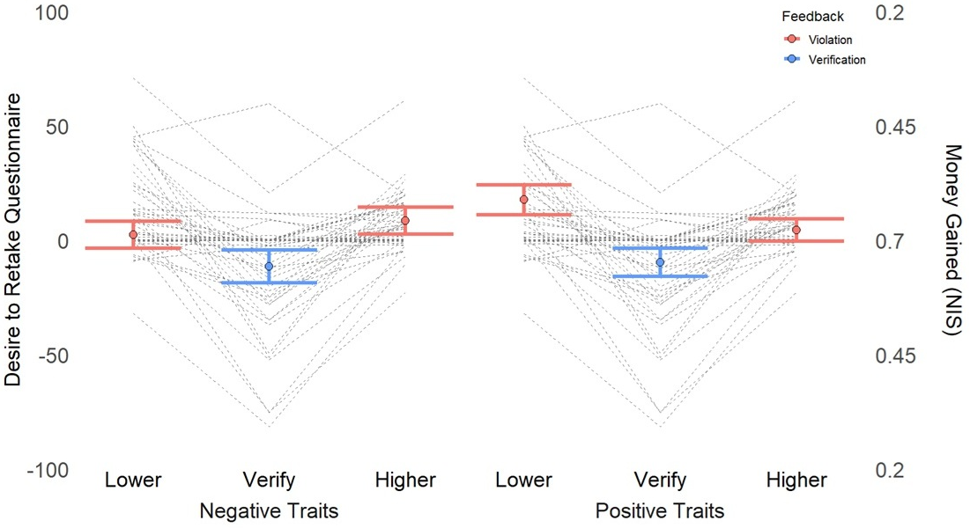
Figure 3. The main results in Study 2. Averaged data of each participant (gray dotted lines) for the main model. Facets differ between negative (left) and positive (right) traits. the Y-axis represents participants' desire to retake/avoid retaking each questionnaire such that positive values indicate a preference to retake a questionnaire and negative values represent a preference to avoid a questionnaire, corresponding to monetary values as displayed on the right y-axis. Red and blue error bars represent the mean and confidence intervals of preference in violating (lower or higher) conditions and verifying conditions respectively.

Discussion Studies 1 & 2
The results of Studies 1 & 2 (and replication Study S4) demonstrate that participants are willing to forgo money to retake questionnaires providing self-violating feedback and avoid retaking questionnaires providing verifying feedback, in contrast to the predictions of the self-verification theory. Interestingly, these results are also inconsistent with self-enhancement: within violating questionnaires, participants preferred to retake negatively violating ones as evident in Study 1 and partially in Study 2 (significant only for positive traits); within verifying questionnaires, in Study 1, participants preferred to avoid positively verifying ones more than non-positively verifying questionnaires.
One potential interpretation of these results could be that participants wanted to correct the violating questionnaires to subsequently receive more verification or more positive evaluations, while avoiding tampering with already verifying questionnaires. This interpretation would be consistent with a combined effect of self-verification and self-enhancement (Swann et al., 1989; Szumowska et al., 2023). However, a potential competing interpretation may relate to the instrumental value of these choices. Specifically, self-violating evaluations could arouse curiosity to learn about the self from a surprising evaluation. While self-verification supports maintaining a model of the self and a predictable world, self-learning supports the opposite motivation of updating the self-model to make it more accurate. Study 3 aimed to arbitrate between these competing interpretations.
Study 3 – Mouse Tracking
Overview
Study 3 aimed to pit participants' motivation to self-verify with the motivation to self-learn (while avoiding the potential for self-verifying correction) by applying a forced choice between two feedback sources across many traits. One source included feedback from a supposedly validated trained algorithm that integrates responses to trait questionnaires to a single trait rating. The other source was participants’ own self-rating on the trait. To measure the conflict between feedback preferences, we tracked the participants' mouse trajectories on their way to the chosen option. In line with past mouse tracking studies (O’Hora et al., 2016), a motivational pull of one source of information should impact the mouse trajectory from the starting to the ending point. Specifically, a curved or otherwise non-straight line indicates a conflict between the chosen response and its alternative.
To characterize the motivational conflict, we introduced monetary incentives and measured mouse trajectories under two different conditions. In the neutral condition, both choice options were worth an equal amount of money. In the incentivized condition, one of the options was worth more money than the other. Observing a motivational pull for one option when the other option is incentivized would indicate a motivational preference for that option.
Specific details of study conditions and relevant mouse tracking specifications (screen size, mouse speed, etc.) are available in the supplementary materials (S3.1). Data was collected in the lab between 19/04/2023 and 18/05/2023. The study was conducted using Gorilla, approved by the Department of Psychology ethical committee, and pre-registered via OSF (https://osf.io/b67mk?view_only=b3ec3d3ebed54348959127af0b7360c5).
Participants
Participants were recruited as in Study 1. Two additional inclusion criteria were added: being right-handed and having normal color vision. After excluding 18 participants according to pre-registered criteria (see S3.2), the final analyzable sample included 50 participants (Mean_{age} = 23.9, SD = 1.29, range 21-27; 90% identified as women and the rest as men), meeting our pre-registered goal in line with studies using similar methods (Freeman, 2014; Schneider et al., 2015). All participants identified as Israelis, and 76% also identified as Jewish.
Materials
The traits used as stimuli were similar to the traits used in Studies 1 & 2 (see full trait list in S3.3). Participants answered three questionnaires for exploratory pre-registered analyses searching for mediating variables: RSE (Rosenberg, 1965), Self-Concept Clarity (SCC; Campbell, 1996), and Intrapersonal Curiosity (IpC; Litman et al., 2017). As they have not revealed any consistent or significant results they are elaborated only in the supplementary materials (S3.6).
Procedure
After arriving to the lab and signing an informed consent, participants rated themselves on 42 traits, 27 positive and 15 negative traits. Participants rated themselves on each trait using 4 scales: self-rating (i.e., "How shy are you?"), importance (i.e., "How central is shyness to who you are?"), satisfaction (i.e., "How satisfied are you with your self-ratings concerning shyness?"), and confidence (i.e., "How confident are you in your self-ratings concerning shyness?") in this fixed order. Then, participants completed a mouse-tracking paradigm (see Figure 4). In each trial, participants chose between receiving their own self-rating on a trait (i.e., self-maintaining), or receiving a trait score calculated by a (ostensibly) validated algorithm (i.e., self-learning). The feedback was always said to be provided after the conclusion of the study (see below). The choice buttons were placed on the top right and top left corners of the screen (for accurate dimensions and grid locations see S3.1) and their location was fixed throughout the whole study (counterbalanced between participants). Each trial started with a display of the choice buttons and the trial-specific trait in the middle-bottom of the screen, with a "Go" button below to ensure all trials start with the cursor at the same position. The trial started when the "Go" button was clicked; participants were instructed to initiate mouse movement as quickly as possible and that they have a limited time to make their choice. Participants had 750 ms to initiate mouse movement and 2 seconds to click on a choice. Both times were determined according to a systematic-review examining mouse-tracking methodological specifications (Schoemann et al. 2021) and adjusted to accommodate to the current study's demands. Participants completed 6 practice trials with feedback on initiating or choosing to late and continued only after succeeding in each trial. In total, 11 trials (0.003%) were terminated for failing either one of the time limits, and there were no more than 2 failed trials per participant.
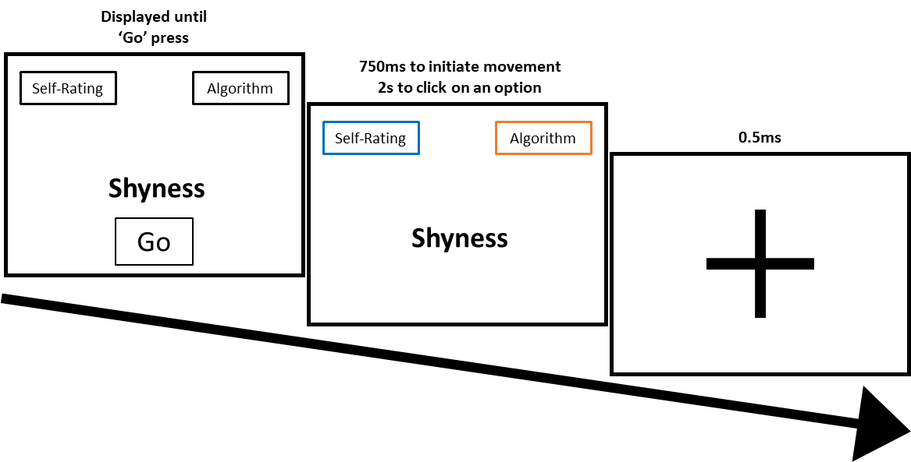
Figure 4. An example of a trial in Study 3. Participants saw the choice option (fixed throughout the study, order counterbalanced between participants) and the trait (e.g. 'Shyness'). Once they pressed the 'Go' button, the perimeter colors of the choice options changes to one of three pre-trained colors indicating an option is more valuable, less valuable or equal; color meaning was counterbalanced between participants. Participants had to initiate mouse movement with 750ms and choose within 2 seconds. After choosing, a fixation-cross screen appeared before starting over the next trial. Exceeding the time limits in the second screen led to termination of the screen a warning explaining what was wrong before being forwarded to the fixation-cross screen. Screen proportions are for illustration purposes only and do not match the real display proportions in the study, elaborated in S3.1.
Importantly, as the participants clicked "Go" and the trial started, the outlines of the choice buttons were colored (either blue, orange or purple). The color coding indicated the amount of money that the choice button added to the final bonus (color coding was counterbalanced between participants). In non-incentivized trials (n_{trials}=14), both choices had the same monetary value (0.5 NIS ~ 0.13 USD) and were colored in the same color. In incentivized trials (n_{trials}=28, equally distributed between choices), one choice was worth more (0.7 NIS ~ 0.19 USD) than the other (0.2 NIS ~ 0.05 USD) with the two options colored differently. Within each set of 14 trials, 9 traits were positive and 5 were negative. Participants were told that a random subset of their choices would be added to a monetary bonus they would receive after the study.
After completing the mouse-tracking paradigm, participants answered the RSE, SCC, and IpC scales, and a demographic questionnaire. Before leaving the lab, participants answered semi-structured gradual open-ended question probes concerning the perceived aim of the study. Finally, participants were debriefed and later paid via an online application.
Analysis
Mouse tracking data was preprocessed according to standard procedure (Freeman, 2014; Freeman & Ambady, 2010; Wulff et al., 2021; see S3.4). To identify the prevailing motivation for each participant, we conducted a logistic generalized linear mixed model using the logit link with the choice (self or algorithm) as the dependent variable with a general intercept as a fixed effect and random intercepts for participants. This analysis included only the non-incentivized condition where only the information should affect participants’ choices.
Other analyses that measured the degree of conflict between motivations used three well-established mouse-tracking paradigm dependent variables: Maximum Absolute Deviation (MAD), Area Under the Curve (AUC), and Reaction Time (RT). To account for conducting three models for each hypothesis, we used the Bonferroni correction, setting α = 0.0167. Additionally, these models were examined separately for the incentivized and the non-incentivized conditions. Within the incentivized trials, we report the analyses for trials in which the profitable option was chosen, as pre-registered (see S3.6 for analyses of the trials in which the non-profitable option was chosen).
As the independent variable in our models is the participant's choice, which is measured rather than manipulated, we deviated from the pre-registration (following the advice of a statistician) and calculated two separate predictors allowing us to model the participants subjective choice bias. We separated the variable choice (learn or verify, coded as 1 or 0 respectively) into two predictors. The first was the between-subject factor (centered), which accounts for each participant's general tendency towards one option (the participant's choice proportion). The second variable was the participant's choice in a specific trial (within-person fluctuations), over the participant's general tendency, calculated by subtracting the choice from the person-mean center (Bell & Jones, 2015; Mundlak, 1978).
We used mixed linear models, one for each of the dependent variables. The models included the three fixed effects of the between-subject factor, the within-subject factor, and their interaction and four random effects: random intercepts for participants and traits, a random slope of the between-subject factor for traits, and a random slope for the within-subject factor for participants. We deviated from the pre-registration by modeling the actual choice as fixed effects rather than the congruency of the choice with the participant's prevailing motivation as a vast majority of the participants displayed 'learning' as their prevailing motivation (see Results section). An additional analysis examined within-subject differences by examining trait ratings (i.e., self- rating, importance, satisfaction and confidence), and between-subject differences using the RSE, SCC and IpC scales as moderatos (See S3.6).
Results
When faced with the choice between learning and verifying, participants chose to learn (coded as 1) most of the time, both when there was no monetary difference between the choices, and even when learning meant receiving less money (Table 4; odds.ratio = 3.158, SE = 0.52, z = 6.753, p < .001). Exploring the random intercept showed that 49 out of the 50 participants preferred learning over verifying, and the only participant who preferred verifying did so by a small margin (8 choices to verify out of 14 trials).
Table 4
Choice distribution between verifying and learning
 | Incentivized |  | Non-Incentivized
 | Loss | Profit | Non-Incentivized
Verify | 60 | 181 | 75
Learn | 516 | 638 | 620
Note. The Loss and Profit choices are complementary as at a given incentivized trial choosing one inherently means the other was not chosen. Non-incentivized choices stand on their own.
As for the amount of conflict, we report only the AUC given the consistency between the models predicting both MAD, AUC and RT and its high correlation with MAD (non-incentivized trials: r = 0.941, p < .001; incentivized trials: r = 0.968, p < .001; see MAD and RT models in S3.4). As AUC denoted the area under the curve above the direct path, larger AUC scores represent a larger conflict when making a choice, e.g., as plotted in Figure 5 (panels A&B).
Participants who generally chose to verify more, over all trials, displayed more conflict as evidenced by a larger AUC (non-incentivized trials: β = -0.308, SE = 0.09, t_{(51.55)} = -3.14, p < .01; incentivized trials: β = -0.487, SE = 0.06, t_{(49.52)} = -7.25, p < .001; see figure 5, panels C&D, x-axis: Between participant differences). Moreover, when looking at participants' choices trial by trial, choosing to verify caused more conflict over the participants' general choice tendency (non-incentivized trials: β = -0.391, SE = 0.08, t_{(22.06)} = -4.59, p < .001; incentivized trials: β = -0.256, SE = 0.06, t_{(31.94)} = -4.13, p < .001; see figure 5, panels C&D color grouping: Within participant deviations). In both models, there was no significant interaction between the within and between person factors (non-incentivized trials: β = -0.447, SE = 0.36, t_{(19.52)} = -1.21, p = .238; incentivized trials: β = -0.488, SE = 0.36, t_{(26.66)} = 1.33, p = .192). Together, these results suggest that (a) participants chose to learn far more than to receive a self-verifying input, and, importantly, that participants experienced a smaller conflict when choosing to learn both (b) between and (c) within participants.

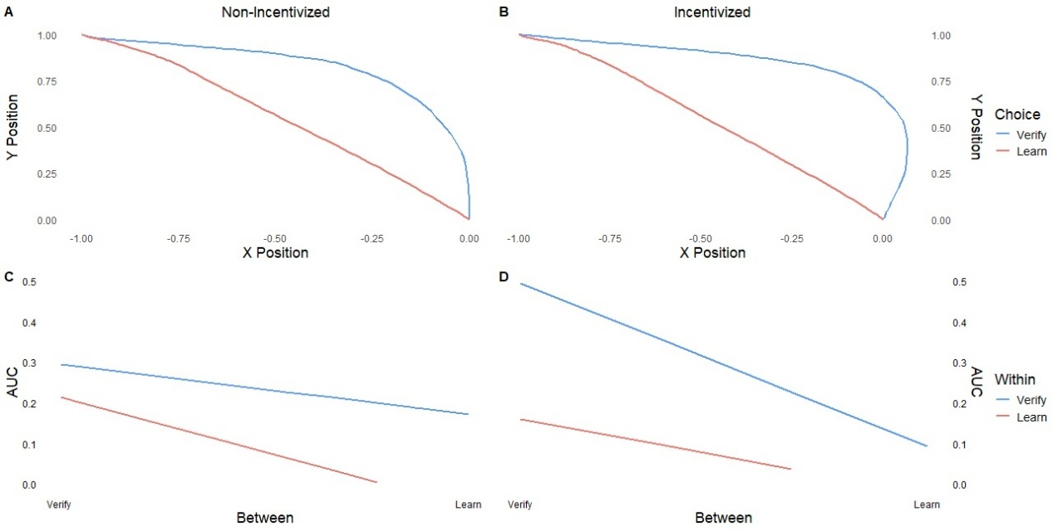Figure 5. Results of Study 3. The aggregated mouse trajectories in the (A) non-incentivized and (B) the incentivized trials in which the profitable option was chosen, and the predicted AUC estimated by the models for (C) non-incentivized and (D) incentivized trials in which the profitable option was chosen. In the top panels (A&B), the y-axis and x-axis represent the mouse position along the time of the trial from the start of the trial (bottom middle of the screen, represented by the coordinates [0,0]) until the choice was made. The color grouping represents the choice that was made. In the bottom panels (C&D), the y-axis represents the AUC. The x-axis ("Between") represents the between participant variable, meaning participants who chose learning more times would be further on the right. The colors represent the Within-participant deviation, that is trials in which participants chose to verify or learn as a deviation from their own general tendency. Blue represents a choice to verify and red represents a choice to learn. The interactions between the Between-factor and the Within-factor did not reach statistical significance (p > .19).

General Discussion
Do individuals prefer to interact with self-verifying, self-enhancing or generally self-inconsistent information? Across three pre-registered studies (and two replication studies; see S4 & S5) we found that participants robustly prefer to interact with self-evaluations that contradicted (Studies 1, 2, & S4) or could potentially contradict (Studies 3 & S5) their own self-assessments. These preferences manifested as willingness to forgo money and reduced conflict when engaging with violating evaluations. Specifically, participants forwent money to (a) retake self-violating questionnaires, especially negatively violating ones, and (b) receive evaluations from a validated algorithm potentially providing self-violations.
These findings stand in apparent contrast to prominent theories predicting that healthy individuals would prefer self-verifying or self-enhancing feedback and evaluations (Sedikides & Gregg, 2008; Swann, 2011; Taylor & Brown, 1988). Indeed, past investigations found that people prefer to seek, interact with, learn, and update (non-central) self-consistent or self-enhancing (i.e., positively violating) feedback (Elder et al., 2022; García-Arch et al., 2025). In stark contrast, our findings (replicated across a total of five studies, total N = 266) indicate a robust preference for interaction with sources of feedback that violate self-perceptions, particularly with sources that provided negatively violating feedback.
One interpretation of the choices participants made in our study lies in their potential utility. An information-seeking perspective (Sharot & Sunstein, 2020) suggests that information that allows one to learn and refine their model of the world would have instrumental utility. In the context of the self, information that allows one to learn is, by definition, information that violates their current self-perception. Indeed, in our studies, participants displayed a greater desire to re-interact with an evaluating source that felt the least accurate. This preference for inaccuracy suggests a motivation for seeking novel information (i.e., curiosity) and perhaps even a desire to learn about the self (particularly as the feedback was not extremely inaccurate to be interpreted as unrealistic; Kube et al., 2022). Notably, most research on self-relevant information seeking has focused on self-verification and self-enhancement theories, testing and comparing people's value of either information that has cognitive utility (i.e., information that helps understand the world around us) or hedonic utility (i.e., information that helps us feel good), respectively. The settings of our studies may have emphasized the instrumental utility of the information over cognitive and hedonic utilities, leading to the current results.
One feature of the current investigation that may explain why these results depart from prior findings concerns the type of evaluator providing self-relevant feedback. Past studies focused on interactions with specific human evaluators that produced a motivation-consistent evaluation (Bosson & Swann, 1999; Swann & Read, 1981a). Our studies, in contrast, provided participants with the opportunity to receive self-verifying or self-violating information from a non-human source (questionnaires in Studies 1 & 2, an algorithm in Study 3). Detaching the social interaction from the information could have allowed our participants to more freely express a motivation to engage with potentially novel information. Importantly, our evaluations were always tailored to specific traits (see Bosson & Swann., 1999), potentially further boosting the informational utility of the feedback. With the increasing prevalence of large language models-generated advice, exploring the impact of non-human (versus human) informational sources on self-related information processing is becoming ever more important.
Our results seemingly contrast with several recent papers that demonstrated that individuals show a self-verifying and self-enhancing bias in information processing (Elder et al., 2023; García-Arch et al., 2024, 2025; Korn et al., 2012). These studies focused on the updating of the self-concept and measured the integration of information. In contrast, the current studies report initial information seeking preferences for self-learning. These preferences impact what information will be processed before it can be integrated with the self-concept. The contribution of the sought-after information to subsequent self-verification and updating remains a challenge for future studies.
Although the current set of findings present consistent and robust results across five studies, a notable limitation is that all studies included samples of healthy young undergraduates. As this population constantly engages in learning in an academic setting, it is likely that they are more motivated to learn about themselves than the general population. In addition, these data were collected through a series of global and national major events (the peak of the COVID-19 pandemic, protests against major judicial reform in Israel, and the 'Iron Swords' war in Gaza). Each of these events could have impacted the self-perceptions of our participants and their motivations. However, if it did, the consistency across studies suggests that it impacted these perceptions in a similar fashion across different (potentially threatening) contexts, further highlighting the robustness of these findings.
Complementing perspectives that highlight the multiple motivational sources driving self-relevant information-seeking (García-Arch et al., 2025; Swann et al., 1989; Szumowska et al., 2023), we robustly demonstrate that participants can be primarily driven to interact with informational sources providing self-inaccurate feedback. To date, the motivation to learn and pursue self-inaccurate feedback has received scant theoretical and empirical scrutiny despite its high relevance for everyday life. Understanding the contexts in which people are motivated to learn about themselves and potentially update their self-concept could, for example, aid therapists who try to help people change and better their self-concept. Furthermore, given the ever-increasing availability of non-human sources of feedback, the current investigation provides a timely first step in studying the impact of these sources on information seeking behaviors. Characterizing when, why, and to what extent individuals prefer self-inaccurate information that may foster self-updating behaviors promises to open a fruitful avenue of research that may benefit both theoretical and applied perspectives of self-related behaviors.

Anwyl-Irvine, A. L., Massonnié, J., Flitton, A., Kirkham, N., & Evershed, J. K. (2020). Gorilla in our midst: An online behavioral experiment builder. Behavior Research Methods, 52(1), 388–407. https://doi.org/10.3758/s13428-019-01237-x
Armony-Sivan, R., Cojocaru, L., & Babkoff, H. (2013). Affective norms for Hebrew words (E-millim): Instruction manual and affecting ratings. Ashkelon Academic College.
Bell, A., & Jones, K. (2015). Explaining Fixed Effects: Random Effects Modeling of Time-Series Cross-Sectional and Panel Data. Political Science Research and Methods, 3(1), 133–153. https://doi.org/10.1017/psrm.2014.7
Bosson, J. K., & Swann, W. B. (1999). Self-Liking, Self-Competence, and the Quest for Self-Verification. Personality and Social Psychology Bulletin, 25(10), 1230–1241. https://doi.org/10.1177/0146167299258005
Bromberg-Martin, E. S., & Sharot, T. (2020). The Value of Beliefs. Neuron, 106(4), 561–565. https://doi.org/10.1016/j.neuron.2020.05.001
Campbell, J. D. (1996). Self-concept clarity: Measurement, personality correlates, and cultural boundaries. Journal of Personality and Social Psychology, 70(1), 141. https://doi.org/10.1037/0022-3514.70.1.141
Charpentier, C. J., Bromberg-Martin, E. S., & Sharot, T. (2018). Valuation of knowledge and ignorance in mesolimbic reward circuitry. Proceedings of the National Academy of Sciences of the United States of America, 115(31), E7255–E7264. https://doi.org/10.1073/pnas.1800547115
Elder, J., Davis, T. H., & Hughes, B. L. (2023). A Fluid Self-Concept: How the Brain Maintains Coherence and Positivity across an Interconnected Self-Concept While Incorporating Social Feedback. The Journal of Neuroscience, 43(22), 4110–4128. https://doi.org/10.1523/JNEUROSCI.1951-22.2023
Elder, J., Davis, T., & Hughes, B. L. (2022). Learning About the Self: Motives for Coherence and Positivity Constrain Learning From Self-Relevant Social Feedback. Psychological Science, 33(4), 629–647. https://doi.org/10.1177/09567976211045934
Epstein, S. (1973). The self-concept revisited. Or a theory of a theory. The American Psychologist, 28(5), 404–416. https://doi.org/10.1037/h0034679
Freeman, J. B. (2014). Abrupt category shifts during real-time person perception. Psychonomic Bulletin & Review, 21(1), 85–92. https://doi.org/10.3758/s13423-013-0470-8
Freeman, J. B., & Ambady, N. (2010). MouseTracker: Software for studying real-time mental processing using a computer mouse-tracking method. Behavior Research Methods, 42(1), 226–241. https://doi.org/10.3758/BRM.42.1.226
García-Arch, J., Friedrich, S., Wu, X., Cucurell, D., & Fuentemilla, L. (2024). Beyond the Positivity Bias: The Processing and Integration of Self-Relevant Feedback Is Driven by Its Alignment With Pre-Existing Self-Views. Cognitive Science, 48(11), e70017. https://doi.org/10.1111/cogs.70017
García-Arch, J., Sabio-Albert, M., & Fuentemilla, L. (2025). Selective Integration of Social Feedback Promotes a Stable and Positively Biased Self-Concept. Scandinavian Journal of Psychology, n/a(n/a). https://doi.org/10.1111/sjop.13113
Hohwy, J., & Michael, J. (2017). Why Should Any Body Have a Self? In F. Vignemont, De & A. J. T. Alsmith (Eds.), The Subject’s Matter: Self-Consciousness and the Body (pp. 364–387). The MIT Press. https://doi.org/10.7551/mitpress/10462.003.0020
Korn, C. W., Prehn, K., Park, S. Q., Walter, H., & Heekeren, H. R. (2012). Positively Biased Processing of Self-Relevant Social Feedback. Journal of Neuroscience, 32(47), 16832–16844. https://doi.org/10.1523/JNEUROSCI.3016-12.2012
Kruglanski, A. W., Jasko, K., & Friston, K. (2020). All Thinking is ‘Wishful’ Thinking. Trends in Cognitive Sciences, 24(6), 413–424. https://doi.org/10.1016/j.tics.2020.03.004
Kruglanski, A. W., Jasko, K., Milyavsky, M., Chernikova, M., Webber, D., Pierro, A., & di Santo, D. (2018). Cognitive Consistency Theory in Social Psychology: A Paradigm Reconsidered. Psychological Inquiry, 29(2), 45–59. https://doi.org/10.1080/1047840X.2018.1480619
Kube, T., Kirchner, L., Lemmer, G., & Glombiewski, J. A. (2022). How the Discrepancy Between Prior Expectations and New Information Influences Expectation Updating in Depression—The Greater, the Better? Clinical Psychological Science, 10(3), 430–449. https://doi.org/10.1177/21677026211024644
Kube, T., & Rozenkrantz, L. (2021). When Beliefs Face Reality: An Integrative Review of Belief Updating in Mental Health and Illness. Perspectives on Psychological Science, 16(2), 247–274. https://doi.org/10.1177/1745691620931496
Kuzmanovic, B., Jefferson, A., & Vogeley, K. (2016). The role of the neural reward circuitry in self-referential optimistic belief updates. NeuroImage, 133, 151–162. https://doi.org/10.1016/j.neuroimage.2016.02.014
Kwang, T., & Swann, W. B. (2010). Do people embrace praise even when they feel unworthy? A review of critical tests of self-enhancement versus self-verification. Personality and Social Psychology Review, 14(3), 263–280. https://doi.org/10.1177/1088868310365876
Lefebvre, G., Lebreton, M., Meyniel, F., Bourgeois-Gironde, S., & Palminteri, S. (2017). Behavioural and neural characterization of optimistic reinforcement learning. Nature Human Behaviour, 1(4), Article 4. https://doi.org/10.1038/s41562-017-0067
Litman, J. A., Robinson, O. C., & Demetre, J. D. (2017). Intrapersonal curiosity: Inquisitiveness about the inner self. Self and Identity, 16(2), 231–250. https://doi.org/10.1080/15298868.2016.1255250
Löwe, B., Kroenke, K., & Gräfe, K. (2005). Detecting and monitoring depression with a two-item questionnaire (PHQ-2). Journal of Psychosomatic Research, 58(2), 163–171. https://doi.org/10.1016/j.jpsychores.2004.09.006
Maheshwari, S., Kurmi, R., & Roy, S. (2021). Does memory bias help in maintaining self-esteem? Exploring the role of self-verification motive in memory bias. Journal of Cognitive Psychology, 33(5), 549–556. https://doi.org/10.1080/20445911.2021.1926466
Manea, L., Gilbody, S., Hewitt, C., North, A., Plummer, F., Richardson, R., Thombs, B. D., Williams, B., & McMillan, D. (2016). Identifying depression with the PHQ-2: A diagnostic meta-analysis. Journal of Affective Disorders, 203, 382–395. https://doi.org/10.1016/j.jad.2016.06.003
Markant, D. (2025). Self-verification and the perceived reliability of uncertain feedback sources. Proceedings of the Annual Meeting of the Cognitive Science Society, 47(0). https://escholarship.org/uc/item/1k36p7ck
Mead, G. H. (1934). Mind, Self, and Society from the Standpoint of a Social Behaviorist. Chicago, IL: University of Chicago Press.
Mokady, A., & Reggev, N. (2022). The Role of Predictions, Their Confirmation, and Reward in Maintaining the Self-Concept. Frontiers in Human Neuroscience, 16. https://doi.org/10.3389/fnhum.2022.824085
Mundlak, Y. (1978). On the Pooling of Time Series and Cross Section Data. Econometrica, 46(1), 69–85. https://doi.org/10.2307/1913646
O’Hora, D., Carey, R., Kervick, A., Crowley, D., & Dabrowski, M. (2016). Decisions in Motion: Decision Dynamics during Intertemporal Choice reflect Subjective Evaluation of Delayed Rewards. Scientific Reports, 6(1), Article 1. https://doi.org/10.1038/srep20740
Reggev, N., Chowdhary, A., & Mitchell, J. P. (2021). Confirmation of interpersonal expectations is intrinsically rewarding. Social Cognitive and Affective Neuroscience, 16(12), 1276–1287. https://doi.org/10.1093/scan/nsab081
Rosenberg, M. (1965). Society and the adolescent self-image. Princeton University Press.
Schneider, I. K., Van Harreveld, F., Rotteveel, M., Topolinski, S., Van Der Pligt, J., Schwarz, N., & Koole, S. L. (2015). The path of ambivalence: Tracing the pull of opposing evaluations using mouse trajectories. Frontiers in Psychology, 6. https://doi.org/10.3389/fpsyg.2015.00996
Sedikides, C. (1993). Assessment, Enhancement, and Verification Determinants of the Self-Evaluation Process. Journal of Personality and Social Psychology, 65(2), 317–338. https://doi.org/10.1037/0022-3514.65.2.317
Sedikides, C., & Green, J. D. (2000). On the self-protective nature of inconsistency-negativity management: Using the person memory paradigm to examine self-referent memory. Journal of Personality and Social Psychology, 79(6), 906–922. https://doi.org/10.1037/0022-3514.79.6.906
Sedikides, C., & Gregg, A. P. (2008). Self-Enhancement: Food for Thought. Perspectives on Psychological Science, 3(2), 102–116. https://doi.org/10.1111/j.1745-6916.2008.00068.x
Sharot, T., & Garrett, N. (2016). Forming Beliefs: Why Valence Matters. Trends in Cognitive Sciences, 20(1), 25–33. https://doi.org/10.1016/j.tics.2015.11.002
Sharot, T., & Sunstein, C. R. (2020). How people decide what they want to know. Nature Human Behaviour, 4(1), Article 1. https://doi.org/10.1038/s41562-019-0793-1
Swann, W. B. (2011). Self-Verification Theory. In P. A. M. Van Lange & A. W. Kruglanski (Eds.), Handbook of Theories of Social Psychology (pp. 23–42). SAGE Publications Ltd. https://doi.org/10.4135/9781446249222.n27
Swann, W. B., De La Ronde, C., & Hixon, J. G. (1994). Authenticity and Positivity Strivings in Marriage and Courtship. Journal of Personality and Social Psychology, 66(5), 857–869. https://doi.org/10.1037/0022-3514.66.5.857
Swann, W. B., Pelham, B. W., & Krull, D. S. (1989). Agreeable Fancy or Disagreeable Truth? Reconciling Self-Enhancement and Self-Verification. Journal of Personality and Social Psychology, 57(5), 782–791. https://doi.org/10.1037/0022-3514.57.5.782
Swann, W. B., & Read, S. J. (1981a). Acquiring self-knowledge: The search for feedback that fits. Journal of Personality and Social Psychology, 41(6), 1119–1128. https://doi.org/10.1037/0022-3514.41.6.1119
Swann, W. B., & Read, S. J. (1981b). Self-verification processes: How we sustain our self-conceptions. Journal of Experimental Social Psychology, 17(4), 351–372. https://doi.org/10.1016/0022-1031(81)90043-3
Szumowska, E., Szwed, P., Wójcik, N., & Kruglanski, A. W. (2023). The interplay of positivity and self-verification strivings: Feedback preference under increased desire for self-enhancement. Learning and Instruction, 83, 101715. https://doi.org/10.1016/j.learninstruc.2022.101715
Tamir, D. I., & Mitchell, J. P. (2012). Disclosing information about the self is intrinsically rewarding. Proceedings of the National Academy of Sciences of the United States of America, 109(21), 8038–8043. https://doi.org/10.1073/pnas.1202129109
Taylor, S. E., & Brown, J. D. (1988). Illusion and Well-Being: A Social Psychological Perspective on Mental Health. Psychological Bulletin, 103(2), 193–210. https://doi.org/10.1037/0033-2909.103.2.193
Van de Cruys, S., & Van Dessel, P. (2021). Mental distress through the prism of predictive processing theory. Current Opinion in Psychology, 41, 107–112. https://doi.org/10.1016/j.copsyc.2021.07.006
Woźniak, M., van Buuren, M., & Tacikowski, P. (2025). Editorial: Self-concept plasticity: behavioral and neural evidence. Frontiers in Human Neuroscience, 19. https://doi.org/10.3389/fnhum.2025.1584910
Wulff, D. U., Kieslich, P. J., Henninger, F., Haslbeck, J., & Schulte-Mecklenbeck, M. (2021). Movement tracking of cognitive processes: A tutorial using mousetrap. PsyArXiv. https://doi.org/10.31234/osf.io/v685r

Cohen's D was approximated by conversions from t values using 't_to_d' function from the 'effectsize' r package with the formula $d_{z}=t/{\sqrt{{df}_{error}}}$

