Supplementary Information
Table S1. ﻿List of coupled climate models from the CMIP6 and SPEAR simulation archive analyzed in this study, along with the realization, variables, and rank for pattern correlation of runoff with observation over Upper Colorado River Basin. Black dots indicate the variable is publicly available. PR is precipitation. RUNF is total runoff (or the “mrro” in CMIP6 archive). TAS is surface air temperature. SNW is snow amount. EP is evapotranspiration.
 | Model name | corr. rank | historical | SSP585 | PR | RUNF | TAS | SNW | EP
1 | ACCESS-CM2 | 39 | r1i1p1f1 | r1i1p1f1 | • | • | • | • | •
2 | ACCESS-ESM1-5 | 37 | r1i1p1f1 | r1i1p1f1 | • | • | • | • | •
3 | BCC-CSM2-MR | 41 | r1i1p1f1 | r1i1p1f1 | • | • | • | • | •
4 | CanESM5 | 35 | r1i1p1f1 | r1i1p1f1 | • | • | • | • | •
5 | CESM2 | 17 | r1i1p1f1 | r1i1p1f4 | • | • | • | • | •
6 | CESM2-WACCM | 18 | r1i1p1f1 | r1i1p1f1 | • | • | • | • | •
7 | CMCC-CM2-SR5 | 28 | r1i1p1f1 | r1i1p1f1 | • | • | • |  | •
8 | CMCC-ESM2 | 27 | r1i1p1f1 | r1i1p1f1 | • | • | • |  | •
9 | CNRM-CM6-1 | 9 | r1i1p1f2 | r1i1p1f2 | • | • | • | • | •
10 | CNRM-CM6-1-HR | 1 | r1i1p1f2 | r1i1p1f2 | • | • | • | • | •
11 | CNRM-ESM2-1 | 5 | r1i1p1f2 | r1i1p1f2 | • | • | • | • | •
12 | E3SM-1-0 | 23 | r1i1p1f1 | r1i1p1f1 | • | • | • | • | •
13 | EC-Earth3 | 7 | r1i1p1f1 | r1i1p1f1 | • | • | • | • | •
14 | EC-Earth3-CC | 8 | r1i1p1f1 | r1i1p1f1 | • | • | • | • | •
15 | EC-Earth3-Veg | 4 | r1i1p1f1 | r1i1p1f1 | • | • | • | • | •
16 | EC-Earth3-Veg-LR | 3 | r1i1p1f1 | r1i1p1f1 | • | • | • | • | •
17 | FGOALS-f3-L | 13 | r1i1p1f1 | r1i1p1f1 | • | • | • |  | •
18 | FGOALS-g3 | 11 | r1i1p1f1 | r1i1p1f1 | • | • | • |  | •
19 | FIO-ESM2-0 | 22 | r1i1p1f1 | r1i1p1f1 | • | • | •
20 | GFDL-CM4 | 21 | r1i1p1f1 | r1i1p1f1 | • | • | • | •
21 | GFDL-ESM4 | 14 | r1i1p1f1 | r1i1p1f1 | • | • | • | • | •
22 | GISS-E2-1-G | 6 | r1i1p1f1 | r1i1p1f2 | • | • | • | • | •
23 | GISS-E2-1-H | 10 | r1i1p1f1 | r1i1p1f2 | • | • | • | • | •
24 | HadGEM3-GC31-LL | 40 | r1i1p1f3 | r1i1p1f3 | • | • | • | • | •
25 | HadGEM3-GC31-MM | 24 | r1i1p1f3 | r1i1p1f3 | • | • | • | • | •
26 | INM-CM4-8 | 32 | r1i1p1f1 | r1i1p1f1 | • | • | • |  | •
27 | INM-CM5-0 | 38 | r1i1p1f1 | r1i1p1f1 | • | • | • |  | •
28 | IPSL-CM6A-LR | 29 | r1i1p1f1 | r1i1p1f1 | • | • | • | • | •
29 | KACE-1-0-G | 30 | r1i1p1f1 | r1i1p1f1 | • | • | •
30 | KIOST-ESM | 26 | r1i1p1f1 | r1i1p1f1 | • | • | • | •
31 | MIROC6 | 33 | r1i1p1f1 | r1i1p1f1 | • | • | • | • | •
32 | MIROC-ES2H | 34 | r1i1p4f2 | r1i1p4f3 | • | • | • | • | •
33 | MIROC-ES2L | 36 | r1i1p1f2 | r1i1p1f2 | • | • | • | • | •
34 | MPI-ESM1-2-HR | 19 | r1i1p1f1 | r1i1p1f1 | • | • | • | • | •
35 | MPI-ESM1-2-LR | 43 | r1i1p1f1 | r1i1p1f1 | • | • | • | • | •
36 | MRI-ESM2-0 | 15 | r1i1p1f1 | r1i1p1f1 | • | • | • | • | •
37 | NorESM2-LM | 42 | r1i1p1f1 | r1i1p1f1 | • | • | • | • | •
38 | NorESM2-MM | 20 | r1i1p1f1 | r1i1p1f1 | • | • | • | • | •
39 | TaiESM1 | 25 | r1i1p1f1 | r1i1p1f1 | • | • | • |  | •
40 | UKESM1-0-LL | 31 | r1i1p1f2 | r1i1p1f2 | • | • | • | •
41 | SPEAR-LO | 16 | 30 ensembles | 30 ensembles | • | • | • | • | •
42 | SPEAR-MED | 12 | 30 ensembles | 30 ensembles | • | • | • | • | •
43 | SPEAR-HI | 2 | 10 ensembles | 10 ensembles | • | • | • | • | •

Table S2. Model list for better-performing and poorer-performing groups.
Pattern correlation of runoff |  | Pattern correlation of precipitation
better performing | poorer performing | Better performing | poorer performing
MPI-ESM1-2-LR | FIO-ESM-2-0 | MPI-ESM1-2-LR | INM-CM4-8
NorESM2-LM | GFDL-CM4 | BCC-CSM2-MR | FGOALS-f3-L
BCC-CSM2-MR | NorESM2-MM | NorESM2-LM | GISS-E2-1-G
HadGEM3-GC31-LL | MPI-ESM1-2-HR | UKESM1-0-LL | NorESM2-MM
ACCESS-CM2 | CESM2-WACCM | FIO-ESM-2-0 | MIROC6
INM-CM5-0 | CESM2 | IPSL-CM6A-LR | GFDL-CM4
ACCESS-ESM1-5 | MRI-ESM2-0 | KACE-1-0-G | HadGEM3-GC31-MM
MIROC-ES2L | GFDL-ESM4 | CanESM5 | MPI-ESM1-2-HR
CanESM5 | FGOALS-f3-L | KIOST-ESM | GFDL-ESM4
MIROC-ES2H | FGOALS-g3 | TaiESM1 | CNRM-CM6-1
MIROC6 | GISS-E2-1-H | CMCC-ESM2 | CNRM-ESM2-1
INM-CM4-8 | CNRM-CM6-1 | CMCC-CM2-SR5 | ACCESS-ESM1-5
UKESM1-0-LL | EC-Earth3-CC | MIROC-ES2L | CESM2-WACCM
KACE-1-0-G | EC-Earth3 | HadGEM3-GC31-LL | EC-Earth3-Veg-LR
IPSL-CM6A-LR | GISS-E2-1-G | MIROC-ES2H | EC-Earth3
CMCC-CM2-SR5 | CNRM-ESM2-1 | ACCESS-CM2 | CESM2
CMCC-ESM2 | EC-Earth3-Veg | FGOALS-g3 | EC-Earth3-Veg
KIOST-ESM | EC-Earth3-Veg-LR | MRI-ESM2-0 | EC-Earth3-CC
TaiESM1 | SPEAR-HI | INM-CM5-0 | SPEAR-HI
HadGEM3-GC31-MM | CNRM-CM6-1-HR | GISS-E2-1-H | CNRM-CM6-1-HR

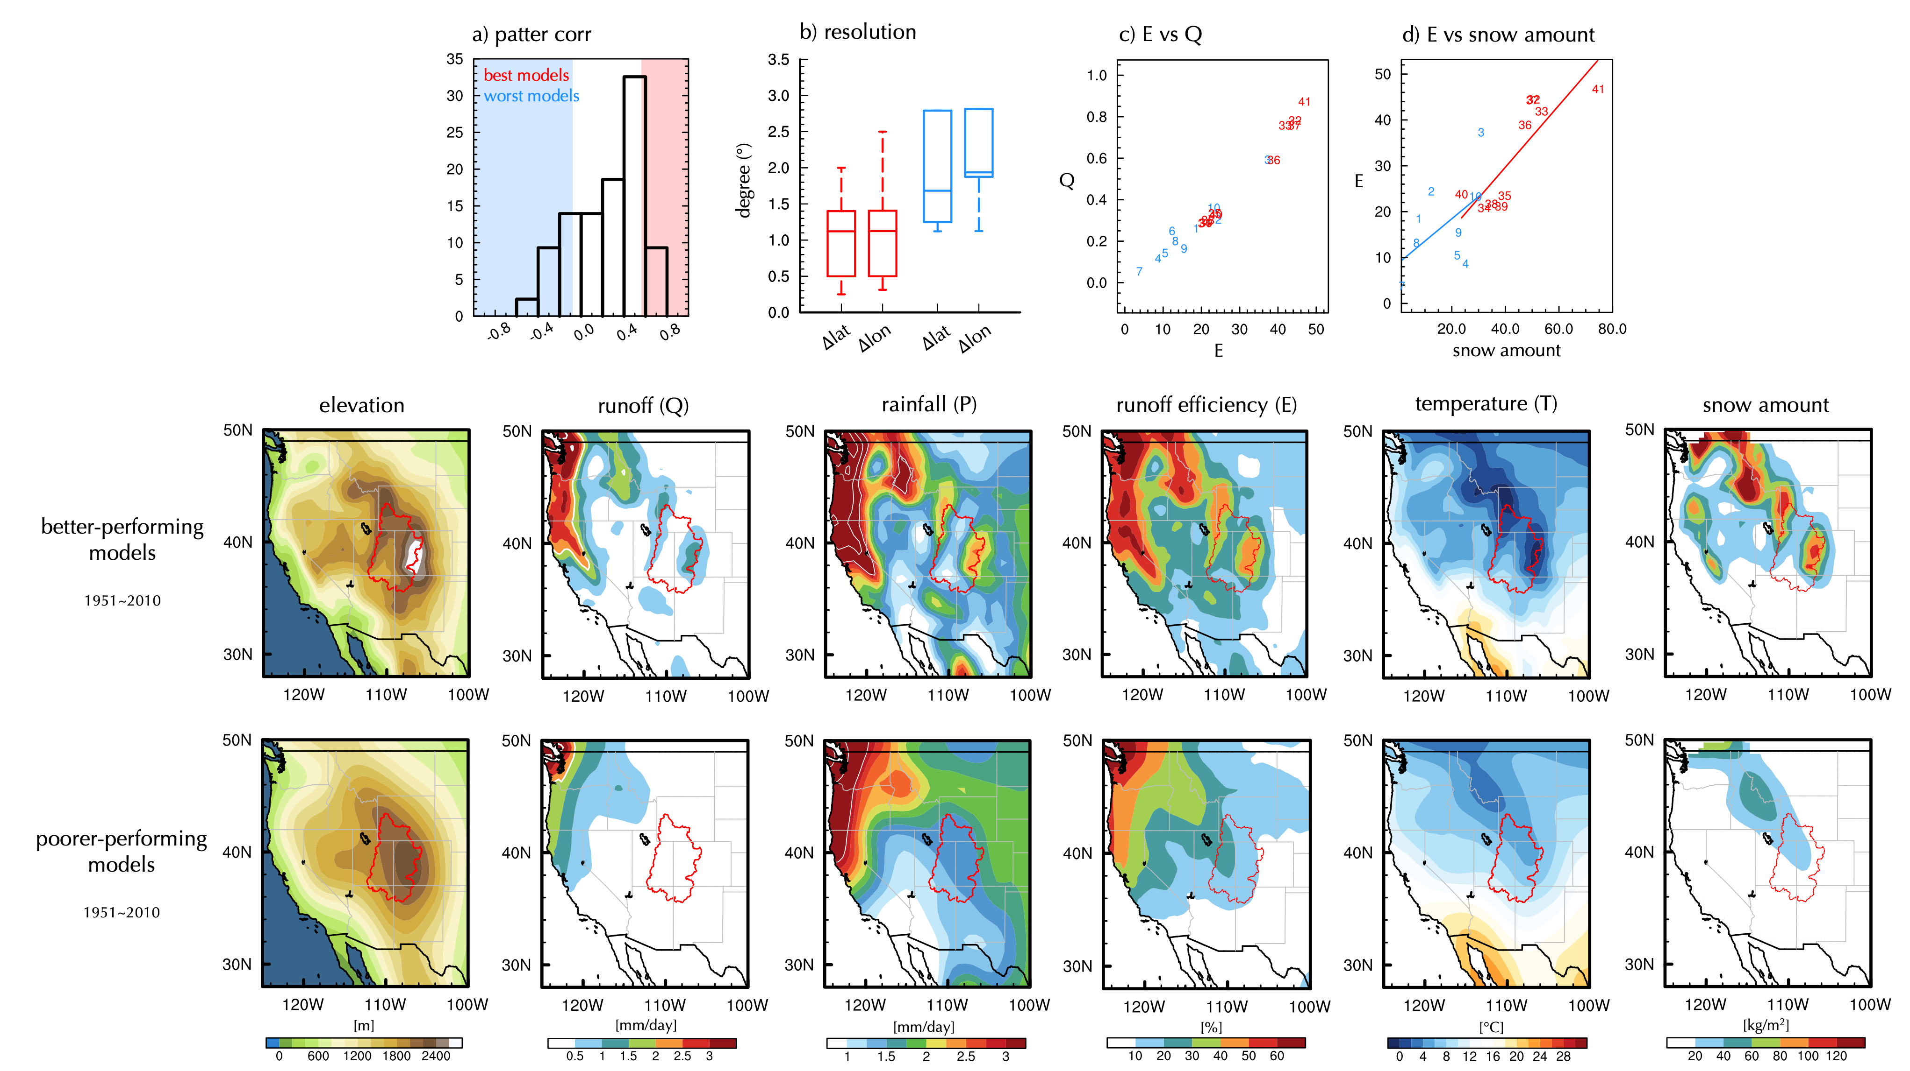
Figure S1. ﻿As Figure 2, but for the 10 best models (i.e., the 10 models that have the highest pattern correlation over UCRB) and the 10 worst models (i.e., the 10 models that have the lowest pattern correlation over UCRB).

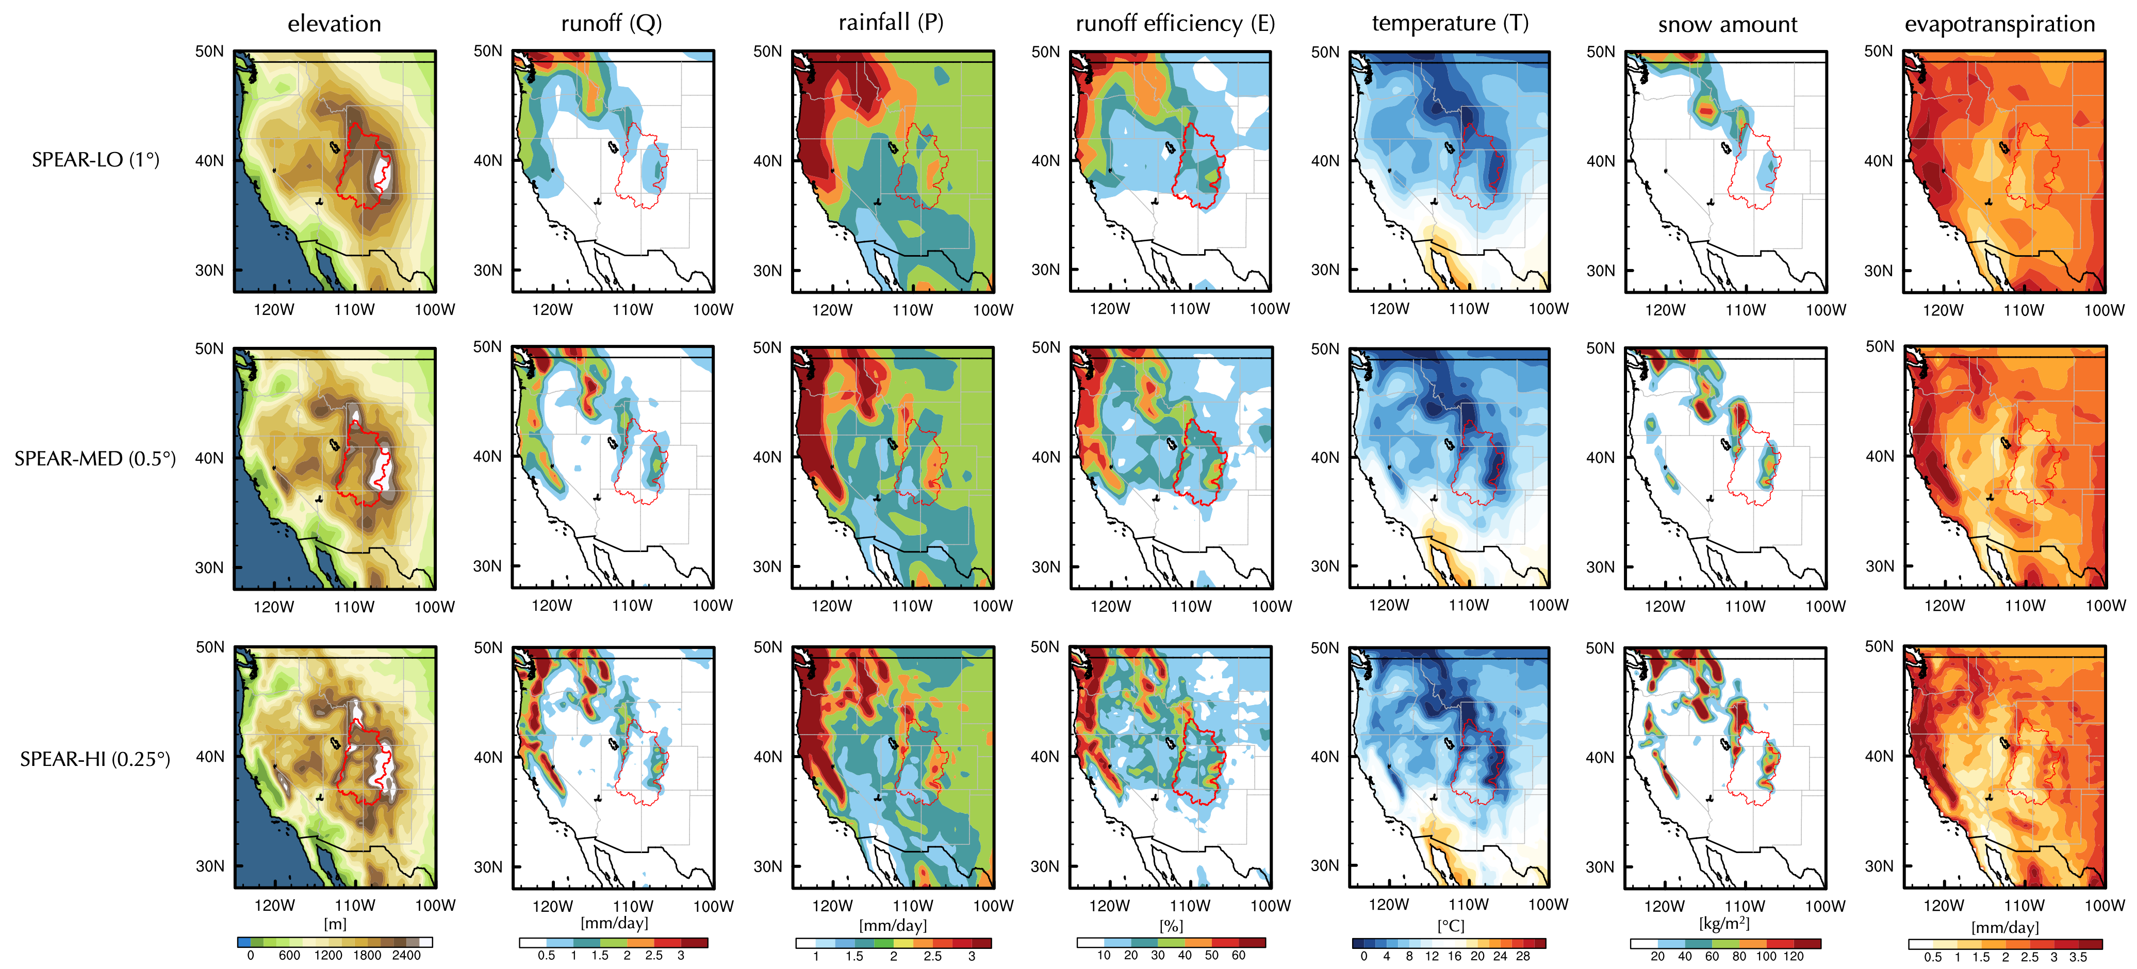
Figure S2.﻿ Simulated (first column) elevation (m), climatological mean (second column) runoff (mm/day), (third column) precipitation (mm/day), (fourth column) runoff efficiency (%), (fifth column) temperature (°C), (sixth column) snow amount (kg/m²) in 1951-2010 for 30 ensembles of (upper row) SPEAR LO, (middle row) SPEAR MED, and (bottom row) SPEAR HI experiments. Red counters outline the Upper Colorado River Basin.

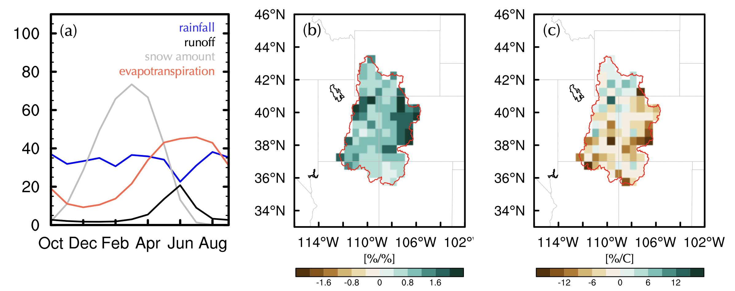
Figure S3. (a) As Figure 2d, but for observation. (b-c) As Figures 3b-c, but for observations (Livneh).

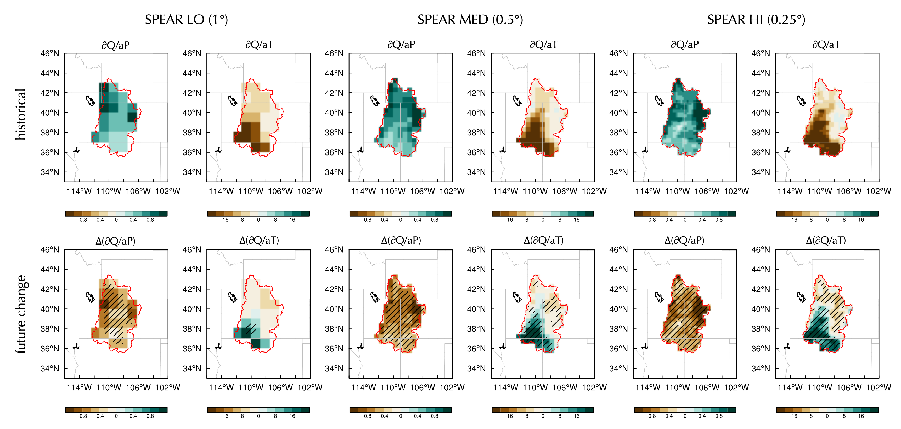
Figure S4. As Figure 3, but for SPEAR LO, SPEAR MED, and SPEAR HI. The shading in the bottom panel indicates the changes in runoff sensitivities significant at 95% confidence level according to two tailed student’s t test.

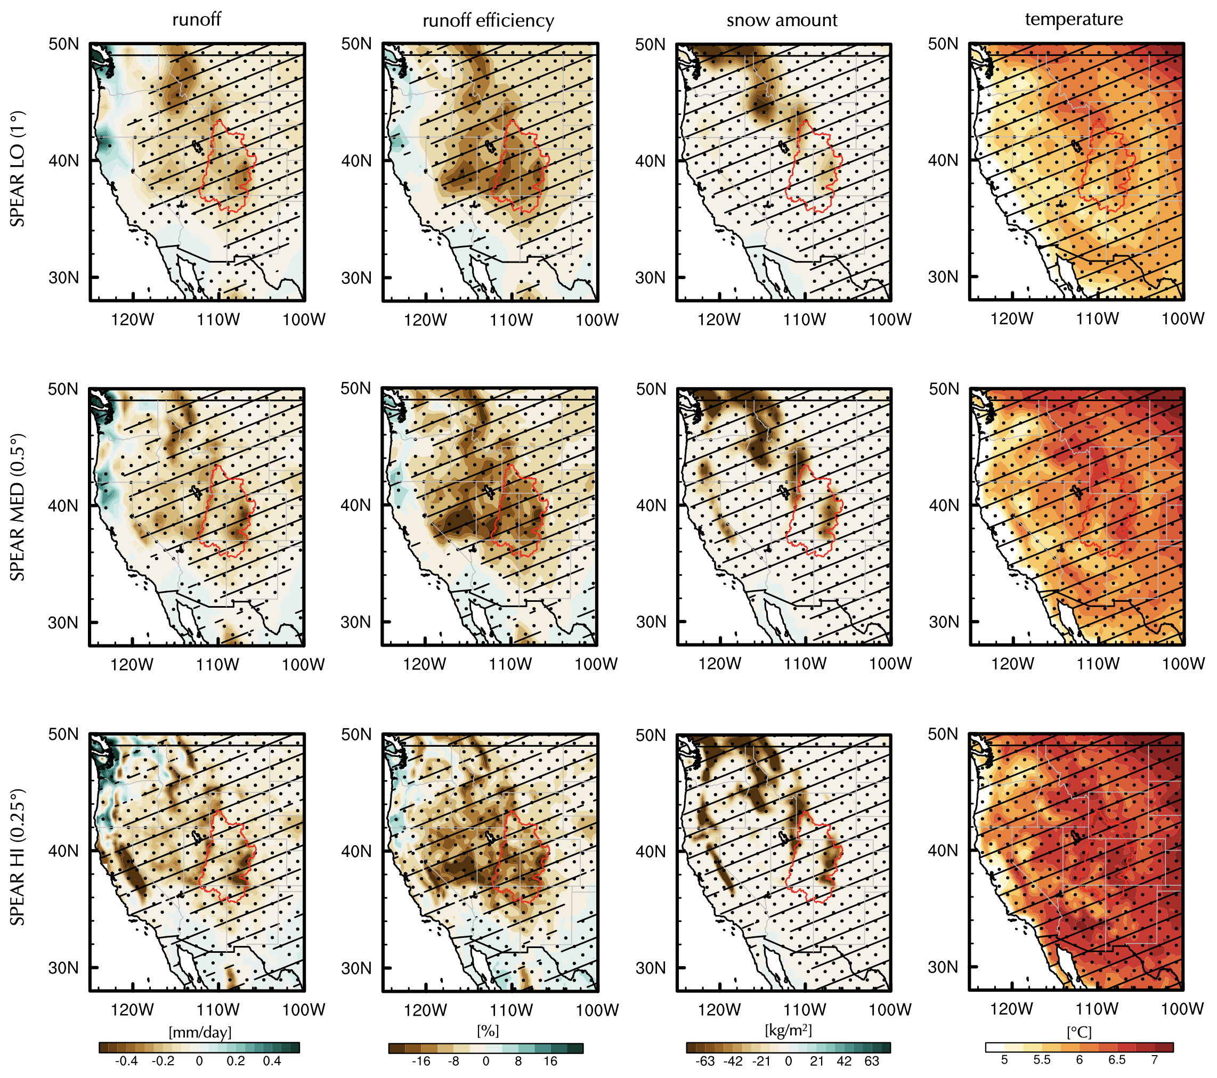
Figure S5. Difference of (first column) runoff (mm/day), (second column) runoff efficiency (%), (third column) snow amount (kg/m²), and (fourth column) temperature between 1951-1980 and 2071-2100 in (top row) SPEAR LO, (middle row) SPEAR MED, and (bottom row) SPEAR HI. Stippling denotes areas more than 3/4 of the ensemble members agree on the sign of future projection. Hatching indicates the area where the signal-to-noise ratio (S/N; ratio of multi-model mean projection versus the standard deviation of inter-model spread) is greater than 1. The red counter outlines the Upper Colorado River Basin.

