Supplementary Figure 1: IMRT plan using the SIB technique, with 45 Gy to the whole bladder and 55 Gy to the right lateral wall of the bladder in 20 fractions. Yellow, CTV whole bladder; blue, CTV boost.

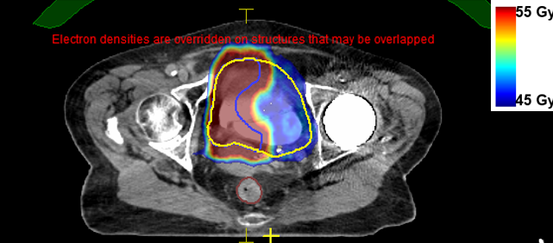

Supplementary Figure 2: MRgRT daily workflow.

