SUPPLEMENTARY MATERIAL

1 Supplementary Data

Global Spatial Analysis (Univariate Moran’s I)

Analyzed variable:
Absolute number of diagnosed cases of leprosy by census tract.
Results:
Moran’s I: -0.0059
Expected value (E[I]): -0.0007
Standard deviation: 0.0149
Z-Score: -0.3719
Pseudo p-value: 0.4542
Supplementary Figure 1. Spatial scatter plot of univariate Moran’s I applied to the number of leprosy cases by census sector.

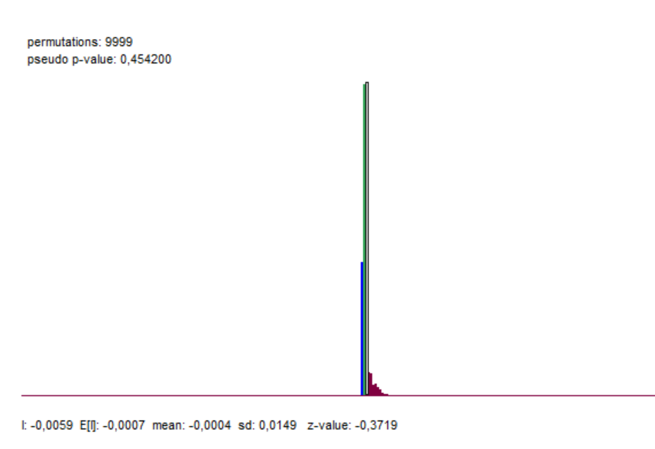
Supplementary Figure 2. Empirical distribution of Moran’s I permutations (9,999 permutations) for leprosy cases, with observed value, expected value and pseudo p-value.

Variable analyzed:
Number of patients with positive serology for IgM Anti-Mce1A by census sector.
Results:
Moran’s I: -0.004
Expected value (E[I]): -0.0007
Standard deviation: 0.0155
Z-Score: -0.0144
Pseudo p-value: 0.4369
Supplementary Figure 3. Spatial scatter plot of univariate Moran’s I applied to the number of patients with positive serology for IgM Anti-Mce1A by census sector.

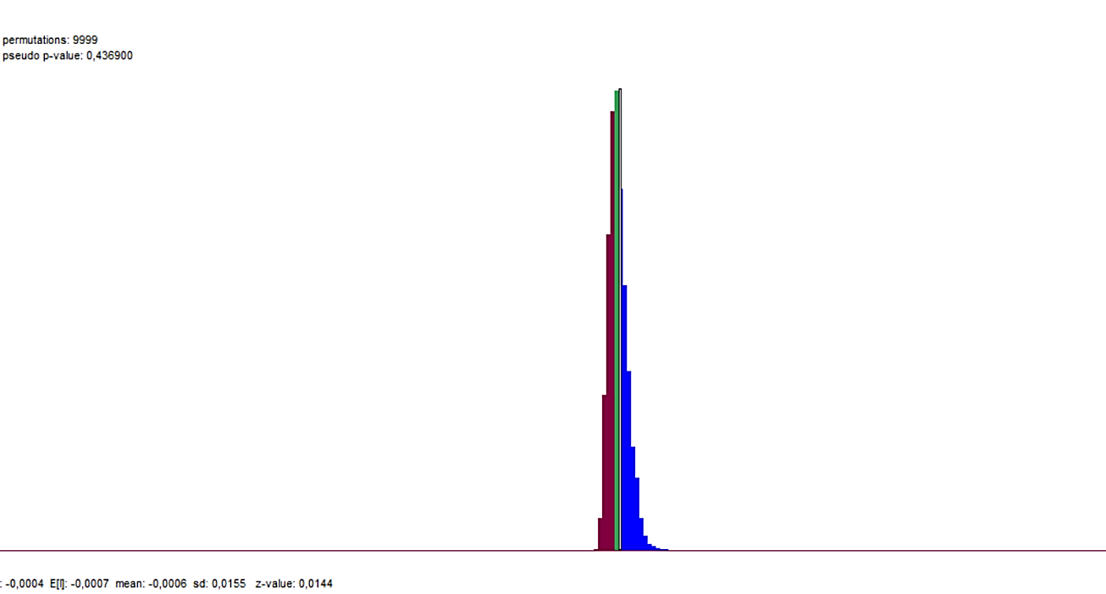
Supplementary Figure 4. Empirical distribution of Moran’s I permutations (9,999 permutations) for cases with positive serology for IgM Anti-Mce1A, with observed value, expected value and pseudo p-value.

2 Supplementary Data
Local Spatial Analysis (Univariate LISA)

Analyzed variable:
1. Absolute number of diagnosed cases of leprosy by census sector.
2. Number of patients with positive serology for IgM Anti-Mce1A by census sector.
Supplementary Figure 5. Spatial cluster map (univariate LISA) for leprosy cases after adjustment for False Discovery Rate (FDR), showing absence of local spatial significance.

Supplementary Figure 6. Spatial cluster map (univariate LISA) for patients with positive IgM Anti-Mce1A serology after adjustment for False Discovery Rate (FDR), showing absence of local spatial significance.

3 Supplementary Data

Bivariate LISA Analysis

Supplementary Table 1. Results of the Bivariate LISA Analysis between leprosy cases and IgM Anti-Mce1A serology and sociodemographic variables, with correction for False Discovery Rate (FDR).

Sociodemographic variable analyzed | Variable type | Bivariate LISA result with FDR (999 permutations)
Average number of residents in the household | Continuous quantitative | No significant clusters
Per capita income in the households | Continuous quantitative | No significant clusters
Proportion of households with water supply | Proportional (%) | No significant clusters
Proportion of households with sewage system | Proportional (%) | No significant clusters
Proportion of households with electricity | Proportional (%) | No significant clusters
IPVS classification (São Paulo Social Vulnerability Index) | Categorical ordinal | No significant clusters

