Supplementary Information

Aerosol Assisted Chemical Vapor Deposition of Cobalt Phosphate Co-Catalysts on BiVO₄-based Photoelectrodes for Solar Water Splitting Systems

Mengyuan Huang¹, George Creasey,^{1,2} Zhipeng Lin¹, Anna Hankin², Brian Tam¹* and Andreas Kafizas^{1,3}*
*co-corresponding authors = b.tam18@imperial.ac.uk and a.kafizas@imperial.ac.uk

¹Department of Chemistry, Molecular Sciences Research Hub, Imperial College London, White City, London, W12 0BZ, UK
²Department of Chemical Engineering, Imperial College London, South Kensington, London, London, SW7 2AZ, UK
³London Centre for Nanotechnology, Imperial College London, South Kensington, London, SW7 2AZ, UK

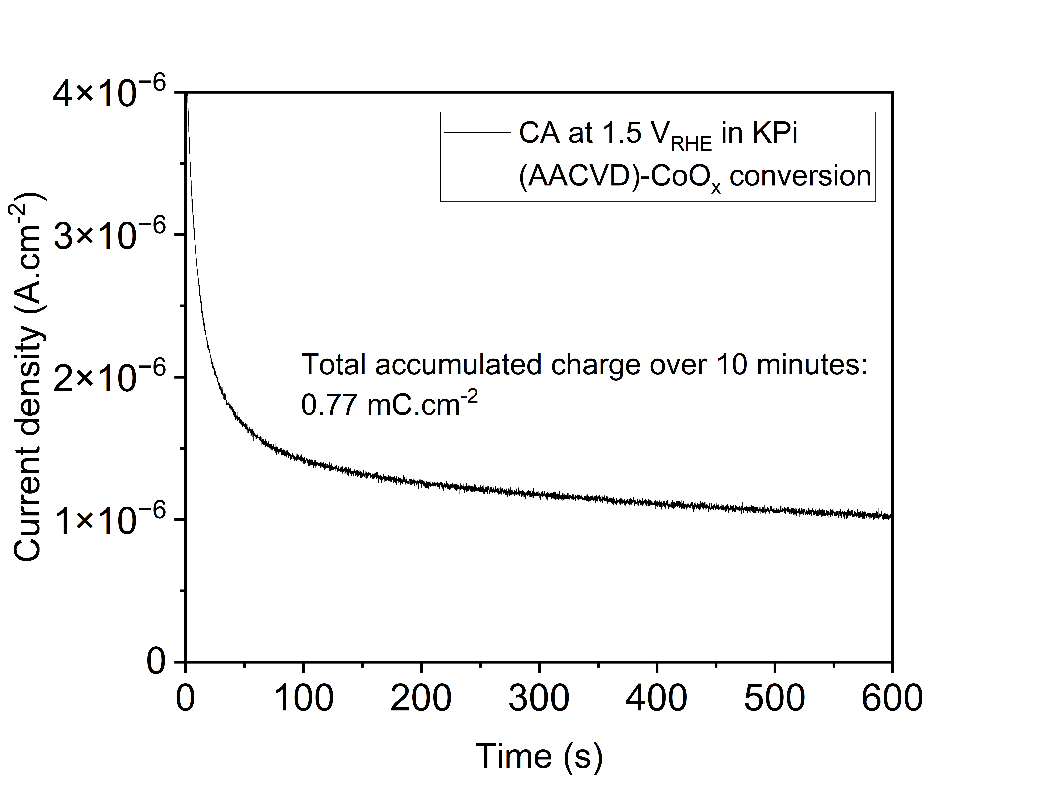
Figure S1. Chronoamperometry recorded for the electrochemical conversion of CoO_{x} to CoPi in the dark. The experiment was conducted in a pH 7.0, 0.1 M potassium phosphate (KPi) buffer at an applied potential of 1.5 V_{RHE} for 600 seconds for a geometric area of 2 cm². The CoO_{x} thin film was 80 nm thick and deposited via AACVD under air using 20 mL 0.5 mM Co(acac)₂ solution.
Taking 0.77 mC.cm⁻² to be proportional to the conversion of Co²⁺ in CoO to Co³⁺ in CoPO₄ with m/w of 154 g/mol, the total converted species is 4.81 x 10¹⁵ CoPO₄ or 7.98 x 10⁻⁹ mol, which is 1.22 x 10⁻⁶ g. With an approximate density of 4 g.cm⁻³, and 2 cm² film area, the CoPi would be expected to have a mass/thickness of 8 g per cm. Thus, the layer of CoPi would be 1.22 x 10⁻⁶ / 8 = 1.53 nm thick.

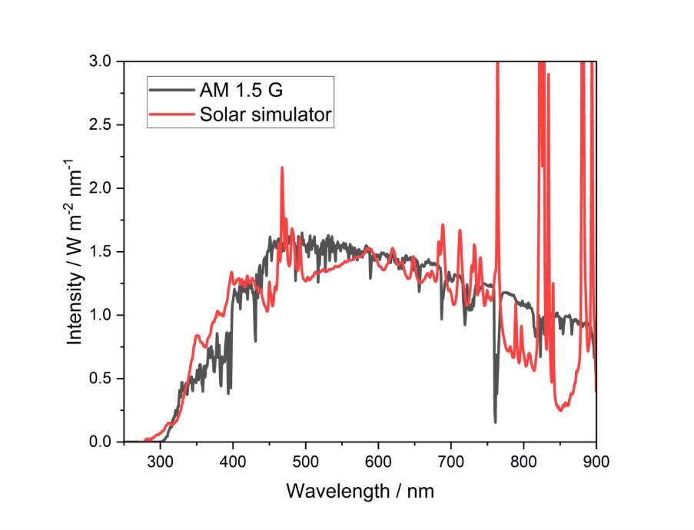
Figure S2. Spectrum of the Sun2000 solar simulator equipped with an AM 1.5G filter, used for one sun measurements 100 mW cm⁻², compared with the NREL AM 1.5G reference spectrum.¹

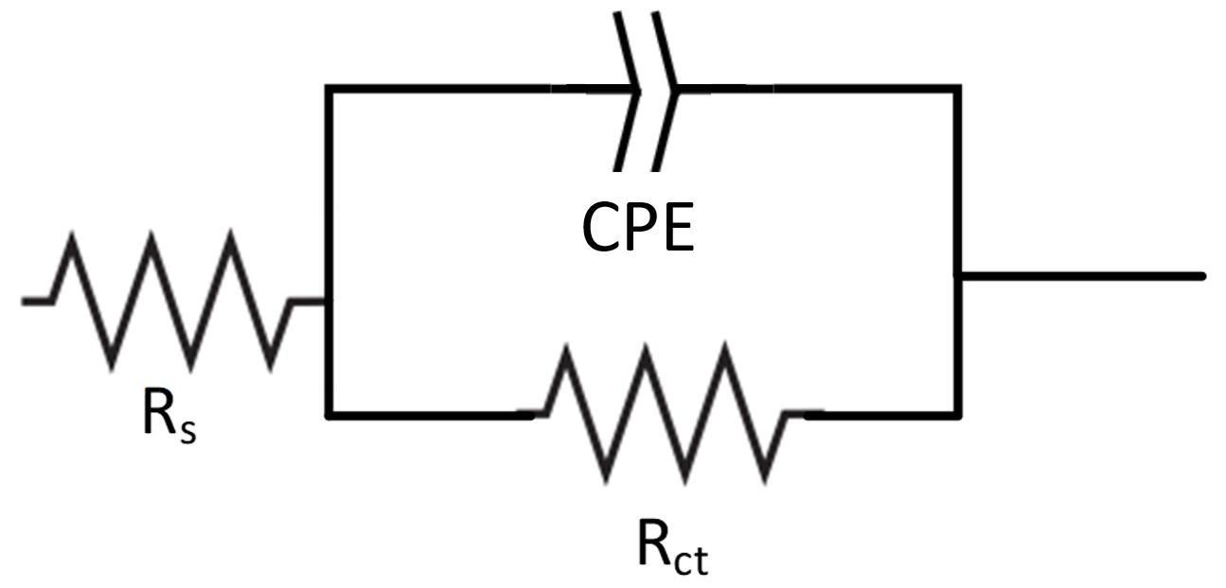
Figure S3. Equivalent electrical circuit (comprised of two resistors and a constant phase element (CPE) used for fitting PEIS spectra shown in Figure 6.

Table S1. Effect of co-catalysts on resistance and capacitance values of BiVO₄ electrodes
Electrode | R_{s} (Ω) | R_{ct} (Ω) | CPE (μS·s^{N}) | N
(AACVD)-CoO_{x} BiVO₄ | 81 | 2450 | 67 | 0.603
(AACVD+ET)-CoPi BiVO₄ | 81 | 533 | 158 | 0.434
(PED)-CoPi BiVO₄ | 81 | 500 | 10.4 | 0.746
Note: bare BiVO₄ could not be reliably fitted with the model in Figure S3, likely due to inefficient charge transfer processes in the absence of active co-catalyst sites. Therefore, it was not possible to make a comparison to the equivalent circuit parameters for the BiVO₄ electrodes with co-catalysts.

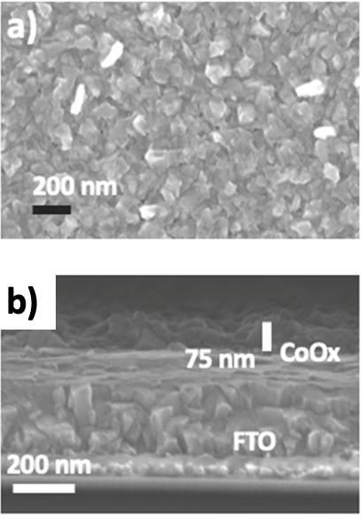
Figure S4. a) Top-down SEM image of (AACVD)-CoO_{x} on FTO, and b) side-on SEM image of -(AACVD)-CoO_{x} on FTO
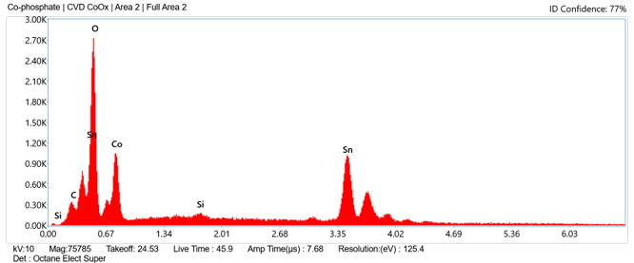
Figure S5. X-ray spectra of elements detected by EDX analysis (AACVD+ET)-CoPi on FTO
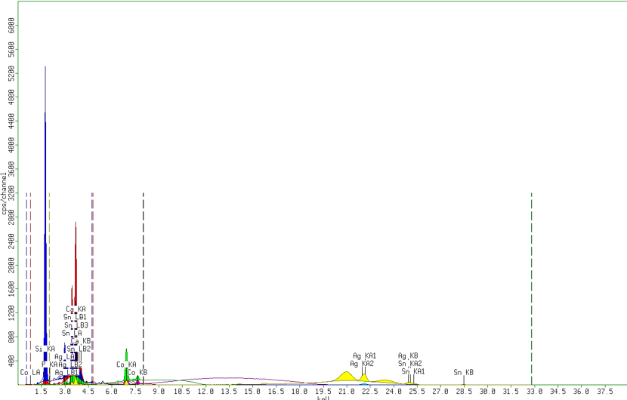
Figure S6. XRF spectra of elements detected by XRF analysis (AACVD+ET)-CoPi on FTO
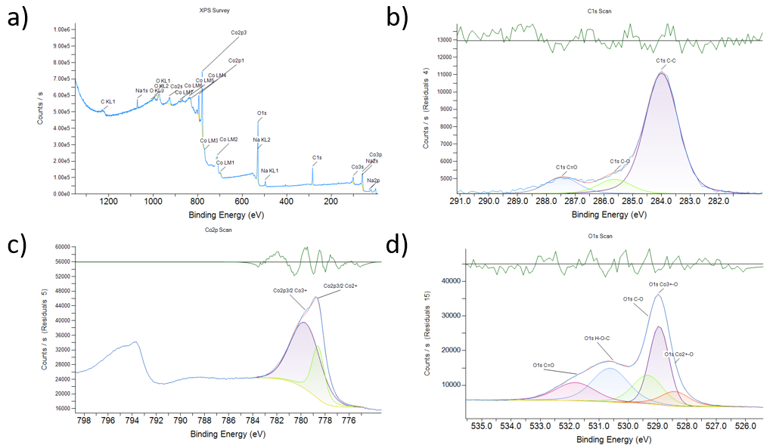
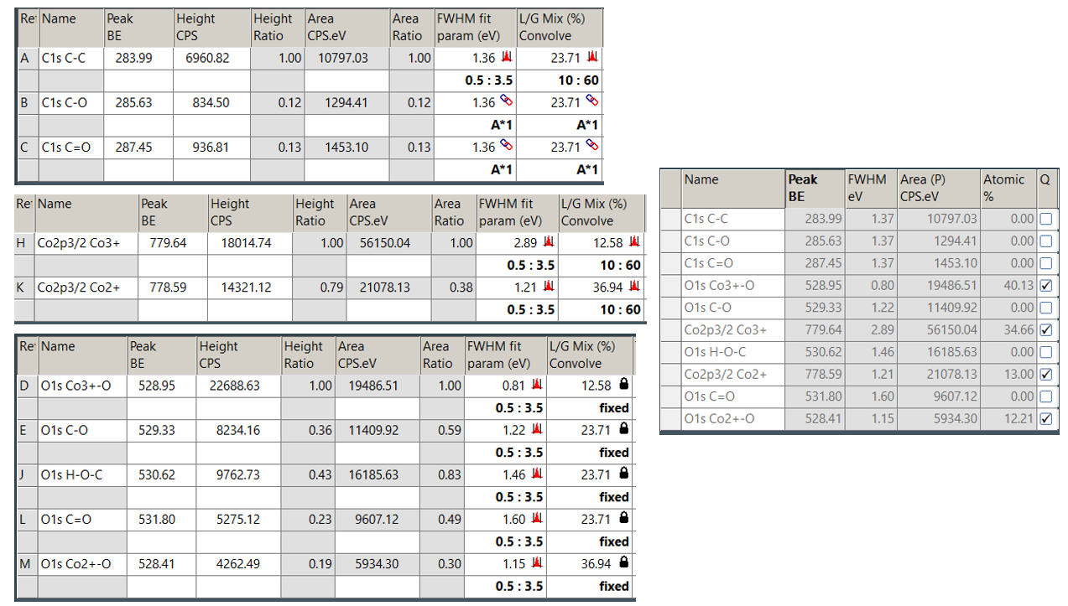
Figure S7. XPS spectra of AACVD CoO_{x} for a) survey scan, b) C 1s, c) Co 2p, d) O 1s, and corresponding fitting data tables and atomic% calculated with Avantage software

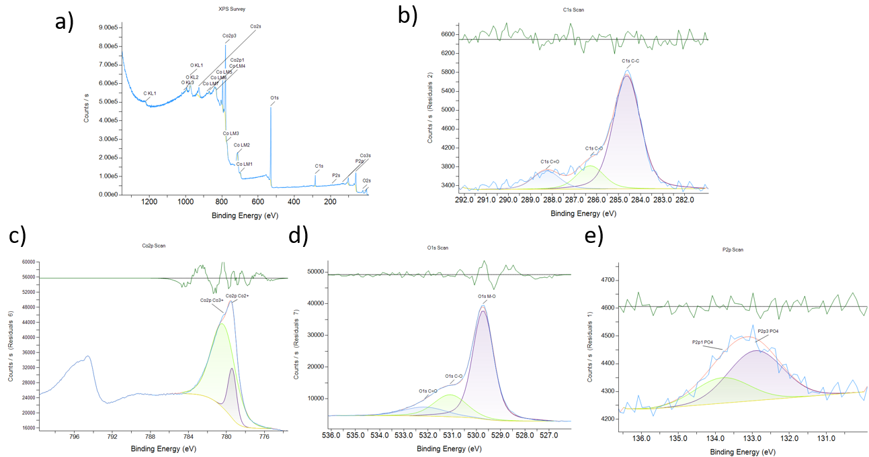
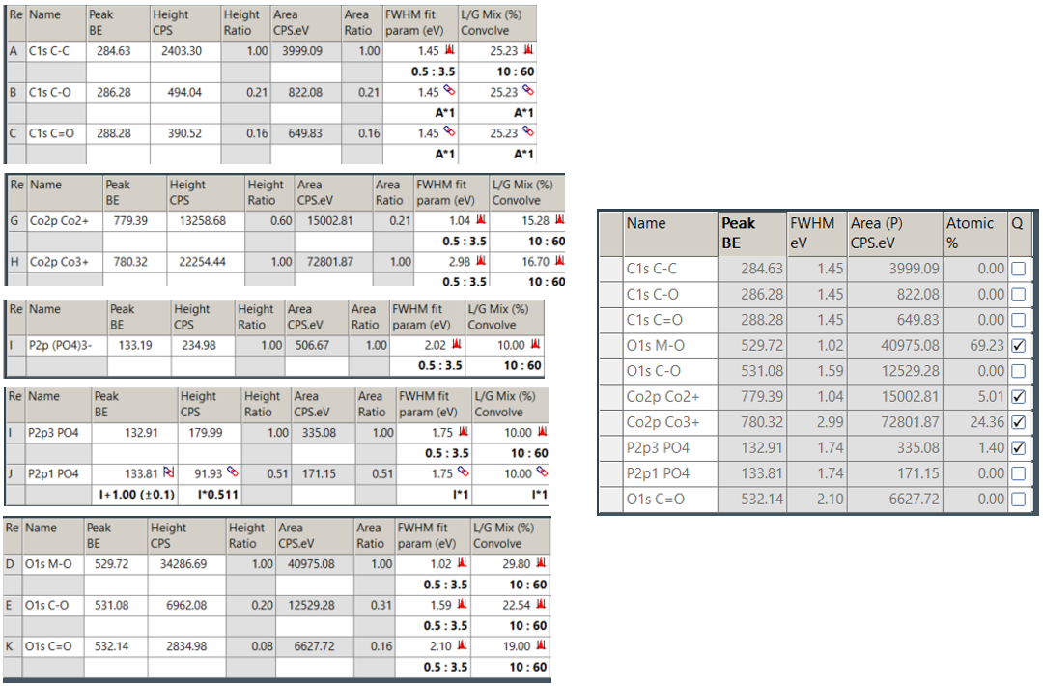
Figure S8. XPS spectra of AACVD+ET CoPi for a) survey scan, b) C 1s, c) Co 2p, d) O 1s, e) P 2p, and corresponding fitting data tables and atomic% calculated with Avantage software

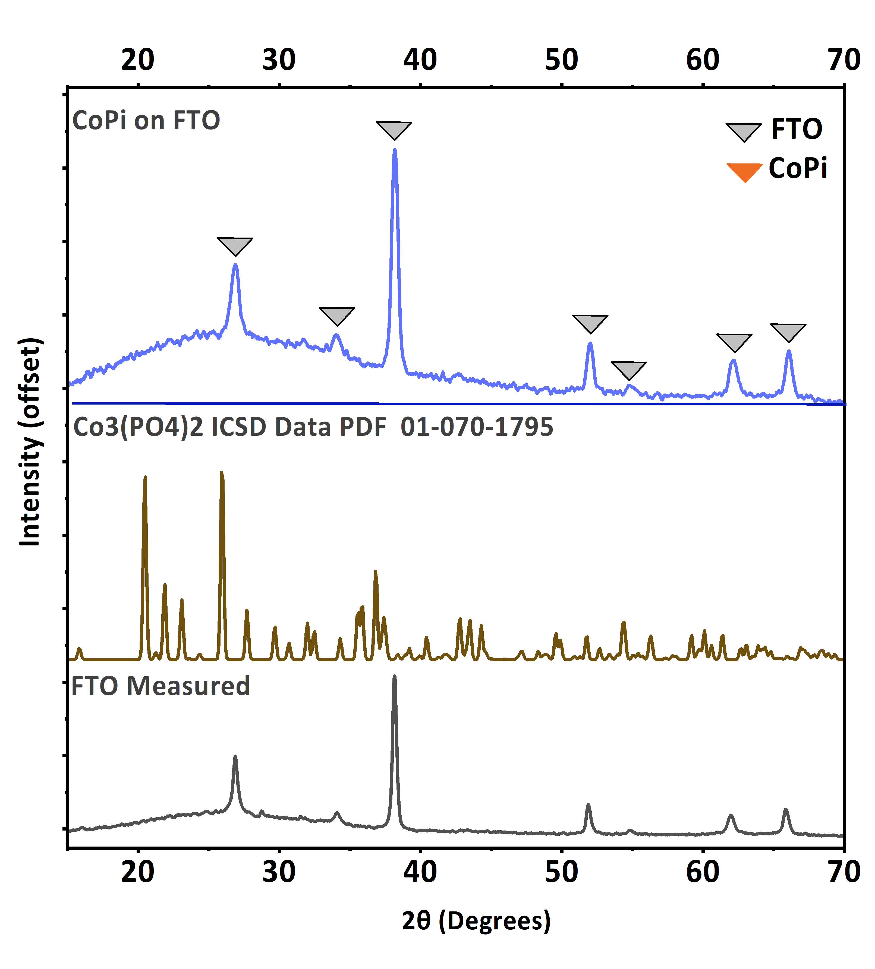
Figure S9. XRD characterization of PED-fabricated (PED)-CoPi compared to reference patterns
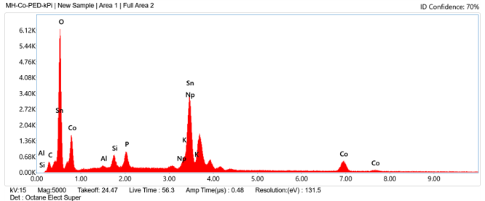
Figure S10. X-ray spectra of elements detected by EDX analysis for (PED)-CoPi on FTO
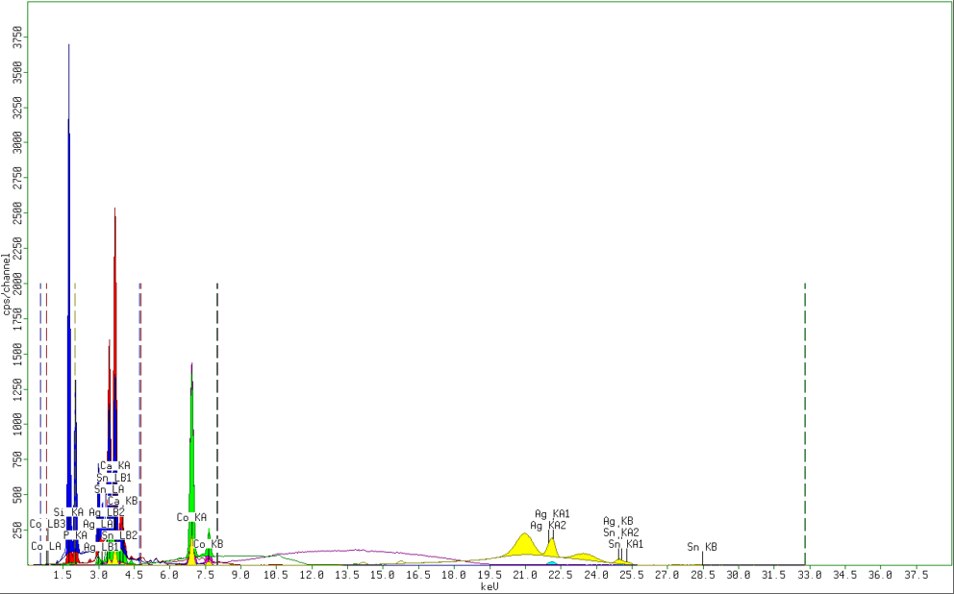
Figure S11. X-ray spectra of elements detected by XRF analysis for (PED)-CoPi on FTO

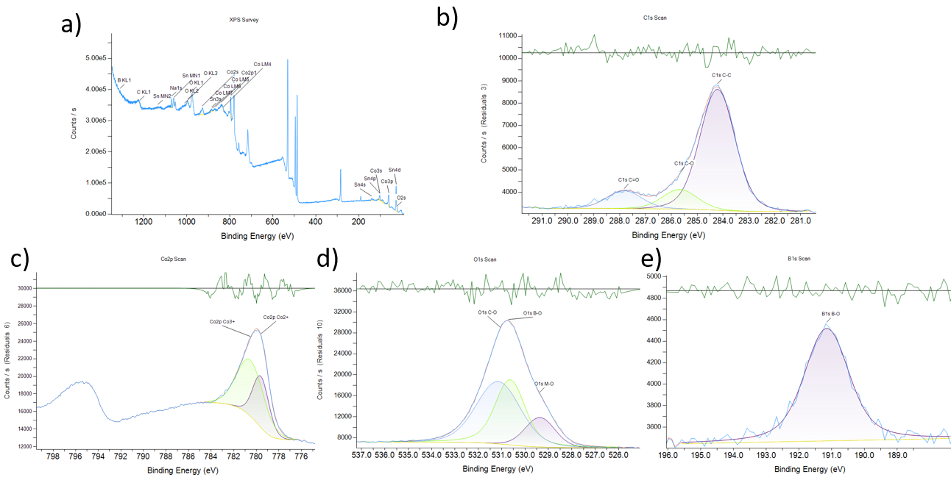
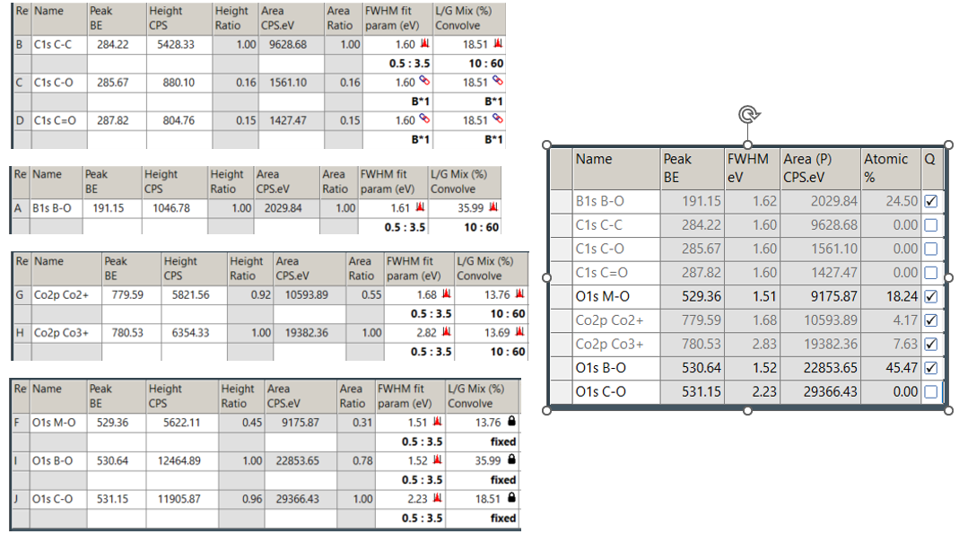
Figure S12. XPS spectra of PED CoO_{x} for a) survey scan, b) C 1s, c) Co 2p, d) O 1s, e) B 1s, and corresponding fitting data tables and atomic% calculated with Avantage software

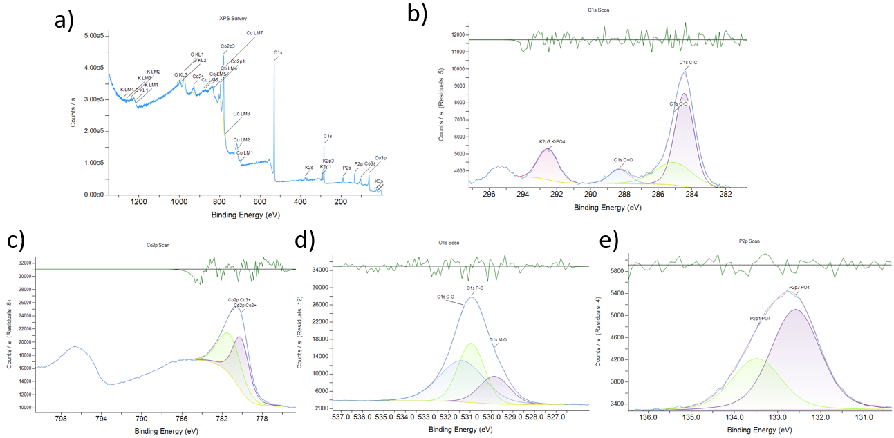
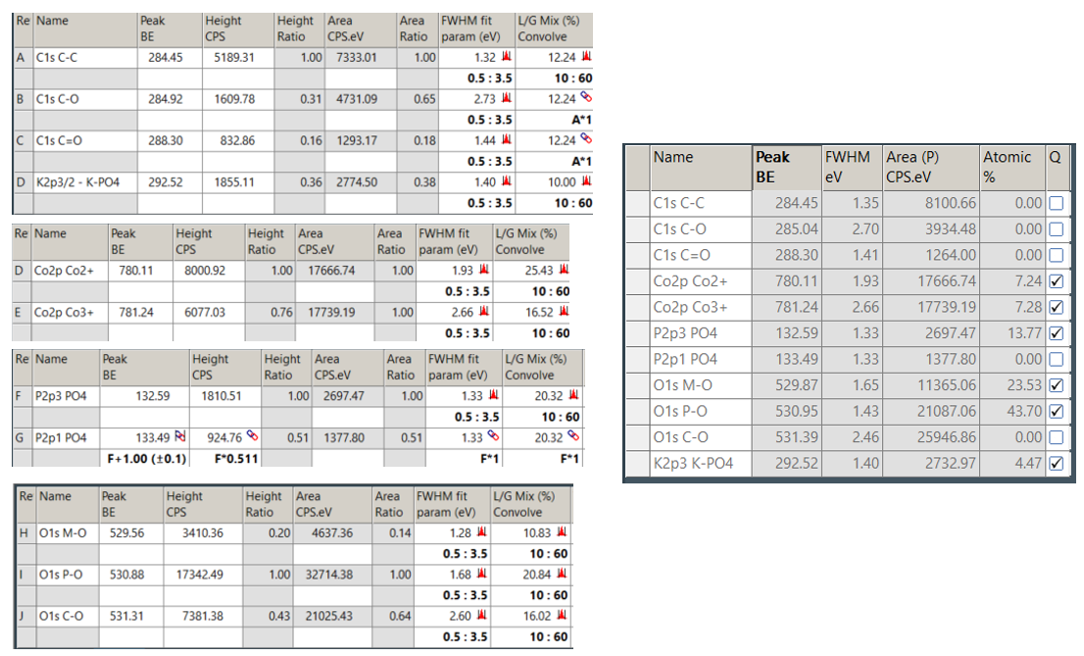
Figure S13. XPS spectra of PED CoPi for a) survey scan, b) C 1s & K 2p, c) Co 2p, d) O 1s, e) P 2p, and corresponding fitting data tables and atomic% calculated with Avantage software

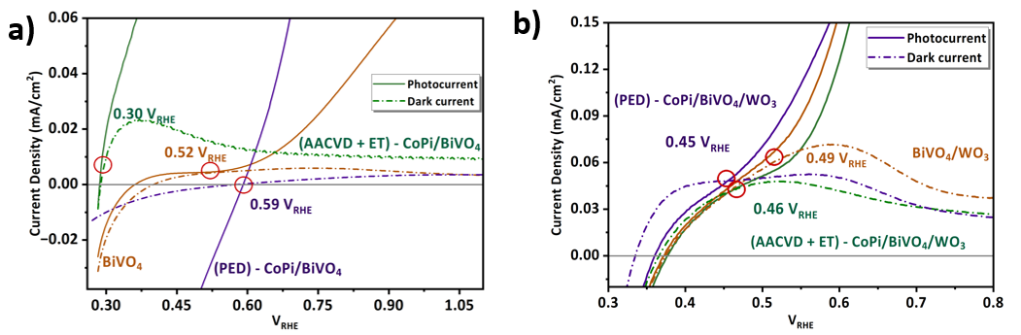
Figure S14. Zoomed in determination of photocurrent onset potential from the potentials at which the photocurrent LSV curves first deviate from the dark current LSV curves in Figure 4

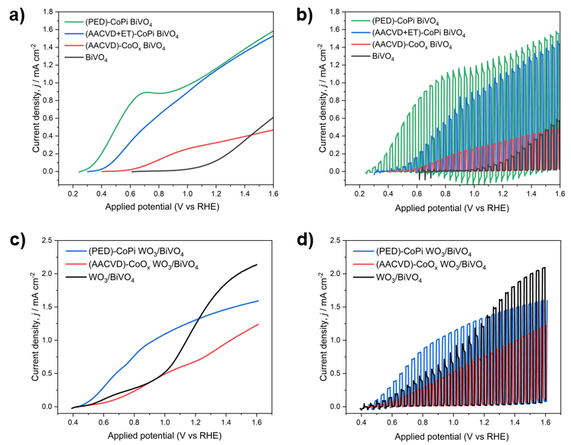
Figure S15. BiVO₄ electrodes with CoO_{x} or CoPi co-catalysts under a) continuous and b) chopped illumination. WO₃/BiVO₄ electrodes with CoO_{x} or CoPi co-catalysts under c) continuous and d) chopped illumination. All LSV measurements were taken under 1 sun (100 mW cm⁻², AM 1.5G) simulated sunlight with a 20 mV/s scan rate and illumination in b) and d) were chopped with a frequency of 1 Hz.

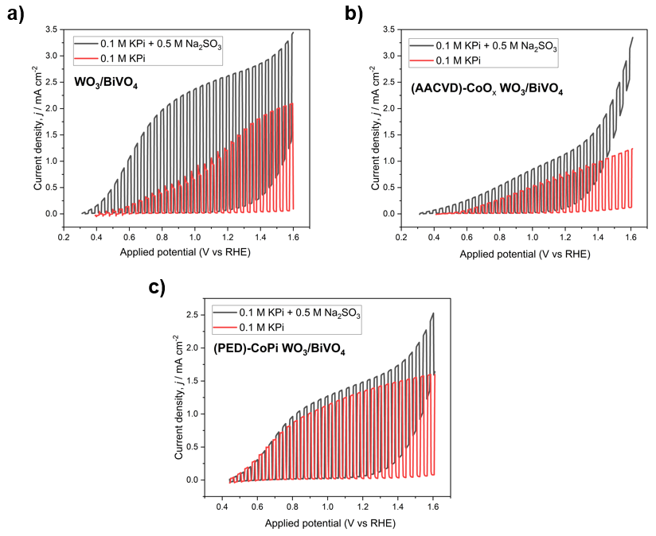
Figure S16. Chopped linear sweep voltammetry for water and sulfite oxidation of WO₃|BiVO₄ heterojunction photoanodes: a) without a co-catalyst, b) with (AACVD)-CoO_{x}, and c) with (PED)-CoPi. All LSV measurements were taken under 1 sun (100 mW cm⁻², AM 1.5G) simulated sunlight with a 20 mV/s scan rate and chopped light measurements used a chopping frequency of 1 Hz.

Table S2. Key parameters from chopped light LSV measurements under one sun illumination
Photoanode structure | j_{Na2SO3}  (mA cm⁻²) | j_{H2O}  (mA cm⁻²) | $ϕ_{sep}$(%) | $ϕ_{inj}$(%) | V_{onset,H2O} (V)
BiVO₄ | 0.66 | 0.15 | 30 | 22 | 1.09
(AACVD)-CoO_{x}  BiVO₄ | 0.51 | 0.50 | 23 | 98 | 0.56
(AACVD+ET)-CoPi BiVO₄ | 1.83 | 1.17 | 84 | 64 | 0.48
(PED)-CoPi BiVO₄ | 1.53 | 1.19 | 70 | 78 | 0.31
WO₃/BiVO₄ | 2.56 | 1.35 | 44 | 53 | 0.89
(AACVD)- CoO_{x}  WO₃/BiVO₄ | 1.18 | 0.72 | 20 | 61 | 0.74
(PED)-CoPi WO₃/BiVO₄ | 1.54 | 1.33 | 27 | 86 | 0.47
j_{Na2SO3} = sulfite splitting photocurrent density (mA cm⁻²) at 1.23 V_{RHE} under continuous one sun illumination
j_{H2O} = water splitting photocurrent density (mA cm⁻²) at 1.23 V_{RHE} under continuous one sun illumination
$ϕ_{sep}$ = charge separation efficiency (%)
$ϕ_{inj}$ = charge injection efficiency (%)
V_{onset,H2O} = onset potential (V vs RHE) for water oxidation

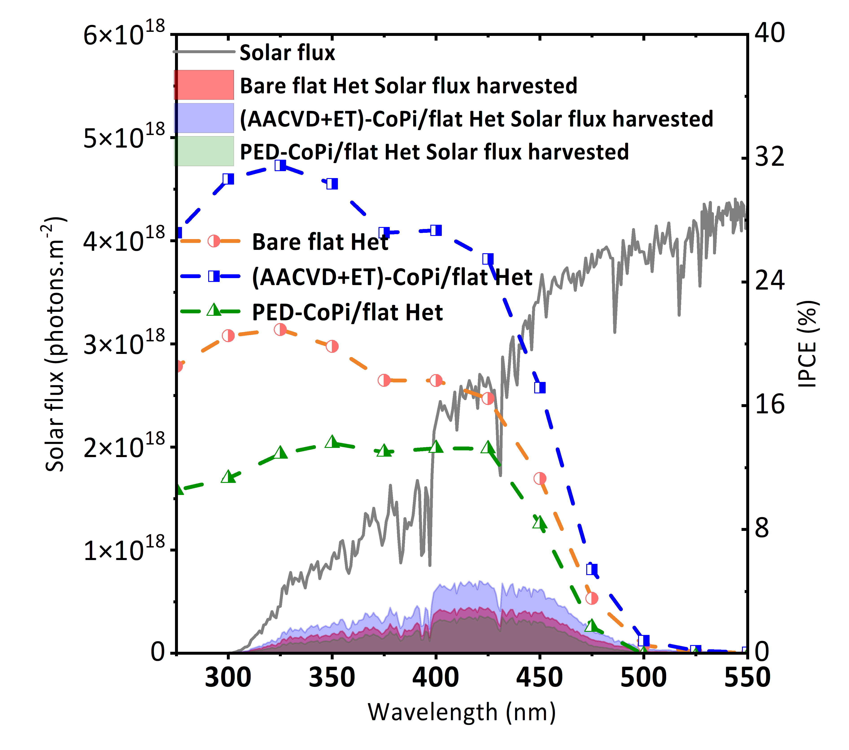
Figure S17. (AACVD+ET)-CoPi deposited on flat BiVO₄/WO₃ heterojunction yielding an SPP of 1.12 mA cm⁻² and a corresponding STH efficiency of 1.38%, which is an improvement over the bare flat heterojunction that exhibited an SPP of 0.71 mA cm⁻² and a corresponding STH efficiency of 0.87% but is less effective than the nanostructured photoanodes.

References:
1. National Renewable Energy Laboratory. Reference Air Mass 1.5 Spectra. https://www.nrel.gov/grid/solar-resource/spectra-am1.5.html.

