SUPPLEMENTARY TEXT 1
Astronomical calibration of the middle Cambrian in Baltica: Global carbon cycle synchronization and climate dynamics

Valentin JAMART, Damien PAS, Linda A. HINNOV, Jorge E. SPANGENBERG, Thierry ADATTE, Arne T. NIELSEN, Niels H. SCHOVSBO, Nicolas THIBAULT, Michiel ARTS, Allison C. DALEY

- MATERIALS AND METHODS
  - Stratigraphy
    - Geological setting

  - Geochemical proxies
    - X-ray fluorescence (XRF) core scanning
    - ICP-MS
    - Rock-Eval pyrolysis
    - Organic carbon stable isotopes
    - X-ray diffraction (XRD)

  - Cyclostratigraphy and time series analysis
    - Preparation of the data
    - Z-score normalization
    - Time series analysis protocol

- RESULTS & DISCUSSION
  - Stratigraphy, geochemistry and signal preservation
    - Fossil identification
    - Preservation of the carbon isotope signal

  - Geochemical events and global correlations
    - Identification of the DICE event in Baltica

  - Time series analysis
    - Proxy selection
    - Cyclicity in the signal
    - 173 kyr identification
      - MTM and EHA
      - Zhao et al (2022)’s supplementary data
      - Ratio of frequencies
      - ASM and average sedimentation rate
    - Age-depth model
    - Hilbert modulation analysis
    - Astronomical forcing from Obliquity to Eccentricity dominated intervals

  - Astronomically-tuned age model for the Miaolingian Series
    - Duration estimates of Biozones
    - Duration estimates of the Miaolingian Series, stages, and events
      - Duration of Series and stages
      - DICE event
      - Other events

Supplementary Figures S1-S13
REFERENCES

- MATERIALS AND METHODS
  - Stratigraphy
    - Geological setting
The Albjära-1 core was drilled north of the village of Svalöv in Scania (southern Sweden, Fig. 1C) and is curated at the University of Copenhagen, Denmark. During the Cambrian, Scania was located on the external margin (deepest environment) of the Scandinavian Shelf which extended northward from northern Poland to Finnmark (northern Norway) and eastward from the Oslo area in Norway to the St. Petersburg area in western Russia¹⁻³.
In the Albjära-1 core, the ASF extends from the Wuliuan Ptychagnostus gibbus (agnostoid) to the Tremadocian Bryograptus kjerulfi (graptolite) Biozone^{2,4}. The ASF has been central to numerous studies in paleontology^{e.g.,5,6-9}, stratigraphy^{e.g.,1,10-13}, geochemistry^{e.g.,5,14,15-17}, and more recently, cyclostratigraphy^{2,18}. These studies have contributed to establishing of a robust biostratigraphic framework for Baltica, enabling intercontinental correlations^{1,10-13,19,20}. The ASF overlies a significant unconformity resulting from the Hawke Bay Event sensu lato regression (Fig. 2) and associated major hiatuses that have significantly affected the geological record of the Scandinavian Shelf^{1,4,10}. The Hawke Bay Event sensu lato is a major epeirogenically-induced regressive sea-level event located at the Stage 4 – Wuliuan boundary, in the sedimentary record of Baltica and several other localities boarding the Iapetus Ocean^{10,21,22}.
Directly underlying the ASF is an interval of approximately 13 cm thick, consisting of glauconitic and partly phosphoritic, light gray greywacke locally displaying macropyrite mineralization (Fig. S1). These sedimentary features suggest a phase of renewed drowning of the shelf¹. Comparison of the lithological succession with the Andrarum-1 and Gislövshammar boreholes, both in Scania, described by Westergård¹¹, indicates that the greywacke observed in the Albjära-1 core is likely to belong to the Age 3-4 Holmia kjerulfi Biozone, which correspond to the Gislöv Formation according to Nielsen and Schovsbo¹. The limited extension of the Gislöv Formation in the Albjära-1 core is linked to the hiatuses and erosion caused by the Hawke Bay Event sensu lato. We interpret this 13 cm-thick sequence boundary as the record of the Hawke Bay event sensu lato in the core (see also Nielsen and Schovsbo¹).
The Hardeberga Formation (Fig. 2) is ~ 5 m thick and is characterized by light gray sandstones with evaporites pseudomorphs in its upper part. This formation extends from the Age 2 Platysolenites antiquissimus (Small Shelly Fossil) to the lower part of the Age 3 Schmidtiellus mickwitzi (trilobite) Biozone^{1,20}.

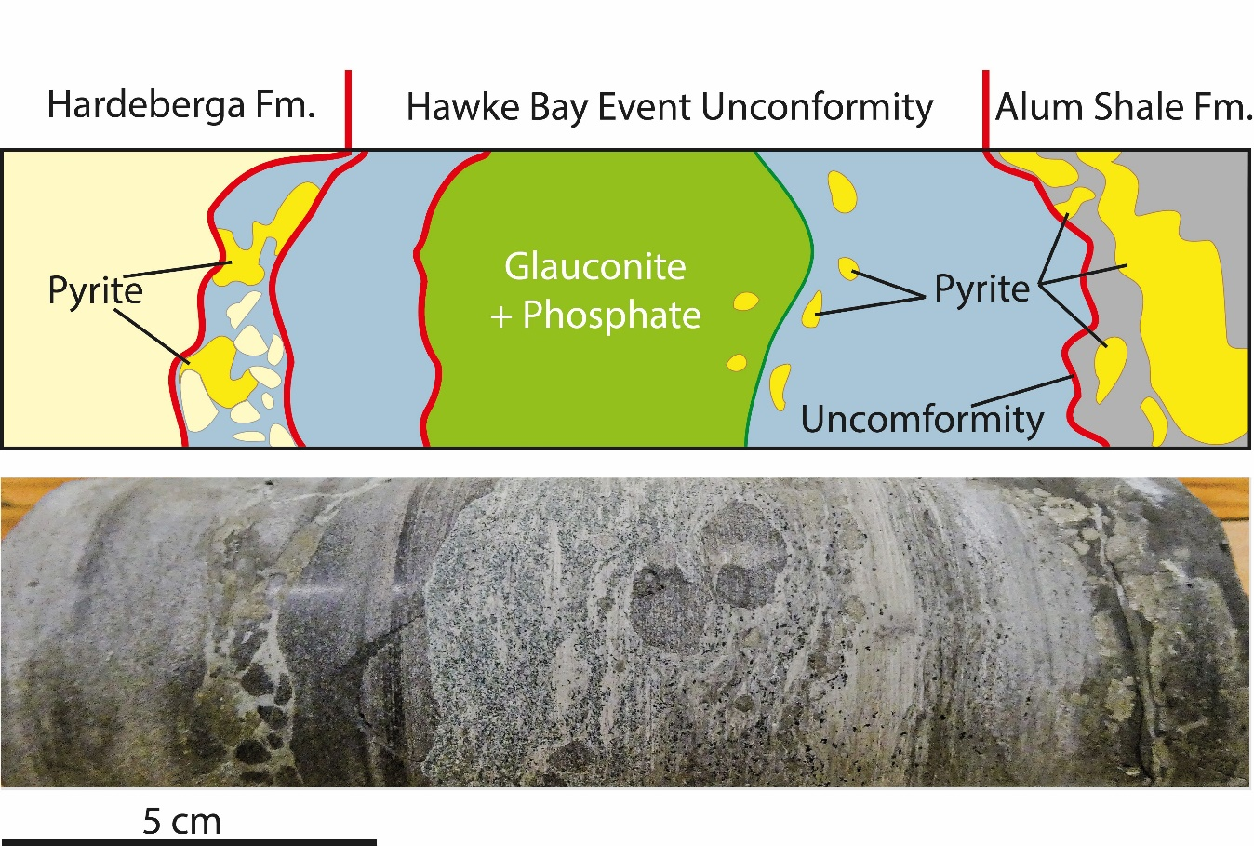

Figure S1: Close-up view of the Hawke Bay unconformity sensu lato.

  - Geochemical proxies
    - X-ray fluorescence (XRF) core scanning
The Albjära-1 Core Lower part (ACL) was scanned using an Itrax core scanner (University of Stockholm, Sweden). The parameters of the Itrax core scanner are as follows: Mo tube as X-ray source, 40 kV voltage, 10 mA current, 1000 microns (1mm) step size and 20 s of XRF exposure time. A chlorine-rich dough was applied on the cracks and gaps of the core, prior to the scanning, to easily identify and remove them in the resulting XRF dataset. Resulting in a total measurement, in count per second (cps), of 28 chemical elements (e.g. Al, Ti, Si, K, Zr, Ca).
To calibrate the scanner output (cps), 50 pressed powder pellets, with known elemental concentration measured with ICP-MS, were scanned under identical parameters except for a reduced step size of 500 μm. Only those standard pellets with elemental trends consistent with corresponding core intervals were used for final calibration.

    - ICP-MS
The Ultratrace 4 – Near Total Digestion – ICP-MS method protocol, as presented by Activation Laboratories Ltd, is as follow: A 0.25 g sample is digested with four acids beginning with hydrofluoric, followed by a mixture of nitric and perchloric acids, heated using precise programmer-controlled heating in several ramping and holding cycles which takes the samples to dryness. After dryness is attained, samples are brought back into solution using hydrochloric and nitric acids. This digestion may not be completely total if resistant minerals are present. As, Sb and Cr may be partially volatilized. Digested samples are diluted and analyzed by an ICP-MS. One blank is run for every 40 samples. In-house control is run every 20 samples. Digested standards are run every 80 samples. After every 15 samples, a digestion duplicate is analyzed. Instrument is recalibrated every 80 samples. An in-lab standard (traceable to certified reference materials) or certified reference materials are used for quality control.

    - Rock-Eval pyrolysis
The protocol used to perform Rock-Eval analysis is as follow: 60 to 70 mg of powdered bulk rock were placed in an oven, heated at 300°C under an inert atmosphere, and then gradually pyrolyzed up to 650°C. After the pyrolysis, the samples were transferred into another oven and gradually heated up to 850°C in the presence of air, analyzing the CO₂ and hydrocarbon (HC) concentration during the entire process. The measured parameters included the total organic carbon content (TOC in wt %), carbonate content (CaCO₃, wt %), hydrogen index (HI, mg HC/g TOC), oxygen index (OI, mg CO2/g TOC), S2 peak (mg HC/g), and T max (°C). The analytic error for the TOC measurement is of 0.1 wt %²³.

    - Organic carbon stable isotopes
The protocol used to perform organic carbon stable isotope analysis is as follow: the used EA/IRMS system at the Institute of Earth Surface Dynamics of the University of Lausanne (UNIL, IDYST) consisted of a Carlo Erba 1108 (Fisons Instruments, Milan, Italy) elemental analyzer connected to a Delta V Plus isotope-ratio mass spectrometer via Con-Flo III split interface (both of Thermo Fisher Scientific, Bremen, Germany) operated under continuous helium flow. Before analysis the samples were decarbonated by treatment with 10 % v/v HCl, thoroughly washed with deionized water, and dried (40°C, 48 h). The calibration and normalization of the measured ¹³C values to the VPDB scale was performed with international reference materials and UNIL in-house standards^{24,25}. The repeatability and intermediate precision were better than 0.1 ‰ for δ¹³C_{org}.

    - X-ray diffraction (XRD)
The protocol used to perform XRD analysis is as follows: The XRD patterns were acquired on 800 mg powder samples pressed (20 bars) into a powder holder (energy, 40 kV, 45 mA; CuKα, λ = 1.54060 Å; angle 2°-65° 2°θ) to determine the mineralogical composition of the bulk rock against external standards. A margin of error of 5-10 % was permitted for phyllosilicates and 5 % for grain minerals. Diffractograms were used to better identify minerals by peak position (2θ)²⁶, in addition to semi-quantitative approach used for clay minerals quantification.

  - Cyclostratigraphy and time series analysis
    - Preparation of the data
Prior conducting the time series analysis, we compared the XRF data of the detrital element and Ca from both the overlapping part of Zhao, et al.² and our dataset. This allows us to identify a distinctive 5 cm calcite veins framework at 212.22 m as a marker that is clearly visible in the XRF core scanning data. This alignment serves as the reference point to construct our depth model.
To anchor our astronomical time scale (ATS), we used the absolute age of 499.9115 ± 0.9 Ma located at a depth of 212.49 m from the calibrated ATS from Zhao, et al.².
To ensure consistency with downhole measurements, we compared our depth-referenced dataset with the in-well Gamma-Ray (GR) and resistivity logs, which correspond to the in situ depth recorded during the drilling.
This comparison revealed a systematic offset of + 0.18 m (= “Corrected Depth” in Fig. S5), indicating that both the Zhao, et al.² depths and our measurements required a correction to align key lithological features, specifically, prominent limestone horizons with those occurring in the GR and resistivity logs. This alignment also helped identify potential anomalies in detrital input trends.
Although XRF core scanning was conducted on the interval between 232.62 and 237.4 m, this portion was not studied due to the presence of a major unconformity between 232.616 and 232.745 m, which interrupts the stratigraphic continuity and prevents reliable time-series interpretation.
Once both datasets were anchored, we prepared the ACL data as follows:
- The thickness of the anthraconite concretions (> 2mm, < 25% Si, and > 15% Ca) was reduced to 20% following Sørensen, et al.¹⁸ and Zhao, et al.². The thickness of syndepositional limestones (cf. Andrarum and Exsulans limestones, Fig. 2) was not reduced. The resulting depths are anchored in direct continuity to the adjusted depths reported in Zhao, et al.². These adjusted depths will be the only one to be referred to in the rest of this work. The anchoring between ACL and ACU, located at 212.22 m corresponds to an adjusted depth of 73.452 m. Thus, the ACU ranges from 0 to 73.72 m and the ACL ranges from 71.41 to 98.395 m.
- To minimize lithology-related biases in time series analysis caused by the significant differences in detrital element concentrations between contrasting lithologies (e.g., shale vs limestone), we divided the entire dataset into 24 intervals (see Supplementary Table S4). These intervals correspond to major lithological shifts that strongly influence the detrital signal and affect normalization. A Z-score normalization was then applied within each interval. (see section 1.3.2 Z-score normalization for more details).
- To support the detection and interpretation of major Milankovitch cycles, the expected duration of both short and long eccentricity, obliquity and precession cycles were recalculated using the astronomical model of Wu, et al.²⁷ for the 497-505 Ma interval (Table S4) using a precession constant (k) of 59.78 arcsec/year, presented in Wu, et al.²⁷, as derived the Alum Shale Formation based on data from Sørensen, et al.¹⁸.

    - Z-score normalization
The Alum Shale Formation (ASF) recorded in both Zhao, et al.² and this study dataset is characterized by black shale deposits disrupted with few limestone horizons resulting in a high variability observed in the detrital elements (e.g. Ti values ranging from 0.3 to 0.8 % in black shales and from 0.1 to 0.2 % in the limestones). This significant range of variability between lithologies, if not addressed, will impact on the results from the time series analysis.
One solution to address the limestone issue is to simply remove the data and/or create a gap in the dataset prior conducting time series analysis on discrete intervals separated by these gaps. We believe that this solution could result in the adding of some temporal gap as the thickness corresponding to the limestone’s horizons will not be taken into account.
Another solution is to integrate the limestone’s horizons. To do so, we applied a Z-score normalization on the dataset.
Z-score normalization is a data processing which is the most frequently used standardization function in signal processing when high variability is observed^{e.g.,28-30}. Z-score function can be formulated as:
Z-score =$\frac{X-µ}{σ}$
where X is the measured data, µ is the mean value of a selected interval (including X) and σ is the standard deviation of a selected interval (including X).
We first divided the 62.111-93.610 m composite dataset (ACU + ACL) into 13 intervals corresponding to major shift from shale to limestone lithologies then we applied a Z-score normalization. After the Z-score normalization, we identify that the variability within the limestone was still significant, and we subdivided them into 11 additional intervals resulting in a total of 24 intervals for the entire composite dataset. A few data located in transition zones between two significant lithological changes were removed prior performing the Z-score normalization. The Z-score normalized dataset with the Z-score function applied for Al, Si, Ti, K, Zr, and Ca is available in Table S1.

    - Timpe series analysis protocol
The complete protocol for our spectral analysis is as follows:
- The data were resampled at a 5 mm resolution to ensure a constant spacing between sample points and to limit high-frequency noise before subtracting a 20% “LOWESS” trend to avoid low frequency noise, similar to Sørensen, et al.¹⁸ and Zhao, et al.².
- The Multi-Taper Method (MTM)³¹ was performed with two Slepian tapers allowing the identification of significant periodicities that are > 90% confidence level (90% CL) in the signal.
- The frequency ratios for periodicities > 90% CL were compared to the theoretical ratios of Cambrian Milankovitch cycles reported in the literature.
- Variations in periodicities and power over time, suggestive of sedimentation rate variation, were tracked using Evolutive Harmonic Analysis (EHA)³¹ and Continuous Wavelet Transform (CWT)³².
- To estimate the sedimentation rate in the ACL, the Average Spectral Misfit method (ASM)³³ was performed by integrating the > 90 % CL frequencies in regard of their theoretical duration.
- To better visualize the imprint of the > 90% CL periodicities in the sedimentary record, they were accurately isolated in the stratigraphic domain using a Taner bandpass filtering³⁴.
- We tuned the dataset using the trough function on the minima of the dominant periodicity (0.76-1 m) assumed to correspond to the 173 kyr cycle.
- Analysis presented in points ii and iv were applied in time domain on the floating astronomically-tuned dataset.
- To test the phase relationship between obliquity band frequencies and the 173 kyr metronome in time domain, we conducted an amplitude modulation analysis. First, we filtered out the obliquity using a 28-40 kyr bandpass taner filter. The 173 kyr cycle was then isolated using a 155-195 kyr bandapss taner filter from the Hilbert transform of the obliquity and compared to the 173 kyr cycle isolated from the dataset using a 155-195 kyr bandpass taner filter.
- Step ix was replicated to test the phase relationship between the 173 kyr metronome (155-195 kyr) and the long obliquity modulation (1150-1300 kyr).
- The tracking of the 173 kyr cycles for Al, Si, Ti, and K elements in CWT using WaverideR allows us to build an age-depth model with reduced uncertainties and with a maximum cumulative uncertainty of ± 167 kyr over 4.3 Myr. This also allows us to reduce the uncertainties of biozones durations to less than 10%.
- The obtain high resolution floating astronomical time scale is anchored at 73.72 m to the absolute age of 499.9115 ± 0.9 Ma reported in Zhao, et al.².
- To identify the primary orbital forcing on the sedimentary record in Baltica, the composite ATS spanning the entire Miaolingian Series was filtered using Milankovitch-band frequencies in time domain.
- The lag-1 analysis of the Ti series was performed to identify the relationship of Milankovitch cycles with sea level fluctuations.

- RESULTS & DISCUSSION
  - Stratigraphy, geochemistry and signal preservation
    - Fossils identification
The combination of literature and newly identified cranidia and pygidia of agnostid and trilobite species along the core, representative of the Drumian Stage of Baltica, allowed us to precisely identify the Wuliuan – Drumian and Drumian – Guzhangian boundaries in the ACL (Fig. 2, S2).

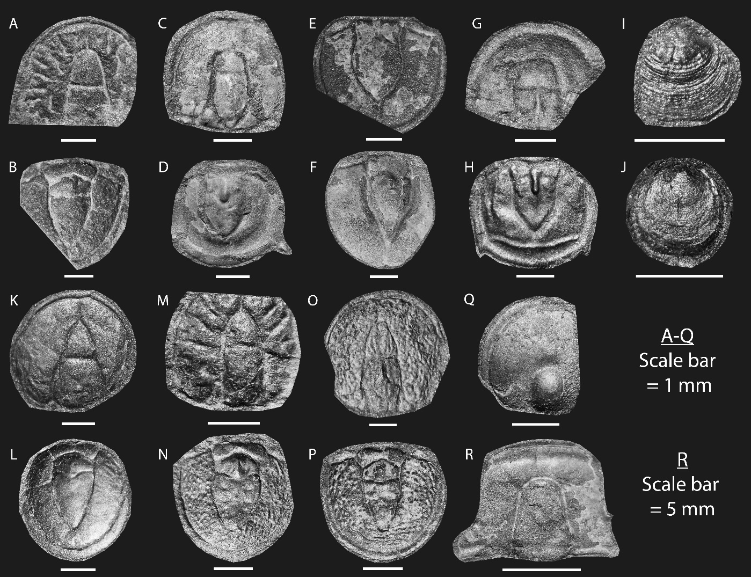

Figure S2: Agnostoids, trilobite and brachiopods from the Albjära-1 core. A-B – Acidusus atavus = Ptychagnostus atavus³⁵. C-D – Acadagnostus ferox (Tullberg, 1880)³⁵. E – Svenax pusillus? (Tullberg, 1880)³⁵. F – Doryagnostus incertus (Brøgger, 1878)³⁶. G-H – Diplagnostus planicauda bilobatus Kobayashi (1939)³⁷. I-J – Brachiopods indet. K-L – Lejopyge lundgreni (Tullberg, 1880)³⁵. M-N – Ptychagnostus affinis (Brøgger, 1878)³⁶. O-P – Ptychagnostus punctuosus (Angelin, 1851)³⁸. Q – Hypagostus sp. (mammillatus (Brøgger, 1878) or parvifrons (Linnarsson, 1869))^{36,39}. R – Parasolenopleura linnarssoni (Brøgger, 1878)³⁶.

Concerning the base of L. laevigata Biozone, in Baltica, this Biozone is inferred to coincide with the base of the local Solenopleura brachymetopa Biozone that corresponds to the base of the Andrarum limestone in Scania^{4,8,13,40}. The base of the Andrarum limestone in the ACL is located at 76.305 m.
Concerning the P. atavus Biozone, we identified the lowest occurrence of P. atavus at 89.695 m. However, In Baltica and Siberia, the lower part of the P. atavus Biozone coincides with the Tomagnostus fissus Biozone^{4,20,41}. T. fissus is identified by in the Albjära-1 core at ~ 90.295 m (~ 229.3 m in Lauridsen⁴²) allowing the delineation of the Wuliuan – Drumian boundary in the ACL

    - Preservation of the carbon isotope signal
In the ACL, the δ¹³C_{org} values recorded fall within the expected range of Cambrian values, suggesting a limited metamorphic imprint on the organic carbon isotopes^{43,44} (Fig. S3A).
To assess the primary organic signal preservation is to examine the correlation between the δ¹³C_{org} and TOC values⁴⁵⁻⁴⁷. The absence of a statistically significant and positive trend (R² = 0.08, Fig. S3B) between δ¹³C_{org} and TOC suggests that δ¹³C_{org} signal is preserved.
The analysis of Rock-Eval derived HI/OI ratio and T_{max} can be conducted to estimate the thermal maturity of the organic carbon data⁴⁸. According to Peters⁴⁸ the interpretation of T max is valid only if S₂ peak values are above a threshold value of 0.2. In ACL, 73 of the S₂ peak values, obtained through Rock-Eval pyrolysis, are superior to the 0.2 threshold (see Table S2). However, the pyrograms resulting from Rock-Eval analysis show that the S₂ peaks are tricky to identify which makes HI values extremely low. Consequently, the T_{max} values cannot be used with sufficient confidence and will not be discussed. Nonetheless, Based on Buchardt and Lewan⁴⁹, Sanei, et al.⁵⁰ and Zhao, et al.⁵¹, the ASF have experienced T_{max} around 400°C indicative of late diagenesis to low grade metamorphic conditions. The average reflectance of vitrinite-like particles is 2.1% Ro - dry gas window - measured on five samples from the Tremadocian to Furongian interval⁵². Concerning the HI/OI ratio, the majority of the data, exhibiting both a low HI and OI values, are located in the lower left corner of a modified pseudo van Krevelen diagram confirming that the organic matter (OM) of the rocks is mature to overmature⁴⁸.
The clay mineral assemblage in the <2 μm size fraction along the ACL (Fig. S3C) is composed primarily of illite (38–68%), chlorite (24–48%), and illite–smectite mixed-layer phases (IS) containing 10–21% smectite layers. Illite–smectite mixed layers are present in all samples, and their smectite content was estimated following the method of Moore and Reynolds²⁶. The average smectite content of the IS fraction is approximately 16%. These mixed-layer clays represent intermediate transformation phases in the progressive conversion of smectite to illite, a process known as illitization, and are indicative of deep diagenetic to anchizone conditions. The degree of illite crystallinity, expressed through the Kübler Index⁵³, calculated on the <2 μm fraction, ranges from 0.32 to 0.40 Δ°2θ, suggesting deep diagenesis extending into the base of the anchizone. These values correspond to paleotemperatures potentially reaching but not exceeding ~300 °C, which implies a burial depth of approximately 4–6 km, assuming a geothermal gradient of 25–30 °C/km (see also Schovsbo, et al.⁵⁴ for 1D thermal models of the area). The absence of kaolinite and smectite is consistent with these interpretations. Supporting geochemical data from Rock-Eval pyrolysis reveal low Hydrogen Index (HI) values (2–60 mg HC/g TOC) and elevated Tmax values (>450 °C), both of which are characteristic of advanced kerogen transformation and burial-related thermal maturation.

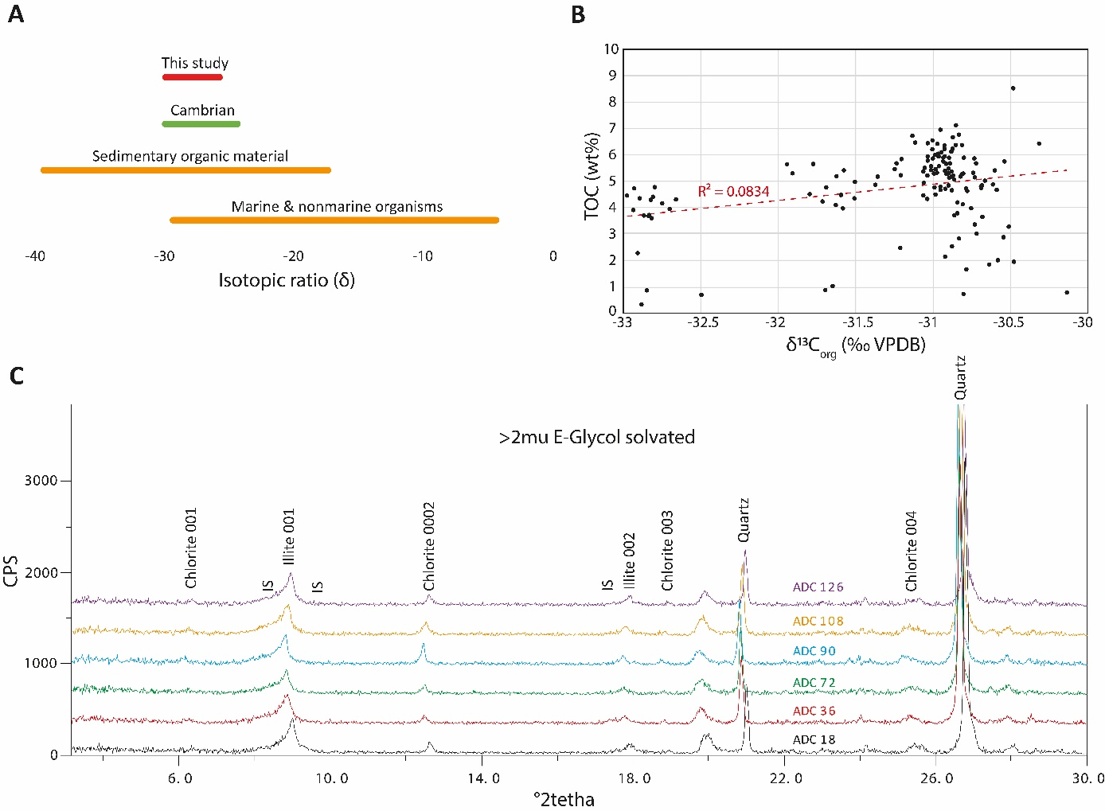
Figure S3: Signal preservation and organic matter maturation. A – δ¹³C_{org} range in the different reservoir integrating value range of the Cambrian period and this study; B – TOC versus δ¹³C_{org} graph; C – XRD graphs and identification of the clay minerals
  - Geochemical events and global correlations
    - Identification of the DICE event in Baltica
The Drumian Carbon isotope Excursion (DICE) is defined as a negative CIE situated approximately at the base of the Drumian Stage^{20,55,56}. The excursion peak typically records δ¹³C_{carb} values around -2 ‰, though it can vary from -1 ‰ in West Gondwana⁵⁷ up to -4 ‰ in Siberia and East Laurentia^{58,59}. The DICE, based on chemo- and biostratigraphic data, roughly correspond with the Wuliuan – Drumian stage boundary in South China^{46,56,60,61}, North China⁶²⁻⁶⁴, Tarim^{65,66}, Laurentia^{55,59,67-69}, Siberia⁵⁸, North Gondwana^{70,71}, West Gondwana⁵⁷, and potentially East Gondwana^{72,73}.
The first appearance datum (FAD) of the agnostid Ptychagnostus atavus (= Aciduscus atavus) is the criterion used to define the Wuliuan – Drumian boundary^{20,55}. In the Albjära-1 core, the lowest occurrence of P. atavus is identified at ~ 90.295 m allowing the delineation of the Wuliuan – Drumian boundary in the ACL (see section 2.1.1. Fossils identification).
Due to the combination of high TOC and low carbonate content in the core, only δ¹³C_{org} data could be obtained. However, δ¹³C_{org} alone is not typically sufficient for global chemostratigraphic correlation, as δ¹³C_{carb} is the standard reference in such comparisons. This makes direct correlation with global records more challenging. However, several studies indicate that the global trends in both δ¹³C_{carb} and δ¹³C_{org} data fluctuate simultaneously in response to major perturbation in the carbon cycle such as the DICE^{46,57,64}.
The precise location and identification of the DICE in Baltica is unclear in the literature and global chemostratigraphic correlations are difficult. To address this issue and identify the DICE in the ACL we compared our δ¹³C_{org} data with the studies of Ahlberg, et al.⁵, Álvaro, et al.¹⁴, Lehnert, et al.¹⁵, Lundberg¹⁶, and Shembilu and Azmy⁵⁹ conducted in Baltica and surrounding areas (Fig. S4).
The data published in Ahlberg, et al.⁵ for the Andrarum-3 drill core (Scania, Baltica) display some similarities such as: a plateau of value around - 30.2‰ in the G. nathrosti and P. punctuosus biozones, then a slightly positive shift up to - 30‰ is observed in the upper P. atavus Biozone before the values shift back to more negative values. The peak of the excursion is ~ - 30.5‰. However, it is difficult to correlate precisely our data with the one presented in Ahlberg, et al.⁵ as a “U” shape excursion is not observed in the Albjära-1 core hindering the precise identification of the DICE, and the sampling rate is significantly different, ~1 m in Ahlberg, et al.⁵ vs 15 cm in this study. In addition, based on the correlation with the stratigraphic column established by Westergård¹¹ for the Andrarum-1 borehole (200 m away from Andrarum-3 borehole), the excursion observed in Ahlberg, et al.⁵ is located in the middle of the P. atavus Biozone. The comparison with other sections in Baltica (Fig. S4) reveals that the weak amplitude (< 0.5‰) combined with the different positioning of the excursion (middle P. atavus vs P. gibbus) of Ahlberg, et al.⁵ is unlikely to be the DICE.
In Álvaro, et al.¹⁴, Brantevik section (Scania, Baltica), a negative excursion of 9‰ amplitude in δ¹³C_{carb} is identified between the Exsulans and Forsemölla Limestones Beds (Fig. S4). However, as elucidated by Álvaro, et al.¹⁴, the few data points delineating this negative excursion are situated below and above unconformities/discontinuities. The combination of the limited data points and the presence of unconformities hamper a reliable identification of this excursion as the DICE.
In Lehnert, et al.¹⁵, Almbacken drill-core (Scania, Baltica), a prominent δ¹³C_{org} negative excursion is identified between the Exsulans and Forsemölla Limestones Beds in a trilobite/agnostoid barren interval, with a peak value at ~ -33‰ (Fig. S4). This excursion, located in the P. gibbus Biozone, is followed by a positive shift of 1.5‰. Our δ¹³C_{org} curve is similar to the unpublished curve of Lehnert, et al.¹⁵.
In Lundberg¹⁶, Tomten-1 core (Västergötland, Baltica), a prominent δ¹³C_{org} negative excursion is identified below the Exsulans Limestone, in the P. gibbus Biozone, with a peak value at ~ -33.75‰ (Fig. S4). This excursion is followed by a 2‰ positive shift. Our δ¹³C_{org} curve is similar to the curve of Lundberg¹⁶.
In Shembilu and Azmy⁵⁹, NF-02 core (Newfoundland, East Laurentia), the observe trend in the δ¹³C_{org} record present the same overall morphology to what is observed in the Albjära-1 core (Fig. S4). However, some differences can be noted: 1) the Laurentian record is in δ¹³C_{carb} and therefore not directly comparable to the δ¹³C_{org} presented in this study; 2) the sampling rate is significantly different, ~ 5m in Shembilu and Azmy⁵⁹ VS 15 cm in this study; 3) the base of the P. atavus Biozone is located on the upper shoulder of the excursion in Shembilu and Azmy⁵⁹ compared to this study where it is located close to the maximum of the CIE immediately above the -33‰ negative plateau.
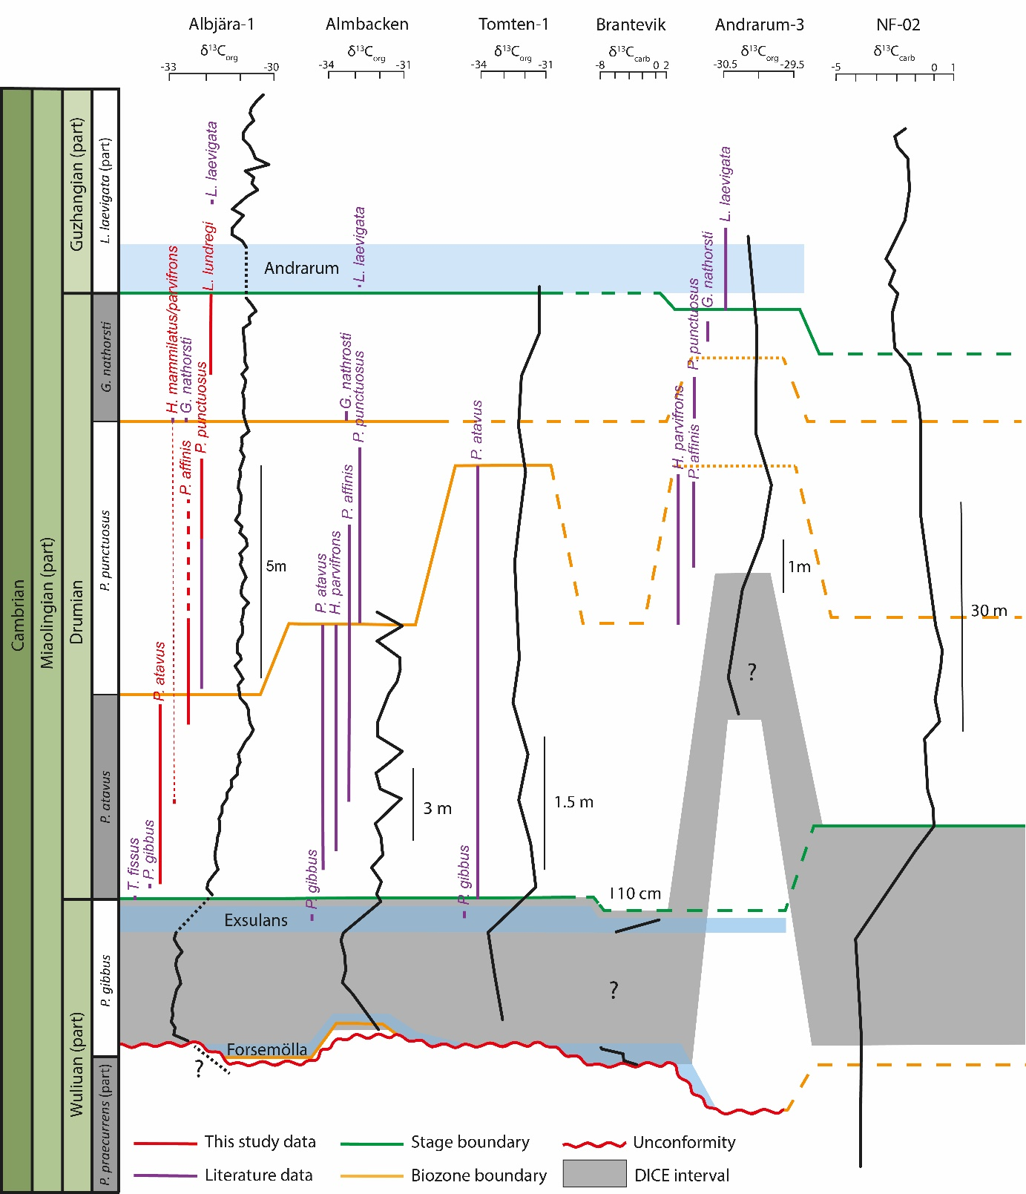

Figure S4: Comparison of the localities that recorded the DICE in the surrounding of the Baltic craton. Albjära-1 (this study); Almbacken¹⁵; Tomten-1¹⁶; Brantevik¹⁴; Andrarum-3⁵; NF-02⁵⁹. For Baltica localities, the base of the Andrarum and Exsulans Limestones Beds have been used to tie and compare the carbon isotope curves.

  - Time series analysis
    - Proxy selection
This study focuses on the detrital element to identify Milankovitch cycles in the Miaolingian Series of Baltica in the Albjära-1 core ranging from 63.273 to 95.611 m. The detrital elements measured in this study (73.452-95.611 m) are Al, Si, Ti, K and Zr. Amongst the detrital elements, only Al, Ti and Si data are covering the entire Miaolingian Series in the Albjära-1 core as K and Zr are not presented in the supplementary file of Zhao, et al.² for the 63.273 - 73.452 m portion of the ACU.
In this study, Ti was preferred due to its better expressed cyclicity, its short residence time (< 1 kyr) in the ocean, its inert behavior to redox change in seawater, and its invariance to any type of biological cycles (not essential element for life)^{74,75}.
Ti is preferred to Al to avoid any misinterpretation due to the light mass of Al element making it close or below the limit of detection of the XRF core scanner technique.
Ti is preferred to Si to avoid any cps to % errors in the calibration of the Si data, as in the acid digestion procedure for ICP-MS, Si was not measured (due to the digestion method). However, we recalculated the Si concentration (in %) as follows: Si = 100% - concentration (in %) of the other elements.
Liu, et al.⁷⁵ demonstrated that during late diagenesis (high thermal maturity) of black shales, Ti can be partially solubilized which could lead to misinterpretation of the XRF results. However, the porosity in such rocks is limited, and so is the migration of Ti that precipitate rapidly, minimizing the possible errors in interpreting the results^{75,76}.

    - Cyclicity in the signal
The identification of any visible cyclicity or unconformity in the signal for detrital elements, through an overview of the tendencies observed in the depth domain, is recommended by Sinnesael, et al.⁷⁷ prior performing time series analysis.
In this study, GR and resistivity curves along the ACL exhibit patterns consistent with variations in detrital proxies (Ti, Si, Al, K), suggesting minimal post-depositional alteration (Fig. S5) and supporting their use in time-series analysis.

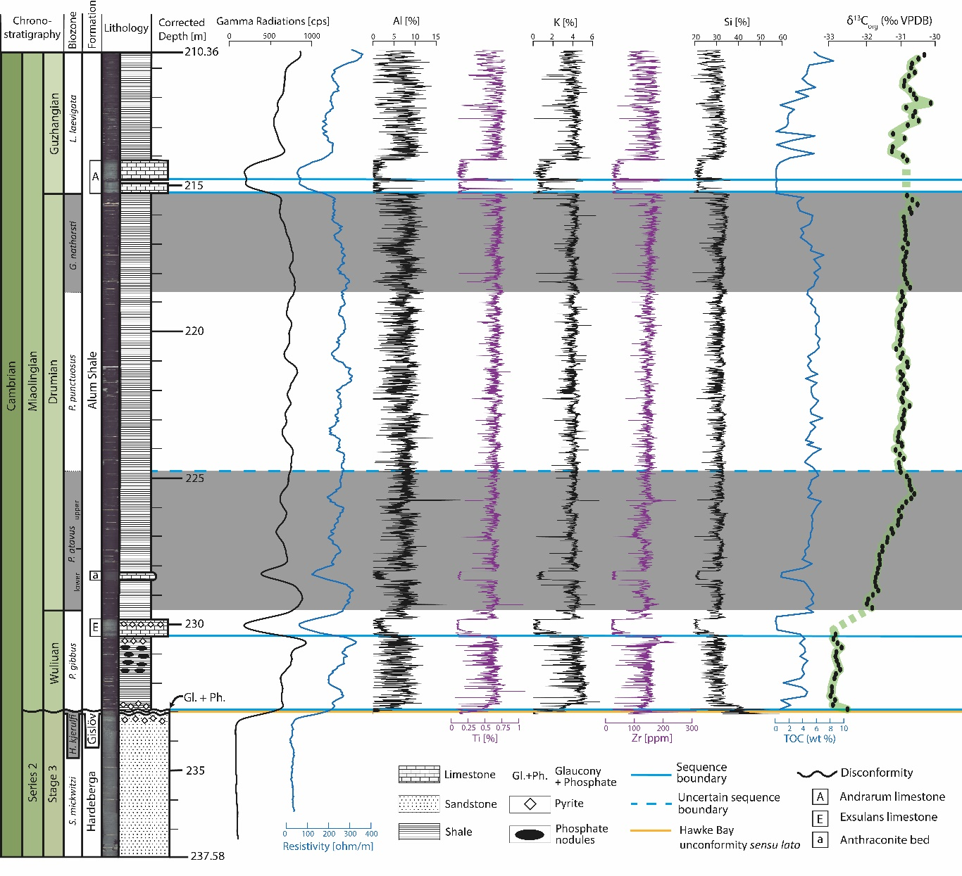

Figure S5: Visualization of the variations in depth domain of Gamma Radiation (GR), Formation Resistivity, detrital elements (Al, Ti, K, Zr, Si), TOC and δ¹³C_{org} curves along the Alum Shale part of the ACL. The depths are corrected by adding +0.18 m to fit with the GR and resistivity curves. Well log curves are from Schovsbo and Nielsen⁴.

    - 173 kyr identification
To evaluate and validate the record of the 173 kyr cycle in the signal in the ACL we carried out a careful study and comparison of literature, MTM, EHA, Ratio of frequencies and ASM results.
The 173 kyr long obliquity cycle is thought to arise from modulation in orbital inclination, which is driven by interactions between obliquity-related secular frequencies s3 and s6, associated with the orbital motions of Earth and Saturn, respectively^{e.g.,78-80}.
Zeebe and Kocken⁸¹ outlined that the I₁₇₃ metronome can fluctuate or alternate between ~151 kyr (s4-s6) to ~173 kyr (s3-s6) due to variations in the s3 and s4 secular frequencies and suggested that the I₁₇₃ can be used exclusively in sections where s3 and s4 appear stable, and not for extended periods.
The 405 kyr long-eccentricity metronome is usually preferred due to its enhanced stability over time. However, as explained by Laskar⁸⁰ and Zeebe and Lantink⁸², this cycle is not always observable, and its stability is questioned for sedimentary records older than a few hundreds of millions of years.
In the ACU, Zhao, et al.² identified the 405 kyr with confidence in the Furongian Series (1.75 to 3 m periodicities). In the Guzhangian Stage, the 405 kyr cycle is still occurring but show a decreasing power and becomes difficult to accurately identify in the EHA supplementary Fig. 4 in 2. In our data, spanning the early Guzhangian to late Wuliuan, the power of the 1.75-3 m cycle interpreted as the 405 kyr eccentricity is weak to nearly absent. In contrast, whereas other orbital components identified by Zhao, et al.² are clearly expressed in similar frequency bands. The weakness of the 405 kyr cycle in our record may be attributed to its predicted instability during this period⁸¹. In addition, in the astronomical solution R44 from Zeebe and Lantink⁸², at 528 Ma, the 405-kyr cycles is observed but its dampening in power compared to the short-eccentricity. This is similar to what we observed in the MTM of all the detrital elements. Due to the high latitude positioning of Baltica during the Miaolingian, this dampening in power, predicted by the R44 astronomical solution, would result in an even weaker expression of the 405 kyr cycle. While in high latitude localities, the 405 kyr cycle can appear weak compared to other cycles, in Lower Cambrian strata from localities near the equator, the 405 kyr cycle has been observed with a strong power^{83,84}.
The weakness of the 405 kyr observed in our dataset could also suggest that the presence of the 405 kyr cycle may be episodic, perhaps depending on when the cycle became stable during the Cambrian. This hypothesis remains to be tested and would require expanded stratigraphic coverage across the entire Cambrian and various paleogeographic settings.

      - MTM and EHA
The 2π MTM spectrum of the detrital elements resulted in the identification of significant frequencies matching with the observation presented in Zhao, et al.² and with the recalculation based on Wu, et al.²⁷’s data (Fig. 5, 6AB, S6).

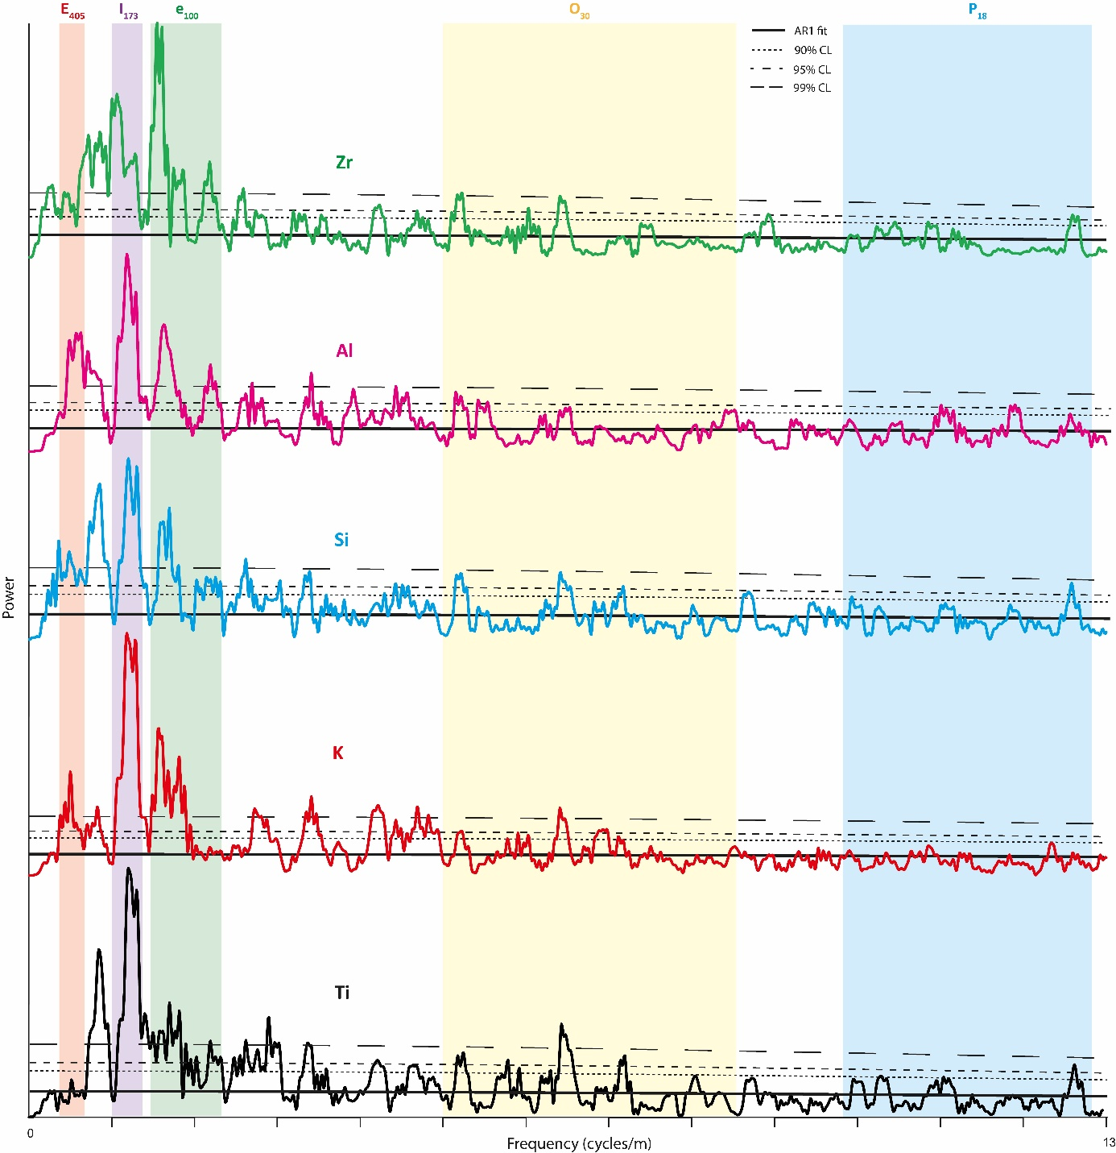

Figure S6: 2π MTM spectrum of the detrital elements (5 mm resampling and 20% LOWESS detrending) allowing the identification of Milankovitch bands.

While the MTM is a powerful tool, it does not allow us to evaluate whether the observed cyclicities occur continuously throughout the record or if it corresponds to repeated isolated events (not linked to Milankovitch forcing). To identify the continuity of the cycles, on the Ti record, we used the EHA method which confirms the presence of eccentricity, obliquity and precession in the signal (Fig. 5). Similar observations as shown in EHA are observed in the CWT (Fig. S7).

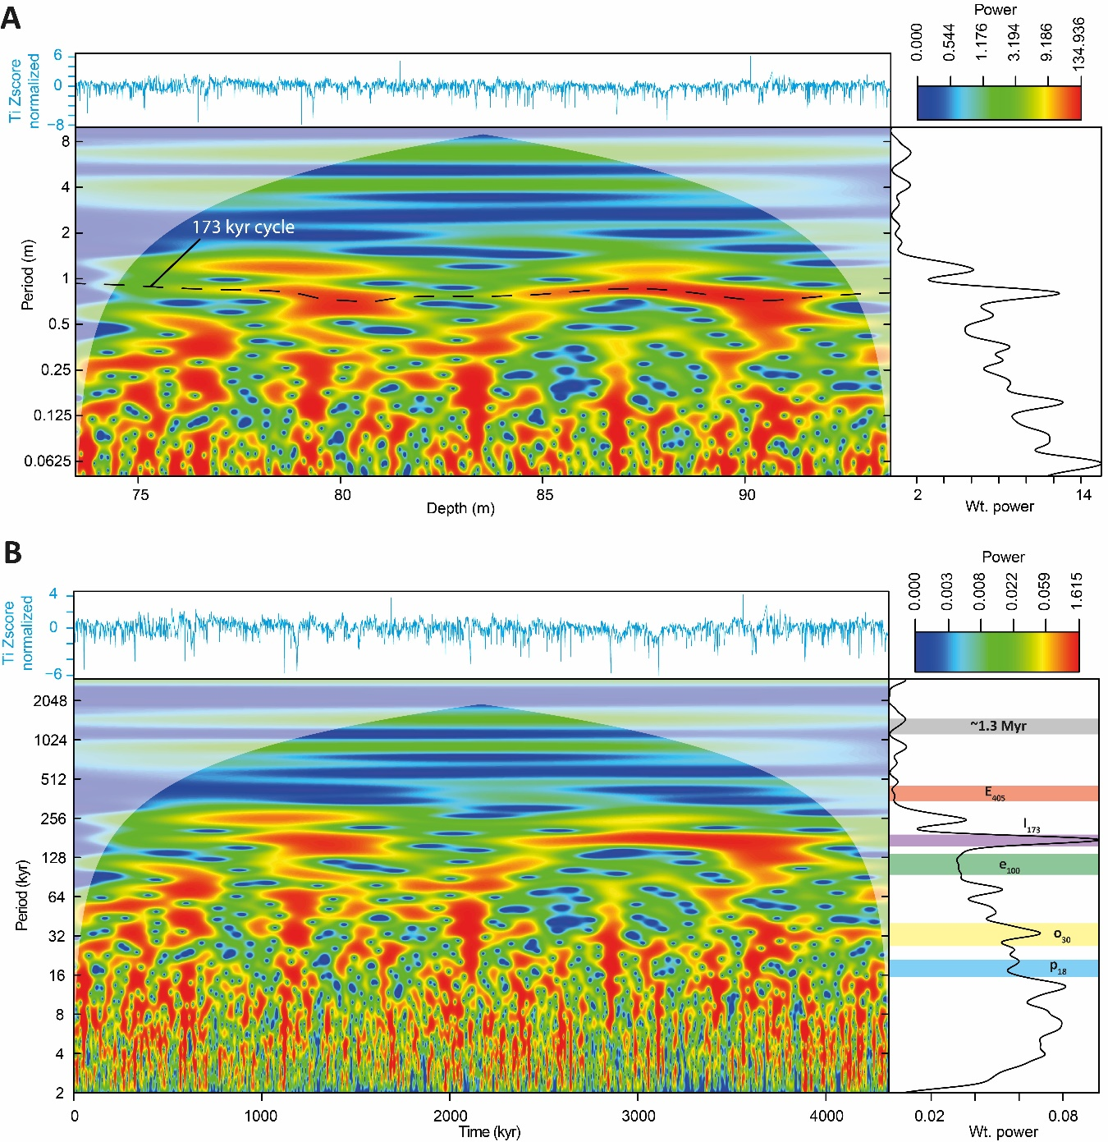

Figure S7: CWT in depth and time domains. A – Depth domain. B – Time domain.

      - Zhao et al (2022)’s supplementary data
The spectral analysis of MTM, EHA, and CWT revealed that in the 1-1.35 cycles/m band of the ACL, assumed to correspond to the I₁₇₃ cycle, the power is above 99 % CL.
To verify that it is not an artifact, we compared our results with the data presented in Zhao, et al.². In their work, while strong obliquity is identified, they did not identify the 173 kyr cycle. However, we notice a significant peak with a power slightly above the 90 % CL in a 1 and 1.5 cycles/m band in the Guzhangian – Paibian interval (subset IV) of their supplementary figure 4.
We interpret that this amount of power in a band close to our observation (1-1.32 cycles/m) is likely to represent the I₁₇₃ cycle. The presence of the I₁₇₃ up to the Paibian Stage confirms that what we observe is unlikely to be an artifact due to data preparation and acquisition.

      - Ratio of frequencies
The comparison of the > 90% CL frequency ratios with the I₁₇₃ was conducted on a total of 11 frequencies estimated to correspond to long and short eccentricity, obliquity and precession bands. The analysis revealed that all the 11 frequencies align on a line (r² = 0.9997) ranging from 0 kyr to 173 kyr suggesting a reliable attribution of these frequencies to their corresponding astronomical cycles (Fig. S8).
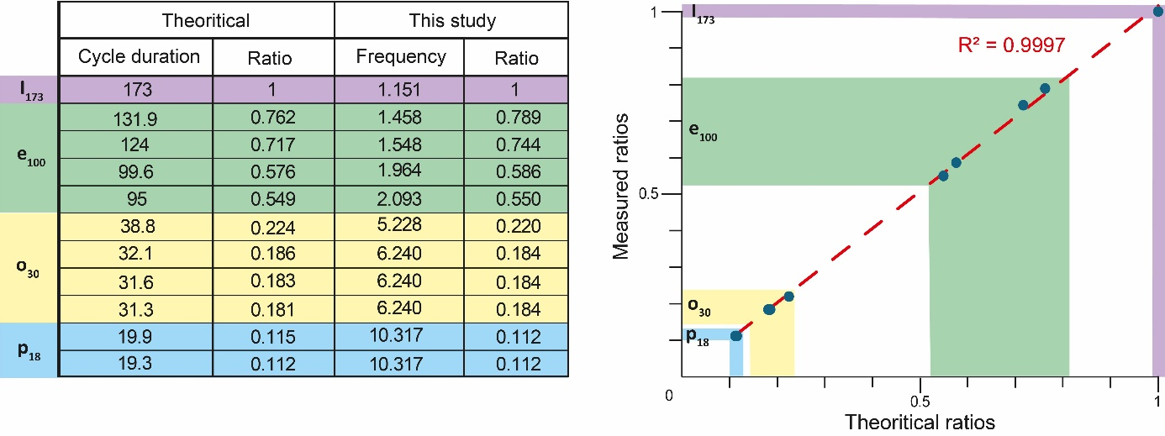

Figure S8: ratios of frequencies

      - ASM and average sedimentation rate
The ASM analysis was conducted, on the untuned dataset, by comparing the frequencies > 90% CL located within Milankovitch bands with 17 Milankovitch frequencies from the literature for long and short eccentricity, obliquity and precession cycles (see Table S4 for more information).
This resulted in an average sedimentation rate of 0.493 cm/kyr (Fig. S9) that perfectly matches the 0.4-0.6 cm/kyr excepted sedimentation rate for the Alum Shale Formation i.e., 2,3,18. The concordance of the ASM with the literature suggests a reliable identification of the astronomical cycles including the I₁₇₃.

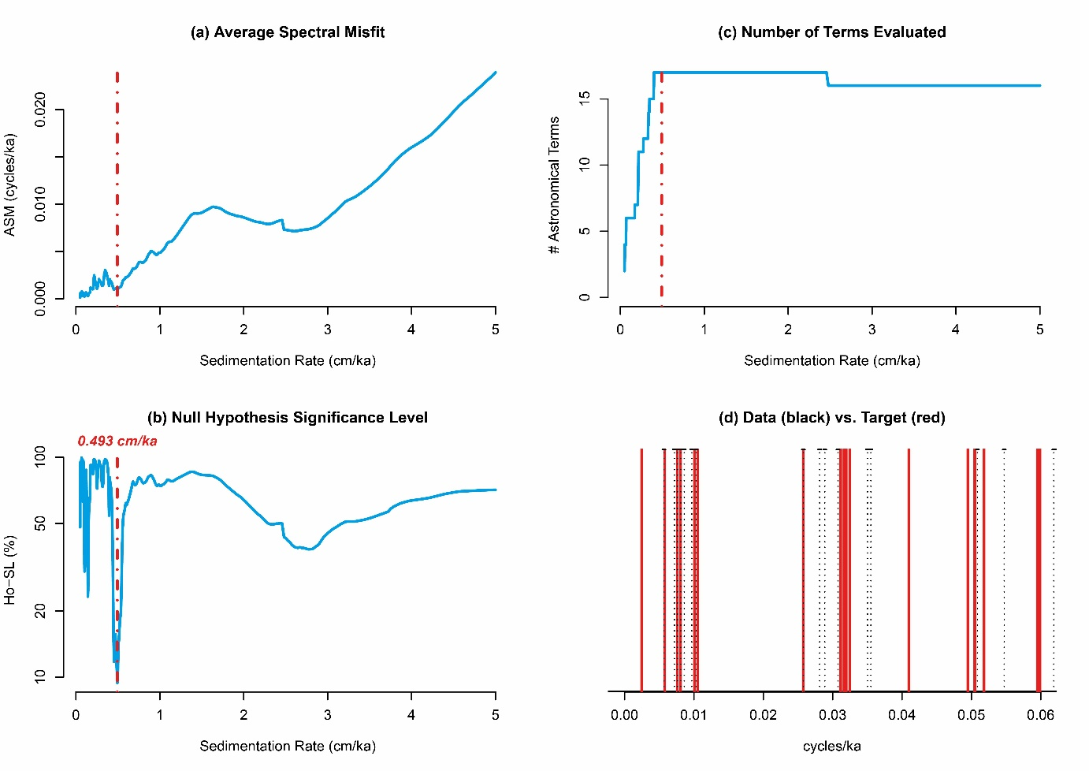

Figure S9: Average Spectral Misfit analysis performed on 17 Milankovitch-band frequencies targets.

When filtering and tuning, to the 173 kyr cycle, the minima of the tracked frequency band (0.76-1m) for Al, Si, Ti, and K detrital elements in CWT, we were able to calculate sedimentations rates for all of the detrital elements (Fig. S10) and it resulted in a mean sedimentation rate of 0.465 cm/kyr, in line with the 0.493 cm/kyr ASM estimation and the literature.
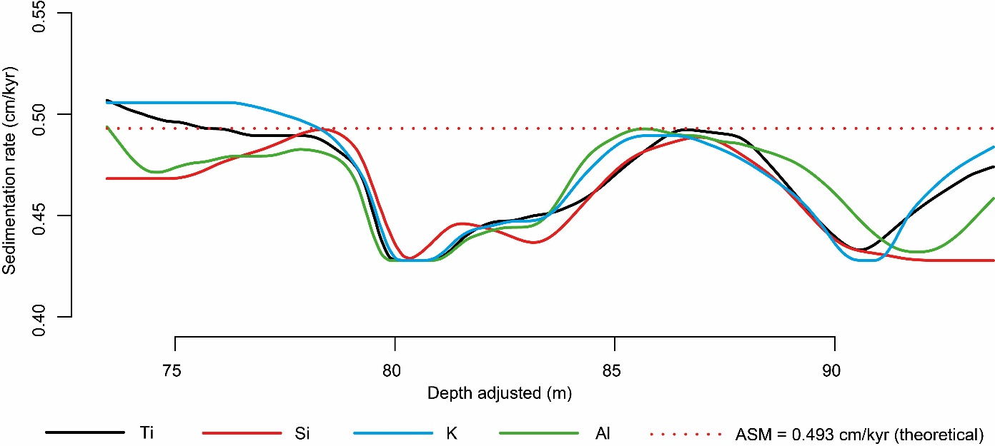

Figure S10: Sedimentation rate of the detrital elements and comparison with the ASM expectation.

    - Age-depth model
The tracking of the powerful 0.76-1m band (=173-kyr cycle) in CWT for Al, Si, Ti, and K elements allows us to build a depth model of the tracking of the 173-kyr cycles with a reduced period uncertainty (Fig. S11).
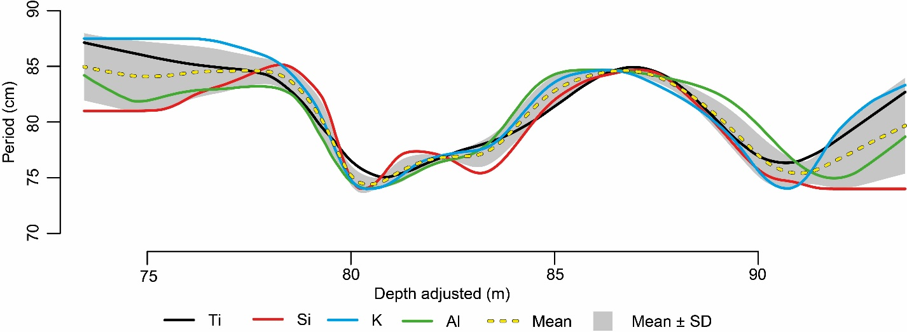

Figure S11: tracking of the 173 kyr in depth model for four detrital elements.

The tuning to the 173 kyr cycles of our depth model allows us to build an age-depth model with a reduced cumulative uncertainty of maximum ± 167 kyr over the 4.3 Myr recorded in the core (Fig. S12).
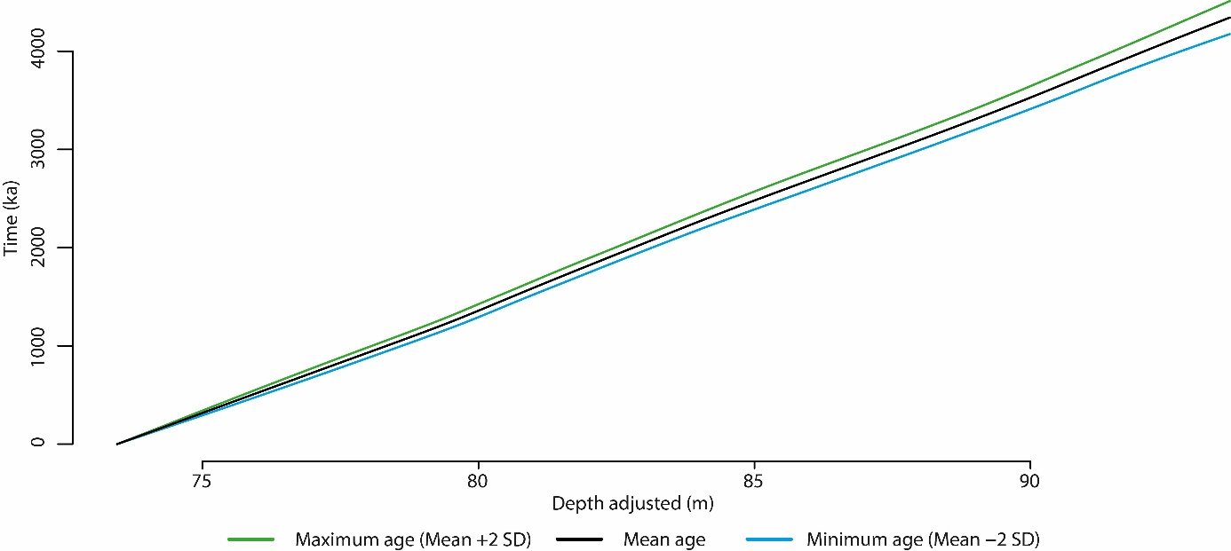

Figure S12: Robust age-depth model with low cumulative uncertainty.

    - Hilbert modulation analysis
Based on the literature and the spectral analysis observations (MTM, EHA, CWT, ratios), a strong obliquity signal is present in the ACL. In theory, both the I₁₇₃ cycle and the ~ 1.2 Myr long obliquity cycles result from the modulation of the obliquity band^{e.g.,78,80,85} therefore to test the phase relationship between the obliquity band, the I₁₇₃ cycle, and the ~ 1.2 Myr cycle, we conducted amplitude modulation analysis using Hilbert transform. This brings an additional supporting line to the reliable identification of the Inclination metronome.
To test the phase relationship between the obliquity band and the I₁₇₃ metronome, both these cycles were isolated using a Taner filter respectively of 28-40 kyr and 155-195 kyr (Fig. 6C). The amplitude modulation of the obliquity band was extracted using the Hilbert transform function. The I₁₇₃ metronome cycle was then isolated from the obliquity-extracted amplitude modulation and compared to the I₁₇₃ metronome cycle isolated from the dataset. This analysis revealed that the lower part of the ACL (1.8-4 Myr) exhibits a phase relationship between obliquity and I₁₇₃ suggesting a reliable identification of the I₁₇₃ cycle. However, in the upper part of the ACL (0-1.8 Myr), a limited antiphase relationship in the obliquity that tend to diminish over time is observed. This antiphase relationship is sudden and start at ~ 1.8 Myr. This shift could be linked to 1) a bad preservation of the obliquity signal; 2) an unseen gap in the sedimentary record that would have vanished few obliquity cycles disrupting the Hilbert envelope; 3) an overlapping in the obliquity band of other events at ~1.8 Myr; 4) a non-direct response of the environment to obliquity forcing.
To test the phase relationship between I₁₇₃ (155-195 kyr) and the ~ 1.2 Myr cycles (1150-1300 kyr) on the non-detrended time series, the same protocol as explain above was conducted (Fig. 6C). This results in a phase relationship along the ACL between the two cycles suggesting a reliable identification of the I₁₇₃ cycle.
On a long time scale (173 kyr – 1.2 Myr cycles comparison), a phase relationship is observed for the entire ACL in the whereas, at a shorter time scale (obliquity – 173 kyr cycle comparison), a limited antiphase relationship is observed. This observation is in favor of a local and limited perturbation of the obliquity record as the long obliquity modulations are not significantly affected.

    - Astronomical forcing from Obliquity to Eccentricity dominated intervals
The filtering and analysis of the Milankovitch bands, in time domain, reveal that three intervals can be distinguished in the Ti series (Fig. S13). From 497.085 to ~499.4 Ma, the signal appears to be dominantly modulated by long and short eccentricity cycles rather than by obliquity which is present but does not dominate the signal (Fig. S13A). From ~499.4 to ~500.3 Ma, the dominant Milankovitch cycle modulating the signal is difficult to identify and this interval is interpreted as a progressive transition from eccentricity to obliquity-dominated signal (Fig. S13B). From ~500.3 to 504.154 Ma, the signal is obliquity-dominated and the main Milankovitch cycle modulating the signal is the 173 kyr cycle (Fig. S13C).

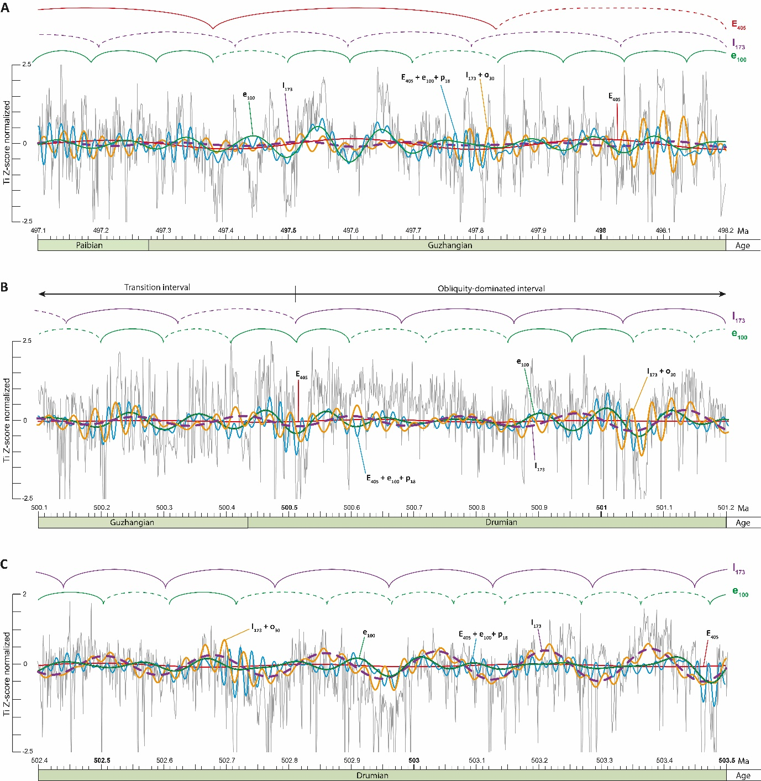

Figure S13: Close-up view of selected part of the eccentricity-dominated (A), end of the transition zone (B), and obliquity dominated (C) intervals observed in the tuned Ti series (Z-score).

  - Astronomically-tuned age model for the Miaolingian Series
    - Duration estimates of Biozones
Based on our astronomical time scale, the duration of the Ptychagnotus forchhammeri Biozone (L. laevigata + Agnostus pisiformis biozones) is estimated at 3.165 Myr, consistent with the ~3 Myr extrapolation proposed by Zhao, et al.². The Goniagnostus nathorsti Biozone is estimated to span 691 ± 24 kyr, closely matching the ~676 kyr duration estimated by Fang, et al.⁸⁶ for its equivalent interval (G. nathorsti + Lejopyge armata biozones) at the Guzhangian GSSP in South China. The Ptychagnostus punctuosus Biozone is estimated to represent 1,326 ± 32 kyr in duration. The Ptychagnostus atavus Biozone span 992 ± 22 kyr. The Ptychagnostus gibbus Biozone (part) is estimated to last 746 ± 49 kyr.
    - Duration estimates of the Miaolingian Series, Stages and events
      - Duration of Series and stages
The identification of Wuliuan, Drumian and Guzhangian boundaries allows to delineate the Miaolingian Series in the Labjära-1 core. The Guzhangian – Paibian boundary is defined by the FAD of the agnostid Glyptagnostus reticulatus coinciding with the onset of the SPICE^{20,87,88}, which in Baltica corresponds to the base of Olenus Biozone^{2,89}, is identified at 62.273 m (= 497.277 +1.2/-0.9 Ma). The Guzhangian – Drumian boundary coincides with the base of the Andrarum limestone located at 76.306 m (= 500.443 ± 0.941 Ma).
Therefore, the Guzhangian Stage is estimated to span approximately 3.165 Myr. This ~3 Myr duration is in line with the extrapolation proposed by Zhao, et al.². Our estimate for the base of the Guzhangian Stage (~ 500.44 Myr) closely aligns with the age estimation of ~ 500.5 Ma reported in both GTS 2020²⁰ and ICS 2024/12 timescale⁹⁰. However, recent studies from Laurentia^{91,92} suggest a significantly younger age of ~494.4 Ma for the upper boundary of the Guzhangian Stage. This estimate, derived from maximum deposition ages of detrital zircons, is somewhat less precise than radiometric ages from ash beds but offers useful chronostratigraphic constraint.
The nearly 3 Myr difference was already pinpointed by Cothren, et al.⁹¹, in which they stated that this difference between the maximum age deposition (MAD) and the ATS study of Zhao, et al.² is likely due to an incorrect tuning during the cyclostratigraphic study.
In 2022, when these MADs and ATS data were the only one available, this explanation was plausible as the duration estimates of Drumian and Wuliuan stages were not precisely time constraint due to the limited radioisotope ages located within the Drumian Stage that serves to calibrate the entire Miaolingian Series. Nonetheless, the ~494.4 Ma age for the upper Guzhangian boundary would have resulted in the base of the Drumian to be at ~501.9 Ma and the base of the Wuliuan to be at ~ 506.4 Ma, if the GTS 2020 stage durations estimate are correct (Guzhangian ~ 3.5 Myr; Drumian ~ 4.0 Myr; Wuliuan ~ 4.5 Myr)²⁰. While the base of the Wuliuan would be in line with the ~506.3 Ma recent estimate for the Series-Miaolingian boundary from Karlstrom, et al.⁹³, Sundberg, et al.⁹⁴, Landing, et al.⁹⁵, the base of the Drumian Stage would significantly differs with the lowermost Drumian dated volcanic ash of 503.14 ± 0.13 presented in Landing, et al.⁹⁶.
In this study, after conducting the spectral analysis and building an ATS, we were able to give duration to the Drumian Stage (~3.0 Myr) and extrapolate on the duration of the Wuliuan Stage (~3.5 Myr), see after for more information. If we anchor our ATS to the U-Pb maximum deposition age at the base of the SPICE (494.35 ± 0.46 Ma) as reported by Cothren, et al.⁹¹, this results in the following age estimate: the base of the Guzhangian, Drumian and Wuliuan stages would be respectively at 497.55 ± 0.94 Ma, 500.75 ± 1.02 Ma and ~ 504.25 Ma. While these alternative ages are broadly in lines with the estimates proposed by Farrell, et al.⁹², they diverge from those adopted in the GTS 2020²⁰ and the ICS⁹⁰. On the contrary, when anchoring our ATS to the one presented in Zhao, et al.2, the base of the Guzhangian, Drumian and Wuliuan stages are respectively at 500.44 ± 0.94 Ma, 503.45 ± 1.02 Ma, ~ 506.9 ± 1.07 Ma. These ages are in accordance with the 503.14 ± 0.13 Ma and ~506.3 Ma ages for the lowermost Drumian and Stage 4 – Wuliuan boundary respectively.
Therefore, In this study, we preferred to anchor our ATS to the data published by Zhao, et al.², which offers a robust stratigraphic coherence and better aligns with current global and regional chronostratigraphic expectation.
To confirm the duration of the Paibian and Guzhangian stages, further studies should be conducted in Laurentia and other regions.
The Guzhangian – Drumian boundary is located at 76.306 m (= 500.443 ± 0.941 Ma) and the Drumian – Wuliuan boundary is identified at 90.295 m (= 503.451 ± 1.018 Ma). It result that the Drumian Stage is estimated at 3.009 ± 0.078 Myr in duration, which aligns with theoretical expectation proposed by Farrell, et al.⁹². However, our estimate is 1 Myr shorter than the duration suggested in the GTS 2020²⁰ and the ICS timescale⁹⁰. It has to be noted that only two radioisotopes ages have been integrated for the time estimate of the Drumian Stage in the GTS, one of them has an uncertainty of 2.4 Myr. Therefore, our estimate is reasonable and falls within the expected margin of error for current global standards. Our estimation of the base of the Drumian Stage (~503.45 Ma), closely match with the absolute age of 503.14 ± 0.13 Ma recorded in the base of the Drumian^{94,96,97}.
The preserved portion of the Wuliuan Stage located above the Hawke Bay Event sensu lato is estimated to 745.96 ± 48.9 kyr and the base of the Alum Shale Formation in the Albjära-1 core is estimated at 504.197 ± 1.067 Myr.
Summing the duration of the Wuliuan, Drumian, and Guzhangian stages yields a duration estimate of 6.92 +0.386/-0.167 Myr for the Miaolingian Series in the Albjära-1 core, ranging from 504.197 ± 1.067 Myr to 497.277 +1.2/-0.9 Myr. It is important to note that this estimate reflects an incomplete record in Baltica, as part of the Wuliuan has been eroded as a result of the Hawke Bay Event sensu lato.
According to the GTS 2020²⁰, the P. gibbus Biozone, which is nearly complete in the ACL, represent about one-fifth of the Wuliuan Stage and is estimated to last ~750 kyr if complete. If we extrapolate this proportion, the Wuliuan Stage would be ~3.5 Myr in duration. This places the base of the Wuliuan Stage at ~ 506.9 ± 1.1 Ma, which is 2 Myr earlier than the ~509 Ma estimate from the GTS 2020²⁰ and the ICS⁹⁰. Nonetheless, this earlier age is in line with the recent stratigraphic and geochronologic data from Karlstrom, et al.⁹³, Sundberg, et al.⁹⁴, and Landing, et al.⁹⁵ that estimate the base of the Wuliuan to be at ~506.3 Ma. Continued refinement through integrated approach, including cyclostratigraphy, radiometric dating and biostratigraphy will be essential to better constrain the lower boundary of the Miaolingian Series.

      - DICE event
The correlations presented in point “2.2.1 Identification of the DICE event in Baltica”, allows us to reliably identify the DICE in Baltica for which we estimate the duration to be ~750-800 kyr, essentially located within the P. gibbus Biozone. New cyclostratigraphic studies would be necessary to precisely delineate the timing of DICE in sections where the excursion is fully expressed and well constraint.
      - Other events
Based on the literature and our ATS, we were also able to estimate the time missing in the Albjära-1 core due to the Hawke Bay unconformity sensu lato. According to Nielsen and Schovsbo^{1,10}, the Læsa Formation is not recorded in northern and northeastern Scania. Consequently, there is no formations inbetween the top of the Hardeberga Formation (= base of the Schmidtiellus mickwitzi Biozone) estimate at ~ 518.5 Ma (GTS2020) and the base of the Alum Shale Formation (= Ptychagnostus gibbus Biozone) estimate in this study at 504.197 ± 1.07 Ma, the resulting time missing is estimate to ~13 Myr.

REFERENCES

1 Nielsen, A. T. & Schovsbo, N. H. The lower Cambrian of Scandinavia: Depositional environment, sequence stratigraphy and palaeogeography. Earth-Sci Rev 107, 207-310, doi:10.1016/j.earscirev.2010.12.004 (2011).
2 Zhao, Z. F. et al. Synchronizing rock clocks in the late Cambrian. Nat Commun 13, doi:10.1038/s41467-022-29651-4 (2022).
3 Nielsen, A. T. & Schovsbo, N. H. The Cambro-Ordovician Alum Shale Fm og Scandinavia: Distribution, depositional environment and stratigraphy. 1-58 (2013).
4 Schovsbo, N. H. & Nielsen, A. T. The Albjära-1, Gislövshammar-2 and Fågeltofta-2 scientific wells, Scania, southern Sweden. Biostratigraphy, log correlation and TOC analysis., Vol. 55 1-61 (2012).
5 Ahlberg, P. et al. Cambrian high-resolution biostratigraphy and carbon isotope chemostratigraphy in Scania, Sweden: first record of the SPICE and DICE excursions in Scandinavia. Lethaia 42, 2-16, doi:10.1111/j.1502-3931.2008.00127.x (2009).
6 Cederström, P., Geyer, G., Ahlberg, P., Nilsson, C. H. & Ahlgren, J. Ellipsocephalid trilobites from Cambrian Series 2 and Stage 4, with emphasis on the taxonomy, morphological plasticity and biostratigraphic significance of ellipsocephalids from Scania, Sweden. Fossil and Strata 67, 1-131, doi:10.18261/9788215065779-2022-01 (2022).
7 Hammer, O. & Svensen, H. H. Biostratigraphy and carbon and nitrogen geochemistry of the SPICE event in Cambrian low-grade metamorphic black shale, Southern Norway. Palaeogeogr Palaeocl 468, 216-227, doi:10.1016/j.palaeo.2016.12.016 (2017).
8 Weidner, T. & Nielsen, A. T. The Middle Cambrian Paradoxides paradoxissimus Superzone on Oland, Sweden. Gff 131, 253-268, doi:10.1080/11035890903189827 (2009).
9 Wolvers, H. M. & Maletz, J. The benthic graptolite (Opik, 1933) from the Middle Cambrian of Krekling, Oslo Region, Norway. Norw J Geol 96, 311-318, doi:10.17850/n096-4-02 (2016).
10 Nielsen, A. T. & Schovsbo, N. H. The regressive early-mid Cambrian 'Hawke Bay Event' in Baltoscandia: Epeirogenic uplift in concert with eustasy. Earth-Sci Rev 151, 288-350, doi:10.1016/j.earscirev.2015.09.012 (2015).
11 Westergård, A. H. in Lunds Geologiska Fältklubb 1892-1942, 185-204 (1942).
12 Nielsen, A. T. & Schovsbo, N. H. Cambrian to basal Ordovician lithostratigraphy in southern Scandinavia. B Geol Soc Denmark 53, 47-92 (2006).
13 Westergård, A. H. Agnostidea of the Middle Cambrian of Sweden. Sveriges Geologiska Undersökning Serie C 477, 1-141 (1946).
14 Álvaro, J. J., Ahlberg, P. & Axheimer, N. Skeletal carbonate productivity and phosphogenesis at the lower-middle Cambrian transition of Scania, southern Sweden. Geol Mag 147, 59-76, doi:10.1017/S0016756809990021 (2010).
15 Lehnert, O., Ahlberg, P., Calner, M. & Joachimski, M. M. The Drumian Isotopic Carbon Excursion (DICE) in Scania, southern Sweden : a mirror of the onset of the Marjumiid Biomere at a time of increased primary production? [Publication information missing], 172-174 (2013).
16 Lundberg, F. Cambrian stratigraphy and depositional dynamics based on the Tomten-1 drill core, Falbygden, Västergötland, Sweden. Dissertation in Geology at Lund University No. 462, 41 pp. (2016).
17 Zhao, Z. F. et al. Dynamic oceanic redox conditions across the late Cambrian SPICE event constrained by molybdenum and uranium isotopes. Earth Planet Sc Lett 604, doi:10.1016/j.epsl.2023.118013 (2023).
18 Sørensen, A. L. et al. Astronomically forced climate change in the late Cambrian. Earth Planet Sc Lett 548, doi:10.1016/j.epsl.2020.116475 (2020).
19 Geyer, G. A comprehensive Cambrian correlation chart. Episodes 42, 321-332, doi:10.18814/epiiugs/2019/019026 (2019).
20 Peng, S. C., Babcock, L. E. & Ahlberg, P. in Geological Time Scale 2020 Vol. 2 (eds F. M. Gradstein, J. G. Ogg, M. D. Schmitz, & G. M. Ogg) Ch. 19, 565-629 (Elsevier, 2020).
21 Landing, E., Webster, M. & Bowser, S. S. Terminal Ediacaran-Late Ordovician evolution of the NE Laurentia palaeocontinent: rift-drift-onset of Taconic Orogeny, sea-level change and 'Hawke Bay' onlap (not offlap). Geological Society, London, Special Publications 542, doi:10.1144/sp542-2023-4 (2023).
22 Palmer, A. R. & James, N. P. in The Caledonides in the USA Vol. 2 (ed D. R. Wones) 15-18 (Department of Geological Sciences, Virginia Polytechnic Institue and State University Memoirs, 1980).
23 Behar, F., Beaumont, V. & Penteado, H. L. D. B. Rock-Eval 6 technology: Performances and developments. Oil Gas Sci Technol 56, 111-134, doi:10.2516/ogst:2001013 (2001).
24 Spangenberg, J. E. & Herlec, U. Hydrocarbon biomarkers in the Topla-Mezica zinc-lead deposits, northern Karavanke/Drau Range, Slovenia: Paleoenvironment at the site of ore formation. Econ Geol 101, 997-1021, doi:10.2113/gsecongeo.101.5.997 (2006).
25 Spangenberg, J. E. Bulk C, H, O, and fatty acid C stable isotope analyses for purity assessment of vegetable oils from the southern and northern hemispheres. Rapid Commun Mass Sp 30, 2447-2461, doi:10.1002/rcm.7734 (2016).
26 Moore, D. M. & Reynolds, R. J. X-ray Diffraction and the Identification and Analysis of Clay Minerals. 332 pp (1989).
27 Wu, Y. J., Malinverno, A., Meyers, S. R. & Hinnov, L. A. A 650-Myr history of Earth's axial precession frequency and the evolution of the Earth-Moon system derived from cyclostratigraphy. Sci Adv 10, doi:10.1126/sciadv.ado2412 (2024).
28 Bluman, A. G. Elementary statistics: a step by step approach. 9th edn, (2014).
29 Wang, X., Liesaputra, V., Liu, Z., Wang, Y. & Huang, Z. An in-depth survey on Deep Learning-based Motor Imagery Electroencephalogram (EEG) classification. Artif Intell Med 147, 102738, doi:10.1016/j.artmed.2023.102738 (2024).
30 Wu, H., Hayes, M. J., Weiss, A. & Hu, Q. An evaluation of the Standardized Precipitation Index, the China-Z Index and the statistical Z-Score. Int J Climatol 21, 745-758, doi:10.1002/joc.658 (2001).
31 Thomson, D. J. Spectrum Estimation and Harmonic-Analysis. P Ieee 70, 1055-1096, doi:10.1109/Proc.1982.12433 (1982).
32 Torrence, C. & Compo, G. P. A practical guide to wavelet analysis. B Am Meteorol Soc 79, 61-78, doi:10.1175/1520-0477(1998)079<0061:APGTWA>2.0.CO;2 (1998).
33 Meyers, S. R. & Sageman, B. B. Quantification of deep-time orbital forcing by average spectral misfit. Am J Sci 307, 773-792, doi:10.2475/05.2007.01 (2007).
34 Taner, M. T., Koehler, F. & Sheriff, R. E. Complex Seismic Trace Analysis. Geophysics 44, 1041-1063, doi:10.1190/1.1440994 (1979).
35 Tullberg, S. A. Om Agnostus-arterna i de kambriska aflagringarne vid Andrarum. Fossils and Strata 32, 1-202 (1880).
36 Brøgger, W. C. Om Paradoxidesskifrene ved Krekling. Nyt Magazin for Naturvidenskaberne 24, 18-88 (1878).
37 Kobayashi, T. On the agnostids (Part 1). Journal of the Faculty of Science, Imperial University of Tpkyo, Section II 5, 69-198 (1939).
38 Angelin, N. P. Palaeontologia Scandinavica. I: Iconographia crustaceorum formationis transitionis. (Fasc. 1, 24 pp. Lund, 1851).
39 Linnarsson, J. G. O. Om Vestergötlands cambriska och siluriska aflagringar. Kongliga Svenska Vetenskaps-Akademiens Handlingar 8, 1-89 (1869).
40 Ahlberg, P. et al. Integrated Cambrian biostratigraphy and carbon isotope chemostratigraphy of the Grönhögen-2015 drill core, Öland, Sweden. Geol Mag 156, 935-949, doi:10.1017/S0016756818000298 (2019).
41 Høyberget, M. & Bruton, D. L. Middle Cambrian trilobites of the suborders Agnostina and Eodiscina from the Oslo Region, Norway. Palaeontographica 286, 1-100 (2008).
42 Lauridsen, B. W. The Cambrian-Tremadoc interval of the Albjära-1 drill-core, Scania, Sweden (unpublished thesis). University of Copenhagen (2000).
43 Krissansen-Totton, J., Buick, R. & Catling, D. C. A statistical analysis of the carbon isotope record from the Archean to Phanerozoic and implications for the rise of oxygen. Am J Sci 315, 275-316, doi:10.2475/04.2015.01 (2015).
44 Sharp, Z. Principles of stable isotope geochemistry. 2nd edn, (University of New Mexico, 2017).
45 Kaufman, A. J. & Knoll, A. H. Neoproterozoic variations in the C-isotopic composition of seawater - stratigraphic and biogeochemical implications. Precambrian Res 73, 27-49, doi:10.1016/0301-9268(94)00070-8 (1995).
46 Li, D. et al. A paired carbonate-organic δ¹³C approach to understanding the Cambrian Drumian carbon isotope excursion (DICE). Precambrian Res 349, doi:10.1016/j.precamres.2019.105503 (2020).
47 Álvaro, J. J. in Carbon Isotope Stratigraphy Vol. 5 Stratigraphy & Timescales (ed M. Montenari) Ch. 5, 269-317 (Elsevier, 2020).
48 Peters, K. E. Guidelines for Evaluating Petroleum Source Rock Using Programmed Pyrolysis. Aapg Bull 70, 318-329 (1986).
49 Buchardt, B. & Lewan, M. D. Reflectance of vitrinite-like macerals as a thermal maturity index for Cambrian Ordovician Alum Shale, Southern Scandinavia. Aapg Bull 74, 394-406 (1990).
50 Sanei, H., Petersen, H. I., Schovsbo, N. H., Jiang, C. & Goodsite, M. E. Petrographic and geochemical composition of kerogen in the Furongian (U.Cambrian) Alum Shale, central Sweden: Reflections on the petroleum generation potential. Int J Coal Geol 132, 158-169, doi:10.1016/j.coal.2014.08.010 (2014).
51 Zhao, Z. F. et al. High-resolution carbon isotope chemostratigraphy of the middle Cambrian to lowermost Ordovician in southern Scandinavia: Implications for global correlation. Global Planet Change 209, doi:10.1016/j.gloplacha.2022.103751 (2022).
52 Schovsbo, N. H. Maturity database for the Lower Palaeozoic in Scandinavia. ArcGis project version 1.0. 1-29 (2011).
53 Kübler, B. La cristallinité de l'illite et les zones tout à fait supérieures du métamorphisme. I. Etages tectoniques, Colloque de Neuchâtel 1966, Edition de la Baconnière, Neuchâtel, Switzerland. 105-121. (1967).
54 Schovsbo, N. H., Mathiesen, A. & Nielsen, A. T. Thermal modelling of the Lower Palaeozoic shales on Zealand and Scania., 1-36 (2015).
55 Babcock, L. E., Robison, R. A., Rees, M. N., Peng, S.-C. & Saltzman, M. R. The Global boundary Stratotype Section and Point (GSSP) of the Drumian Stage (Cambrian) in the Drum Mountains, Utah, USA. Episodes 30, 85-95, doi:10.18814/epiiugs/2007/v30i2/003 (2007).
56 Zhu, M.-Y., Babcock, L. E. & Peng, S.-C. Advances in Cambrian stratigraphy and paleontology: Integrating correlation techniques, paleobiology, taphonomy and paleoenvironmental reconstruction. Palaeoworld 15, 217-222, doi:10.1016/j.palwor.2006.10.016 (2006).
57 Jamart, V. et al. The Cambrian ROECE and DICE carbon isotope excursions in western Gondwana (Montagne Noire, southern France): Implications for regional and global correlations of the Miaolingian Series. Palaeogeogr Palaeocl 670, 1-14, doi:10.1016/j.palaeo.2025.112951 (2025).
58 Kouchinsky, A. et al. Early-middle Cambrian stratigraphy and faunas from northern Siberia. Acta Palaeontol Pol 67, 341-464, doi:10.4202/app.00930.2021 (2022).
59 Shembilu, N. & Azmy, K. Carbon-isotope stratigraphy of the middle-upper Cambrian in eastern Laurentia: Implications for global correlation. Mar Petrol Geol 128, doi:10.1016/j.marpetgeo.2021.105052 (2021).
60 Dong, Y. X. et al. The paleoenvironmental evolution of the Cambrian Miaolingian Epoch in South China. Palaeogeogr Palaeocl 661, doi:10.1016/j.palaeo.2024.112713 (2025).
61 Li, Z., Yang, X. L., Yuan, Y., Hu, Y. & Wang, D. Z. Carbon isotope fluctuations from the Cambrian Jialao Formation in Jianhe County, Guizhou Province, China: Implications for stratigraphic correlation. Palaeogeogr Palaeocl 661, doi:10.1016/j.palaeo.2024.112680 (2025).
62 Zhu, M.-Y., Zhang, J. M., Li, G. X. & Yang, A. H. Evolution of C isotopes in the Cambrian of China: implications for Cambrian subdivision and trilobite mass extinctions. Geobios-Lyon 37, 287-301, doi:10.1016/j.geobios.2003.06.001 (2004).
63 Zuo, J., Zhu, X., Chen, Y. & Zhai, W. Carbon isotope from shallow marine system in North China: Implications for stratigraphical correlation and sea-level changes in Cambrian. J Earth Sci-China 34, 1777-1792, doi:10.1007/s12583-021-1463-6 (2023).
64 LeRoy, M. A., Gill, B. C., Sperling, E. A., McKenzie, N. R. & Park, T. Y. S. Variable redox conditions as an evolutionary driver? A multi-basin comparison of redox in the middle and later Cambrian oceans (Drumian-Paibian). Palaeogeogr Palaeocl 566, doi:10.1016/j.palaeo.2020.110209 (2021).
65 Wu, Y. S. et al. Evolution patterns of seawater carbon isotope composition during the Cambrian and their stratigraphic significance. Geol J 56, 457-474, doi:10.1002/gj.3957 (2021).
66 Yang, X., Li, Z., Gao, B. & Zhou, Y. The Cambrian Drumian carbon isotope excursion (DICE) in the Keping area of the northwestern Tarim Basin, NW China. Palaeogeogr Palaeocl 571, doi:10.1016/j.palaeo.2021.110385 (2021).
67 Faggetter, L. E. et al. Sequence stratigraphy, chemostratigraphy and facies analysis of Cambrian Series 2-Series 3 boundary strata in northwestern Scotland. Geol Mag 155, 865-877, doi:10.1017/S0016756816000947 (2016).
68 Montañez, I. P., Osleger, D. A., Banner, J. L., Mack, L. E. & Musgrove, M. Evolution of the Sr and C Isotope Composition of Cambrian Oceans. GSA Today 10, 7 (2000).
69 Howley, R. A. & Jiang, G. The Cambrian Drumian carbon isotope excursion (DICE) in the Great Basin, western United States. Palaeogeogr Palaeocl 296, 138-150, doi:10.1016/j.palaeo.2010.07.001 (2010).
70 Pagès, A. & Schmid, S. Euxinia linked to the Cambrian Drumian carbon isotope excursion (DICE) in Australia: Geochemical and chemostratigraphic evidence. Palaeogeogr Palaeocl 461, 65-76, doi:10.1016/j.palaeo.2016.08.008 (2016).
71 Schmid, S. Chemostratigraphy and palaeo-environmental characterisation of the Cambrian stratigraphy in the Amadeus Basin, Australia. Chem Geol 451, 169-182, doi:10.1016/j.chemgeo.2017.01.019 (2017).
72 Gomez, F. J., Ogle, N., Astin, R. A. & Kalin, R. M. Paleoenvironmental and carbon-oxygen isotope record of middle Cambrian carbonates (la laja formation) in the Argentine precordillera. J Sediment Res 77, 826-842, doi:10.2110/jsr.2007.079 (2007).
73 Gomez, F. J. & Astini, R. A. Sedimentology and sequence stratigraphy from a mixed (carbonate-siliciclastic) rift to passive margin transition: The early to middle Cambrian of the Argentine Precordillera. Sediment Geol 316, 39-61, doi:10.1016/j.sedgeo.2014.11.003 (2015).
74 Aarons, S. M. et al. Titanium transport and isotopic fractionation in the Critical Zone. Geochim Cosmochim Ac 352, 175-193, doi:10.1016/j.gca.2023.05.008 (2023).
75 Liu, Z. R. R., Zhou, M. F., Williams-Jones, A. E., Wang, W. & Gao, J. F. Diagenetic mobilization of Ti and formation of brookite/anatase in early Cambrian black shales, South China. Chem Geol 506, 79-96, doi:10.1016/j.chemgeo.2018.12.022 (2019).
76 Gao, F. L. et al. Pore characteristics and dominant controlling factors of overmature shales: A case study of the Wangyinpu and Guanyintang Formations in the Jiangxi Xiuwu Basin. Interpretation-J Sub 6, T393-T412, doi:10.1190/Int-2017-0128.1 (2018).
77 Sinnesael, M. et al. The Cyclostratigraphy Intercomparison Project (CIP): consistency, merits and pitfalls. Earth-Sci Rev 199, doi:10.1016/j.earscirev.2019.102965 (2019).
78 Boulila, S. et al. Towards a robust and consistent middle Eocene astronomical timescale. Earth Planet Sc Lett 486, 94-107, doi:10.1016/j.epsl.2018.01.003 (2018).
79 Charbonnier, G. et al. Obliquity pacing of the hydrological cycle during the Oceanic Anoxic Event 2. Earth Planet Sc Lett 499, 266-277, doi:10.1016/j.epsl.2018.07.029 (2018).
80 Laskar, J. in Geologic Time Scale 2020 (eds F. M. Gradstein, J. G. Ogg, M. D. Schmitz, & G. M. Ogg) Ch. 4, 139-158 (Elsevier, 2020).
81 Zeebe, R. E. & Kocken, I. J. Applying astronomical solutions and Milanković forcing in the Earth sciences. Earth-Sci Rev 261, 1-22, doi:10.1016/j.earscirev.2024.104959 (2025).
82 Zeebe, R. E. & Lantink, M. L. A Secular Solar System Resonance that Disrupts the Dominant Cycle in Earth's Orbital Eccentricity (g2-g5): Implications for Astrochronology. Astron J 167, doi:10.3847/1538-3881/ad32cf (2024).
83 Zhang, T. et al. Orbital forcing of tropical climate dynamics in the Early Cambrian. Global Planet Change 219, doi:10.1016/j.gloplacha.2022.103985 (2022).
84 Zhang, T. et al. Orbitally-paced climate change in the early Cambrian and its implications for the history of the Solar System. Earth Planet Sc Lett 583, doi:10.1016/j.epsl.2022.117420 (2022).
85 Spiering, B. R. et al. Initial cyclostratigraphy of the middle Nama Group (Schwarzrand Subgroup) in southern Namibia. Precambrian Res 397, doi:10.1016/j.precamres.2023.107200 (2023).
86 Fang, J. C. et al. Cyclostratigraphy of the global stratotype section and point (GSSP) of the basal Guzhangian Stage of the Cambrian Period. Palaeogeogr Palaeocl 540, doi:10.1016/j.palaeo.2019.109530 (2020).
87 Peng, S. C. et al. Global Standard Stratotype-section and Point (GSSP) of the Furongian Series and Paibian Stage (Cambrian). Lethaia 37, 365-379, doi:10.1080/00241160410002081 (2004).
88 Saltzman, M. R. et al. A global carbon isotope excursion (SPICE) during the late Cambrian: relation to trilobite extinctions, organic-matter burial and sea level. Palaeogeogr Palaeocl 162, 211-223, doi:10.1016/S0031-0182(00)00128-0 (2000).
89 Nielsen, A. T., Høyberget, M. & Ahlberg, P. The Furongian (upper Cambrian) Alum Shale of Scandinavia: revision of zonation. Lethaia 53, 462-485, doi:10.1111/let.12370 (2020).
90 Cohen, K. M., Finney, S. C., Gibbard, P. L. & Fan, J. X. The ICS International Chronostratigraphic Chart. Episodes 36, 199-204, doi:10.18814/epiiugs/2013/v36i3/002 (2013; updated).
91 Cothren, H. R., Farrell, T. P., Sundberg, F. A., Dehler, C. M. & Schmitz, M. D. Novel age constraints for the onset of the Steptoean Positive Isotopic Carbon Excursion (SPICE) and the late Cambrian time scale using high-precision U-Pb detrital zircon ages. Geology 50, 1415-1420, doi:10.1130/G50434.1 (2022).
92 Farrell, T. P. et al. Revising the late Cambrian time scale and the duration of the SPICE event using a novel Bayesian age modeling approach. GSA Bulletin 2025, 1-26, doi:10.1130/B37919.1 (2025).
93 Karlstrom, K. E. et al. Redefining the Tonto Group of Grand Canyon and recalibrating the Cambrian time scale. Geology 48, 425-430, doi:10.1130/G46755.1 (2020).
94 Sundberg, F. A. et al. Asynchronous trilobite extinctions at the early to middle Cambrian transition. Geology 48, 441-445, doi:10.1130/G46913.1 (2020).
95 Landing, E., Schmitz, M. D., Westrop, S. R. & Geyer, G. U-Pb zircon dates from North American and British Avalonia bracket the Lower-Middle Cambrian boundary interval, with evaluation of the Miaolingian Series as a global unit. Geol Mag 160, 1790-1816, doi:10.1017/S0016756823000729 (2023).
96 Landing, E., Geyer, G., Buchwaldt, R. & Bowring, S. A. Geochronology of the Cambrian: a precise Middle Cambrian U-Pb zircon date from the German margin of West Gondwana. Geol Mag 152, 28-40, doi:10.1017/S0016756814000119 (2015).
97 Rowland, S. M., Korolev, S., Hagadorn, J. W. & Ghosh, K. Frenchman Mountain Dolostone: A new formation of the Cambrian Tonto Group, Grand Canyon and Basin and Range, USA. Geosphere 19, 719-747, doi:10.1130/Ges02514.1 (2023).

