Supplementary Figure 1. Illustrates intra-oral photographs of 7 different occlusal traits (1a-g).

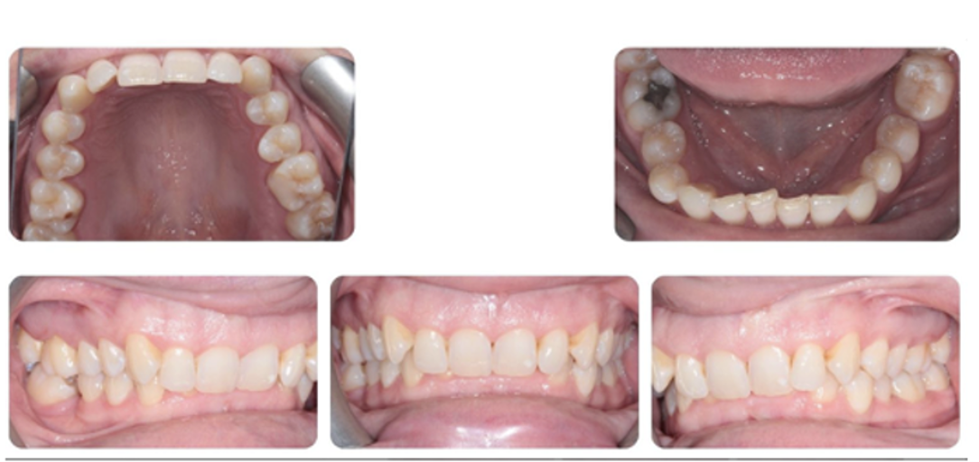
Clinical Case 1a

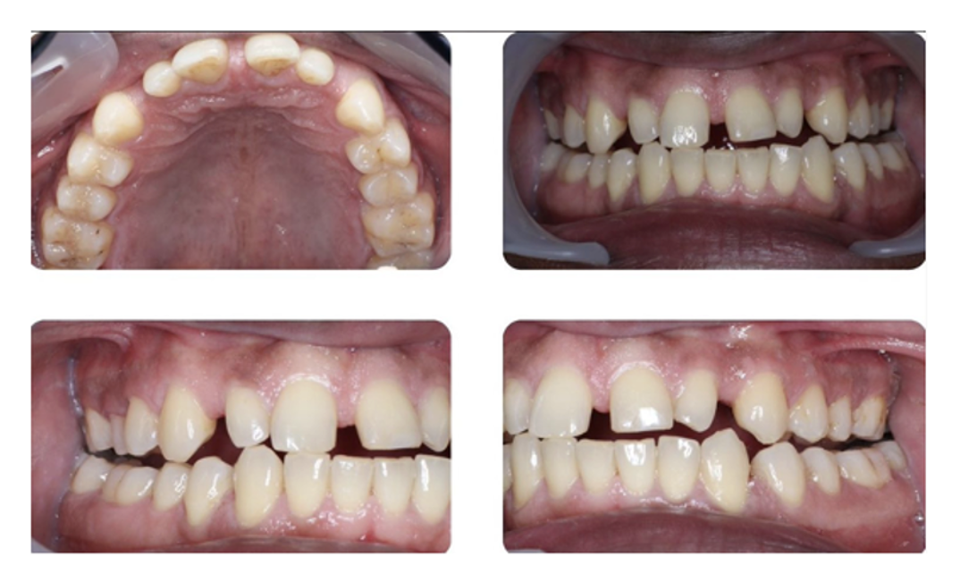
Clinical Case 1b

Clinical Case 1c
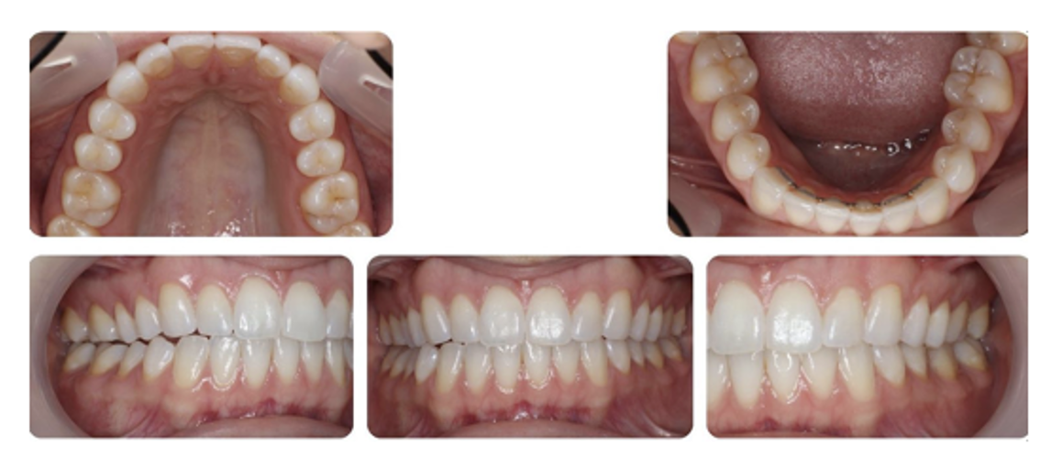

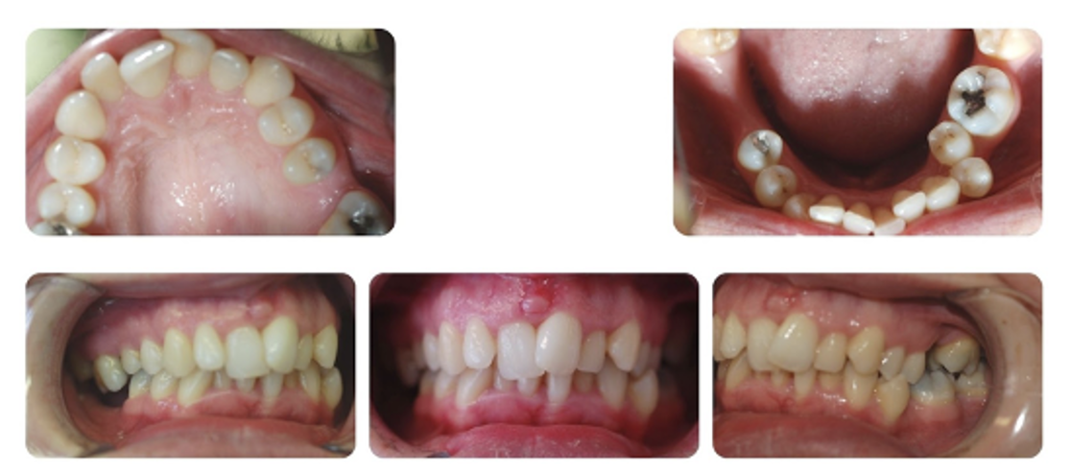
Clinical Case 1d

Clinical Case 1e

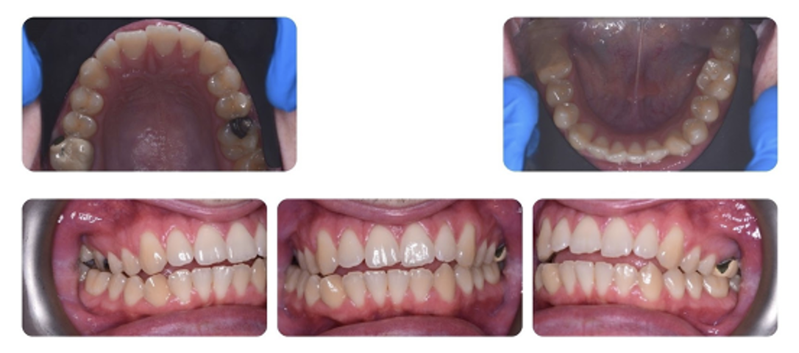
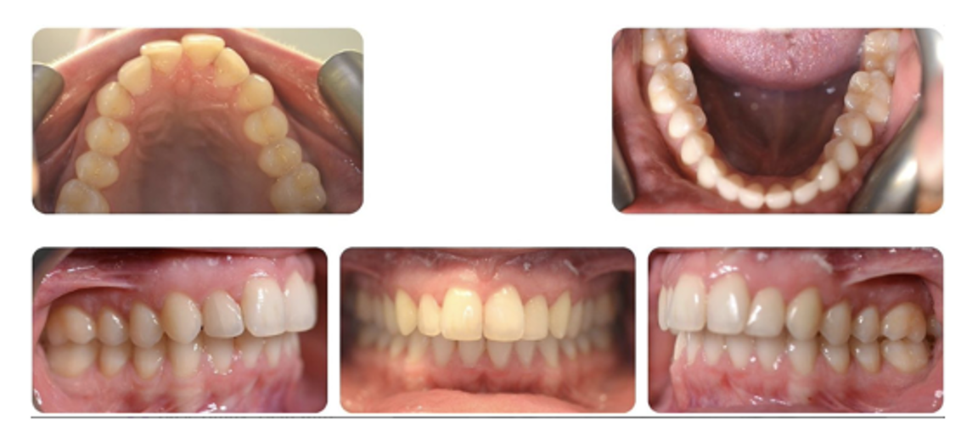
Clinical Case 1f

Clinical Case 1g

