SUPPLEMENTARY MATERIAL

Metrics | Formula
Dice Similarity Coefficient (DSC) / F1 score  Intersection Over Union (IoU)  Sensitivity (Recall)  Specificity  False Negative Ratio (FNR)  False Discovery Rate (FDR)  Positive Predictive Value (PPV/Precision)  Matthew’s Correlation Coefficient (MCC) | $$DSC= \frac{2×TP}{2×TP+FP+FN}$$  $$IoU= \frac{TP}{TP+FP+FN}$$  $$Recall= \frac{TP}{TP+FN}$$  $$Specificity= \frac{TN}{TN+FP}$$  $$FNR= \frac{FN}{FN+TP}$$  $$FDR= \frac{FP}{FP+TP}$$  $$PPV= \frac{TP}{TP+FP}$$  $$MCC= \frac{(\left(TN*TP\right)-\left(FN*FP\right))}{\sqrt{(\left(TP+FP\right)*\left(TP+FN\right)*\left(TN+FP\right)*\left(TN+FN\right))}}$$
Supplementary Table S1. Evaluation metrics.

Metrics | MP2RAGE+FLAIR |  |  |  | MP2RAGE |  |  |  | FLAIR
Metrics | Test 1 | Test 2 | Test 3 | Test 4 | Test 1 | Test 2 | Test 3 | Test 4 | Test 1 | Test 2 | Test 3 | Test 4
False Negative (FN) | 15384 | 7543 | 3716 | 6460 | 17603 | 6774 | 3740 | 7004 | 18226 | 10809 | 5706 | 10133
False positive (FP) | 3369 | 4531 | 940 | 8338 | 3953 | 4420 | 3062 | 11358 | 14440 | 12132 | 5878 | 14306
True Positive (TP) | 28438 | 11542 | 4557 | 19842 | 26219 | 12311 | 4533 | 19298 | 25596 | 8276 | 2567 | 16169
Sensitivity (Recall) | 0.65 | 0.61 | 0.55 | 0.75 | 0.60 | 0.65 | 0.55 | 0.73 | 0.58 | 0.43 | 0.31 | 0.61
False Negative Rate (FNR) | 0.35 | 0.40 | 0.45 | 0.25 | 0.40 | 0.36 | 0.45 | 0.27 | 0.42 | 0.57 | 0.69 | 0.39
Positive predictive value (PPV/Precision) | 0.89 | 0.72 | 0.83 | 0.70 | 0.87 | 0.74 | 0.60 | 0.63 | 0.64 | 0.41 | 0.30 | 0.53
False Discovery Ratio (FDR) | 0.11 | 0.28 | 0.17 | 0.30 | 0.13 | 0.26 | 0.40 | 0.37 | 0.36 | 0.59 | 0.70 | 0.47
Dice similarity coefficient (DSC) | 0.75 | 0.66 | 0.66 | 0.73 | 0.71 | 0.69 | 0.57 | 0.68 | 0.61 | 0.42 | 0.31 | 0.57
Intersection Over Union (IoU) | 0.60 | 0.48 | 0.50 | 0.57 | 0.55 | 0.52 | 0.40 | 0.51 | 0.44 | 0.27 | 0.18 | 0.40
Matthew’s Correlation Coefficient (MCC) | 0.76 | 0.66 | 0.68 | 0.73 | 0.72 | 0.69 | 0.57 | 0.68 | 0.61 | 0.42 | 0.31 | 0.57
Supplementary Table S2. Voxel-wise evaluation metrics for four test cases.

Metrics | MP2RAGE+FLAIR |  | MP2RAGE |  | FLAIR
Metrics | Valid 1 | Valid 2 | Valid 1 | Valid 2 | Valid 1 | Valid 2
False Negative (FN) | 11107 | 10120 | 10582 | 14300 | 12923 | 15709
False Positive (FP) | 7714 | 4382 | 9180 | 4496 | 15489 | 5394
True Positive (TP) | 17768 | 29883 | 18293 | 25703 | 15952 | 24294
Sensitivity (Recall) | 0.62 | 0.75 | 0.63 | 0.64 | 0.55 | 0.61
False Negative Ratio (FNR) | 0.39 | 0.25 | 0.37 | 0.36 | 0.45 | 0.39
Positive predictive value (PPV/Precision) | 0.70 | 0.87 | 0.67 | 0.85 | 0.51 | 0.82
False Discovery Ratio (FDR) | 0.30 | 0.13 | 0.33 | 0.15 | 0.49 | 0.18
Dice similarity coefficient (DSC) | 0.65 | 0.81 | 0.65 | 0.73 | 0.53 | 0.70
Intersection Over Union (IoU) | 0.49 | 0.67 | 0.48 | 0.58 | 0.36 | 0.54
Matthew’s Correlation Coefficient (MCC) | 0.66 | 0.81 | 0.65 | 0.74 | 0.53 | 0.70
Supplementary Table S3. Voxel-wise evaluation metrics for two validation cases.

Contrasts | Thr | GT | TP | FN | FP | F1 score | PPV
Test 1
FLAIR+  MP2RAGE | 1% | 41 | 30 | 11 | 10 | 0.74 | 0.75
FLAIR+  MP2RAGE | 30% | 41 | 30 | 11 | 10 | 0.74 | 0.75
MP2RAGE | 1% | 41 | 30 | 11 | 17 | 0.68 | 0.64
MP2RAGE | 30% | 41 | 26 | 15 | 17 | 0.62 | 0.61
FLAIR | 1% | 41 | 27 | 14 | 68 | 0.40 | 0.28
FLAIR | 30% | 41 | 24 | 17 | 68 | 0.36 | 0.26
Test 2
FLAIR+  MP2RAGE | 1% | 50 | 38 | 12 | 16 | 0.73 | 0.70
FLAIR+  MP2RAGE | 30% | 50 | 34 | 16 | 16 | 0.68 | 0.68
MP2RAGE | 1% | 50 | 38 | 12 | 19 | 0.71 | 0.67
MP2RAGE | 30% | 50 | 36 | 14 | 19 | 0.69 | 0.66
FLAIR | 1% | 50 | 24 | 26 | 64 | 0.35 | 0.27
FLAIR | 30% | 50 | 15 | 35 | 64 | 0.23 | 0.19
Test 3
FLAIR+  MP2RAGE | 1% | 42 | 30 | 12 | 7 | 0.76 | 0.81
FLAIR+  MP2RAGE | 30% | 42 | 28 | 14 | 7 | 0.73 | 0.80
MP2RAGE | 1% | 42 | 29 | 13 | 28 | 0.59 | 0.51
MP2RAGE | 30% | 42 | 28 | 14 | 28 | 0.57 | 0.50
FLAIR | 1% | 42 | 14 | 28 | 32 | 0.32 | 0.30
FLAIR | 30% | 42 | 12 | 30 | 32 | 0.28 | 0.27
Test 4
FLAIR+  MP2RAGE | 1% | 68 | 58 | 10 | 26 | 0.76 | 0.69
FLAIR+  MP2RAGE | 30% | 68 | 54 | 14 | 26 | 0.73 | 0.68
MP2RAGE | 1% | 68 | 59 | 9 | 34 | 0.73 | 0.63
MP2RAGE | 30% | 68 | 55 | 13 | 34 | 0.70 | 0.62
FLAIR | 1% | 68 | 44 | 24 | 41 | 0.58 | 0.52
FLAIR | 30% | 68 | 39 | 29 | 41 | 0.53 | 0.49
Supplementary Table S4. Lesion-wise evaluation metrics for four test cases.

Contrasts | Thr | GT | TP | FN | FP | F1 score | PPV
Valid 1
FLAIR+  MP2RAGE | 1% | 52 | 39 | 13 | 23 | 0.68 | 0.63
FLAIR+  MP2RAGE | 30% | 52 | 37 | 15 | 23 | 0.66 | 0.62
MP2RAGE | 1% | 52 | 37 | 15 | 29 | 0.63 | 0.56
MP2RAGE | 30% | 52 | 37 | 15 | 29 | 0.63 | 0.56
FLAIR | 1% | 52 | 32 | 20 | 37 | 0.53 | 0.46
FLAIR | 30% | 52 | 26 | 26 | 37 | 0.45 | 0.41
Valid 2
FLAIR+  MP2RAGE | 1% | 16 | 16 | 0 | 14 | 0.70 | 0.53
FLAIR+  MP2RAGE | 30% | 16 | 16 | 0 | 14 | 0.70 | 0.53
MP2RAGE | 1% | 16 | 16 | 0 | 30 | 0.50 | 0.35
MP2RAGE | 30% | 16 | 15 | 1 | 30 | 0.49 | 0.33
FLAIR | 1% | 16 | 12 | 4 | 29 | 0.42 | 0.29
FLAIR | 30% | 16 | 10 | 6 | 29 | 0.36 | 0.26
Supplementary Table S5. Lesion-wise evaluation metrics for two validation cases.

Metrics | Test 1 |  | Test 2 |  | Test 3 |  | Test 4
Metrics | MP2RAGE | FLAIR | MP2RAGE | FLAIR | MP2RAGE | FLAIR | MP2RAGE | FLAIR
False Negative (FN) | 23735 | 23768 | 9227 | 11604 | 5494 | 5529 | 9035 | 8575
False Positive (FP) | 11074 | 5198 | 10503 | 8256 | 7999 | 4636 | 32258 | 20902
True Positive (TP) | 20087 | 20054 | 9858 | 7481 | 2779 | 2744 | 17267 | 17727
Sensitivity (Recall) | 0.46 | 0.46 | 0.52 | 0.39 | 0.34 | 0.33 | 0.66 | 0.67
False Negative Ratio (FNR) | 0.54 | 0.54 | 0.48 | 0.61 | 0.66 | 0.69 | 0.34 | 0.33
Positive predictive value (PPV/Precision) | 0.65 | 0.79 | 0.48 | 0.48 | 0.26 | 0.37 | 0.35 | 0.46
False Discovery Ratio (FDR) | 0.36 | 0.21 | 0.52 | 0.53 | 0.74 | 0.63 | 0.65 | 0.54
Dice similarity coefficient (DSC) | 0.54 | 0.58 | 0.50 | 0.43 | 0.29 | 0.35 | 0.46 | 0.55
Intersection Over Union (IoU) | 0.37 | 0.41 | 0.33 | 0.27 | 0.17 | 0.21 | 0.30 | 0.38
Matthew’s Correlation Coefficient (MCC) | 0.54 | 0.60 | 0.50 | 0.43 | 0.29 | 0.35 | 0.49 | 0.56
Supplementary Table S6. Voxel-wise evaluation for MindGlide for test dataset.

Contrasts | Thr | GT | TP | FN | FP | F1 score | PPV
Test 1
MP2RAGE | 1% | 41 | 16 | 25 | 30 | 0.37 | 0.35
MP2RAGE | 30% | 41 | 6 | 35 | 30 | 0.16 | 0.17
FLAIR | 1% | 41 | 18 | 23 | 31 | 0.40 | 0.37
FLAIR | 30% | 41 | 9 | 32 | 31 | 0.22 | 0.23
Test 2
MP2RAGE | 1% | 50 | 28 | 22 | 6 | 0.67 | 0.82
MP2RAGE | 30% | 50 | 24 | 26 | 6 | 0.60 | 0.80
FLAIR | 1% | 50 | 24 | 26 | 16 | 0.53 | 0.60
FLAIR | 30% | 50 | 16 | 34 | 16 | 0.39 | 0.50
Test 3
MP2RAGE | 1% | 42 | 18 | 24 | 17 | 0.47 | 0.51
MP2RAGE | 30% | 42 | 14 | 28 | 17 | 0.38 | 0.45
FLAIR | 1% | 42 | 19 | 23 | 29 | 0.42 | 0.40
FLAIR | 30% | 42 | 12 | 30 | 29 | 0.29 | 0.29
Test 4
MP2RAGE | 1% | 68 | 47 | 21 | 18 | 0.71 | 0.72
MP2RAGE | 30% | 68 | 42 | 26 | 18 | 0.66 | 0.70
FLAIR | 1% | 68 | 47 | 21 | 21 | 0.69 | 0.69
FLAIR | 30% | 68 | 41 | 27 | 21 | 0.63 | 0.66
Supplementary Table S7. Lesion-wise evaluation for MindGlide test dataset
Metrics | Test 1 |  | Test 2 |  | Test 3 |  | Test 4
Metrics | LGA | LPA | LGA | LPA | LGA | LPA | LGA | LPA
False Negative (FN) | 19564 | 20708 | 11599 | 8342 | 5610 | 4648 | 8738 | 6089
False Positive (FP) | 9991 | 47829 | 11892 | 129843 | 2474 | 82700 | 28696 | 506591
True Positive (TP) | 24258 | 23114 | 7486 | 10743 | 2663 | 3625 | 17564 | 20213
Sensitivity (Recall) | 0.55 | 0.53 | 0.39 | 0.56 | 0.32 | 0.44 | 0.67 | 0.77
False Negative Ratio (FNR) | 0.47 | 0.47 | 0.61 | 0.44 | 0.68 | 0.56 | 0.33 | 0.23
Positive predictive value (PPV/Precision) | 0.71 | 0.33 | 0.39 | 0.08 | 0.52 | 0.04 | 0.38 | 0.04
False Discovery Ratio (FDR) | 0.29 | 0.67 | 0.61 | 0.92 | 0.48 | 0.96 | 0.62 | 0.96
Dice similarity coefficient (DSC) | 0.62 | 0.40 | 0.39 | 0.14 | 0.40 | 0.08 | 0.48 | 0.08
Intersection Over Union (IoU) | 0.45 | 0.25 | 0.24 | 0.07 | 0.25 | 0.04 | 0.32 | 0.04
Matthew’s Correlation Coefficient (MCC) | 0.63 | 0.41 | 0.39 | 0.21 | 0.41 | 0.14 | 0.50 | 0.14

Supplementary Table S8. Voxel-wise evaluation for SPM12 LST dataset.

Contrasts | Thr | GT | TP | FN | FP | F1 score | PPV
Test 1
LGA | 1% | 41 | 25 | 16 | 95 | 0.31 | 0.21
LGA | 30% | 41 | 14 | 27 | 95 | 0.19 | 0.13
LPA | 1% | 41 | 24 | 17 | 1005 | 0.05 | 0.02
LPA | 30% | 41 | 18 | 23 | 1005 | 0.03 | 0.02
Test 2
LGA | 1% | 50 | 25 | 25 | 84 | 0.31 | 0.23
LGA | 30% | 50 | 13 | 37 | 84 | 0.18 | 0.13
LPA | 1% | 50 | 25 | 25 | 1159 | 0.04 | 0.02
LPA | 30% | 50 | 18 | 32 | 1159 | 0.03 | 0.02
Test 3
LGA | 1% | 42 | 15 | 27 | 27 | 0.36 | 0.36
LGA | 30% | 42 | 10 | 32 | 27 | 0.25 | 0.27
LPA | 1% | 42 | 20 | 22 | 946 | 0.04 | 0.02
LPA | 30% | 42 | 18 | 24 | 946 | 0.04 | 0.02
Test 4
LGA | 1% | 68 | 40 | 28 | 48 | 0.51 | 0,46
LGA | 30% | 68 | 35 | 33 | 48 | 0.46 | 0.42
LPA | 1% | 68 | 47 | 21 | 1092 | 0.09 | 0.04
LPA | 30% | 68 | 46 | 22 | 1092 | 0.08 | 0.04
Supplementary Table S9. Lesion-wise evaluation for SPM12 LST test dataset.

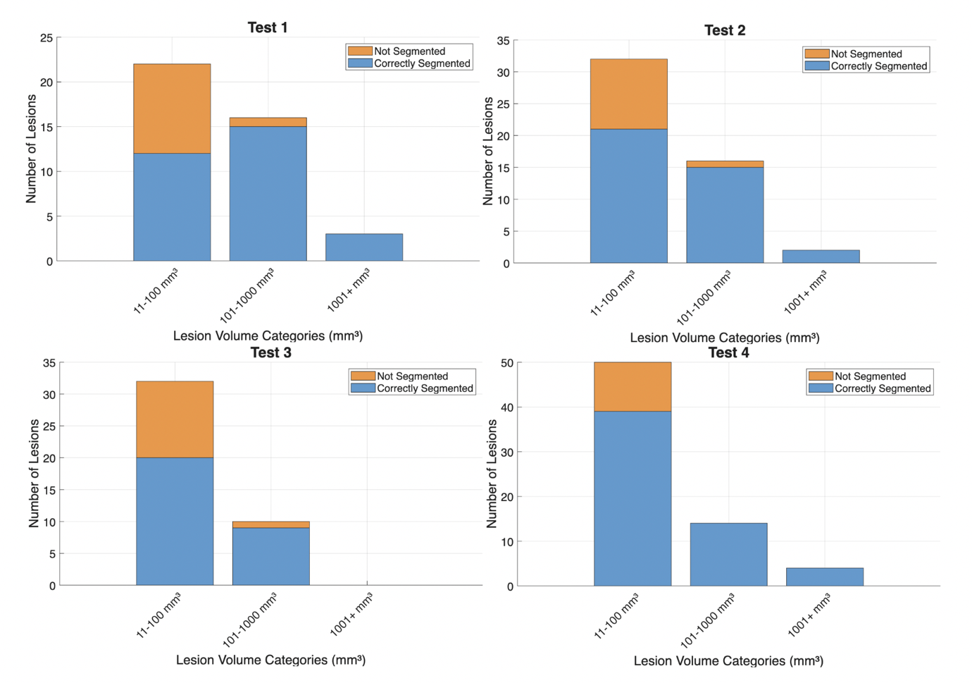
Supplementary Figure S1. Correctly (blue) and not segmented (orange) lesions by volume category for one contrast (MP2RAGE) for four test cases.

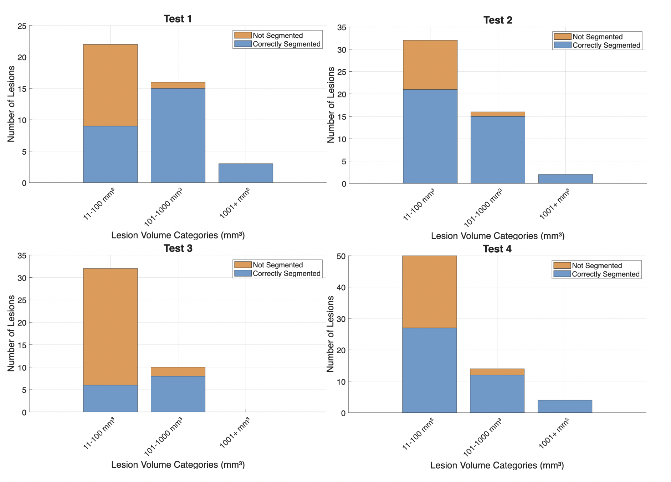
Supplementary Figure S2. Correctly (blue) and not segmented (orange) lesions by volume category for one contrast (FLAIR) for four test cases.

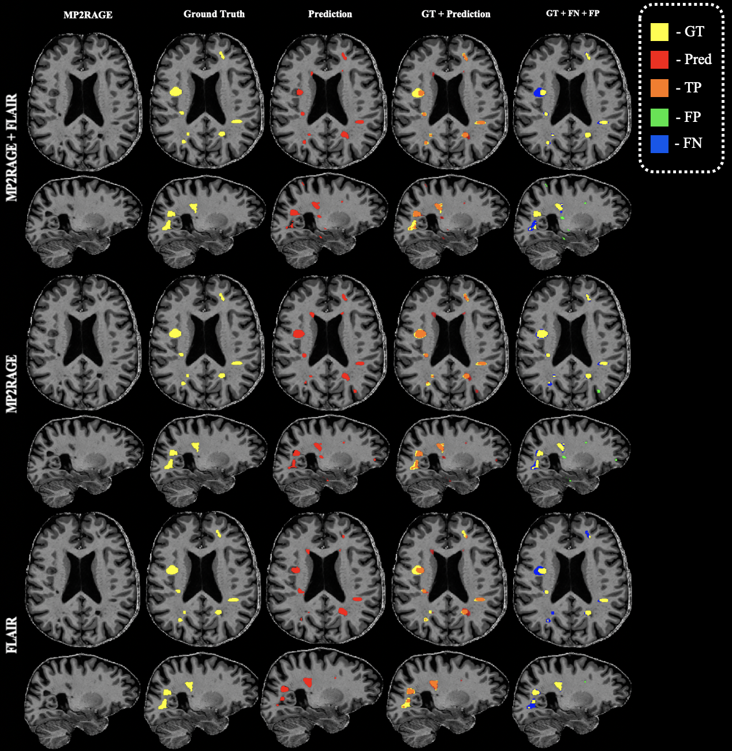 Supplementary Figure S3. Comparison of lesion segmentation results from models trained using different combinations of MP2RAGE and FLAIR contrasts, showed on axial and sagittal slices of the first validation case. (Ground truth (GT) lesions are shown in yellow, model predictions in red, overlap of GT and Prediction in orange, false negatives (FN) in blue, and false positives (FP) in green.)
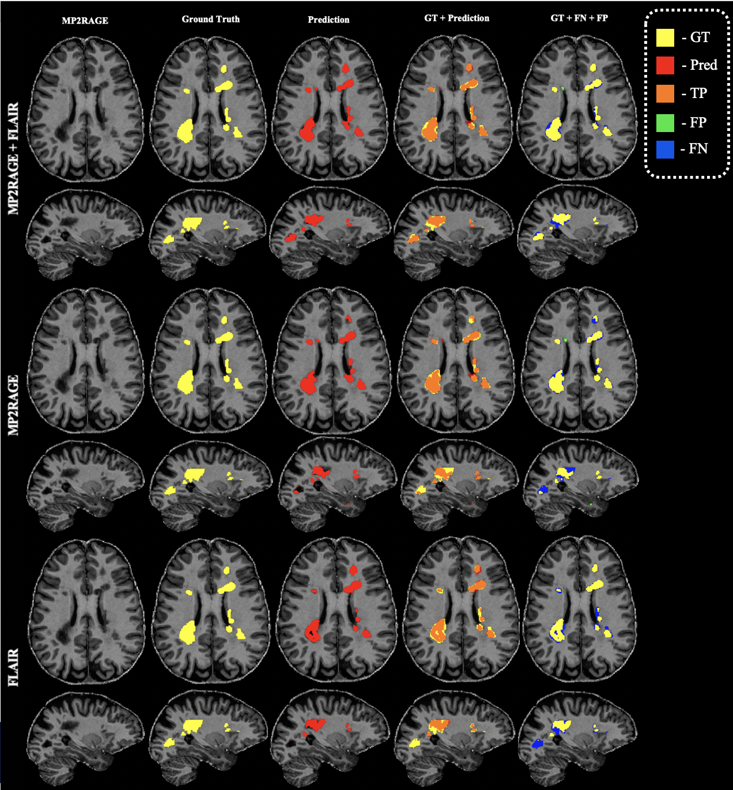
Supplementary Figure S4. Comparison of lesion segmentation results from models trained using different combinations of MP2RAGE and FLAIR contrasts, showed on axial and sagittal slices of the second validation case. (Ground truth (GT) lesions are shown in yellow, model predictions in red, overlap of GT and Prediction in orange, false negatives (FN) in blue, and false positives (FP) in green.)
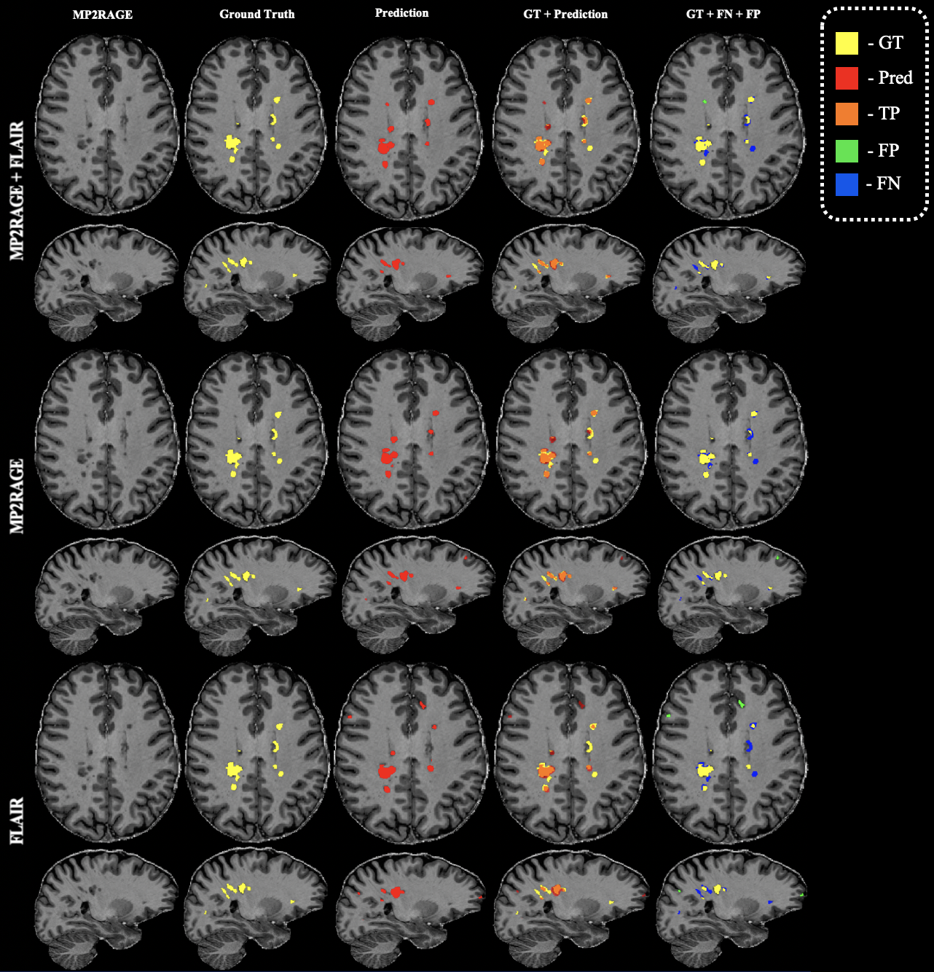
Supplementary Figure S5. Comparison of lesion segmentation results from models trained using different combinations of MP2RAGE and FLAIR contrasts, showed on axial and sagittal slices of the second test case. (Ground truth (GT) lesions are shown in yellow, model predictions in red, overlap of GT and Prediction in orange, false negatives (FN) in blue, and false positives (FP) in green.)
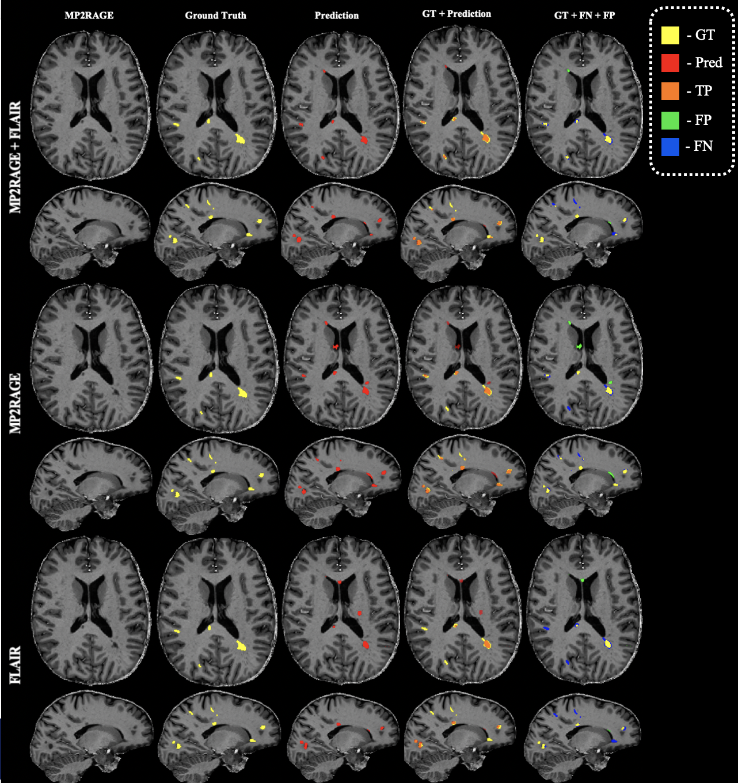
Supplementary Figure S6. Comparison of lesion segmentation results from models trained using different combinations of MP2RAGE and FLAIR contrasts, showed on axial and sagittal slices of the third test case. (Ground truth (GT) lesions are shown in yellow, model predictions in red, overlap of GT and Prediction in orange, false negatives (FN) in blue, and false positives (FP) in green.)

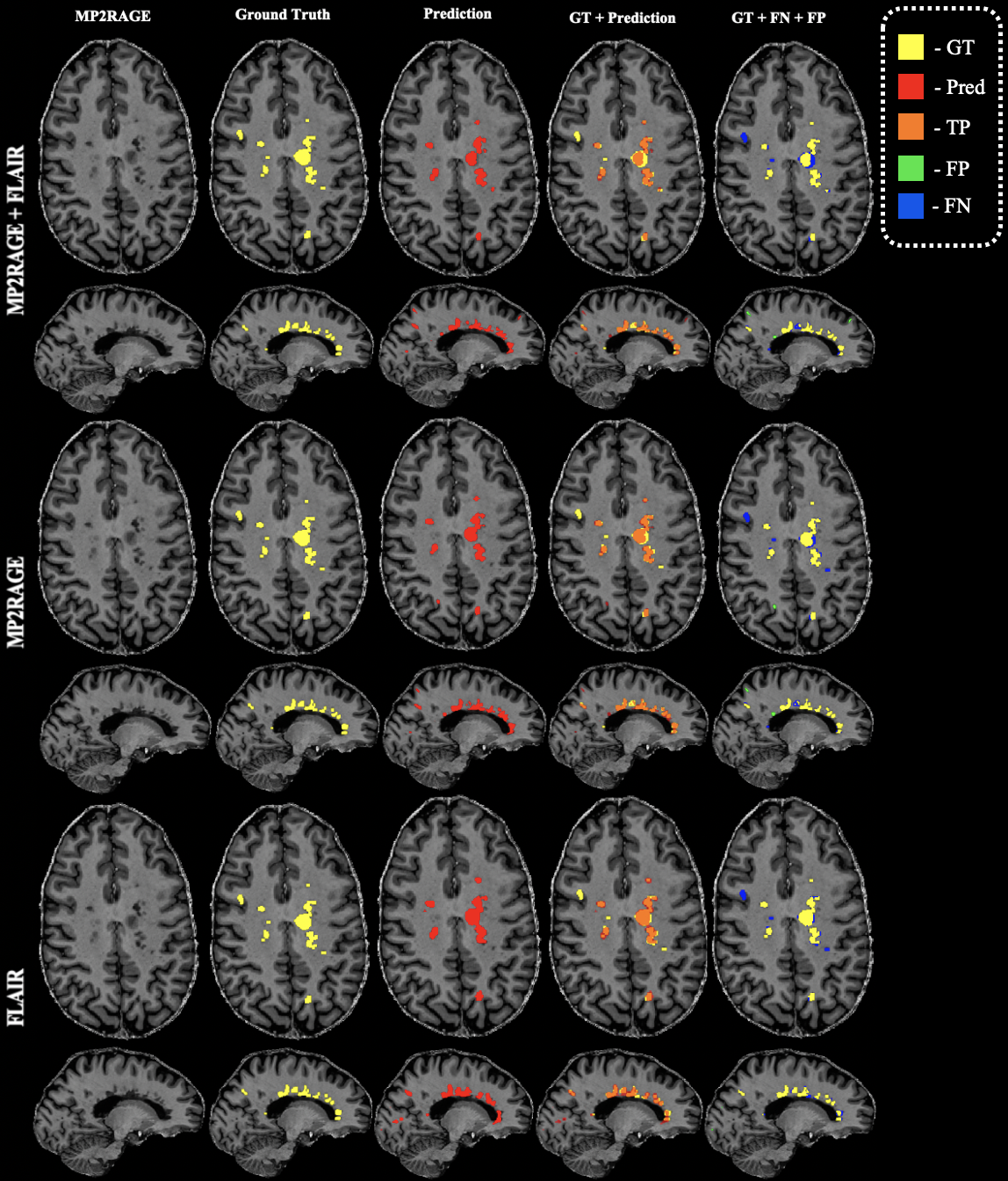
Supplementary Figure S7. Comparison of lesion segmentation results from models trained using different combinations of MP2RAGE and FLAIR contrasts, showed on axial and sagittal slices of the fourth test case. (Ground truth (GT) lesions are shown in yellow, model predictions in red, overlap of GT and Prediction in orange, false negatives (FN) in blue, and false positives (FP) in green

Method | Type of NN | Dataset | Number of cases | Dice score(avr) | DOI
Proposed  (FLAIR+MP2RAGE) | 3D CNN | in-house | 48 | 0.70
Hashemi et.al (2018) | 3D FCNN | MICCAI2016  ISBI 2015 | 72 | 69.9  65.7 | 10.1109/ACCESS.2018.2886371
Valverde et.al. (2019) | 3D CNN | MICCAI 2008  MICCAI 2016  ISBI 2015  Clinical | 120 | 63 | 10.1016/j.nicl.2018.101638
McKinley et.al (2021) | 3D CNN | MICCAI 2016  Insel 92  Insel 32 | 129 | 60 | 10.1038/s41598-020-79925-4
Zhang et.al (2022) | 2D CNN | Multi-centre dataset | 135 | 80 | 10.1007/s00234-021-02820-w
Hou et.al (2020) | 3D U-Net | ISBI 2015 | 19 | 64.3 | 10.1109/BIBM47256.2019.8983149
Brosch et.al. (2016) | 3D CNN | MICCAI 2008  ISBI 2015  Clinical | 250 | 64 | 10.1109/TMI.2016.2528821
Coronado et.al. (2021) | 3D CNN | CombiRx | 1006 | 77 | 10.1177/1352458520921364
Raab et.al. (2023) | 2D CNN | ISBI 2015  MICCAI 2016 | 34 | 78 | 10.1038/s41598-023-48578-4
Aslani et.al. (2020) | 2D CNN | Clinical  ISBI 2015 | 117 | 50 | 10.1109/ISBI45749.2020.9098721
Amaludin et.al. (2023) | 3D U-Net | ISBI 2015  OpenMS | 49 | 86 | 10.1002/ima.22941
Supplementary Table S10. Comparison proposed methods with other published NN.

