Supplementary information - Evaluating the impact of capitation funding top-up payments in primary care

Introduction
Table S1 – details of funding sources and weighting of workload measures in the LLR funding formula.
Scope of Formula | Components of Formula | Component Description | % Distribution
In scope  Global sum  CCG discretionary  Local enhanced services  Prescribing incentive Scheme  Miscellaneous | Core funding component | A fixed sum of 48% of a practice’s existing Carr-Hill Global Sum | 41.2% of in scope  (27.1% of in + out of scope)
 | Needs-based funding component | - Case mix adjusted, coding adjusted expected relative service activity, then  - Further adjustment for patient turnover, then  - Further communications adjustment | 52.9% of in scope  (34.8% of in + out of scope)
 | Deprivation component | Based on practice level Index of Multiple Deprivation derived from postal code areas of registered patients | 5.9% of in scope  (3.8% of in + out of scope)
Out of scope  QOF income  DES  Primary Care Network |  | Paid on existing arrangements | (34.3% of in + out of scope)
Outside scope discussion (by unanimous agreement)  Premises  Prescribing | Premises funding unsuitable for this process  Prescribing too destabilizing a risk at practice level | Paid on existing arrangements | N/A

Methods
We performed the following sensitivity analyses
- Using 2023 GPPS scores as our outcome: As the survey changed in 2024, the 2023 survey may be more comparable to its baseline value
- Examining only ‘very good’ responses on the GPPS survey: Responses tend to skew positively for patient experience, so examining the proportion of top scores may allow us to detect subtler changes in experience
- Controlling for different sets of variables: We examined whether results changed in an unadjusted model or a model with only the baseline value of the outcome of interest.
- Dose-response: We split intervention practices into two groups, one given higher and one given lower top-up payment amounts to understand whether the treatment effect was greater in the higher-payment group.
- Missing data analysis: Practices missing data on administrative and nursing staff were excluded from the complete-case analysis. To understand whether excluding these influenced our results, we dropped the administrative and nurse staff variables from the matching process, and performed the regression with these additional practices (and controlling for the dropped staff variables).

Results
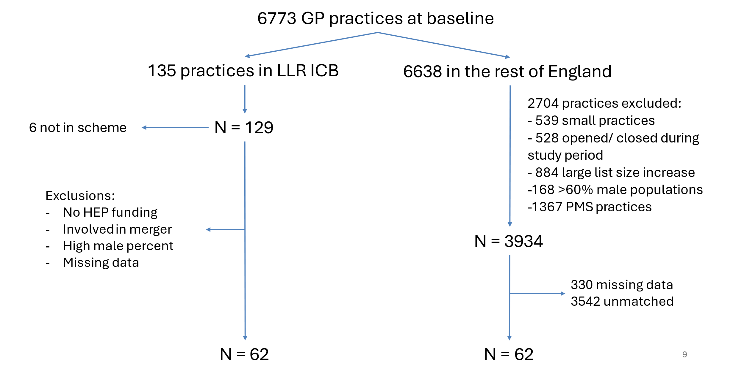
Figure S1 – Flow diagram describing the inclusion and exclusion of practices from the pool of available practices for matching. Numbers have been removed from the LLR flow diagram to avoid disclosure.

Table S2 comparison of characteristics between practices in LLR that received HEP and those that did not. The total numbers of practices were calculated after data cleaning. 1 = mean (SD), 2 = n (%).
 | Received HEP  (N=71) | Did not receive HEP  (N=47)
List size ¹ | 9090 (5130) | 8960 (5360)
Percentage of registered patients are male ¹ | 50.2 (1.76) | 50.9 (2.45)
IMD quintile based on registered patient place of residence ²
1 | 8 (11.3%) | *** (***)
2 | 22 (31.0%) | 12 (25.5%)
3 | 6 (8.5%) | *** (***)
4 | 20 (28.2%) | 7 (14.9%)
5 | 15 (21.1%) | 22 (46.8%)
Percentage of registered patients are >65 years old ¹ | 15.8 (4.92) | 17.1 (6.62)
Percentage of registered patients living in rural areas ¹ | 9.82 (21.8) | 32.5 (40.3)
Percentage of white people living in LSOAs of registered patients ¹ | 65.0 (30.2) | 75.1 (25.0)
Percentage of people with English as a second language living in LSOAs of registered patients ¹ | 20.8 (19.9) | 15.2 (16.9)
Carr-Hill Index ¹ | 0.950 (0.0519) | 0.960 (0.0843)
FTE GPs (excluding training grade) per 1000 weighted patients ¹ | 0.483 (0.167) | 0.536 (0.310)
Missing | 0 (0%) | 1 (2.1%)
FTE nurses per 1000 weighted patients ¹ | 0.246 (0.113) | 0.230 (0.113)
Missing | 5 (7.0%) | 3 (6.4%)
FTE admin per 1000 weighted patients ¹ | 1.19 (0.297) | 1.19 (0.389)
Missing | 2 (2.8%) | 1 (2.1%)
Single partner practices ²
Multi-partner | 52 (73.2%) | 36 (76.6%)
Single partner | 19 (26.8%) | 11 (23.4%)
Percentage of respondents reporting good overall experience of booking an appointment ¹ | 0.530 (0.135) | 0.609 (0.171)
Percentage of respondents reporting good overall experience of their GP practice ¹ | 0.690 (0.119) | 0.730 (0.143)
Percentage of respondents reporting yes overall to whether their needs were met at their last appointment ¹ | 0.889 (0.0613) | 0.909 (0.0536)
Percentage of total QOF points achieved ¹ | 97.5 (3.69) | 96.0 (5.95)
Prevalence of asthma ¹ | 0.0642 (0.0139) | 0.0591 (0.0169)
Prevalence of chronic kidney disease ¹ | 0.0344 (0.0163) | 0.0327 (0.0142)
Prevalence of chronic obstructive pulmonary disease ¹ | 0.0166 (0.00690) | 0.0150 (0.00577)
Prevalence of coronary heart disease ¹ | 0.0281 (0.00556) | 0.0276 (0.00892)
Prevalence of diabetes mellitus ¹ | 0.0939 (0.0284) | 0.0772 (0.0318)
Prevalence of hypertension ¹ | 0.148 (0.0252) | 0.144 (0.0390)

