Investigating the role of rare missense variants in RAB11B in Autism Spectrum Disorder
Marta Viggiano¹*, Laura Sandoni¹*, Fabiola Ceroni^{1,2}, Paola Visconti³, Annio Posar^{3,4}, Maria Cristina Scaduto³, Joana Rosmaninho Salgado⁵, Alessandro Vaisfeld^{6,7}, Elena Maestrini^{1§}, Elena Bacchelli^{1,8 §}
¹ Department of Pharmacy and Biotechnology, University of Bologna, Bologna, Italy.
² School of Biological and Medical Sciences, Faculty of Health, Science and Technology (HST), Oxford Brookes University, Oxford, UK.
³ IRCCS Istituto delle Scienze Neurologiche di Bologna, UOSI Disturbi dello Spettro Autistico, Bologna, Italy.
⁴ Department of Biomedical and Neuromotor Sciences, University of Bologna, Bologna, Italy.
⁵ Medical Genetics Unit, Hospital Pediátrico, Centro Hospitalar e Universitário de Coimbra, Coimbra, Portugal.
⁶ Department of Medical and Surgical Sciences, University of Bologna, Bologna, Italy.
⁷ Medical Genetics Unit, IRCCS Azienda Ospedaliero-Universitaria di Bologna, Bologna, Italy
⁸ IRCCS Istituto delle Scienze Neurologiche di Bologna, Bologna, Italy

Corresponding author: Elena Bacchelli, elena.bacchelli@unibo.it

* These authors contributed equally
§ These authors contributed equally

Supplementary Information
Phenotypic description of Individual 1 (proband 52.3)
The patient is a 14-years-old boy, referred to genetic counseling for developmental delay and ASD.
He was born from healthy, non-consanguineous parents. His paternal half-sister is also reported in good health and the overall family history is unremarkable.
He was born at 41 weeks through c-section (performed for prolonged labor) after an uneventful pregnancy. The birth parameters are unknown. As infant, no issues are reported. While his main motor milestones were regularly acquired, verbal skills were delayed: at 18 months, the language was still absent. Since then, only slight improvements are reported and the language is still very poor and characterized by pronoun reversals.
Since the age of 2 and 6/12 years, the parents reported the presence of stereotypies (most frequently, hand flapping), lack of coordination and poor balance. He was then referred to a child neurologist and finally got ASD diagnosis at the age of 3 and 6/12. No clear anomalies were detected at brain MRI (4 years of age) and EEG (5 years of age), while ECG revealed a “Brugada-like” pattern, for which he is in strict follow-up. At 6 years of age an episode of seizure occurred, characterized by hypotonia, eye movements, sweating and sopor (after EEG, deemed an occipital crisis). Similar episodes, with spontaneous remission and lasting less than 3 minutes, have been repeated in a few months and an antiepileptic therapy was initiated with clear improvements in terms of number and duration of crisis. A cognitive formal evaluation was performed using a non-verbal scale (Leiter-R) at 8 years of age, resulting in a mild-moderate ID (brief IQ 56, fluid reasoning (FR) 63). The presence and severity of ASD was evaluated using the Autism Diagnostic Observation Schedule-Second Edition, ADOS-2 (score 6, Autism) and The Childhood Autism Rating Scale-Second Edition, CARS-2ST (score 39, Severe). Adaptive functioning was assessed using the Vineland Adaptive Behavior Scale (VABS2) (chronological age: 106 months; Adaptive Behavior Composite score, age equivalent (AE): 54 months (>99%ile); Communication domain, AE: 50 months (>99%ile); Daily living Skills domain, AE: 69 months (>99%ile); Socialization domain, AE: 39 months (99%ile)).
At the last evaluation, at the age of 14 years, his height was 179 cm (97th pc) and OFC 55,5 cm (70th pc). As main facial features (Supplementary figure 1), we noted a low anterior hairline, prominent superciliary arches, broad and prominent glabella, prominent nasal bridge, thick lips vermilion with accentuated Cupid’s bow, widely spaced teeth with diastema. As additional issues, we only have to report flat feet.

Supplementary Figure 1. Facial photographs of Individual 1 (proband 52.3) carrying de novo p.Arg33His variant. Written consent was obtained for publication of the photographs. Photograph a) was taken at 3 years old, when the proband got the ASD diagnosis. Photograph b) was taken at 14 years old, time of last genetical evaluation.
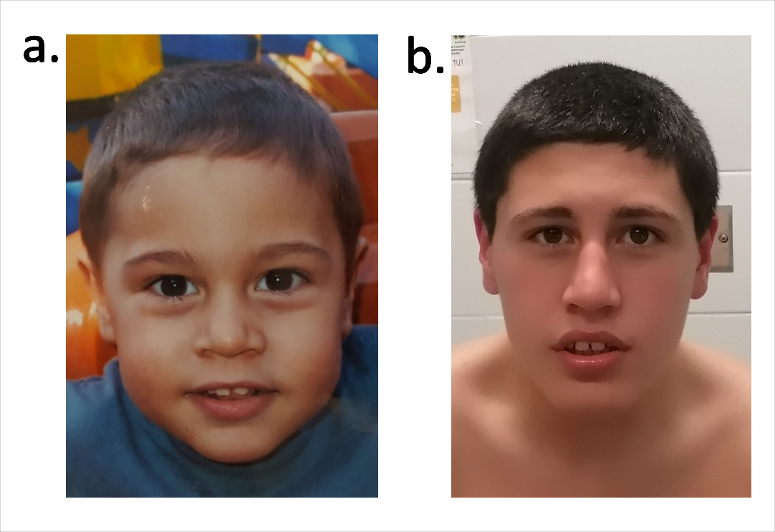

Supplementary Figure 2. Yasara simulation of variants of known effect on the tertiary structure of RAB11B. The inactive GDP-bound (PDB identifier: 2F9L) and the active GTP-bound (PDB identifier: 2F9M) structures are superposed and color-coded in red and green, respectively. a) The substitution Ser25Asn caused the loss of the interaction with the coordination magnesium ion, that is crucial for GTP binding; the loss of this interaction generated a constitutively inactive protein, unable to bind and transport endosomes. b) The substitution Gln70Leu led to the loss of a hydrogen bond with Ala68 in the inactive structure; the loss of the conformational shift from active to inactive structure renders the protein constitutively active.
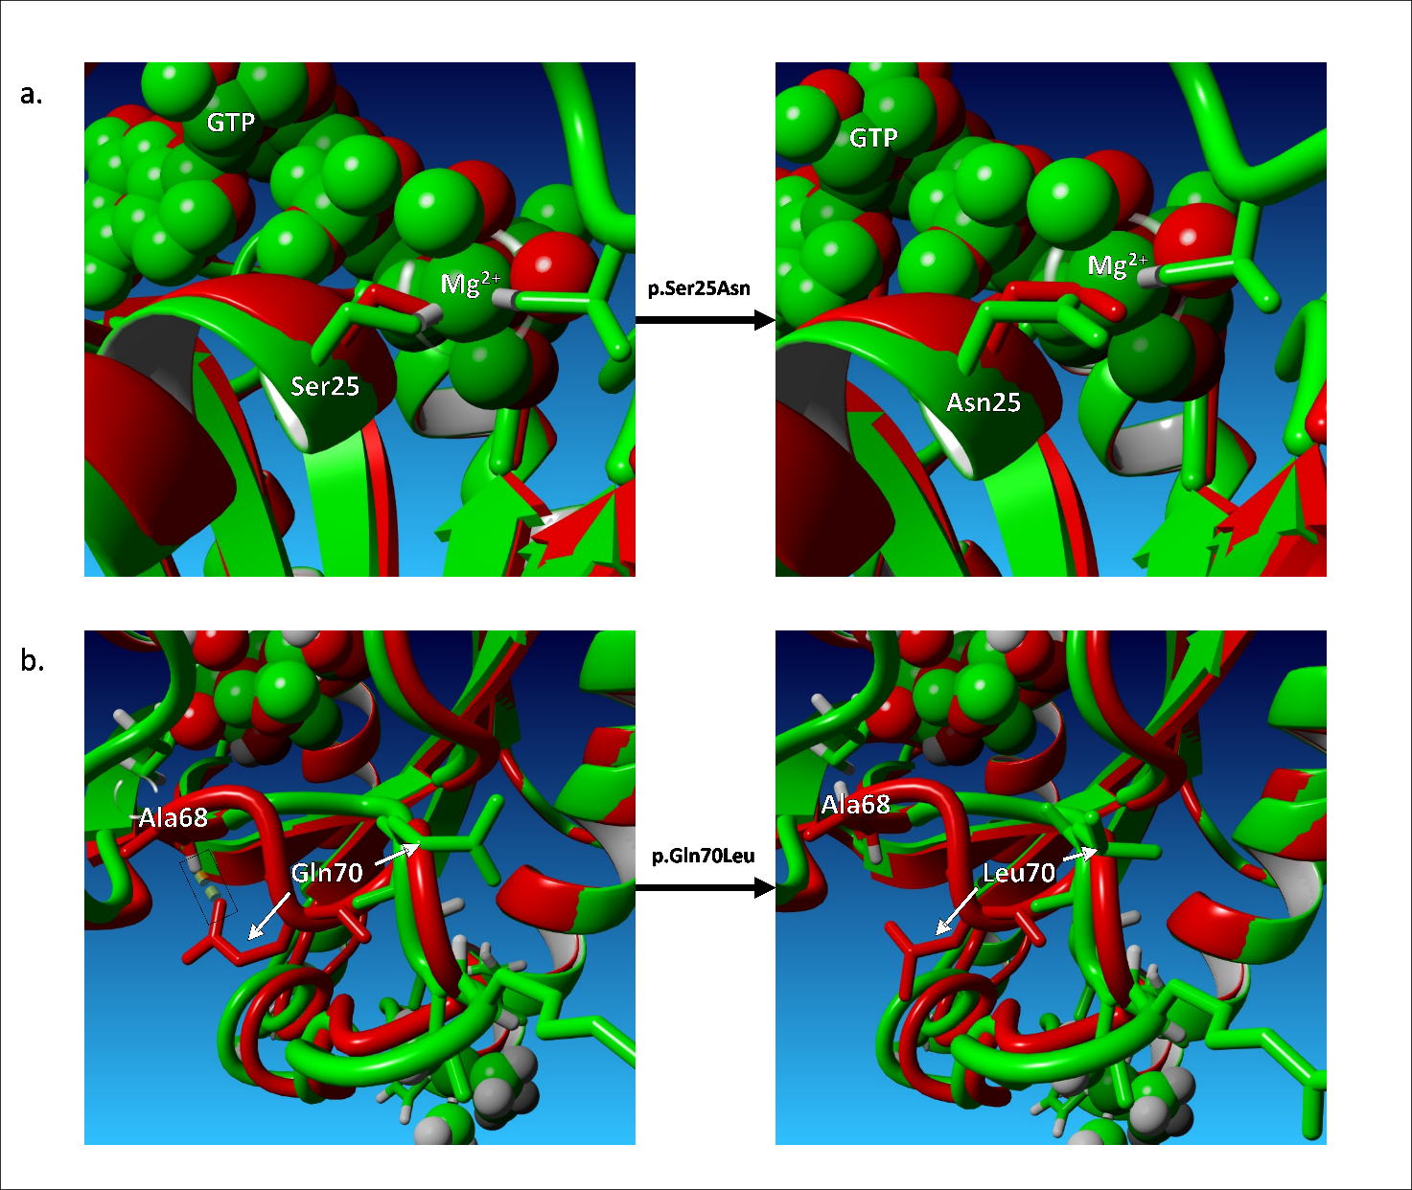

Supplementary Figure 3. STRING network of predicted protein-protein interactions for RAB11B and TOGARAM1 genes. RAB11B and TOGARAM1 are indirectly linked via RAB11FIP3, coding a regulator of endocytic traffic by participating in membrane delivery.
The edges represent the predicted functional associations and line colour indicates the type of interaction evidence: Red line—presence of fusion evidence; Green line—neighbourhood evidence; Blue line—cooccurrence evidence; Purple line—experimental evidence; Light green line—text-mining evidence; Light blue line—database evidence; Black line—co-expression evidence. RAB11B and RAB11FIP3 show experimental and textmining interaction evidence; RAB11FIP3 and TOGARAM1 show co-expression and text-mining interaction evidence.
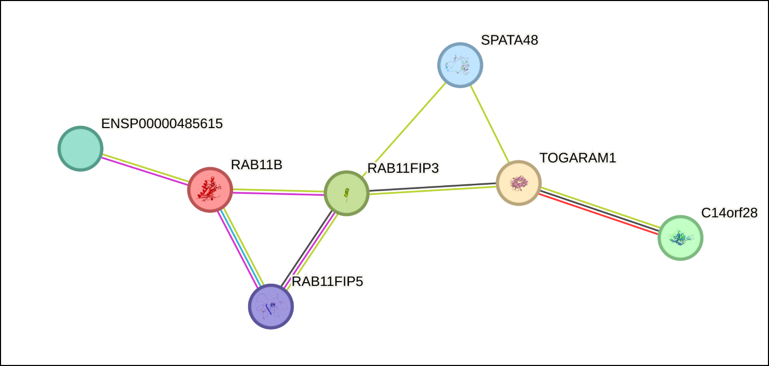

Supplementary Table 1. Sequence of primers employed for site-directed mutagenesis. Mismatch sites corresponding to changes introduced in plasmid constructs sequence are reported in bold. Primer RAB11B_S25N_R was used for the introduction of both S25N and D157N mutations.
Primer name | Sequence (5’-3’)
RAB11B_R33H_F | gcttcacccacaacgagttcaacctgg
RAB11B_R33H_R | gcgacagcaggttgctctt
RAB11B_S25N_F | ggcaagaacaacctgctgtcgc
RAB11B_S25N_R | cgaacgacctacaccgaact
RAB11B_Q70L_F | gctcactcaaaggcggtaatacg
RAB11B_Q70L_R | gcgctccaggccagcggt
RAB11B_R72C_F | caggagtgctaccgcgccat
RAB11B_R72C_R | gcaccgcctacatacctcg
RAB11B_D157N_F | cagccttgaattccactaacgtagag
RAB11B_S25N_R | cgaacgacctacaccgaact

