SUPPLEMENTARY FIGURES

*Size of the circle is relative of the number of Variants identified;
Figure 1 : The Venn diagram showing number of shared variants between different groups according to different agro-climatic zone.
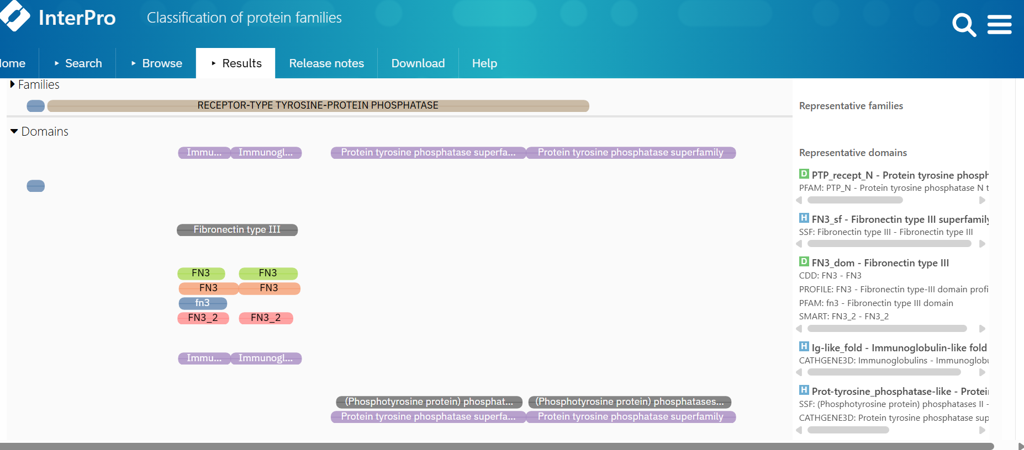
Figure 2: Functional domain of PTPRC which is FNIII as predicted by Interpro
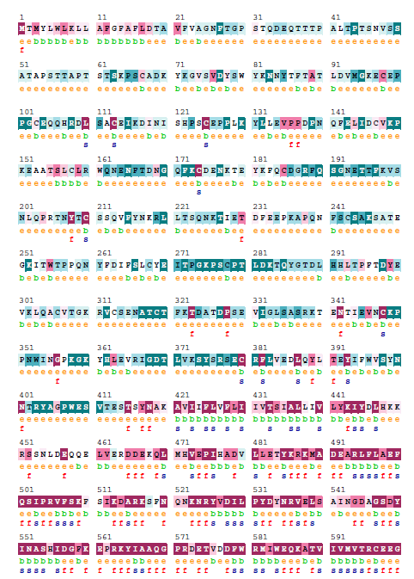
Figure 3 Consurf sequence of PTPRC Protein indicating conserved score at 76 position

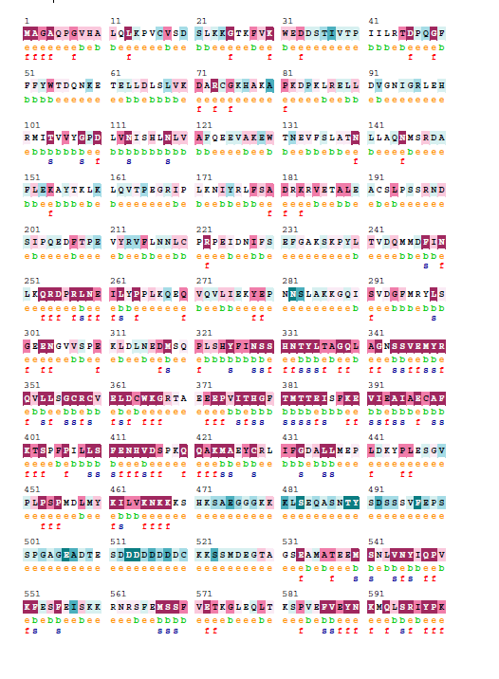
Figure 4 Consurf sequence of PLCB1 Protein indicating non- conserved score at 196

