Supplementary Information
Multimodal liquid transport enabled by crassula muscosa shoot inspired rachet-shaped leaves channel
Zehang Cui^{1,#}, Liang Chen^{1,#}, Guoqiang Li¹*, Dongxu Xiao¹, Haojie Xu¹, Yiyu Chen¹, Haoyu Bai², Jiaxin Yu¹*, and Moyuan Cao²*

¹School of Manufacture Science and Engineering, Key Laboratory of Testing Technology for Manufacturing Process, Ministry of Education, Southwest University of Science and Technology, Mianyang 621010, China.
²School of Materials Science and Engineering, Smart Sensing Interdisciplinary Science Center, Nankai University, Tianjin 300350, P. R. China.
#These authors contributed equally: Zehang Cui, Liang Chen.
*Corresponding author. E-mail: guoqli@ustc.edu.cn; yujiaxin@swust.edu.cn; mycao@nankai.edu.cn

This file includes：
Supplementary Figures 1-5

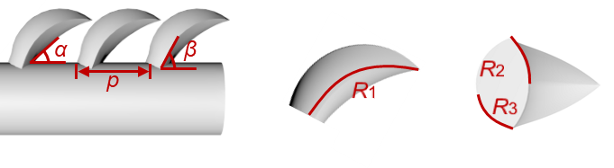
Fig. S1 Schematic diagram of the design of asymmetric tilted ratchet leaves.

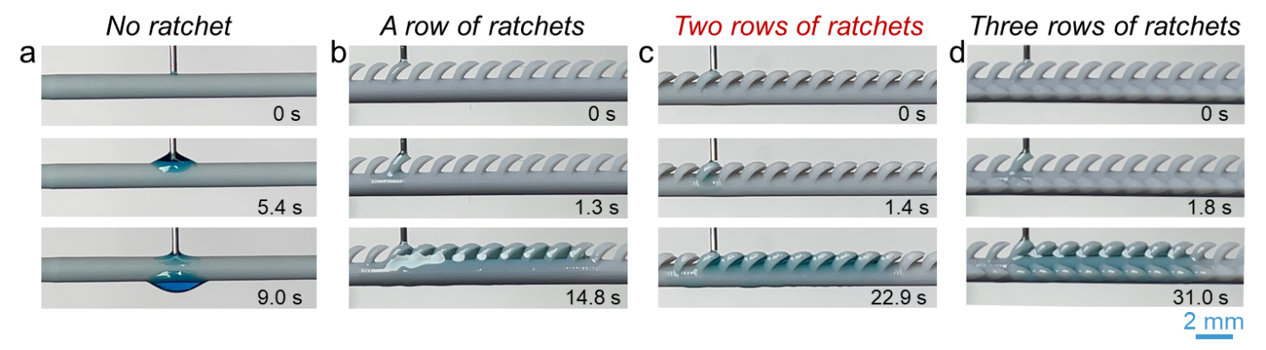
Fig. S2 Ethanol transport comparison in MDRC with different ratchet row numbers. a No ratchet; b A row of ratchets; c Two rows of ratchets; d Three rows of ratchets.

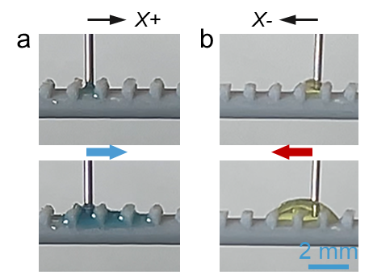
Fig. S3 Asymmetric ratchet structure of MDRC mediated Laplace pressure asymmetry for a low surface tension liquids and b high surface tension liquids. The upper part of the ratchet structure is cut away to eliminate the influence of the tilted feature on the direction of fluid transport. It can be seen that under the action of the asymmetric characteristics of the ratchet structure, low surface tension liquids (c = 100%) and high surface tension liquids (c = 20%) tend to be transported to X+ and X- direction respectively.

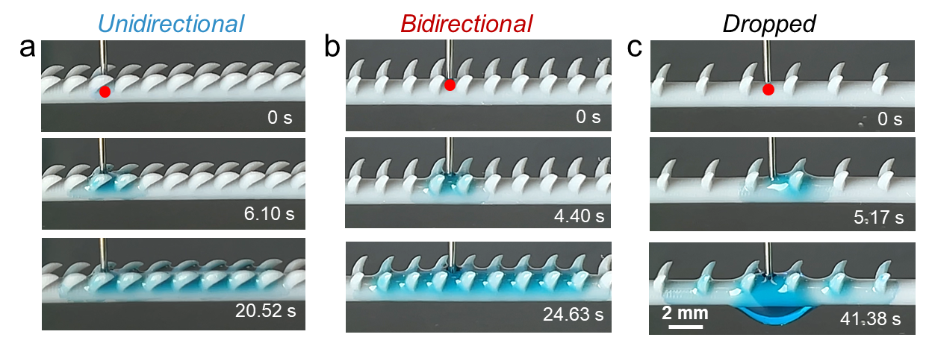
Fig. S4 The spreading behaviors comparison of ethanol in MDRC with different structural parameters (inclination angle α and spacing p). a α = 50° and p = 1.6 mm; b α = 90° and p = 1.6 mm; c α =90° and p = 2.6 mm.

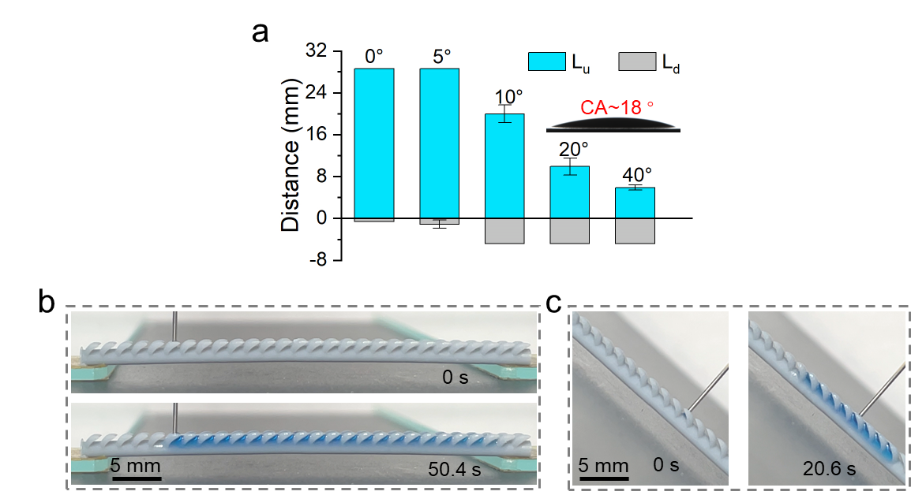
Fig. S5 Statistics a and experimental images b-c of water transport distances on hydrophilic MDRC at different inclination angles.

