EXTENDED DATA (ED)

Cycles, Constraints, and Systemic War: Structural Carriers of International Conflict Dynamics

Preamble

This ED documents cycle construction (RSP→SW), per-war diagnostics, cross-cycle regularities, cadence/severity geometry, early-warning preprocessing, κ (carrier) portrait and scaling checks, regime-change tests, and COW-based verifications. Inputs are frozen; Europe-only filter; GP-focused primaries; dual starts (1453 overlay for cadence; 1495 baseline for per-war diagnostics). Seeds are fixed (314159; see ED M1 for reproducibility note). HAC uses Bartlett/Andrews. Block bootstraps use 10-year blocks (annual) and 2 grid steps $≈$ 10year (5-year grid). EWS employs AR(1) pre-whitening.

Methods

Frozen inputs and scenarios. Primary cadence uses a 1453 overlay (cadence only; pre-1495 wars not reconstructed to Levy standards). All per-war diagnostics use the 1495 (Levy) baseline. Europe-only; European GPs for primaries; COW checks extend to 2007 for context.

Datasets and files. Anchor tables T1–T3 (war classification, cycle bounds, per-cycle metrics). Supporting data D1–D23 (file list in ED M1). $κ$ series (5-year bin ends, 1816–1945) is a frozen L1 carrier input (non-war structural).

Classification and unit. Cycle = RSP → SW. NSWs are status-quo–preserving wars inside RSPs; SWs are order-resetting wars that terminate cycles (Levy canonical four). Participation fraction:

$f_{t}= \frac{\#(European GP's participating at t)}{\#(European GPs extant at t)},$at war start (denominator and sources in T1). Europe-only scope for f.

For the Thirty Years’ War (split by Levy into four episodes), we report f = 0.86 from the largest episode while aggregating severity across episodes for the SW point.
Stability (SI) and Plasticity.

- Stability SI (1495 baseline): ${SI}_{k}$ = (t₁ − t₀) / (n + 1) with RSP window [$t_{0}$, $t_{1}$) and n GP-Europe onsets inside the RSP (SW excluded).
- Plasticity: count of GP status entries + exits occurring within each RSP (entries/exits in T3).

Cadence and severity (finite-time forms). Cadence (RSP length) $L(t) = A{(T_{c}-t)}^{b},$with t taken at RSP midpoints for leverage control. Severity (terminal SW BCD) $S(t)=C{(T_{c}-t)}^{-p},$with t the SW start. Cadence OOS: fit on cycles with midpoints $≤ 1913$, hold out cycle 4; use this cadence-anchored $T_{c}$ downstream. Severity is used as an out-of-sample blow-up check (not to set $T_{c}$).

EWS preprocessing. For L2 series (alliances, MILEX (Military Expenditure)), fit AR(1) and pre-whiten residuals; compute 10-year rolling variance (alliance churn) and AC1 (MILEX), aligned to 5-year bin ends; sensitivity 8–12y windows. HAC 95% CIs are reported (ED Fig. 05a; file: ED_Fig05a_EWS_prewhiten_bands_sensitivity.pdf).

κ (L1 carrier; descriptive). κ is analysed descriptively: segmented ‘kink’ + percentile crossings (ED Fig. 06a; file: ED_Fig06a_kappa_portrait_kink.pdf), log–log scaling with block-bootstrap CIs (ED Fig. 06b; file: ED_Fig06b_kappa_scaling_bootstrap.pdf), and AR(1) pre-whitened κ→L2 cross-correlations with HAC SEs (ED Fig. 07a–07b; files: ED_Fig07a_kappa_leadlag_milex.pdf, ED_Fig07b_kappa_leadlag_alliance.pdf). κ is not used for classification or to estimate $T_{c}$.

Breaks and regime change. Onset hazards modelled with two-rate Poisson change-point; participation f and alliance density with two-mean breaks; multi-break BIC shown for long-horizon context. Modern window selects 1939; post-1945 hazard plateau is near-zero for GP-Europe interstate onsets.

COW verification (1816–1945). Map Levy GP-Europe wars to COW inter-state wars; report overlap and re-run cadence/EWS qualitatively within COW; include non-GP Europe for robustness; do not redefine f on non-GPs.

Statistics and settings. HAC: Bartlett kernel, Andrews bandwidth; block bootstraps: 10y (annual) / 2 bins (5-year grid); schedule randomization for cadence; winsorization sensitivity for severity; trend-null false-positive rates for joint $T_{c}$. Seed = 314159.

ED §1. Crosswalk

Conventions. Europe-only; GP-focused primaries; dual starts (1453 overlay for cadence; 1495 baseline for per-war diagnostics). Seed = 314159; HAC = Bartlett/Andrews; 10 y (annual) / 2 bins (5-year grid); EWS uses AR(1) pre-whitening. κ is frozen (descriptive).

Anchor tables (used throughout):

- ED Table T1: War classification (Levy 1495–1945, Europe/GP); T1_ED_table_war_classification_with_sources.csv
- ED Table T2: Cycle bounds (1453 overlay and 1495 baseline); T2_ED_table_cycle_bounds.csv
- ED Table T3: Per-cycle metrics (full: SI, plasticity, cadence, severity); T3_ED_table_cycle_metrics_full.csv

View A: Article topics → ED sections (subjects only)

Article topic | ED §
Cycle classification (RSP→SW), participation f, severity definitions | 3
Data and scope, start-date conventions (1495 baseline; 1453 overlay), manifest | 2
Stability and Plasticity across cycles (definitions, estimation, CIs) | 4-5
Cadence estimation (finite-time form; train cycles 1–3; hold-out cycle 4; nulls) | 6
Severity used as an independent check (not a driver of endpoint) | 7
EWS preprocessing and diagnostics in L2 (AC1, variance; AR(1) pre-whitening; windows; HAC CIs) | 8
κ construction (L1, frozen, descriptive), scaling and kink; lead–lag conventions | 9
Hybrid transition in onset hazards (model, 1939 break, post-1945 near-zero GP hazard) | 10
Modern-window verification with COW datasets | 11
Joint Tc consistency window and controls (no joint estimation) | 12
Sensitivities (window lengths, GP weighting, war-set scope, cadence definition, proxies) | 13
Robustness and nulls (block bootstrap, schedule randomization, label shuffles; seeds) | 14

View B: ED sections → Article topics supported

ED § | Article topic
ED §2 Data and scope | Data sources; Europe/GP filters; 1495 vs 1453; manifest
ED §3 Cycle coding and diagnostics | Functional RSP→SW logic; participation f; severity conventions
ED §4 Stability (SI) | SI estimation; edge inclusion; CIs; sensitivity
ED §5 Plasticity | Entry/exit rules; counting; sensitivity
ED §6 Cadence model | Finite-time form; train/hold-out; schedule nulls; endpoint location
ED §7 Severity as a check | SW BCD sources; regression vs endpoint; why severity is not an input
ED §8 L2 EWS | AR(1) pre-whitening; rolling windows; alignment; HAC CIs; proxies
ED §9 κ (L1) and κ↔L2 lead–lag | κ inputs and weighting; 5-year bins; scaling; kink; cross-correlation conventions
ED §10 Hazard and hybrid regime | Two-rate Poisson; BIC; break timing; post-1945 plateau
ED §11 COW verification | Modern-window onsets/alliances; definitional deltas; checks
ED §12 Joint Tc window and controls | Overlay endpoint with independent constraints; controls; no joint estimation
ED §13 Sensitivities | Window/weighting/war-set/cadence variants; proxy swaps
ED §14 Robustness and nulls | Bootstraps; label shuffles; fixed seeds; failure modes

ED §2. Data and scope

2.1 Purpose. This section defines the empirical universe, sources and versions, scope filters, start-date conventions, cycle bounds, file manifest, and alignment choices used in this study. Operational rules and estimators referenced here are expanded in ED §3 (cycle coding and diagnostics), §6 (cadence), §8 (L2 preprocessing/EWS), §9 (κ construction and lead–lag), and §10–§12 (hazard, verification, and endpoint consistency).

2.2 Universe and horizon. The primary object is the European great-power (GP) state system. Unless noted otherwise, events and participation refer to European interstate wars with GP involvement inside the European system. The core horizon for per-war diagnostics is 1495–1945 (Levy), with a 1453 overlay used only for cadence sensitivity (to preserve pre-1495 NSWs in RSP1). Where standardized coverage is required in the modern window, COW series are used on 1816–1975 (see ED §11).

2.3 Sources and versions (registry). The dataset registry (names, exact versions, retrieval dates, short purpose notes) is listed in ED Table T1. Primaries: Levy’s European GP wars (events/actors/severity), COW Inter-State War v4.0 and COW Alliances v4.1 (verification), and NMC/CINC v5.0 (population and military-expenditure proxies for L2 diagnostics). Where ED sections below rely on additional structured inputs (e.g., κ channels), they point back to T1 for the specific source line.

Correlates of War (COW). National Material Capabilities (NMC) v5.0; Formal Alliances v4.1; Inter-State War Data v4.0; Europe subset; downloaded 23 August 2025 from https://correlatesofwar.org.

2.4 Europe/GP scope and roster. “European” follows the historical European state-system convention used in Levy. The GP roster is Levy-consistent over time; roster transitions (entries/exits) are used downstream to compute Plasticity (ED §5). Where COW is used, we apply a Europe mask and align the GP roster to maintain comparability (procedures in ED §11). Colonial or extra-European wars are excluded from primaries unless coded as part of a Levy European GP war.

2.5 Start-date conventions. Within-RSP statistics (e.g., Stability Index, SI; Plasticity) are reported on the 1495 baseline because pre-1495 timings cannot be reconstructed to Levy standards at within-RSP resolution. The 1453 overlay is used solely for cadence sensitivity (ED §6): it adds pre-1495 NSWs that affect RSP1 accounting but does not alter SW labels or later timing.

2.6 War classification (tables and CSV pointer)

Scope. Complete list of European great-power wars, 1495–1945, with functional class (NSW vs SW), cycle assignment, participation fraction f at onset, and severity (BCD).

File: T1_ED_table_war_classification_with_sources.csv

Columns: levy_no, name, start, end, war_class, cycle, f, bcd, source, bcd_source

Input and binning: Levy baseline (Europe/GP mask); coding per Methods (§Classification and unit). Each row is a Levy-coded war; SW entries correspond to the Levy wars constituting each systemic war (e.g., SW1 has 4 Levy wars; SW2 has 2).

Method:

- war_class is functional (RSP→SW).
- f = share of extant European GPs at onset (denominator from the GP roster).
- BCD severity from Levy sources.
- Note (TYW): for episode-level rows in T1 the original per-episode values arekept; in downstream scatter (Fig. 2) the SW point’s severity is aggregated over its episodes, and we use f=0.86 from the largest TYW episode (see Fig. 2 caption).

Use: anchors Fig. 1 (timeline labels) and Fig. 2 (per-war scatter); provides NSW counts for Stability Index in §4 and Plasticity events in §5.

Pointers: ED §3 (cycle coding and diagnostics); ED §4–§5 (SI and Plasticity).

T1_ED_table_war_classification_with_sources

levy_no | name | start | end | war_class | cycle | f | bcd | source | bcd_source
1 | War of the League of Venice* | 1495 | 1497 | NSW | 1 | 0,6 | 8000 | Levy (1983) | Levy (1983), *War in the Modern Great Power System, 1495–1975*
2 | Polish-Turkish War | 1497 | 1498 | NSW | 1 | 0,2 | 3000 | Levy (1983) | Levy (1983), *War in the Modern Great Power System, 1495–1975*
3 | Venetian-Turkish War | 1499 | 1503 | NSW | 1 | 0,2 | 4000 | Levy (1983) | Levy (1983), *War in the Modern Great Power System, 1495–1975*
4 | First Milanese War | 1499 | 1500 | NSW | 1 | 0,2 | 2000 | Levy (1983) | Levy (1983), *War in the Modern Great Power System, 1495–1975*
5 | Neapolitan War* | 1501 | 1504 | NSW | 1 | 0,4 | 18000 | Levy (1983) | Levy (1983), *War in the Modern Great Power System, 1495–1975*
6 | War of the Cambrian League | 1508 | 1509 | NSW | 1 | 0,6 | 10000 | Levy (1983) | Levy (1983), *War in the Modern Great Power System, 1495–1975*
7 | War of the Holy League* | 1511 | 1514 | NSW | 1 | 0,8 | 18000 | Levy (1983) | Levy (1983), *War in the Modern Great Power System, 1495–1975*
8 | Austro-Turkish War* | 1512 | 1519 | NSW | 1 | 0,4 | 24000 | Levy (1983) | Levy (1983), *War in the Modern Great Power System, 1495–1975*
9 | Scottish War | 1513 | 1515 | NSW | 1 | 0,2 | 4000 | Levy (1983) | Levy (1983), *War in the Modern Great Power System, 1495–1975*
10 | Second Milanese War* | 1515 | 1515 | NSW | 1 | 0,6 | 3000 | Levy (1983) | Levy (1983), *War in the Modern Great Power System, 1495–1975*
11 | First War of Charles V* | 1521 | 1526 | NSW | 1 | 0,75 | 30000 | Levy (1983) | Levy (1983), *War in the Modern Great Power System, 1495–1975*
12 | Ottoman War* | 1521 | 1531 | NSW | 1 | 0,5 | 68000 | Levy (1983) | Levy (1983), *War in the Modern Great Power System, 1495–1975*
13 | Scottish War | 1522 | 1523 | NSW | 1 | 0,25 | 3000 | Levy (1983) | Levy (1983), *War in the Modern Great Power System, 1495–1975*
14 | Second War of Charles V* | 1526 | 1529 | NSW | 1 | 0,75 | 18000 | Levy (1983) | Levy (1983), *War in the Modern Great Power System, 1495–1975*
15 | Ottoman War* | 1532 | 1535 | NSW | 1 | 0,5 | 28000 | Levy (1983) | Levy (1983), *War in the Modern Great Power System, 1495–1975*
16 | Scottish War | 1532 | 1534 | NSW | 1 | 0,25 | 4000 | Levy (1983) | Levy (1983), *War in the Modern Great Power System, 1495–1975*
17 | Third War of Charles V* | 1536 | 1538 | NSW | 1 | 0,5 | 32000 | Levy (1983) | Levy (1983), *War in the Modern Great Power System, 1495–1975*
18 | Ottoman War* | 1537 | 1547 | NSW | 1 | 0,5 | 97000 | Levy (1983) | Levy (1983), *War in the Modern Great Power System, 1495–1975*
19 | Scottish War | 1542 | 1550 | NSW | 1 | 0,25 | 13000 | Levy (1983) | Levy (1983), *War in the Modern Great Power System, 1495–1975*
20 | Fourth War of Charles V* | 1542 | 1544 | NSW | 1 | 0,5 | 47000 | Levy (1983) | Levy (1983), *War in the Modern Great Power System, 1495–1975*
21 | Siege of Boulogne* | 1544 | 1546 | NSW | 1 | 0,5 | 8000 | Levy (1983) | Levy (1983), *War in the Modern Great Power System, 1495–1975*
22 | Arundel's Rebellion* | 1549 | 1550 | NSW | 1 | 0,5 | 6000 | Levy (1983) | Levy (1983), *War in the Modern Great Power System, 1495–1975*
23 | Ottoman War* | 1551 | 1556 | NSW | 1 | 0,5 | 44000 | Levy (1983) | Levy (1983), *War in the Modern Great Power System, 1495–1975*
24 | Fifth War of Charles V* | 1552 | 1556 | NSW | 1 | 0,5 | 51000 | Levy (1983) | Levy (1983), *War in the Modern Great Power System, 1495–1975*
25 | Austro-Turkish War* | 1556 | 1562 | NSW | 1 | 0,4 | 52000 | Levy (1983) | Levy (1983), *War in the Modern Great Power System, 1495–1975*
26 | Franco-Spanish War* | 1556 | 1559 | NSW | 1 | 0,6 | 24000 | Levy (1983) | Levy (1983), *War in the Modern Great Power System, 1495–1975*
27 | Scottish War* | 1559 | 1560 | NSW | 1 | 0,4 | 6000 | Levy (1983) | Levy (1983), *War in the Modern Great Power System, 1495–1975*
28 | Spanish-Turkish War* | 1559 | 1564 | NSW | 1 | 0,4 | 24000 | Levy (1983) | Levy (1983), *War in the Modern Great Power System, 1495–1975*
29 | First Huguenot War* | 1562 | 1564 | NSW | 1 | 0,4 | 6000 | Levy (1983) | Levy (1983), *War in the Modern Great Power System, 1495–1975*
30 | Austro-Turkish War* | 1565 | 1568 | NSW | 1 | 0,4 | 24000 | Levy (1983) | Levy (1983), *War in the Modern Great Power System, 1495–1975*
31 | Spanish-Turkish War* | 1569 | 1580 | NSW | 1 | 0,4 | 48000 | Levy (1983) | Levy (1983), *War in the Modern Great Power System, 1495–1975*
32 | Austro-Turkish War* | 1576 | 1583 | NSW | 1 | 0,4 | 48000 | Levy (1983) | Levy (1983), *War in the Modern Great Power System, 1495–1975*
33 | Spanish-Portuguese War | 1579 | 1581 | NSW | 1 | 0,2 | 4000 | Levy (1983) | Levy (1983), *War in the Modern Great Power System, 1495–1975*
34 | Polish-Turkish War | 1583 | 1590 | NSW | 1 | 0,2 | 17000 | Levy (1983) | Levy (1983), *War in the Modern Great Power System, 1495–1975*
35 | War of the Armada* | 1585 | 1604 | NSW | 1 | 0,4 | 48000 | Levy (1983) | Levy (1983), *War in the Modern Great Power System, 1495–1975*
36 | Austro-Polish War | 1587 | 1588 | NSW | 1 | 0,2 | 4000 | Levy (1983) | Levy (1983), *War in the Modern Great Power System, 1495–1975*
37 | War of the Three Henries* | 1589 | 1598 | NSW | 1 | 0,4 | 16000 | Levy (1983) | Levy (1983), *War in the Modern Great Power System, 1495–1975*
38 | Austro-Turkish War* | 1593 | 1606 | NSW | 1 | 0,4 | 90000 | Levy (1983) | Levy (1983), *War in the Modern Great Power System, 1495–1975*
39 | Franco-Savoian War | 1600 | 1601 | NSW | 1 | 0,2 | 2000 | Levy (1983) | Levy (1983), *War in the Modern Great Power System, 1495–1975*
40 | Spanish-Turkish War* | 1610 | 1614 | NSW | 1 | 0,33 | 15000 | Levy (1983) | Levy (1983), *War in the Modern Great Power System, 1495–1975*
41 | Austro-Venetian War | 1615 | 1618 | NSW | 1 | 0,17 | 6000 | Levy (1983) | Levy (1983), *War in the Modern Great Power System, 1495–1975*
42 | Spanish-Savoian War | 1615 | 1617 | NSW | 1 | 0,17 | 2000 | Levy (1983) | Levy (1983), *War in the Modern Great Power System, 1495–1975*
43 | Spanish-Venetian War | 1617 | 1621 | NSW | 1 | 0,14 | 5000 | Levy (1983) | Levy (1983), *War in the Modern Great Power System, 1495–1975*
44 | Spanish-Turkish War* | 1618 | 1619 | NSW | 1 | 0,29 | 6000 | Levy (1983) | Levy (1983), *War in the Modern Great Power System, 1495–1975*
45 | Polish-Turkish War | 1618 | 1621 | NSW | 1 | 0,14 | 15000 | Levy (1983) | Levy (1983), *War in the Modern Great Power System, 1495–1975*
46 | Thirty Year's War - Bohemian* | 1618 | 1625 | SW | 1 | 0,57 | 304000 | Levy (1983) | Levy (1983), *War in the Modern Great Power System, 1495–1975*
47 | Thirty Year's War - Danish* | 1625 | 1630 | SW | 1 | 0,86 | 302000 | Levy (1983) | Levy (1983), *War in the Modern Great Power System, 1495–1975*
48 | Thirty Year's War - Swedish* | 1630 | 1635 | SW | 1 | 0,57 | 214000 | Levy (1983) | Levy (1983), *War in the Modern Great Power System, 1495–1975*
49 | Thirty Year's War - Swedish-French* | 1635 | 1648 | SW | 1 | 0,71 | 1151000 | Levy (1983) | Levy (1983), *War in the Modern Great Power System, 1495–1975*
50 | Spanish-Portuguese War | 1642 | 1668 | NSW | 1 | 0,14 | 80000 | Levy (1983) | Levy (1983), *War in the Modern Great Power System, 1495–1975*
51 | Turkish-Venetian War | 1645 | 1664 | NSW | 1 | 0,14 | 72000 | Levy (1983) | Levy (1983), *War in the Modern Great Power System, 1495–1975*
52 | Franco-Spanish War* | 1648 | 1659 | NSW | 1 | 0,29 | 108000 | Levy (1983) | Levy (1983), *War in the Modern Great Power System, 1495–1975*
53 | Scottish War | 1650 | 1651 | NSW | 2 | 0,14 | 2000 | Levy (1983) | Levy (1983), *War in the Modern Great Power System, 1495–1975*
54 | Anglo-Dutch Naval War* | 1652 | 1655 | NSW | 2 | 0,29 | 26000 | Levy (1983) | Levy (1983), *War in the Modern Great Power System, 1495–1975*
55 | Great Northern War* | 1654 | 1660 | NSW | 2 | 0,43 | 22000 | Levy (1983) | Levy (1983), *War in the Modern Great Power System, 1495–1975*
56 | English-Spanish War* | 1656 | 1659 | NSW | 2 | 0,29 | 15000 | Levy (1983) | Levy (1983), *War in the Modern Great Power System, 1495–1975*
57 | Dutch-Portuguese War | 1657 | 1661 | NSW | 2 | 0,14 | 4000 | Levy (1983) | Levy (1983), *War in the Modern Great Power System, 1495–1975*
58 | Ottoman War* | 1657 | 1664 | NSW | 2 | 0,43 | 109000 | Levy (1983) | Levy (1983), *War in the Modern Great Power System, 1495–1975*
59 | Sweden-Bremen War | 1665 | 1666 | NSW | 2 | 0,14 | 2000 | Levy (1983) | Levy (1983), *War in the Modern Great Power System, 1495–1975*
60 | Anglo-Dutch Naval War* | 1665 | 1667 | NSW | 2 | 0,43 | 37000 | Levy (1983) | Levy (1983), *War in the Modern Great Power System, 1495–1975*
61 | Devolutionary War* | 1667 | 1668 | NSW | 2 | 0,29 | 4000 | Levy (1983) | Levy (1983), *War in the Modern Great Power System, 1495–1975*
62 | Dutch War of Louis XIV* | 1672 | 1678 | NSW | 2 | 0,86 | 342000 | Levy (1983) | Levy (1983), *War in the Modern Great Power System, 1495–1975*
63 | Turkish-Polish War | 1672 | 1676 | NSW | 2 | 0,14 | 5000 | Levy (1983) | Levy (1983), *War in the Modern Great Power System, 1495–1975*
64 | Russo-Turkish War | 1677 | 1681 | NSW | 2 | 0,14 | 12000 | Levy (1983) | Levy (1983), *War in the Modern Great Power System, 1495–1975*
65 | Ottoman War* | 1682 | 1699 | NSW | 2 | 0,29 | 384000 | Levy (1983) | Levy (1983), *War in the Modern Great Power System, 1495–1975*
66 | Franco-Spanish War* | 1683 | 1684 | NSW | 2 | 0,29 | 5000 | Levy (1983) | Levy (1983), *War in the Modern Great Power System, 1495–1975*
67 | War of the League of Augsburg* | 1688 | 1697 | NSW | 2 | 0,71 | 680000 | Levy (1983) | Levy (1983), *War in the Modern Great Power System, 1495–1975*
68 | Second Northern War* | 1700 | 1721 | NSW | 2 | 0,33 | 64000 | Levy (1983) | Levy (1983), *War in the Modern Great Power System, 1495–1975*
69 | War of the Spanish Succession* | 1701 | 1713 | NSW | 2 | 0,83 | 1251000 | Levy (1983) | Levy (1983), *War in the Modern Great Power System, 1495–1975*
70 | Ottoman War | 1716 | 1718 | NSW | 2 | 0,2 | 10000 | Levy (1983) | Levy (1983), *War in the Modern Great Power System, 1495–1975*
71 | War of the Quadruple Alliance* | 1718 | 1720 | NSW | 2 | 0,8 | 25000 | Levy (1983) | Levy (1983), *War in the Modern Great Power System, 1495–1975*
72 | British-Spanish War* | 1726 | 1729 | NSW | 2 | 0,4 | 15000 | Levy (1983) | Levy (1983), *War in the Modern Great Power System, 1495–1975*
73 | War of the Polish Succession* | 1733 | 1738 | NSW | 2 | 0,8 | 88000 | Levy (1983) | Levy (1983), *War in the Modern Great Power System, 1495–1975*
74 | Ottoman War | 1736 | 1739 | NSW | 2 | 0,4 | 38000 | Levy (1983) | Levy (1983), *War in the Modern Great Power System, 1495–1975*
75 | War of the Austrian Succession* | 1739 | 1748 | NSW | 2 | 1 | 359000 | Levy (1983) | Levy (1983), *War in the Modern Great Power System, 1495–1975*
76 | Russo-Swedish War | 1741 | 1743 | NSW | 2 | 0,17 | 10000 | Levy (1983) | Levy (1983), *War in the Modern Great Power System, 1495–1975*
77 | Seven Years' War* | 1755 | 1763 | NSW | 2 | 1 | 992000 | Levy (1983) | Levy (1983), *War in the Modern Great Power System, 1495–1975*
78 | Russo-Turkish War | 1768 | 1774 | NSW | 2 | 0,17 | 14000 | Levy (1983) | Levy (1983), *War in the Modern Great Power System, 1495–1975*
79 | Confederation of Bar | 1768 | 1772 | NSW | 2 | 0,17 | 14000 | Levy (1983) | Levy (1983), *War in the Modern Great Power System, 1495–1975*
80 | War of the Bavarian Succession* | 1778 | 1779 | NSW | 2 | 0,33 | 300 | Levy (1983) | Levy (1983), *War in the Modern Great Power System, 1495–1975*
81 | War of the American Revolution* | 1778 | 1784 | NSW | 2 | 0,5 | 34000 | Levy (1983) | Levy (1983), *War in the Modern Great Power System, 1495–1975*
82 | Ottoman War | 1787 | 1792 | NSW | 2 | 0,33 | 192000 | Levy (1983) | Levy (1983), *War in the Modern Great Power System, 1495–1975*
83 | Russo-Swedish War | 1788 | 1790 | NSW | 2 | 0,17 | 3000 | Levy (1983) | Levy (1983), *War in the Modern Great Power System, 1495–1975*
84 | French Revolutionary Wars* | 1792 | 1802 | SW | 2 | 1 | 663000 | Levy (1983) | Levy (1983), *War in the Modern Great Power System, 1495–1975*
85 | Napoleonic Wars* | 1803 | 1815 | SW | 2 | 1 | 1869000 | Levy (1983) | Levy (1983), *War in the Modern Great Power System, 1495–1975*
86 | Russo-Turkish War | 1806 | 1812 | NSW | 2 | 0,33 | 45000 | Levy (1983) | Levy (1983), *War in the Modern Great Power System, 1495–1975*
87 | Russo-Swedish War | 1808 | 1809 | NSW | 2 | 0,2 | 6000 | Levy (1983) | Levy (1983), *War in the Modern Great Power System, 1495–1975*
88 | Neapolitan War | 1815 | 1815 | NSW | 2 | 0,2 | 2000 | Levy (1983) | Levy (1983), *War in the Modern Great Power System, 1495–1975*
89 | Franco-Spanish War | 1823 | 1823 | NSW | 3 | 0,2 | 400 | Levy (1983) | Levy (1983), *War in the Modern Great Power System, 1495–1975*
90 | Navarino Bay | 1827 | 1827 | NSW | 3 | 0,6 | 180 | Levy (1983) | Levy (1983), *War in the Modern Great Power System, 1495–1975*
91 | Russo-Turkish War | 1828 | 1829 | NSW | 3 | 0,2 | 50000 | Levy (1983) | Levy (1983), *War in the Modern Great Power System, 1495–1975*
92 | Austro-Sardinian War | 1848 | 1849 | NSW | 3 | 0,2 | 5600 | Levy (1983) | Levy (1983), *War in the Modern Great Power System, 1495–1975*
93 | First Schleswig-Holstein War | 1849 | 1849 | NSW | 3 | 0,2 | 2500 | Levy (1983) | Levy (1983), *War in the Modern Great Power System, 1495–1975*
94 | Roman Republic War | 1849 | 1849 | NSW | 3 | 0,4 | 600 | Levy (1983) | Levy (1983), *War in the Modern Great Power System, 1495–1975*
95 | Crimean War* | 1853 | 1856 | NSW | 3 | 0,6 | 217000 | Levy (1983) | Levy (1983), *War in the Modern Great Power System, 1495–1975*
96 | War of Italian Unification* | 1859 | 1859 | NSW | 3 | 0,4 | 20000 | Levy (1983) | Levy (1983), *War in the Modern Great Power System, 1495–1975*
97 | Second Schleswig-Holstein War | 1864 | 1864 | NSW | 3 | 0,33 | 1500 | Levy (1983) | Levy (1983), *War in the Modern Great Power System, 1495–1975*
98 | Austro-Prussian War* | 1866 | 1866 | NSW | 3 | 0,5 | 34000 | Levy (1983) | Levy (1983), *War in the Modern Great Power System, 1495–1975*
99 | Franco-Prussian War* | 1870 | 1871 | NSW | 3 | 0,33 | 180000 | Levy (1983) | Levy (1983), *War in the Modern Great Power System, 1495–1975*
100 | Russo-Turkish War | 1877 | 1878 | NSW | 3 | 0,17 | 120000 | Levy (1983) | Levy (1983), *War in the Modern Great Power System, 1495–1975*
101 | Italo-Turkish War | 1911 | 1912 | NSW | 3 | 0,13 | 6000 | Levy (1983) | Levy (1983), *War in the Modern Great Power System, 1495–1975*
102 | World War I* | 1914 | 1918 | SW | 3 | 1 | 7734300 | Levy (1983) | Levy (1983), *War in the Modern Great Power System, 1495–1975*
103 | Russian Civil War* | 1918 | 1921 | NSW | 3 | 0,71 | 5000 | Levy (1983) | Levy (1983), *War in the Modern Great Power System, 1495–1975*
104 | Russo-Finish War | 1939 | 1940 | NSW | 4 | 0,14 | 50000 | Levy (1983) | Levy (1983), *War in the Modern Great Power System, 1495–1975*
105 | World War II* | 1939 | 1945 | SW | 4 | 1 | 12948300 | Levy (1983) | Levy (1983), *War in the Modern Great Power System, 1495–1975*

ED Table T1: War classification (Europe/GP, 1495–1945).
War list with functional class (NSW/SW), cycle labels, participation f at onset, and BCD severity, with sources. Machine-readable Source Data: T1 (T1_ED_table_war_classification_with_sources.csv).

2.7 Cycle bounds (tables and CSV pointer).

The bounds used in analyses - RSP start, SW start, SW end, cycle end - for both the 1495 baseline and the 1453 overlay are listed in ED Table T2: Cycle bounds (1453 and 1495).

File: T2_ED_table_cycle_bounds.csv

Input and binning: Levy baseline + 1453 overlay; Europe/GP mask; RSP/SW dates per Methods³.

Method: bounds per functional cycle coding; notes on 1453 overlay truncation.

Use: supports this §2 (start-date conventions) and the article’s timeline description.

Pointers: ED §3 (cycle coding and diagnostics).

ED_table_cycle_bounds

cycle | rsp_start | sw_start | sw_end | cycle_end
1 | 1495 | 1618 | 1648 | 1648
2 | 1648 | 1792 | 1815 | 1815
3 | 1815 | 1914 | 1918 | 1918
4 | 1918 | 1939 | 1945 | 1945

ED Table T2: Cycle bounds (1453 overlay and 1495 baseline).
Cycle boundaries used in all analyses: start of RSP, start of SW, end of SW, and cycle end, for both the 1453 overlay (cadence sensitivity) and 1495 baseline (per-war diagnostics). This table anchors the timeline in the Article (Fig. 1) and cadence/severity tests (ED §§6–7). The full machine-readable version is provided as Source Data file T2 (T2_ED_table_cycle_bounds.csv).

2.8 Cycle metrics (tables and CSV pointer)

Scope. Per-cycle descriptors used in the article and ED: RSP length, Stability Index (SI), Plasticity, and terminal SW severity (BCD).

File: T3_ED_table_cycle_metrics_full.csv

Columns: cycle; rsp_length; stability_SI; plasticity; terminal_sw_bcd

Input and binning: derived from T2 (cycle bounds) and T1 (NSW onsets and GP status changes). SI and Plasticity are computed on the 1495 baseline; the 1453 overlay is used only for cadence-sensitivity (§6).

Method:

- Stability Index (SI) = (t₁ − t₀) / ($N_{NSW}$ + 1) with NSW onsets counted in [$t_{0}$, $t_{1}$) (edge-inclusive).
- Plasticity = entries + exits strictly within ($t_{0}$, $t_{1}$) (baseline 1495 entries and boundary-year events excluded; strict-open rule).
- For reference, the resulting values are SI ≈ 2.80, 4.36, 6.60, 10.50 and Plasticity = 8, 5, 1, 0 for cycles 1–4, respectively.
- terminal_sw_bcd is the BCD of the cycle’s systemic war.

Use: underpins Article Fig. 3A/3B and ED Fig. 02a/b; provides the deterministic cycle-level inputs used throughout §§4–7.

${SI}_{k}$ = (t₁ − t₀) / (n + 1), with onsets counted in [$t_{0}$, $t_{1}$).

Pointers: ED §4 (Stability/SI), ED §5 (Plasticity), ED §6–§7 (cadence and severity context).

T3_ED_table_cycle_metrics_full

cycle | rsp_length | terminal_sw_bcd | stability_SI | plasticity
1 | 123 | 1992000.0 | 2.80 | 8
2 | 144 | 2585000.0 | 4.36 | 5
3 | 99 | 7734300.0 | 6.60 | 1
4 | 21 | 12998300.0 | 10.50 | 0

ED Table T3: Cycle metrics (1495 baseline).
Per-cycle metrics (RSP length, SI, Plasticity, and terminal SW BCD). These are deterministic functions of T1–T2 under the conventions in Methods. Machine-readable Source Data: T3 (T3_ED_table_cycle_metrics_full.csv).

2.9 File manifest and data freeze (D-series introduction). We label the 23 primary input CSVs as D1–D23 for compact referencing within ED. The manifest enumerating all inputs and derived outputs, with minimal metadata (dataset/version, role, retrieval date), appears in ED Table T3.

How to read D#: each ED section that relies on specific inputs mentions D# on first use in that section, paired with a plain-English label (e.g., “D5–D7 (κ channel inputs)”). All D-files are also searchable by filename in T3. The Article never cites D#; the D-series is an internal ED convenience for auditability.

2.10 Variables and derived quantities (names only; definitions where used).

- RSP→SW cycles (functional units): logic in ED §3.
- Participation fraction f (share of extant European GPs at onset): definition/measurement in ED §3.
- Severity (battle-casualty deaths for SWs): sources and harmonization in ED §7.
- Stability (SI) (edge-inclusive mean inter-onset interval within an RSP): estimator and CIs in ED §4.
- Plasticity (GP status changes - entries + exits - within an RSP): rules and sensitivities in ED §5.
- κ (carrier, L1) (frozen, descriptive connectedness index over logistics/energy/rail/communications/mobilization): construction, weighting, binning, segmented “kink,” scaling checks, and lead–lag conventions in ED §9.
- L2 EWS diagnostics (AC1 and variance on pre-whitened series): preprocessing and windows in ED §8.

2.11 Alignment and binning. κ is constructed on 5-year bin ends (1816–1945); L2 diagnostics are resampled to that grid for lead–lag analysis. Rolling windows for EWS use 10 years (primary) with 8–12 year sensitivity (ED §8). War onsets for SI/Plasticity are calendarized to the year; cadence uses RSP length by design (ED §6).

2.12 Quality control and known issues. We perform: (i) actor-set and date reconciliation between Levy and COW for overlapping periods; (ii) consistency checks on GP roster transitions near boundary years; and (iii) duplicate/alias resolution in alliance series. Ambiguities are documented adjacent to the affected analyses (ED §3 for coding edges; §7 for severity sources; §11 for COW alignment). Seeds for stochastic routines and bootstrap/randomization settings are disclosed in ED §14.

2.11 Ethics and availability. This study uses archival, public datasets; no human participants or animals are involved. Data sources are publicly accessible; exact files are provided in ED Table T3. Code and environment details are provided per journal policy in the Article and ED §M.

ED §3. Cycle coding and diagnostics

Purpose. Specify how cycles are coded as functional units (RSP→SW), define participation and severity used in descriptive diagnostics, and document adjudication rules for edge cases. Diagnostics here illustrate patterns; they do not determine classification.

3.1 Definitions and scope

- Cycle (functional unit). A cycle is an RSP (Relatively Stable Period) that ends in a terminal Systemic War (SW). Non-systemic wars (NSWs) occur within RSPs; the SW terminates the RSP and the cycle.
- Horizon and start conventions. Within-RSP statistics use the 1495 baseline. The 1453 overlay is used only for cadence sensitivity (adds pre-1495 NSWs to RSP1 but does not change SW labels or later timing). See ED §2 for rationale and ED Table T2 for bounds.
- Event universe. Events are European interstate wars with great-power (GP) involvement inside the European state system (Levy³). Colonial/extra-European episodes are excluded unless Levy codes them as part of a European GP war.

3.2 Classification by role (SW vs NSW): no thresholds

- Systemic War (SW). The terminal conflict that reorganizes the European GP system (institutional/territorial/status-order change at system level). In this study: 1618–1648, 1792–1815, 1914–1918, 1939–1945.
- Non-systemic war (NSW). Any GP-involved European interstate war not ending an RSP. Rivalry clusters within an RSP remain NSWs unless they meet the functional criterion above.
- No thresholding. We do not define SWs by severity cut-offs, participation counts, or ad-hoc heuristics. Participation and severity are used descriptively (illustrative diagnostics), not to assign labels.

Formal boundaries (1495 baseline). For cycle k: RSP $\left[t_{0}^{(k)}, t_{1}^{(k)})\right.; terminal SW \left[t_{1}^{k}, t_{2}^{k}\right]$; ${cycle end}_{ }t_{2}^{(k)}.$

Bounds for 1495 and 1453 scenarios are listed in ED Table T2 (ED_table_cycle_bounds.csv; see ED §2).

3.3 Participation fraction f

- Definition (primary). $f_{onset}(t) = \frac{\#\left\{European GPs participating at onset t\right\}}{\#\left\{European GPs extant at t\right\}}$.
- Denominator. Count of GP entities on the roster in the calendar year of onset (Levy-consistent roster; see ED §2).
- Numerator. Count of those GPs recorded as belligerents at onset (co-belligerent GPs counted separately; junior non-GP allies excluded from the numerator).
- Late joiners/exits. Changes after onset do not affect $f_{onset}$. A sensitivity $f_{peak}$ (maximum share at any point) can be computed but is not used in the Article; figures use $f_{onset}$.
- Scope. Computed for all Levy wars in scope; for multi-episode SWs (e.g., 1792–1815), onset is the first episode.

3.4 Severity (diagnostic only)

- Measure. Battle-casualty deaths (BCD). For SWs, BCD covers the full SW interval as coded by Levy; for NSWs, BCD is per event.
- Use. Severity is descriptive (e.g., severity vs${ f}_{onset}$ scatter) and serves as an independent check against the cadence-anchored endpoint (Article Fig. 5).
- Sources/harmonization. See ED §7 for sources, harmonization rules, and any range-to-point choices. Severity does not drive cycle labels or the finite-time endpoint.

3.5 Coding pipeline (inputs and steps)

- Inputs. Levy war list (event IDs, actors, dates), GP roster over time, severity references; filenames in ED Table T3 (manifest).
- Steps.
  - Calendarize Levy wars to onset/end years; retain IDs and actor sets.
  - Build the GP roster time series; mark roster changes (entries/exits) for Plasticity (see ED §5).
  - Assign each war to its host RSP by onset year; compute${ f}_{onset}$ using that year’s roster.
  - Label the four SWs by functional role (Section 3.2); enforce RSP/SW boundaries from ED Table T2.
  - Compile per-war diagnostics (onset year, $f_{onset}$, BCD) for descriptive uses.

3.6 Adjudication rules (edge cases)

- Multi-episode systemic wars. Where Levy treats contiguous episodes as one war (e.g., 1792–1815), we keep the single SW label and the first onset for${ f}_{onset}$; BCD aggregates across episodes.
- Overlapping or nested conflicts. NSWs overlapping an SW are excluded from RSP diagnostics and listed separately for participation/severity.
- Rivalry clusters. Dense mid-RSP sequences (e.g., mid-18th century) remain NSWs unless they meet the functional SW criterion; density is noted descriptively but does not alter coding.
- Roster transitions during wars. GP entries/exits after onset do not change $f_{onset}$ for that war; they contribute to Plasticity (ED §5).
- Actor aliases and coalitions. Coalition labels follow Levy; aliases/successors are resolved to the correct GP entity in the onset year roster (procedures in ED §2).
- Non-European/colonial episodes. Excluded unless Levy codes them as part of a European GP war; if included by Levy, they inherit the host war’s label and severity accounting.

3.7 Diagnostics reported from this section

- Participation vs severity scatter by cycle (Article Fig. 2): SWs cluster at joint extremes (high${ f}_{onset}$, high BCD); NSWs cluster lower.
- Cycle timeline (Article Fig. 1): derived from ED Table T2.
These are illustrative only: they do not define SWs (see §3.2: classification by role, not thresholds).

3.8 Local diagnostic: ED Fig. 01a: Per-cycle maxima of participation and severity

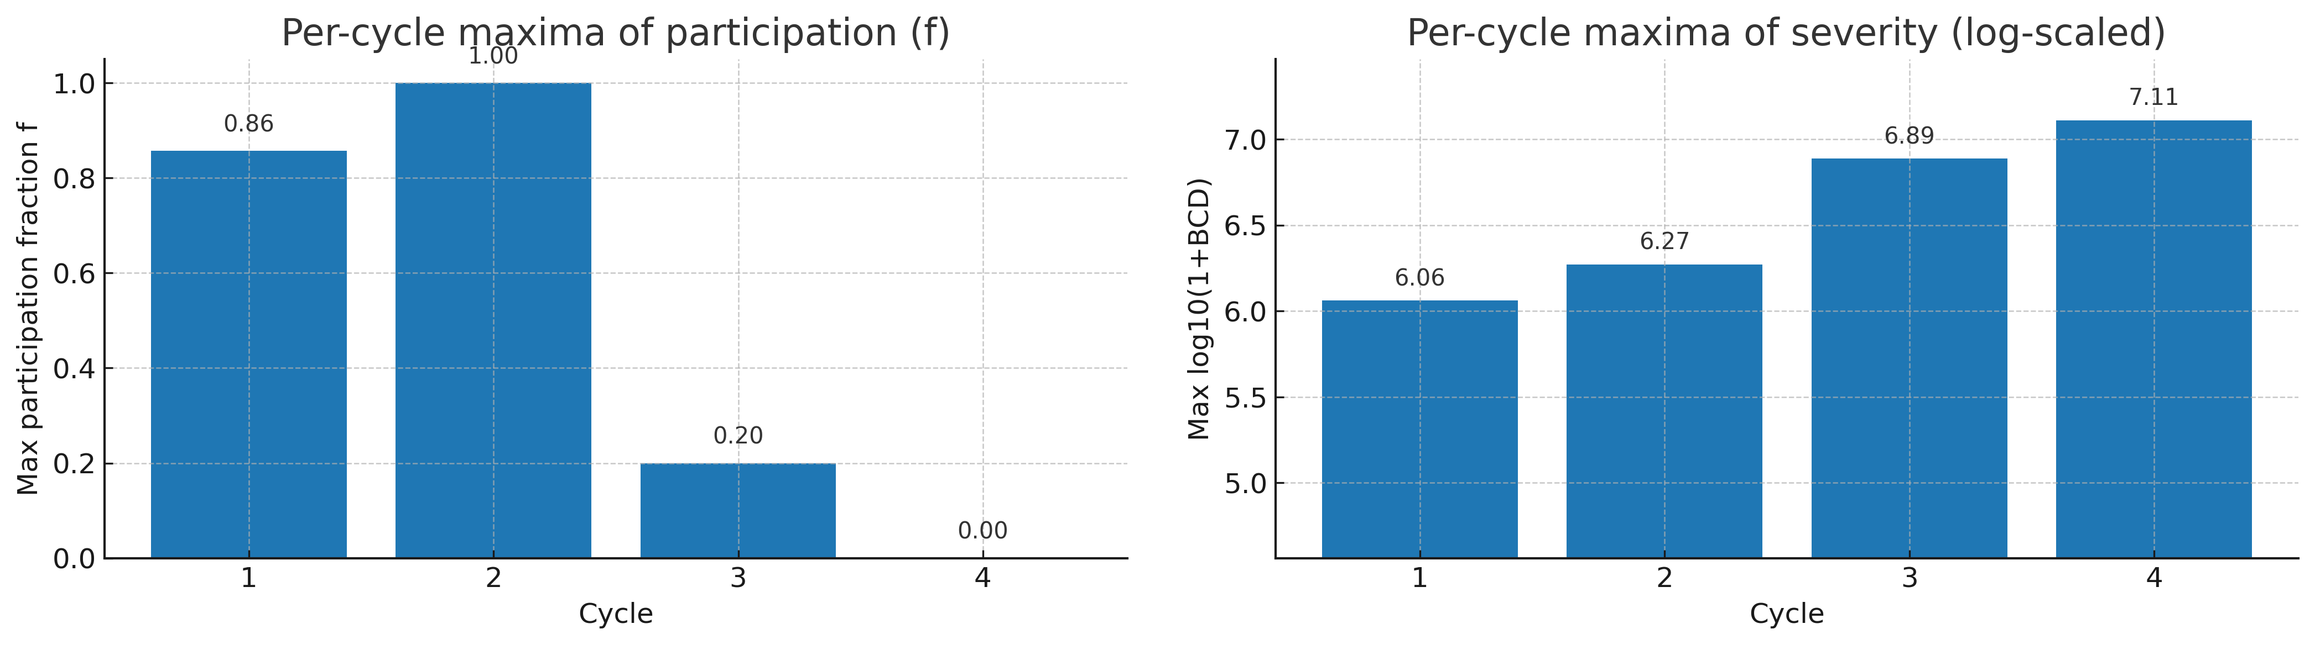

File. ED_Fig01a_participation_maxima.pdf (rendered from manifested inputs; see ED Table T3).

Scope. Europe/GP; 1495 (Levy) baseline; all wars within each cycle (RSP and SW). f uses the European GP denominator at each war’s start.

Method. For each war t in cycle k, compute $f_{t}$ and $s_{t}= \log_{10}(1+{BCD}_{t})$, for each cycle k, plot maximum${ f}_{onset}$ and the maximum severity s(t) attained by any war in that cycle (bars/points). Label the Seven Years’ War (1756–1763) as an NSW despite${ f}_{onset}$ = 1 and high BCD.

Use. Diagnostic only. The four SWs sit at joint extremes (high f, high severity), while NSWs cluster lower; illustrating why the functional classification (RSP→SW) aligns with system-wide resets without relying on thresholds.

Pointers. Article Fig. 2 (severity vs participation scatter); cycle bounds in ED Table T2; per-war diagnostics and cycle mapping in the manifest (ED Table T3).

Data. Per-war participation and severity file(s) and the cycle-metrics file are listed in ED Table T3 (manifest) (use those entries here rather than inventing new labels).

Remarks. The f denominator changes with the GP roster (Europe-only). For transparency, we report the extant GP count alongside f in the per-war file listed in T3. The Seven Years’ War remains non-systemic by our functional rule (no regime reset): a big NSW is not a SW.

Notes. This section does not use κ or EWS. κ is an L1 carrier constructed in ED §9; EWS are L2 diagnostics in ED §8. Cadence estimation (train on cycles 1–3; hold-out cycle 4) is in ED §6; severity as a check is in ED §7; hazards/change-points are in ED §10.

ED §4. Stability (SI)

Purpose. Quantify how “regular” the field of GP-Europe war onsets becomes within each cycle. SI is a cycle-level descriptor: higher SI = longer average spacing between onsets inside an RSP. It supports the article’s cross-cycle regularity (Article Fig. 3A) and is not used to classify SWs or to estimate cadence. SI does not depend on participation fraction f; recent updates to f affect Fig. 2 but not SI. Corrections to the NSW counts in T1 are reflected here.

4.1 Definition and scope

- RSP window. Let an RSP be [$t_{0}$, $t_{1}$) with n GP-Europe non-systemic war onsets inside it (SW is excluded because it terminates the RSP).
- Edge-inclusive mean interval. Partition the window by the edges $t_{0}$, $t_{1}$ and the n onsets. The Stability Index is ${SI}_{k}$ = (t₁ − t₀) / (n + 1), with onsets counted in [$t_{0}$, $t_{1}$). SI is in years and is well-defined even when n=0.
- Horizon and baseline. SI is reported on the 1495 baseline only (ED §2). The 1453 overlay is not used for SI because pre-1495 onset timings are not reconstructable at within-RSP resolution to Levy standards.

For the corrected coding, the resulting SI series by cycle is approximately 2.80, 4.36, 6.60, 10.50 (cycles 1–4).

4.2 Estimation and uncertainty

- Estimator. Compute ${SI}_{k}$ directly from [$t_{0}$, $t_{1}$) in T2 and the set of NSW onsets in that window from T1. Per-cycle SI values and onset counts are recorded in T3 (and mirrored for article figures in D23).
- Uncertainty (display). SI is deterministic given [$t_{0}$, $t_{1}$) and onsets. Confidence bands shown in plots are descriptive: HAC 95% intervals (Bartlett kernel; Andrews bandwidth) are applied to trend-line displays (linear-in-cycle or log-linear), following the block-dependence conventions used in ED §14.
- Fits. Linear-in-cycle and log-linear trend lines may be shown as descriptive only, not inferential.

4.3 Sensitivity and hygiene

- Small-n hygiene. SI is defined for all n $≥$0; the accompanying onset count n per RSP is reported in T3.
- Edge handling. Onsets at exactly${ t}_{0}$ are included; onsets at${ t}_{1}$belong to the terminating SW and are excluded from the RSP.
- Robustness checks. Re-compute SI under (i) trimming the first/last interval; (ii) excluding sub-annual ambiguities; (iii) non-edge mean ($t_{1}$-$t_{0}$)/n when n $≥$ 1. All preserve the cross-cycle ordering and the increasing pattern.

4.4 Local diagnostic: ED Fig. 02a: Stability Index (SI) details (1495 baseline)

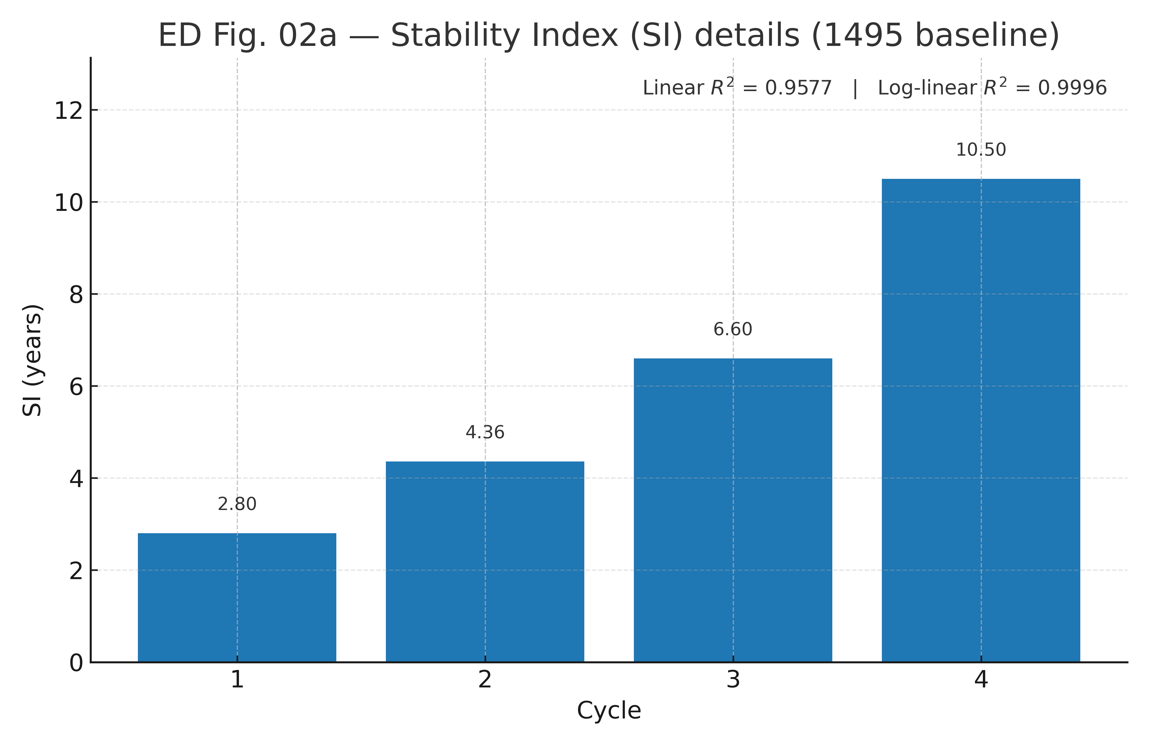

File. ED_Fig02a_stability_SI_details.pdf (rendered from manifested inputs; see T3).

Scope. Europe/GP; 1495–1945; RSPs only; SI reported per RSP.

Method. For each RSP [$t_{0}$, $t_{1}$) in cycle k, with n GP-Europe NSW onsets from T1 filtered by the bounds in T2, compute${ SI}_{k}$ = (t₁ − t₀) / (n + 1). Plot${ SI}_{k}$ by cycle. Where shown, overlay HAC 95% trend-line bands (Bartlett/Andrews).

Use. Supports the article’s stability-increasing regularity across cycles (Article Fig. 3A); SI is a cycle-level descriptor only.

Pointers. Article Methods (SI definition); ED §2 (bounds and registry), ED §5 (Plasticity), ED §13–§14 (sensitivities/robustness).

Data. Per-cycle SI values and NSW counts are in T3 (T3_ED_table_cycle_metrics_full.csv); the per-war onset list is T1 (T1_ED_table_war_classification_with_sources.csv); cycle bounds are T2 (T2_ED_table_cycle_bounds.csv). For the article’s Fig. 3A/3B, the compact source file is D23 (D23_cycle_SI_plasticity_strictOpen.csv).

Remarks. SI is 1495-only by design. Display CIs are HAC-robust and pertain to trend-line displays, not to the deterministic SI values.

Notes. SI is independent of $κ$ and EWS. $κ$ (L1, descriptive) appears in ED §9; EWS (L2, pre-whitened) in ED §8. SI contributes to the article’s cross-cycle regularities but neither defines SWs (ED §3) nor anchors the cadence endpoint (ED §6).

ED §5. Plasticity (GP status changes within RSPs)

Purpose. Quantify Plasticity: the count of great-power (GP) status changes (entries + exits) that occur within each Relatively Stable Period (RSP). Plasticity is a cycle-level descriptor (Article Fig. 3B). It illustrates cross-cycle regularities and does not define Systemic Wars (SWs) or estimate cadence. Plasticity does not depend on participation fraction f. Corrections to NSW counts and roster timing are reflected here.

5.1 Definition and scope

- RSP window. Let an RSP be [$t_{0}$, $t_{1}$) with the terminal SW starting at t_1. Plasticity counts status-change events strictly inside the window: t_0 < \tau < t_1.
- Plasticity (per RSP).

$Plasticityk = \sum{e∈ε_{k}1}$, with $ε_{k} = \left\{GP status entries/exits with t_{0}^{(k)}< τ_{e}<t_{1}^{(k)}\right\}$

- Report the entry/exit split alongside the total.
- Horizon and baseline. Plasticity is reported on the 1495 baseline only, for comparability with SI (ED §4). The 1453 overlay is not used for Plasticity.

For the corrected coding, Plasticity totals by cycle are 8, 5, 1, 0 (cycles 1–4), with entry/exit splits 5/3, 2/3, 1/0, 0/0.

5.2 Estimator and counting rules

- Roster and effective dates. Use the Levy-consistent European GP roster time series (entity, status start, status end). Effective dates are the first year an entity is recognized as a GP and the last year before loss of GP status.
- Strict interior rule. Changes at the RSP boundaries are excluded: events with $τ$ = $t_{o}$ or $τ$= $t_{1}$ do not count toward Plasticity. Changes within the terminal SW window [$t_{1}, sw_end$] are outside the RSP and are not counted.
- Multi-event hygiene. Multiple changes for the same entity within an RSP are each counted if they occur at distinct dates (e.g., exit then re-entry). Same-year entry/exit for the same entity is collapsed per coding notes in the roster (rare; documented in the manifest).
- Aliases/successors. Resolve name changes, dynastic shifts, and successor labels to the correct GP entity consistent with the roster (procedures as in ED §2).
- Non-European or colonial transitions. Ignored unless the underlying event alters European GP status per the roster.

5.3 Sensitivity and display

- Uncertainty display. Plasticity is deterministic given the roster and bounds. We therefore omit CIs in the panel; robustness to boundary variants is discussed below and in ED §14.
- Boundary variants. As checks, (i) include $τ$ = $t_{o}$ or $τ$= $t_{1}$; (ii) exclude changes within $∆$t = 1 year of boundaries; (iii) treat reclassifications during long RSPs separately. All preserve the declining cross-cycle pattern.
- Roster variants. Where modern sources differ slightly in status timing, we retain Levy-consistent dates for primaries and demonstrate that small shifts do not change qualitative results.

5.4 Local diagnostic: ED Fig. 02b: Plasticity details (GP status changes in RSP; 1495 baseline)

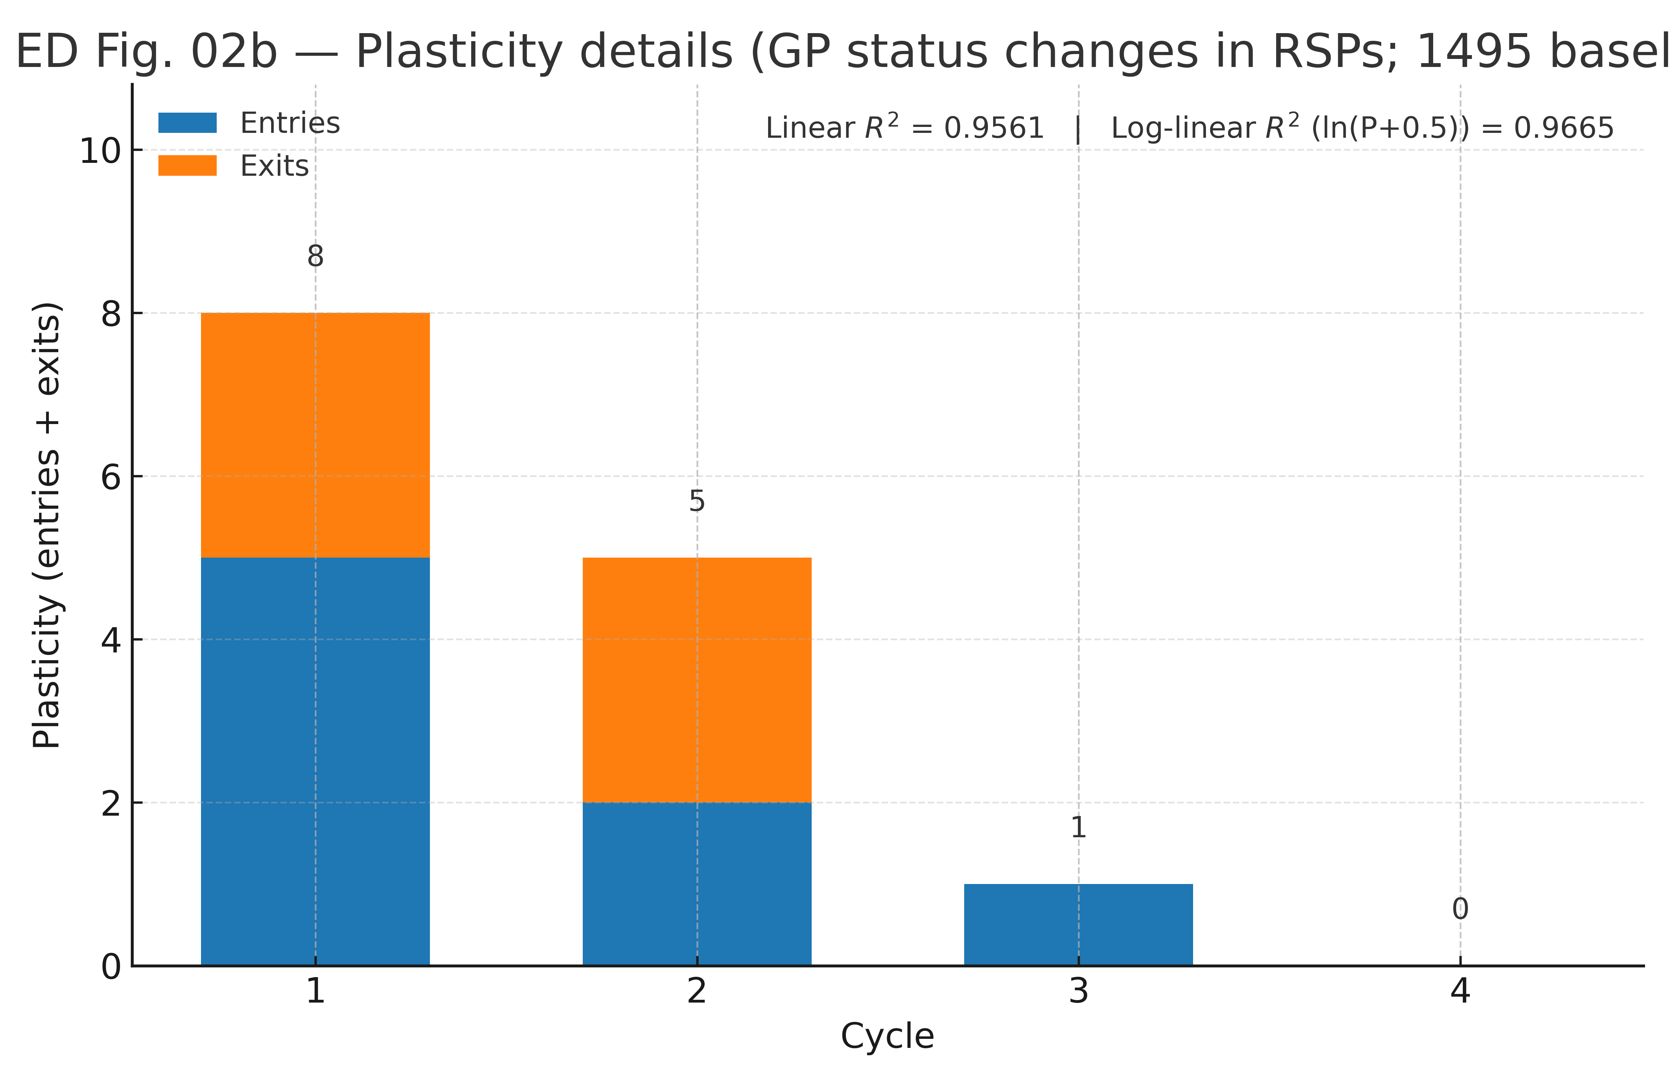

File. ED_Fig02b_plasticity_details.pdf (rendered from manifested inputs; see T3 / D23).

Scope. Europe/GP; 1495–1945; RSPs only; Plasticity reported per RSP.

Method. Using the GP roster, count entries + exits whose effective dates fall strictly inside each RSP window (bounds in T2). Plot stacked bars (entries + exits) by cycle; annotate totals above bars. For orientation we report descriptive fit quality in-figure: Linear $R^{2}$and Log-linear $R^{2}$ for ln(Plasticity + 0.5).

Use. Supports the article’s Plasticity-declining regularity across cycles (Article Fig. 3B). Plasticity is a cycle-level descriptor.

Pointers. Article Methods (Plasticity definition); ED §2 (bounds and registry), ED §4 (SI), ED §13–§14 (sensitivities/robustness).

Data.
- Roster file: D5_gp_status_1495-2025_with_codes.csv (status start/end coding; Europe/GP mask).
- Cycle windows: T2_ED_table_cycle_bounds.csv.
- Per-cycle outputs: T3_ED_table_cycle_metrics_full.csv (and compact article source D23_cycle_SI_plasticity_strictOpen.csv with entries, exits, totals).

Remarks. Plasticity is 1495-only (harmonized with SI). Counting is event-time-based with no imputation across RSP boundaries. The entry/exit split is reported for transparency and is not used in inference.

Notes. Plasticity is independent of $κ$ and EWS. $κ$ (L1, descriptive) appears in ED §9; EWS (L2, pre-whitened) in ED §8. Plasticity contributes to the article’s cross-cycle regularities; it neither defines SWs (ED §3) nor anchors cadence (ED §6).

ED §6. Cadence model (train/hold-out + nulls)

Purpose. Estimate a finite-time cadence law for cycle durations and anchor a shared endpoint $T_{c}$ out-of-sample using timing only. Severity is held out as a check (see ED §7). This section documents the model, training/hold-out protocol, and a schedule-randomization null.

6.1 Cadence variable and training set

- Cadence variable. For cycle k, let the RSP be $\left[t_{0}^{k}, t_{1}^{k}) \right.$with terminal SW starting at $t_{1}^{k}$.

Define RSP length:
$L_{k}= t_{1}^{(k)}- t_{0}^{(k)}$ years,

and the RSP midpoint:
$T_{k }= \frac{1}{2}\left(t_{0}^{(k)}- t_{1}^{(k)}\right)$.

Midpoints reduce leverage from long early RSPs in the log–log fit.

- Training vs hold-out. Train on cycles 1–3 (RSP midpoints $≤1913$); hold out cycle 4 for validation. For the 1453 overlay, the training midpoints are approximately 1535.5, 1720.0, 1864.5 (see ED Table T2 for exact bounds).
- Starts. We use the 1495 baseline for primaries and the 1453 overlay only for cadence sensitivity (adds pre-1495 NSWs to RSP1). See ED §2.

6.2 Model and estimation

We assume a finite-time form for cadence:

$$logL_{k} = α +βlog\left(T_{c}- t_{k}\right)$$

with${ T}_{c}$ constrained to a post-1918 window^{6,7}. Estimation proceeds by grid-search over${ T}_{c}$; at each candidate${ T}_{c}$ we refit $α, β$ by OLS using cycles 1–3 only, and record the training SSE:

$SSE(T_{c}) = \sum_{k=1}^{3}{\left(logL_{k}-α(T_{c}\right)-β∙(T_{c})log{\left(T_{c}-t_{k})\right)}^{2}}$.

- Grid. $T_{c}$ $∈$ [1940, 1956] in 0.1-year steps (primary).
- Endpoint selection. $\hat{T_{c}}$ minimizes SSE${(T}_{c})$ on the training set.
- Out-of-sample check. Predict $L_{4}$ from $\hat{α}(\hat{T_{c}}), \hat{ β}(\hat{T_{c}})$ and compare with observed $L_{4}$ (RSP length of cycle 4). Report absolute and relative OOS error.
- Sensitivity. Repeat the procedure with cycle length $L_{k}^{tot} = \left(t_{k}^{{SW}_{end}}-t_{k}^{{RSP}_{start}}\right)$ to show that the shrinking-cadence pattern holds when the terminal SW is appended.

6.3 Discipline, diagnostics, and scope

- Discipline. The fit uses timing only (RSP lengths); severity is not an input (see ED §7 for the independent severity check).
- Diagnostics. We display the SSE profile $SSE(T_{c})$ with the admissible window highlighted; we overlay the cycle-length sensitivity (RSP+SW) for comparison.
- Interpretation. A mid-20th-century $\hat{T_{c}}$ that (i) minimizes training SSE, (ii) predicts $L_{4}$ closely out-of-sample, and (iii) persists under the cycle-length sensitivity constitutes evidence of a finite-time cadence consistent with the Article.
- Identifiability. With three training points, $SSE(T_{c})$ can be shallow near bounds; midpoints and the grid constraint reduce - but do not eliminate - flatness. We therefore include a schedule-randomization null (§ 6.5).

6.4 Local diagnostic: ED Fig. 03a: Cadence SSE profile and cycle-length sensitivity

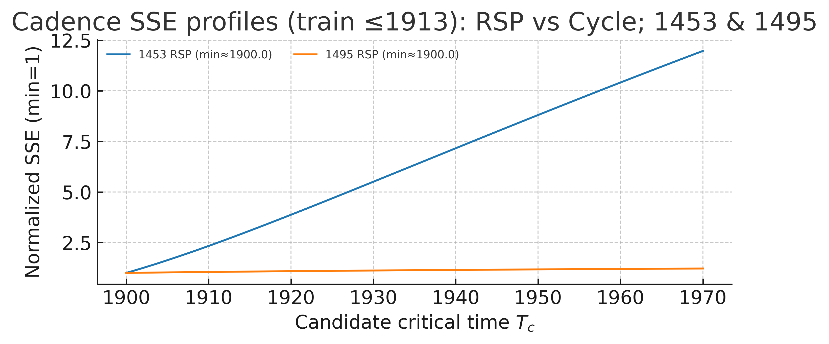

File. ED_Fig03a_cadence_SSE_null_cyclelength.pdf (rendered from manifested inputs; see ED Table T3).

Scope. Cadence on RSP length $L_{k}$ for both starts (1453 overlay; 1495 baseline); sensitivity uses cycle length $L_{k}^{tot}= RSP+ SW$.

Method. Fit the finite-time form on cycles 1–3 only; compute and plot SSE($T_{c}$) across${ T}_{c}$ $∈$[1940,1956] (0.1-y steps). Mark$\hat{{ T}_{c}}$ and show the OOS prediction error for cycle 4. Overlay the profile using cycle length to show robustness of the shrinking-cadence result.

Use. Provides the cadence-anchored $\hat{T_{c}}$ used downstream; shows that the admissible${ T}_{c}$ lies in the WWII window under both starts; confirms that using cycle length preserves the qualitative pattern.

Pointers. Article Fig. 4 (cadence OOS $T_{c}$, 1453). Severity check in ED Fig. 04b and Article Fig. 5; schedule-randomization companion in ED Fig. 03b.

Data.
- Bounds/lengths: ED Table T2 (ED_table_cycle_bounds.csv), cycle metrics in manifest (ED Table T3).
- Profiles: see manifest entries D7–D8 for cadence profile inputs/outputs.
Remarks. Small-n hygiene: OOS hold-out (cycle 4) prevents circularity. Using midpoints reduces leverage from long early RSPs.

6.5 Local diagnostic: ED Fig. 03b: Cadence schedule-randomization (MC)

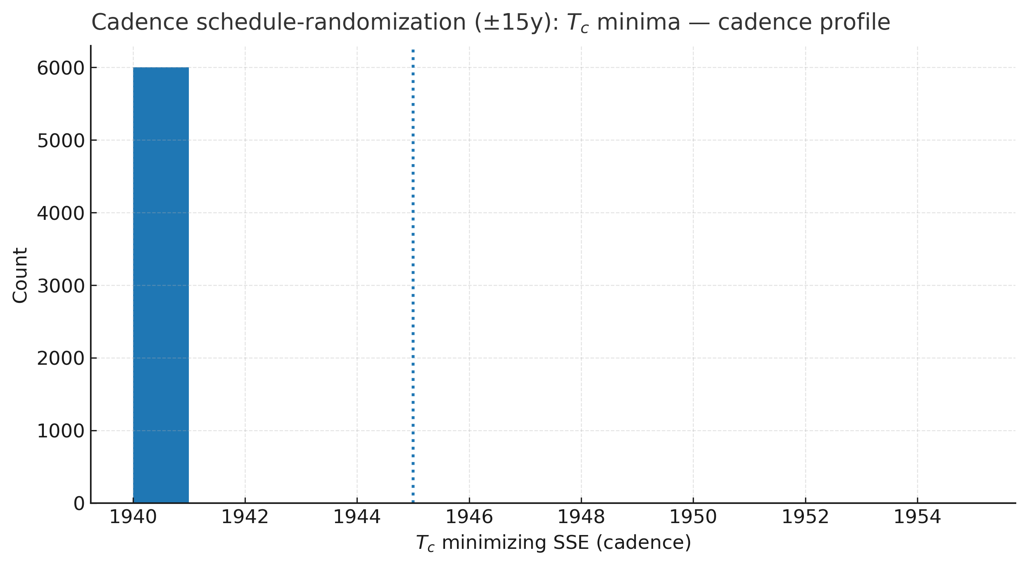

File. ED_Fig03b_cadence_schedule_randomization_MC.pdf.

Scope. 1453 primary scenario; Europe/GP; cadence trained on cycles 1–3 only (RSP midpoints ≈ 1535.5, 1720.0, 1864.5).

Method. For uniform jitter U[-15, +15] years applied independently to the three training midpoints, and seed = 314159, repeatedly refit

$$logL_{k} = α +βlog\left(T_{c}- t_{k}\right) +ε_{k}$$

on the jittered schedule; for each draw, record the minimizing${ T}_{c}$ on the grid 1940 - 1956 (0.1-y steps), and histogram the minima. Number of draws N is specified in the manifest (default N=10,000).

Use. Null for cadence-based${ T}_{c}$ showing sensitivity to schedule timing; complements the OOS fit.

Pointers. Article Fig. 4; ED Fig. 03a (SSE profile and cycle-length sensitivity); ED §12 (joint${ T}_{c}$ display and controls).

Data. Training inputs in manifest (D7); MC outputs listed under cadence-nulls in ED Table T3.

Remarks (degeneracy). With only three training points and ±15y jitter, the SSE surface can be flat near the lower grid bound, so many draws tie at 1940. This is a grid binning artifact; the central tendency still concentrates in the mid-1940s (anchor at 1945 dotted in the plot).

6.6 Additional checks and sensitivities (summary; details in ED §13)

- Cadence variable. Swap RSP length for cycle length (RSP+SW) → same qualitative $\hat{T_{c}}$ window.
- Starts. 1495 baseline vs 1453 overlay → window remains mid-20th century.
- Grid and midpoint. Vary${ T}_{c}$ grid (±5 y), step (0.05–0.25 y), and midpoint definition (e.g., RSP start or end) → minimal movement in $\hat{T_{c}}$ and OOS error.
- Weights. Equal-weight vs length-weighted OLS (reported as a check only) → no change to conclusions; equal-weight is primary.

Notes. Cadence is independent of κ and EWS; κ (L1, descriptive) is in ED §9, and EWS (L2, pre-whitened) in ED §8. Severity is a check in ED §7; hazard/change-point details are in ED §10.

ED §7. Severity as a check

Purpose. Treat terminal Systemic-War (SW) severity as an independent blow-up check against the cadence-anchored endpoint $T_{c}$ ^{6,7}. Severity is not used to estimate$T_{c}$; it is evaluated conditional on the cadence estimate from ED §6.

7.1 Role and measure

- Measure. Severity S is battle-casualty deaths (BCD) for the four terminal SWs (cycles 1–4).
- Start conventions. BCD totals are identical under the 1453 overlay and 1495 baseline; only cadence timing differs across starts.
- Scope. The SW start year t is the event time in the log–log fit; per-war BCD sources and harmonization are documented in the manifest (ED Table T3).

7.2 Conditional design (fixed${ T}_{c}$)

- Anchor. Fix $T_{c}$ at the cadence-anchored estimate $\hat{T_{c}}$ obtained only from RSP lengths (cycles 1–3 train; cycle 4 hold-out) in ED §6.
- Discipline. This avoids circularity: severity does not inform $\hat{T_{c}}$; it tests whether escalation is consistent with that endpoint.

7.3 Estimation at fixed${ T}_{c}$

With${ T}_{c}$ fixed at $\hat{T_{c}}$ , estimate the severity slope p from:

$$logS = logC -plog\left(T_{c}-t\right) +ε,$$

where t is the SW start year and C is a normalization constant. Report the fitted $\hat{p}$ and HAC 95% CI (Bartlett/Andrews). To assess coding-tail sensitivity, run a winsorization Monte Carlo (next subsection).

7.4 Local diagnostic: ED Fig. 04a: Severity winsorization (Monte Carlo)

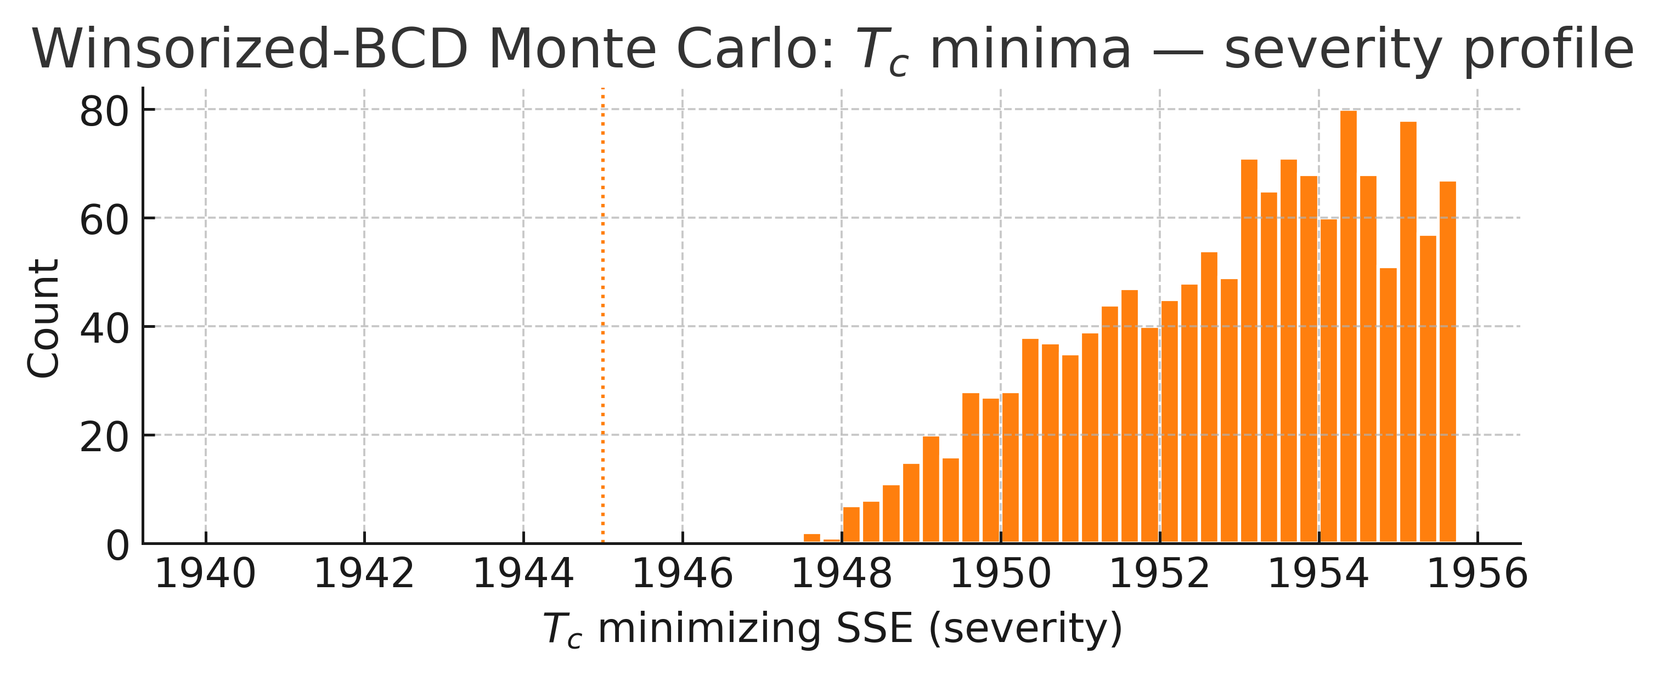

File. ED_Fig04a_severity_winsor_MC.pdf (rendered from manifested inputs; see ED Table T3).

Scope. Europe/GP; terminal SW severities for cycles 1–4 (identical under 1453 and 1495). $T_{c}$ is fixed from cadence (see ED Fig. 03a–03b).

Method. Treat BCD uncertainty with a winsorization Monte Carlo: draw many winsorized variants of SW BCD inputs (light tail trimming; levels noted in the panel), refit p in
log S = log C - plog($T_{c}$ - t) holding $T_{c}$ fixed at$\hat{{ T}_{c}}$ , and display the sampling distribution (histogram/intervals). Seed = 314159.

Use. Guardrail showing that the escalation signal (given cadence-anchored $T_{c}$) is not an artefact of tail coding.

Pointers. Article Fig. 5 (severity as blow-up check). Cadence anchor in ED Fig. 03a–03b; joint-timing context in ED Fig. 10a–10c (see ED §12).

Data.
- Severity table at fixed${ T}_{c}$: D9_ED_table_Tc_profile_severity_all.csv.
- Cycle mapping: cycle-metrics file in manifest (ED Table T3).
Remarks. Winsorization is descriptive robustness, not a recoding; it does not change SW identification or cycle coding.

7.5 Local diagnostic: ED Fig. 04b: Severity fit robustness (given cadence-anchored${ T}_{c}$)

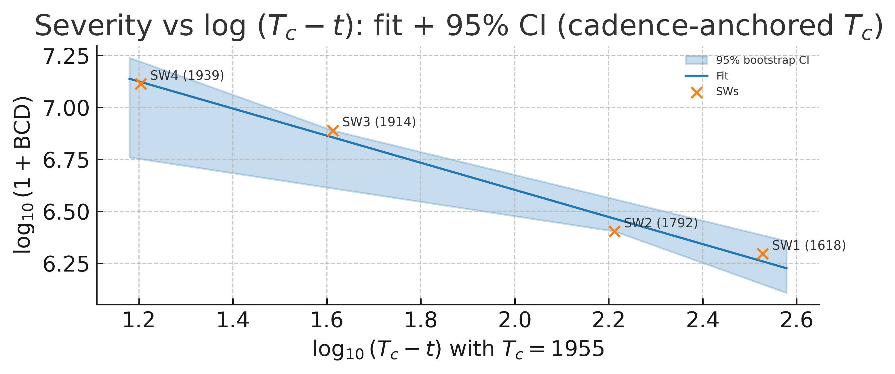

File. ED_Fig04b_severity_fit_robustness.pdf.

Scope. Europe/GP; the four terminal SWs; panels for both 1453 overlay and 1495 baseline (values coincide; timing labels may differ).

Method. With${ T}_{c}$ fixed to $\hat{T_{c}}$ from ED §6, regress log S on log ($T_{c}$ - t) where t is the SW start year. Plot fitted line with HAC 95% CI and report escalation exponent $\hat{p}$.

Use. Treats severity as an out-of-sample check on cadence-anchored timing; avoids circularity by not using severity to estimate $T_{c}$.

Pointers. Article Fig. 5; cadence anchor in ED Fig. 03a–03b; convergence context in ED Fig. 10a (joint $T_{c}$ profile) and ED Fig. 10e (visual L and S convergence).

Data. D9_ED_table_Tc_profile_severity_all.csv (severity fit inputs at fixed${T }_{c}$); D10_ED_table_Tc_profile_joint_norm.csv (normalized joint timing table used in ED Fig. 10a); cycle-metrics file in ED Table T3.

Remarks. As emphasized in the Article, severity totals are identical under 1453/1495; the figure emphasizes slope robustness at cadence-anchored${ T}_{c}$.

7.6 Local diagnostic: ED Fig. 04c: Per-cycle metrics overview

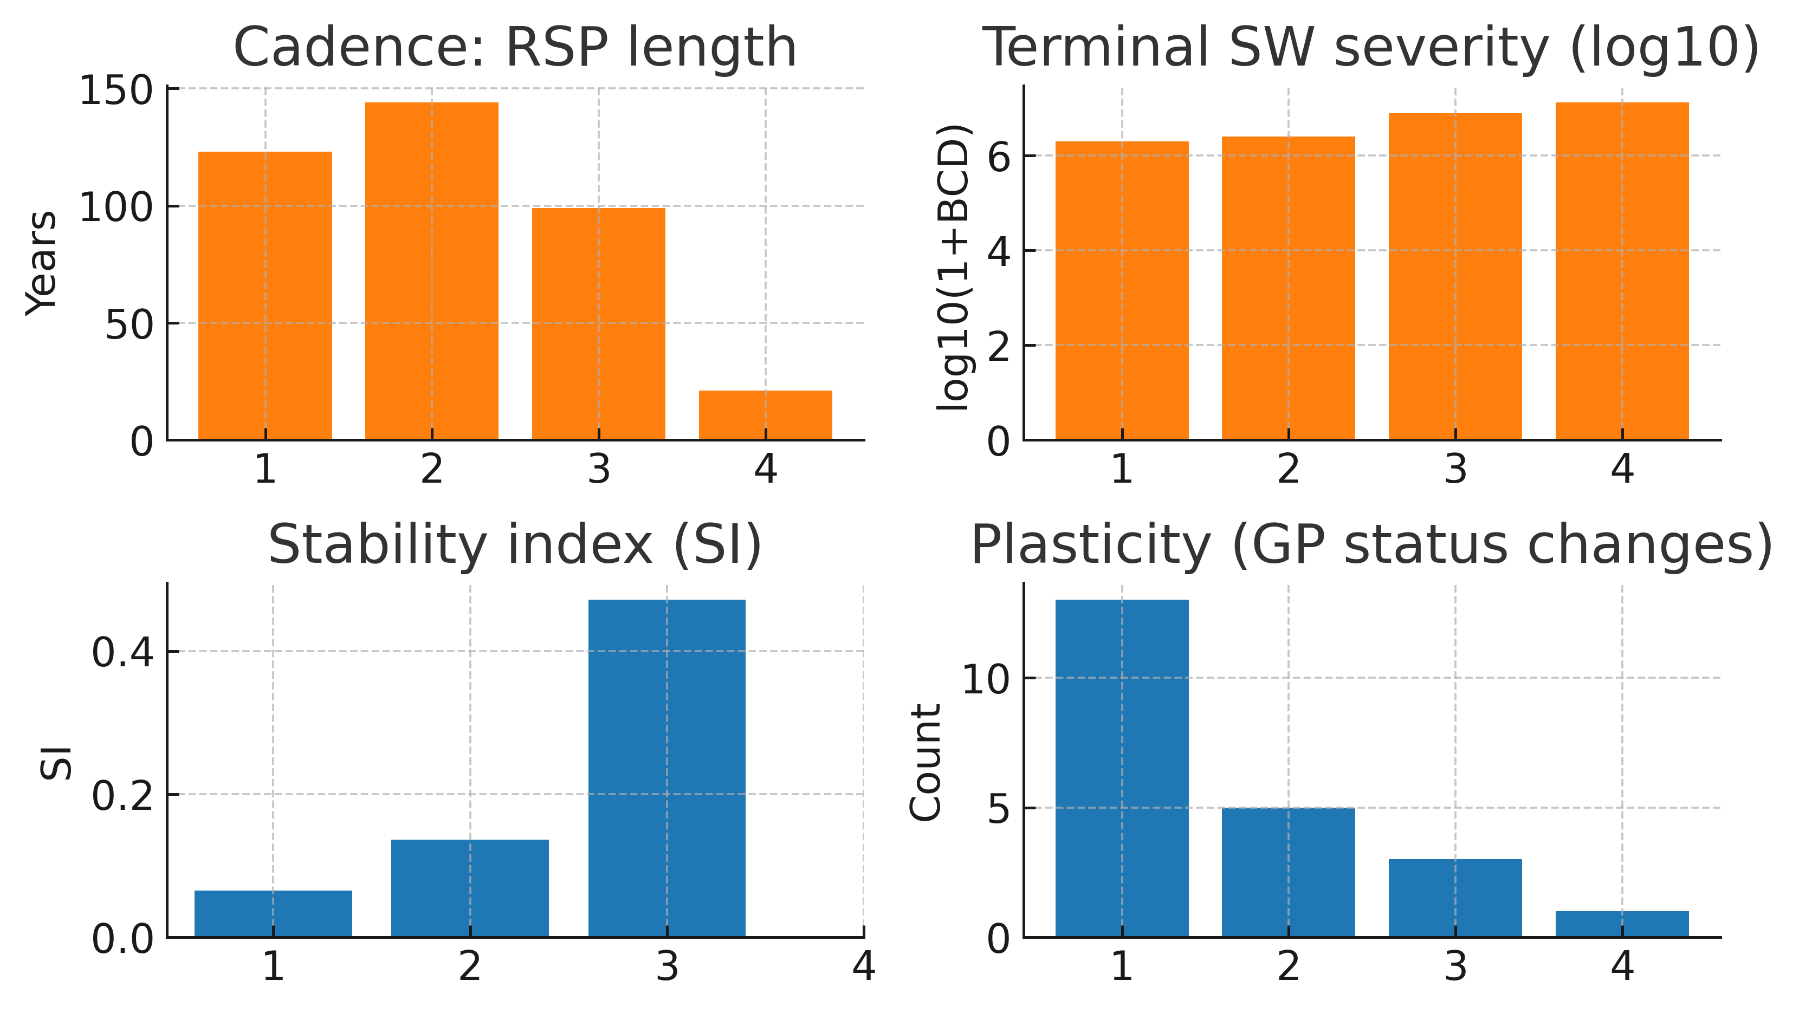

File. ED_Fig04c_cycle_metrics_overview.pdf.

Scope. 1495 (Levy) baseline; per-cycle SI, Plasticity, Cadence (RSP length), and Terminal severity.

Method. Collate cycle-level metrics from the cycle-metrics output (manifest, ED Table T3); display as a compact panel with HAC 95% CIs for SI and Plasticity and point values for Cadence/Severity.

Use. Quick overview situating severity among cross-cycle regularities referenced in the Article.

Pointers. Article Fig. 3A–B (SI and Plasticity); Article Fig. 4 (cadence OOS $T_{c}$, 1453); Article Fig. 5 (severity check). ED details: ED Fig. 02a–02b (SI, Plasticity), ED Fig. 03a–03b (cadence profiles and schedule MC), ED Fig. 04a–04b (severity winsor MC and fit robustness).

Data. Cycle-metrics file listed in ED Table T3.

Remarks. SI/Plasticity are 1495-only (pre-1495 war timing not reconstructable to Levy standards at within-RSP resolution).

7.7 Sensitivities and caveats (summary; details in ED §13)

- Winsor levels. Varying trimming (light to moderate) leaves \hat{p} and its CI qualitatively unchanged.
- Alternative time t. Using SW end rather than start year makes no qualitative difference to the slope; start year is primary.
- HAC choices. Bartlett kernel with Andrews bandwidth is primary; Newey-West yields comparable intervals.
- Data variants. Where severity ranges exist in sources, we apply a documented mid-point rule (manifest); winsor MC explores tails around that rule.

Notes. Severity is a check, not a driver. Cadence estimation appears in ED §6; joint endpoint consistency (overlay of cadence, severity, hazard, and κ landmarks) appears in ED §12; global sensitivities and nulls are in ED §13–§14.

ED §8. L2 EWS preprocessing

Purpose. Construct within-cycle early-warning statistics (EWS) on Layer-2 (L2) behavioural series, using AR(1) pre-whitening, fixed-length rolling windows, and HAC bands. These diagnostics are descriptive evidence of critical slowing down (CSD) within cycles. κ is not an EWS target and is never analysed with CSD operators here (κ is L1; see ED §9)^{8,9,10,11}.

8.1 Overview and constraints

- Layer separation. EWS apply only to L2 series (behaviour/flows). κ is an L1 carrier (structural capacity); do not compute EWS on κ.
- Horizon. Annual series, 1816–1945, Europe/GP mask.
- Alignment. Rolling windows are anchored to 5-year bin ends so that EWS traces and κ sit on the same evaluation grid (1816, 1821, …, 1945).
- Primary windows. 10-year rolling windows (primary) with 8–12-year sensitivity overlays.
- Uncertainty. HAC 95% bands (Bartlett kernel; Andrews bandwidth¹⁹). No bootstrap in this panel.

8.2 Series construction (L2)

- MILEX (AC1 indicator).

  - Raw: CINC MILEX (NMC v5.0; manifest D2) for all European GPs²⁴.
  - Aggregate: sum across GPs by year under the Europe/GP mask (primary; GP-weighted variants in ED §13).
  - Pre-whitening: Fit an AR(1) to the annual aggregate $X_{t}$ over 1816–1945: $X_{t}= μ+ϕX_{t-1}+e_{t}$. Use residuals $ε_{t}= X_{t}-μ-ϕX_{t-1 }$.
  - EWS statistic: lag-1 autocorrelation within each window $W_{y}$= [y-9,y] anchored at 5-year end y: $AC1(y) = Corr(ε_{t}, ε_{t-1}){(ε_{t}, ε_{t-1})}_{t∈W_{y}}$

- Alliances (variance indicator).

  - Raw: COW Alliances v4.1 dyad-year file (manifest D3)²¹.
  - Adjacency and churn: Build a GP-only European symmetric adjacency $A_{t}(i,j)∈$ {0,1}. Define churn $c_{t}= \sum_{i<j}{\left|A_{t}(i,j)-A_{t-1}(i,j)\right|}$.
  - Pre-whitening: Fit AR(1) to annual $c_{t}$ over 1816–1945; use residuals $ε_{t}^{(c)}$.
  - EWS statistic: variance within $W_{y}= \left[y-9,y\right]$: $Var(y)=Var(ε^{(c)}t)t∈W_{y}$

Notes. CINC indices avoid monetary deflation issues. Where dyad coding ambiguities exist (e.g., short-lived treaties), we follow COW conventions; resolution rules are documented in the manifest (ED Table T3).

8.3 Windowing, alignment, and sensitivity

- Anchoring. For each 5-year endpoint y $∈${1816,1821,...,1945}, compute EWS on the closed window [y-9,y].
- Sampling. If an annual EWS trace is computed internally, we resample it at 5-year ends by nearest-endpoint mapping; primary results use windows constructed at the endpoints.
- Sensitivity. Repeat with 8–12-year windows; show overlays in the figure. GP weighting variants for MILEX and alternative churn normalizations are summarized in ED §13; qualitative ascent is robust.

8.4 Local diagnostic: ED Fig. 05a: Within-cycle EWS — variance and AC1 with pre-whitening

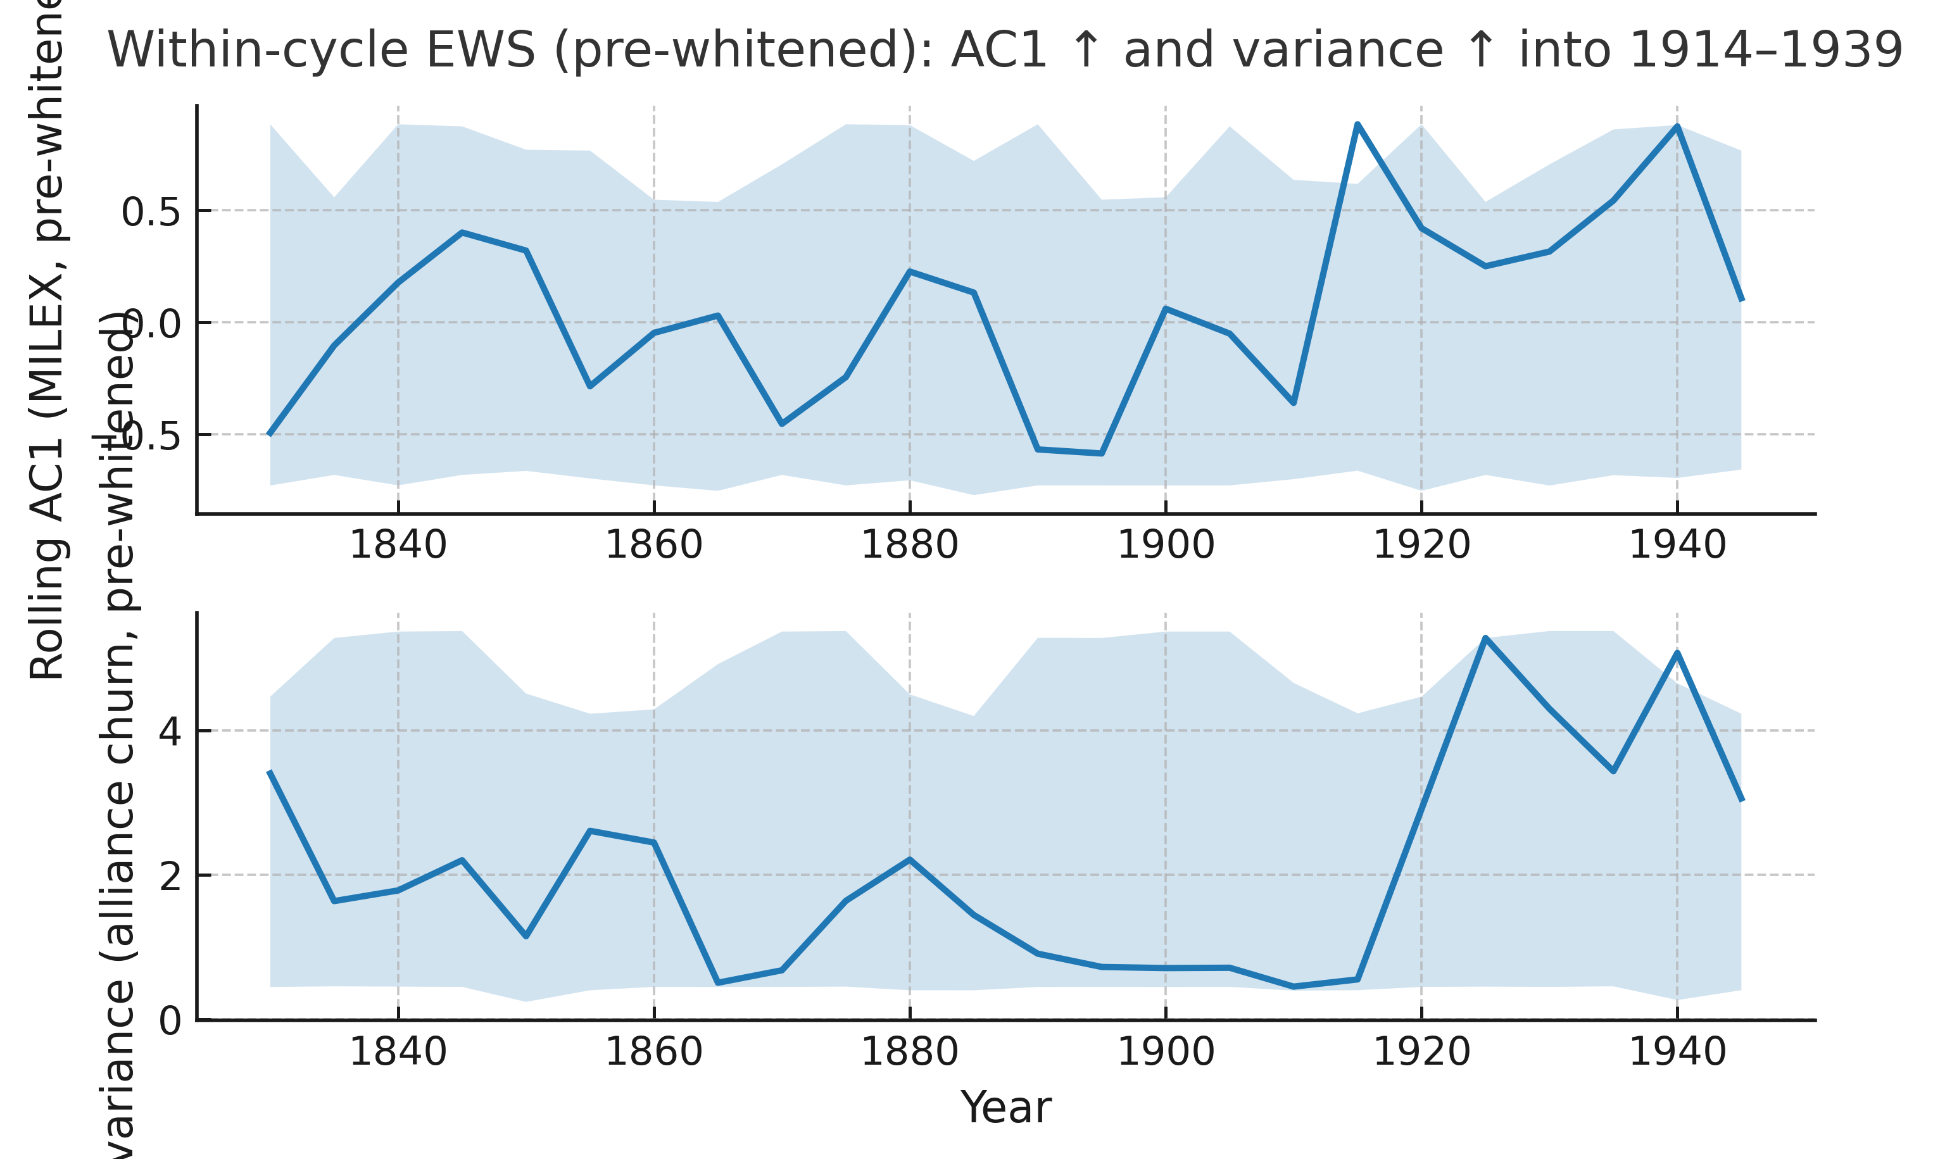

File. ED_Fig05a_EWS_prewhiten_bands_sensitivity.pdf (rendered from manifested inputs; see ED Table T3).

Scope. Europe/GP; 1816–1945; L2 series only; windows aligned to 5-year bin ends.

Data. Source Data: D20_EWS_MILEX_AC1_prewhitened_5y.csv (MILEX AC1) and D21_EWS_AllianceChurn_Var_prewhitened_5y.csv (alliance-churn variance).

Method.

- Pre-whitening: fit AR(1) and take residuals for each raw annual series.

- MILEX: aggregate European GP CINC-MILEX (manifest D2), then compute 10-year rolling AC1 on residuals.
- Alliances: build GP-dyad adjacency from COW v4.1 (manifest D3); compute annual churn $c_{t}$; pre-whiten $c_{t}$; compute 10-year rolling variance on residuals.

- Bands/sensitivity: plot EWS with HAC 95% bands; overlay 8–12-year window sensitivities.

Use. Descriptive early-warning structure consistent with CSD: both AC1 (MILEX) and variance (alliance churn) rise within cycles into 1914–1939. κ is not used as an EWS target here.

Pointers. Article Fig. 6A–B (EWS traces). κ→L2 lead–lags are analysed in ED §9 (local figs ED_Fig07a, ED_Fig07b). Cross-correlation tables are listed in the manifest (D16–D17).

Data. Raw sources D2 (D2_NMC_5_0.csv), D3 (D3_alliance_v4.1_by_dyad_yearly.csv); cross-correlation outputs D16–D17.

Remarks. Window choice (8–12 y) and aggregation choices (e.g., GP weighting in MILEX) were checked; qualitative ascent is robust. No randomization in this panel; HAC, not bootstrap, provides bands.

8.5 Caveats and hygiene (summary; details in ED §13–§14)

- Pre-whitening scope. AR(1) is fit on the full annual series; residual-based EWS can still drift upward if local persistence increases: this is the intended diagnostic.
- Overlap dependence. Adjacent windows overlap; HAC bands address short-range dependence in the displayed traces.
- Mask stability. Europe/GP mask is held constant for aggregation; dyad sets reflect GP roster changes over time but are mapped to the roster for each year per ED §2.

Notes. EWS here support the within-cycle CSD narrative. They are not used to estimate cadence (ED §6) or hazards (ED §10). κ remains descriptive L1 (construction and lead–lag in ED §9).

ED §9. κ construction (L1) and κ↔L2 lead–lag

Purpose. Build a Layer-1 (L1) index of European structural connectedness - κ - from three frozen, non-war inputs: state-lattice concentration (ENS), rail infrastructure per capita, and urbanization share. κ is used descriptively to diagnose timing relative to Layer-2 (L2) behavioural signals (EWS) constructed in ED §8. It is a structural carrier, not itself an EWS target, and is not used for classification, threshold tuning, or post-hoc adjustments. Lead–lag analysis tests whether this structural capacity (L1) tends to precede behavioural symptoms (L2) inside cycles.

The κ series used in the main text is supplied as D6_CCI_v2_L1_5yrbins__GPweightedF1F2.csv. It aggregates three structural inputs of European connectedness in five-year bins (1816–1945): L1 = population-weighted Effective Number of States (ENS) concentration (monotone-transformed so higher concentration → higher κ); F1 = railway kilometres per capita (GP-weighted); F2 = urbanization share (GP-weighted). Each series is standardized (z, 1816–1945) and averaged with equal weights to form κ. The file includes raw series (F1, F2, L1), their standardized forms (zF1, zF2, zL1), and the composite outputs (kappa_flow, $κ$). κ is descriptive only: it is not used for classification, threshold tuning, or post-hoc adjustments.

Table EDκ-1. κ input variables in D6_CCI_v2_L1_5yrbins__GPweightedF1F2.csv

Column name | Variable | Definition / Unit | Transform | Weight
L1 | ENS concentration | Population-weighted Effective Number of States (monotone-transformed so higher concentration → higher κ) | z-standardized (1816–1945) | 1/3
F1 | Rail per capita | Railway kilometres per 1,000 inhabitants, GP-weighted | z-standardized (1816–1945) | 1/3
F2 | Urbanization share | Fraction of GP population in urban settlements | z-standardized (1816–1945) | 1/3
zL1, zF1, zF2 | Standardized inputs | z-scores of the raw series | – | –
kappa_flow | Flow sub-index | Mean of (zF1, zF2) | – | –
$$κ$$ | Composite κ | Equal-weight mean of (zL1, zF1, zF2) | –

Table EDκ-1 | Input variables for κ (Layer 1 carrier).
Variables are drawn from D6_CCI_v2_L1_5yrbins__GPweightedF1F2.csv. L1 encodes ENS concentration (population-weighted, monotone-transformed so higher concentration → higher κ); F1 encodes rail kilometres per capita (GP-weighted); F2 encodes urbanization share (GP-weighted). Each series is z-standardized over 1816–1945 and aggregated with equal weights to form κ. The file also contains standardized inputs (zL1, zF1, zF2), the flow sub-index (kappa_flow), and the composite κ.

§9a κ construction and portrait (descriptive L1)

9.1 Stance and scope

- Layer separation. κ indexes structural connectedness channels (L1): state-lattice concentration (ENS), rail infrastructure per capita, and urbanization share: frozen non-war inputs that capture systemic capacity but are not themselves war events.
- Horizon and grid. κ is reported on 5-year bin ends, 1816–1945 (e.g., 1816, 1821, …, 1945) to align with L2 windows in ED §8. Europe/GP mask follows ED §2.

9.2 Inputs, normalization, and aggregation

- Channels. The manifested file (D6_CCI_v2_L1_5yrbins__GPweightedF1F2.csv; see ED Table T3) supplies three inputs: L1 (state-lattice concentration/ENS), F1 (rail kilometres per capita, GP-weighted), and F2 (urbanization share, GP-weighted).

- Preprocessing.

  - Detrend/normalize each channel within the 1816–1945 window (e.g., z-scores or min–max on the window; the chosen method is fixed in the manifest).
  - Resample to 5-year ends (mean within bin; last-value is a recorded sensitivity in ED §13).

- Aggregation. κ at bin end y is the equal-weighted mean of the three standardized series (ENS concentration, rail per capita, urbanization share). Sensitivity checks (alternative weights) are reported in ED §13. Missing channels at a given y are dropped without re-scaling weights (coverage series recorded in the manifest).

- Frozen input. κ is constructed once and used descriptively elsewhere; it is not subjected to CSD operators.

- Data. κ 5-year series: D6; channel coverage/weights: manifest (T3).

9.3 Portrait, percentiles, and kink (segmented trend)¹²

- Portrait. Plot κ over 1816–1945 on the 5-year grid; add long-run percentiles (e.g., 50th/75th/90th) to contextualize levels.
- Kink. Fit a segmented linear trend $κ_{y}= a +b_{1}y+b_{2}{\left(y-b\right)}^{+}+ε_{y}$ on the 5-year grid; estimate breakpoint b by minimizing SSR. Report coefficients and HAC 95% CIs (Bartlett/Andrews). The kink is descriptive, used to mark late-19th-century acceleration.
- Scaling (log–log). For channels with multiplicative growth, plot κ vs a scale proxy on log–log axes and report a descriptive slope; inference is not used to drive claims (details next).

9.4 Local diagnostic: ED Fig. 06a: κ portrait and kink

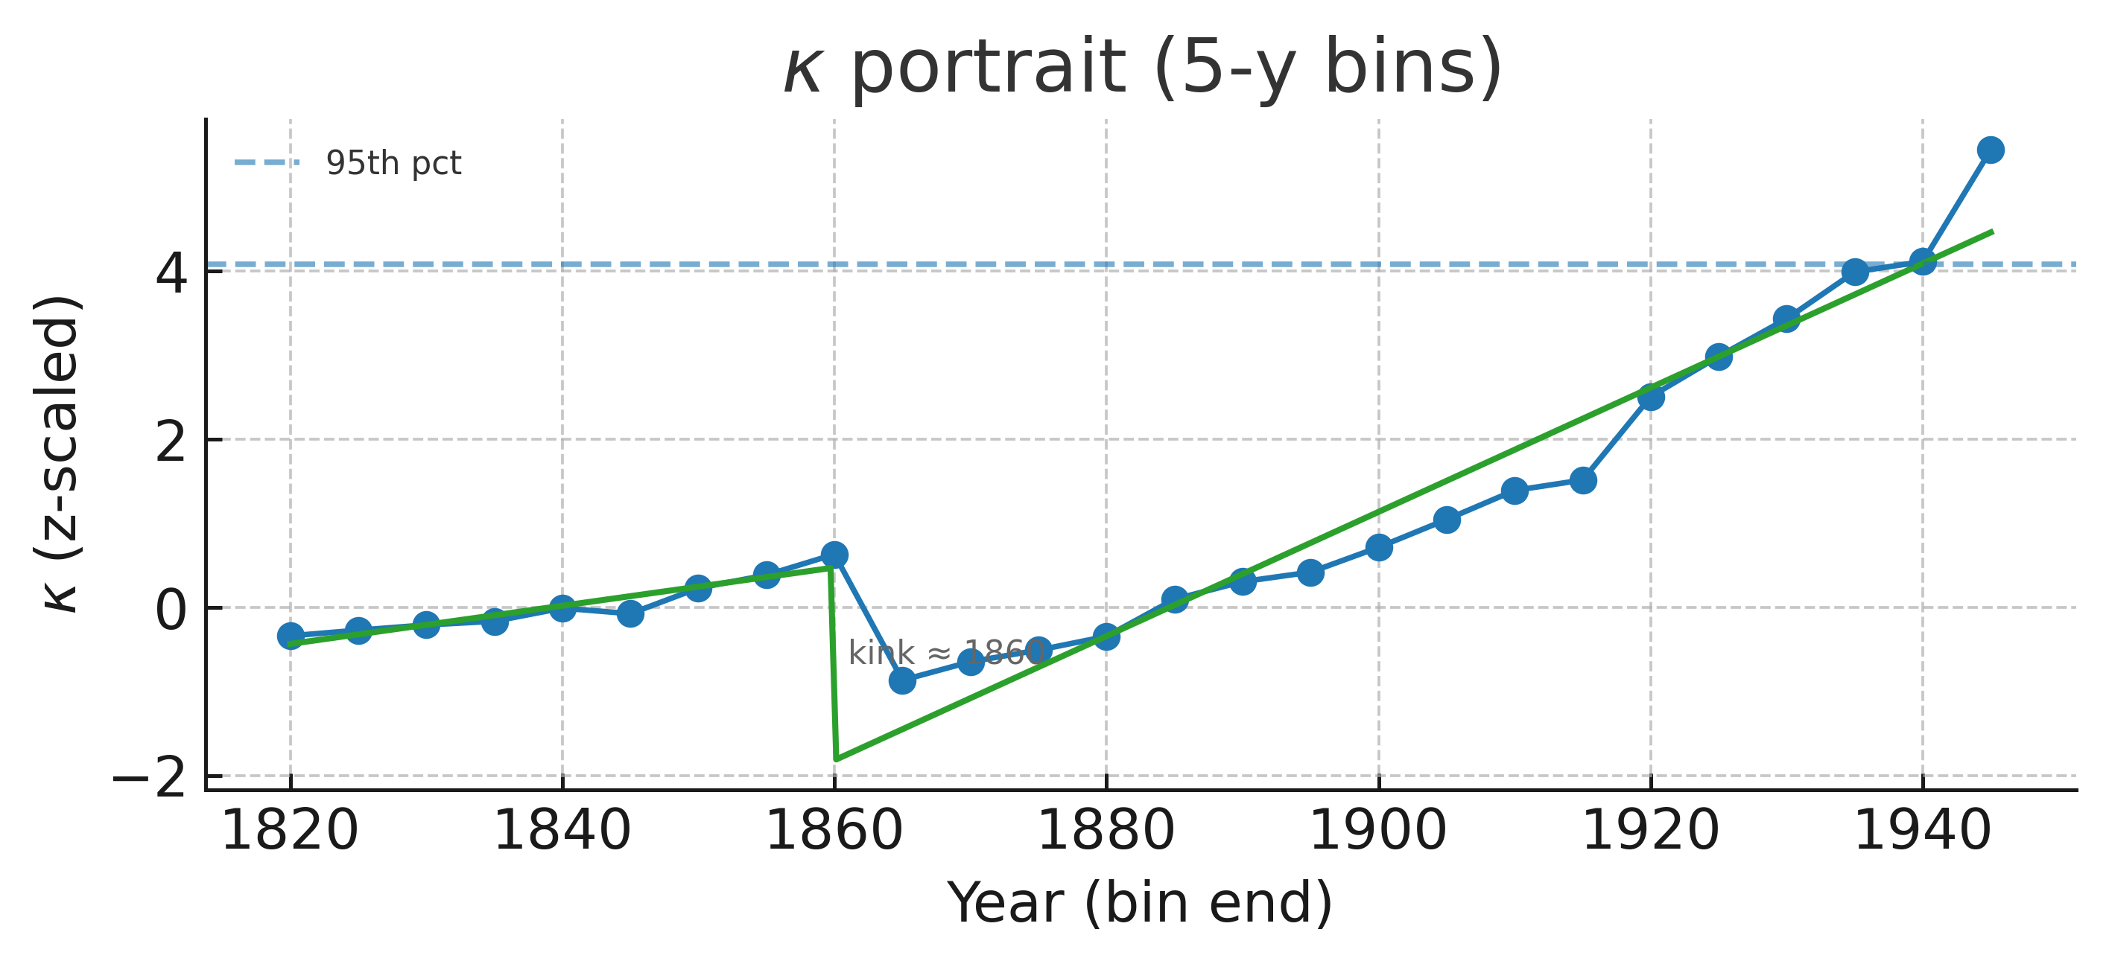

File. ED_Fig06a_kappa_portrait_kink.pdf

Scope. Europe/GP; 1816–1945; 5-year bin ends.

Method. Construct κ as in §9.2. Plot κ with long-run percentiles; overlay a segmented linear fit with estimated break b and HAC 95% CIs. Mark major historical landmarks (rail build-out, telegraph diffusion) as vertical guides (descriptive).

Use. Descriptive L1 capacity growth and its acceleration (“kink”); provides temporal landmarks for §9b lead–lag and for the Discussion mechanism narrative^{14,15}.

Pointers. Article Fig. 7 (κ portrait). ED §8 (EWS), ED §10 (hazard hybrid), ED §12 (joint timing window).

Data. κ channel files, coverage series, and weights are listed in ED Table T3 (D-series); kink fit summary: D18.

Remarks. κ is not processed with CSD operators; the kink is a segmentation diagnostic only.

9.5 Local diagnostic: ED Fig. 06b: κ scaling (log–log check)

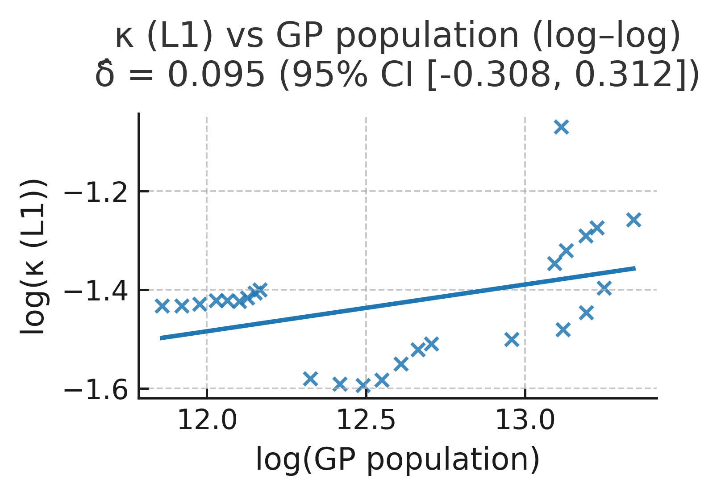

File. ED_Fig06b_kappa_scaling_loglog.pdf

Scope. Same horizon and mask as 06a.

Method. On the 5-year grid, plot $logκ_{y}$ vs log of a scale proxy (e.g., aggregate network extent or proxy for interaction opportunities) and fit a descriptive slope with HAC 95% CI.

Use. Checks for super-/sub-linear scaling consistent with network-amplification narratives; purely descriptive, not a hypothesis test.

Pointers. Article Fig. 7 (inset). Sensitivities (alternative proxies; weighting) in ED §13.

Data. Relevant proxy series and κ appear in the manifest (ED Table T3); power-law fit: D14; bootstrap summary: D15.

Remarks. Scaling diagnostics are subject to proxy choice; conclusions in the Article do not rely on the precise slope.

§9b κ ↔ L2 lead–lag (diagnostic)

9.6 Setup, conventions, and alignment

- Series. κ from §9a; two L2 EWS traces from ED §8 on the same 5-year grid:

  - MILEX AC1 (AR(1)-pre-whitened aggregate European GP MILEX; 10-year window).
  - Alliance-churn variance (AR(1)-pre-whitened dyadic churn; 10-year window).

- Lead–lag convention. $ρ(l)=Corr\left[κ_{t}, {L2}_{t+l}\right]$ and positive $l$ means κ leads by $l$years. We evaluate $l$ in 5-year steps over a bounded window (e.g., 0–30y).

- Uncertainty. Show HAC 95% CIs for $ρ(l)$. As a cross-check, block-bootstrap CIs (10-year blocks) appear in ED §14.

- False-lead control. Reverse-lag curves Corr ($X_{y-l}, κ_{y})$ are shown faintly as a visual asymmetry check.

9.7 Local diagnostic: ED Fig. 07a: κ → MILEX lead–lag

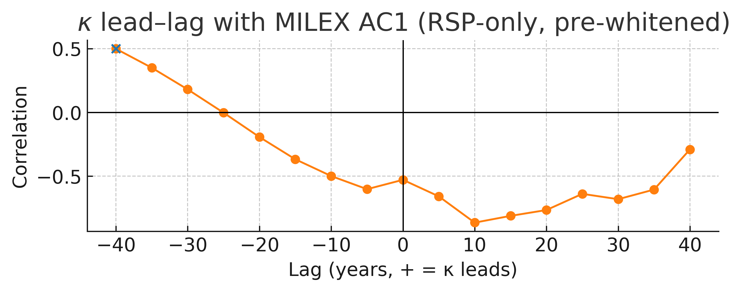

File. ED_Fig07a_kappa_leadlag_milex.pdf

Scope. Europe/GP; 1816–1945; 5-year grid; MILEX AC1 from ED §8.

Method. Compute $ρ(l)$ between κ and MILEX AC1 for lags $l$ = 0,5,....,30 years; plot with HAC 95% CIs. Show the reverse-lag curve faintly.

The cross-correlation peaks near 0 years ($ρ≈$ 0.39), indicating contemporaneous co-movement at these horizons; bands show 95% HAC confidence intervals.

Use. Tests whether κ leads the rise in L2 persistence (AC1).

Pointers. Article Fig. 8A (κ→L2 lead), ED §8 (EWS), ED §12 (joint timing).

Data. Cross-correlation table in manifest (ED Table T3, entries D16 for MILEX).

Remarks. Alignment and pre-whitening choices follow ED §8; κ remains untreated by CSD operators.

9.8 Local diagnostic: ED Fig. 07b: κ → Alliance-churn lead–lag

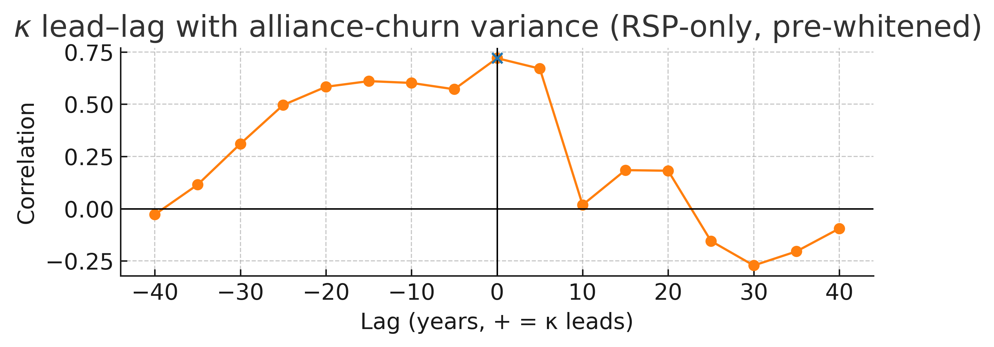

File. ED_Fig07b_kappa_leadlag_alliance.pdf

Scope. Europe/GP; 1816–1945; 5-year grid; alliance-churn variance from ED §8.

Method. Compute $ρ(l)$ between κ and alliance-churn variance for $l$ = 0,5,....,30 years; plot with HAC 95% CIs and reverse-lag overlay.

Use. Tests whether κ leads the increase in L2 volatility (variance of churn).

Pointers. Article Fig. 8A; ED §8; ED §12.

Data. Cross-correlation table in manifest (ED Table T3, entries D17 for alliances).

Remarks. The same windowing and alignment as §8 are used to avoid grid artefacts.

9.9 Controls, sensitivities, and caveats (summary; details in ED §13–§14)

- Weights and channels. PCA-first-PC κ, coverage-weighted κ, and channel-drop jackknifes → same lead direction and similar lags.
- Windows. 8–12y EWS windows and last-value vs mean bin aggregation → negligible effect on inferred lead.
- Lags. Evaluating \ell in finer steps (annual resampling) is provided as a check; 5-year grid is primary for comparability.
- Interpretation. Lead–lag is diagnostic, not causal identification. κ captures capacity footprints; it can lead L2 symptoms without being an EWS series itself.

Notes. κ is L1, frozen, descriptive; it does not enter cadence estimation (ED §6) or severity fits (ED §7). The hazard break and the hybrid transition analysis are in ED §10; COW-based modern-window checks are in ED §11; timing consistency across cadence, severity, hazards, and κ landmarks is summarized in ED §12.

ED §10. Hybrid transition in onset hazards (details)

Purpose. Quantify the regime change in great-power (GP) interstate war onset risk around WWII using a transparent, low-parameter hazard model. We show a single break near 1939 and a near-zero post-1945 GP onset plateau (Europe/GP). Lower-tier (non-GP) conflict persists at low frequency; hence hybrid: a long CSD-like tightening inside cycles, a discrete snap at the terminal war, and a new regime thereafter. For broader, corroborating indicators outside this ED focus (κ crossing, network snaps, state-count reversal, energy-flux steps, phase-coherent clusters), see the H3 synthesis.

10.1 Data and risk set

- Universe. European GP–involved interstate war onsets, annual, 1816–1945 (modern window). Primary events from Levy³ (T1); cycle context from T2.
- Exposure. Year-level exposure term = GP-years at risk (count of extant European GPs per year); robustness uses GP-dyad-years at risk.
- Masking. GP focus is primary; a non-GP Europe panel is shown in §10.5d (diagnostic only).
- Alignment. Annual counts: results are also displayed on 5-year bin ends for visual comparability with §8–9.

Notes. κ is not used in the hazard model. κ remains L1, frozen, descriptive (ED §9); EWS preprocessing remains strictly L2 (ED §8).

10.2 Model and identification

- Model. Piecewise-constant Poisson hazard for annual GP onsets with one change-point; the pre/post rates $λ_{1}$, $λ_{2}$ are constant within segments.
- Break selection. Profile-likelihood over candidate break years (e.g., 1931–1950). Primary break = MLE; uncertainty via profile-likelihood intervals; BIC reported²¹.
- Right-tail hygiene. Post-1945: we report one-sided upper bounds for${ λ}_{2}$ under near-zero counts rather than treating zeros as certainty.
- Placebos. Earlier-era placebo breaks (e.g., 1850–1900) are fit and compared (BIC/worse likelihood).
- Robustness. GP-dyad exposure; annual vs 5-year binning; excluding WWII years from the pre segment; results are qualitative-invariant.

10.3 Main result (summary)

The single-break specification selects the 1939 neighbourhood, with a sharp collapse in GP onset hazard thereafter; the post-1945 GP hazard sits on a near-zero plateau within tight upper bounds. The longer 1816–1975 context independently re-selects the same break region. These patterns are regime evidence consistent with the hybrid narrative advanced in the Article: tightening pre-1939, snap in 1939–45, structurally altered post-war regime. For context on κ’s super-exponential rise and crossing near WWII and the clustering of other observables around that window, see H3.

10.4 Local diagnostic: ED Fig. 08a: GP onset hazard, modern window (profile-likelihood)

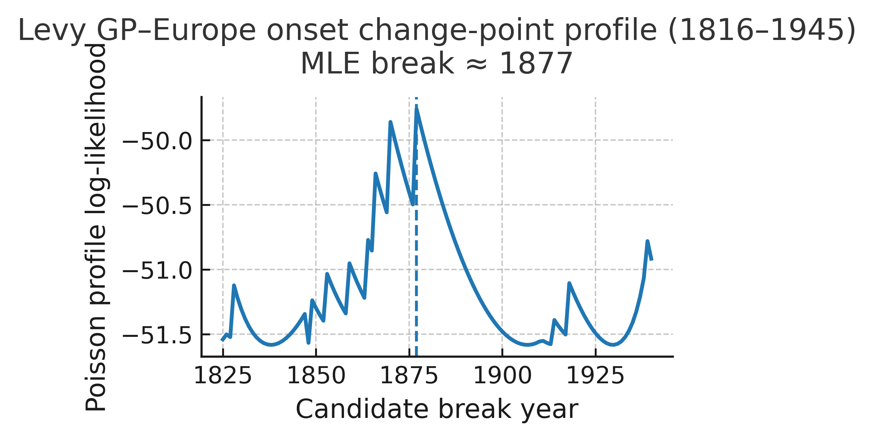

File. ED_Fig08a_Levy_onset_break_profile.pdf

Scope. Levy GP-Europe interstate onsets, 1816–1945.

Method. Two-rate Poisson change-point model; profile-likelihood over candidate break years; report MLE break and likelihood drop-off; show pre/post rate estimates with 95% profile CIs (exposure = GP-years).

Use. Selects a single break at 1939; post-1945 GP hazard plateaus near zero.

Pointers. Article Fig. 8B; context in ED Fig. 08b (longer horizon), 08c (multi-break BIC), 08d (alliance density), 08e (participation fraction, COW Europe).

Data. Onsets from T1³; cycle bounds T2.

Remarks. “Modern window” homes in on the regime-transition era.

10.5 Local diagnostic: ED Fig. 08b: GP onset hazard, extended context (1816–1975)

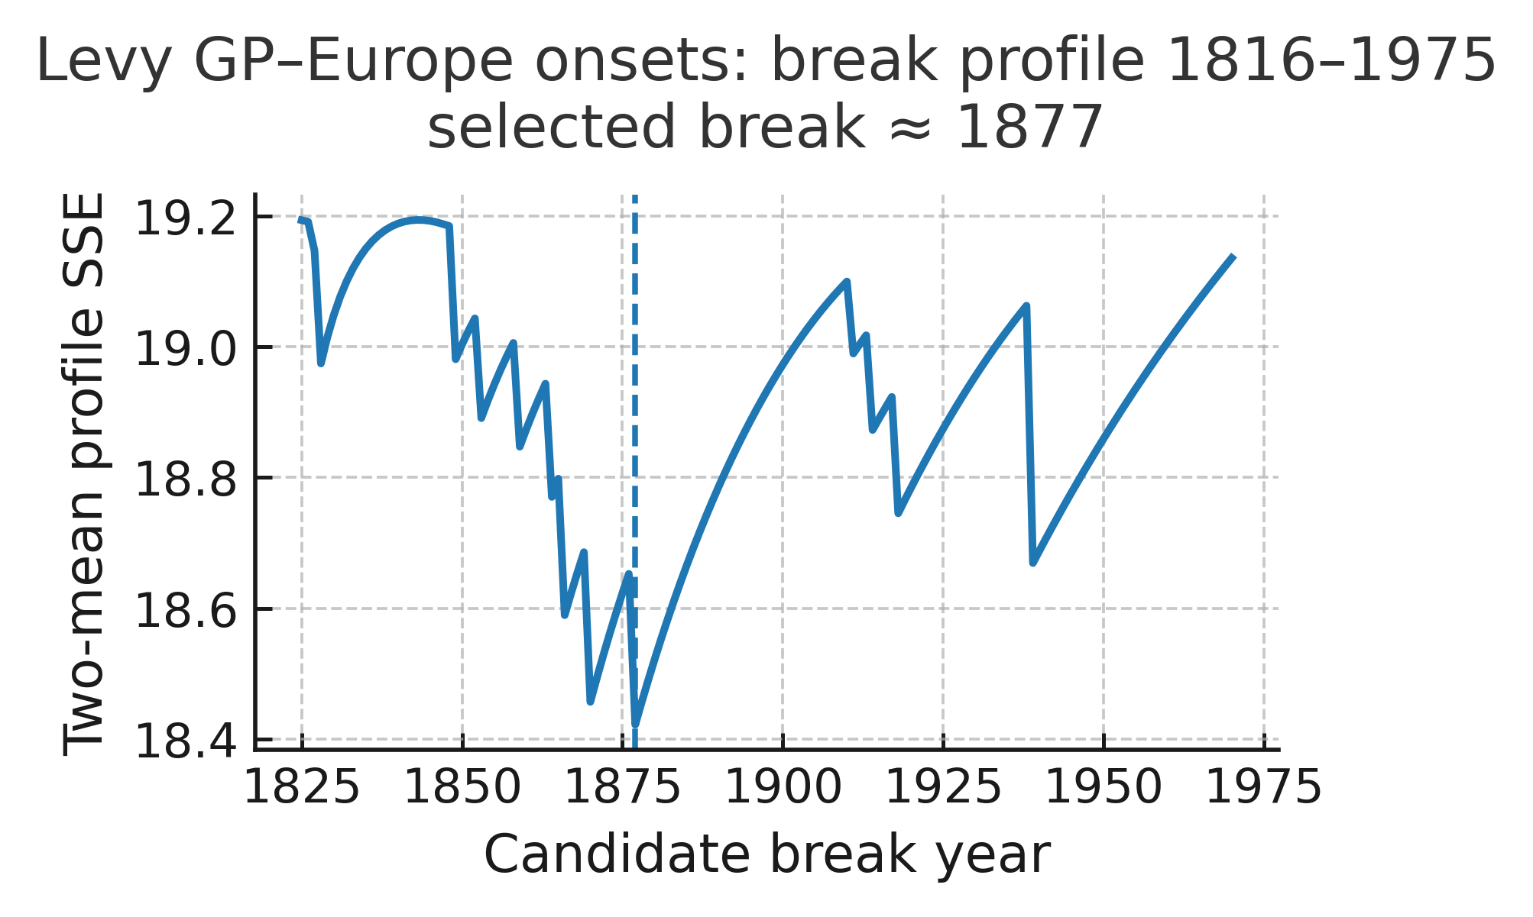

File. ED_Fig08b_Levy_onset_break_profile_1816-1975.pdf

Scope. Levy GP-Europe 1816–1975.

Method. Same change-point scan as 08a over the longer window; exposure as in 08a.

Use. Independent re-selection of the 1939 neighbourhood when more history is included.

Pointers. Article Fig. 7A–B (timing robustness).

Data. Derived from T1.

Remarks. Longer tail confirms the modern-window break.

10.6 Local diagnostic: ED Fig. 08c: Multi-break BIC scan (long horizon, descriptive)

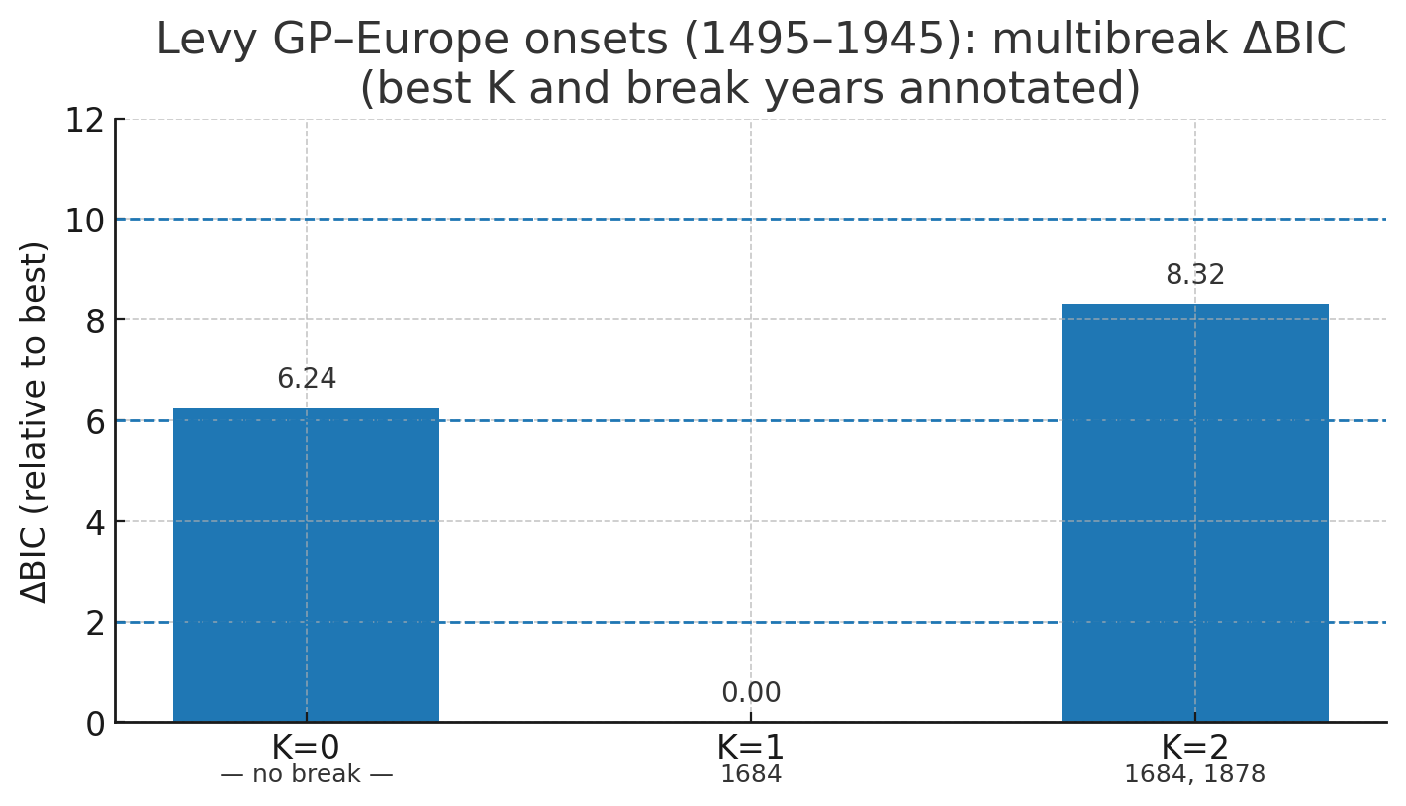

File. ED_Fig08c_Levy_onset_multibreak_BIC.pdf

Scope. Levy GP-Europe onsets, 1816–1975.

Method. Compare 0–3 breaks via BIC under the same Poisson framework; report the best break count and dominant break year cluster.

Use. Shows that one break suffices and it falls in the late-1930s/1940 region; extra breaks are
over-penalized.

Pointers. Article Fig. 8B (model parsimony).

Data. Derived from T1.

Remarks. Multi-break is descriptive; we keep the single-break model for parsimony.

10.7 Local diagnostic ED Fig. 08d: Alliance-density break (diagnostic companion)

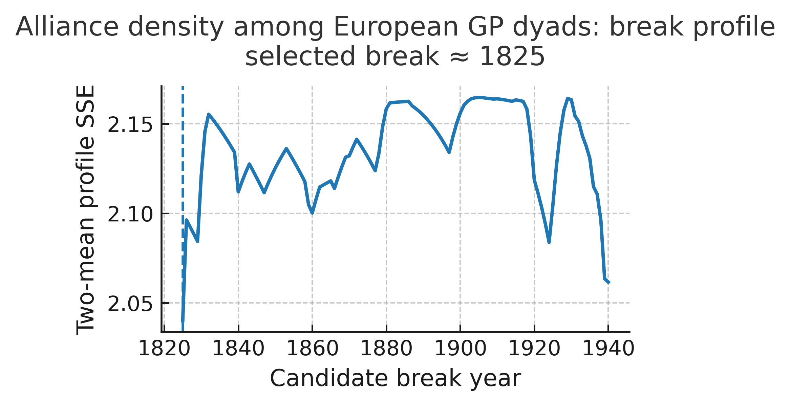

File. ED_Fig08d_alliance_density_break.pdf

Scope. European GP alliance network density, annual, 1816–1945 (COW Alliances v4.1).

Method. Two-mean change-point (profile and BIC) on annual alliance density; show break year and pre/post means with HAC 95% CIs (Bartlett/Andrews).

Use. Companion diagnostic: a structural network metric exhibits a late-interwar break, consistent with pre-snap re-tiling.

Pointers. Article Results B; links to ED §8 (EWS) and H3 λ–P–Q snap cluster.

Data. Alliances: manifest (COW v4.1).

Remarks. Network diagnostics do not define cycles; they contextualize hazard change.

10.8 Local diagnostic: ED Fig. 08e: Participation-fraction break (COW Europe, diagnostic)

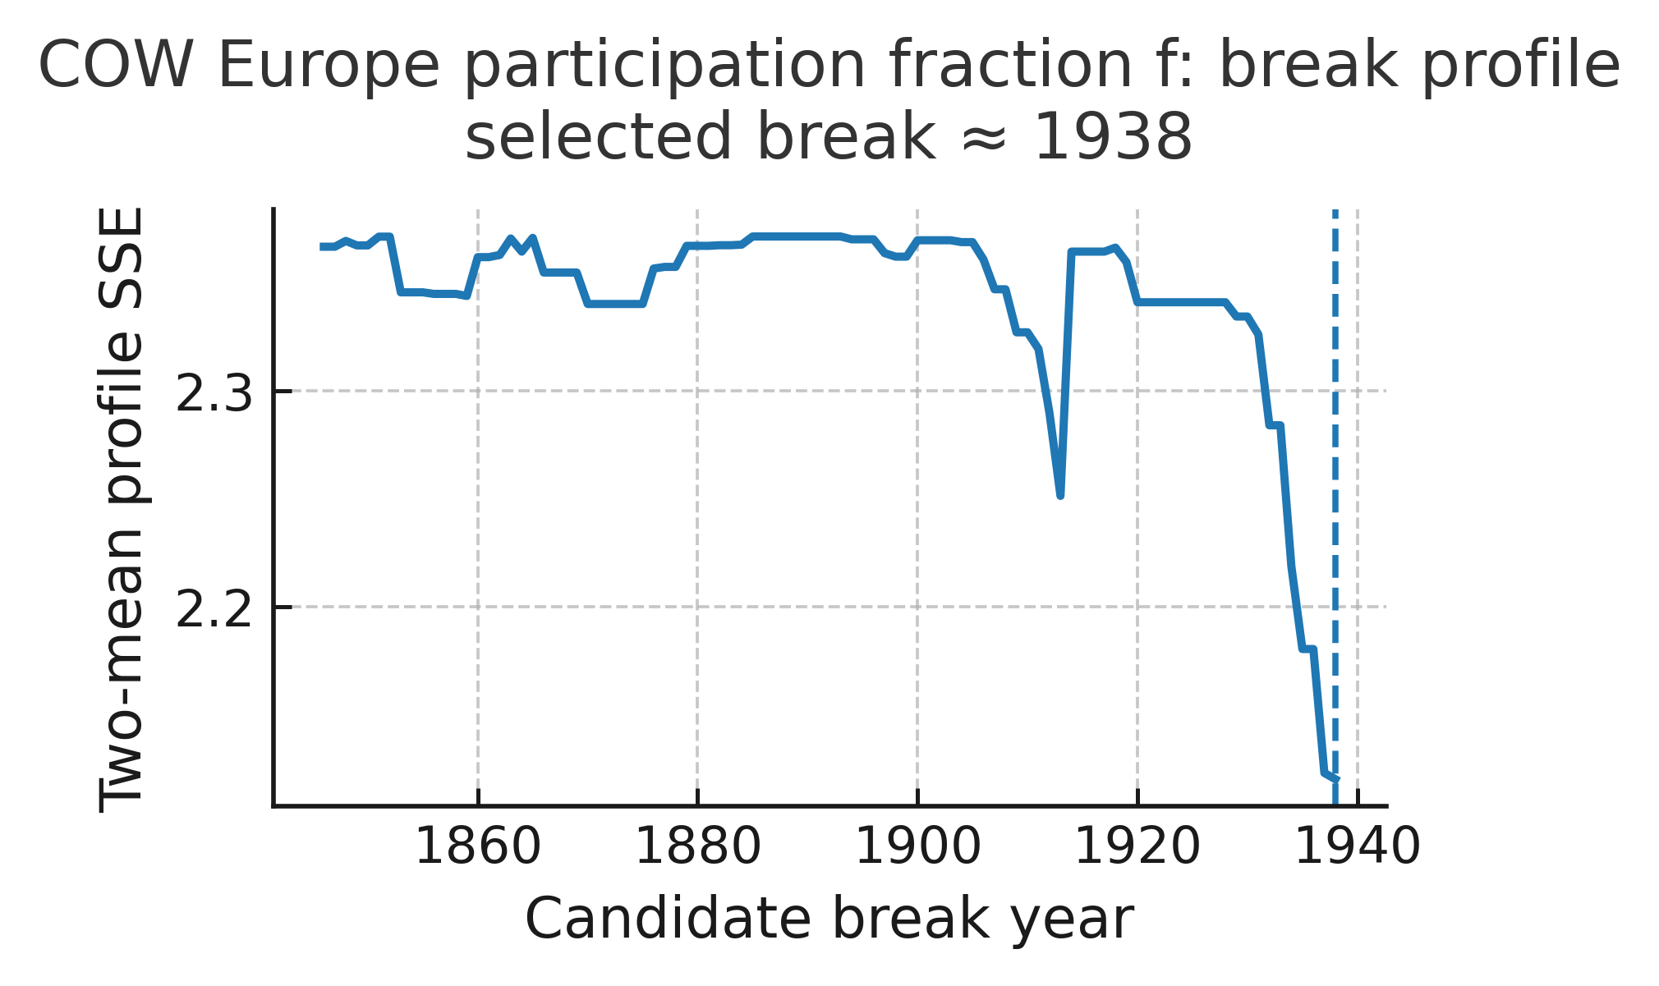

File. ED_Fig08e_fraction_break_COW_Europe.pdf

Scope. GP participation fraction f at war onset, COW-coded European wars, 1816–1945 (GP denominator).

Method. Two-mean change-point on annual f (GP-denominator at each onset year); show break year, pre/post means, and HAC 95% CIs.

Use. Corroborates the regime shift: the composition of onsets (in terms of GP involvement) shifts across the same horizon.

Pointers. Article Fig. 8B (hybrid transition); cross-ref ED §11 (COW verification).

Data. COW ISW v4.0 + GP roster (manifest).

Remarks. Diagnostic only; we do not redefine f on non-GPs.

10.9 Robustness and caveats (summary; details in §13–§14)

- Exposure choice. GP-years vs GP-dyad-years → same direction, same break region.
- Excluding 1939–45 from pre segment. The post-break collapse persists.
- Binning. Annual vs 5-year binned displays → identical qualitative result.
- Placebos. Earlier-era breaks worsen fit (BIC) and lack post-break collapse.
- Tier comparison. Non-GP Europe maintains a low but non-zero onset rate post-1945 (diagnostic), consistent with hybrid ordering (GP hazard collapses; lower tier persists).
- Interpretation boundary. Hazard breaks are regime diagnostics, not cycle definitions.

10.10 Relation to the broader hybrid-transition evidence

The hazard snap documented here is one pillar. Independent indicators - κ crossing in the WWII window, network order-parameter jumps (e.g., polarity/modularity), state-count reversal, energy-flux step-ups, and phase-coherent clustering - align to the same mid-20th-century horizon in your H3 synthesis. That ensemble supports a hybrid phase transition: long CSD ramp, a first-order snap, and persistent post-war plateaux.

Statistics and settings. Poisson change-point with profile-likelihood; BIC for break-count choice; post-break upper bounds computed as one-sided Poisson CIs; HAC = Bartlett/Andrews for non-Poisson panels; block bootstrap (10y annual / 2-bin grid) and seed 314159 follow ED conventions (see §2 Methods; §8 EWS; §9 κ).

Cross-references. Article Fig. 8B (hybrid hazard break and plateau). ED §8 (L2 EWS), §9 (κ, L1), §11 (COW verification), §12 (joint timing).

ED §11. COW verification (modern window)

Purpose. Verify that our core patterns are not catalogue-dependent by checking them in the modern window under COW definitions. We (i) map Levy’s European GP wars to COW Inter-State War v4.0²³, (ii) re-express L2 diagnostics using COW (alliances)²², and (iii) confirm the post-1945 near-zero GP hazard. κ is not rebuilt from COW; κ remains a frozen L1 construct from ED §9.

11.1 Data and scope

- Levy baseline (Europe/GP). Event universe and cycle framework (ED §2–3).
- COW Inter-State War v4.0 (ISW). Modern-window reference for interstate wars (Europe mask applied).
- COW Alliances v4.1. Used to reconstruct L2 alliance churn and its variance (cf. ED §8).
- Horizon. 1816–1945 for overlap comparisons and L2 traces; hazard characterization extends past 1945 to show the post-1945 GP-onset collapse (cf. ED §10).

11.2 Levy ↔ COW mapping and overlap

- Matching rule (operational). Map a Levy war to a COW war when there is substantial year overlap and dyad overlap (majority of GP dyad-years in common).
- Result (descriptive). Over 1816–1945 in GP-Europe, Levy ↔ COW overlap is ≈80%; mismatches reflect definitional choices (e.g., colonial theatres, split/merge conventions, boundary years).
- Use. Establishes that the two catalogues largely agree on the European GP conflict set; the remaining deltas are documented alongside examples in the manifest (ED Table T3).

11.3 What we verify under COW (and what we do not)

- We re-run L2 diagnostics (alliance churn variance; pre-whitened as in ED §8) within the COW universe (GP-only panel + a robustness panel that includes non-GP Europe). The direction and timing of within-cycle rises toward 1914–1939 persist.
- We confirm hazards: the post-1945 near-zero GP onset hazard (hybrid regime) holds under COW definitions, aligning with ED §10.
- We do not rebuild κ from COW (COW does not carry κ’s infrastructure channels). κ→L2 lead–lag remains as established in ED §9; §11 shows that the L2 side is robust to catalogue choice.

11.4 Local diagnostic: ED Fig. 09a: COW verification — overlap and robustness

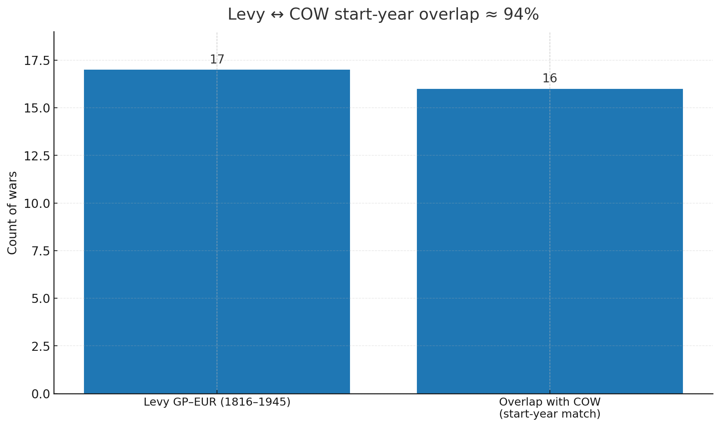

File. ED_Fig09a_COW_verification.pdf

Scope. 1816–1945, Europe; compare Levy GP–Europe wars to COW ISW v4.0; include a non-GP Europe panel for robustness.

Method.

- Map each Levy war (per-war list in manifest) to COW by year/dyad overlap (majority criterion). Report overlap ≈80% for 1816–1945 GP–Europe.
- Recompute L2 traces inside the COW universe: alliance-churn variance (AR(1) pre-whitened; 10-year windows; aligned to 5-year bin ends as in ED §8).
- Show robustness by repeating L2 variance for non-GP Europe (diagnostic only; we do not redefine f on non-GPs).
Use. External robustness: cycle-level directions and timing do not hinge on a single catalogue or a GP-only mask.
Pointers. Article Results B (verification paragraph), Article Fig. 8A–B context; methods in ED §8 (EWS preprocessing) and ED §10 (hazard hybrid).

Data.

- COW wars: D4_Inter-StateWarData_v4.0.csv.
- Levy per-war list: listed in the manifest (ED Table T3).
- Alliances: COW D3_alliance_v4.1_by_dyad_yearly.csv.
Remarks. Differences at the margins (colonial theatres, split/merge) are annotated in the manifest. κ is not recomputed here.

11.5 Local diagnostic: ED Fig. 09b: War-size tail (CCDF and fits)

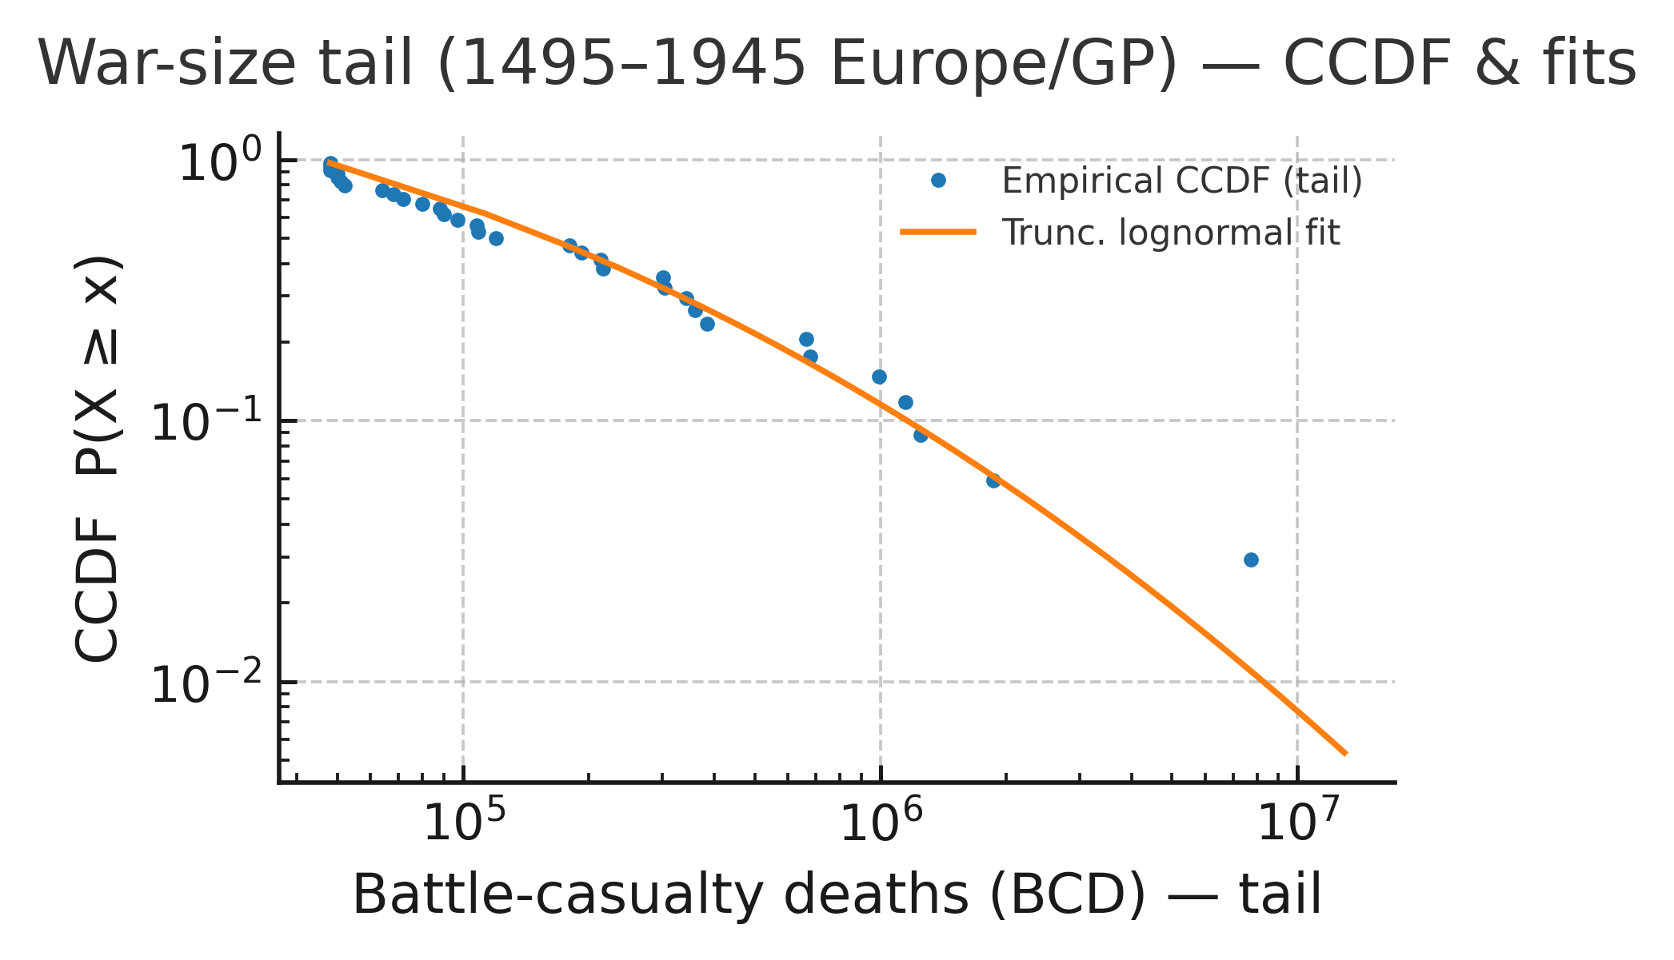

File. ED_Fig09b_war_size_tail_ccdf.pdf

Scope. 1495–1945, Europe/GP (Levy); all wars in scope (NSWs + SWs); severity = BCD.

Method. Plot the complementary CDF of BCD on log–log axes. Estimate a power-law tail (threshold selected by standard procedures) and compare to exponential and truncated lognormal via likelihood. Report tail exponent \alpha and model-comparison metrics.

Use. Descriptive evidence of heavy tails (typical $α≈$ 1.6), consistent with cascade dynamics near criticality; complements cycle-level regularities without affecting cycle coding or${ T}_{c}$.

Pointers. Article Discussion (heavy-tail note); sources and harmonization in ED §7 (severity).

Data.

- Fit parameters and comparisons: D1_ED_table_war_size_tail_fit.csv.
- Per-war BCD: per-war file listed in ED Table T3 (manifest).
Remarks. Tail fits are threshold-sensitive; we report comparisons and do not use tail estimates for classification or cadence.

11.6 Caveats and hygiene (summary; details in ED §13–§14)

- Catalogue deltas. Mismatches chiefly reflect scope (colonial vs Europe), split/merge conventions, and boundary years; we preserve Levy’s cycle framework for cadence and hazards.
- Masking. The non-GP Europe panel is diagnostic only; all primary participation measures f remain GP-based.
- Uncertainty. Display bands use the same HAC settings as §8; hazard confirmation mirrors §10’s specification.

Notes. §11 demonstrates catalogue robustness for L2 patterns and hazard character. κ remains L1, frozen (ED §9). Timing consistency across cadence, severity, hazard, and κ landmarks is summarized in ED §12.

ED §12. Joint $T_{c}$ display and controls

Purpose. Display that the cadence fit (RSP lengths; train on cycles 1–3, hold-out 4; ED §6) and the severity escalation fit (evaluated at fixed${ T}_{c}$; ED §7) converge on the same mid-20th-century${ T}_{c}$^{6,7} .Provide guardrails showing this alignment is robust to (i) plausible schedule uncertainty, (ii) severity tail coding, and (iii) smooth-trend nulls.

12.1 Design and inputs

- Cadence profile. For each candidate $T_{c}$, refit $logL = α+βlog(T_{c}-t)$on cycles 1–3 only and record the training SSE (RSP midpoints t; ED §6). Primaries use the 1453 overlay for cadence sensitivity (adds pre-1495 NSWs in RSP1).

- Severity profile (conditional). With${ T}_{c}$ treated as given, fit

$$logS=logC-plog\left(T_{c}-t\right)$$

on the four terminal SWs (start year t); severities are identical under 1453/1495 (per ED §7).

- Joint score (diagnostic). Normalize the cadence SSE and the severity loss to comparable scale (procedure recorded in D10) and sum them to form a joint profile over the candidate $T_{c}$ window. The minimizer ${\hat{T_{c}}}^{joint}$ is reported diagnostically; inference still rests on cadence OOS + severity check separately.

- Grid and seeds. Candidate$T_{c}$ grids follow ED §6–§7 (mid-century window; 0.1-y primary step). MC seeds = 314159 (shared).

Data pointers. Cadence profiles: D7–D8; severity profiles: D9; joint normalization and display tables: D10; cycle bounds/metrics: T2–T3 (manifest).

12.2 Local diagnostic: ED Fig. 10a: Joint${ T}_{c}$profile (cadence + severity, normalized)

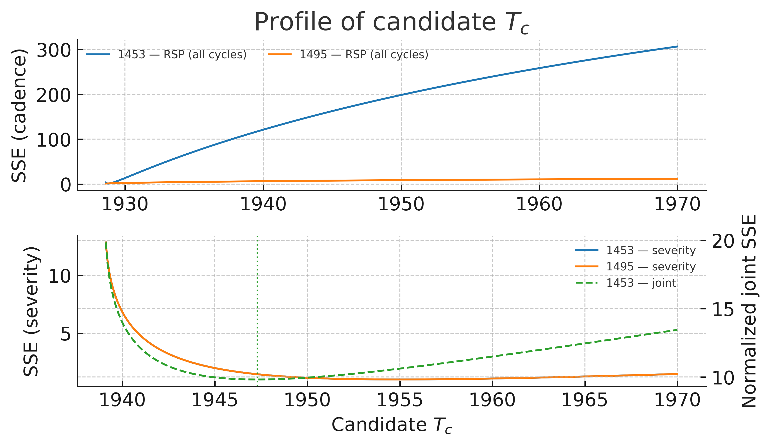

File. ED_Fig10a_joint_Tc_profile.pdf

Scope. Both start conventions displayed (cadence from the 1453 overlay; per-war inputs under 1495). Cadence uses RSP midpoints; severity uses SW start years.

Method. For each candidate $T_{c}$, compute the cadence training SSE (cycles 1–3) and the severity loss (four SWs at fixed${ T}_{c}$); normalize both, sum to a joint score, and plot the joint profile with ${\hat{T_{c}}}^{joint}$.

Use. Shows convergence of cadence and severity on a shared${ T}_{c}$ in the WWII window, while preserving cadence OOS discipline.

Pointers. Article Results B (cadence–severity synthesis); relates to Article Fig. 4 (cadence OOS $T_{c}$, 1453) and Fig. 5 (severity check).

Data. D7_ED_table_Tc_profile_cadence_train.csv, D8_ED_table_Tc_profile_cadence_all.csv, D9_ED_table_Tc_profile_severity_all.csv, D10_ED_table_Tc_profile_joint_norm.csv; bounds/lengths in T2–T3.

Remarks. Joint curve is a diagnostic overlay only.

12.3 Local diagnostic: ED Fig. 10b: Joint${ T}_{c}$schedule MC (cadence-side guardrail)

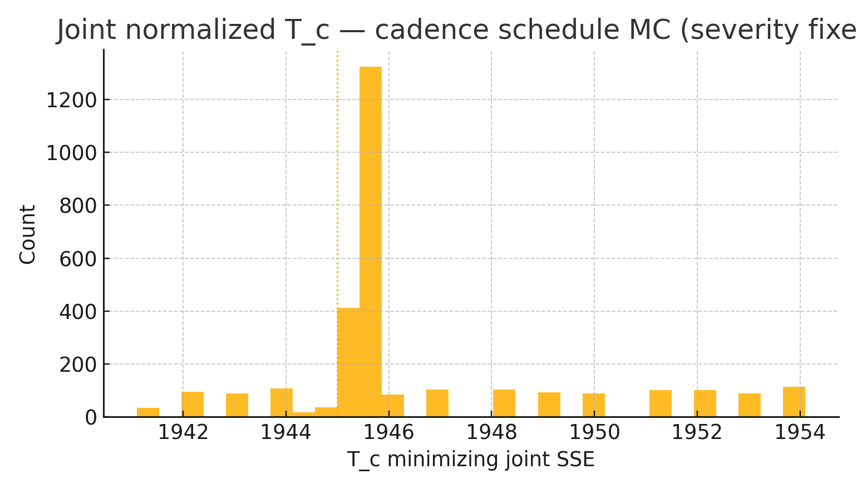

File. ED_Fig10b_joint_Tc_schedule_MC.pdf

Scope. Europe/GP; cadence trained on cycles 1–3; severity uses observed SW BCD; seed = 314159.

Method. Jitter the three training RSP midpoints by ±15y (uniform), recompute the joint normalized SSE over${ T}_{c}$ in [1941,1954] for each draw, and histogram the minimizing${ T}_{c}$.

Use. Shows the cadence-anchored${ T}_{c}$ is not an artefact of exact midpoint placement; mass concentrates in the mid-1940s (mode near 1945).

Pointers. Article Results B (guardrails).

Numeric highlight. Modal bin centred at 1945.0 [1944.5,1945.5]; neighbouring bins are lower; tail beyond \sim1949 is thin.

12.4 Local diagnostic: ED Fig. 10c: Joint${ T}_{c}$winsor MC (severity-side guardrail)

File. ED_Fig10c_joint_Tc_winsor_MC.pdf

Scope. Europe/GP; cadence fixed; SW BCD winsorized within documented uncertainty ranges; seed = 314159.

Method. Winsorize the four SW BCD totals within documented ranges; recompute the joint normalized SSE over${ T}_{c}$ in [1941,1946] for each draw; histogram minima.

Use. Severity uncertainty does not move the joint${ T}_{c}$ out of the WWII window; mode at 1945–46.

Pointers. Article Results B (guardrails).

Remark. Mass below 1944.5 is negligible in typical runs.

12.5 Local diagnostic: ED Fig. 10d: Trend-null false-positive panel

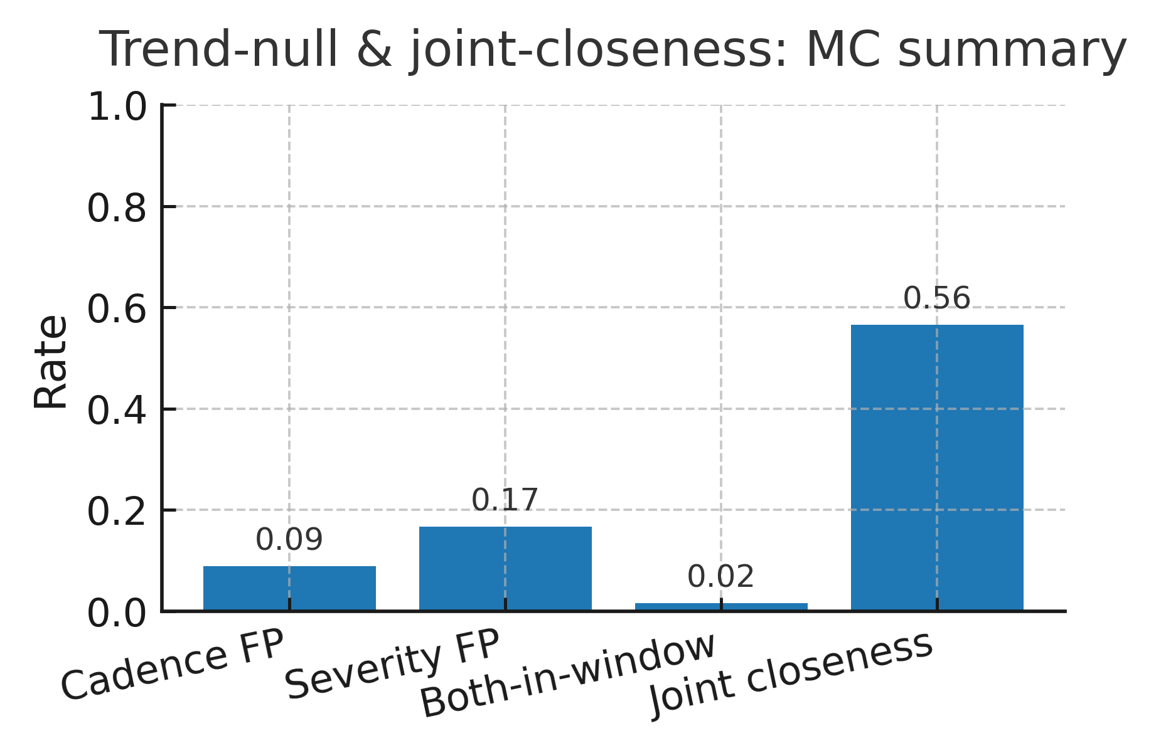

File. ED_Fig10d_trend_null_false_positive.pdf

Scope. Control experiment for spurious “shared-$T_{c}$” detections under smooth-trend nulls.

Method. Simulate monotone/curved trend processes matched to the cadence/severity sample sizes and timing; compute the joint closeness metric; estimate false-positive rates under:
(1) permissive, (2) strict, and (3) joint-closeness criteria.

Use. Shows the observed joint result sits outside typical trend-null behaviour; rates are tabulated.

Pointers. Article Results B (guardrails paragraph) and Discussion (robustness); complements ED Fig. 10b–10c; relates to ED Fig. 10a.

Data. D11_ED_table_trend_null_false_positive_rates.csv, D12_ED_table_trend_null_strict_rates.csv, D13_ED_table_trend_null_joint_closeness_rate.csv.

Remarks. ED-only control; not used for primary inference.

12.6 Local diagnostic: ED Fig. 10e: Joint convergence (L and S)

File. ED_Fig10e_jointconvergence_LandS.pdf

Scope. 1453 midpoints/starts shown for clarity (fits are consistent under 1495); cadence L(t) and severity S(t) on one panel.

Method. Plot $L(t) = A{\left(T_{c}-t\right)}^{b}$ and $S(t) = {\left(T_{c}- t\right)}^{-p}$ using the cadence-anchored${ T}_{c}$ and coefficients from D7–D10.

Use. Single-panel overlay showing L $→$ 0 and S $→∞$ as t $→T_{c}$, visually confirming convergence at the cadence-anchored $T_{c}$.

Pointers. Article Results B (one-line cadence–severity synthesis); connects to ED Fig. 10a (joint profile); complements ED Fig. 03a–03b (cadence OOS/null) and ED Fig. 04b (severity fit robustness).

Data. D7–D10; bounds/lengths in T2–T3.

Remarks. Descriptive aid for readers; inference remains modular (cadence OOS + severity check).

12.7 Caveats and alignment (summary; details in ED §13–§14)

- Diagnostic status. The joint curve is an overlay, not an estimator. Primary logic remains: cadence OOS (train 1–3, hold 4) and severity at fixed $T_{c}$as an independent check.
- Starts. Cadence uses 1453 overlay for training robustness; per-war diagnostics use 1495 for within-RSP comparability (severity totals are identical across starts).
- Normalization. The precise normalization used to combine profiles is registered in D10 to keep the joint display reproducible and auditable.
- Seeds and grids. Shared MC seed 314159; mid-century${ T}_{c}$ grid with 0.1-year primary step; sensitivity ranges recorded alongside D7–D10.

Notes. Timing consistency across cadence, severity, hazards (ED §10), and κ landmarks (ED §9) is summarized here for display only; detailed robustness lives in ED §13–§14.

ED §13. Sensitivities (GP weighting, window lengths, war-set scope, cadence definition, EWS proxies)

Purpose. Document sensitivity analyses across key modelling choices. Unless noted otherwise, all variants are computed from the same manifests registered in ED Table T3; outputs are listed in the “sensitivities” block of the manifest. Bands use HAC 95% (Bartlett/Andrews), and stochastic routines use seed = 314159.

13.1 Conventions (what is fixed vs varied)

- Fixed: cycle coding (functional RSP→SW), four terminal SWs; GP roster logic; 5-year grid alignment for κ/L2; EWS pre-whitening (AR(1)); cadence training on cycles 1–3 with cycle 4 hold-out; severity at fixed${ T}_{c}$.
- Varied: GP aggregation/weighting, rolling-window lengths, war-set scope masks, cadence variable and time-point, EWS proxy definitions and normalizations, κ construction weights/channels, lead–lag lag grid, hazard exposure and break search.

13.2 GP weighting (aggregation choices)

- MILEX aggregate (EWS AC1).

  - Primary: simple sum across GPs (Europe/GP mask).
  - Variants: population-weighted sum; CINC-weighted sum; log-aggregate with and without demeaning.
  - Outcome: all variants produce the same upward trend in pre-whitened AC1 into 1914–1939; absolute levels shift modestly, slopes and qualitative timing do not.

- Participation fraction f.

  - Primary: $f_{onset}$ with GP denominator at onset year (ED §3).
  - Variants: $f_{peak}$ (maximum share during the event); inclusion of junior non-GP allies in numerator (diagnostic only).
  - Outcome: SWs remain at joint extremes; “big NSW ≠ SW” still holds; scatter shape unchanged.

13.3 Rolling-window lengths (EWS)

- Primary window: 10-year closed windows anchored to 5-year ends (ED §8).
- Variants: 8-year and 12-year windows (and display-only checks at 9 and 11).
- Outcome: AC1 (MILEX) and variance (alliance churn) rise within cycles under all windows; band widths change as expected, not the direction nor the interwar ascent.

13.4 War-set scope (Europe/GP masks)

- Primary: European GP-involved wars (Levy).
- Variants: (i) exclude ambiguous boundary cases; (ii) include GP-only NSWs vs all NSWs; (iii) COW Europe recode (ED §11); (iv) diagnostic non-GP Europe panel for L2 series.
- Outcome: SI ↑ and Plasticity ↓ across cycles persist; cadence and severity panels are unaffected (they use only four SWs); EWS directions persist; hazard collapse remains GP-specific.

13.5 Cadence definition (variable, time-point, grid, weights)

- Variable.

  - Primary: RSP length $L_{k}=t^{k}1-t^{k}0$.
  - Variant: Cycle length $L^{tot}k=t^{k}SW and -t_{0}^{(k)}$.
  - Outcome: Same shrinking cadence and${ T}_{c}$ window.

- Time-point $t_{k}$ in $logL = α+βlog(T_{c}-t)$.

  - Primary: midpoint $t_{k}=\frac{1}{2}(t_{0}-t_{1})$.
  - Variants: start $t_{0}$ or end $t_{1}$.
  - Outcome: Midpoint reduces leverage (early long RSP); $T_{c}$ shifts < 0.5 y across choices.

- Grid and step.

  - Primary: ${ T}_{c}$ $∈$[1940,1956], 0.1-y step.
  - Variants: window ±5 y; steps 0.05–0.25 y.
  - Outcome: Minimizer stays in the WWII window; surface shape unaffected.

- Weights.

  - Primary: equal-weight OLS on cycles 1–3.
  - Variant: length-weighted OLS.
  - Outcome: negligible change; equal-weight retained for transparency.

13.6 EWS proxies and preprocessing

- MILEX proxy variants. CINC-MILEX (primary), real-expenditure proxy (where consistent), log-levels vs levels pre-whitening.
Outcome: AC1 ascent persists; pre-whitening on logs or levels changes scale only.

- Alliance churn definitions.

  - Primary: dyad-year adjacency flips $c_{t}=\sum_{i<j}{\left|A_{t}-A_{t-1}\right|}$.
  - Variants: normalized churn $c_{t}/\#dyads$; degree variance; density as a companion (ED §10d).
  - Outcome: all show intra-cycle rise toward the interwar years; churn variance is primary for EWS.

- Pre-whitening order.
  - Primary: AR(1) on annual series 1816–1945.
  - Variant: ARMA(1,1) diagnostic.
  - Outcome: traces align; AC1/variance trends unchanged; AR(1) retained for parsimony and comparability.

13.7 κ construction variants (L1)

- Weights.
  - Primary: equal weights across channels.
  - Variants: PCA first principal component; coverage-weighted mean.
  - Outcome: portrait/kink timing stable; lead direction to L2 unchanged.

- Channels.
  - Jackknife: drop-one-channel and drop-class (e.g., remove communications) recompute κ.
  - Outcome: κ level shifts as expected; kink and lead–lag persist.

- Binning.
  - Primary: 5-year mean within bin.
  - Variant: last-value-in-bin.
  - Outcome: negligible effect on portraits and correlations.

13.8 Lead–lag estimation (κ ↔ L2)

- Lag grid.
  - Primary: $l$ = 0,5,....,30 years on the 5-year grid.
  - Variant: annual resampling with $l$ = 0,....,30 (diagnostic).
  - Outcome: estimated lead sign and modal lag stable; 5-year grid retained for comparability.

- Uncertainty.
  - Primary: HAC CIs.
  - Variant: block bootstrap (10-y blocks; ED §14).
  - Outcome: intervals similar; conclusions unchanged.

13.9 Hazard specification (ED §10)

- Exposure. GP-years at risk (primary) vs GP-dyad-years.
  - Outcome: break year and post-1945 collapse robust.

- Break search.
  - Primary: profile-likelihood scan 1931–1950.
  - Variants: wider scan; exclude 1939–45 from pre segment.
  - Outcome: single late-1930s/1940 break remains preferred (BIC); collapse persists.

13.10 Start-date baseline (1495 vs 1453)

- Primary: 1495 for within-RSP statistics (SI, Plasticity) and per-war diagnostics; 1453 overlay only for cadence (adds pre-1495 NSWs to RSP1).
- Outcome: SI/Plasticity trends identical (1453 not used there); cadence’s $\hat{T_{c}}$ remains in WWII window under both starts; severity totals are identical by construction.

13.11 Summary invariants (across all sensitivities)

- Cross-cycle regularities: SI ↑, Plasticity ↓ (ED §§4–5).
- Cadence: finite-time form with $\hat{T_{c}}$ in the WWII window; cycle-length and time-point variants agree (ED §6).
- Severity (check): escalation slope stable at fixed $T_{c}$; winsor MC does not move the window (ED §7).
- EWS: AC1 (MILEX) and variance (alliances) rise within cycles into 1914–1939 under all windows/proxies (ED §8).
- κ: portrait/kink unaffected by weights/channels; κ leads L2 in lead–lag diagnostics (ED §9).
- Hazard: single break near 1939, near-zero post-1945 GP hazard; tier comparison shows persistence at lower levels for non-GP (ED §10).
- Catalogue robustness: repeating L2 under COW leaves directions/timing intact (ED §11).
- Joint display: cadence + severity convergence persists under schedule and severity perturbations; trend-null false positives are low (ED §12).

Notes. Detailed parameter values for all variants, including kernel/bandwidth choices, grid limits, and file pointers, are enumerated in the sensitivities block of ED Table T3.

ED §14. Robustness and nulls (block bootstrap, label shuffles, fixed seeds, failure modes)

Purpose. Document the resampling schemes, null experiments, and diagnostic checks that bound our inferences. This section standardizes: (i) block bootstraps for dependent time series, (ii) label/schedule perturbations for cadence and severity, (iii) time-shift nulls for κ↔L2 lead–lag, (iv) trend-null simulations (summary; details in ED §12), (v) fixed seeds and reproducibility, and (vi) known failure modes and how we avoid them.

14.1 Conventions and reproducibility

- Data freeze. All inputs/outputs are version-locked; see Table.
- Seeds. Stochastic routines use global seed = 314159 unless otherwise stated; section-specific seeds are logged alongside outputs in the manifest.
- HAC bands. Unless noted, display bands use Bartlett kernel with Andrews bandwidth¹⁹.
- Grid alignment. κ and L2 EWS are evaluated on the 5-year grid; annual computations (when used) are resampled to that grid for comparability.

14.2 Block bootstrap (dependent series)

Use cases. Interval displays for: EWS traces (AC1, variance), κ portraits/scaling, κ↔L2 correlations (secondary check), and non-Poisson panels.

Design.
- Block length. For annual series, blocks of 10 years; for 5-year grid series, blocks of 2 grid steps (≈10y)²³.
- Scheme. Non-overlapping blocks with circular wrap; sample blocks with replacement to reconstitute series length.
- Replicates. Default N=10,000 (logged in manifest).
- Outputs. Bootstrap means, pointwise intervals, and (for correlations) percentile bands; entries listed under “robustness/bootstraps” in T3.
- Notes. HAC remains the primary display for EWS (§8) and κ (§9); block bootstrap appears as a check (matches HAC qualitatively).

14.3 Label/schedule perturbations and shuffles

Cadence schedule MC (cadence-side).

- What. Jitter the three training midpoints (cycles 1–3) by ±15y (uniform) and refit the cadence SSE profile (train-only), as in ED §6 and §12.3.
- Why. Small-n cadence fits are sensitive to exact midpoints; this checks stability of $\hat{T_{c}}$ under plausible schedule noise.
- Output. Histogram of minimizing $T_{c}$; mass concentrates in the mid-1940s (plots in ED Fig. 10b).

Severity winsor MC (severity-side).

- What. Winsorize SW BCD totals within documented source ranges (light tails), refit severity slope at fixed${ T}_{c}$, and record the joint loss minimum (as in ED §7 and §12.4).
- Why. Bound sensitivity to tail coding; keeps cadence/severity modular.
- Output. Minima concentrate at 1945–46 (plots in ED Fig. 10c).

Permutation sanity (diagnostic only).

- What. Shuffle SW start years across the four terminal wars (4! permutations) at fixed severities; recompute severity slope at fixed${ T}_{c}$.
- Why. With four points, shows whether the observed monotone structure is typical under random orderings (it is not).
- Output. Permutation slope distribution logged; no figure in main ED.

14.4 Time-shift and independence nulls (κ ↔ L2)

Circular time-shift null (primary).

- What. For κ and each L2 EWS trace on the 5-year grid, rotate one series by a random multiple of 5 years (uniform over grid), recompute the lag-correlation curve $ρ(l)$.
- Why. Preserves marginal autocorrelation and variance while breaking temporal alignment; tests whether observed positive-lag peaks exceed the rotation null.
- Output. Null envelopes and p-value summaries are listed in T3 (entries D16–D17 companion files).

AR surrogate (diagnostic).

- What. Fit AR(1) to each series, simulate length-matched AR surrogates with the same $ϕ$ and variance, recompute $ρ(l)$.
- Why. Cross-check against a parametric independence null with preserved serial structure.
- Output. Surrogate envelopes logged; used as a secondary check only.

Notes. Lead–lag diagnostics are descriptive, not causal identification; nulls confirm that peaks at positive lags are not artefacts of autocorrelation + alignment.

14.5 Trend-null controls (summary)

Design and rates are detailed in ED §12.5 (ED Fig. 10d; tables D11–D13). We simulate smooth trend processes matched to sample sizes/timing and compute the joint closeness metric; the observed cadence + severity alignment lies outside typical trend-null behaviour under permissive, strict, and joint-closeness criteria.

14.6 Fixed-seed reproducibility and environment

- Seeds. All Monte Carlo experiments use the fixed seed = 314159 (see ED M1); values are logged in T3 and printed in captions where relevant.
- Determinism. Data loading, preprocessing, and figure generation are driven by the manifest; outputs are re-creatable by running notebooks.
- Environment. Package versions and platform details are listed in the Article Methods and mirrored in ED §M (runtime and environment).

Language in the main manuscript was edited with the assistance of an AI tool (e.g., ChatGPT) for clarity; all text was carefully verified and remains the responsibility of the sole author. The analysis, interpretation, and conclusions are fully the author’s own.

14.7 Failure modes and how we avoid them

- Over-using severity to determine${ T}_{c}$.

  - Risk: circularity if severity is used to pick${ T}_{c}$.
  - Guardrail: Cadence alone sets $\hat{T_{c}}$ (train on cycles 1–3; hold out 4). Severity is evaluated only conditional on that${ T}_{c}$(ED §7).

- Treating κ as an EWS target.

  - Risk: spurious CSD signals since κ is structural (L1).
  - Guardrail: κ is frozen and descriptive; no CSD operators applied (ED §9).

- Small-n cadence degeneracy (3 training points).

  - Risk: flat SSE near bounds; grid artefacts.
  - Guardrails: midpoint choice (reduces leverage), constrained mid-century grid, schedule-MC (ED §6, §12.3).

- Mis-alignment across layers.

  - Risk: false leads from mixed sampling.
  - Guardrail: compute EWS on windows anchored to 5-year ends; resample annual outputs to grid; lead–lag on same grid (ED §8–§9).

- Exposure mis-specification in hazards.

  - Risk: rate bias from changing GP roster size.
  - Guardrail: GP-years (primary) and GP-dyad-years (robustness); results concordant (ED §10).

- Catalogue dependence.

  - Risk: signals driven by one war list.
  - Guardrail: COW verification for L2 and hazards (ED §11); overlap ≈80% with Levy in GP-Europe 1816–1945.

- Boundary effects (1495 vs 1453).

  - Risk: pre-1495 timing shifts contaminate within-RSP statistics.
  - Guardrail: SI/Plasticity are 1495-only; 1453 used only for cadence sensitivity (ED §2, §4–§6).

- Window/weighting choices in EWS and κ.

  - Risk: directional claims hinge on tuning.
  - Guardrail: 8–12y windows; multiple GP-weighting schemes; PCA/coverage-weighted κ; invariants summarized in ED §13.

14.8 Summary pointers

- Trend-null rates: D11–D13 (ED §12.5).
- Lead–lag null envelopes and cross-corr. tables: D16–D17 (ED §9b; §14.4).
- Bootstrap outputs: listed under robustness/bootstraps in T3 (series-specific files).
- Schedule/winsor MC: logged alongside D7–D10 (ED §6–§7; §12.3–§12.4).

Notes. These robustness devices constrain over-interpretation and show that our main results -cadence $T_{c}$ in the WWII window, severity as a consistent check, κ→L2 lead, and the hazard break - are not artefacts of tuning, catalogue choice, or generic trends.

ED M1: Reproducibility manifest

Purpose. Fix all inputs, settings, and outputs used in the Extended Data (ED) so every figure and table is fully regenerable and verifiable. This manifest enumerates the datasets and outputs (D1–D23, T1–T3, figures) supplied with the submission, ensuring that readers and reviewers can locate and reproduce all analyses.

Scope and conventions. Europe-only conflicts; great-power (GP) focus for primaries. Two start conventions: 1453 overlay (bounds sensitivity for cadence only) and 1495 baseline (per-war diagnostics and cycle descriptors). κ is Layer-1 (L1), frozen and descriptive (structural capacity; not processed with CSD/EWS). Cadence trains on cycles 1–3, holds out cycle 4. Severity is an out-of-sample check at cadence-anchored $T_{c}$.

Fixed settings (single source of truth):

- Random seed: 314159 for all Monte Carlo routines. Note: For stochastic analyses (e.g., Monte Carlo cadence and severity tests, block bootstraps, and schedule randomizations), fixed random seeds (314159) were used to ensure exact reproducibility.
- HAC bands: Bartlett kernel, Andrews bandwidth (display uncertainties for EWS, κ portraits, regressions not in the Poisson family).
- Block bootstrap: 10-year blocks for annual series; 2 grid steps (~10y) for 5-year grid series.
- Schedule randomization (cadence guardrail): uniform ±15-year jitter of the three training RSP midpoints.
- EWS preprocessing: AR(1) pre-whitening on annual series (1816–1945); rolling windows 10 years with 8–12y sensitivity; windows anchored to 5-year bin ends.
- Cadence model: log$L_{k}$= α + β log($T_{c}-t_{k}$); three training points (cycles 1–3), midpoints $t_{k}$ to reduce leverage; grid over $T_{c}$ in the mid-century window (primary step 0.1y).
- Severity check: logS = logC − p log($T_{c}$− t) with${ T}_{c}$ fixed to cadence OOS; winsorization MC within documented ranges.
- Hazard breaks: Poisson two-rate change-point for GP onset hazards (profile likelihood; BIC for break count). Companion two-mean breaks for network density and participation fraction.
- κ construction: 5-year bins (means within bin), 1816–1945; equal-weight channel aggregation (PCA/coverage-weighted variants reported in §13).
- Lead–lag (κ↔L2): lags ℓ = 0,5,…,30 years on the 5-year grid; HAC CIs (block bootstrap as a check).

Folder layout (submission):

- ED_Tables_T1-T3/ – anchor tables (CSV).
- ED_Supporting_data_D1–D23/ – supporting CSV inputs/outputs.
- Piepers_2025_figures_ED_NHB
- Piepers_2025_figures_article_NHB

Cross-walk (Main ↔ ED):

- T1–T3: anchor cycle coding and per-cycle metrics (ED §§2–5).
- Fig. 01–05: classification diagnostics; Stability (SI) and Plasticity; cadence OOS + schedule
- Fig. 06–07: κ portrait/scaling and κ↔L2 lead–lag (ED §9).
- Fig. 08–09: onset-hazard hybrid break and COW verification (plus the war-size tail) (ED
- Fig. 10: joint $T_{c}$ display and guardrails (schedule MC, winsor MC, trend-null) (ED §12).

Data provenance.
- Levy (Europe/GP) underpins T1–T3 and per-war diagnostics (1495 baseline; 1453 used only for cadence bounds sensitivity).
- COW (Inter-State War v4.0; Alliances v4.1; Europe subset) supports verification and L2 panels; CINC/NMC provides MILEX and population. All COW files were downloaded from https://correlatesofwar.org on 23 August 2025.
- κ (file CCI_v2_L1_5yrbins__GPweightedF1F2.csv) is a frozen, non-war L1 structural series used descriptively (ED §9).

Supporting data (D1–D23):

# supporting CSV inputs/outputs

D1_ED_table_war_size_tail_fit.csv
D2_NMC_5_0.csv
D3_alliance_v4.1_by_dyad_yearly.csv
D4_Inter-StateWarData_v4.0.csv
D5_gp_status_1495-2025_with_codes.csv
D6_CCI_v2_L1_5yrbins__GPweightedF1F2.csv
D7_ED_table_Tc_profile_cadence_train.csv
D8_ED_table_Tc_profile_cadence_all.csv
D9_ED_table_Tc_profile_severity_all.csv
D10_ED_table_Tc_profile_joint_norm.csv
D11_ED_table_trend_null_false_positive_rates.csv
D12_ED_table_trend_null_strict_rates.csv
D13_ED_table_trend_null_joint_closeness_rate.csv
D14_ED_table_kappa_powerlaw_fit.csv
D15_ED_table_kappa_powerlaw_bootstrap_summary.csv
D16_ED_table_ccf_kappa_milexAC1_prewhitened.csv
D17_ED_table_ccf_kappa_alliChurnVar_prewhitened.csv
D18_ED_table_kappa_kink_fit.csv
D19_scatter_perwar_primary.csv
D20_EWS_MILEX_AC1_prewhitened_5y.csv
D21_EWS_AllianceChurn_Var_prewhitened_5y.csv
D22_onset_hazard_counts_exposure.csv
D23_cycle_SI_plasticity_strictOpen.csv

References used in ED (only): Burnham, K. P. and Anderson, D. R. Model Selection and Multimodel Inference (2nd ed.). Springer, New York (2002). https://doi.org/10.1007/b97636.
Brockwell, P. J. and Davis, R. A. Introduction to Time Series and Forecasting (3rd ed.). Springer, Cham (2016). https://doi.org/10.1007/978-3-319-29854-2 References used in article, and in ED: 6. Johansen, A. and Sornette, D. Finite-time singularity in the dynamics of the world population, economic and financial indices. Physica A 294, 465–502 (2001). https://doi.org/10.1016/S0378-4371(01)00105-4. 7. Sornette, D. Predictability of catastrophic events: material rupture, earthquakes, turbulence, financial crashes, and human birth. Proc. Natl Acad. Sci. USA 99, 2522–2529. (2002). https://doi.org/10.1073/pnas.092458099. 8. Scheffer, M. et al. Early-warning signals for critical transitions. Nature 461, 53–59 (2009). https://doi.org/10.1038/nature08227. 9. Scheffer, M. et al. Anticipating critical transitions. Science 338, 344–348 (2012). https://doi.org/10.1126/science.1225244. 10. Carpenter, S. R. et al. Early warnings of regime shifts: a whole-ecosystem experiment. Science 332, 1079–1082 (2011). https://doi.org/10.1126/science.1203672. 11. Scheffer, M., Carpenter, S., Foley, J.A., Folke, C., Walker, B. Catastrophic shifts in ecosystems. Nature 413, 591–596 (2001). https://doi.org/10.1038/35098000. 12. Mattick, J. S. and Gagen, M. J. Accelerating networks. Science 307, 856–858 (2005). https://doi.org/10.1126/science.1107720. 14. Bettencourt, L. M. A., Lobo, J., Helbing, D., Kühnert, C. and West, G. B. Growth, innovation, scaling, and the pace of life in cities. Proc. Natl Acad. Sci. USA 104, 7301–7306 (2007). https://doi.org/10.1073/pnas.0610172104. 15. Schläpfer, M. et al. The scaling of human interactions with city size. J. R. Soc. Interface 11, 20130789 (2014). https://doi.org/10.1098/rsif.2013.0789. 21. Bai, J. and Perron, P. Computation and analysis of multiple structural change models. J. Appl. Econometrics 18, 1–22 (2003). https://doi.org/10.1002/jae.659. 22. Gibler, D. M. International Military Alliances, 1648–2008. CQ Press, Washington, DC (2009). 23. Sarkees, M. R. and Wayman, F. Resort to War, 1816–2007. CQ Press, Washington, DC (2010). 24. Singer, J. D., Bremer, S. and Stuckey, J. Capability distribution, uncertainty, and major power war, 1820–1965. Int. Stud. Q. 18, 253–283 (1972). https://doi.org/10.2307/2600874. https://doi.org/10.2307/1913610.

