Supplementary Information
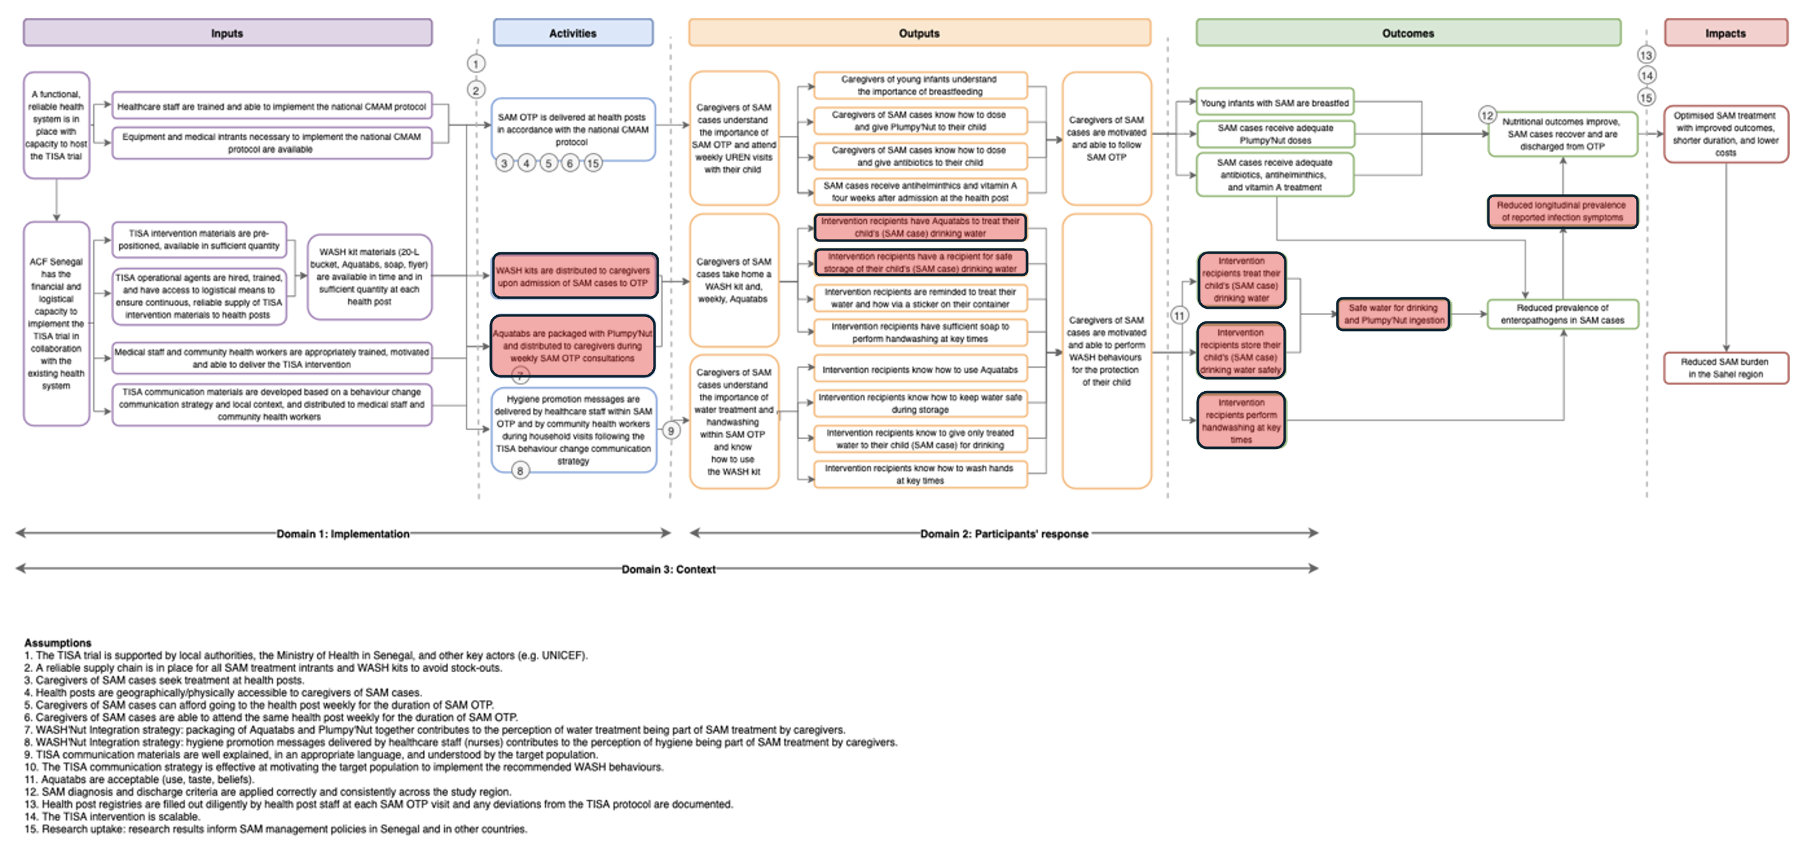

Supplementary figure 1: Theory of change of the TISA trial, highlighting in red the components presented in this sub-study

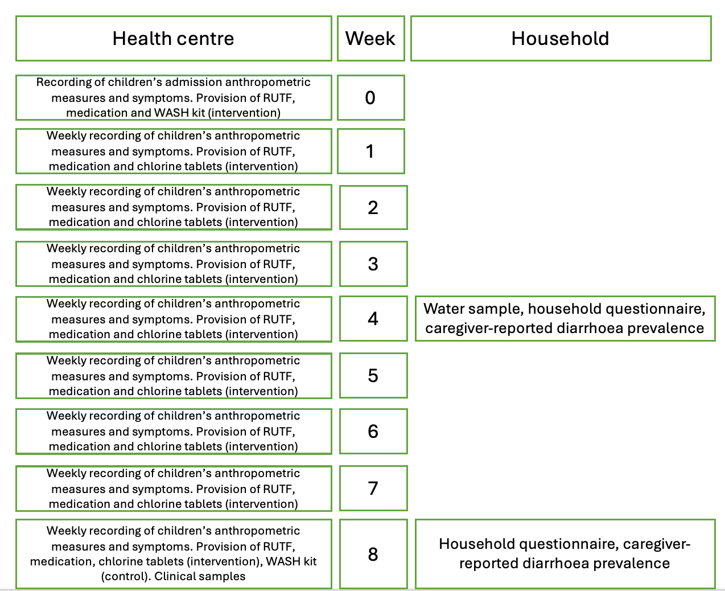
Supplementary figure 2: Enrolment and follow-up schedule. RUTF = ready-to-use therapeutic food

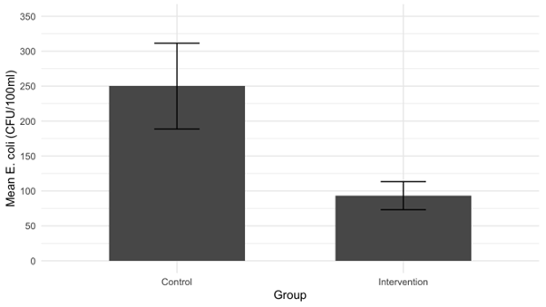
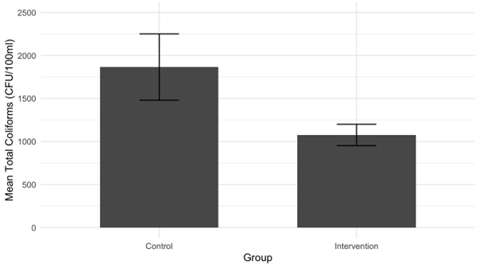
Supplementary figure 3: Mean E. coli (top) and total coliform (bottom) concentration (CFU/100 mL) in household drinking water samples. Error bars represent standard error.

Supplementary table 1: Summary of chlorine residual concentrations (mg/L) by time since water treatment among households using chlorine to treat water. Chlorine residuals tend to decrease with increasing time since treatment.
Time since treating water with chlorine | n | Median chlorine residual (mg/L) | Interquartile range (mg/L)
1 hour | 13 | 1 | 1.5
12 hours | 132 | 1 | 1.75
24 hours | 25 | 1.5 | 3.5
48 hours | 10 | 0.1 | 0
Do not remember | 5 | 0.5 | 0.4

Supplementary table 2: Association between microbial water quality, chlorine residual levels, and diarrhoea prevalence. Water sample with chlorine residual ≥0.2 mg/L were significantly more likely to have microbiologically safe drinking water (<1 E. coli CFU/100 ml) compared to those with residuals <0.2 mg/L (aOR = 2.56, 95% CI: 1.43–4.66; p = 0.0016). While lower diarrhoea prevalence was observed among children with microbiologically safe water at week 8, especially when using the <10 CFU/100 ml threshold (13.1% vs. 23.3%, aOR = 0.50, 95% CI: 0.28–0.87; p = 0.014), this association was weaker and not statistically significant when using the <1 CFU/100 mL threshold (aOR = 0.68, 95% CI: 0.41–1.12; p = 0.129). No significant association was found between chlorine residual levels and diarrhoea prevalence at week 8.
Microbial water quality
 |  | Chlorine residual <0.2 mg/L |  |  | Chlorine residual ≥0.2 mg/L |  |  |  |  | Crude effect¹ |  |  |  |  |  |  | Adjusted effect²
 |  | n/N | % |  | n/N |  | % |  |  | Odds ratio |  |  | 95% CI |  | p-value |  | Odds ratio |  | 95% CI |  | p-value
Safe water (<1 E. coli CFU/100 mL) | 75/246 |  | 30.0% |  | 105/199 |  | 52.8% |  |  | 2.55 |  |  | 1.44, 4.50 |  | 0.0013 |  | 2.56 |  | 1.43, 4.66 |  | 0.0016
Diarrhoea prevalence
 |  | Unsafe water (≥1 E.coli CFU/100 mL) |  |  |  | Safe water (<1 E.coli CFU/100 mL) |  |  |  |  | Crude effect¹ |  |  |  |  |  | Adjusted effect²
 |  | n/N |  | % |  | n/N |  | % |  |  | Odds ratio |  | 95% CI |  | p-value |  | Odds ratio |  | 95% CI |  | p-value
Week 0 |  | 99/265 |  | 37.4% |  | 63/180 |  |  | 35.0% |  |  | 1.00 |  |  |  |  |  | 1.00
Week 8 |  | 40/209 |  | 19.1% |  | 20/149 |  |  | 13.4% |  |  | 0.66 |  | 0.34, 1.08 |  | 0.1 |  | 0.68 |  | 0.41, 1.12 |  | 0.129
Diarrhoea prevalence
 |  | Unsafe water (≥10 E.coli CFU/ 100ml) |  |  |  | Safe water (<10 E.coli CFU/ 100ml) |  |  |  |  | Crude effect¹ |  |  |  |  |  | Adjusted effect²
 |  | n/N |  | % |  | n/N |  | % |  |  | Odds ratio |  | 95% CI |  | p-value |  | Odds ratio |  | 95% CI |  | p-value
Week 0 |  | 69/171 |  | 40.4% |  | 93/274 |  |  | 33.9% |  |  | 1.0 |  |  |  |  |  | 1.00
Week 8 |  | 30/129 |  | 23.3% |  | 30/229 |  |  | 13.1% |  |  | 0.5 |  | 0.29, 0.85 |  | 0.015 |  | 0.5 |  | 0.28, 0.87 |  | 0.014
Diarrhoea prevalence
 |  | Chlorine residual <0.2 mg/L |  |  |  | Chlorine residual ≥0.2 mg/L |  |  |  |  | Crude effect¹ |  |  |  |  |  | Adjusted effect²
 |  | n/N |  | % |  | n/N |  | % |  |  | Odds ratio |  | 95% CI |  | p-value |  | Odds ratio |  | 95% CI |  | p-value
Week 0 |  | 89/246 |  | 36.2% |  | 73/199 |  |  | 36.7% |  |  | 1.00 |  |  |  |  |  | 1.00
Week 8 |  | 35/196 |  | 17.9% |  | 25/162 |  |  | 15.4% |  |  | 0.84 |  | 0.47, 1.5 |  | 0.069 |  | 0.81 |  | 0.46, 1.46 |  | 0.49
¹ Crude effect based on logistic regression with robust standard errors to account for clustering
² Adjusted for clustering, age, sex, open defecation, and diarrhoea prevalence at admission

Questionnaire #1
Traitement Intégré de la Sous-Nutrition Aiguë (TISA) Study
Administered at UREN immediately after enrolment.

Enumerator ID: ______________
UREN location: _______________
UREN ID: _______________
Date of survey: DD/MM/YYYY

DEMOGRAPHICS
- Select the respondent’s sex.
- Male
- Female

- In what month and year were you born?
Month: _____________; Year: ______________

- What is the highest level of school you attended?
- None (go to #5)
- Primary
- Secondary
- Higher
- Prefer not to answer
- Don’t know

- What is the highest grade completed at that school? _______________

- How many children do you have, including the child seeking care today?

WASH PRACTICES
- Where do you usually collect water from for drinking? (Select one option.)

- Community tap
- Tap at the household
- Unprotected well
- Protected well
- Surface water (river, ponds)
- Rainwater
- Other: ____________

- Do you sometimes collect water for drinking from other sources?
- Yes
- No (go to #9)
- Don’t know (go to #9)

- What are the other water sources that you use for drinking? (Multiple answers possible.)

- Community tap
- Tap at the household
- Unprotected well
- Protected well
- Surface water (river, ponds)
- Rainwater
- Other: ____________

- Do you collect water for other purposes such as laundry from other sources?

- Yes
- No (go to #11)
- Don’t know (go to #11)

- What are the water sources that you use for purposes other than drinking? (Multiple answers possible.)
- Community tap
- Tap at the household
- Unprotected well
- Protected well
- Surface water (river, ponds)
- Rainwater
- Other: ____________

- Do you usually do something with the water that you collect before giving it to your child for drinking?
- Yes
- No (go to #13)
- Don’t know (go to #13)

- What do you usually do with the water that you collect before giving it to your child for drinking?
- Let settle
- Filter through a cloth
- Boil
- Treat with chlorine tablets
- Treat with liquid chlorine
- Other: ____________

- What treatments do you know of that can make water safe to drink?
- Settling
- Cloth filtration
- Boiling
- Chlorine tablets
- Liquid chlorine
- Other: ____________

- Have you washed your hands within the last day (since this time yesterday)?
- Yes
- No (go to #17)
- Don’t know (go to #17)

- What were all of the times when you washed your hands within the last day (since this time yesterday)? (Do not prompt. After each response, ask “any other times?”)
- After defecation
- After cleaning/wiping the child’s bottom
- After changing the nappy
- Before preparing food
- Before eating
- Before feeding the child
- After eating
- Coming back from work/outside the home
- Other: _______________________________
- Cannot remember/does not know

- What did you use to wash your hands?
- Water only
- Soap and water
- Dirt
- Ash and water
- Other: _____________

- Have you had diarrhea in the past week? Diarrhea means three or more loose stools per day at any point (show Bristol stool chart and point to Types 6 and 7).
- Yes
- No
- Don’t know

- Has your child had diarrhea in the past week?
- Yes
- No
- Don’t know

- What type of latrine or sanitation system do you use most often?
- Flush/pour flush toilet to piped sewer system
- Flush/pour flush toilet to underground pit/tank
- Pit latrine with concrete slab (not pour flush)
- Pit latrine without slab (not pour flush)
- Bucket (go to #21)
- Bag (go to #21)
- Open defecation (no facilities) (go to #21)
- Other: __________________

- Is this toilet/latrine shared with other households or is it for your private use only?

- Shared
- Private
- Don’t know

- Where did your child last defecate?
- Nappy
- Potty
- Toilet at household
- On the ground/in the open
- Other: __________________
- Don’t know

- What was done to dispose of the feces?
- Put/rinsed into toilet or latrine
- Put/rinsed into drain or ditch
- Thrown into garbage
- Buried
- Left in the open
- Other: ______________________
- Don’t know

Questionnaire #2 (week 4)
Traitement Intégré de la Sous-Nutrition Aiguë (TISA) Study
Administered at households during the first follow-up visit.

Enumerator ID: ______________
Location: ___________________
Household ID: _______________
Date of Survey: DD/MM/YYYY

GPS coordinates:

- Are you the person responsible for taking care of children in this household?
- Yes (go to #4)
- No

- May I speak with the person responsible for taking care of children in this household?
- Yes (go to #4 and continue with the children’s caregiver)
- No

- When do you expect the person responsible for taking care of children in this household to come back?

- Are you enrolled in the TISA study with your child?
- Yes
- No (interrupt).
- Don’t know (interrupt)

HOUSEHOLD CHARACTERISTICS

- Select floor type. (Multiple answers possible.)
- Dirt
- Concrete
- Tiles
- Other: _______

- Select wall type. (Multiple answers possible.)
- Dirt
- Concrete
- Bricks
- Wood
- Plastic/cloth
- Other: ______

- Select roof type. (Multiple answers possible.)
- Metallic
- Straw
- Wood
- Plastic/cloth
- Other: _________

- Does your household have electricity?
- Yes
- No (go to #10)

- What is your source of electricity?
- Network
- Generator
- Solar panels
- Batteries
- Other: ________

- Does your household own cattle?
- Yes
- No (go to #12)

- Can you tell me the type and number of animals that you have?
- Cows: _____
- Sheep: _____
- Goats: _____
- Chicken: _____
- Horse/mule: _____
- Other: ____

ADHERENCE TO SAM TREATMENT
- When is the last time you went to the health post with your child?
- Within the past 7 days
- 1-2 weeks ago
- More than 2 weeks ago

- Have you received Plumpy’Nut to give to your child in the last two weeks?
- Yes
- No
- Don’t know

- How many Plumpy’Nut sachets do you currently have at home? ______

- How many sachets of Plumpy’Nut do you give to your child daily? _____________

- Do you do anything with the Plumpy’Nut sachet before giving them to your child?

- Nothing
- Wash them
- Mix with other food
- Other: ______

WASH

- Can you please show me where you keep the water that you give your child for drinking? (Observe and select container type, only one.)
- Clay pot
- Jerrycan
- Plastic bucket
- Large barrel
- Buried clay reservoir
- Plastic bottles
- Doesn’t know / not showing / no water (go to #33)
- Other: __________

- Observe and select all that apply: the container is…
- Covered
- With a tap
- Empty

- Observe and estimate container volume: ________

For the intervention group only:
24a. Observe: is this the container that was provided to TISA participants?
- Yes
- No
- Unclear

- Where does the water in this container come from? (Point at the container identified in #21.)
- Community tap
- Tap at the household
- Unprotected well
- Protected well
- Surface water (river, ponds)
- Rainwater
- Other: ____________

- When is the last time that you refilled this container?
- Less than 1 hour ago
- 1-12 hours ago
- 12-24 hours ago
- 24-48 hours ago
- More than 48 hours ago

- Did you treat the water in this container after collection?
- Yes
- No (go to #27)
- Don’t know (go to #27)

- Can you please show me what you used to treat the water in this container? (Select all that apply.)
- Settling
- Cloth filtration
- Chlorine tablets
- Liquid chlorine
- Other: ____________

For the intervention group only:
28a. Observe: are these the chlorine tablets that were distributed to TISA participants?
- Yes
- No (go to #28c)
- Unclear (go to #28c)
28b. Can you show me how many chlorine tablets you currently have at home?
Estimate number:_________ (Go to #29.)
28c. Did you receive chlorine tablets at the UREN?
- Yes
- No (go to #29)
- Unclear (go to #29)
28d. Why are you not using the chlorine tablets that you received?
- No time
- Bad taste
- Forgot
- No tablets left
- Other: ________

- May I have a cup of water from this container?
- Yes
- No / refuse (go to #33)

- Measure turbidity (NTU): _______

- Measure free chlorine residual (mg/L): ______

- Measure total chlorine (mg/L): ______

- Do you sometimes collect water for drinking from other sources than the one where you collected the water from this container? (Point at the container from where you received the sample.)
- Yes
- No (go to #29)
- Don’t know (go to #29)

- What are the other water sources that you use for drinking? (Multiple answers possible).
- Community tap
- Tap at the household
- Unprotected well
- Protected well
- Surface water (river, ponds)
- Rainwater
- Other: ____________

- Do you collect water for other purposes such as laundry from other sources?
- Yes
- No (go to #31)
- Don’t know (go to #31)

- What are the water sources that you use for purposes other than drinking?
- Community tap
- Tap at the household
- Unprotected well
- Protected well
- Surface water (river, ponds)
- Rainwater
- Other: ____________

- What treatments do you know of that can make water safe to drink?
- Settling
- Cloth filtration
- Boiling
- Chlorine tablets
- Liquid chlorine
- Other: ____________

- Have you washed your hands within the last day (since this time yesterday)?
- Yes
- No (go to #34)
- Don’t know (go to #34)

- What were all of the times when you washed your hands within the last day (since this time yesterday)? (Do not prompt. After each response, ask “any other times?”)
- After defecation
- After cleaning/wiping the child’s bottom
- After changing the nappy
- Before preparing food
- Before eating
- Before feeding the child
- After eating
- Coming back from work/outside the home
- Other: _______________________________
- Cannot remember/does not know

- What did you use to wash your hands?
- Water only
- Soap and water
- Sand
- Ash and water
- Other: _____________

- Have you had diarrhea in the past two weeks? Diarrhea means three or more loose stools per day at any point (show Bristol stool chart and point to Types 6 and 7).
- Yes
- No
- Don’t know

- Has your child had diarrhea in the past two weeks?
- Yes
- No
- Don’t know

- What type of toilet/latrine or sanitation system do you use most often?
- Flush/pour flush toilet to piped sewer system
- Flush/pour flush toilet to underground pit/tank
- Pit latrine with concrete slab (not pour flush)
- Pit latrine without slab (not pour flush)
- Bucket
- Bag (end survey)
- Open defecation (no facilities) (end survey)
- Other: __________________

- Is this toilet/latrine shared with other households or is it for your private use only?
- Shared
- Private
- Don’t know

- Is your child eating Plumpy’nut or other food today?
- Yes – Plumpy’nut
- Yes – other food
- Yes - both
- No

- If eating Plumpy’nut, when was the packaging opened?
- < 1 hour ago
- 1-3 hours ago
- 3-6 hours ago
- More than 6 hours ago

- If eating Plumpy’nut, can we collect a swab sample (explain procedure and give caregiver an unopened Plumpy’nut after collecting the sample)?
- Yes
- No

- If eating other food, what type of food is your child eating today?
- Solid food
- Provide name
- Liquid food
- Provide name

- Is this food raw or cooked?
- Raw
- Cooked
- If cooked, when was it cooked?
- <2 hours ago
- 2-6 hours ago
- More than 6 hours ago
- If cooked more than 2 hours ago, was it reheated?
- Yes
- No

- If eating other food, can we collect a sample (explain the procedure)?
- Yes
- No

