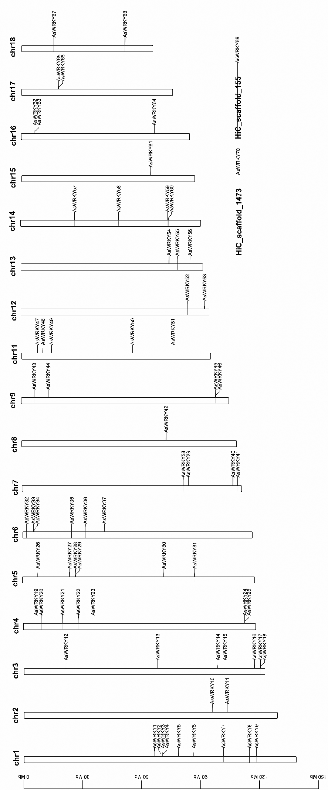
Fig. S1 Chromosomal localization and distribution of the WRKY Gene Family in A. sesquipedale.

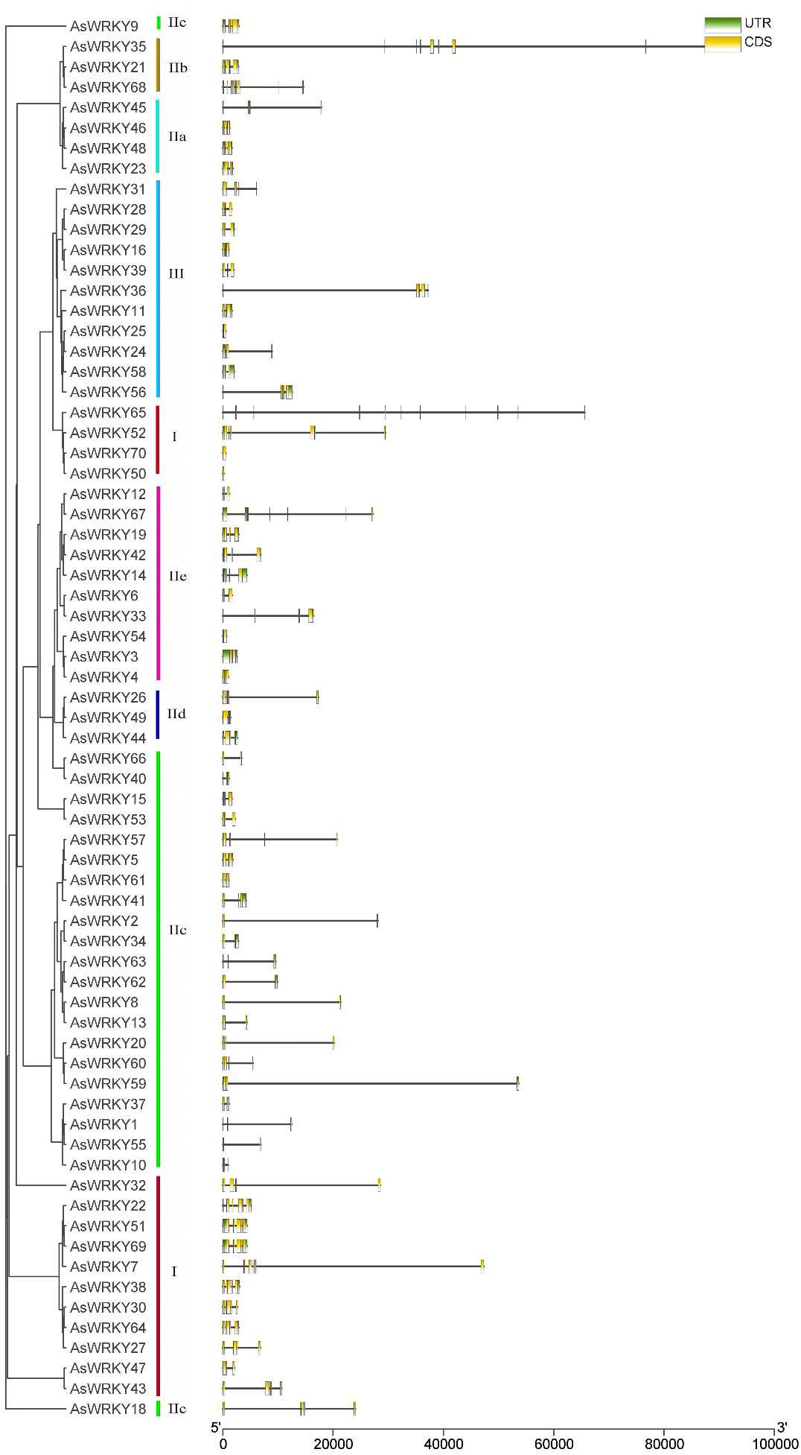
Fig. S2 Comprehensive Analysis of Conserved Motifs and Gene Structure in AsWRKY proteins. In the gene structure diagram, yellow boxes and lines represent exons and introns, respectively.
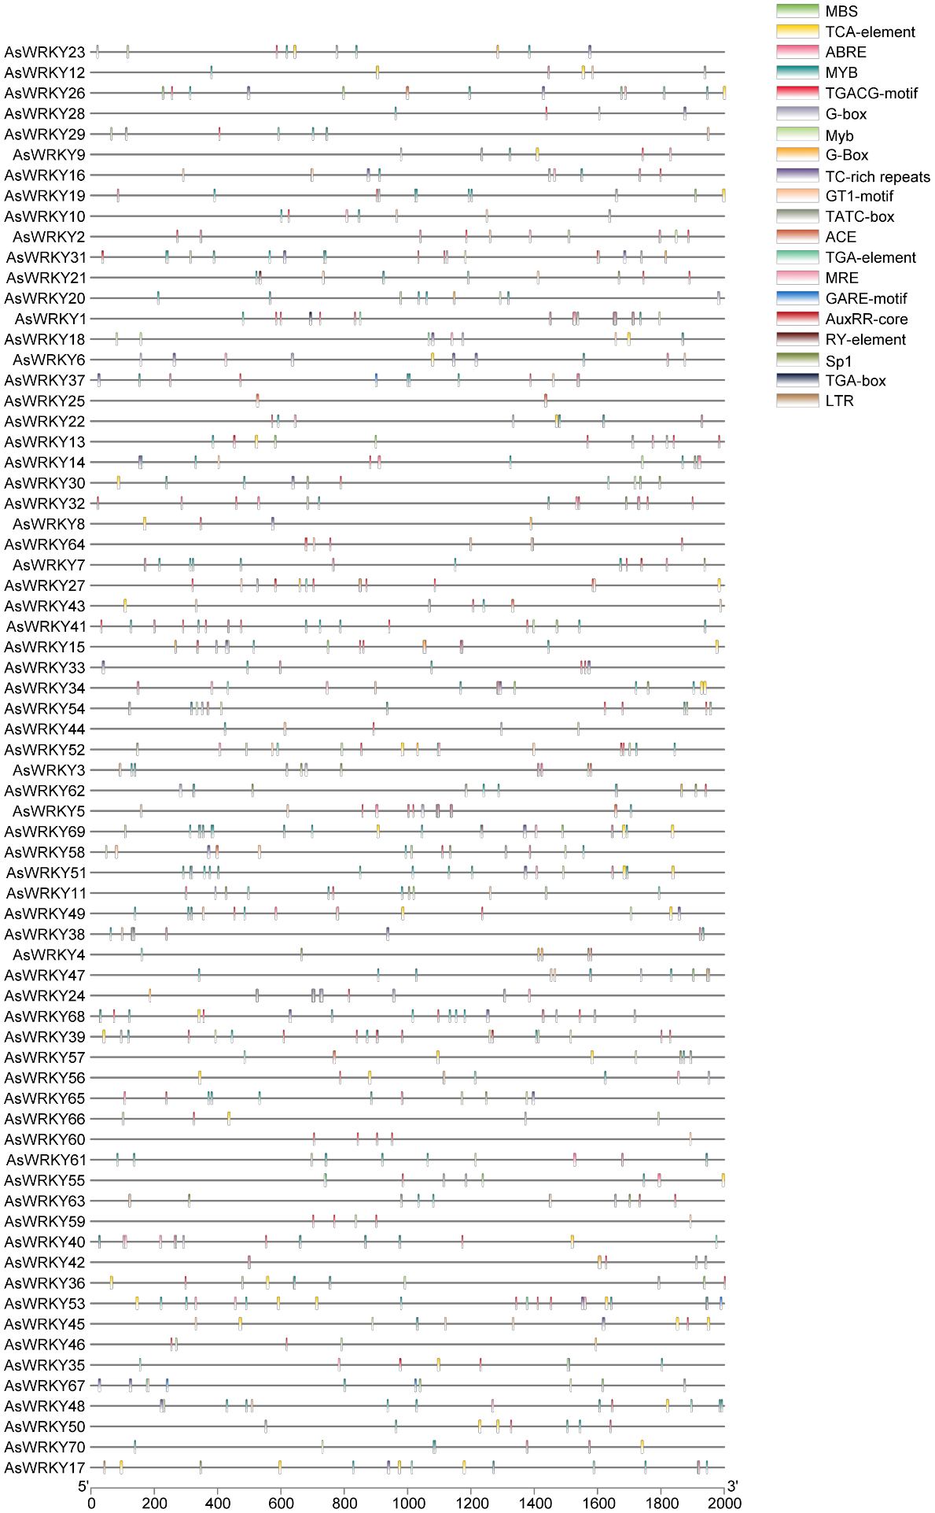
Fig. S3 Prediction of cis-responsive elements in the 1500 bp upstream regulatory regions of AsWRKYs. Different cis-responsive elements are represented by different colored boxes.

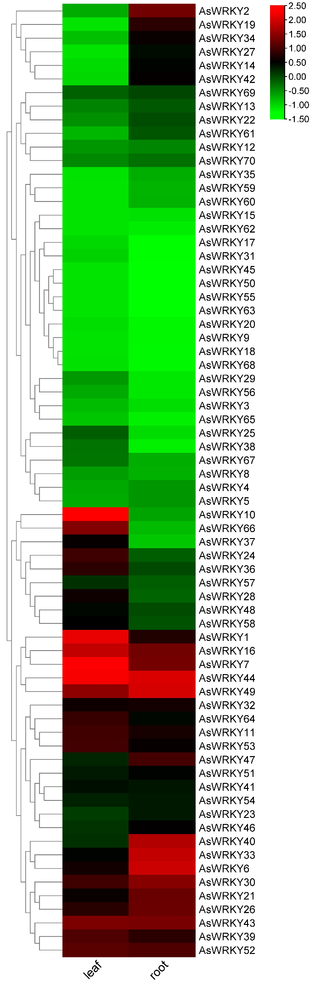
Fig. S4 Expression profile analysis of AsWRKYs in two tissues. Transcriptome data were used to measure the expression levels of AsWRKYs in roots, leaves. The colored scale for the different expression levels is shown.

