SUPPLEMENTARY DATA
Table S1: Antibiotic discs used for AST
No. | Antibiotic Disc Name | Abbrev. | Antibiotic class | Conc (mcg)
1 | Gentamicin | GEN | Aminoglycosides | 10
2 | Doxycycline Hydrochloride | DOX | Tetracyclines | 30
3 | Ciprofloxacin | CIP | Fluoroquinolones | 5
4 | Trimethoprim | TMP | Folate-pathway-antagonists | 5
5 | Moxifloxacin | MXF | Fluoroquinolones | 5
6 | Chloramphenicol | CHL | Phenicols | 30
7 | Tetracycline | TET | Tetracyclines | 30
8 | Amoxicillin/ Clavulanic acid | AMC | Penicillins | 30 (20/10)
9 | Ampicillin | AMP | Penicillins | 10
10 | Aztreonam | ATM | Monobactams | 30
11 | Cefotaxime | CTX | cephalosporins | 5
12 | Meropenem | MEM | Carbapenems | 10
13 | Ceftriaxone | CRO | cephalosporins | 30
14 | Cefixime | CPM | cephalosporins | 5

Table S2: Water Quality Characteristics of Inlet and Outlet Samples from Five WWTPs
Sampling Locations | Sample Type | pH | TDS (ppm) | DO (mg/L) | Salinity (ppt) | ORP (mV) | Conductivity (µS/cm) | Turbidity (NTU) | Nitrate (mg/L) | Ammonium (mg/L) | Resistivity (Ω-cm) | BOD  (ppm) | COD (ppm) | TOC filtered (ppm) | TP (ppm)
WWTP A | A_inlet | 7.25 | 1739.00 | 1.04 | 0.74 | -228.20 | 1482.00 | 297.00 | 31.80 | 120.00 | 641.00 | 368.1 | 672.00 | 187.81 | 52.92
WWTP A | A_outlet | 7.69 | 721.00 | 4.90 | 0.72 | 162.80 | 1448.00 | 4.86 | 33.40 | 22.70 | 691.00 | 32.7 | 298.00 | 39.35 | 1.95
WWTP B | B_inlet | 7.23 | 1950.00 | 0.89 | 0.96 | -242.70 | 1890.00 | 242.00 | 19.50 | 198.00 | 529.00 | 381.4 | 456.00 | 153.58 | 42.4
WWTP B | B_outlet | 7.63 | 1654.00 | 4.40 | 1.68 | 86.00 | 3220.00 | 10.90 | 35.00 | 191.80 | 311.00 | 35.5 | 335.00 | 34.76 | 1.86
WWTP C | C_inlet | 6.71 | 1213.00 | 0.53 | 1.23 | -36.30 | 2390.00 | 618.00 | 13.30 | 110.00 | 418.00 | 263.0 | 624.00 | 138.00 | 9.91
WWTP C | C_outlet | 7.38 | 940.00 | 5.23 | 2.14 | 168.60 | 2050.00 | 35.67 | 10.20 | 94.00 | 247.00 | 28 | 254.00 | 28.80 | 2.78
WWTP D | D_inlet | 6.13 | 566.00 | 0.99 | 0.57 | -36.90 | 1145.00 | 37.57 | 29.30 | 209.00 | 874.00 | 125 | 815.00 | 221.70 | 12.54
WWTP D | D_outlet | 6.94 | 997.00 | 5.74 | 1.02 | 319.90 | 1997.00 | 82.20 | 17.20 | 111.00 | 523.00 | 36.3 | 386.00 | 34.10 | 3.64
WWTP E | E_inlet | 7.21 | 1560.00 | 1.76 | 0.73 | -214.00 | 1532.00 | 198.00 | 25.30 | 42.00 | 671.00 | 362 | 901.00 | 160.48 | 42.50
WWTP E | E_outlet | 7.67 | 753.00 | 4.30 | 0.71 | 97.00 | 1440.00 | 5.89 | 15.60 | 11.00 | 389.00 | 46 | 376.00 | 33.10 | 1.89

Table S3. Assessment of Water Quality Parameters and Removal Efficiency Across the Effluent Treatment Plants.
Removal Efficiency (%) | WWTP A | WWTP B | WWTP C | WWTP D | WWTP E
TDS (ppm) | 58.54 | 15.18 | 22.51 | -76.15 | 51.73
Salinity (ppt) | 2.70 | -75.00 | -73.98 | -78.95 | 2.74
ORP/Redox (mV) | 171.34 | 135.43 | 564.46 | 966.94 | 145.33
Conductivity (µS/cm) | 2.29 | -70.37 | 14.22 | -74.41 | 6.01
Turbidity (NTU) | 98.36 | 95.50 | 94.23 | -118.81 | 97.02
Ammonium (mg/L) | 81.08 | 3.13 | 14.54 | 46.89 | 73.81
Resistivity (Ω-cm) | -7.80 | 41.21 | 40.91 | 40.16 | 42.02
BOD (ppm) | 91.11 | 90.69 | 89.65 | 70.96 | 87
COD (ppm) | 55.65 | 26.53 | 59.24 | 52.64 | 58.27
TOC (ppm) | 79.05 | 77.37 | 79.24 | 84.62 | 79.37

Table S4: Bacterial Counts (CFU/mL) for Different Agar Media with and without Antibiotics (Mean ± Standard Deviation)
Sampling Locations | Sample ID | TBX B 44  (Log CFU/ml) | OSS 44  (Log CFU/ml) | OSS 30  (Log CFU/ml) | CARB 44  (Log CFU/ml) | CARB 30  (Log CFU/ml) | ESBL 44  (Log CFU/ml) | ESBL 30  (Log CFU/ml)
WWTP A | A_inlet | 4.858 ± 0.011 | 0.343 ± 0.011 | 4.598 ± 0.020 | 4.582 ± 0.021 | 4.575 ± 0.021 | 2.687 ± 0.000 | 4.605 ± 0.020
WWTP A | A_outlet | 0.343 ± 0.011 | 0.343 ± 0.011 | 0.343 ± 0.000 | 0.343 ± 0.011 | 0.343 ± 0.000 | 0.343 ± 0.000 | 0.343 ± 0.000
WWTP B | B_inlet | 4.564 ± 0.011 | 2.316 ± 0.082 | 4.604 ± 0.021 | 0.343 ± 0.011 | 4.211 ± 0.031 | 3.125 ± 0.034 | 4.651 ± 0.001
WWTP B | B_outlet | 0.343 ± 0.011 | 0.343 ± 0.011 | 2.839 ± 0.049 | 0.343 ± 0.011 | 0.343 ± 0.000 | 0.343 ± 0.011 | 3.140 ± 0.034
WWTP C | C_inlet | 2.790 ± 0.011 | 0.343 ± 0.011 | 2.863 ± 0.033 | 0.343 ± 0.011 | 1.131 ± 0.198 | 0.343 ± 0.011 | 1.256 ± 0.176
WWTP C | C_outlet | 0.955 ± 0.011 | 0.343 ± 0.011 | 1.499 ± 0.139 | 0.343 ± 0.011 | 0.654 ± 0.301 | 0.343 ± 0.011 | 0.654 ± 0.301
WWTP D | D_inlet | 4.138 ± 0.011 | 0.343 ± 0.011 | 4.882 ± 0.010 | 0.343 ± 0.011 | 4.406 ± 0.018 | 0.343 ± 0.011 | 4.902 ± 0.010
WWTP D | D_outlet | 2.540 ± 0.011 | 0.343 ± 0.011 | 1.955 ± 0.088 | 0.343 ± 0.011 | 0.654 ± 0.301 | 0.343 ± 0.011 | 1.131 ± 0.198
WWTP E | E_inlet | 0.343 ± 0.011 | 0.343 ± 0.011 | 4.917 ± 0.010 | 0.343 ± 0.011 | 4.842 ± 0.011 | 0.343 ± 0.011 | 4.487 ± 0.022
WWTP E | E_outlet | 0.343 ± 0.011 | 0.343 ± 0.011 | 2.517 ± 0.048 | 0.343 ± 0.011 | 2.695 ± 0.040 | 0.343 ± 0.011 | 2.803 ± 0.035

Table S5: AST profiles of the E. coli isolates from various Sampling Locations
No | WWTP Name | Sample Type | Isolate Number | GEN | DOX | TET | CIP | MXF | TMP | CHL | AMC | AMP | ATM | CTX | CRO | CPM | MEM
1 | WWTP A | inlet | 31 | S | R | S | S | S | R | S | R | R | S | S | R | S | S
2 | WWTP A | inlet | 32 | S | R | R | R | R | R | S | R | R | R | S | S | S | S
3 | WWTP A | inlet | 33 | S | R | R | R | R | R | S | R | S | S | S | S | S | S
4 | WWTP A | inlet | 34 | S | R | R | R | R | R | S | R | R | R | R | R | S | S
5 | WWTP A | inlet | 35 | S | R | R | R | R | R | S | S | R | R | R | S | S | S
6 | WWTP A | inlet | 36 | S | R | R | S | R | R | R | R | R | S | S | S | S | S
7 | WWTP A | inlet | 37 | S | R | S | S | R | R | S | R | R | R | S | S | S | S
8 | WWTP A | inlet | 38 | S | R | S | S | R | R | R | R | S | S | S | R | S | S
9 | WWTP A | inlet | 39 | S | R | S | S | R | R | R | S | S | R | S | S | S | S
10 | WWTP A | inlet | 40 | R | S | R | S | R | S | S | R | R | R | R | R | R | S
11 | WWTP A | inlet | 41 | S | S | R | S | R | S | S | R | R | R | R | R | R | S
12 | WWTP A | inlet | 42 | R | S | S | S | R | R | S | R | R | S | R | S | R | S
13 | WWTP A | inlet | 43 | R | R | R | S | R | R | S | R | R | S | S | R | R | S
14 | WWTP A | inlet | 44 | S | R | R | S | S | R | S | R | R | S | S | S | S | S
15 | WWTP B | inlet | 1 | S | R | R | S | S | R | S | R | S | S | R | S | S | S
16 | WWTP B | inlet | 2 | S | S | S | S | R | S | S | S | R | S | S | S | S | S
17 | WWTP B | inlet | 3 | S | R | R | S | S | R | R | R | S | S | S | R | S | S
18 | WWTP B | inlet | 4 | S | S | S | S | S | S | S | S | R | S | S | R | R | S
19 | WWTP B | inlet | 5 | S | S | R | S | R | R | S | S | R | S | S | S | S | S
20 | WWTP B | inlet | 6 | S | S | S | R | S | R | S | S | R | S | S | S | S | S
21 | WWTP B | inlet | 7 | S | S | S | S | S | R | S | R | R | S | R | S | S | S
22 | WWTP B | inlet | 8 | S | S | R | R | S | S | S | S | S | S | R | R | R | S
23 | WWTP B | inlet | 9 | S | S | S | R | S | S | S | S | S | R | S | S | S | S
24 | WWTP B | inlet | 10 | S | R | S | S | S | S | S | S | R | S | S | S | S | S
25 | WWTP B | inlet | 11 | S | S | S | R | R | S | S | S | S | S | S | S | S | S
26 | WWTP B | inlet | 12 | S | S | S | S | R | S | S | S | R | S | R | S | S | S
27 | WWTP B | inlet | 13 | S | R | R | R | R | R | S | S | R | S | S | S | S | S
28 | WWTP B | inlet | 14 | S | S | R | S | S | R | S | S | S | S | R | R | R | S
29 | WWTP B | inlet | 15 | S | S | S | R | R | S | S | R | R | S | R | S | S | S
30 | WWTP B | inlet | 16 | S | S | S | S | S | S | S | S | S | S | R | R | S | S
31 | WWTP B | inlet | 17 | S | S | S | S | S | S | S | R | R | S | S | S | S | S
32 | WWTP B | inlet | 18 | S | S | S | S | R | S | S | S | R | S | S | S | S | S
33 | WWTP B | inlet | 19 | S | R | S | S | S | S | S | R | R | S | R | S | S | S
34 | WWTP B | inlet | 20 | S | R | S | S | S | R | S | R | R | S | S | S | S | S
35 | WWTP B | inlet | 21 | S | S | S | S | S | S | S | S | R | R | R | R | R | S
36 | WWTP B | inlet | 22 | S | S | S | S | S | S | S | S | R | R | R | R | R | S
37 | WWTP B | inlet | 23 | S | S | S | S | S | R | S | R | R | R | R | R | R | S
38 | WWTP B | inlet | 24 | S | S | S | S | S | S | S | S | R | R | R | R | R | S
39 | WWTP B | inlet | 25 | S | S | S | R | R | S | S | S | S | S | S | S | S | S
40 | WWTP B | inlet | 26 | S | S | S | S | S | S | S | S | R | R | R | R | R | S
41 | WWTP B | inlet | 27 | S | S | R | S | S | S | S | R | R | R | R | R | R | S
42 | WWTP B | inlet | 28 | S | S | S | S | S | S | S | R | R | R | R | R | R | S
43 | WWTP B | inlet | 29 | S | S | S | S | S | S | S | S | R | R | R | R | R | S
44 | WWTP B | inlet | 30 | S | S | S | S | S | S | S | S | R | S | R | R | R | S
45 | WWTP C | inlet | 94 | S | S | S | S | S | S | S | S | R | S | R | R | R | S
46 | WWTP C | inlet | 95 | S | S | S | S | S | S | R | R | S | R | S | S | R | S
47 | WWTP C | inlet | 96 | S | S | S | S | R | S | S | S | S | S | R | R | S | S
48 | WWTP C | inlet | 97 | S | S | S | S | S | S | S | S | R | S | R | R | R | S
49 | WWTP D | inlet | 45 | S | S | S | R | R | R | R | R | R | R | R | R | R | S
50 | WWTP D | inlet | 46 | S | S | S | R | R | R | S | R | R | S | S | S | S | S
51 | WWTP D | inlet | 47 | S | R | S | R | R | S | S | S | S | S | S | S | S | S
52 | WWTP D | inlet | 48 | R | S | R | R | R | R | S | R | R | R | R | S | S | S
53 | WWTP D | inlet | 49 | S | R | S | R | R | R | S | R | R | R | R | R | S | S
54 | WWTP D | inlet | 50 | S | R | S | R | R | R | S | R | R | R | S | S | S | S
55 | WWTP D | inlet | 51 | S | R | R | R | R | R | R | R | R | S | R | R | S | S
56 | WWTP D | inlet | 52 | S | S | S | R | R | R | S | R | R | S | S | S | S | S
57 | WWTP D | inlet | 53 | S | S | R | R | R | R | R | R | R | S | S | S | S | S
58 | WWTP D | inlet | 54 | S | R | R | R | R | R | R | R | R | S | S | S | S | S
59 | WWTP D | inlet | 55 | R | S | R | R | R | R | R | R | R | R | R | R | R | S
60 | WWTP D | inlet | 56 | S | S | S | R | R | R | S | R | R | S | S | S | S | S
61 | WWTP D | inlet | 57 | S | S | R | R | R | R | R | R | R | S | R | R | R | S
62 | WWTP D | inlet | 58 | R | S | R | R | R | R | S | R | R | S | S | S | S | S
63 | WWTP D | inlet | 59 | R | S | R | R | R | R | S | R | R | R | S | S | S | S
64 | WWTP D | inlet | 60 | S | S | R | R | R | R | R | R | R | S | S | S | S | S
65 | WWTP D | inlet | 61 | S | R | R | R | R | R | R | R | R | R | R | R | S | S
66 | WWTP D | inlet | 62 | R | R | R | S | R | R | R | R | R | S | S | S | S | S
67 | WWTP D | inlet | 63 | S | R | R | R | R | R | S | R | R | S | R | S | S | S
68 | WWTP D | inlet | 64 | S | R | S | S | R | S | S | S | R | S | S | S | S | S
69 | WWTP D | inlet | 65 | S | S | S | R | R | S | S | S | S | S | S | S | S | S
70 | WWTP D | inlet | 66 | S | S | S | R | R | R | S | R | R | R | R | R | R | S
71 | WWTP D | inlet | 67 | S | S | S | R | R | S | S | R | R | S | S | S | R | S
72 | WWTP D | inlet | 68 | S | S | S | R | R | R | S | S | R | S | S | S | S | S
73 | WWTP D | inlet | 69 | S | R | R | S | R | S | S | R | R | S | S | S | S | S
74 | WWTP D | inlet | 70 | S | S | S | R | R | R | S | R | R | R | R | R | R | S
75 | WWTP D | inlet | 71 | S | S | S | S | R | R | S | R | R | S | S | S | R | S
76 | WWTP D | inlet | 72 | S | R | R | R | R | R | S | R | R | S | S | S | R | S
77 | WWTP D | inlet | 73 | S | S | S | S | S | S | S | S | R | R | R | R | R | S
78 | WWTP D | Outlet | 74 | S | R | R | R | R | R | R | R | R | R | R | R | S | S
79 | WWTP D | Outlet | 75 | S | S | S | S | R | R | R | R | R | S | R | S | S | S
80 | WWTP D | Outlet | 76 | R | S | R | R | R | R | S | R | R | R | R | R | R | S
81 | WWTP D | Outlet | 77 | S | R | S | R | R | R | R | R | R | S | R | R | R | S
82 | WWTP D | Outlet | 78 | S | R | S | S | R | R | R | S | R | R | R | S | R | S
83 | WWTP D | Outlet | 79 | S | S | S | R | R | R | S | R | R | S | S | S | R | S
84 | WWTP D | Outlet | 80 | S | R | R | R | R | R | R | R | R | R | R | S | R | R
85 | WWTP D | Outlet | 81 | S | S | S | R | R | R | S | R | R | S | R | R | S | S
86 | WWTP D | Outlet | 82 | S | S | S | S | R | R | S | R | R | S | R | R | S | S
87 | WWTP D | Outlet | 83 | S | S | S | R | R | R | S | R | R | S | R | S | S | S
88 | WWTP D | Outlet | 84 | S | S | R | R | R | R | R | R | R | S | R | R | R | S
89 | WWTP D | Outlet | 85 | S | R | R | R | R | R | R | R | R | R | R | R | R | S
90 | WWTP D | Outlet | 86 | S | S | S | R | R | R | S | S | R | S | R | R | S | S
91 | WWTP D | Outlet | 87 | S | S | S | S | S | R | S | S | R | R | R | R | R | S
92 | WWTP D | Outlet | 88 | S | S | S | S | S | S | S | R | R | R | R | R | R | S
93 | WWTP D | Outlet | 89 | S | S | S | S | S | R | R | S | R | R | R | R | R | S
94 | WWTP D | Outlet | 90 | S | S | S | S | S | S | S | S | R | R | R | R | R | S
95 | WWTP D | Outlet | 91 | R | R | R | R | R | R | S | R | R | S | S | S | R | S
96 | WWTP D | Outlet | 92 | S | S | S | S | S | S | S | S | R | R | R | R | R | S
97 | WWTP D | Outlet | 93 | S | R | R | R | R | R | S | R | R | S | S | S | R | S

Table S6: Biochemical Characterisation of the Bacterial Isolates
WWTP Name | Sample Type | Isolate Number | Gram Staining | Motility | Indole | TSI | Citrate | Methyl Red test | Catalase Test | Oxidase | Urease | VP test | H2S
WWTP A | inlet | 31 | N | P | P | P | N | P | P | N | N | N | N
WWTP A | inlet | 32 | N | P | P | P | N | P | P | N | N | N | N
WWTP A | inlet | 33 | N | P | P | P | N | P | P | N | N | N | N
WWTP A | inlet | 34 | N | P | P | P | N | P | P | N | N | N | N
WWTP A | inlet | 35 | N | P | P | P | N | P | P | N | N | N | N
WWTP A | inlet | 36 | N | P | P | P | N | P | P | N | N | N | N
WWTP A | inlet | 37 | N | P | P | P | N | P | P | N | N | N | N
WWTP A | inlet | 38 | N | P | P | P | N | P | P | N | N | N | N
WWTP A | inlet | 39 | N | P | P | P | N | P | P | N | N | N | N
WWTP A | inlet | 40 | N | P | P | P | N | P | P | N | N | N | N
WWTP A | inlet | 41 | N | P | P | P | N | P | P | N | N | N | N
WWTP A | inlet | 42 | N | P | P | P | N | P | P | N | N | N | N
WWTP A | inlet | 43 | N | P | P | P | N | P | P | N | N | N | N
WWTP A | inlet | 44 | N | P | P | P | N | P | P | N | N | N | N
WWTP B | inlet | 1 | N | P | P | P | N | P | P | N | N | N | N
WWTP B | inlet | 2 | N | P | P | P | N | P | P | N | N | N | N
WWTP B | inlet | 3 | N | P | P | P | N | P | P | N | N | N | N
WWTP B | inlet | 4 | N | P | P | P | N | P | P | N | N | N | N
WWTP B | inlet | 5 | N | P | P | P | N | P | P | N | N | N | N
WWTP B | inlet | 6 | N | P | P | P | N | P | P | N | N | N | N
WWTP B | inlet | 7 | N | P | P | P | N | P | P | N | N | N | N
WWTP B | inlet | 8 | N | P | P | P | N | P | P | N | N | N | N
WWTP B | inlet | 9 | N | P | P | P | N | P | P | N | N | N | N
WWTP B | inlet | 10 | N | P | P | P | N | P | P | N | N | N | N
WWTP B | inlet | 11 | N | P | P | P | N | P | P | N | N | N | N
WWTP B | inlet | 12 | N | P | P | P | N | P | P | N | N | N | N
WWTP B | inlet | 13 | N | P | P | P | N | P | P | N | N | N | N
WWTP B | inlet | 14 | N | P | P | P | N | P | P | N | N | N | N
WWTP B | inlet | 15 | N | P | P | P | N | P | P | N | N | N | N
WWTP B | inlet | 16 | N | P | P | P | N | P | P | N | N | N | N
WWTP B | inlet | 17 | N | P | P | P | N | P | P | N | N | N | N
WWTP B | inlet | 18 | N | P | P | P | N | P | P | N | N | N | N
WWTP B | inlet | 19 | N | P | P | P | N | P | P | N | N | N | N
WWTP B | inlet | 20 | N | P | P | P | N | P | P | N | N | N | N
WWTP B | inlet | 21 | N | P | P | P | N | P | P | N | N | N | N
WWTP B | inlet | 22 | N | P | P | P | N | P | P | N | N | N | N
WWTP B | inlet | 23 | N | P | P | P | N | P | P | N | N | N | N
WWTP B | inlet | 24 | N | P | P | P | N | P | P | N | N | N | N
WWTP B | inlet | 25 | N | P | P | P | N | P | P | N | N | N | N
WWTP B | inlet | 26 | N | P | P | P | N | P | P | N | N | N | N
WWTP B | inlet | 27 | N | P | P | P | N | P | P | N | N | N | N
WWTP B | inlet | 28 | N | P | P | P | N | P | P | N | N | N | N
WWTP B | inlet | 29 | N | P | P | P | N | P | P | N | N | N | N
WWTP B | inlet | 30 | N | P | P | P | N | P | P | N | N | N | N
WWTP C | inlet | 94 | N | P | P | P | N | P | P | N | N | N | N
WWTP C | inlet | 95 | N | P | P | P | N | P | P | N | N | N | N
WWTP C | inlet | 96 | N | P | P | P | N | P | P | N | N | N | N
WWTP C | inlet | 97 | N | P | P | P | N | P | P | N | N | N | N
WWTP D | inlet | 45 | N | P | P | P | N | P | P | N | N | N | N
WWTP D | inlet | 46 | N | P | P | P | N | P | P | N | N | N | N
WWTP D | inlet | 47 | N | P | P | P | N | P | P | N | N | N | N
WWTP D | inlet | 48 | N | P | P | P | N | P | P | N | N | N | N
WWTP D | inlet | 49 | N | P | P | P | N | P | P | N | N | N | N
WWTP D | inlet | 50 | N | P | P | P | N | P | P | N | N | N | N
WWTP D | inlet | 51 | N | P | P | P | N | P | P | N | N | N | N
WWTP D | inlet | 52 | N | P | P | P | N | P | P | N | N | N | N
WWTP D | inlet | 53 | N | P | P | P | N | P | P | N | N | N | N
WWTP D | inlet | 54 | N | P | P | P | N | P | P | N | N | N | N
WWTP D | inlet | 55 | N | P | P | P | N | P | P | N | N | N | N
WWTP D | inlet | 56 | N | P | P | P | N | P | P | N | N | N | N
WWTP D | inlet | 57 | N | P | P | P | N | P | P | N | N | N | N
WWTP D | inlet | 58 | N | P | P | P | N | P | P | N | N | N | N
WWTP D | inlet | 59 | N | P | P | P | N | P | P | N | N | N | N
WWTP D | inlet | 60 | N | P | P | P | N | P | P | N | N | N | N
WWTP D | inlet | 61 | N | P | P | P | N | P | P | N | N | N | N
WWTP D | inlet | 62 | N | P | P | P | N | P | P | N | N | N | N
WWTP D | inlet | 63 | N | P | P | P | N | P | P | N | N | N | N
WWTP D | inlet | 64 | N | P | P | P | N | P | P | N | N | N | N
WWTP D | inlet | 65 | N | P | P | P | N | P | P | N | N | N | N
WWTP D | inlet | 66 | N | P | P | P | N | P | P | N | N | N | N
WWTP D | inlet | 67 | N | P | P | P | N | P | P | N | N | N | N
WWTP D | inlet | 68 | N | P | P | P | N | P | P | N | N | N | N
WWTP D | inlet | 69 | N | P | P | P | N | P | P | N | N | N | N
WWTP D | inlet | 70 | N | P | P | P | N | P | P | N | N | N | N
WWTP D | inlet | 71 | N | P | P | P | N | P | P | N | N | N | N
WWTP D | inlet | 72 | N | P | P | P | N | P | P | N | N | N | N
WWTP D | inlet | 73 | N | P | P | P | N | P | P | N | N | N | N
WWTP D | Outlet | 74 | N | P | P | P | N | P | P | N | N | N | N
WWTP D | Outlet | 75 | N | P | P | P | N | P | P | N | N | N | N
WWTP D | Outlet | 76 | N | P | P | P | N | P | P | N | N | N | N
WWTP D | Outlet | 77 | N | P | P | P | N | P | P | N | N | N | N
WWTP D | Outlet | 78 | N | P | P | P | N | P | P | N | N | N | N
WWTP D | Outlet | 79 | N | P | P | P | N | P | P | N | N | N | N
WWTP D | Outlet | 80 | N | P | P | P | N | P | P | N | N | N | N
WWTP D | Outlet | 81 | N | P | P | P | N | P | P | N | N | N | N
WWTP D | Outlet | 82 | N | P | P | P | N | P | P | N | N | N | N
WWTP D | Outlet | 83 | N | P | P | P | N | P | P | N | N | N | N
WWTP D | Outlet | 84 | N | P | P | P | N | P | P | N | N | N | N
WWTP D | Outlet | 85 | N | P | P | P | N | P | P | N | N | N | N
WWTP D | Outlet | 86 | N | P | P | P | N | P | P | N | N | N | N
WWTP D | Outlet | 87 | N | P | P | P | N | P | P | N | N | N | N
WWTP D | Outlet | 88 | N | P | P | P | N | P | P | N | N | N | N
WWTP D | Outlet | 89 | N | P | P | P | N | P | P | N | N | N | N
WWTP D | Outlet | 90 | N | P | P | P | N | P | P | N | N | N | N
WWTP D | Outlet | 91 | N | P | P | P | N | P | P | N | N | N | N
WWTP D | Outlet | 92 | N | P | P | P | N | P | P | N | N | N | N
WWTP D | Outlet | 93 | N | P | P | P | N | P | P | N | N | N | N

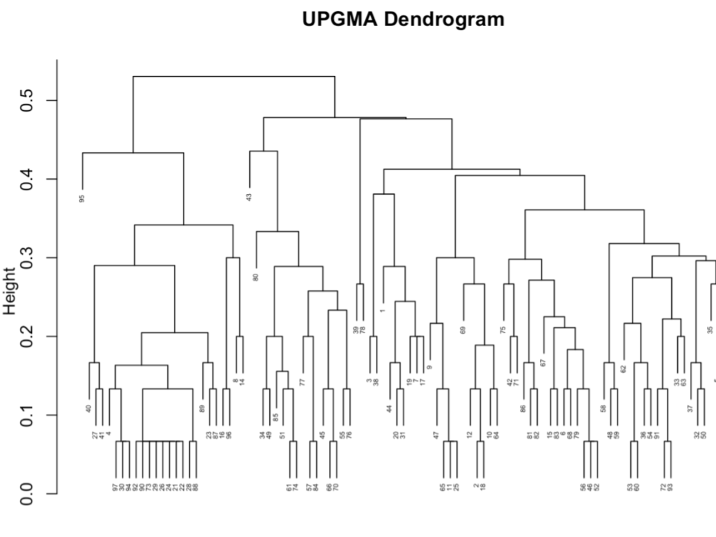

Figure S1: Dendrogram Visualization of Antibiotic Resistance Profiles of E. coli Isolates from the Five WWTPs
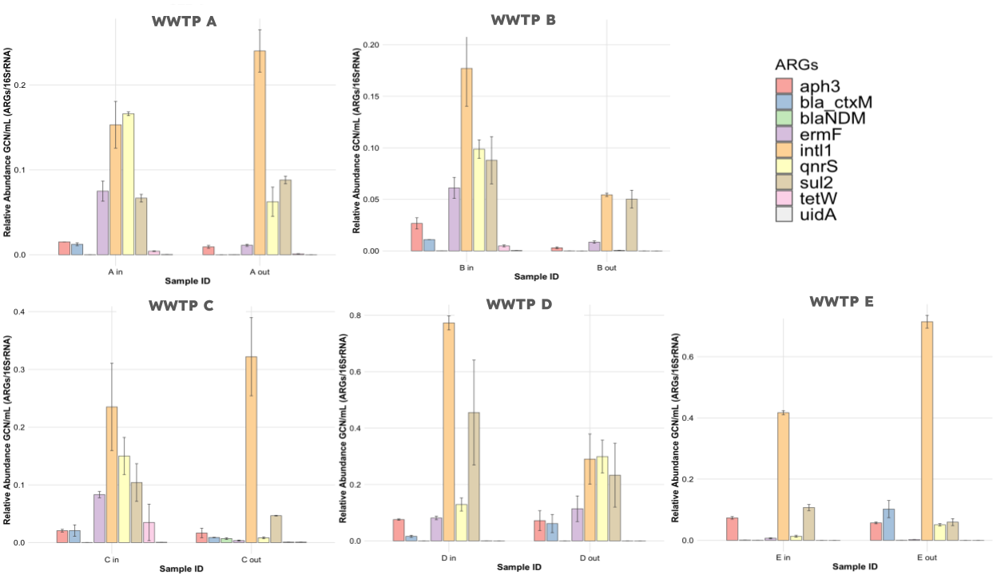

Fig S2: Relative Abundance of ARGs in Various WWTPs

