Supplementary Material
Influence of the defect of activated carbon surface on cigarette smoke components adsorption: A DFT study
Xinxin Li^{1,2}, Lu Ning^{1,2}, Jiangfei Yin³, Jing Che^{1,2}, Congxin Chen^{1,2}, Qiang Liu^{1,2}, Hongyun Hu^{4*}
1 China Tobacco Hubei Industrial Co., Ltd., Wuhan 430070, P. R. China;
2 China Tobacco Hubei Industrial of Cigarette Material Co., Ltd., Wuhan 430040,P. R. China;
3 Future-Tech Innovation Institute, Wuhan 430058,P. R. China;
4 State key Laboratory of Coal Combustion, School of Energy and Power Engineering, Huazhong University of Science and Technology, Wuhan, 430074, China

Total number of pages: 8
Total number of table and figures: 12

Figure and Table captions
Fig. S1. Adsorption structures of CO on activated carbon (AC).
Table S1 Adsorption energy of CO on activated carbon (AC).
Fig. S2. Adsorption structures of nicotine on activated carbon (AC).
Table S2 Adsorption energy of nicotine on activated carbon (AC).
Fig. S3. Adsorption structures of phenol on activated carbon (AC).
Table S3 Adsorption energy of phenol on activated carbon (AC).
Fig. S4. Adsorption structures of CO on defective activated carbon (AC1).
Table S4 Adsorption energy of CO on defective activated carbon (AC1).
Fig. S5. Adsorption structures of nicotine on defective activated carbon (AC1).
Table S5 Adsorption energy of nicotine on defective activated carbon (AC1).
Fig. S6. Adsorption structures of phenol on defective activated carbon (AC1).
Table S6 Adsorption energy of phenol on defective activated carbon (AC1).

S1-1. AC-CO S1-2. AC-N₂O
Fig. S1. Adsorption structures of CO on activated carbon (AC).
Table S1 Adsorption energy of CO on activated carbon (AC)
Structure | E_{ads} (kJ/mol)
S1-1. AC-CO | -161.16
S1-2. AC-CO | -159.72

S2-1. AC-nicotine S2-2. AC-nicotine
S2-3. AC-nicotine S2-4. AC-nicotine
Fig. S2. Adsorption structures of nicotine on activated carbon (AC).
Table S2 Adsorption energy of nicotine on activated carbon (AC)
Structure | E_{ads} (kJ/mol)
S2-1. AC-nicotine | -85.07
S2-2. AC-nicotine | -90.77
S2-3. AC-nicotine | -4.36
S2-4. AC-nicotine | -112.38

S3-1. AC-phenol S3-2. AC-phenol
S3-3. AC-phenol
Fig. S3. Adsorption structures of phenol on activated carbon (AC).
Table S3 Adsorption energy of phenol on activated carbon (AC)
Structure | E_{ads} (kJ/mol)
S3-1. AC-phenol | -186.95
S3-2. AC-phenol | -13.13
S3-3. AC-phenol | -13.32

S4-1. AC1-CO S4-2. AC1-N₂O
Fig. S4. Adsorption structures of CO on defective activated carbon (AC1).
Table S4 Adsorption energy of CO on defective activated carbon (AC1)
Structure | E_{ads} (kJ/mol)
S4-1. AC1-CO | -359.98
S4-2. AC1-CO | -160.04

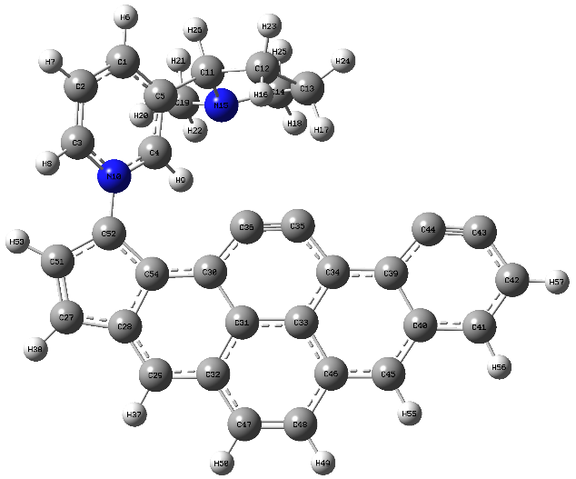
S5-1. AC1-nicotine S5-2. AC1-nicotine
S5-3. AC1-nicotine S5-4. AC1-nicotine
Fig. S5. Adsorption structures of nicotine on defective activated carbon (AC1).
Table S5 Adsorption energy of nicotine on defective activated carbon (AC1)
Structure | E_{ads} (kJ/mol)
S5-1. AC1-nicotine | -320.18
S5-2. AC1-nicotine | -109.90
S5-3. AC1-nicotine | -111.89
S5-4. AC1-nicotine | -165.87

S6-1. AC1-phenol S6-2. AC1-phenol
S6-3. AC1-phenol S6-4. AC1-phenol
Fig. S6. Adsorption structures of phenol on defective activated carbon (AC1).
Table S6 Adsorption energy of phenol on defective activated carbon (AC1)
Structure | E_{ads} (kJ/mol)
S6-1. AC1-phenol | -259.84
S6-2. AC1-phenol | -12.83
S6-3. AC1-phenol | -176.08
S6-4. AC1-phenol | -204.49

