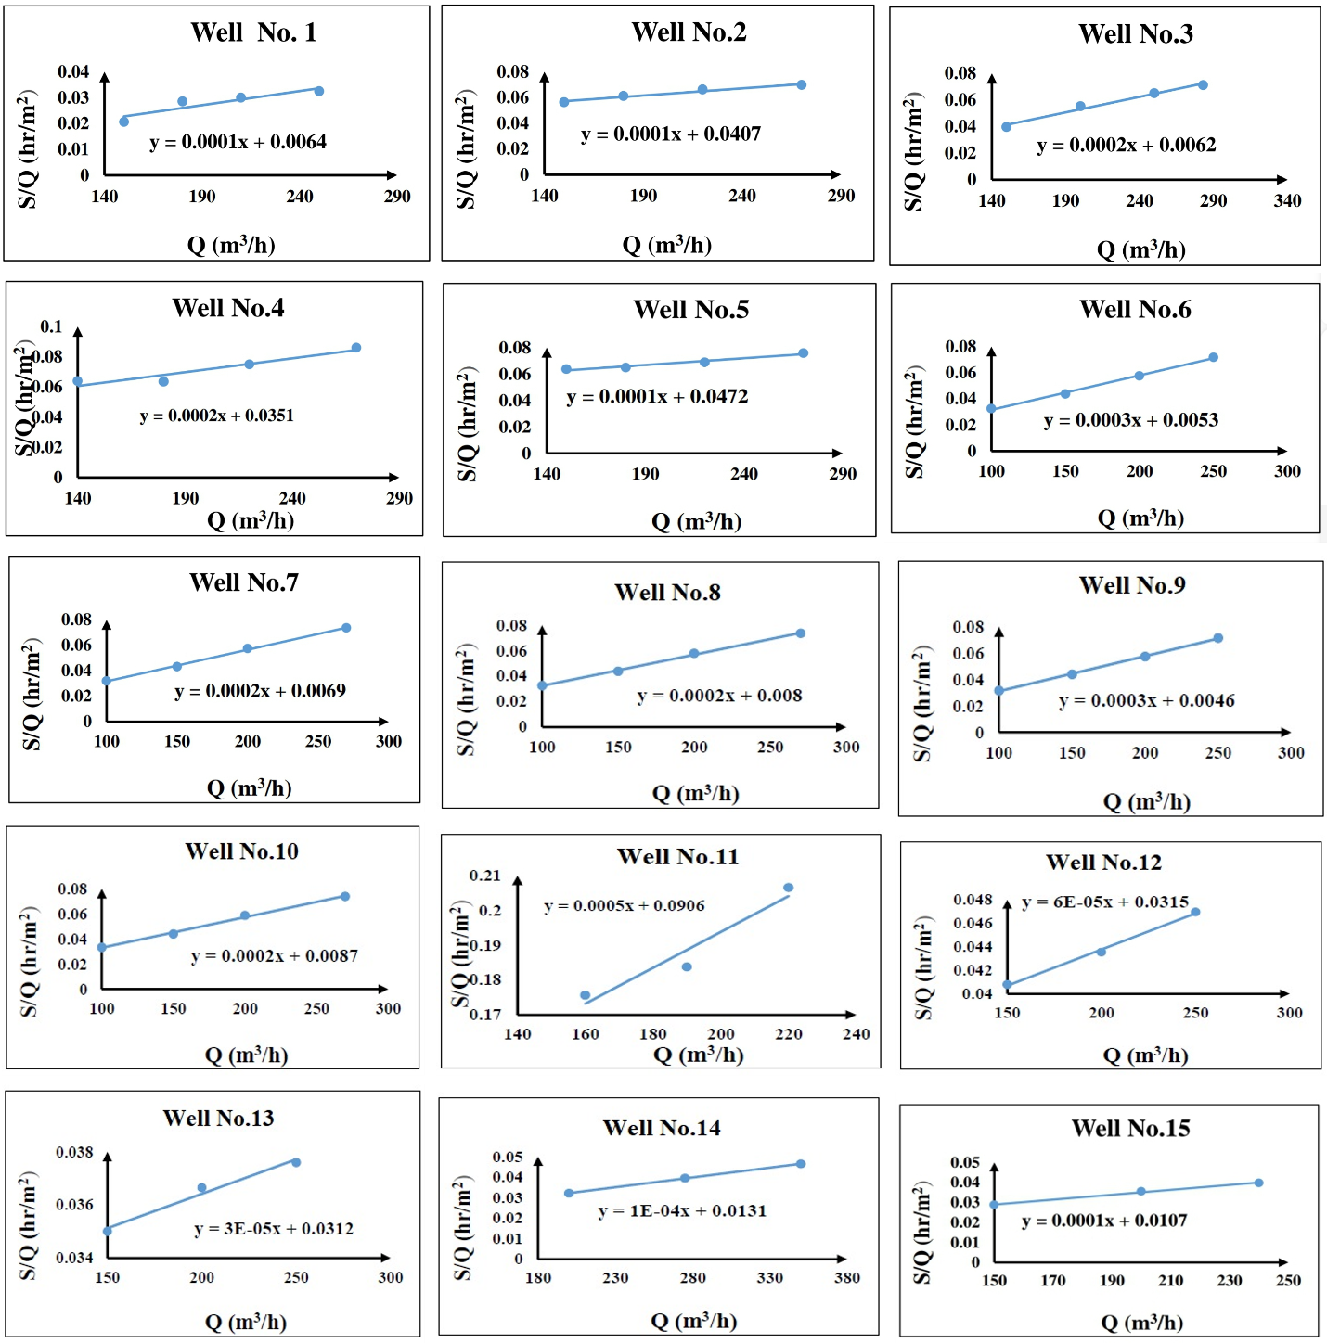
Fig. 1S. The step-drawdown test at the studied wells 1-15
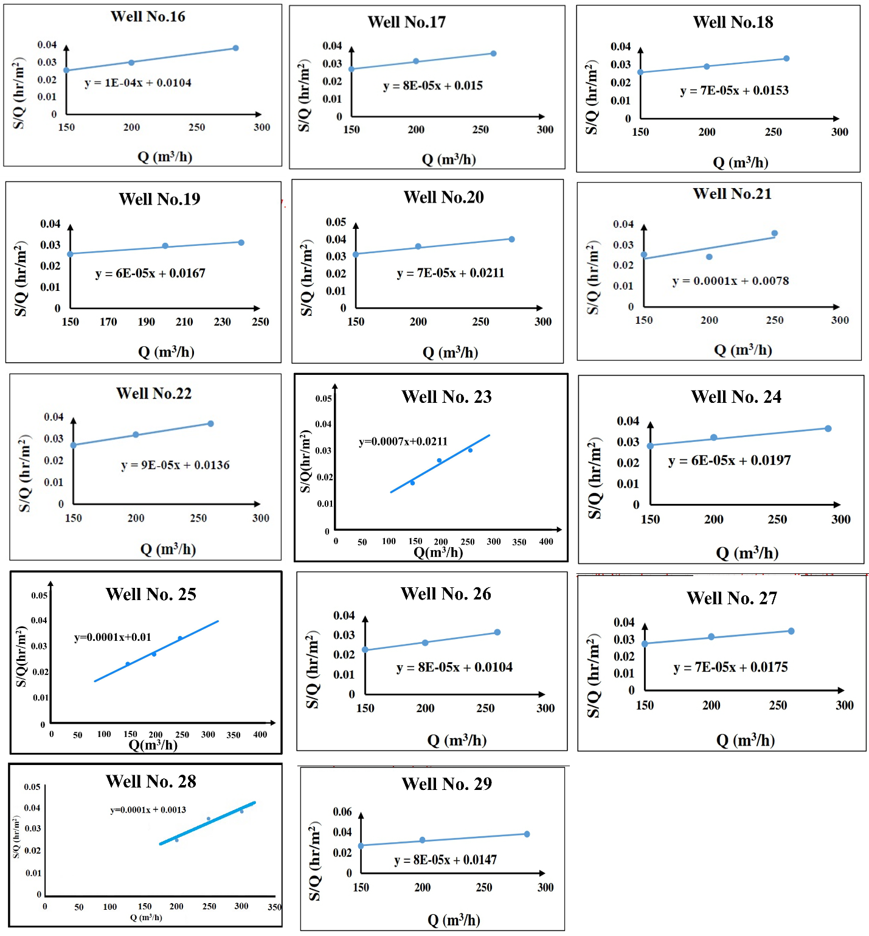
Fig. 1S. Continued: The step-drawdown test at the studied wells 16-29

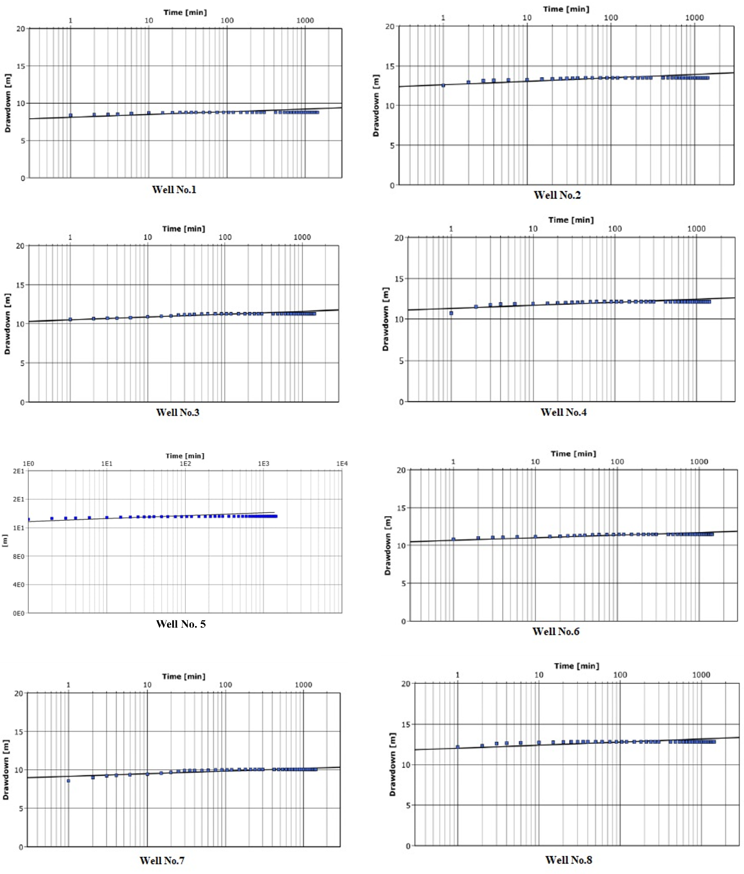
Fig. 2S. Long duration constant discharge pumping test at wells 1-8

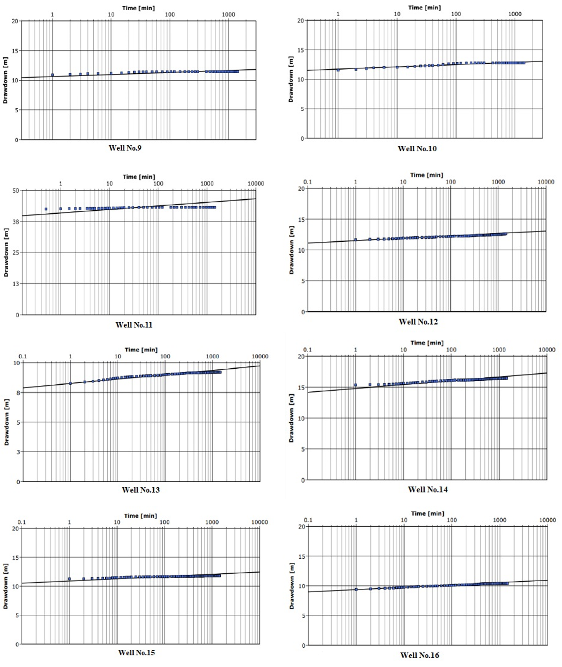
Fig. 2S. Continued: Long duration constant discharge pumping test at wells 9-16

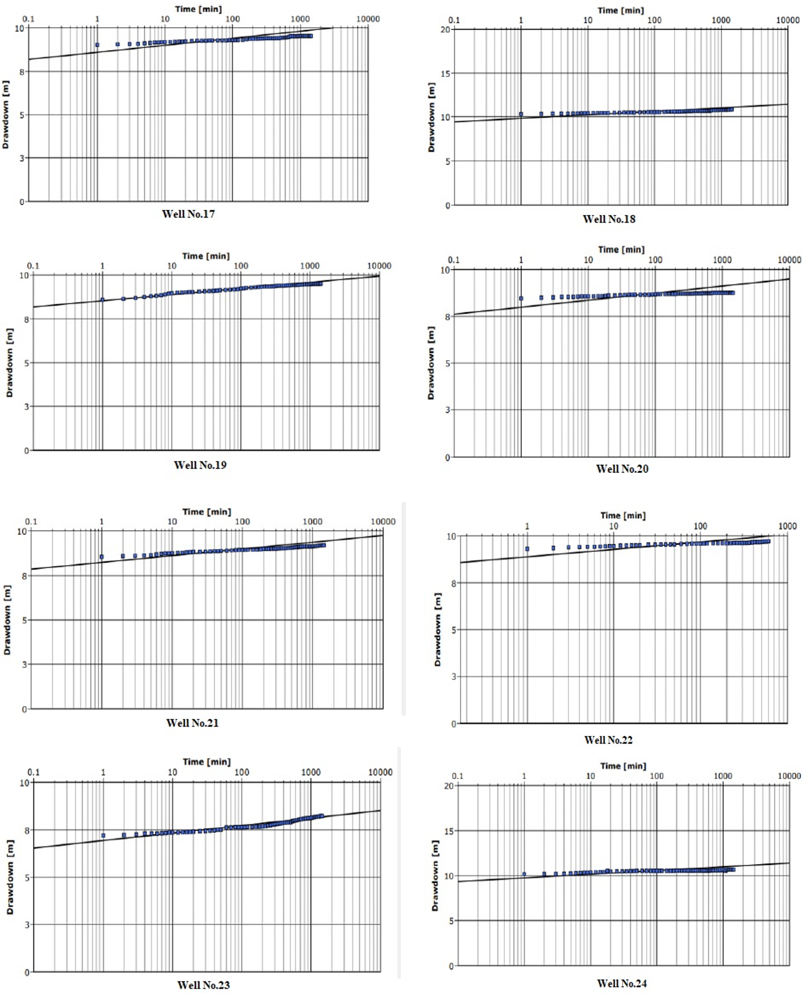
Fig. 2S. Continued: Long duration constant discharge pumping test at wells 17-24

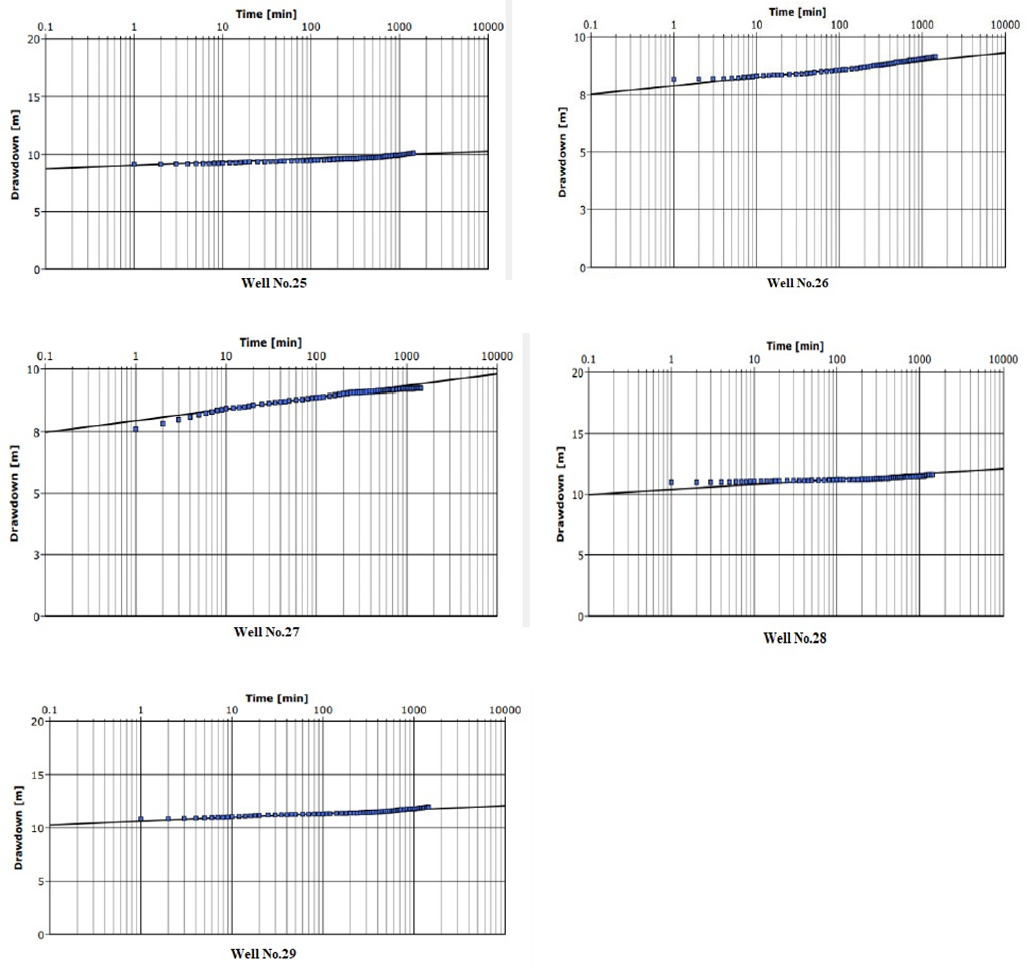
Fig. 2S. Continued: Long duration constant discharge pumping test at wells 25-29

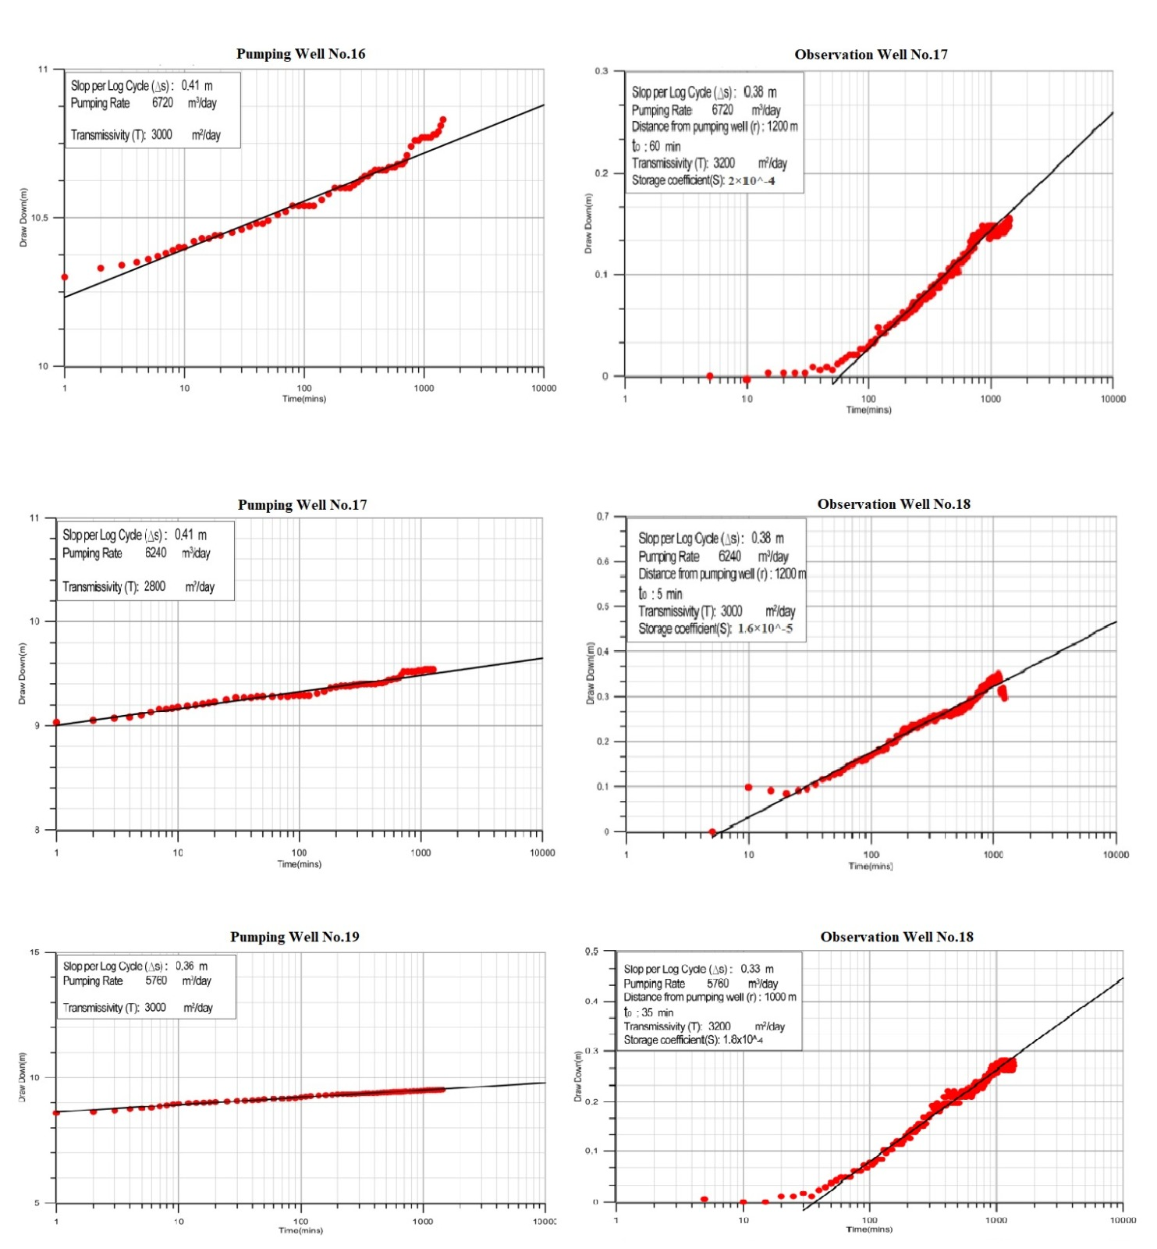
Fig. 3S. Long duration constant discharge pumping test by pumping (left) and observation wells (right) (see Table 6)
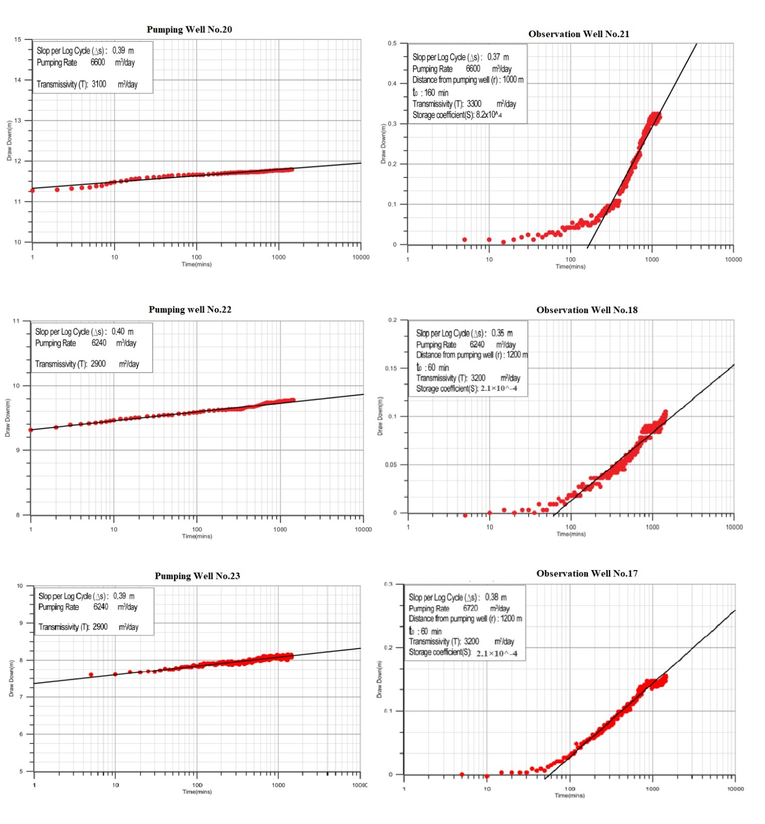
Fig. 3S.Continued: long duration constant discharge pumping test pumping (left) and observation wells (right) (see Table 6)

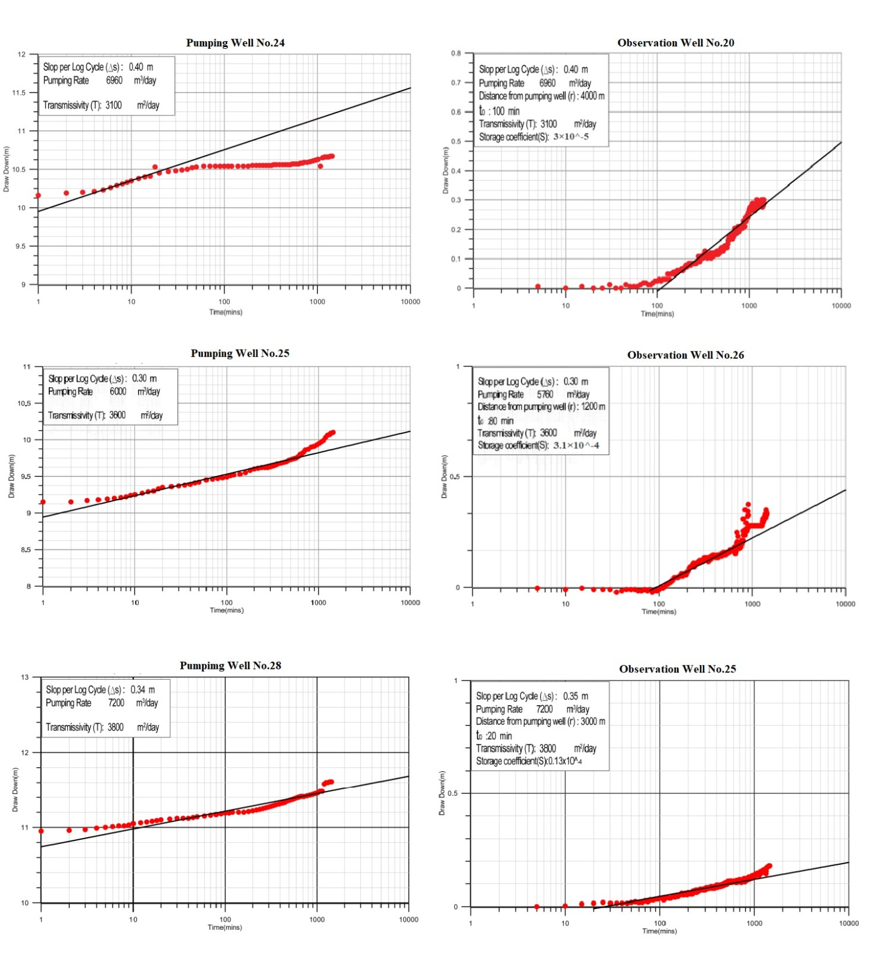
Fig. 3S.Continued: long duration constant discharge pumping test pumping (left) and observation wells (right) (see Table 6)

